### Users

A user is **anyone who logs in to Salesforce**. Users are employees atyour company, such as sales reps, managers, and IT specialists, whoneed access to the company's records. Every user in Salesforce has a user account

### Creating A User

1. From Setup, in the Quick Find box, enter Users.
2. Select Users.
3. Click New User.
4. Enter the First Name, **Class,** Last Name, **Teacher** and (Your) email address anda unique username in the form of an email address. By default, the username is the same as the email address.
5. Select a User License as salesforce.

**NOTE** - As **Salesforce** license can only be used by 2 Users at a time in Dev Org, so If

you don’t find a salesforce license then deactivate a user who has a salesforce license Or change the license type from Salesforce to any other.

1. Select a profile as Standard user.
2. Check Generate new password and notify the user immediately to have the user’s login name and a temporary password emailed to your email.

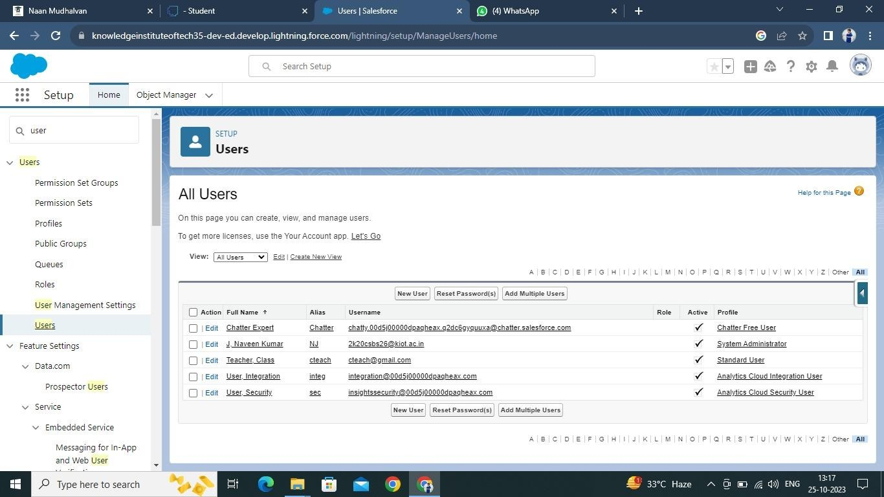

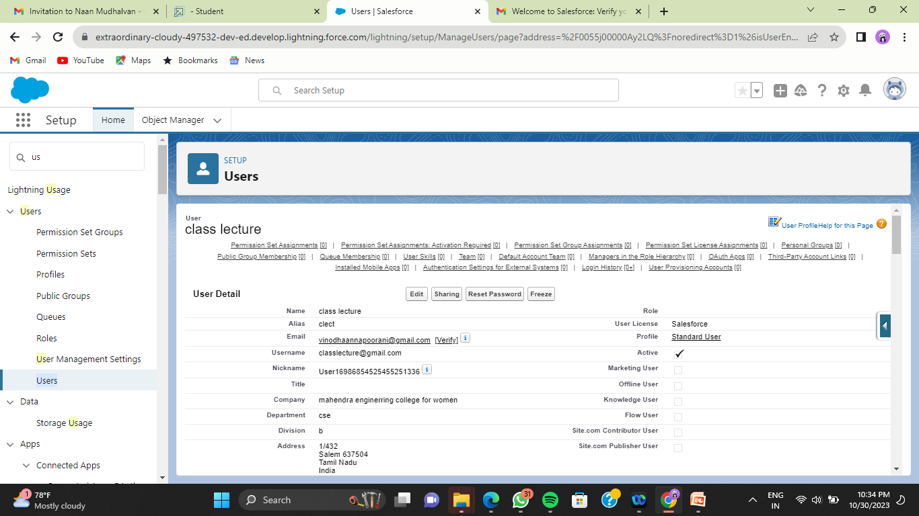

### Create Record (Course Details)

1. Click on App Launcher on left side of screen.
2. Search **Candidate Internal Result Card** App & click on it.
3. Click on **Course Details** tab.
4. Click new button
5. Fill all **Course Details** record details.
6. Click on Save Button.

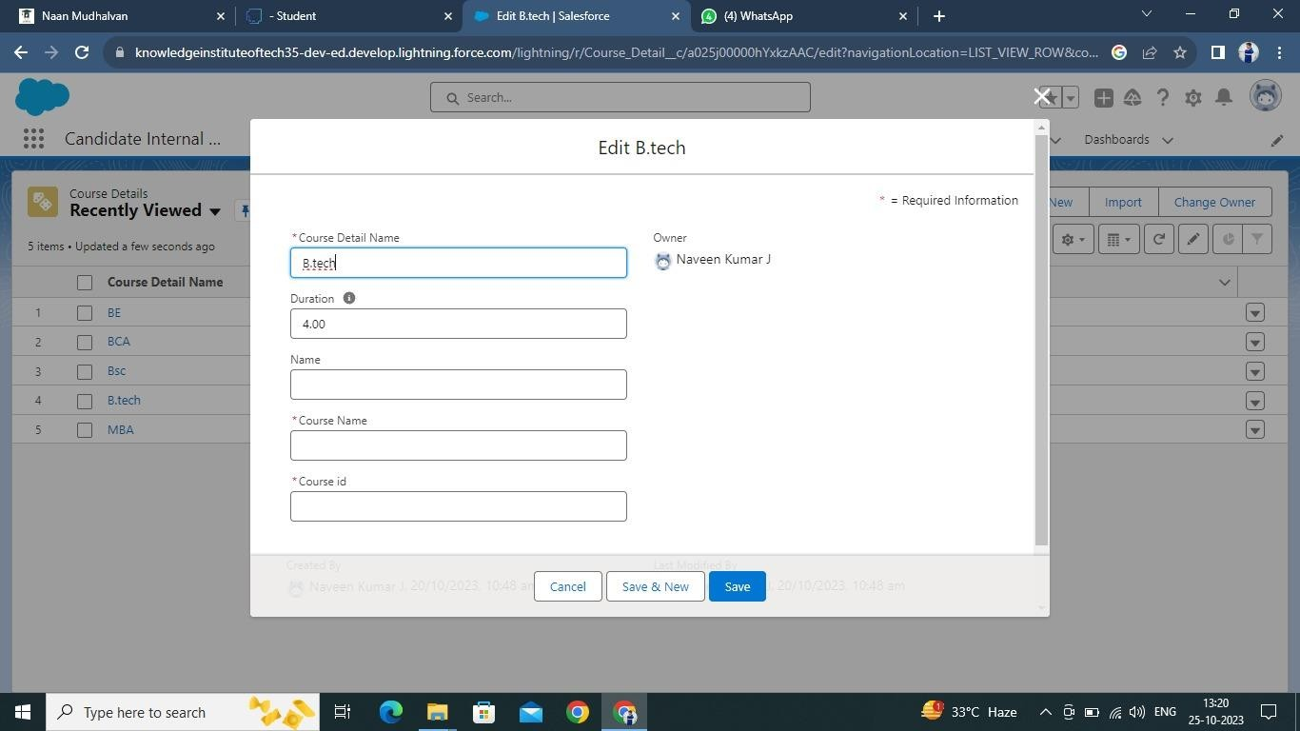

### View Record (Course Details)

1. Click on App Launcher on left side of screen.
2. Search **Candidate Internal Result Card** & click on it.
3. Click on **Course details** Tab.
4. Click on any record name. you can see the details of the Driver.

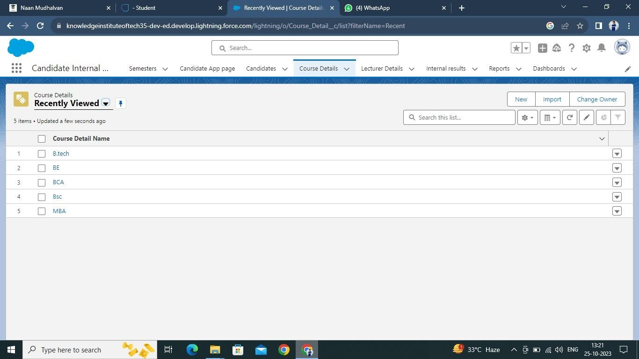

### Delete Record (Course Details)

1. Click on App Launcher on left side of screen.
2. Search **Candidate Internal Result Card** & click on it.
3. Click **on Course details** Tab.
4. Click on Arrow at right hand side on that Particular record.
5. Click delete and delete again.

