1. Create a table with 5 fields with primary key(student)

Solution:

CREATE TABLE Students(

id int,

name varchar(50),

address text,

grades varchar(50),

phone varchar(10)

);

Output:

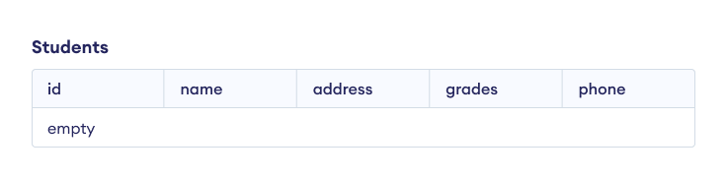2. Create a table with 5 fields with primary key(course)

Solution:

CREATE TABLE courses (

course VARCHAR(50) PRIMARY KEY,

course_name VARCHAR(100),

instructor VARCHAR(50),

credits INT,

department VARCHAR(50)

);

Output:

Courses

|  |  |  |  |  |
| --- | --- | --- | --- | --- |
| course | course_name | instructor | credits | department |
| empty | | | | |