Title: Analyzing Instagram Post Performance: Insights on Engagement, Reach, and Effectiveness
Name: Yuvashri Rajendran
1. Introduction:
Social media has become a vital tool for businesses, influencers, and content creators to engage with their audiences. Understanding key performance metrics is essential for optimizing content strategy and maximizing reach and engagement. This report analyzes social media performance data from Instagram and Facebook, focusing on impressions, reach, engagement, and the impact of hashtags.
The primary objective of this report is to explore trends in audience interaction, identify high-performing content, and provide actionable insights for improving engagement rates. By leveraging data visualization in Power BI and conducting Exploratory Data Analysis (EDA) in Python, we aim to highlight the most effective strategies for increasing visibility and fostering community engagement across both platforms.
This report will cover data preparation, key performance indicators (KPIs), exploratory data findings, and strategic recommendations based on data-driven insights.

Figure 1: Social Media Account Users

2. Exploratory Data Analysis:
2.1. Data Cleaning:
The dataset comprises multiple observations of Instagram performance metrics, with key attributes such as profile impressions, shares, engagement, profile visits, profile reach, reel shares, and new followers. Notably, there are 340 missing values in the 'New followers' column and 6 missing values in 'RowHash', while all other columns remain complete. The presence of missing values in critical engagement metrics necessitates appropriate handling to maintain data integrity.
Further data exploration will focus on addressing these gaps and analyzing the impact of engagement factors on audience growth. This process ensures a reliable foundation for deriving insights into Instagram content effectiveness and audience interaction trends.
The dataset contains 6 duplicate rows based on the 'RowHash' column, indicating potential redundancy in the data. Identifying and addressing these duplicates is crucial to ensuring accurate analysis and preventing skewed insights. Additionally, missing values, particularly in the 'New followers' column, were handled by replacing them with 0 to maintain data consistency. This approach ensures that missing values do not distort engagement metrics while preserving the dataset's overall structure. By cleaning duplicates and handling missing data effectively, the dataset is now more reliable for further exploration and analysis, leading to more accurate insights into Instagram post-performance and audience engagement trends.

3. Statistical Analysis:
3.1. New Followers Analysis on Instagram:
New followers represent the growth of an Instagram profile and indicate how well content, branding, and engagement strategies attract users. This metric is essential for assessing audience expansion and the effectiveness of marketing efforts. A higher number of new followers suggests increased brand awareness, while fluctuations can indicate shifts in content performance or external factors affecting reach.
From the dataset, Instagram gained 194 new followers, reflecting steady growth in audience reach. This increase may be attributed to engaging content, strategic hashtag usage, or effective promotions. To sustain and improve follower acquisition, it is crucial to analyze which posts, campaigns, or engagement tactics contributed most to this growth. Additionally, optimizing posting frequency, leveraging influencer collaborations, and refining content strategy can further enhance follower retention and attract a broader audience.

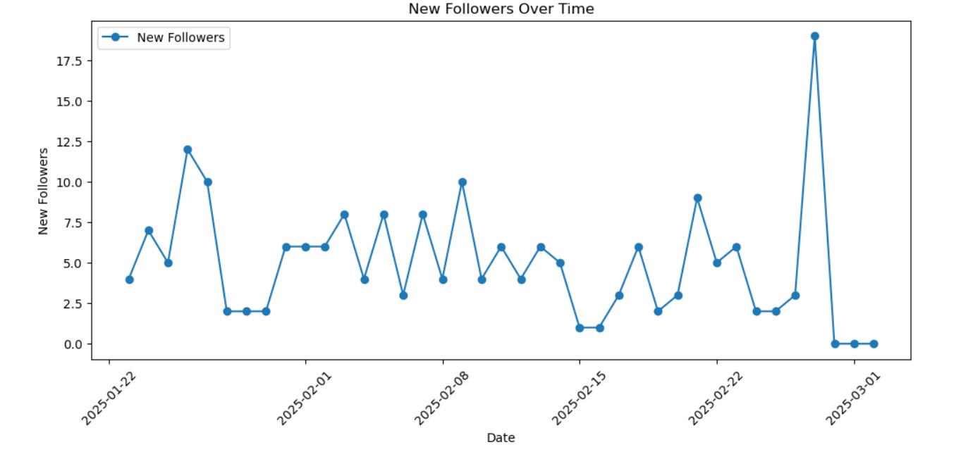
Figure 3.1.1: Line Chart of New Followers of Instagram over Time

3.2. Total Engagement Analysis on Instagram vs Facebook:
Total engagement is a key performance indicator that reflects audience interaction with social media content, encompassing likes, comments, shares, and saves. It serves as a measure of content effectiveness, brand visibility, and audience interest.
Total Engagement = Like Count + Comments Count + Shares + Unique Saves
A higher engagement rate often signifies that the content resonates well with the target audience, driving more interactions and fostering a stronger online community. On Instagram, engagement levels fluctuate across different posts, with some posts receiving minimal interaction while others peak at 667 engagements. Such variations indicate that certain types of content, themes, or posting times yield higher audience participation. By analyzing engagement trends, businesses can identify which content strategies are most effective and adjust their approach to maximize impact.
On Facebook, engagement levels exhibit even greater fluctuation, ranging from 12.9 to 2500 interactions. This broad variation suggests that some posts successfully capture audience attention while others fail to generate significant interaction.
Total Engagement = Total Post Reactions + Comments on Posts + Shares on Posts + Post Link Clicks
Understanding these engagement trends is essential for refining social media strategies, optimizing content formats, and improving post scheduling. High engagement rates indicate that the content aligns well with user preferences, while lower figures may signal the need for improved targeting or creative adjustments. By leveraging these insights, businesses can develop more data-driven strategies to enhance audience interaction, build brand loyalty, and ultimately drive better results from their social media efforts.
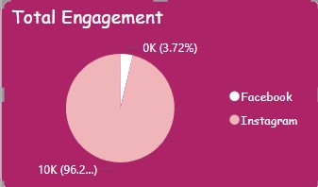
Figure 3.2.1: Pie Chart showing Total Engagement of Different Platforms

3.3. Profile Followers of Instagram based on Age:
The analysis of Instagram profile followers by age group provides valuable insights into audience demographics and engagement trends. The platform’s primary user base consists of individuals aged 35-44, representing 7,332 followers, followed by the 25-34 age group with 2,503 followers. This indicates that the platform is most popular among working professionals and middle-aged users. Additionally, the 45-54 segment accounts for 2,150 followers, further reinforcing the platform’s appeal to an older yet active audience.
In contrast, engagement among younger demographics remains significantly lower, with only 115 followers in the 18-24 bracket and 37 in the 13-17 category. This suggests an opportunity for targeted marketing efforts to attract younger users. Similarly, the 55-64 and 65+ groups, with 163 and 147 followers respectively, highlight a smaller but potentially valuable segment that could be tapped into with tailored content and engagement strategies.
From a business perspective, these insights can inform strategic decision-making regarding content creation, advertising campaigns, and audience engagement initiatives. By focusing on the dominant middle-aged segment while simultaneously implementing strategies to attract younger and older demographics, businesses can optimize their social media efforts to drive greater reach and engagement.

Figure 3.3.1: Bar graph of Profile followers based on Age

3.4. Engagement Rate by Reach:
Engagement Rate by Reach (ERR) is a crucial metric that measures the percentage of users who engaged with a post out of the total number of people who saw it. It is calculated using the formula,
ERR = (Total Engagement / Total Reach) × 100
A high ERR indicates that the content is resonating well with the audience, leading to increased interactions such as likes, comments, shares, and saves. The dataset reveals significant variations in ERR, with peaks reaching 10.67%, suggesting that certain posts are highly engaging. However, lower ERR values indicate that some content is not effectively capturing audience interest. To improve engagement, businesses should analyze high-performing posts and refine their content strategy by optimizing post timing, captions, and visual elements.

3.5. Engagement Rate by Impressions:
Engagement Rate by Impressions (ERI) evaluates the effectiveness of content based on the number of times a post appears in users' feeds. It is calculated using the formula,
ERI = (Total Engagement / Total Impressions) × 100
The dataset shows fluctuations in ERI, with some posts achieving engagement rates of up to 9.13%, while others perform significantly lower. This variability highlights the importance of content relevance, creative appeal, and audience targeting. By closely monitoring ERI trends, businesses can refine their content strategies, optimize ad placements, and enhance creative execution to maximize engagement and overall brand visibility.

Figure 3.5.1: Engagement Rate by Reach vs Engagement Rate by Impressions

3.6. Hashtag Performance Analysis for Instagram:
Total Impressions and Reach:
The analysis of hashtag performance highlights the visibility of specific hashtags based on their total impressions. Hashtags such as #singlemums (72,541), #singlemomlife (70,535), and #mumguilt (64,933) have the highest total impressions, indicating strong reach among users. This suggests that content incorporating these hashtags is widely seen, making them effective for increasing brand awareness and engagement. By leveraging hashtags with high impressions, Instagram accounts can maximize their reach and attract a broader audience.
Engagement and Effectiveness:
While high impressions indicate visibility, engagement is a key factor in determining a hashtag's effectiveness. The total engagement metric shows how users interact with posts using specific hashtags. #mumanxiety (2.12), #mumguilt (2.12), and #singlemums (1.98) demonstrate higher engagement levels, reflecting strong audience interest. However, hashtags like #divorcecommunity and #divorcedmom (1.87) also generate notable engagement, making them valuable for niche content targeting specific user groups. Focusing on these hashtags can enhance interaction rates and foster community engagement.
Engagement rate, calculated using the formula:
Engagement Rate = (Total Impressions / Total Engagement) × 100
provides insight into how well a hashtag drives user interaction relative to its visibility. Hashtags with the highest engagement rates include #singlemumsuk (0.000052), #divorcecoach (0.000049), and #supportingchrildrenthroughdivorce (0.000049).
These hashtags, while having lower total impressions compared to broader hashtags, demonstrate a higher rate of meaningful engagement. This suggests that they are particularly effective for targeting a highly engaged audience. Instagram accounts should prioritize a mix of high-impression hashtags for visibility and high-engagement-rate hashtags for deeper interaction to optimize their content strategy.

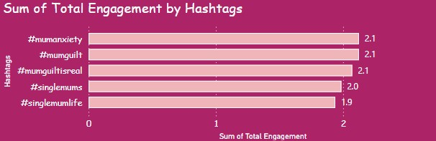
Figure 3.6.1: Top Hashtags showing impact on Total Engagement

Additionally, A/B testing allows advertisers to gain deeper insights into audience preferences, enabling them to tailor future campaigns based on data-driven learnings. By continuously testing and iterating ad creatives, businesses can enhance ad relevance, reduce ad fatigue, and improve overall campaign efficiency. Moreover, incorporating elements such as different calls-to-action (CTAs), video versus static images, and varying color schemes can further refine ad effectiveness. Ultimately, a well-executed A/B testing strategy empowers businesses to maximize engagement, drive higher conversion rates, and achieve sustainable growth in their digital advertising efforts.

3.7. Instagram Followers based on Location:

Figure 2.4.1: Followers based on Location

The analysis of profile followers based on location reveals significant geographic trends in audience distribution. London leads with the highest number of followers (293), indicating strong engagement from the UK market, followed by Cape Town (168) and Cairo (135), demonstrating notable traction in South Africa and Egypt. Major metropolitan cities such as Nairobi (126), Melbourne (87), and Karachi (84) also show substantial engagement, reflecting a diverse international audience. North American representation is led by Toronto (69) and New York (57), while key Middle Eastern and South Asian hubs, including Dubai (39), Lahore (56), and Mumbai (53), further contribute to the global reach.
The data suggests that audience concentration aligns with major urban centers, highlighting the potential for targeted content strategies based on regional preferences. To enhance engagement, location-specific campaigns and localized content could be leveraged to cater to followers in high-density regions while also exploring growth opportunities in emerging markets.

4. Conclusion:
The analysis of Instagram and Facebook post-performance has provided valuable insights into audience engagement, content effectiveness, and hashtag impact. By examining key metrics such as impressions, engagement rates, and follower demographics, we have identified trends that can enhance social media strategy. The findings indicate that strategic hashtag usage plays a crucial role in increasing visibility and engagement, with hashtags like #singlemums and #mumguilt demonstrating strong interaction rates. Additionally, the analysis of new followers and geographic distribution highlights opportunities for targeted content tailored to specific audience segments. Notably, the top-performing Instagram post, which focused on parenting and divorce, achieved the highest engagement rate, reinforcing the importance of relevant and relatable content in driving audience interaction.
Engagement rate by reach (ERR) and engagement rate by impressions (ERI) proved to be essential indicators of content performance. Posts with higher engagement rates tended to generate stronger audience interaction, suggesting that optimizing content format, post timing, and creative elements can enhance overall reach and engagement. Furthermore, Facebook ad performance can be significantly improved through A/B testing, allowing businesses to identify the most effective creative assets and messaging. By analyzing metrics such as click-through rate (CTR), conversion rate, and cost per acquisition, advertisers can refine their strategies to maximize return on investment. The highest-performing Facebook post, which featured supportive messaging around co-parenting, achieved the greatest number of interactions, highlighting the importance of emotionally resonant content.
To further improve social media performance, businesses should leverage data-driven insights to optimize their content strategy. This includes balancing high-impression hashtags for broader reach with high-engagement hashtags for deeper audience interaction. Additionally, implementing region-specific campaigns based on audience demographics can enhance engagement and brand loyalty. By continuously analyzing engagement trends, refining creative strategies, and testing ad variations, businesses can strengthen their online presence and achieve sustained growth on Instagram and Facebook. Prioritizing content that resonates with the audience, as seen in the top-performing posts, will be key to maintaining and increasing engagement levels.
4.1. Future Analysis:
For a comprehensive Instagram performance evaluation, additional analyses are recommended to gain deeper insights into audience behavior and content effectiveness. First, sentiment analysis of comments and direct messages can help understand audience perception and engagement quality. Second, follower growth trend analysis can identify periods of rapid increase or decline, helping refine content and engagement strategies. Third, analyzing post timing and frequency can determine the optimal posting schedule for maximum reach and engagement.

