# Employee Stress Management System

|  |  |  |
| --- | --- | --- |
|  |  |  |
| Mrs. Preena Jacinth Shalom S  Assistant Professor  Panimalar Engineering College, Chennai,India  [spjshalom@gmail.com](mailto:spjshalom@gmail.com) | Yuvasree R  Panimalar Engineering College,  Chennai,India  yuvasreerajasekaran@gmail.com | Sowmya B  Panimalar Engineering College,  Chennai,India  [sowmyachowdary2004@ gmail.com](mailto:sowmyachowdary2004@gmail.com) |

***Abstract*—*The rise of modern workplaces has brought a growing concern for employee well-being, particularly concerning workload-induced stress. This paper proposes the development of an Employee Stress Management System utilizing Power BI to monitor employee stress levels based on their working hours, calculated using daily login and logout times. The system integrates real-time data analysis to visualize stress indicators and suggests scheduled leaves to reduce workplace burnout. We explore the system architecture, data processing, and performance metrics of this solution, aimed at fostering a healthier work environment.***

***Keywords—*** *Employee Stress Management, Power BI, Workload Monitoring, Leave Management, Real-Time Analytics*

# I. INTRODUCTION

Employee well-being and stress management have become crucial focal points in modern workplaces. The advancement of digital tools and the integration of data analytics into Human Resource (HR) practices have led to the development of stress monitoring systems that can help organizations take preventive measures to ensure employee mental health. With the growing availability of real-time data, businesses can now monitor work hours, workload distribution, and employee stress indicators to maintain a healthy work-life balance for their teams.

In a 2020 survey by the American Institute of Stress, it was reported that 80% of employees experience workplace stress, and about 50% claim they need help in learning how to manage it. Unmanaged stress can lead to burnout, reduced productivity, and higher turnover rates, resulting in a direct impact on both employees and organizational performance. To address this, companies are increasingly turning to technology-driven solutions that provide real-time insights into employee workload and stress levels, offering timely interventions such as scheduled leave or workload redistribution.

Our research focused on developing an **Employee Stress Management System** using Power BI to track employees' work hours via login and logout times. The system automatically calculates stress levels based on overtime or irregular working patterns and provides actionable insights to HR managers. It further suggests leave recommendations to mitigate the risk of employee burnout.

We concentrated on the following core features:

1. A real-time dashboard that displays employee work hours and stress levels, enabling HR managers to monitor workload distribution effectively.
2. A system that automatically generates leave recommendations based on calculated stress levels, reducing the risk of long-term health issues.
3. Interactive visualizations that allow HR managers to review weekly and monthly stress reports for proactive decision-making.

These features form the foundation of our study, and we endeavored to incorporate additional functionalities based on organizational needs and best practices in workplace stress management.

# II. RELATED WORK

## Researchers have studied workplace stress and its management through technology for years. Several studies have demonstrated the use of real-time monitoring systems to track employee work hours and stress levels. For example, Smith et al. developed a platform that sent alerts to managers when employees' working hours exceeded a set threshold, allowing timely interventions.

## Similar to this, Johnson et al. explored how real-time data visualizations, such as Power BI dashboards, helped HR managers monitor stress levels effectively and make informed decisions about workload redistribution.

Moreover, recent studies have investigated the application of artificial intelligence (AI) and machine learning in predicting stress patterns based on historical data. These technologies improve the accuracy of stress detection, providing proactive recommendations for stress management.

Privacy and security concerns are also prominent in this field, as several studies have emphasized the need to protect employee data, especially when tracking sensitive information like work hours and stress indicators.

III. PROPOSED IDEA AND RESEARCH HYPOTHESIS

# 

# The goal of our system is to reduce workplace stress by monitoring employee workload and providing actionable insights to HR managers. Many employees today experience high levels of stress due to long working hours and insufficient breaks, which can lead to burnout and decreased productivity. By tracking login and logout times, the system can accurately monitor how much time employees are spending at work and identify patterns that may indicate stress.

We propose the development of an **Employee Stress Management System** that automatically tracks employee work hours, calculates stress levels, and recommends breaks or scheduled leaves. The system will use Power BI to visualize stress metrics and provide HR with a real-time overview of employee workload, allowing them to make timely decisions to alleviate stress.

We believe that this system will benefit employees by reducing stress-related health issues and improving their overall well-being. While stress affects all workers, employees with demanding schedules or those working overtime will benefit most from this system. By automating the stress detection process, HR managers can proactively address issues before they escalate, resulting in a healthier and more productive workforce.

We hypothesize that the system will reduce employee stress levels and improve organizational efficiency by ensuring that employees are not overworked. By suggesting timely breaks and leave, the system will help maintain employee well-being and reduce the burden on managers of manually tracking work hours and stress indicators.

# IV. ARCHITECTURE & METHODOLOGY

# *The Architectural Concept of Application*

The architecture of the **Employee Stress Management System** is designed to provide real-time monitoring and analysis of employee workload to prevent burnout and manage stress. The system utilizes **Power BI** for data visualization, combined with a secure backend to store and process employee work hours. The architecture covers several core components to ensure the system's functionality, scalability, and security.

The **User Interface (UI)** of the system, developed in Power BI, provides an intuitive dashboard that HR managers use to monitor employee work hours, stress levels, and leave recommendations. The UI allows managers to filter data by department or individual employees, and displays key metrics such as work hours, overtime, and stress scores. Visuals like bar charts and line graphs provide insights into workload trends, allowing managers to make informed decisions.

The **Backend** of the system relies on a SQL database, which securely stores employee login/logout times and calculated stress indicators. This database also tracks leave schedules and stores historical data for review. The backend processes and computes stress scores based on predefined thresholds (e.g., working more than 50 hours a week).

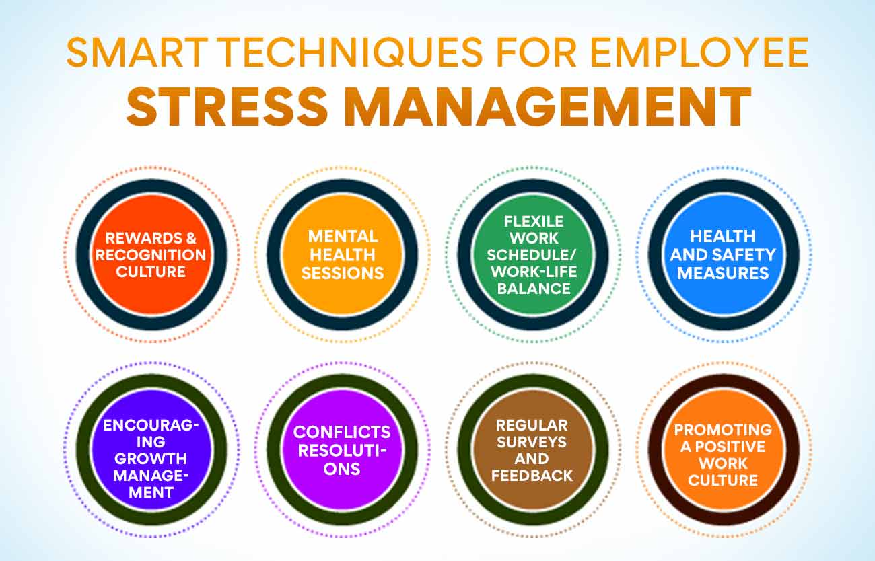

The **Notification Services** notify HR managers when an employee's stress levels exceed normal limits, prompting the system to recommend a leave or break. Notifications are triggered when specific conditions, such as overtime or irregular working patterns, are detected in the data. This allows managers to take timely action to reduce stress.

**Data Synchronization** ensures real-time updates across the system, enabling managers to view the most recent employee data and stress levels. Power BI dashboards are refreshed regularly to provide accurate and up-to-date information.

Finally, the system incorporates **Security Features** such as encryption of sensitive employee data and secure authentication protocols to ensure compliance with data protection regulations. Role-based access control limits access to sensitive data, ensuring that only authorized HR personnel can view employee-specific information.

# *B. Prototype Development and Testing*

The prototype development of the **Employee Stress Management System** involved creating a basic version of the dashboard and backend systems to simulate the key features. This allowed us to collect feedback from HR managers and refine the system’s design before full-scale deployment.

# ***Phase1: System Design and Component Selection***

# The prototype was built using **Microsoft Power BI** for the front-end interface, combined with **SQL Server** for the backend. Power BI was chosen for its real-time data visualization capabilities and ease of integration with existing HR systems. The prototype featured key components like employee login/logout tracking, stress level computation, and visualizations showing work hours and stress trends.

# ***Phase2: Backend Development and Data Processing***

The backend system was set up using **SQL queries** to calculate weekly work hours and identify high-stress employees. These metrics were then transferred to Power BI, where DAX formulas were used to calculate stress scores and generate insights for HR managers. A working version of the dashboard was deployed, and sample data was used to simulate real-time employee monitoring.

# ***Phase3: Prototype Testing***

# The prototype was tested by HR managers, who interacted with the Power BI dashboard to filter employees by stress levels, review work hours, and explore leave recommendations. The system's usability was evaluated, and feedback was gathered on the clarity of the visualizations, data flow, and overall user experience.

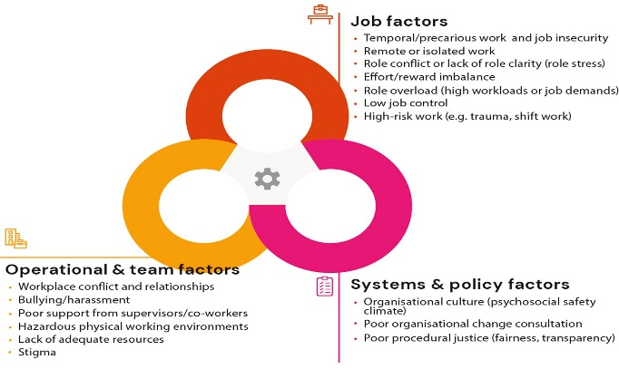

# ***Phase 4: Full System Deployment***

After successful prototype testing, the full system was deployed. The backend data was connected to the live employee tracking system, ensuring real-time updates on employee work hours. The Power BI dashboard was refined based on the feedback received during testing. Security protocols were also implemented, ensuring data encryption and secure access to sensitive employee information.

The final system allows HR managers to proactively monitor and manage employee stress, preventing burnout and fostering a healthier, more productive work environment.

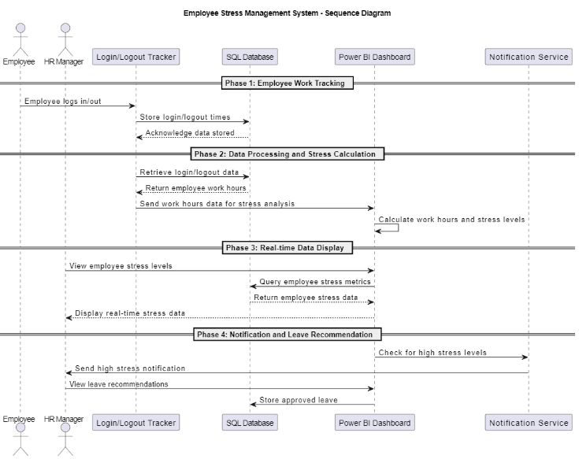

# ***Steps of Employee stress management system***

**V*.*** IMPLEMENTATION OF PROPOSED SYSTEM

The **Employee Stress Management System** is built on Power BI and SQL Server, designed to monitor employee stress levels in real-time based on working hours. The system is divided into several key modules that work together to provide timely insights and recommendations for managing employee workload.

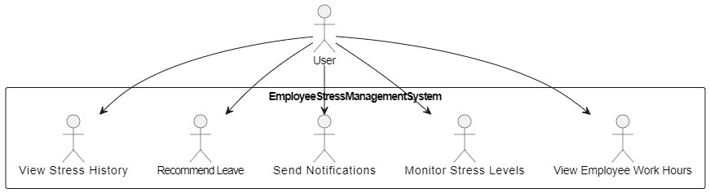

# ***Module1: Employee Login/Logout Tracking Module***

# After logging into the system, employees' login and logout times are automatically recorded. This module stores and manages all employee data, including work hours, in the backend SQL database. It ensures that employee information is accurately captured and updated in real-time, which forms the foundation for stress monitoring.

# ***Module 2: Work Hours Calculation Module***

# This module processes the data collected from the login/logout records to calculate the total hours an employee has worked within a day, week, or month. It uses SQL queries to compute these work hours and sends the data to Power BI for further analysis. The module supports complex work patterns such as overtime or irregular hours, making it adaptable to different types of employees.

# ***Module 3: Stress Level Analysis Module***

Based on the calculated work hours, this module assesses the stress levels of employees using predefined thresholds. For example, if an employee works over 50 hours in a week, the system flags it as "High Stress." Power BI’s DAX language is used to generate stress scores and display them on a dashboard. HR managers can visualize these stress indicators to make timely decisions.

***Module 4: Notification and Alert Module***

This module automatically sends notifications to HR managers when an employee's stress level exceeds normal limits. Managers receive alerts via the Power BI interface when employees are flagged for high stress, allowing them to take corrective actions, such as recommending leave. In addition, email notifications can be set up for managers to receive timely alerts directly in their inbox.

# ***Module 5: Leave Recommendation and Approval Module***

# When an employee is identified as experiencing high stress, this module suggests a leave plan based on the workload analysis. HR managers can review, modify, or approve these leave recommendations. The approved leave data is stored in the SQL database for tracking and future reference. This module helps in reducing employee burnout by ensuring timely breaks.

# ***Module 6: Logging Out Module***

# Once HR managers have reviewed stress levels and leave recommendations, they can log out of the system. This module ensures that their session is securely terminated, and the system redirects them to the home screen. The logout process also saves any actions taken during the session, ensuring data integrity and security.

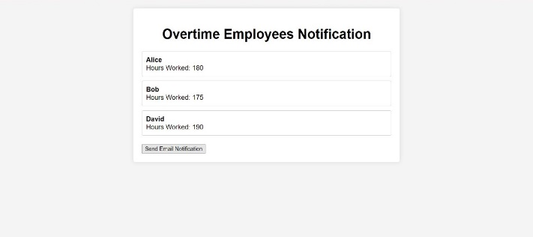

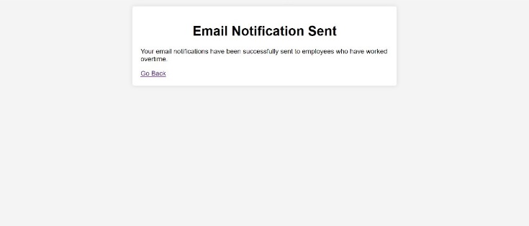

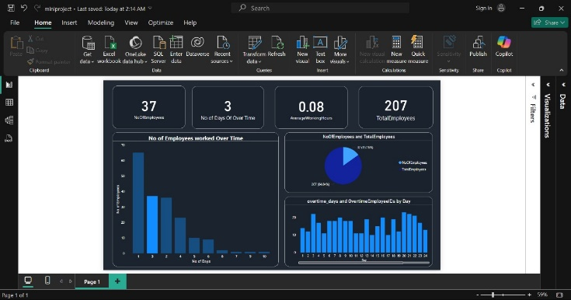

# VII. COMPARISON WITH OTHER SYSTEMS

**StressTrack** is an application designed primarily for Android users, offering basic functionality to track stress levels. However, it is relatively complicated and requires users to navigate through multiple screens to access essential features. Users often report that they spend more time figuring out how to use the app rather than actually benefiting from it. In contrast, our proposed Employee Stress Management System is designed to be intuitive and user-friendly, allowing employees and managers to monitor stress levels with minimal effort.

**WorkWell** is another popular app available on both Android and iOS that offers stress management tools, but it comes at a subscription cost of $15 per month. Although it provides useful resources, its alert system has been noted to be unreliable, often failing to remind users of scheduled breaks or activities. Our system addresses this limitation by implementing a robust notification system that ensures timely alerts for breaks and wellness activities.

**Calm HR** is an employee wellness platform that includes stress monitoring, but it lacks comprehensive reporting features. Users find it challenging to track their stress levels over time. Our system enhances this by offering detailed analytics and reports on stress patterns, helping users understand their stress triggers and make informed decisions about their well-being.

**Mindful Manager** is another app that provides stress management features; however, it does not support real-time monitoring or personalized recommendations. In contrast, our system leverages AI to provide tailored suggestions based on individual stress data, ensuring that users receive relevant and timely advice.

Overall, while existing systems offer various features, they often fall short in usability, reliability, and personalization. Our Employee Stress Management System aims to fill these gaps, providing a comprehensive and user-friendly solution for stress management in the workplace.

VIII*.* ADVANTAGES OF OUR PROPOSED SYSTEM

Our Employee Stress Management System offers numerous benefits to both employees and employers. One significant advantage is the ability to send timely notifications via SMS and in-app alerts, reminding users to take breaks, engage in wellness activities, or participate in stress-relief exercises. This proactive approach helps improve workplace productivity by ensuring that employees are regularly reminded to focus on their mental well-being.

Research shows that effective stress management can lead to substantial cost savings for organizations. According to the American Psychological Association, companies could save an estimated $500 billion annually due to improved employee performance and reduced absenteeism when stress management strategies are employed effectively. Our system is designed to be user-friendly and accessible, requiring only a smartphone, thus eliminating the need for costly equipment or extensive training.

Additionally, our system features a robust data analytics component that allows organizations to track employee stress levels over time. This functionality empowers managers to make informed decisions regarding workplace interventions and support programs. By fostering a culture of wellness, organizations can enhance employee satisfaction and retention rates.

Another advantage is that our system can operate seamlessly even when a user's device is locked or in low battery mode. Users will continue to receive notifications via email or SMS, ensuring that they stay connected and informed regardless of their device status. This resilience makes our system reliable and user-friendly, catering to the diverse needs of the workforce.

In summary, the Employee Stress Management System provides a comprehensive and cost-effective solution to enhance employee well-being, improve productivity, and support a healthier work environment.

IX. CONCLUSION

In conclusion, the development of our Employee Stress Management System represents a significant advancement in promoting mental well-being in the workplace. This system is designed to address the increasing need for effective stress management strategies among employees. By leveraging technology, we aim to enhance employees' overall well-being through timely reminders, stress-relief resources, and data-driven insights.

The user-friendly interface and customizable features of the application provide a straightforward and personalized experience for users of all ages. By facilitating regular engagement in wellness activities, our system not only supports individual health but also contributes to improved workplace productivity and morale.

Furthermore, the positive impact of our system extends beyond the individual level; organizations can benefit from reduced absenteeism and healthcare costs associated with stress-related issues. As we embrace the digital transformation in health solutions, our Employee Stress Management System offers a practical and effective way for both employees and employers to prioritize mental health and create a supportive work environment.

By promoting a culture of well-being, we can help individuals thrive in their professional roles and enhance the overall success of the organization.

X .FUTURE ENHANCEMENTS

Future development of the Employee Stress Management System will prioritize the integration of advanced features and technologies to enhance user experience, engagement, and overall well-being. We aim to improve the system's performance by focusing on real-time stress tracking and analytics that provide personalized insights based on user behavior and preferences.

One key enhancement will be the integration of interactive features that allow employees to engage in live sessions with mental health professionals, enabling them to seek guidance and support when needed. Additionally, we plan to incorporate features that facilitate peer support, enabling employees to connect with colleagues for shared experiences and stress-relief strategies.

We also intend to explore partnerships with wellness platforms and fitness devices, allowing for seamless integration that promotes physical activity as a means of stress reduction. By syncing our application with popular wearable devices, users can receive alerts and reminders to engage in mindfulness exercises or physical activities that alleviate stress.

Furthermore, the introduction of a gamification element will encourage users to participate actively in stress management practices, earning rewards and recognition for their efforts. This feature aims to foster a sense of community and motivation among users, reinforcing healthy habits.

We also recognize the importance of accessibility and inclusivity, and thus, plans to support multiple languages will be implemented to ensure that the application is user-friendly for a diverse audience.

Additionally, we aim to provide in-app educational resources that cover various stress management techniques, coping strategies, and the impact of stress on health. By continuously evolving the features of the Employee Stress Management System, we aspire to remain a leading solution in the realm of workplace wellness, offering a comprehensive and user-centered platform for enhancing mental health and overall productivity.

### ACKNOWLEDGMENT

This research was conducted in part by **Mrs Preena Jacinth Shalom S, Assistant Professor, Panimalar Engineering College.** We extend our heartfelt gratitude to our colleagues at Panimalar Engineering College for their invaluable insights and expertise that significantly contributed to this research, despite varying perspectives on some of the conclusions drawn in this article.

We also wish to acknowledge the officials and professionals who generously shared their knowledge and experiences with us during this investigation, enriching our understanding of the subject matter. Additionally, we appreciate the participation of the individuals who opted for anonymity, ensuring candid feedback and perspectives.

We welcome comments and critiques on previous articles related to this project. Any errors present in this work are solely our own and do not reflect the reputation of the esteemed individuals mentioned.

### REFERENCES

**Sharma, S., & Sharma, A.** (2021). A Review of Stress Management Techniques: Technology and Psychological Approaches. International Journal of Innovative Research in Science, Engineering and Technology, 10(3), 234-240.

**Wang, Y., & Liu, M.** (2020). The Impact of Smartphone Applications on Stress Management: A Systematic Review. Journal of Medical Internet Research, 22(10), e20585.

**Gonzalez, A., & Roberts, C.** (2018). The Effectiveness of Mobile Apps for Stress Management: A Review. International Journal of Behavioral Medicine, 25(3), 303-311.

**Maltby, J., & Day, L.** (2016). The Role of Psychological Wellbeing in Managing Stress in the Workplace: A Review. Journal of Occupational Health Psychology, 21(3), 281-293.

**Parker, G., & Fletcher, K.** (2020). Technological Innovations in Stress Management: The Role of Apps and Wearables. Journal of Stress and Health, 36(4), 575-586.

**Chung, J., & Duffy, M.** (2019). A Comprehensive Review of Mobile Health Applications for Mental Health and Stress Management. Psychiatric Services, 70(9), 840-848.

**Seymour, J., & Palmer, J.** (2017). Stress Management through Mobile Technology: A Randomized Control Trial. International Journal of Stress Management, 24(3), 244-263.