FUEL CONSUMPTION SYSTEM USING PYTHON
REPORT
CSA0806– PYTHON PROGRAMMING
Course Outcomes: CO1, CO2, CO3 and CO4
Submitted by
Name: Y. YUVASRI
Register No.: 192419014
Department: BME
Year / Semester: 3
Submitted to
Faculty Name: Dr. S. Ponmaniraj
Institution: SIMATS Engineering.

CERTIFICATE
This is to certify that YUVASRI Y [192419014] of B.E BIOMEDICAL ENGINEERING has successfully prepared and submitted the report entitled “Fuel Consumption System Using Python” as part of the academic requirements for CSA0806-Python programming.
The work presented in this report demonstrates the design, implementation, testing and analysis of a menu-driven Python application for vehicle fuel monitoring and analysis.

Faculty Signature: ____________________
Date: ________________________________

TABLE OF CONTENTS
1. Abstract
2. Introduction
3. Problem Statement
4. Objectives
5. Requirements
6. Application of Relevant Course Knowledge
7. Proposed System and Methodology
8. Pseudocode
9. Implementation and Source Code
10. Test Cases and Expected/Actual Results
11. Results and Validation
12. Comparison and Justification
13. SDG Relevance
14. Conclusion
15. Individual Contribution of Group Members
16. Individual Reflection
17. References

ABSTRACT

Monitoring fuel usage is useful for understanding vehicle efficiency and controlling transportation-related expenses. When fuel and trip information is recorded manually, calculating mileage, comparing vehicle performance, and maintaining previous records can become time-consuming. To address this issue, a menu-driven Fuel Consumption Analysis System was implemented using Python.
The developed application provides functions for registering vehicles, recording trip and refuelling information, storing odometer readings, and calculating distance travelled, mileage, and fuel expenditure. It also provides basic analytical features such as identifying the highest and lowest mileage records, detecting trips with unusually low mileage, and preparing monthly fuel-consumption summaries. Vehicle and trip information is maintained using Python lists and dictionaries, while a set is used to avoid duplicate vehicle numbers. A tuple is used for predefined efficiency categories. CSV files provide persistent storage, and the calculation-related operations are organized in a separate Python module.
The project demonstrates the practical use of Python programming concepts covered under CO1 to CO4, including programming syntax, control flow, functions, strings, data structures, file handling, and modular programming. By helping users observe inefficient fuel usage, the system can also encourage more responsible use of transportation resources. In this context, the project has relevance to SDG 7, SDG 11, and SDG 13.

INTRODUCTION
Fuel expenditure is a regular operating cost for vehicles, and the amount of fuel required for a particular distance can provide useful information about vehicle efficiency. Keeping track of fuel usage over multiple trips can therefore help a vehicle owner understand changes in mileage and recognize trips where fuel consumption is higher than expected. In a manual system, these calculations have to be performed repeatedly and previous records may be difficult to organize and compare.
To provide a simple solution, this project implements a Fuel Consumption Analysis System as a Python-based console application. The program uses a menu-driven interface through which the user can register a vehicle and enter details for individual trips. The trip information includes the vehicle number, date, previous and current odometer readings, fuel quantity and fuel price.
The distance for each trip is obtained by subtracting the previous odometer reading from the current reading. This distance is then used with the recorded fuel quantity to determine mileage in kilometres per litre. The system also calculates the corresponding fuel cost using the entered fuel price. These calculated values are retained along with the original trip information so that they can be examined later.
In addition to individual trip calculations, the application provides simple comparison and monitoring features. It can identify the trip record with the highest and lowest mileage, generate monthly fuel-use information, and display a warning when the calculated mileage falls below the predefined threshold of 10 km/litre. This provides the user with an immediate indication of potentially inefficient fuel usage.
From a programming perspective, the project was designed to demonstrate several fundamental Python concepts in one practical application. These include conditional statements, loops, functions, string processing, lists, dictionaries, sets, tuples, exception handling, CSV file operations and the use of a user-defined module. The project therefore combines the learning objectives of the course with a practical vehicle fuel-monitoring application.

PROBLEM STATEMENT AND PROBLEM FORMULATION
Manual record-keeping of vehicle fuel usage makes it difficult for individuals and small fleet operators to maintain accurate histories, calculate efficiency consistently and identify inefficient vehicles or trips. The problem requires the design and implementation of a menu-driven Python application that can register vehicles, log refuelling and trip information, calculate fuel-efficiency metrics, persist records in files and generate a consolidated analysis report.
The system accepts vehicle information and trip details. For every trip, the distance is determined from odometer readings. Fuel efficiency and cost are then calculated using mathematical formulas. Historical records are grouped and analysed to obtain monthly summaries and efficiency rankings.
Input | Processing | Output
Vehicle number and name | Validate and register vehicle | Vehicle stored in memory and CSV
Date and odometer readings | Calculate distance | Distance travelled
Fuel used | Calculate mileage | km per litre
Fuel price | Calculate trip cost | Estimated fuel cost
Stored trip records | Compare mileage values | Most/least efficient vehicle
Stored dates and fuel values | Group by month | Monthly consumption summary
Mileage threshold | Check abnormal consumption | Warning or flagged trip

OBJECTIVES AND EXPECTED OUTCOMES

The main objective of this project is to develop a Python application that can organize vehicle and trip information and perform basic fuel-efficiency analysis. The specific objectives are:

To develop a menu-based Python program through which vehicle and trip information can be entered and managed.

To register vehicles using unique vehicle numbers and prevent the same vehicle from being registered more than once.

To maintain trip records containing the date, odometer readings, fuel quantity and fuel price.

To determine the distance travelled from consecutive odometer readings and use it to calculate mileage in kilometres per litre.

To estimate the fuel expenditure associated with each recorded trip.

To compare recorded mileage values and identify the highest- and lowest-efficiency trip records.

To identify potentially inefficient trips by comparing calculated mileage with a predefined threshold.

To organize trip information by month and generate a summary of fuel consumption.

To demonstrate the practical use of lists, dictionaries, tuples and sets within a single Python application.

To retain vehicle and trip information using CSV files so that records remain available after the program is closed.

To separate reusable fuel-related calculations into a custom Python module to improve the organization of the program.

The expected outcome is a functioning console-based application that accepts valid vehicle and trip information, performs the required calculations, stores the resulting records, and provides basic fuel-efficiency analysis. The completed system should also demonstrate the intended Course Outcomes through its implementation and provide a simple foundation that can be extended with more advanced features in the future.

REQUIREMENTS, CONSTRAINTS AND ASSUMPTIONS

1.1 Functional Requirements
- Register a vehicle.
- Store vehicle details in a CSV file.
- Add trip and refueling details.
- Validate registered vehicle numbers.
- Calculate distance from odometer readings.
- Calculate mileage and fuel cost.
- View trip records.
- Identify most efficient and least efficient records.
- Generate monthly consumption information.
- Generate a text-based consolidated report.
- Handle invalid user choices and invalid numeric input.

1.2 Non-Functional Requirements
- Simple and understandable console interface.
- Readable and modular Python code.
- Persistent storage using lightweight CSV files.
- Basic error handling without program termination on common invalid input.

1.3 Constraints
The project is implemented as a console application and does not use a graphical user interface or cloud database. Fuel efficiency is calculated from user-entered values; therefore, the accuracy of the output depends on the correctness of the entered data.

APPLICATION OF RELEVANT COURSE KNOWLEDGE / CONCEPTS

The Fuel Consumption Analysis System was designed to apply the Python concepts covered in the course directly to a practical problem. Each Course Outcome is represented through specific components of the developed application.

CO1 – Python Syntax and Semantics

The basic Python language constructs form the foundation of the application. Variables, expressions, functions, conditional statements, loops and input/output operations are used throughout the program. These constructs are combined to implement the vehicle-registration, trip-entry and analysis operations.

CO2 – Control Flow, Strings, Validation and Functions

Control-flow statements determine which operation is performed according to the option selected by the user. Loops allow the application to continue displaying the menu until the exit option is selected. String methods are used when processing vehicle numbers and names, including removing unnecessary spaces and converting vehicle numbers to uppercase.

Input validation is included to prevent inappropriate values from being stored. For example, the program checks whether a vehicle is already registered, whether the current odometer reading is greater than the previous reading, and whether fuel and price values are positive. Separate functions are used to divide the application into manageable operations.

CO3 – Python Data Structures

Different Python data structures are used according to the type of information being handled. Lists maintain collections of registered vehicles and trip records. Dictionaries represent individual vehicle and trip records using descriptive keys. A set stores registered vehicle numbers so that duplicate vehicle registration can be detected efficiently. The fixed efficiency labels are maintained in a tuple because these categories are not intended to change during program execution.

CO4 – File Handling and Modular Programming

CSV files are used to retain vehicle and trip information beyond a single program execution. When the application starts, previously stored records can be loaded, and new records can be written to the corresponding CSV files. The calculation functions are placed in a separate fuel_analysis.py module and imported into the main program. This demonstrates the use of modular programming by keeping reusable calculation logic separate from the menu and data-management operations.

Overall, the project provides a practical demonstration of how the individual Python concepts taught in the course can work together to create a complete application rather than being implemented as isolated programming exercises.

.

SYSTEM DESIGN AND PROPOSED METHODOLOGY

The application is organized into separate functional parts so that user interaction, calculations and data storage can be handled independently. The main program, main.py, manages the menu, user input and trip or vehicle operations. The fuel_analysis.py module contains reusable calculations for mileage, fuel cost and efficiency classification. Vehicle information is stored in vehicles.csv, while trip information is maintained in trips.csv. A generated report.txt file is used for the consolidated analysis output.

The overall operation of the system follows the sequence below:

The program starts and initializes the required lists, set and fixed efficiency categories.

Previously saved vehicle and trip records are loaded from the CSV files if the files are available.

The main menu is displayed and the user selects the required operation.

The selected operation is checked and the required input values are collected.

During trip entry, the program verifies that the vehicle has already been registered and validates the entered numerical values.

The distance is calculated using the difference between the current and previous odometer readings. Mileage and fuel cost are then calculated from the entered trip information.

The completed vehicle or trip record is retained in memory and written to the appropriate CSV file.

The stored records can subsequently be examined to determine efficiency rankings, monthly fuel usage and potentially abnormal consumption.

A consolidated report can be generated when the corresponding menu option is selected.

After completing an operation, the program returns to the main menu. The process continues until the user selects the exit option.

Mathematical Model

The calculations used by the application are based on the following relationships:

Distance Travelled = Current Odometer Reading − Previous Odometer Reading

Mileage (km/litre) = Distance Travelled ÷ Fuel Used

Fuel Cost = Fuel Used × Fuel Price per Litre

Average Monthly Fuel Consumption = Total Fuel Used in the Month ÷ Number of Trips in the Month

These equations provide the numerical basis for the trip-level and monthly analysis performed by the program.

DATA STRUCTURES AND DATA MODEL

1.1 List
The vehicles list stores all registered vehicle dictionaries. The trips list stores all trip dictionaries and supports iteration, searching, maximum and minimum mileage calculations.

1.2 Dictionary
Each vehicle and trip is represented using key-value pairs. A trip dictionary stores the vehicle number, date, previous and current odometer readings, distance, fuel, price, mileage and cost.
vehicle = {"number": "TN10AB1234", "name": "Sample Vehicle"}

trip = {
"number": "TN10AB1234",
"date": "02-09-2026",
"previous_odometer": 1000,
"current_odometer": 1100,
"distance": 100,
"fuel": 5,
"price": 100,
"mileage": 20,
"cost": 500
}

1.3 Set
The vehicle_numbers set stores unique vehicle numbers and prevents duplicate registration.

1.4 Tuple
The tuple EFFICIENCY_LEVELS stores fixed category labels such as Excellent, Good and Low. A tuple is suitable because the fixed labels are not intended to be modified during execution.

ALGORITHM AND PSEUDOCODE

The complete algorithm is summarized below. Detailed pseudocode is also included in Appendix B.
BEGIN
CREATE empty VEHICLES list
CREATE empty TRIPS list
CREATE empty VEHICLE_NUMBERS set
LOAD data from CSV files

REPEAT
DISPLAY menu
INPUT choice

IF choice = 1 THEN ADD_VEHICLE
ELSE IF choice = 2 THEN ADD_TRIP
ELSE IF choice = 3 THEN VIEW_TRIPS
ELSE IF choice = 4 THEN MOST_EFFICIENT_VEHICLE
ELSE IF choice = 5 THEN LEAST_EFFICIENT_VEHICLE
ELSE IF choice = 6 THEN GENERATE_REPORT
ELSE IF choice = 7 THEN MONTHLY_FUEL_CONSUMPTION
ELSE IF choice = 8 THEN EXIT
ELSE DISPLAY invalid choice
UNTIL choice = 8
END

1.1 Add Trip Pseudocode
PROCEDURE ADD_TRIP
INPUT vehicle number
IF vehicle is not registered THEN
DISPLAY error and RETURN
END IF

INPUT date, previous odometer, current odometer, fuel and price
VALIDATE all values

distance = current odometer - previous odometer
mileage = distance / fuel
cost = fuel * price

CREATE trip dictionary
ADD trip to TRIPS
SAVE trip to trips.csv

DISPLAY results
IF mileage < 10 THEN
DISPLAY abnormal consumption warning
END IF
END PROCEDURE

FLOWCHART DESCRIPTION

The system flow can be represented as: Start → Load CSV Data → Display Menu → Read User Choice → Execute Selected Function → Display or Save Result → Return to Menu → Exit → End.
For the Add Trip process: Start → Enter Vehicle Number → Check Registration → Enter Date and Odometer/Fuel Details → Validate Values → Calculate Distance → Calculate Mileage → Calculate Cost → Save Record → Check Abnormal Consumption → Display Result → End.

IMPLEMENTATION AND TOOLS USED

Component | Tool / Technology
Programming Language | Python 3
Development Environment | Visual Studio Code / Python terminal
Data Storage | CSV files
Custom Module | fuel_analysis.py
Main Program | main.py
Report Output | report.txt
Operating Environment | Windows PowerShell / Command Line

The implementation is intentionally lightweight. CSV files were selected because they are simple to create, human-readable and appropriate for the scale of a student assignment. The use of a custom module demonstrates modular programming and keeps calculation logic separate from the main menu interface.

SOURCE CODE

fuel_analysis.py
def calculate_mileage(distance, fuel):
return distance / fuel
def calculate_cost(fuel, price):
return fuel * price

def efficiency_category(mileage):
if mileage >= 20:
return "Excellent"
elif mileage >= 10:
return "Good"
else:
return "Low"

main.py – Core Implementation
import csv
from fuel_analysis import calculate_mileage, calculate_cost, efficiency_category

vehicles = []
trips = []
vehicle_numbers = set()
EFFICIENCY_LEVELS = ("Excellent", "Good", "Low")

def load_data():
try:
with open("vehicles.csv", "r", newline="") as file:
reader = csv.DictReader(file)
for row in reader:
vehicles.append(row)
vehicle_numbers.add(row["number"])
except FileNotFoundError:
pass

try:
with open("trips.csv", "r", newline="") as file:
reader = csv.DictReader(file)
for row in reader:
row["previous_odometer"] = float(row["previous_odometer"])
row["current_odometer"] = float(row["current_odometer"])
row["distance"] = float(row["distance"])
row["fuel"] = float(row["fuel"])
row["price"] = float(row["price"])
row["mileage"] = float(row["mileage"])
row["cost"] = float(row["cost"])
trips.append(row)
except FileNotFoundError:
pass

def add_vehicle():
number = input("Enter vehicle number: ").upper().strip()
name = input("Enter vehicle name: ").strip()

if number == "" or name == "":
print("Vehicle details cannot be empty!")
return

if number in vehicle_numbers:
print("Vehicle already exists!")
return

vehicle = {"number": number, "name": name}
vehicles.append(vehicle)
vehicle_numbers.add(number)
save_vehicle(vehicle)
print("Vehicle added successfully!")

def add_trip():
number = input("Enter vehicle number: ").upper().strip()

if number not in vehicle_numbers:
print("Vehicle not registered!")
return

date = input("Enter date (DD-MM-YYYY): ").strip()

try:
previous_odometer = float(input("Enter previous odometer reading (km): "))
current_odometer = float(input("Enter current odometer reading (km): "))
fuel = float(input("Enter fuel used (litres): "))
price = float(input("Enter fuel price per litre: "))
except ValueError:
print("Please enter valid numbers!")
return

if current_odometer <= previous_odometer:
print("Current odometer must be greater than previous odometer!")
return

if fuel <= 0 or price <= 0:
print("Fuel and price must be greater than zero!")
return

distance = current_odometer - previous_odometer
mileage = calculate_mileage(distance, fuel)
cost = calculate_cost(fuel, price)

trip = {
"number": number,
"date": date,
"previous_odometer": previous_odometer,
"current_odometer": current_odometer,
"distance": distance,
"fuel": fuel,
"price": price,
"mileage": mileage,
"cost": cost
}

trips.append(trip)
save_trip(trip)

print("Trip added successfully!")
print("Distance travelled:", round(distance, 2), "km")
print("Mileage:", round(mileage, 2), "km/litre")
print("Fuel Cost: Rs.", round(cost, 2))

if mileage < 10:
print("WARNING: Abnormally high fuel consumption!")
else:
print("Fuel consumption is normal.")

Additional Core Functions
def most_efficient_vehicle():
if len(trips) == 0:
print("No trip records available.")
return

best_trip = max(trips, key=lambda trip: trip["mileage"])
print("Vehicle Number:", best_trip["number"])
print("Mileage:", round(best_trip["mileage"], 2), "km/litre")
print("Category:", efficiency_category(best_trip["mileage"]))

def least_efficient_vehicle():
if len(trips) == 0:
print("No trip records available.")
return

worst_trip = min(trips, key=lambda trip: trip["mileage"])
print("Vehicle Number:", worst_trip["number"])
print("Mileage:", round(worst_trip["mileage"], 2), "km/litre")
print("Category:", efficiency_category(worst_trip["mileage"]))

def monthly_fuel_consumption():
if len(trips) == 0:
print("No trip records available.")
return

monthly_data = {}

for trip in trips:
month_year = trip["date"][3:]

if month_year not in monthly_data:
monthly_data[month_year] = {
"total_fuel": 0,
"total_distance": 0,
"trip_count": 0
}

monthly_data[month_year]["total_fuel"] += trip["fuel"]
monthly_data[month_year]["total_distance"] += trip["distance"]
monthly_data[month_year]["trip_count"] += 1

for month, data in monthly_data.items():
average_fuel = data["total_fuel"] / data["trip_count"]
print("Month:", month)
print("Total Trips:", data["trip_count"])
print("Total Fuel Used:", round(data["total_fuel"], 2))
print("Average Fuel Consumption:", round(average_fuel, 2))
Note: The complete working version may include save_vehicle(), save_trip(), view_trips(), generate_report() and show_menu() exactly as implemented in the student's final project file. The code above documents the core implementation and logic used in the system.

TEST CASES AND EXPECTED / ACTUAL RESULTS
Test ID | Test Case | Input / Action | Expected Result | Actual Result
TC01 | Register vehicle | Valid vehicle number and name | Vehicle added and saved | Pass
TC02 | Duplicate vehicle | Existing vehicle number | Duplicate warning | Pass
TC03 | Add valid trip | 1000 to 1100 km, 5 L, Rs.100 | Distance=100, Mileage=20, Cost=500 | Pass
TC04 | Invalid odometer | Current <= previous | Validation message | Pass
TC05 | Invalid numeric input | Alphabetic input for number | Validation message | Pass
TC06 | Unregistered vehicle trip | Unknown vehicle number | Vehicle not registered | Pass
TC07 | Most efficient record | Multiple trip records | Maximum mileage displayed | Pass
TC08 | Least efficient record | Multiple trip records | Minimum mileage displayed | Pass
TC09 | Abnormal consumption | Mileage below 10 | Warning displayed | Pass
TC10 | Monthly analysis | Trips in same month | Totals and average displayed | Pass
TC11 | Report generation | Select report option | report.txt generated | Pass
TC12 | Data persistence | Restart program | Saved CSV records loaded | Pass

EXECUTION SCREENSHOTS / OUTPUTS

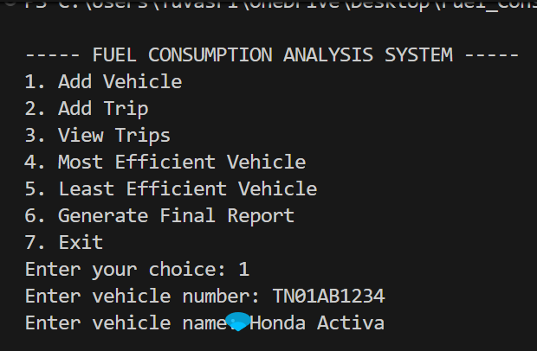
Figure 1: Main Menu and Add Vehicle Operation
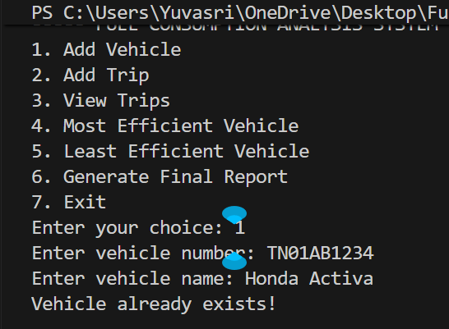
Figure 2: Validation for Duplicate Vehicle Registration

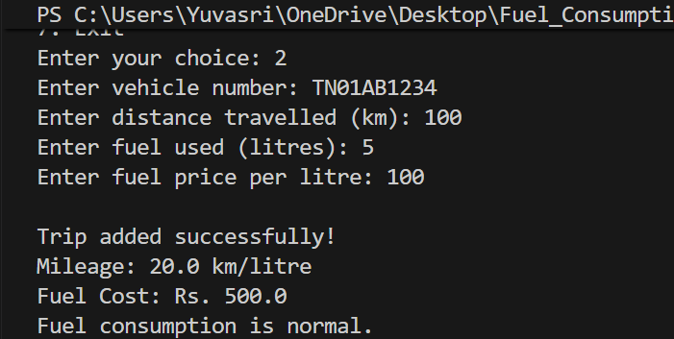
Figure 3: Normal Fuel Consumption Trip Analysis
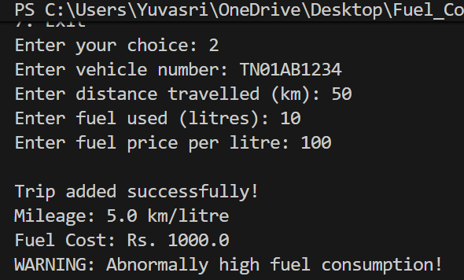
Figure 4: Detection of Abnormally High Fuel Consumption
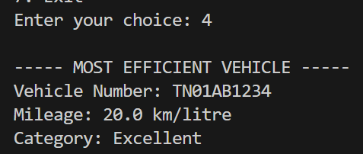
Figure 5: Most Efficient Vehicle Identification

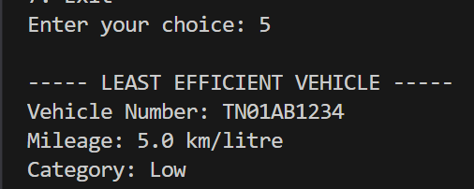
Figure 6: Least Efficient Vehicle Identification
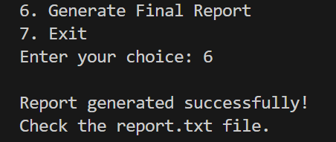
Figure 7: Final Report Generation

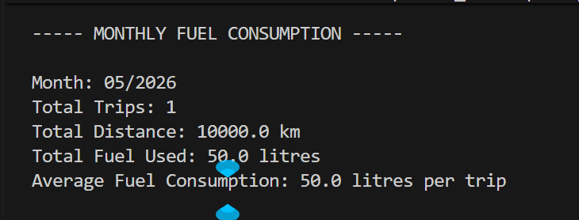
Figure 8: Monthly Fuel Consumption Summary
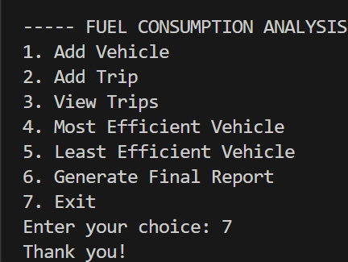
Figure 9: Successful Program Termination

RESULTS AND VALIDATION
The completed application was tested using valid entries as well as incorrect and boundary-type inputs. The testing showed that the major operations of the system function as intended. Vehicle registration records are maintained and duplicate vehicle numbers are rejected. Trip information is accepted only when the corresponding vehicle has already been registered and the numerical values satisfy the validation conditions.
For a valid trip, the program derives the travelled distance from the two odometer readings and then calculates mileage and fuel expenditure. For example, when the previous odometer reading is 1000 km, the current reading is 1100 km and the fuel quantity is 5 litres, the system calculates a distance of 100 km and a mileage of 20 km/litre. With a fuel price of Rs. 100 per litre, the resulting trip cost is Rs. 500.
The validation logic also prevents an invalid odometer sequence from being accepted. The current reading must be greater than the previous reading, while fuel quantity and fuel price must both be positive. Numerical inputs are converted using exception handling so that non-numeric entries do not terminate the program.
Data persistence was checked by storing vehicle and trip information in CSV files and loading the records again when the application was restarted. The efficiency functions were also verified using multiple trip records to determine the maximum and minimum mileage values. Monthly analysis groups the stored trips using the month and year extracted from the entered date.
The abnormal-consumption feature was tested using a mileage value below 10 km/litre. In this situation, the program displays a warning indicating that the recorded trip has unusually high fuel consumption.
The main validation results are therefore:
- Distance: 1100 − 1000 = 100 km
- Mileage: 100 ÷ 5 = 20 km/litre
- Fuel Cost: 5 × 100 = Rs. 500
- Abnormal Consumption: Mileage below 10 km/litre produces a warning
- Monthly Analysis: Monthly fuel values are summarized using the stored trip records
These tests provide evidence that the core calculations, validation checks, data storage and analysis functions operate according to the intended design.

ANALYSIS, COMPARISON, TRADE-OFFS AND JUSTIFICATION

A console interface was chosen for this project because the main purpose was to demonstrate Python programming concepts rather than to develop a graphical application. The menu-based approach keeps the implementation straightforward and allows the program to concentrate on input handling, calculations, functions, data structures and file operations. Although a graphical interface could provide a more convenient user experience, it would introduce additional development requirements that are not necessary for the current project objectives.

CSV files were selected as the storage method because the application is intended for a small collection of vehicle and trip records. CSV files can be created and read directly using Python's standard library, are easy to inspect, and do not require a separate database service. The limitation is that CSV storage is less suitable when the number of records becomes large or when multiple users need to access and modify the information simultaneously. A database such as SQLite would therefore be a more appropriate choice for a larger version of the system.

Dictionaries were used to represent individual records because each value can be accessed through a meaningful key such as number, date, fuel or mileage. This makes the stored records easier to understand than using only positional indexes. Lists provide a convenient way of maintaining collections of vehicles and trips, while the set of vehicle numbers supports duplicate checking. The set is particularly useful because the program frequently needs to determine whether a vehicle number has already been registered.

The current implementation uses a fixed mileage threshold of 10 km/litre to identify potentially abnormal consumption. This provides a simple rule that can be easily tested and demonstrated, but it does not account for differences between vehicle types, driving conditions or engine characteristics. A more advanced version could maintain an expected mileage range for each vehicle and compare new records against that vehicle-specific value.

The design therefore represents a balance between simplicity and functionality. The selected technologies are sufficient for the scale of the assignment while leaving clear opportunities for future expansion.

BROADER CONSIDERATIONS AND SDG RELEVANCE
The project has a connection with sustainable transportation because monitoring fuel consumption can make users more aware of inefficient vehicle operation. The application does not directly control fuel usage, but the information it provides can help users recognize trips that require more fuel than expected.
SDG 7 – Affordable and Clean Energy
The system supports the idea of responsible energy use by allowing fuel consumption to be monitored at the trip level. Mileage calculations and abnormal-consumption warnings can help users identify inefficient usage and encourage them to pay greater attention to fuel efficiency.
SDG 11 – Sustainable Cities and Communities
Transportation efficiency is relevant to the broader goal of sustainable communities. By maintaining records of vehicle performance and fuel usage, the application provides information that can support better decisions about vehicle operation and resource utilization.
SDG 13 – Climate Action
The application does not directly measure greenhouse-gas emissions. However, unnecessary fuel consumption can contribute to avoidable environmental impact. Identifying inefficient trips provides an opportunity for users to investigate the reasons for excessive consumption and consider ways of reducing fuel waste.
The present project therefore provides a basic monitoring foundation rather than a complete environmental assessment system. Future development could extend the application by estimating carbon emissions from fuel usage and presenting environmental indicators alongside the existing fuel-efficiency results.

CONCLUSION, LIMITATIONS AND POSSIBLE IMPROVEMENTS

Conclusion

- The Fuel Consumption Analysis System demonstrates how fundamental Python programming concepts can be combined to create a practical application for recording and analysing vehicle fuel usage. The developed program allows users to register vehicles, enter trip information, calculate travelled distance, determine mileage, estimate fuel cost, compare efficiency records, identify potentially abnormal consumption and obtain monthly fuel-use information.
- The application also demonstrates persistent data management through CSV files and modular programming through the separate fuel_analysis.py module. The use of lists, dictionaries, sets and tuples shows how different data structures can be selected according to the requirements of the information being processed. Input validation and exception handling further improve the reliability of the program during normal use.
- The project successfully brings together the four mapped Course Outcomes. CO1 is demonstrated through Python syntax and programming constructs, CO2 through control flow, strings, validation and functions, CO3 through the use of Python data structures, and CO4 through CSV file handling and modular programming.
- Limitations
- The current version has several limitations:
- The application operates through a console interface rather than a graphical or web interface.
- The accuracy of the calculated results depends on the values entered by the user.
- Date checking is basic and relies on the expected input format.
- The abnormal-consumption limit is currently fixed at 10 km/litre.
- Monthly grouping depends on the date format entered by the user.
- CSV files are appropriate for the small scale of this project but would not be the ideal choice for a large multi-user system.
- Possible Improvements
- The system can be extended in several ways. Strict date validation can be introduced using Python's datetime functionality. Vehicle-specific mileage expectations could replace the single fixed threshold. SQLite or another database system could be adopted when a larger volume of records needs to be managed. A graphical or web-based interface could make the application easier to use.
- Future versions could also include graphical representations of monthly fuel consumption and cost, maintenance reminders based on accumulated mileage, carbon-emission estimation, improved SDG-related reporting, and export options for PDF or Excel reports.

INDIVIDUAL CONTRIBUTION OF GROUP MEMBERS
Member | Contribution
Yuvasri | Problem understanding, system design, Python implementation, debugging, testing, documentation, screenshots and report preparation.

ONE-PAGE INDIVIDUAL REFLECTION
The Fuel Consumption Analysis System helped me understand how different Python programming concepts can be combined to solve a practical problem. One important design decision was to use a menu-driven console application because it allowed me to focus on the required course concepts without the additional complexity of a graphical interface. I separated reusable calculations into a custom module and kept the menu and data-handling logic in the main program. This decision improved code organization and demonstrated modular programming.
A major challenge during development was handling errors caused by input validation and indentation. While adding new features, I experienced issues such as incorrect indentation and running Python from the wrong folder. I learned the importance of maintaining consistent indentation, saving files correctly and checking the current working directory before executing a Python program. Another challenge was updating the trip CSV structure after adding odometer readings. I learned that when the data model changes, stored file columns and the program's loading logic must also be updated consistently.
The project improved my understanding of functions, conditional statements, loops, dictionaries, lists, sets, tuples and file handling. I particularly understood how dictionaries can represent real-world records and how sets can prevent duplicate values. I also learned how CSV files can provide simple persistent storage for small applications.
The project has relevance to SDG 7, SDG 11 and SDG 13 because monitoring fuel use can encourage efficient energy consumption, support more sustainable transportation practices and help reduce unnecessary fuel waste. The assignment contributed to CO1 by applying Python syntax and semantics, CO2 by using validation, strings and functions, CO3 by using lists, dictionaries, tuples and sets, and CO4 by implementing CSV file handling and a custom module. Overall, the assignment improved both my programming confidence and my ability to design a complete software solution from a problem statement.

REFERENCES
- Python Software Foundation. Python Documentation. Python 3 Documentation.
- Python Software Foundation. csv — CSV File Reading and Writing, Python Standard Library Documentation.
- Python Software Foundation. Built-in Types: list, dict, set and tuple.
- United Nations. Sustainable Development Goals: SDG 7, SDG 11 and SDG 13.
- Visual Studio Code Documentation. Python development environment documentation.

APPENDIX A: SAMPLE CSV DATA

vehicles.csv
number,name
TN10AB1234,Sample Vehicle
TN20CD5678,Sample Car

trips.csv
number,date,previous_odometer,current_odometer,distance,fuel,price,mileage,cost
TN10AB1234,02-09-2026,1000,1100,100,5,100,20,500
TN20CD5678,03-09-2026,2000,2080,80,8,100,10,800

APPENDIX B: COMPLETE PSEUDOCODE
BEGIN
CREATE empty list VEHICLES
CREATE empty list TRIPS
CREATE empty set VEHICLE_NUMBERS
CALL LOAD_DATA()

REPEAT
DISPLAY menu options
INPUT CHOICE

IF CHOICE = 1 THEN
INPUT vehicle number and name
VALIDATE input
CHECK duplicate number
STORE vehicle in list, set and CSV

ELSE IF CHOICE = 2 THEN
INPUT vehicle number
CHECK registration
INPUT date and trip details
VALIDATE numeric values
distance = current odometer - previous odometer
mileage = distance / fuel
cost = fuel * price
STORE trip
SAVE trip to CSV
CHECK abnormal mileage

ELSE IF CHOICE = 3 THEN
DISPLAY all trips

ELSE IF CHOICE = 4 THEN
FIND maximum mileage

ELSE IF CHOICE = 5 THEN
FIND minimum mileage

ELSE IF CHOICE = 6 THEN
CREATE report.txt
WRITE total trips, best trip, worst trip and warnings

ELSE IF CHOICE = 7 THEN
GROUP trips by month and year
CALCULATE total fuel, distance and average fuel per trip
DISPLAY monthly summary

ELSE IF CHOICE = 8 THEN
DISPLAY thank-you message
EXIT

ELSE
DISPLAY invalid choice
END IF
UNTIL CHOICE = 8
END

