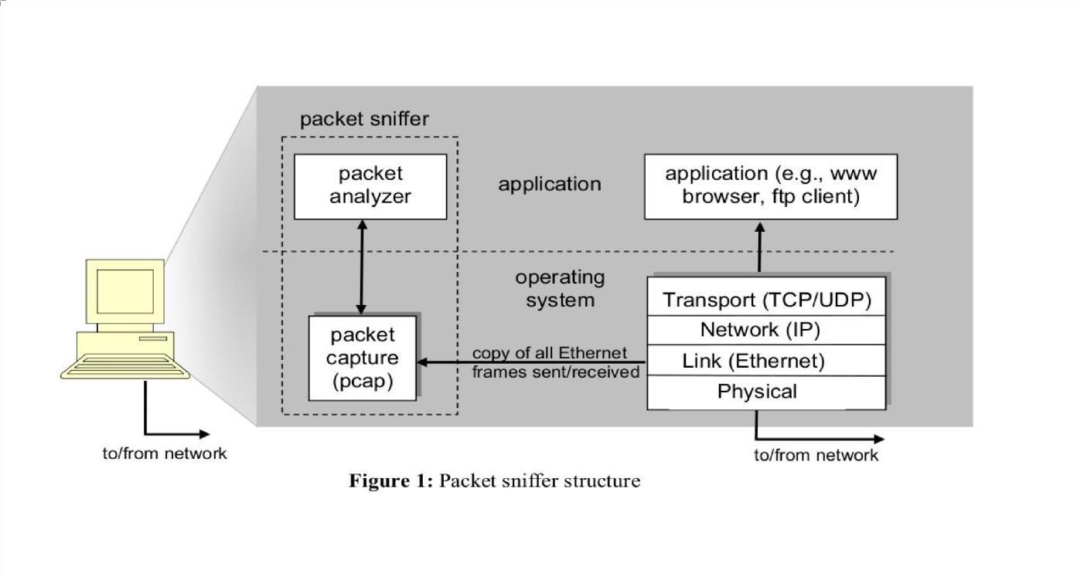
Practical-5
AIM Experiments on Packet capture tool: Wireshark
Packet Sniffer
- Sniffs messages being sent/received from/by your computer
- Store and display the contents of the various protocol fields in the messages
- Passive program
  - never sends packets itself
  - no packets addressed to it
  - receives a copy of all packets (sent/received)
Packet Sniffer Structure Diagnostic Tools
- Tcpdump
  - E.g. tcpdump -enx host 10.129.41.2 -w exe3.out
- Wireshark
  - wireshark -r exe3.out

DESCRIPTION:
WIRESHARK
Wireshark, a network analysis tool formerly known as Ethereal, captures packets in real time and display them in human-readable format. Wireshark includes filters, color coding, and other features that let you dig deep into network traffic and inspect individual packets. You can use Wireshark to inspect a suspicious program’s network traffic, analyze the traffic flow on your network, or troubleshoot network problems.

What we can do with Wireshark:
- Capture network traffic
- Decode packet protocols using dissectors
- Define filters – capture and display
- Watch smart statistics
- Analyze problems
- Interactively browse that traffic

Wireshark used for:
- Network administrators: troubleshoot network problems
- Network security engineers: examine security problems
- Developers: debug protocol implementations
- People: learn network protocol internals

Getting Wireshark
Wireshark can be downloaded for Windows or macOS from its official website. For Linux or another UNIX-like system, Wireshark will be found in its package repositories. For Ubuntu, Wireshark will be found in the Ubuntu Software Center.

Capturing Packets
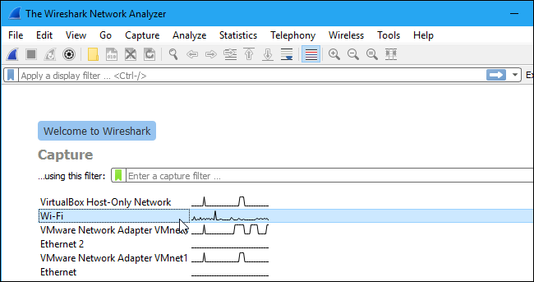
After downloading and installing Wireshark, launch it and double-click the name of a network interface under Capture to start capturing packets on that interface
As soon as you click the interface’s name, you’ll see the packets start to appear in real time. Wireshark captures each packet sent to or from your system.
If you have promiscuous mode enabled—it’s enabled by default—you’ll also see all the other packets on the network instead of only packets addressed to your network adapter. To check if promiscuous mode is enabled, click Capture > Options and verify the “Enable promiscuous mode on all interfaces” checkbox is activated at the bottom of this window.

Packet List
Packet Details

Click the red “Stop” button near the top left corner of the window wh e capturing traffic.
n you want t
The “Packet List” Pane

Packet Bytes

o stop

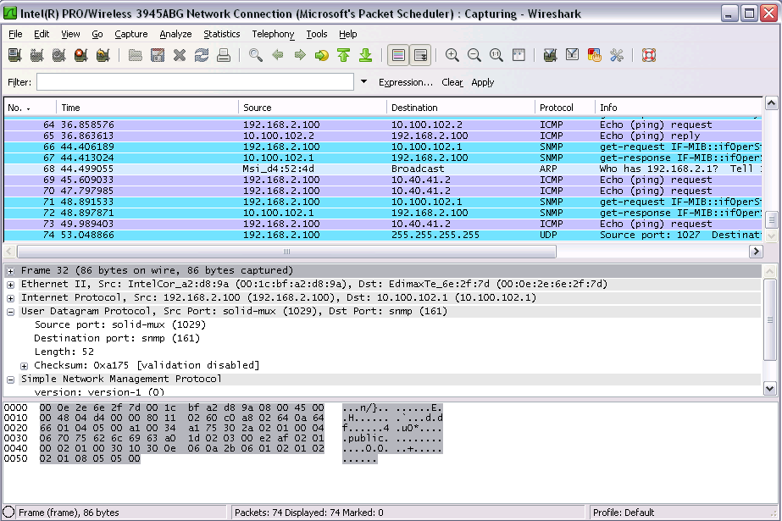
The packet list pane displays all the packets in the current capture file. The “Packet List” pane Each line in the packet list corresponds to one packet in the capture file. If you select a line in this pane, more details will be displayed in the “Packet Details” and “Packet Bytes” panes.

The “Packet Details” Pane
The packet details pane shows the current packet (selected in the “Packet List” pane) in a more detailed form. This pane shows the protocols and protocol fields of the packet selected in the “Packet List” pane. The protocols and fields of the packet shown in a tree which can be expanded and collapsed.

The “Packet Bytes” Pane
The packet bytes pane shows the data of the current packet (selected in the “Packet List” pane) in a hexdump style.

Color Coding
You’ll probably see packets highlighted in a variety of different colors. Wireshark uses colors to help you identify the types of traffic at a glance. By default, light purple is TCP traffic, light blue is UDP traffic, and black identifies packets with errors—for example, they could have been delivered out of order.
To view exactly what the color codes mean, click View > Coloring Rules. You can also customize and modify the coloring rules from here, if you like.

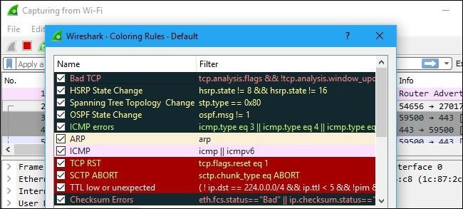

Sample Captures
If there’s nothing interesting on your own network to inspect, Wireshark’s wiki has you covered. The wiki contains a page of sample capture files that you can load and inspect. Click File > Open in Wireshark and browse for your downloaded file to open one.
You can also save your own captures in Wireshark and open them later. Click File > Save to save your captured packets.
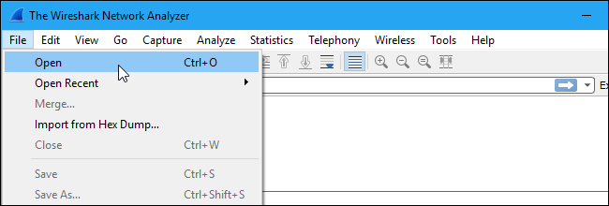

Filtering Packets
If you’re trying to inspect something specific, such as the traffic a program sends when phoning home, it helps to close down all other applications using the network so you can narrow down the traffic. Still, you’ll likely have a large amount of packets to sift through. That’s where Wireshark’s filters come in.

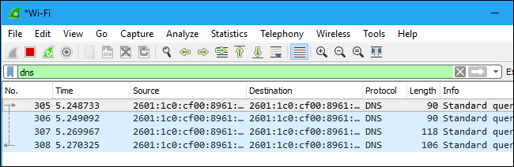
The most basic way to apply a filter is by typing it into the filter box at the top of the window and clicking Apply (or pressing Enter). For example, type “dns” and you’ll see only DNS packets. When you start typing, Wireshark will help you autocomplete your filter.
You can also click Analyze > Display Filters to choose a filter from among the default filters included in Wireshark. From here, you can add your own custom filters and save them to easily access them in the future.
For more information on Wireshark’s display filtering language, read the Building display filter expressions page in the official Wireshark documentation.
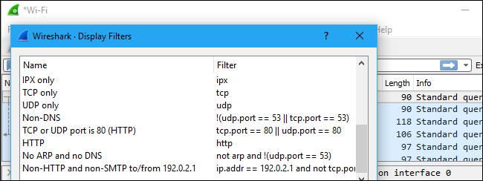

Another interesting thing you can do is right-click a packet and select Follow > TCP Stream. You’ll see the full TCP conversation between the client and the server. You can also click other protocols in the Follow menu to see the full conversations for other protocols, if applicable.

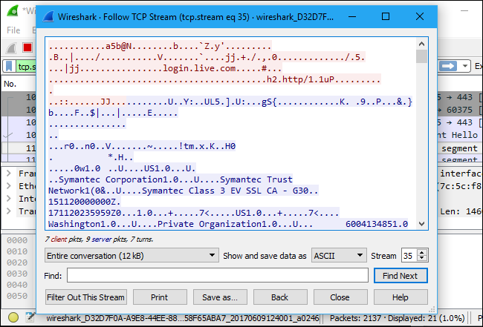
Close the window and you’ll find a filter has been applied automatically. Wireshark is showing you the packets that make up the conversation.
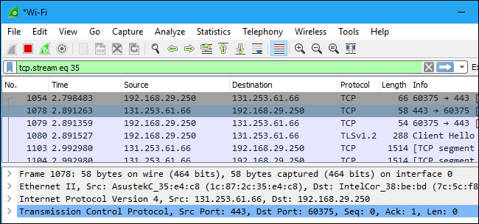

Inspecting Packets
Click a packet to select it and you can dig down to view its details.

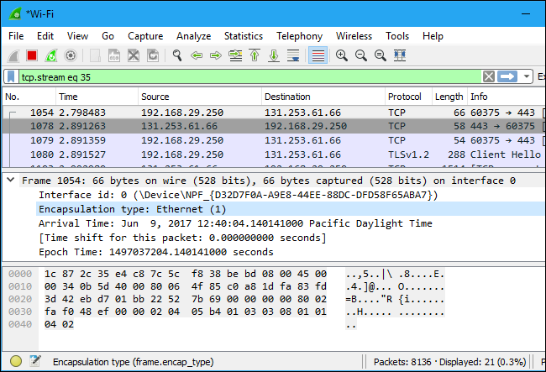
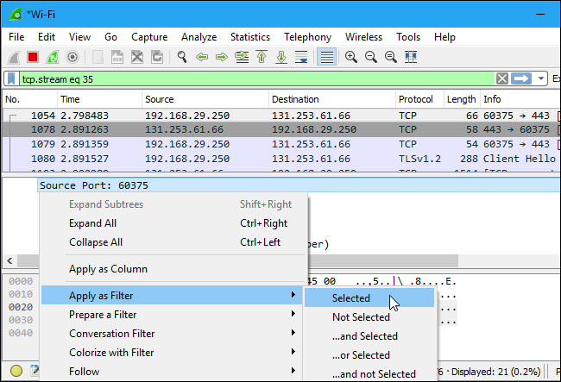
You can also create filters from here — just right-click one of the details and use the Apply as Filter submenu to create a filter based on it.

Wireshark is an extremely powerful tool, and this tutorial is just scratching the surface of what you can do with it. Professionals use it to debug network protocol implementations, examine security problems and inspect network protocol internals.

Flow Graph: Gives a better understanding of what we see.
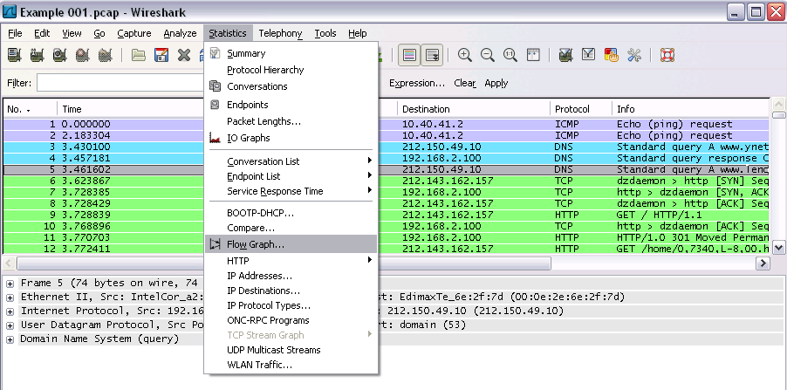
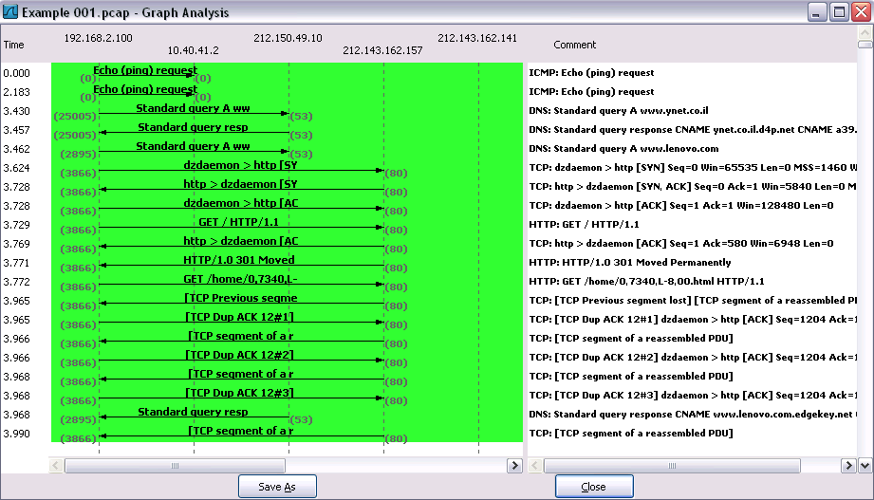

CAPTURING AND ANALYSING PACKETS USING WIRESHARK TOOL
To filter, capture, view, packets in Wireshark Tool.
Capture 100 packets from the Ethernet: IEEE 802.3 LAN Interface and save it.

Procedure
- Select Local Area Connection in Wireshark.
- Go to capture → option
- Select stop capture automatically after 100 packets.
- Then click Start capture.
- Save the packets.
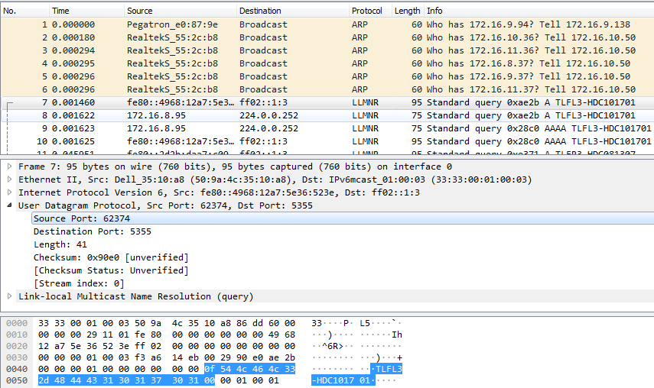
Output
- Create a Filter to display only TCP/UDP packets, inspect the packets and provide the flow graph
Procedure
  - Select Local Area Connection in Wireshark.
  - Go to capture → option
  - Select stop capture automatically after 100 packets.
  - Then click Start capture.
  - Search TCP packets in search bar.
  - To see flow graph click Statistics→Flow graph.
  - Save the packets.

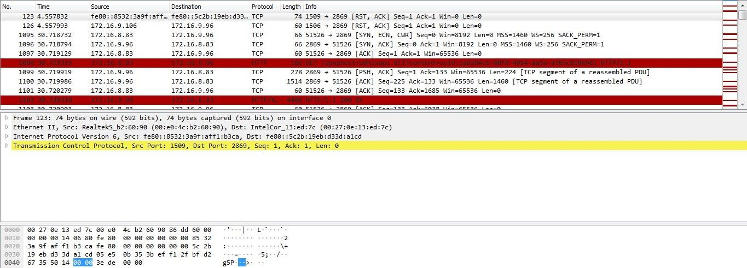

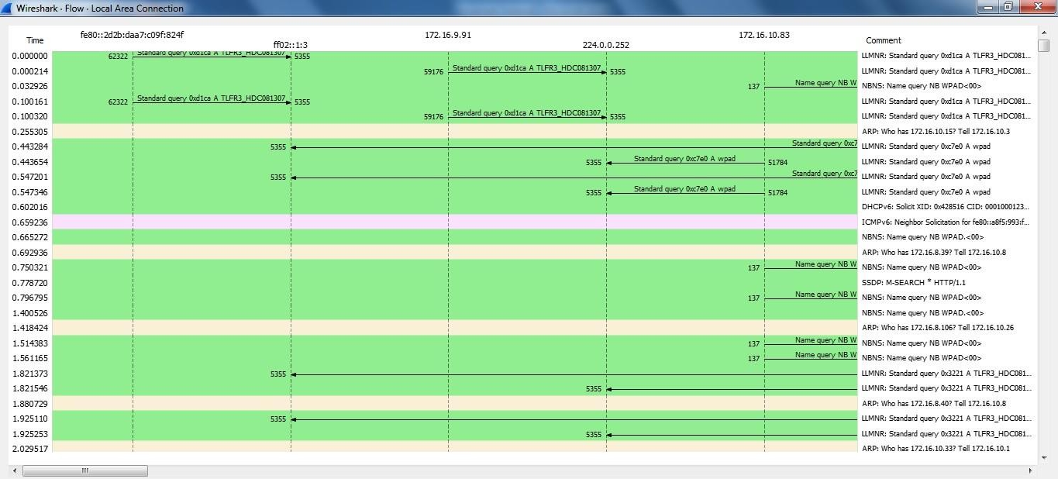
Flow Graph
- Create a Filter to display only ARP packets and inspect the packets. Procedure
  - Go to capture → option
  - Select stop capture automatically after 100 packets.
  - Then click Start capture.
  - Search ARP packets in search bar.
  - Save the packets.

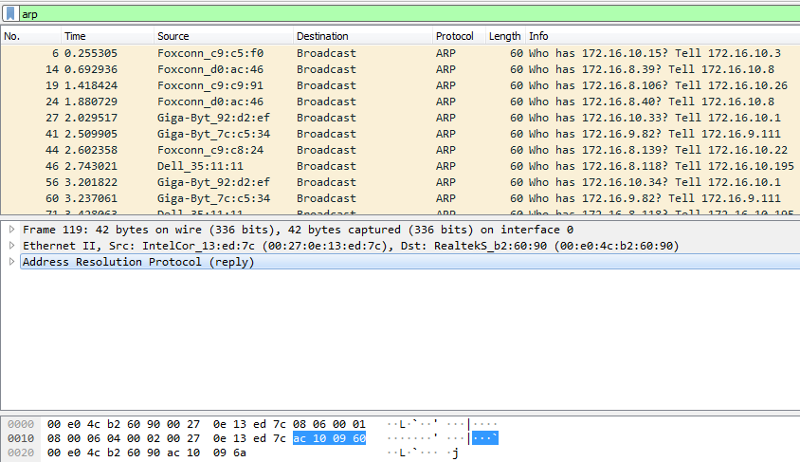
Output

- Create a Filter to display only DNS packets and provide the flow graph. Procedure
  - Go to capture → option
  - Select stop capture automatically after 100 packets.
  - Then click Start capture.
  - Search DNS packets in search bar.
  - To see flow graph click Statistics→Flow graph.
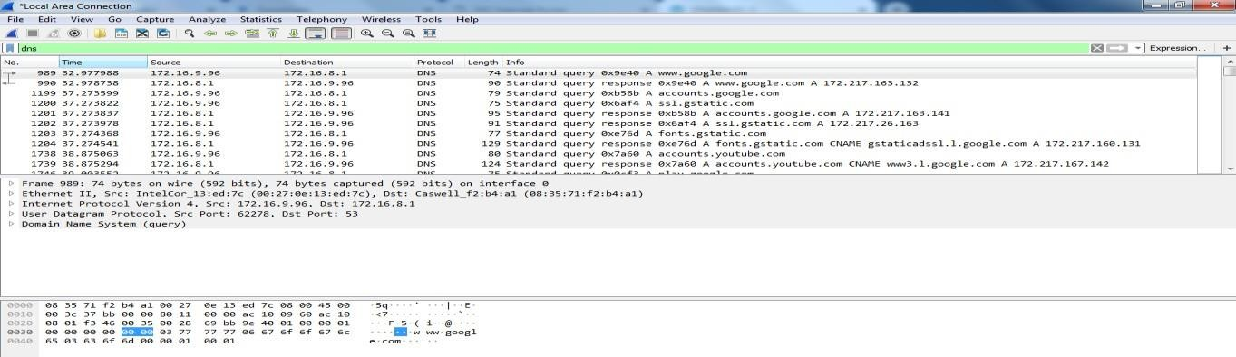
  - Save the packets.

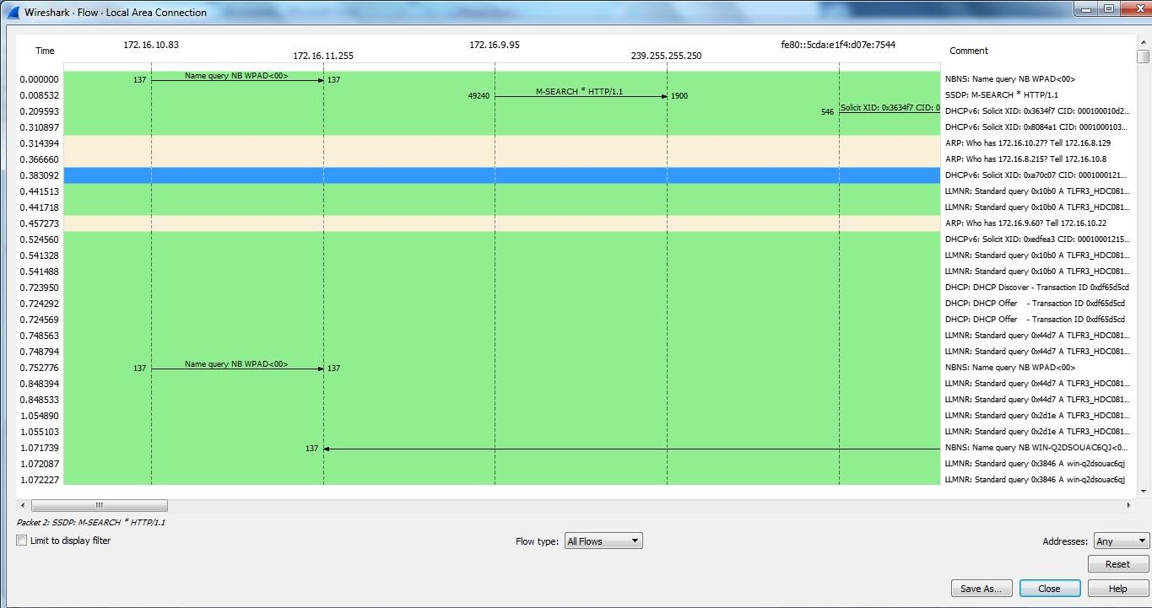

Create a Filter to display only HTTP packets and inspect the packets Procedure
  - Select Local Area Connection in Wireshark.
  - Go to capture → option
  - Select stop capture automatically after 100 packets.
  - Then click Start capture.
  - Search HTTP packets in search bar.
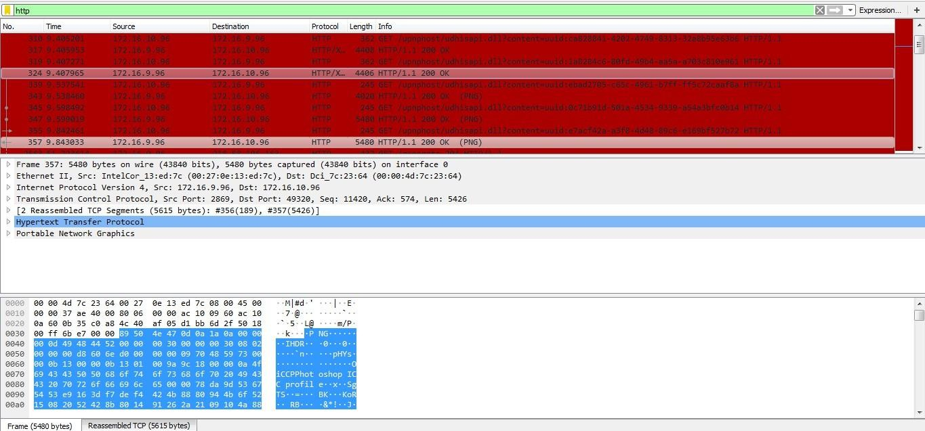
  - Save the packets.

Create a Filter to display only IP/ICMP packets and inspect the packets. Procedure
  - Select Local Area Connection in Wireshark.
  - Go to capture → option
  - Select stop capture automatically after 100 packets.
  - Then click Start capture.
  - Search ICMP/IP packets in search bar.
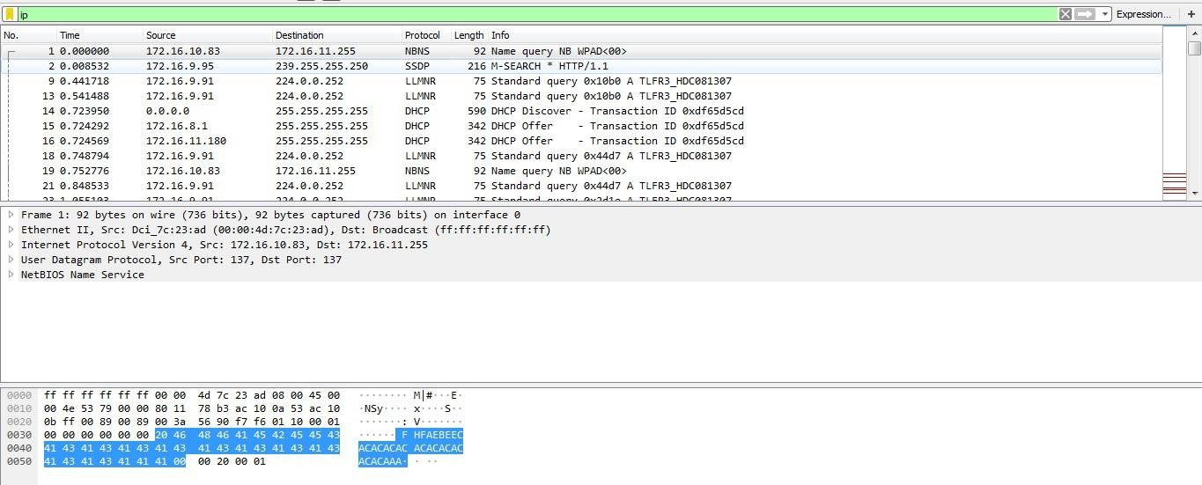
  - Save the packets

Create a Filter to display only DHCP packets and inspect the packets. Procedure
  - Select Local Area Connection in Wireshark.
  - Go to capture → option
  - Select stop capture automatically after 100 packets.
  - Then click Start capture.
  - Search DHCP packets in search bar.
  - Save the packets
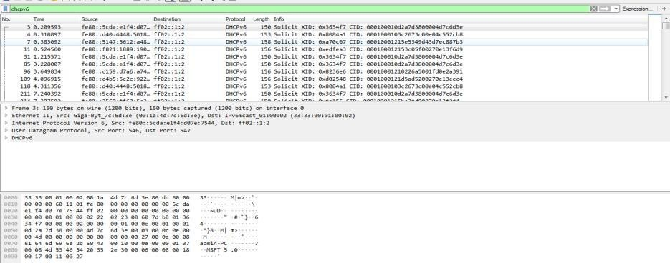
Output

Student observation:
- What is promiscuous mode?
- Does ARP packets has transport layer header? Explain.
- Which transport layer protocol is used by DNS?
- What is the port number used by http protocol?
- What is a broadcast ip address?

