Practical-9
AIM:-Implementation of SUBNETTING in CISCO PACKET TRACER simulator.
Classless IP subnetting is a technique that allows for more efficient use of IP addresses by allowing for subnet masks that are not just the default masks for each IP class. This means that we can divide our IP address space into smaller subnets, which can be useful when we have a limited number of IP addresses but need to create multiple networks.
CREATING A NETWORK TOPOLOGY:
The first step in implementing classless IP subnetting is to create a network topology in Packet Tracer. To create a network topology in Packet Tracer, select the "New" button in the top left corner, then select "Network" and "Generic". This will create a blank network topology that we can use to add devices.
ADDING THE DEVICES:
Once we have created our network topology, we can add devices to it. Here, we will be adding routers, witches, and PCs. To add a device, select the device from the bottom left corner and drag it onto the network topology. Then, connect the devices by dragging a cable from one device's port to another device's port.
SUBNETTING:
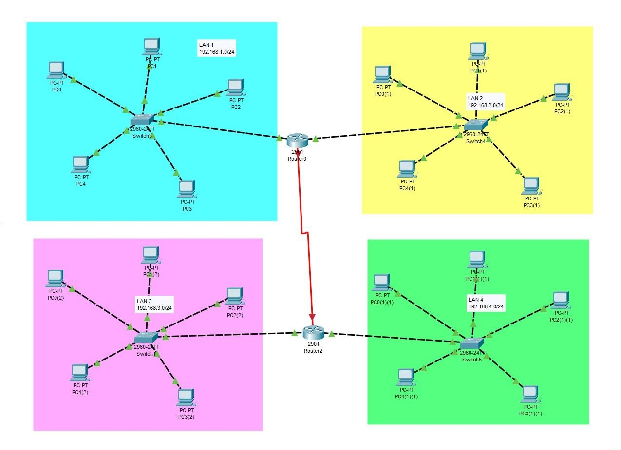
To subnet the network address of 192.168.1.0/24 to provide enough space for at least 5 addresses for end devices, the switch, and the router, we can use a /27 subnet mask. This will give us 8 subnets with 30 host addresses each.

The IP addressing for the network shown in the topology can be as follows:
- Router R1:
- GigabitEthernet0/0: 192.168.1.1
- GigabitEthernet0/1: 192.168.2.1
- Switch S1:
- FastEthernet0/1: 192.168.1.0/27
- PC1: 192.168.1.11
- PC2: 192.168.1.12
- PC3: 192.168.1.13
- PC4: 192.168.1.14
- PC5: 192.168.1.15
- FastEthernet0/2: 192.168.2.0/27
- PC1: 192.168.2.11
- PC2: 192.168.2.12
- PC3: 192.168.2.13
- PC4: 192.168.2.14
- PC5: 192.168.2.15
- Router R2:
- FastEthernet0/0: 192.168.3.1
- FastEthernet0/1: 192.168.4.1
- Switch S2:
- FastEthernet0/1: 192.168.3.0/27
- PC1: 192.168.3.11
- PC2: 192.168.3.12
- PC3: 192.168.3.13
- PC4: 192.168.3.14
- PC5: 192.168.3.15
- FastEthernet0/2: 192.168.4.0/27
- PC1: 192.168.4.11
- PC2: 192.168.4.12
- PC3: 192.168.4.13
- PC4: 192.168.4.14
- PC5: 192.168.4.15

CONFIGURING THE DEVICES:
Now that we have added our devices and connected them, we can start configuring them. We will start by configuring the router. Right-click on the router and select "CLI". This will open the command-line interface (CLI) for the router. In the CLI, enter the following commands: #enable
#configure terminal #interface FastEthernet0/0
#ip address {IP address} {subnet mask} #no shutdown
#exit
interface FastEthernet0/1
ip address {IP address} {subnet mask}
no shutdown exit

Replace "{IP address}" and "{subnet mask}" with your desired IP address and subnet mask. The first interface, FastEthernet0/0, will be connected to the switch, while the second interface, FastEthernet0/1, will be connected to one of the PCs. These commands configure the router's interfaces with IP addresses and subnet masks.
Next, we will configure the switch. Right-click on the switch and select "CLI". In the CLI, enter the following commands:
enable
configure terminal interface FastEthernet0/1 switchport mode access exit
interface FastEthernet0/2 switchport mode access exit
These commands configure the switch to operate in access mode on its two ports, which are connected to the two PCs.
Finally, we will configure the PCs. Right-click on each PC and select "Config". In the configuration window, enter the IP address, subnet mask, default gateway, and DNS server information. The IP address and subnet mask should be within the same subnet as the router's FastEthernet0/1 interface.
To configure the GigabitEthernet interface on the router, you can follow these steps:
- Right-click on the router and select "CLI".
- Enter the following commands: enable
configure terminal
interface GigabitEthernet0/0
ip address {IP address} {subnet mask} no shutdown
exit
Replace "{IP address}" and "{subnet mask}" with your desired IP address and subnet mask. These commands configure the GigabitEthernet interface with an IP address and subnet mask, and enable the interface.

TESTING THE NETWORK:
Now that our network topology is configured, we can test the network. Open a command prompt on each PC and try to ping the other PC. If the ping is successful, then the network is functioning properly. We can also use the "ping" command to test connectivity between the router and the PCs.

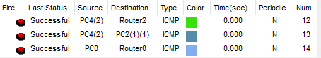

Student observation:
- Write down your understanding of subnetting.
- What is the advantage of implementing subnetting within a Network?
- Find out whether subnetting is implemented in your college. If yes, draw and list down the subnets used with ip addresses.

