EXP 7 COMPUTERNETWORK
Yuvasri V 241501256

AIM: To implement a sliding window flow control protocol in C, where the sender transmits frames within a window through Sender_Buﬀer.txt and the receiver replies with ACK or NACK through Receiver_Buﬀer.txt.

Sender.c:
#include <stdio.h> #include <stdlib.h> #include <string.h>

#ifdef _WIN32 #include <windows.h> void delay(int seconds)
{
Sleep(seconds * 1000);
}
#else
#include <unistd.h> void delay(int seconds)
{
sleep(seconds);
}
#endif

#define SENDER_FILE "Sender_Buffer.txt" #define RECEIVER_FILE "Receiver_Buffer.txt"

void clearFile(const char *filename)
{
FILE *fp = fopen(filename, "w");

if (fp != NULL) fclose(fp);

}

int readAcknowledgement(int *type, int *number)
{
FILE *fp;
char line[100];

fp = fopen(RECEIVER_FILE, "r");

if (fp == NULL) return 0;

if (fgets(line, sizeof(line), fp) == NULL)
{
fclose(fp); return 0;
}

fclose(fp);

if (sscanf(line, "ACK:%d", number) == 1)
{
*type = 1;
return 1;
}

if (sscanf(line, "NACK:%d", number) == 1)
{
*type = 2;
return 1;
}

return 0;
}

void writeFrames(char *message, int start, int end)
{
FILE *fp;

fp = fopen(SENDER_FILE, "w");

if (fp == NULL)
{
printf("Error: Cannot open Sender_Buffer.txt\n"); exit(1);
}

printf("\n \n");
printf("Sending frames %d to %d\n", start, end); printf(" \n");

for (int i = start; i <= end; i++)
{
fprintf(fp, "Frame:%d DATA:%c\n", i, message[i]);

printf("Frame No: %d DATA: %c\n", i,
message[i]);
}

fclose(fp);
}

int main()
{
char message[500]; int windowSize;

int totalFrames; int base = 0;

int ackType;
int ackNumber;

printf("========== SLIDING WINDOW SENDER ==========\n\n");

printf("Enter window size: "); scanf("%d", &windowSize);

if (windowSize <= 0)
{
printf("Invalid window size.\n"); return 1;
}

getchar();

printf("Enter text message: "); fgets(message, sizeof(message), stdin);

message[strcspn(message, "\n")] = '\0';

totalFrames = strlen(message);

if (totalFrames == 0)
{
printf("Message cannot be empty.\n"); return 1;
}

clearFile(SENDER_FILE); clearFile(RECEIVER_FILE);

printf("\nMessage: %s\n", message); printf("Total frames: %d\n", totalFrames); printf("Window size: %d\n", windowSize);

while (base < totalFrames)
{
int end = base + windowSize - 1;

if (end >= totalFrames) end = totalFrames - 1;

writeFrames(message, base, end);

printf("\nSender_Buffer.txt updated."); printf("\nWaiting for acknowledgement");

while (1)
{
delay(2);

if (readAcknowledgement(&ackType, &ackNumber))

{
if (ackType == 1)
{
printf("\nReceived ACK:%d\n", ackNumber);

if (ackNumber >= base)
{
base = ackNumber + 1;

clearFile(RECEIVER_FILE);

printf("Sliding window moved.\n"); break;
}
}
else if (ackType == 2)
{
printf("\nReceived NACK:%d\n", ackNumber);

printf("Resending frames from frame %d...\n", ackNumber);

clearFile(RECEIVER_FILE);

if (ackNumber >= base) base = ackNumber;

break;
}
}
}

}

clearFile(SENDER_FILE);

printf("\n========================================\n");
printf("All frames transmitted successfully!\n"); printf("Message transmission completed.\n"); printf("========================================\n");

return 0;
}

Receiver.c: #include <stdio.h> #include <stdlib.h> #include <string.h>

#ifdef _WIN32 #include <windows.h> void delay(int seconds)
{
Sleep(seconds * 1000);
}
#else
#include <unistd.h> void delay(int seconds)
{
sleep(seconds);
}

#endif

#define SENDER_FILE "Sender_Buffer.txt" #define RECEIVER_FILE "Receiver_Buffer.txt"

int readFrames(int *frameNumbers, char *data, int maxFrames)
{
FILE *fp;
char line[200];

int count = 0;

fp = fopen(SENDER_FILE, "r");

if (fp == NULL) return 0;

while (fgets(line, sizeof(line), fp) != NULL && count < maxFrames)
{
int frameNo; char ch;

if (sscanf(line, "Frame:%d DATA:%c", &frameNo, &ch) == 2)
{
frameNumbers[count] = frameNo; data[count] = ch;

count++;
}

}

fclose(fp);

return count;
}

void writeACK(int number)
{
FILE *fp = fopen(RECEIVER_FILE, "w");

if (fp == NULL) return;

fprintf(fp, "ACK:%d\n", number);

fclose(fp);
}

void writeNACK(int number)
{
FILE *fp = fopen(RECEIVER_FILE, "w");

if (fp == NULL) return;

fprintf(fp, "NACK:%d\n", number);

fclose(fp);
}

int main()
{
int expectedFrame = 0;

int frameNumbers[100]; char data[100];

int lastFirstFrame = -1;

printf("========== SLIDING WINDOW RECEIVER ==========\n\n");

printf("Receiver is waiting for frames...\n");

while (1)
{
int count = readFrames(frameNumbers, data, 100);

if (count > 0)
{
/*
* Process only a new Sender_Buffer window.
*/
if (frameNumbers[0] != lastFirstFrame)
{
int valid = 1;

printf("\n \n");
printf("Frames received:\n");
printf(" \n");

for (int i = 0; i < count; i++)

{
printf("Frame No: %d DATA: %c\n", frameNumbers[i],
data[i]);

if (frameNumbers[i] != expectedFrame)
{
printf("\nExpected Frame: %d\n", expectedFrame);

printf("Received Frame: %d\n", frameNumbers[i]);

printf("ERROR DETECTED!\n");

printf("Sending NACK:%d\n", expectedFrame);

writeNACK(expectedFrame);

valid = 0; break;
}

expectedFrame++;
}

if (valid)
{
int ackNumber = expectedFrame - 1;

printf("\nAll frames received correctly.\n");

printf("Sending ACK:%d\n", ackNumber);

writeACK(ackNumber);
}

lastFirstFrame = frameNumbers[0];
}
}

delay(1);
}

return 0;
}
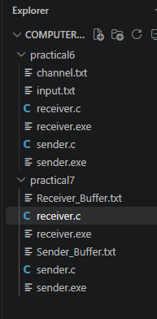

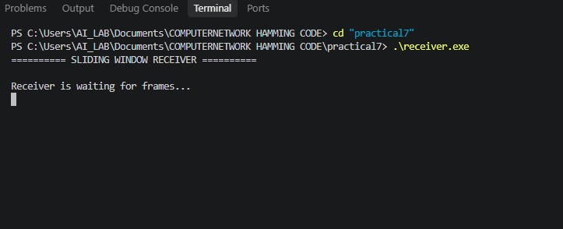

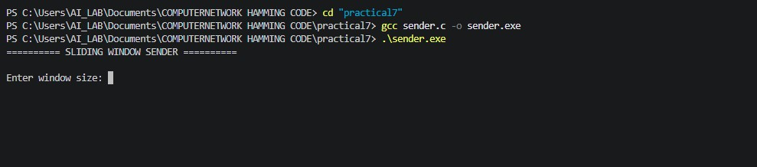

Sender:

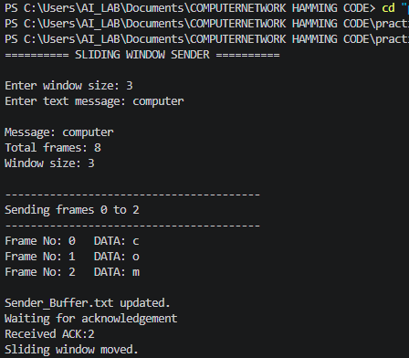
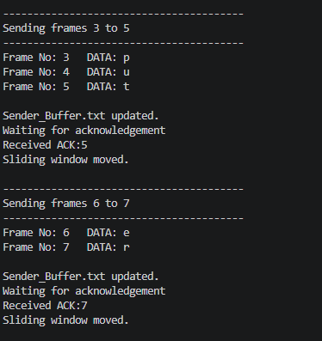

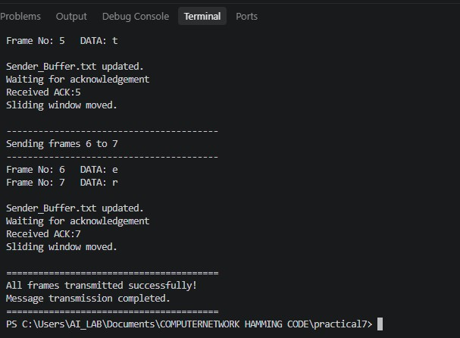

Receiver:

