Practical 15
AIM:- To analyze the different types of web logs using Webalizer tool.

Procedure
Step1: Run webalizer windows version
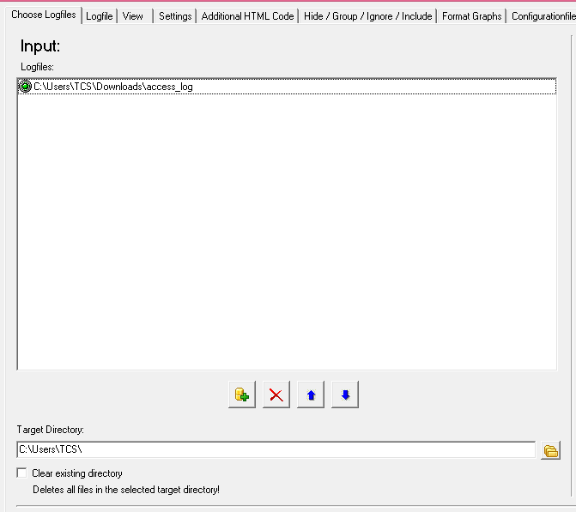
Step2. Input web log file (down load from web) Step3: Press Run webalizer

Output:

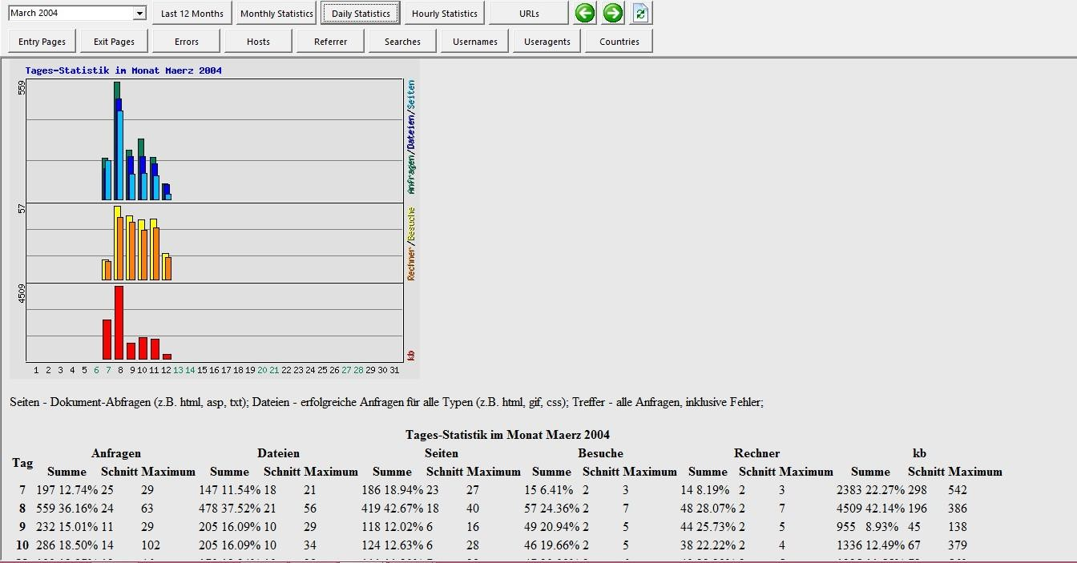
Monthly statistics
Hosts
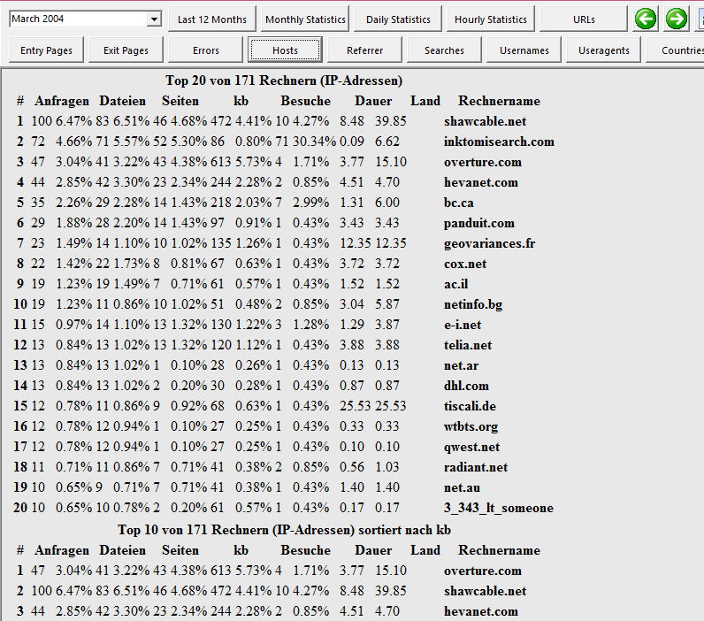

User-agents
