Practical-2

Aim: Study of different types of Network cables.

- Understand different types of network cable.
Different type of cables used in networking are:
  - Unshielded Twisted Pair (UTP) Cable
  - Shielded Twisted Pair (STP) Cable
  - Coaxial Cable
  - Fibre Optic Cable

Cable type | Category | Maximum Data Transmission | Advantages/ Disadvantages | Application/Use | Image
UTP | Category 3 | 10 bps | Advantages  - Cheaper in cost  - Easy to install as they have a smaller overall diameter.  Disadvantages  - More prone to (EMI)  Electromagnetic interference and noise | 10Base-T Ethernet  Fast Ethernet, Gigabit Ethernet  Fast Ethernet, Gigabit Ethernet | 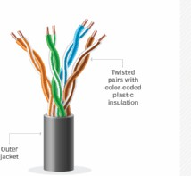
UTP | Category 5 | Up to 100 Mbps
UTP | Category 5e | 1Gbps
STP | Category6,6a | 10Gbps | Advantages  - Shielded.  - Faster than UTP.  - Less susceptible to noise and interference  Disadvantages  - Expensive  - Greater installation effort | Gigabit Ethernet, 10G Ethernet (55m)  Widely used in data centres | 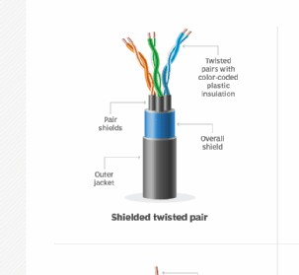  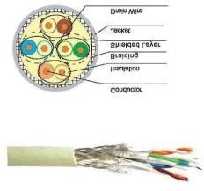
SSTP | Category 7 | 10Gbps |  | Gigabit Ethernet, 10G Ethernet (100m)

 |  |  | - High bandwidth | Speed of signal is 500m  Television network High speed internet connections | 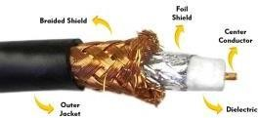
 |  |  | - Immune to
 |  |  | interference
 |  |  | - Low loss
Coaxial cable | RG-6 RG-59  RG-11 | 10-100Mbps | bandwidth  - Versatile
 |  |  | - Disadvantages
 |  |  | - Limited distance
 |  |  | - Cost
 |  |  | - Size is bulky
fibre optics cable | Single mode Multi mode | 100Gbps | Advantages  - High speed  - High bandwidth  - High security  - Long distance  Disadvantages  - Expensive  - Requires skilled installers | - Maximum distance of fibre optics cable is around 100meters | 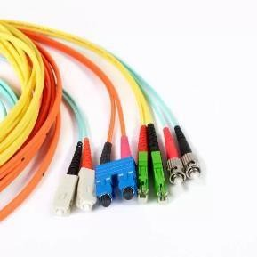

- Make Your Own Ethernet Cross-Over Cable/ Straight cable
Tools and parts needed:
- Ethernet cabling. CAT5e is certified for gigabit support, but CAT5 cabling works as well, just over shorter distances.
- A crimping tool. This is an all-in-one networking tool shaped to push down the pins in the plug and strip and cut the shielding off the cables.
- Two RJ45 plugs.
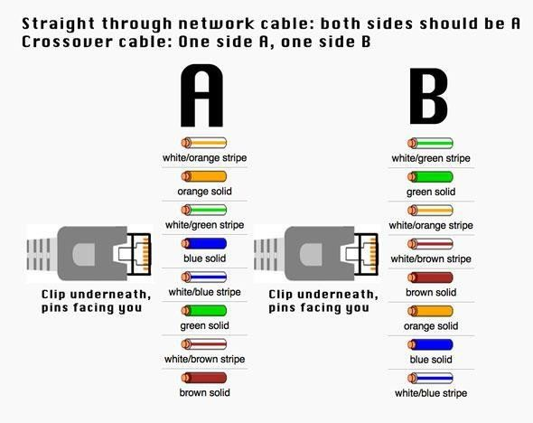
- Optional two plug shields.
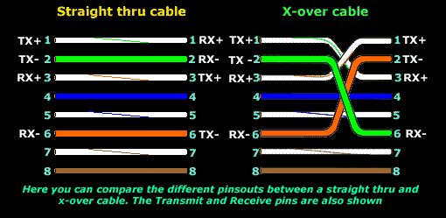
Difference between crossover cable and straight cable Take a print out the diagram below or have it handy as a reference

Step 1: To start construction of the device, begin by threading shields onto the cable.
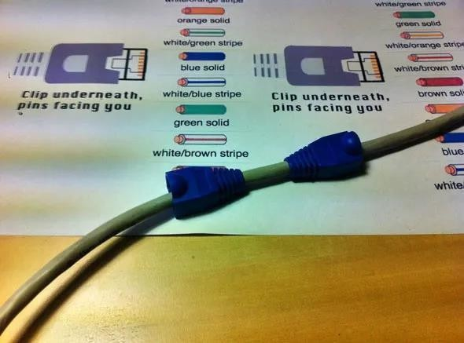

Step 2: Next, strip approximately 1.5 cm of cable shielding from both ends. The crimping tool has a round area to complete this task.
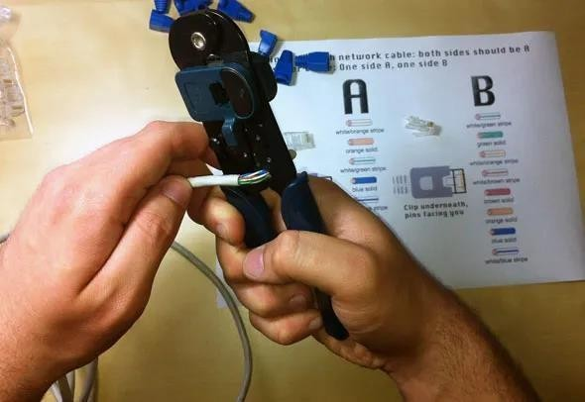

Step 3: After, you will need to untangle the wires; there should be four “twisted pairs.” Referencing back to the sheet, arrange them from top to bottom. One end should be in arrangement A and the other in B.
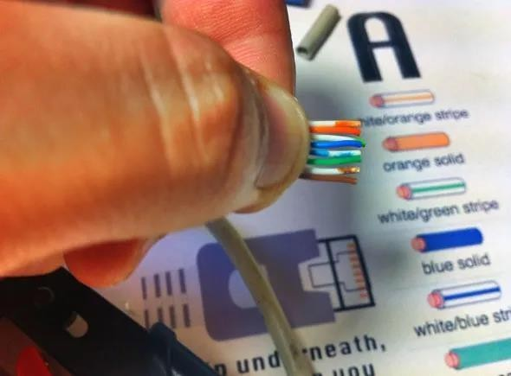
Step 4: Once the order is correct, bunch them together in a line, and if there are any that stick out farther than others, snip them back to create an even level. The difficult aspect is placing these into the RJ45 plug without messing up the order. To do so, hold the plug with the clip side facing away from you and have the gold pins facing toward you, as shown.
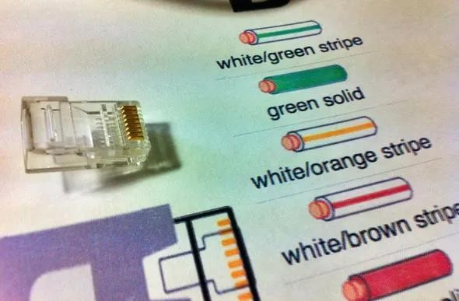

Step 5: Next, push the cable right in. The notch at the end of the plug needs to be just over the cable shielding, and if it isn’t, that means that you stripped off too much shielding. Simply snip the cables back a little more.
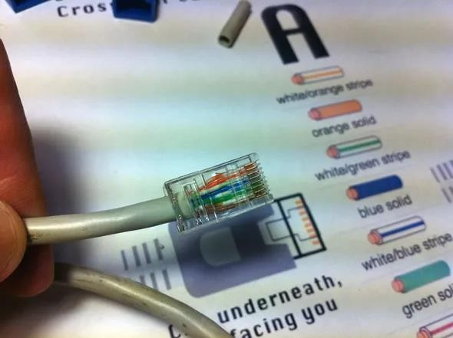

Step 6: After the wires are securely sitting inside the plug, insert it into the crimping tool and push down.
It should be shaped correctly, but pushing too hard can crack the fragile plastic plug.

Step 7: Lastly, repeat for the other end using diagram B (to make a crossover cables)/ using diagram A (to make a straight through cable)

To test it, plug it in and attempt to connect two devices directly.

Student observation:-

  - What is the difference between cross cable and straight cable?
  - Which type of cable is used to connect two PC?(straight/Cross cable)
  - Which type cable is used to connect a router/switch to your PC? (straight/Cross cable)
  - Find out the category of twisted pair cable used in your la to connect the PC to the network socket.
  - Write down your understanding, challenges faced and output received while making a twisted pair cross/straight cable.

