Practical -4
AIM: Setup and configure a LAN (Local area network) using a Switch and Ethernet cables in your lab.

What is a LAN?
A Local Area Network (LAN) refers to a network that connects devices within a limited area, such as an office building, school, or home. It enables users to share resources, including data, printers, and internet access. LAN connects devices to promote collaboration and transfer information between users, such as computers, printers, servers, and switches. A local area network (LAN) switch serves as the primary connecting device, managing and directing communications within the local network. Each connected device on a LAN switch can communicate directly with each other, allowing for fast and secure data transfer.

How to set up a LAN

Step 1. Plan and Design an appropriate network topology taking into account network requirements and equipment location.
Step 2. You can take 4 Computers, a Switch with 8, 16, or 24 ports which is sufficient for networks of these sizes, and 4 Ethernet cables.
Step3: Connect your computers to network switch via an Ethernet cable, which is as simple as plugging one end of the Ethernet cable into your computer and the other end into your network switch.
Step4: Assign IP address to your PCs
- Log on to the client computer as Administrator or as Owner.
- Click Network and Internet Connections.
- Right Click Local Area Connection/Ethernet->Go to Properties->Select Internet Protocol (TCP/IPv4)->Click on Properties->Select use the following ip address option and assign ipaddress.

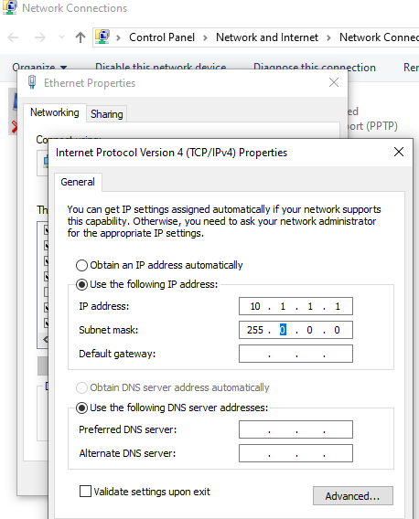
Similarly assign IP address to all the PCS connected to switch. PC1-IP address: 10.1.1.1, subnet mask 255.0.0.0
PC2-IP address-10.1.1.2, subnet mask 255.0.0.0 PC3-IP address 10.1.1.3, subnet mask 255.0.0.0.
PC4-IP address 10.1.1.4, subnet mask 255.0.0.0.
Step 5:- Configure a network switch:
- Connect your computer to the switch: To access the switch's web interface, you will need to connect your computer to the switch using an Ethernet cable.
- Log in to the web interface: Open a web browser and enter the IP address of the switch in the address bar. This should bring up the login page for the switch's web interface. Enter the username and password to log in.
- Configure basic settings: Once you're logged in, you will be able to configure basic settings for the switch,
- Assign IP address as: 10.1.1.5, subnet mask 255.0.0.0.
Step 6:- Check the connectivity between switch and other machine by using ping command in the command prompt of the device.

Step 7: Select a folder, ->go to properties-> click Sharing tab->share it with everyone on the same LAN.
Step 8. Try to access the shared folder from others Computers of the network.

Student observation:

Draw a neat diagram of the LAN in the configuration observation book. that you have implemented in your lab. Write the ip configuration of each and every device. Write the outcome and challenges faced while configuring the LAN.

