Practical 11

AIM:- a)Simulate Static Routing Configuration using CISCO Packet Tracer
Static routes are the routes you manually add to the router’s routing table. The process of adding static routes to the routing table is known as static routing. Let’s take a packet tracer example to understand how to use static routing to create and add a static route to the routing table.

Setting up a practice lab
Create a packet tracer lab as shown in the following image or download the following pre-created lab and load it on Packet Tracer.
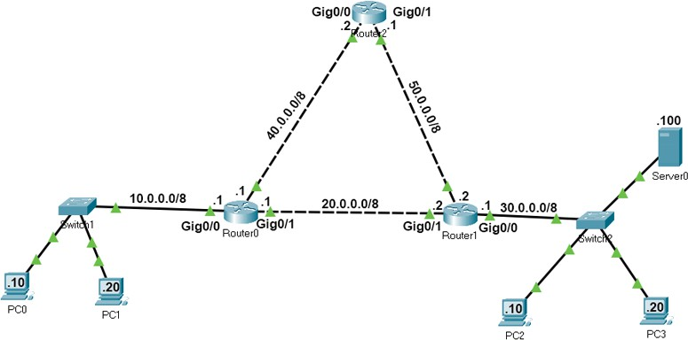
Packet Tracer Lab with Initial IP Configuration

In this lab, each network has two routes to reach. We will configure one route as the main route and another route as the backup route. If the link bandwidth of all routes is the same, we use the route that has the least number of routers as the main route. If the link bandwidth and the number of routers are the same, we can use any route as the main route and another route as the backup route.
If we specify two routes for the same destination, the router automatically selects the best route for the destination and adds the route to the routing table. If you manually want to select a route that the router should add to the routing table, you have to set the AD value of the route lower than other routes. For example, if you use the following commands to create two static routes for network 30.0.0/8, the route will place the first route to the routing table.
#ip route 30.0.0.0 255.0.0.0 20.0.0.2 10
#ip route 30.0.0.0 255.0.0.0 40.0.0.2 20
If the first route fails, the router automatically adds the second route to the routing table.

Creating, adding, verifying static routes
Routers automatically learn their connected networks. We only need to add routes for the networks that are not available on the router’s interfaces. For example, network 10.0.0.0/8, 20.0.0.0/8 and 40.0.0.0/8 are directly connected to Router0. Thus, we don’t need to configure routes for these

networks. Network 30.0.0.0/8 and network 50.0.0.0/8 are not available on Router0. We have to create and add routes only for these networks.
The following table lists the connected networks of each router.
Router | Available networks on local interfaces | Networks available on other routers’ interfaces
Router0 | 10.0.0.0/8,  20.0.0.0/8,  40.0.0.0/8 | 30.0.0.0/8, 50.0.0.0/8
Router1 | 20.0.0.0/8,  30.0.0.0/8,  50.0.0.0/8 | 10.0.0.0/8, 40.0.0.0/8
Router2 | 40.0.0.0/8,  50.0.0.0/8 | 10.0.0.0/8, 20.0.0.0/8, 30.0.0.0/8
Let's create static routes on each router for networks that are not available on the router.

Router0 requirements
- Create two routes for network 30.0.0.0/8 and configure the first route (via -Router1) as the main route and the second route (via-Router2) as a backup route.
- Create two routes for the host 30.0.0.100/8 and configure the first route (via -Router2) as the main route and the second route (via-Router1) as a backup route.
- Create two routes for network 50.0.0.0/8 and configure the first route (via -Router2) as the main route and the second route (via-Router1) as a backup route.
- Verify the router adds only main routes to the routing table.

Router0 configuration
Access the CLI prompt of Router0 and run the following commands.
Router>enable Router#configure terminal
Enter configuration commands, one per line. End with CNTL/Z. Router(config)#ip route 30.0.0.0 255.0.0.0 20.0.0.2 10
Router(config)#ip route 30.0.0.0 255.0.0.0 40.0.0.2 20
Router(config)#ip route 30.0.0.100 255.255.255.255 40.0.0.2 10
Router(config)#ip route 30.0.0.100 255.255.255.255 20.0.0.2 20
Router(config)#ip route 50.0.0.0 255.0.0.0 40.0.0.2 10
Router(config)#ip route 50.0.0.0 255.0.0.0 20.0.0.2 20 Router(config)#exit
Router#show ip route static
30.0.0.0/8 is variably subnetted, 2 subnets, 2 masks S 30.0.0.0/8 [10/0] via 20.0.0.2
S 30.0.0.100/32 [10/0] via 40.0.0.2 S 50.0.0.0/8 [10/0] via 40.0.0.2
Router#

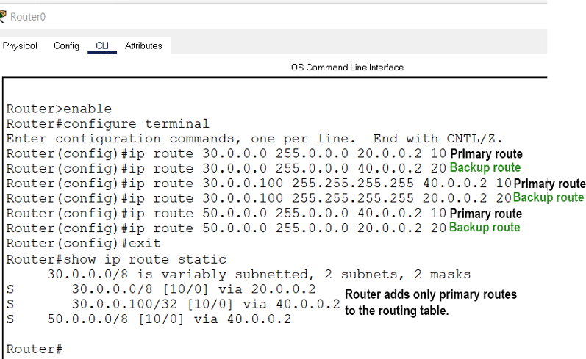

Router1 requirements
- Create two routes for network 10.0.0.0/8 and configure the first route (via -Router0) as the main route and the second route (via-Router1) as a backup route.
- Create two routes for network 40.0.0.0/8 and configure the first route (via -Router0) as the main route and the second route (via-Router2) as a backup route.
- Verify the router adds only main routes to the routing table.

Router1 configuration
Router>enable Router#configure terminal
Enter configuration commands, one per line. End with CNTL/Z. Router(config)#ip route 10.0.0.0 255.0.0.0 20.0.0.1 10
Router(config)#ip route 10.0.0.0 255.0.0.0 50.0.0.1 20
Router(config)#ip route 40.0.0.0 255.0.0.0 20.0.0.1 10
Router(config)#ip route 40.0.0.0 255.0.0.0 50.0.0.1 20 Router(config)#exit
Router#show ip route static
S 10.0.0.0/8 [10/0] via 20.0.0.1 S 40.0.0.0/8 [10/0] via 20.0.0.1
Router#

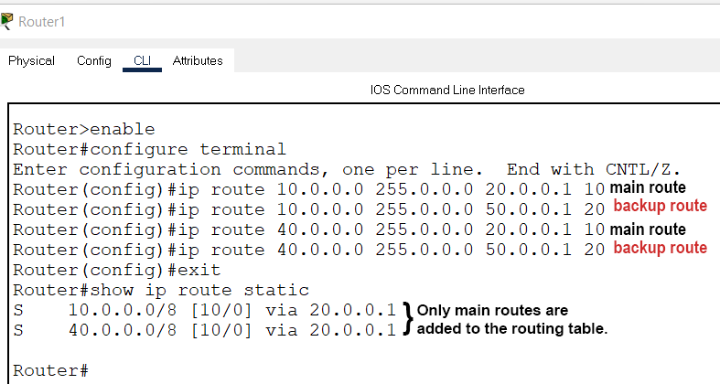

Router2 requirements
Create static routes for network 10.0.0.0/8 and network 30.0.0.0/8 and verify the router adds both routes to the routing table.

Router2 configuration
Router>enable Router#configure terminal
Enter configuration commands, one per line. End with CNTL/Z. Router(config)#ip route 10.0.0.0 255.0.0.0 40.0.0.1
Router(config)#ip route 30.0.0.0 255.0.0.0 50.0.0.2 Router(config)#exit
Router#show ip route static S 10.0.0.0/8 [1/0] via 40.0.0.1 S 30.0.0.0/8 [1/0] via 50.0.0.2
Router#

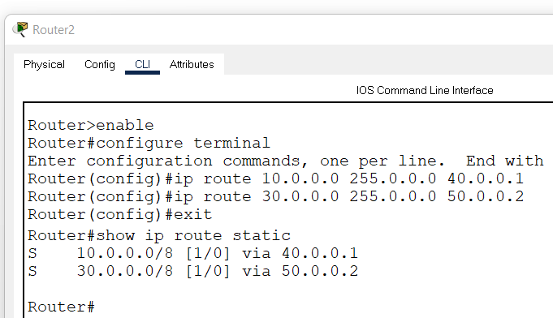

Verifying static routing
On Router0, we configured two routes for network 30.0.0.0/8. These routes are via Router1 and via Router2. We set the first route (via-Router1) as the main route and the second route as the backup route. We can verify this configuration in two ways.
By sending ping requests to a PC of network 30.0.0.0/8 and tracing the path they take to reach the network 30.0.0.0/8. For this, you can use 'tracert' command on a PC of network 10.0.0.0/8. The 'tracert' command sends ping requests to the destination host and tracks the path they take to reach the destination.
By listing the routing table entries on Router0. Since a router uses the routing table to forward data packets, you can check the routing table to figure out the route the router uses to forward data packets for each destination.

The following image shows the above testing.
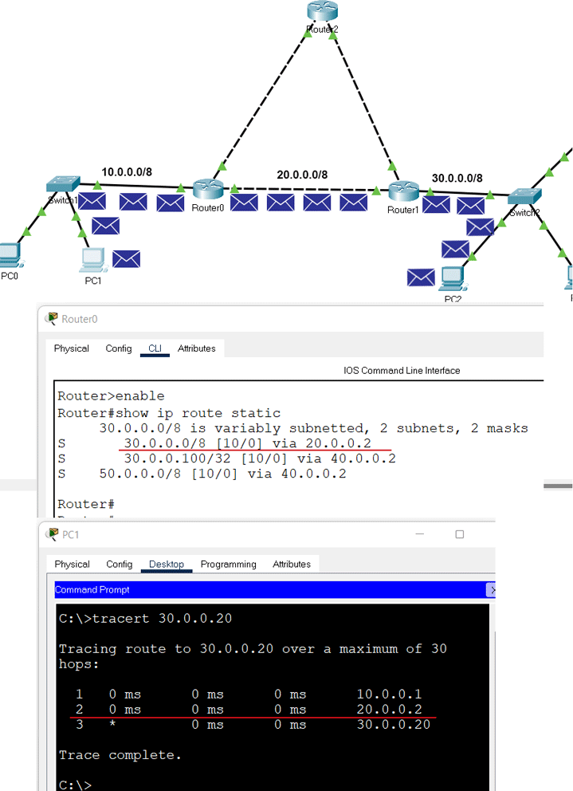

We also configured a separate static host route for the host 30.0.0.100/8. The router must use this route to forward data packets to the host 30.0.0.100/8. To verify this, you can do the same testing for the host 30.0.0.100/8.
The following image shows this testing.
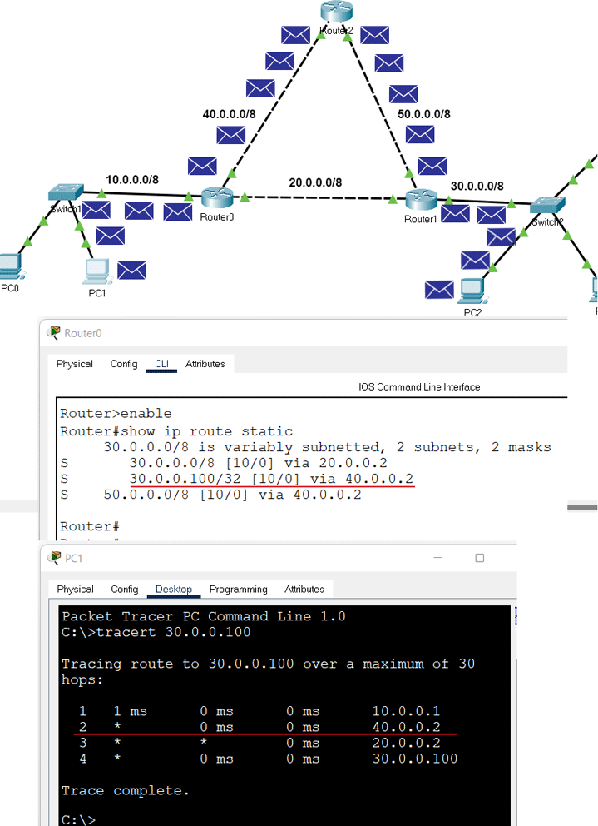

We also configured a backup route for network 30.0.0.0/8. The router must put the backup route to the routing table and use it to forward data packets to network 30.0.0.0/8 when the main route fails. To verify this, we have to simulate the failure of the main route.
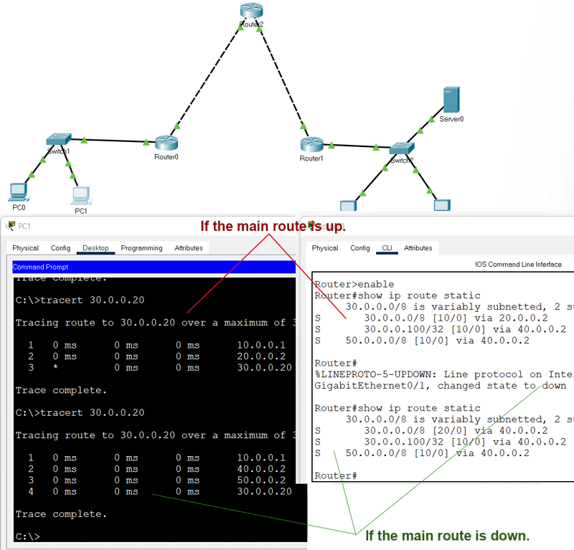
To simulate the failure of the main route, you can delete the link between Router0 and Router1. After deleting the link, do the same testing again for the network 30.0.0.0/8.
The following link provides the configured packet tracer lab of the above example. Packet Tracer Lab with Static Routing Configuration

Deleting a static route
To delete a static route, use the following steps.
- Use the 'show ip route static' command to print all static routes.
- Note down the route you want to delete.
- Use the 'no ip route' command to delete the route.
If you have a backup route, the backup route becomes the main route when you delete the main route.
In our example, we have a backup route and a main route for the host 30.0.0.100/8. The following image shows how to delete both routes.

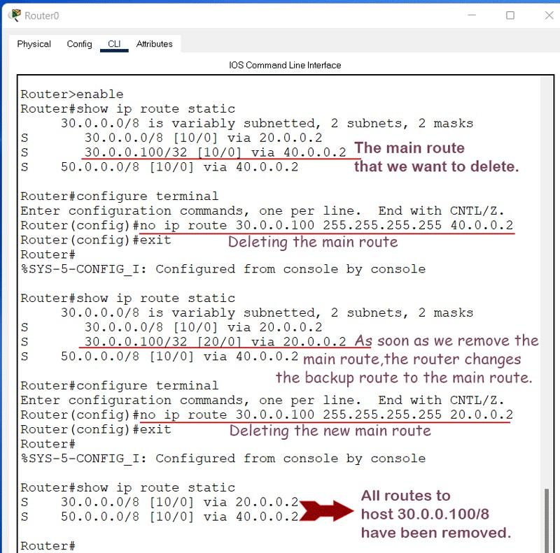

Practical 11
AIM:- b)Simulate RIP using CISCO Packet Tracer

Initial IP configuration
Device | Interface | IP Configuration | Connected with
PC0 | Fast Ethernet | 10.0.0.2/8 | Router0’s Fa0/1
Router0 | Fa0/1 | 10.0.0.1/8 | PC0’s Fast Ethernet
Router0 | S0/0/1 | 192.168.1.254/30 | Router2’s S0/0/1
Router0 | S0/0/0 | 192.168.1.249/30 | Router1’s S0/0/0
Router1 | S0/0/0 | 192.168.1.250/30 | Router0’s S0/0/0
Router1 | S0/0/1 | 192.168.1.246/30 | Router2’s S0/0/0
Router2 | S0/0/0 | 192.168.1.245/30 | Router1’s S0/0/1
Router2 | S0/0/1 | 192.168.1.253/30 | Router0’s S0/0/1
Router2 | Fa0/1 | 20.0.0.1/30 | PC1’s Fast Ethernet
PC1 | Fast Ethernet | 20.0.0.2/30 | Router2’s Fa0/1

Assign IP address to PCs
Double click PCs and click Desktop menu item and click IP Configuration. Assign IP address referring the above table.

Assign IP address to interfaces of routers
Double click Router0 and click CLI and press Enter key to access the command prompt of Router0.
We need to configure IP address and other parameters on interfaces before we could actually use them for routing. Interface mode is used to assign IP address and other parameters. Interface mode can be accessed from global configuration mode. Following commands are used to access the global configuration mode.
Router>enable Router#configure terminal
Enter configuration commands, one per line. End with CNTL/Z. Router(config)#
From global configuration mode we can enter in interface mode. From there we can configure the interface. Following commands will assign IP address on FastEthernet0/0.
Router(config)#interface fastEthernet 0/0 Router(config-if)#ip address 10.0.0.1 255.0.0.0 Router(config-if)#no shutdown Router(config-if)#exit
Router(config)#
interface fastEthernet 0/0 command is used to enter in interface mode.
ip address 10.0.0.1 255.0.0.0 command will assign IP address to interface.

no shutdown command will bring the interface up.
exit command is used to return in global configuration mode.
Serial interface needs two additional parameters clock rate and bandwidth. Every serial cable has two ends DTE and DCE. These parameters are always configured at DCE end.
We can use show controllers interface command from privilege mode to check the cable’s end.
Router#show controllers serial 0/0/0 Interface Serial0/0/0
Hardware is PowerQUICC MPC860 DCE V.35, clock rate 2000000 [Output omitted]
Fourth line of output confirms that DCE end of serial cable is attached. If you see DTE here instead of DCE skip these parameters.
Now we have necessary information let’s assign IP address to serial interface.
Router#configure terminal
Enter configuration commands, one per line. End with CNTL/Z. Router(config)#interface serial 0/0/0
Router(config-if)#ip address 192.168.1.249 255.255.255.252
Router(config-if)#clock rate 64000
Router(config-if)#bandwidth 64 Router(config-if)#no shutdown Router(config-if)#exit Router(config)#interface serial 0/0/1
Router(config-if)#ip address 192.168.1.254 255.255.255.252
Router(config-if)#clock rate 64000
Router(config-if)#bandwidth 64 Router(config-if)#no shutdown Router(config-if)#exit Router(config)#
Router#configure terminal Command is used to enter in global configuration mode. Router(config)#interface serial 0/0/0 Command is used to enter in interface mode. Router(config-if)#ip address 192.168.1.249 255.255.255.252 Command assigns IP address to interface. For serial link we usually use IP address from /30 subnet.
Router(config-if)#clock rate 64000 And Router(config-if)#bandwidth 64 In real life environment these parameters control the data flow between serial links and need to be set at service providers end. In lab environment we need not to worry about these values. We can use these values.
Router(config-if)#no shutdown Command brings interface up.
Router(config-if)#exit Command is used to return in global configuration mode.
We will use same commands to assign IP addresses on interfaces of remaining routers. We need to provided clock rate and bandwidth only on DCE side of serial interface. Following command will assign IP addresses on interface of Router1.

Router1
Router>enable Router#configure terminal
Enter configuration commands, one per line. End with CNTL/Z. Router(config)#interface serial 0/0/0
Router(config-if)#ip address 192.168.1.250 255.255.255.252

Router(config-if)#no shutdown Router(config-if)#exit Router(config)#interface serial 0/0/1
Router(config-if)#ip address 192.168.1.246 255.255.255.252
Router(config-if)#clock rate 64000
Router(config-if)#bandwidth 64 Router(config-if)#no shutdown Router(config-if)#exit

Use same commands to assign IP addresses on interfaces of Router2.

Router2
Router>enable Router#configure terminal
Enter configuration commands, one per line. End with CNTL/Z. Router(config)#interface fastEthernet 0/0
Router(config-if)#ip address 20.0.0.1 255.0.0.0 Router(config-if)#no shutdown Router(config-if)#exit Router(config)#interface serial 0/0/0
Router(config-if)#ip address 192.168.1.245 255.255.255.252 Router(config-if)#no shutdown
Router(config-if)#exit Router(config)#interface serial 0/0/1
Router(config-if)#ip address 192.168.1.253 255.255.255.252 Router(config-if)#no shutdown
Router(config-if)#exit
Now routers have information about the networks that they have on their own interfaces. Routers will not exchange this information between them on their own. We need to implement RIP routing protocol that will insist them to share this information.

Configure RIP routing protocol
Configuration of RIP protocol is much easier than you think. It requires only two steps to configure the RIP routing.
- Enable RIP routing protocol from global configuration mode.
- Tell RIP routing protocol which networks you want to advertise. Let’s configure it in Router0

Router0
Router0(config)#router rip Router0(config-router)# network 10.0.0.0
Router0(config-router)# network 192.168.1.252
Router0(config-router)# network 192.168.1.248
router rip command tell router to enable the RIP routing protocol.
network command allows us to specify the networks which we want to advertise. We only need to specify the networks which are directly connected with the router.
That’s all we need to configure the RIP. Follow same steps on remaining routers.

Router1
Router1(config)#router rip
Router1(config-router)# network 192.168.1.244
Router1(config-router)# network 192.168.1.248
Router2
Router2(config)#router rip

Router2(config-router)# network 20.0.0.0
Router2(config-router)# network 192.168.1.252
Router2(config-router)# network 192.168.1.244
That’s it. Our network is ready to take the advantage of RIP routing. To verify the setup we will use ping command. ping command is used to test the connectivity between two devices.
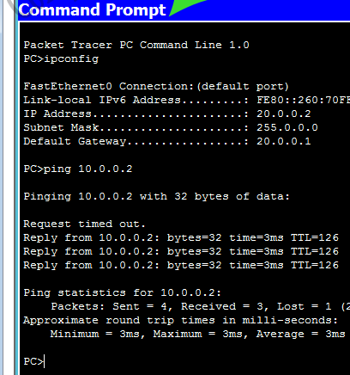
Access the command prompt of PC1 and use ping command to test the connectivity from PC0.

RIP protocol automatically manage all routes for us. If one route goes down, it automatically switches to another available. To explain this process more clearly we have added one more route in our network.
Currently there are two routes between PC0 and PC1.

Route 1
PC0 [Source / destination – 10.0.0.2] <==> Router0 [FastEthernet0/1 – 10.0.0.1] <==> Router0 [Serial0/0/1 – 192.168.1.254] <==> Router2 [Serial 0/0/1 – 192.168.1.253] <==> Router2 [FastEthernet0/0 – 20.0.0.1] <==> PC1 [Destination /source – 20.0.0.2]

Route 2
PC0 [Source / destination – 10.0.0.2] <==> Router0 [FastEthernet0/1 – 10.0.0.1] <==> Router0 [Serial0/0/0 – 192.168.1.249] <==> Router1 [Serial 0/0/0 – 192.168.1.250] <==> Router1 [Serial 0/0/1 – 192.168.1.246] <==> Router2 [Serial 0/0/0 – 192.168.1.245] <==> Router2 [FastEthernet0/0 – 20.0.0.1] <==> PC1 [Destination /source – 20.0.0.2]
By default RIP will use the route that has low hops counts between source and destination. In our network route1 has low hops counts, so it will be selected. We can use tracert command to verify it.
Now suppose route1 is down. We can simulate this situation by removing the cable attached between Router0 [s0/0/1] and Router2 [s0/0/1].
What will happen now? There is no need to worry. RIP will automatically reroute the traffic. Use tracert command again to see the magic of dynamic routing.

