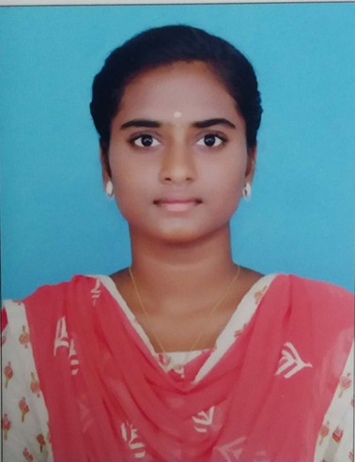
YUVASRI.V

CAREER OBJECTIVE

CONTACT

9655810717
yuvasrivelv@gmail.com
369,perumal kovil st, koovam new colony,thiruvallu DT,631402.

LinkdIn https://www.linkedin.com/in
/yuvasri-v-b7a72a2b1
Hakerrank:https://www.hackerrank
.com/profile/yuvasrivelv1

EDUCATION

2023-2027
PANIMALAR PANIMALAR ENGINEERING COLLEGE
ARTIFICIAL INTELLIGENCE AND DATA DCIENCE
CGPA: 8.5

SKILLS
Learning Ability Teamwork
Collaboration Leadership
Effective Communication
TECHINICAL SKILLS
Java
Python
Power BI My SQL
Data Visualization

SIGNATURE :
Final-year B.Tech student specializing in Artificial Intelligence and Data Science with strong skills in Python, Java, SQL and Full Stack Development. Seeking an entry-level opportunity to applytechnical knowledge, problem-solving abilities, and continuous learning in a growth- oriented organization.

EDUCATION

Currently pursuing a Bachelor of Technology in Artificial Intelligence and Data Scienceat Panimalar Engineering College (2023–2027) with a CGPA of 8.5/10, gaining strong knowledge in java,sql and
software development. Completed Secondary School (Class X) at a Government High School. Higher Secondary education at Government Girls Higher Secondary School (2021–2022).

TECHNICAL SKILLS

Programming Languages: Basics of Python, Java, C Web Technologies: HTML, CSS, JavaScript
Databases: MySQL (queries, joins,normalization, CRUD operations) Tools & Platforms: VS Code, MS Excel (data handling)

PROJECTS
Flight Ticket Booking System– Developed a full-stack web app with user login,booking features, and MySQL database connectivity.
Fake News Detection System (Java)(MINI PROJECT)– Created a Java-based application to classify news as real or fake using text analysis and machine learning concepts.

INTERNSHIPS
Full Stack Development Intern– Infomatronics | [15 DAYS]
Gained hands-onexperience in frontendand backend development, built responsive web pages, integrated MySQL databases, and assisted in debugging and performance improvement.
Manufacturing & Company Development Intern – NIFCO | [15 DAYS]
Learned manufacturing processes, quality control,documentation, and processimprovement, gaining insight into production planning and company operations.

CERTIFICATION
Certified in online:NASSCOM,Infosys,Oracle,NPTEL for pythonand completed TechnicalTraining at Infomatronics.

SOFT SKILLS
Communication, Teamwork,Leadership, Problem Solving,Time Management, Adaptability.

