**COVID19 VACCINE ANALYSIS PROJECT**

|  |  |
| --- | --- |
| **Date** | **04-10-2023** |
| **Team ID** | **3881** |
| **Project Name** | **COVID19 Vaccines Analysis** |

**Table of Contents**

|  |  |
| --- | --- |
| 1 | Introduction |
| 2 | Problem Statement |
| 3 | Design and Innovation Strategies |
| 3.1 | Data Collection and Feature Engineering |
| 3.2 | Data Pre-processing |
| 3.3 | Model Selection and Training |
| 3.4 | Geographic Analysis |
| 4 | Conclusion |

**1. Introduction**

The global response to the COVID-19 pandemic has centred around the development, distribution, and monitoring of vaccines. This comprehensive analysis delves into various aspects of COVID-19 vaccine management, from examining distribution strategies to understanding their impact through geographic analysis. By employing advanced machine learning techniques like clustering and time series forecasting, we aim to uncover hidden patterns and insights that can inform more effective vaccine distribution and adverse effects monitoring.

**2. Problem Statement**

The successful distribution and monitoring of COVID-19 vaccines present formidable challenges on a global scale. Ensuring equitable access, minimizing adverse effects, and optimizing distribution strategies are all crucial objectives. This analysis seeks to address these challenges by leveraging advanced machine learning techniques to enhance vaccine management

**3. Design and Innovation Strategies**

Exploring innovative strategies is vital for improving vaccine distribution and monitoring. We will investigate various design and innovation strategies that can optimize vaccine allocation, delivery, and tracking. This includes examining the potential use of cutting-edge technologies such as blockchain and AI for supply chain management.

**3.1. Data Collection and Feature Engineering**

Robust data collection is the foundation of effective analysis. We will explore methods for gathering comprehensive data on vaccine distribution, administration, and adverse effects. Feature engineering will play a pivotal role in shaping our analytical models by identifying relevant data points and creating meaningful variables for analysis.

**3.2. Data Pre-processing**

Cleaning and pre-processing the collected data are essential steps to ensure data quality and reliability. We will discuss data cleaning techniques, handling missing values, and dealing with outliers to prepare the dataset for modelling.

**3.3. Model Selection and Training**

Choosing the right machine learning models is crucial for accurate predictions and insights. We will explore a range of models, including clustering algorithms and time series forecasting methods, to analyse vaccine distribution patterns and predict adverse effects. Model training and validation will be performed to assess their effectiveness.

**3.4. Geographic Analysis**

Understanding the geographic distribution of vaccines and their impact is critical. We will conduct a detailed geographic analysis to identify disparities in vaccine distribution, monitor the spread of adverse effects, and assess the effectiveness of vaccination campaigns across different regions.

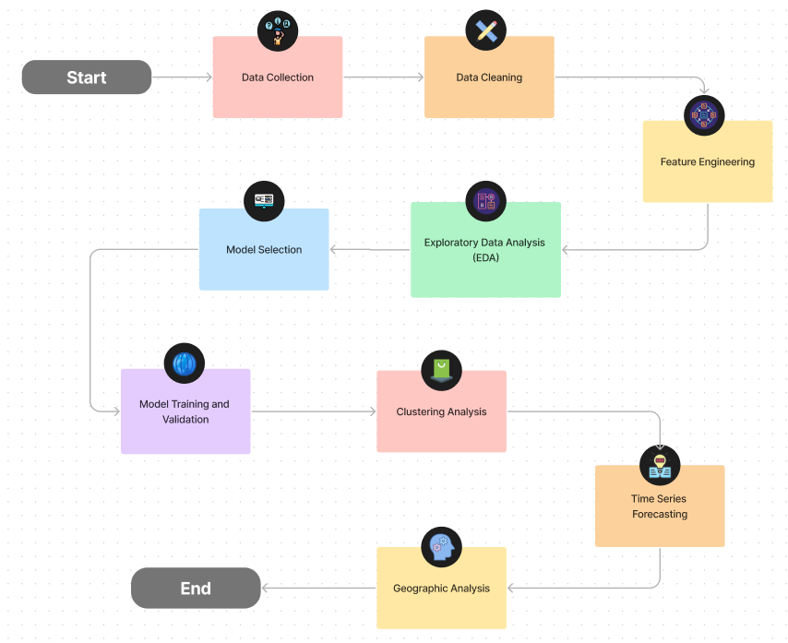

+

**4. Conclusion**

In conclusion, this analysis aims to provide a comprehensive understanding of COVID-19 vaccine distribution and monitoring. By leveraging advanced machine learning techniques, including clustering and time series forecasting, we seek to uncover hidden insights that can inform more equitable and efficient vaccine management strategies. This research has the potential to contribute significantly to the ongoing global effort to combat the pandemic and ensure a safer future for all.