1. **Create a React Application named “cricketapp”.**

**ListofPlayers.js**

import React from "react";

const ListofPlayers = () => {

  const players = [

    { name: "Virat Kohli", score: 88 },

    { name: "Rohit Sharma", score: 65 },

    { name: "KL Rahul", score: 75 },

    { name: "Shubman Gill", score: 45 },

    { name: "Hardik Pandya", score: 72 },

    { name: "Jadeja", score: 60 },

    { name: "Dhoni", score: 99 },

    { name: "Yuvraj", score: 68 },

    { name: "Raina", score: 52 },

    { name: "Bumrah", score: 80 },

    { name: "Ashwin", score: 85 }

  ];

  const playerList = players.map((player, index) => (

    <li key={index}>{player.name} - {player.score}</li>

  ));

  const lowScorers = players.filter(player => player.score < 70);

  return (

    <div>

      <h2>All Players</h2>

      <ul>{playerList}</ul>

      <h3>Players with Score Below 70</h3>

      <ul>

        {lowScorers.map((player, index) => (

          <li key={index}>{player.name} - {player.score}</li>

        ))}

      </ul>

    </div>

  );

};

export default ListofPlayers;

**IndianPlayers.js**

import React from "react";

const IndianPlayers = () => {

  const T20Players = ["Kohli", "Rohit", "Rahul", "Pandya"];

  const RanjiPlayers = ["Gambhir", "Pujara", "Rahane", "Nayar"];

  const AllPlayers = [...T20Players, ...RanjiPlayers];

  const oddTeam = AllPlayers.filter((_, i) => i % 2 === 0);

  const evenTeam = AllPlayers.filter((_, i) => i % 2 !== 0);

  return (

    <div>

      <h2>All Indian Players</h2>

      <ul>

        {AllPlayers.map((player, i) => (

          <li key={i}>{player}</li>

        ))}

      </ul>

      <h3>Odd Team Players</h3>

      <ul>

        {oddTeam.map((p, i) => <li key={i}>{p}</li>)}

      </ul>

      <h3>Even Team Players</h3>

      <ul>

        {evenTeam.map((p, i) => <li key={i}>{p}</li>)}

      </ul>

    </div>

  );

};

export default IndianPlayers;

**App.js**

import React from "react";

import ListofPlayers from "./ListofPlayers";

import IndianPlayers from "./IndianPlayers";

function App() {

  const flag = true;

  return (

    <div className="App">

      <h1>Cricket App</h1>

      {flag ? <ListofPlayers /> : <IndianPlayers />}

    </div>

  );

}

export default App;

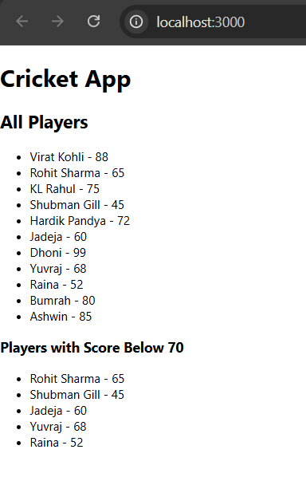

1. **Create a React Application named “officespacerentalapp” which uses React JSX to create elements, attributes and renders DOM to display the page.**

**App.js**

import React from "react";

function App() {

  const heading = <h1>Office Space Rental Listings</h1>;

  const imageUrl = "https://via.placeholder.com/600x300.png?text=Office+Space";

  const office = {

    name: "Startup Hub",

    rent: 50000,

    address: "123 Tech Street, Bangalore"

  };

  const officeList = [

    {

      name: "Startup Hub",

      rent: 50000,

      address: "123 Tech Street, Bangalore"

    },

    {

      name: "Enterprise Park",

      rent: 75000,

      address: "56 Business Ave, Hyderabad"

    },

    {

      name: "CoWork Junction",

      rent: 45000,

      address: "88 Startup Lane, Chennai"

    },

    {

      name: "Elite Tower",

      rent: 90000,

      address: "21 Highrise Rd, Mumbai"

    }

  ];

  const getRentStyle = (rent) => {

    return {

      color: rent < 60000 ? "red" : "green",

      fontWeight: "bold"

    };

  };

  return (

    <div className="App">

      {/* Render Heading */}

      {heading}

      {/* Render Image */}

      <img src={imageUrl} alt="Office Space" style={{ width: "600px", height: "300px" }} />

      {/* Render office details with JSX and JS expressions */}

      <h2>Featured Office</h2>

      <p>Name: {office.name}</p>

      <p style={getRentStyle(office.rent)}>Rent: ₹{office.rent}</p>

      <p>Address: {office.address}</p>

      <hr />

      {/* Loop through the office list using map() */}

      <h2>All Available Offices</h2>

      {officeList.map((o, index) => (

        <div key={index} style={{ borderBottom: "1px solid gray", marginBottom: "15px" }}>

          <p>Name: {o.name}</p>

          <p style={getRentStyle(o.rent)}>Rent: ₹{o.rent}</p>

          <p>Address: {o.address}</p>

        </div>

      ))}

    </div>

  );

}

export default App;

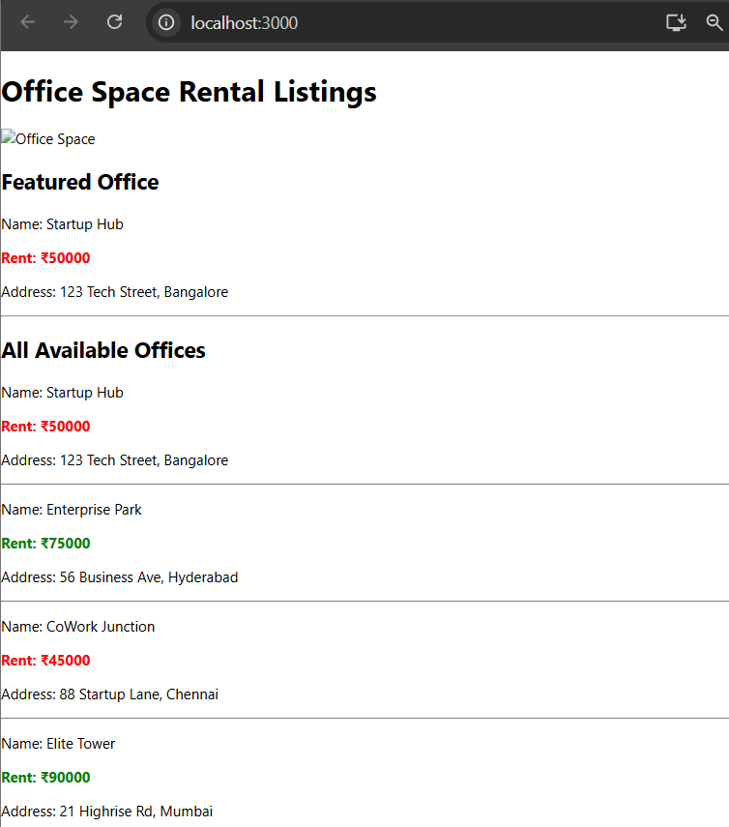

1. **Create a React Application “eventexamplesapp” to handle various events of the form elements in HTML.**

**EventExample.js**

import React, { Component } from "react";

class EventExample extends Component {

  constructor(props) {

    super(props);

    this.state = {

      count: 0,

      message: "",

      rupees: "",

      euro: ""

    };

    this.handleIncrement = this.handleIncrement.bind(this);

    this.sayHello = this.sayHello.bind(this);

    this.incrementAll = this.incrementAll.bind(this);

    this.handleWelcome = this.handleWelcome.bind(this);

    this.handlePress = this.handlePress.bind(this);

    this.handleCurrencyChange = this.handleCurrencyChange.bind(this);

    this.handleConvert = this.handleConvert.bind(this);

  }

  handleIncrement() {

    this.setState({ count: this.state.count + 1 });

  }

  handleDecrement = () => {

    this.setState({ count: this.state.count - 1 });

  };

  sayHello() {

    alert("Hello! This is a static message.");

  }

  incrementAll() {

    this.handleIncrement();

    this.sayHello();

  }

  handleWelcome(message) {

    alert("Welcome! " + message);

  }

  handlePress(event) {

    alert("I was clicked");

  }

  handleCurrencyChange(e) {

    this.setState({ rupees: e.target.value });

  }

  handleConvert(e) {

    e.preventDefault(); // Synthetic event

    const euro = (this.state.rupees / 90).toFixed(2); // Assume 1 Euro = 90 INR

    this.setState({ euro });

  }

  render() {

    return (

      <div style={{ padding: "20px" }}>

        <h2>React Event Handling Example</h2>

        {/* Counter Section */}

        <p>Count: {this.state.count}</p>

        <button onClick={this.incrementAll}>Increment</button>{" "}

        <button onClick={this.handleDecrement}>Decrement</button>

        <br /><br />

        {/* Welcome Button */}

        <button onClick={() => this.handleWelcome("You are awesome!")}>

          Say Welcome

        </button>

        <br /><br />

        {/* Synthetic Event Button */}

        <button onClick={this.handlePress}>Synthetic Event: OnPress</button>

        <br /><br />

        {/* Currency Convertor */}

        <h3>Currency Converter (INR to EURO)</h3>

        <form onSubmit={this.handleConvert}>

          <input

            type="number"

            placeholder="Enter amount in INR"

            value={this.state.rupees}

            onChange={this.handleCurrencyChange}

          />

          <button type="submit">Convert</button>

        </form>

        {this.state.euro && (

          <p>Equivalent in Euro: €{this.state.euro}</p>

        )}

      </div>

    );

  }

}

export default EventExample;

**App.js**

import React from "react";

import EventExample from "./EventExample";

function App() {

  return (

    <div className="App">

      <EventExample />

    </div>

  );

}

export default App;

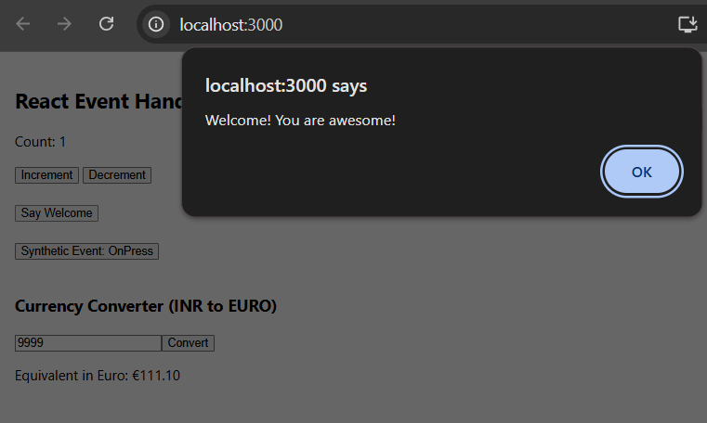

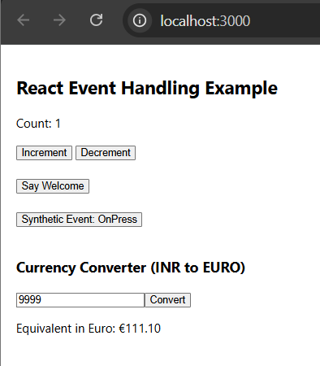

1. **Create a React Application named “ticketbookingapp” where the guest user can browse the page where the flight details are displayed whereas the logged in user only can book tickets.**

**App.js**

import React from "react";

import LoginControl from "./LoginControl";

function App() {

  return (

    <div className="App">

      <LoginControl />

    </div>

  );

}

export default App;

**LoginControl.js**

import React, { useState } from "react";

import Guest from "./Guest";

import User from "./User";

const LoginControl = () => {

  const [isLoggedIn, setIsLoggedIn] = useState(false);

  const handleLoginClick = () => setIsLoggedIn(true);

  const handleLogoutClick = () => setIsLoggedIn(false);

  let page;

  let button;

  if (isLoggedIn) {

    page = <User />;

    button = <button onClick={handleLogoutClick}>Logout</button>;

  } else {

    page = <Guest />;

    button = <button onClick={handleLoginClick}>Login</button>;

  }

  return (

    <div style={{ padding: "20px" }}>

      <h1>Ticket Booking App</h1>

      {button}

      <hr />

      {page}

    </div>

  );

};

export default LoginControl;

**User.js**

import React from "react";

const User = () => {

  return (

    <div>

      <h2>Welcome Back!</h2>

      <p>You can now book your tickets:</p>

      <ul>

        <li>🔘 AI-101 | Book</li>

        <li>🔘 AI-102 | Book</li>

        <li>🔘 AI-103 | Book</li>

      </ul>

    </div>

  );

};

export default User;

**Guest.js**

import React from "react";

const Guest = () => {

  return (

    <div>

      <h2>Welcome Guest!</h2>

      <p>You can browse flight details below:</p>

      <ul>

        <li>✈️ Flight: AI-101 | Delhi → Mumbai | 10:00 AM</li>

        <li>✈️ Flight: AI-102 | Mumbai → Chennai | 1:00 PM</li>

        <li>✈️ Flight: AI-103 | Bangalore → Hyderabad | 5:30 PM</li>

      </ul>

    </div>

  );

};

export default Guest;

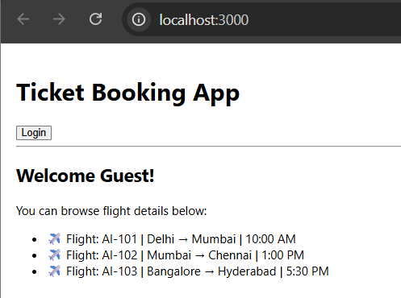

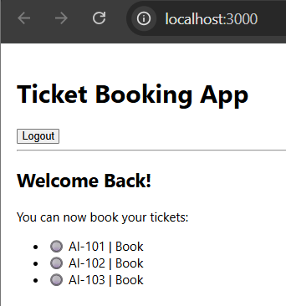

1. **Create a React App named “bloggerapp” in with 3 components.**

* **Book Details**
* **Blog Details**
* **Course Details**

**Implement this with as many ways possible of Conditional Rendering.**

**BookDetails.js**

import React from "react";

const BookDetails = () => {

  const books = [

    { id: 1, title: "Crime and Punishment", author: "Fyodor Dostoyevsky" },

    { id: 2, title: "Metamorphosis", author: "Franz Kafka" },

    { id: 3, title: "Pride and Prejudice", author: "Jane Austen" }

  ];

  return (

    <div>

      <h2> Book Details</h2>

      <ul>

        {books.map(book => (

          <li key={book.id}>{book.title} by {book.author}</li>

        ))}

      </ul>

    </div>

  );

};

export default BookDetails;

**BlogDetails.js**

import React from "react";

const BlogDetails = () => {

  const blogs = [

    { id: 1, topic: "React Hooks Overview" },

    { id: 2, topic: "JavaScript Closures Explained" },

    { id: 3, topic: "How to Use Flexbox" }

  ];

  return (

    <div>

      <h2>📝 Blog Details</h2>

      <ul>

        {blogs.map(blog => (

          <li key={blog.id}>{blog.topic}</li>

        ))}

      </ul>

    </div>

  );

};

export default BlogDetails;

**CourseDetails.js**

import React from "react";

const CourseDetails = () => {

  const courses = [

    { id: 1, name: "Full Stack Development", duration: "6 months" },

    { id: 2, name: "AI & ML", duration: "4 months" },

    { id: 3, name: "Cyber Security", duration: "5 months" }

  ];

  return (

    <div>

      <h2>📘 Course Details</h2>

      <ul>

        {courses.map(course => (

          <li key={course.id}>{course.name} - {course.duration}</li>

        ))}

      </ul>

    </div>

  );

};

export default CourseDetails;

**MainView.js**

import React, { useState } from "react";

import BookDetails from "./BookDetails";

import BlogDetails from "./BlogDetails";

import CourseDetails from "./CourseDetails";

const MainView = () => {

  const [view, setView] = useState("books");

  let componentToRender;

  // Method 1: if-else

  if (view === "books") {

    componentToRender = <BookDetails />;

  } else if (view === "blogs") {

    componentToRender = <BlogDetails />;

  } else {

    componentToRender = <CourseDetails />;

  }

  return (

    <div style={{ padding: "20px" }}>

      <h1>🎨 Blogger App Dashboard</h1>

      <button onClick={() => setView("books")}>Book Details</button>

      <button onClick={() => setView("blogs")}>Blog Details</button>

      <button onClick={() => setView("courses")}>Course Details</button>

      <hr />

      {componentToRender}

      <div>

        <h4>Status:</h4>

        {view === "courses" ? <p>You're viewing Course Details</p> : <p>You're not on Course page</p>}

      </div>

      {view === "blogs" && <p>📢 Tip: You can write your own blog too!</p>}

    </div>

  );

};

export default MainView;

**App.js**

import React from "react";

import MainView from "./MainView";

function App() {

  return (

    <div className="App">

      <MainView />

    </div>

  );

}

export default App;

