**Exercise 1: Control Structures**

**Scenario 1:** The bank wants to apply a discount to loan interest rates for customers above 60 years old.

**Question:** Write a PL/SQL block that loops through all customers, checks their age, and if they are above 60, apply a 1% discount to their current loan interest rates.

**Program:**

BEGIN

FOR rec IN (SELECT * FROM customers) LOOP

IF rec.age > 60 THEN

UPDATE customers

SET loan_interest_rate = loan_interest_rate - 1

WHERE customer_id = rec.customer_id;

END IF;

END LOOP;

END;

/

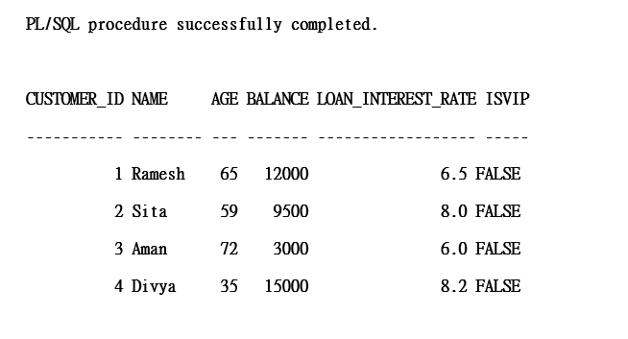

**Scenario 2:** A customer can be promoted to VIP status based on their balance.

**Question**: Write a PL/SQL block that iterates through all customers and sets a flag IsVIP to TRUE for those with a balance over $10,000.

**Program**

BEGIN

FOR rec IN (SELECT * FROM customers) LOOP

IF rec.balance > 10000 THEN

UPDATE customers

SET IsVIP = 'TRUE'

WHERE customer_id = rec.customer_id;

END IF;

END LOOP;

END;

/

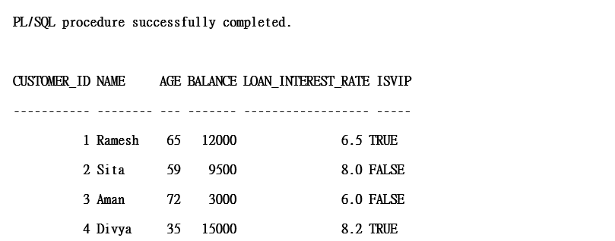

**Scenario 3**: The bank wants to send reminders to customers whose loans are due within the next 30 days.

**Question**: Write a PL/SQL block that fetches all loans due in the next 30 days and prints a reminder message for each customer.

**Program**

BEGIN

FOR rec IN (

SELECT l.loan_id, l.due_date, c.name

FROM loans l

JOIN customers c ON l.customer_id = c.customer_id

WHERE l.due_date <= SYSDATE + 30

) LOOP

DBMS_OUTPUT.PUT_LINE('Reminder: ' || rec.name ||

', your loan (ID: ' || rec.loan_id ||

') is due on ' || TO_CHAR(rec.due_date, 'DD-MON-YYYY'));

END LOOP;

END;

/

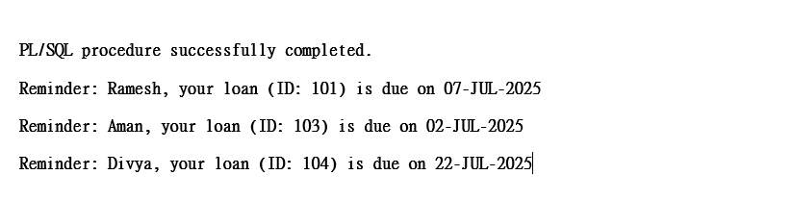

**Exercise 3: Stored Procedures**

**Scenario 1:** The bank needs to process monthly interest for all savings accounts.

**Question:** Write a stored procedure **ProcessMonthlyInterest** that calculates and updates the balance of all savings accounts by applying an interest rate of 1% to the current balance.

**Program:**

BEGIN

EXECUTE IMMEDIATE 'DROP TABLE savings_accounts';

EXCEPTION

WHEN OTHERS THEN

NULL;

END;

/

CREATE TABLE savings_accounts (

account_id NUMBER PRIMARY KEY,

customer_name VARCHAR2(50),

balance NUMBER

);

INSERT INTO savings_accounts VALUES (1, 'Ramesh', 10000);

INSERT INTO savings_accounts VALUES (2, 'Sita', 15000);

INSERT INTO savings_accounts VALUES (3, 'Aman', 5000);

CREATE OR REPLACE PROCEDURE ProcessMonthlyInterest IS

BEGIN

UPDATE savings_accounts

SET balance = balance + (balance * 0.01); -- Adds 1% interest

END;

/

BEGIN

ProcessMonthlyInterest;

END;

/

SELECT * FROM savings_accounts; 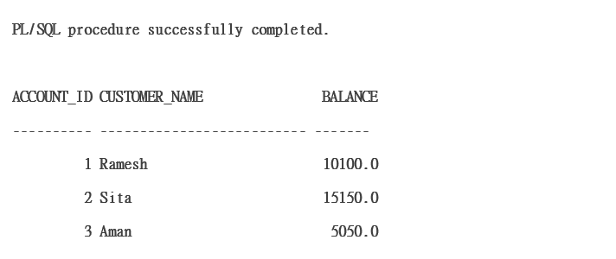

**Scenario 2:** The bank wants to implement a bonus scheme for employees based on their performance.

**Question:** Write a stored procedure **UpdateEmployeeBonus** that updates the salary of employees in a given department by adding a bonus percentage passed as a parameter.

**Program:**

CREATE TABLE employees (

emp_id NUMBER PRIMARY KEY,

emp_name VARCHAR2(50),

department VARCHAR2(30),

salary NUMBER

);

INSERT INTO employees VALUES (1, 'John', 'Sales', 30000);

INSERT INTO employees VALUES (2, 'Radha', 'HR', 25000);

INSERT INTO employees VALUES (3, 'Steve', 'Sales', 35000);

INSERT INTO employees VALUES (4, 'Megha', 'Finance', 40000);

CREATE OR REPLACE PROCEDURE UpdateEmployeeBonus (

dept_name IN VARCHAR2,

bonus_percent IN NUMBER

)

IS

BEGIN

UPDATE employees

SET salary = salary + (salary * bonus_percent / 100)

WHERE department = dept_name;

DBMS_OUTPUT.PUT_LINE('Bonus applied to department: ' || dept_name);

END;

/

SET SERVEROUTPUT ON;

BEGIN

UpdateEmployeeBonus('Sales', 10);

END;

/

SELECT * FROM employees;

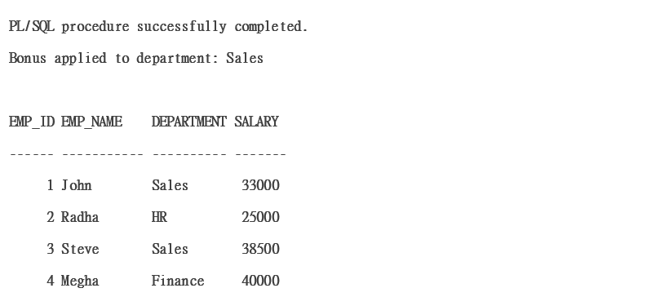

**Scenario 3:** Customers should be able to transfer funds between their accounts.

**Question:** Write a stored procedure **TransferFunds** that transfers a specified amount from one account to another, checking that the source account has sufficient balance before making the transfer

**Program**

BEGIN

EXECUTE IMMEDIATE 'DROP TABLE bank_accounts';

EXCEPTION

WHEN OTHERS THEN

NULL;

END;

/

CREATE TABLE bank_accounts (

account_id NUMBER PRIMARY KEY,

customer_name VARCHAR2(50),

balance NUMBER

);

INSERT INTO bank_accounts VALUES (1, 'Asha', 15000);

INSERT INTO bank_accounts VALUES (2, 'Rahul', 10000);

INSERT INTO bank_accounts VALUES (3, 'Meena', 8000);

CREATE OR REPLACE PROCEDURE TransferFunds (

from_account IN NUMBER,

to_account IN NUMBER,

amount IN NUMBER

)

IS

insufficient_funds EXCEPTION;

current_balance NUMBER;

BEGIN

-- Check current balance of sender

SELECT balance INTO current_balance

FROM bank_accounts

WHERE account_id = from_account;

IF current_balance < amount THEN

RAISE insufficient_funds;

END IF;

UPDATE bank_accounts

SET balance = balance - amount

WHERE account_id = from_account;

UPDATE bank_accounts

SET balance = balance + amount

WHERE account_id = to_account;

DBMS_OUTPUT.PUT_LINE('Transfer successful from Account ' || from_account || ' to Account ' || to_account);

EXCEPTION

WHEN insufficient_funds THEN

DBMS_OUTPUT.PUT_LINE('Error: Insufficient funds in Account ' || from_account);

WHEN OTHERS THEN

DBMS_OUTPUT.PUT_LINE('Unexpected error: ' || SQLERRM);

END;

/

SET SERVEROUTPUT ON;

BEGIN

TransferFunds(1, 2, 4000); -- Transfer ₹4000 from Asha to Rahul

END;

/

SELECT * FROM bank_accounts;

