In this ICP, It is described about the installation of Python and running some basic programs such as, finding Quotient and reminder for two numbers given by user, reversing a name and selecting the random number and checking them to be correct.

1. Difference between Python 2 and python 3

|  |  |
| --- | --- |
| Python 2 | Python 3 |
| **for printing:** we can use ‘’ or “” or ()  ex: print ’xyz’ ; print “xyz”; print(abc) | **For printing:** we can use ()  Print(‘xyz’) ; print() |
| **for input:** raw_input() | **for input: input()** |

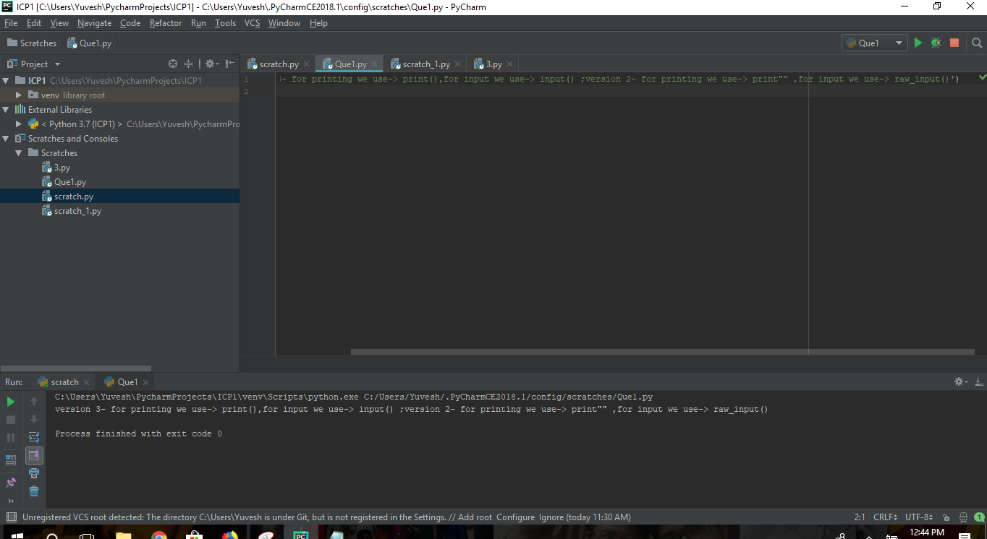

1. (i) Take the user first name and last name and then print it in reverse order.

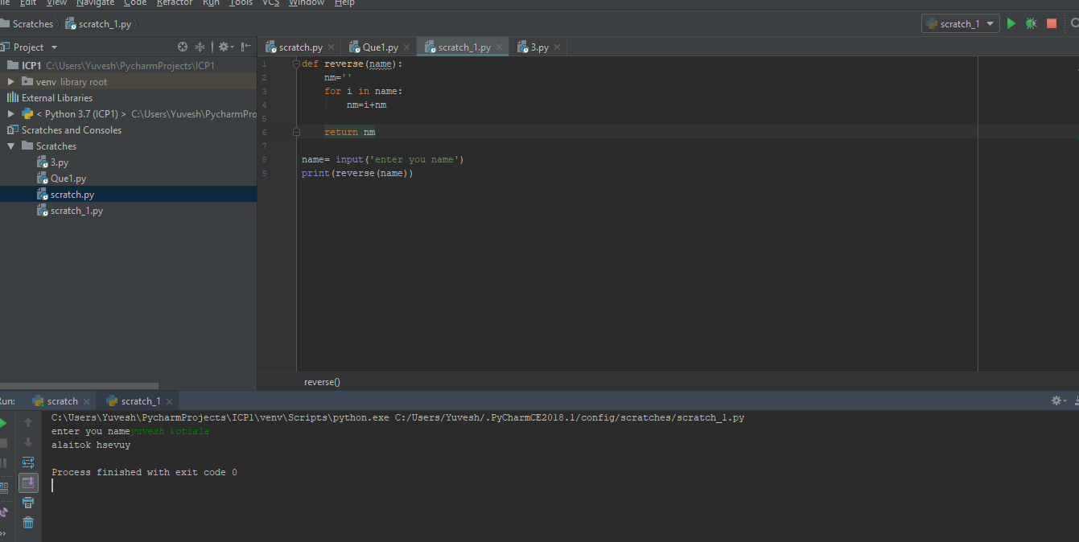

1. (ii) To take two numbers from user and find their quotient and remainder. Print it.

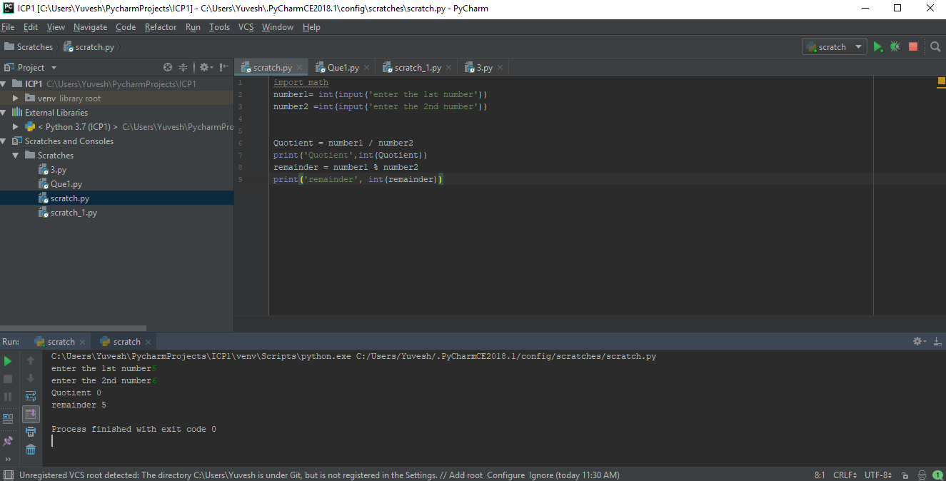

1. Write a python program to this is a number guess exercise.

