BhumiGuide Intelligence : A District-Aware Multilingual Guidance System for Land Purchase in India
Ashish Trivedi
G H Raisoni University / CSE Department, Amravati, India
Pratik Kale, Yuvraj Naktode, Saurabh Bansod, Avantika Chaudhari, Vrushali Lade, Roshni Kirnapure
G H Raisoni University / CSE Department, Amravati, India
ABSTRACT - In India the land buyer carries the burden of checking whether the seller really owns what is being sold. No bank and no builder does that work for them. The information they need is public, yet it sits scattered across state revenue portals that give the same record five different names. Maharashtra calls it a 7/12 Extract, Karnataka an RTC, Madhya Pradesh a Khasra-Khatauni, Gujarat a 7/12 Utara and Rajasthan a Jamabandi. Almost all of it is published only in English. BhumiGuide Intelligence is a web platform that gathers the buying procedure, the documents a state actually demands, the stamp duty payable and the offices to visit for the buyer’s own district, and presents all of it in nine Indian languages. The frontend uses React with Vite. The backend is Node.js and Express over MongoDB, and each state is one data file in which every rule carries the government URL it came from. A charges engine reproduces each state’s own rate structure, including cases that a single rebate field cannot express, such as Gujarat’s full registration-fee exemption for a woman buying in her sole name. An AI assistant replies in the user’s language through a hosted language model, and falls back to a deterministic rule engine when no API key is configured. The dataset covers five states, 197 districts and 1,501 talukas, and the interface is verified at 100 % translation coverage across 2,521 strings. Where a fact could not be confirmed, this paper reports the gap instead of filling it.
Keywords: Land Records, e-Governance, Multilingual Interface, Stamp Duty Computation, AI Assistant, React, Node.js, MongoDB.

1. INTRODUCTION
Buying land in India is not like buying a flat from a developer. In a developer sale, a bank, an approving authority and the builder have each looked at the title before the buyer signs anything. In a land sale nobody does. The buyer alone has to work out who owns the plot, whether any charge is running against it, whether the law even allows a person like them to buy it, and what the deal will cost at the Sub-Registrar’s counter.
That information is public. Every state runs a land-records portal and a registration portal, and the governing Acts are all published. Three things still stand between a first-time buyer and any of it. The first is vocabulary. The record of rights is a 7/12 Extract in Maharashtra, an RTC or Pahani in Karnataka, a Khasra-Khatauni in Madhya Pradesh, a 7/12 Utara in Gujarat and a Jamabandi in Rajasthan, so a buyer who searches for the wrong word finds nothing at all. The second is applicability. A paper that is compulsory in one state may not exist in the next: Maharashtra issues no document called an Encumbrance Certificate, and neither Gujarat nor Rajasthan has the municipal Khata certificate that Karnataka insists on. The third is language. Nearly all of this material is written in English, while a great many buyers read their own district’s language far more comfortably. The result is a market in which buyers lean on middlemen because they do not know which question to ask.
1.1. OBJECTIVES
[1] To present the land buying procedure for the user’s own district instead of a generic national checklist.
[2] To use each state’s own name for each document, and to say plainly when a document is not used in that state at all.
[3] To estimate stamp duty and registration fee from the state’s own rate structure, including its concessions and caps.
[4] To make every visible string available in nine Indian languages.
[5] To answer free-form questions with the selected district’s rules already in context.
[6] To record, and not quietly fill, any fact that could not be confirmed from an official source.
1.2. EXISTING SYSTEM
A buyer today works from several disconnected places at once. Each state runs its own land-records and registration portals. These publish records but not procedure, and they assume the visitor already knows the name of the document they want. General property websites fill the gap with a single national checklist that ignores the differences between states. Stamp duty calculators on private portals usually carry one headline rate per state, so they miss caps, surcharges and concessions, and they are rarely dated. Almost all of this exists only in English. What is missing, then, is not the data but its assembly. Nothing takes a buyer’s own district and returns the procedure, the documents under that state’s rules, the charge estimate and the offices as one answer, in the language that buyer actually reads.
1.3. PROPOSED SYSTEM
BhumiGuide Intelligence takes one input from the user, namely state, district and taluka. It returns the buying procedure, the documents that state really requires, an estimate of the charges payable and the offices involved, in the language the user picks. Four principles govern the design.
[1] Rules travel with their source. Every per-state rule carries the URL of the government page or statutory provision it came from, and the interface shows that link as “Official source”. A claim the system cannot attribute is never presented as fact.
[2] Gaps are recorded, not filled. Where a taluka list, a rate or a rule could not be confirmed from a second source, the omission is written into the data file and into the project documentation instead of being completed with a plausible value.
[3] Optional services degrade but do not break. The application runs with no database installed and with no AI key configured.
[4] Nothing is uploaded silently. The document readiness check reads files inside the browser, and a file reaches the server only if the user chooses to save it to an account.
1.4. SYSTEM FEATURES
[1] A district-aware procedure that names the office answerable for each step, with the time and the fee it usually takes.
[2] A sixteen-document list that each state may rename, re-rank or mark as not applicable, with its source shown.
[3] A charges engine covering basic duty, agricultural adjustment, surcharge, local cess, registration fee, caps and concessions.
[4] A nine-language interface whose coverage is computed at run time and not merely asserted.
[5] An AI assistant with a deterministic rule-engine fallback that stays fully localised.
[6] A browser-side document readiness check for size, format and age.
[7] Accounts secured with JWT and BCrypt, optional Google sign-in, and saved progress.
2. LITERATURE SURVEY
Research on Indian land administration has concentrated on the registry itself. Thakur et al. [1] examine blockchain for land titling and report that computerising records improves transparency and cuts the manual paperwork behind many land disputes. Narayanaprakash et al. [2] survey decentralised land-registry designs and find that a tamper-resistant ledger with smart contracts can automate parts of the transfer process. Yadav and Kushwaha [3] study query optimisation inside a blockchain-based registry and show that a digital land-administration layer makes land services easier to reach.
A second line of work looks at access to legal information rather than the registry. Bhardwaj and Margam [4] study online legal information systems from the user’s side in the Indian setting, and report that retrieval, not availability, is what limits ordinary users. Nikita et al. [5] apply natural-language understanding over an Indian legal property graph and show that a language interface can answer property questions a keyword search cannot. The five studies are set out in Table 1.

Table 1. Summary of the Reviewed Literature
Ref. | Study | Focus of the study | Finding relevant to this work
[1] | Thakur et al., 2020 | Blockchain for the implementation of land titling | Digitisation makes land records easier to reach and improves transparency. Computerisation reduces manual paperwork and the disputes that follow from it.
[2] | Narayanaprakash et al., 2023 | Survey of decentralised registry designs | A tamper-resistant ledger keeps a traceable history of ownership changes, and smart contracts can automate parts of a land transfer.
[3] | Yadav and Kushwaha, 2021 | Query optimisation inside a registry | A digital land-administration layer improves the accessibility and efficiency of land services and reduces paperwork.
[4] | Bhardwaj and Margam, 2016 | Citizen access to online legal information | For ordinary users the difficulty lies in retrieving relevant legal information, not in whether it is available.
[5] | Nikita et al., 2025 | Language understanding over a legal property graph | A natural-language interface answers property questions that keyword search does not reach.

Two observations follow. The registry literature improves the record-keeping system, which the state operates, and the buyer does not. Even a flawless registry will not tell a buyer which counter to visit or which paper to carry. The information-retrieval literature does speak to the citizen, but it works on legal corpora in English and is not organised around any particular district. Neither line produces procedural, district-level, multilingual guidance for the person making the purchase. That is the gap this work occupies, and it complements the existing systems instead of competing with them: BhumiGuide consumes what the official records already publish.
3. SYSTEM ARCHITECTURE
Fig. 1 shows the four layers of the system. On the client side sits a single-page application written in React, bundled by Vite and given its appearance by Tailwind CSS. At start-up it fetches the reference data once and holds it in module-level caches, so every page reads locations, documents, per-state rules, charge rules and the procedure synchronously from one in-memory copy. The API is a stateless Express service exposing twenty endpoints: nineteen across five route modules — reference data, authentication, progress, uploads and the assistant — together with a health check registered on the application itself.
Persistence is optional by design. Given a MongoDB connection string, the server stores users, saved progress and verification records through Mongoose. Left blank, it starts an in-memory MongoDB instance and seeds it on boot, so the project can be cloned and run without installing a database at all. The reference data is not user data: it lives in the repository as JavaScript modules and is seeded into whichever database happens to be active.
The fourth layer holds the sources the dataset was compiled from. These are the state revenue and registration portals [6]–[12], the governing Acts and rules [13]–[17], and the official district and tehsil lists. This layer is offline. The authors consult it, and what it yields is checked into the repository as code with the source URL attached, so a reader of the code can retrace any single rule.

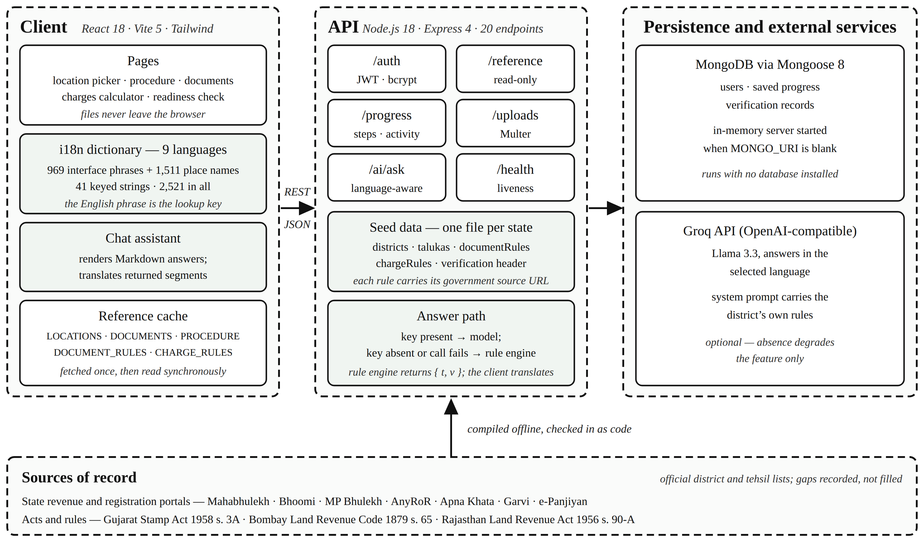
Fig 1. System Architecture

4. METHODOLOGY
The system was developed iteratively. The five states were added one at a time, and each state was treated as a research task before it became a coding task. For every state the team located the record of rights, the issuing office, the encumbrance instrument, the local-body record, the restrictions on who may buy farmland, and the duty and fee rates. Each item was recorded together with its URL, and only then written into the data model.
4.1. PER-STATE DATA MODEL
Each supported state is one file exporting four things: its district-to-taluka map, its charge rules, its document rules, and a short header recording what was verified and what was not. A document rule may rename a document, change its status, replace the note explaining it, and say where it is obtained. Status takes one of three values: mandatory, optional or not-applicable. The third is displayed rather than hidden, so a buyer comparing two states can see that Karnataka requires a municipal Khata certificate [17] while Gujarat issues a Property Card in the City Survey system instead. The same mechanism carries a document a state adds on its own, such as Gujarat’s non-agricultural permission under s. 65 of the Bombay Land Revenue Code [14], or Rajasthan’s conversion order under s. 90-A of its Land Revenue Act [15]. A rule overrides only the fields it declares, and everything else falls through to the shared sixteen-document list. Adding a state is therefore one new file and one line in an index, with no change to any page.
4.2. CHARGES COMPUTATION
For a declared value V the total payable is computed as
T = V(s + a − f)/100 + R + Vb/100 + h + m (1)
Here s is the state’s basic stamp rate, a the adjustment for agricultural land, f the stamp rebate for a woman buyer, b the local-body cess, and h and m the fixed handling and miscellaneous charges. The registration component R is zero where the buyer qualifies for an exemption, and otherwise
R = min(Vr/100, c) (2)
In (2), r is the registration rate and c the cap where the state sets one. Two branches are needed because a single rebate field cannot describe every state. Maharashtra caps the registration fee at ₹30,000, so the fee stops rising once value passes ₹30 lakh. Gujarat gives a woman buying in her sole name no reduction in stamp duty at all, but exempts her from the registration fee entirely; modelling that as a duty rebate would report both the rate and the total wrongly. Two of the headline rates are themselves composites. Gujarat’s 4.9 % is a 3.5 % basic rate plus a surcharge of 40 % of that duty under s. 3A of its Stamp Act [13]. Rajasthan’s 7.8 % is a 6 % basic duty plus a surcharge of 30 % of the duty, and a woman’s concession applies to the basic rate, which gives 6.5 %. A composite rate looks wrong next to the state’s own published basic rate, so each such state carries an explanatory note that the interface shows beside the result.
4.3. MULTILINGUAL INTERFACE
Nine languages are offered: English, together with Hindi, Marathi, Gujarati, Punjabi, Bengali, Tamil, Telugu and Kannada. Three decisions shape the implementation. First, the English phrase is itself the dictionary key, so a lookup for a phrase with no translation returns the English phrase. An incomplete dictionary can therefore never produce a blank screen or a raw key identifier. Second, sentences that contain values are stored whole. “Question 3 of 7” is stored as the single entry “Question {0} of {1}” so that each language can place the numbers where its own grammar needs them. Splitting the sentence into the fragments “Question” and “of” would force every language into English word order. Third, coverage is measured and not asserted. The percentage in the language menu is computed at run time as the share of the measured phrase inventory that a language actually has, so adding an English string without translating it lowers the figure by itself.
District and taluka names live in a separate dictionary of 1,511 entries. These are transliterations and not translations: the name is written in another script and never turned into a different word. Only a descriptive suffix is translated, so “Mumbai Suburban” becomes “मुंबई उपनगर” and not “Mumbai Upanagar”. For each state’s own language the official spelling is used.
4.4. AI ASSISTANT AND THE SEGMENTS PROTOCOL
The assistant has two paths. When an API key is configured, the question, the recent turns of the conversation and a system prompt are sent to a hosted Llama 3.3 model through an OpenAI-compatible endpoint [18]. That prompt carries the selected district’s own rules: its record name, issuing office, duty and fee rates and any concession. The model is instructed to answer in the selected language, and it replies in Markdown, which the client renders into real headings, tables and lists.
When no key is configured, or the call fails, a deterministic rule engine answers instead. This engine runs on the server, which holds no translation dictionary. Shipping one there would mean duplicating 2,521 strings, all 1,511 place names included. So instead of a finished sentence the engine returns an English template together with its values, for example
{ t: "In {0} the land record is called the {1},
issued by the {2}.",
v: ["Maharashtra", "7/12 Extract (Satbara)",
"Tehsildar Office"] }
The client renders that through the same dictionary as the rest of the interface, so the template, the state name, the record name and the office name are each translated. The fallback answer is therefore fully localised even though the server knows no language but English.
4.5. DOCUMENT READINESS AND ACCOUNTS
The readiness check identifies each file a user selects by matching its name against the document list. It flags files that are too small to be legible at a counter, too large for government upload limits, in a format offices reject, or older than the three-to-six month window within which a record extract is normally accepted, and it lists what is still missing for that state. The whole analysis runs in the browser. Accounts use BCrypt password hashing with JSON Web Tokens, optional Google sign-in and optional e-mail verification. Completed steps, collected documents and the activity feed are stored per user.
5. RESULTS AND DISCUSSIONS
5.1. DATASET AND INTERFACE COVERAGE
Table 2 reports the dataset and the interface as measured from the source at the time of writing. Table 3 shows what the per-state model actually captures: five states that name the same record five different ways, charge five different rates, and disagree both on who may buy farmland and on whether a municipal Khata exists at all. The farmland row is not a simple yes or no. Rajasthan places no bar on a non-agriculturist buyer in general, but a sale by a Scheduled Caste or Scheduled Tribe khatedar to a buyer outside that category is void unless the Collector validates it [16].

Table 2. Dataset and Interface Coverage
Item | Measured value
States covered | 5. Maharashtra, Karnataka, Madhya Pradesh, Gujarat, Rajasthan
Districts | 197
Talukas / tehsils | 1,501
Documents explained | 16, with per-state overrides
Procedure steps | 7 main and 6 conditional
API endpoints | 20. 19 across five route modules, plus a health check
Interface languages | 9
Translated strings | 2,521. 969 interface phrases, 1,511 place names, 41 keyed strings
Local office contacts | 1,414, for the first three states only

Table 3. How the Five States Differ
Attribute | Maharashtra | Karnataka | Madhya Pradesh | Gujarat | Rajasthan
Land record | 7/12 Extract (Satbara) | RTC / Pahani | Khasra / Khatauni | 7/12 Utara (VF-7 & VF-12) | Jamabandi (Nakal)
Issued by | Tehsildar Office | Nadakacheri / Taluk Office | Tehsil Office | e-Dhara Kendra, Mamlatdar Office | Tehsil Office
Encumbrance | Index II certified copy | Form 15 EC | Not issued | EC (Boja Certificate) | e-Search; no EC issued
Municipal Khata | Not used | Mandatory | Not used | Property Card instead | Patta instead
Non-agriculturist may buy farmland | No | No | Yes | No | Yes, except SC/ST land
Stamp duty | 6 % | 5 % | 7.5 % | 4.9 % | 7.8 %
Woman buyer | 1 % off duty | No concession | 2 % off duty | Registration fee waived | 1.3 % off duty
Mandatory documents | 9 | 10 | 9 | 9 | 8

5.2. OUTPUTS
Fig. 2 gives the procedure for a selected taluka, listing the responsible office, indicative time and indicative fee against each step. In Fig. 3 the document list follows Maharashtra’s rules: the record extract is titled “7/12 Extract (Satbara)”, and the note records that the state does not use the term Encumbrance Certificate. The same page appears again in Fig. 4, this time with Gujarat selected and the language set to Marathi. Document names, explanatory notes and categories are all in Marathi, while statutory and portal names such as Village Form 7, Garvi, AnyRoR and City Survey stay in Latin script, which is how a reader of these languages would search for them. Fig. 5 shows the case that motivated the second branch of (2): a woman buying in Gujarat pays the full 4.9 % stamp duty but a registration fee of zero, with the composition of the rate explained beside the result. Finally, Fig. 6 captures the assistant answering through the live model, in context for the selected taluka.
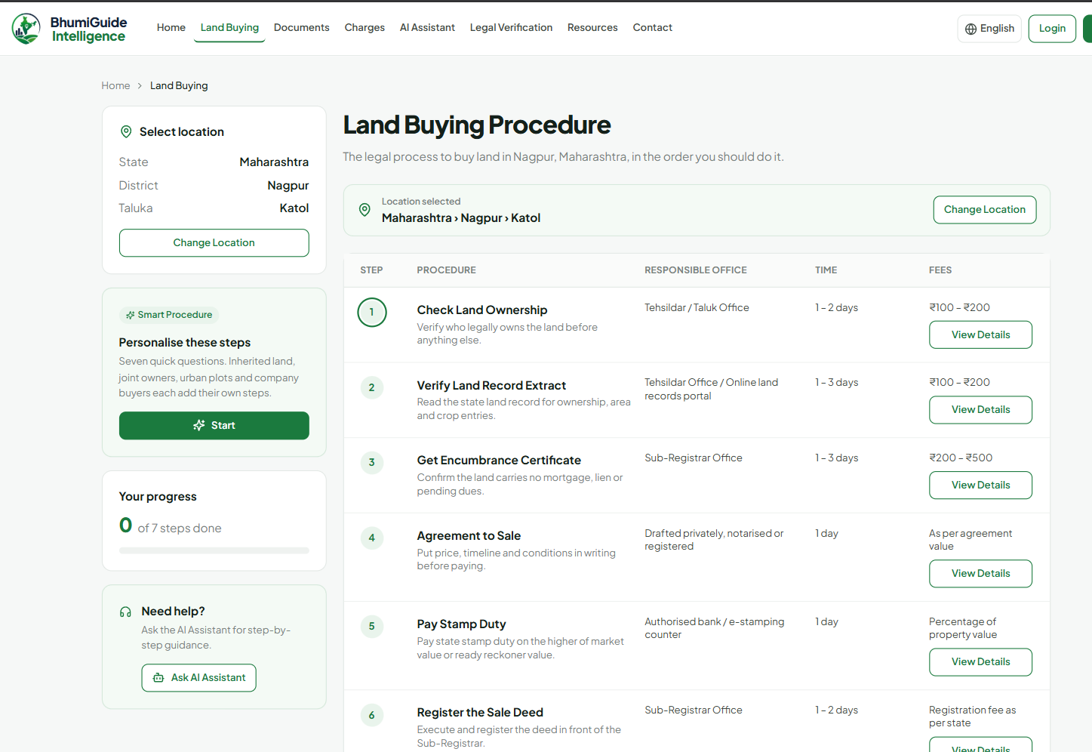
Fig 2. Output of Land Buying Procedure Page
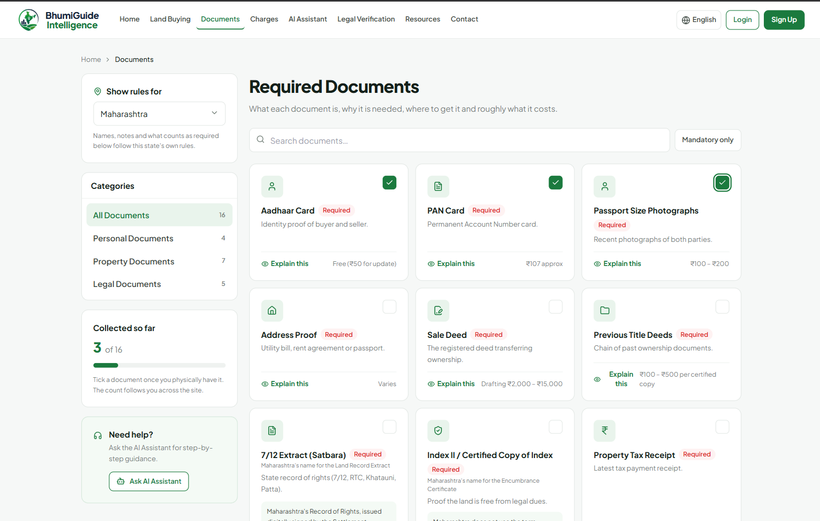
Fig 3. Output of Required Documents Page (Maharashtra)
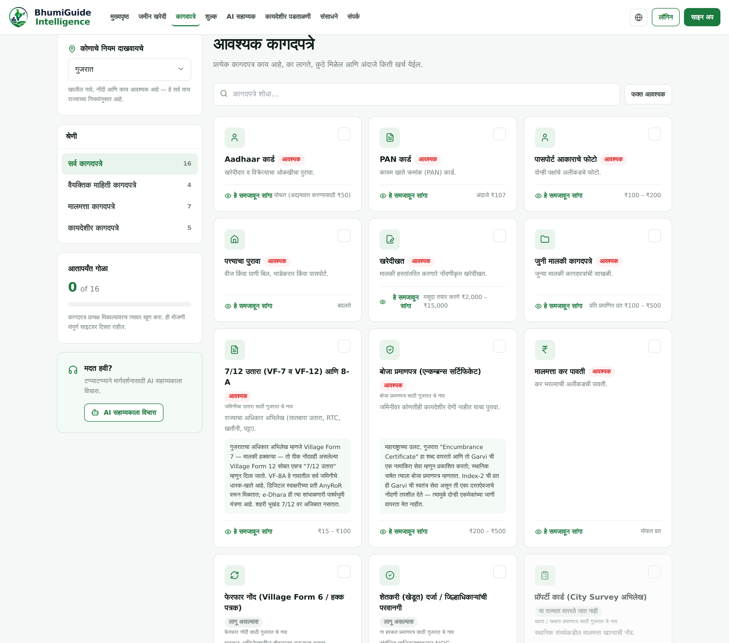
Fig 4. Output of the Same Page in Marathi (Gujarat)
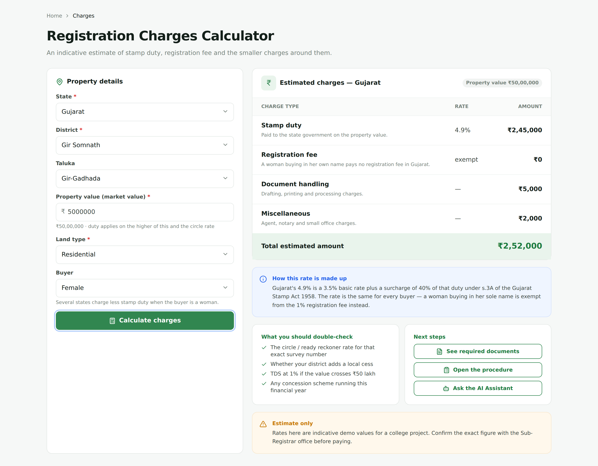
Fig 5. Output of Registration Charges Calculator
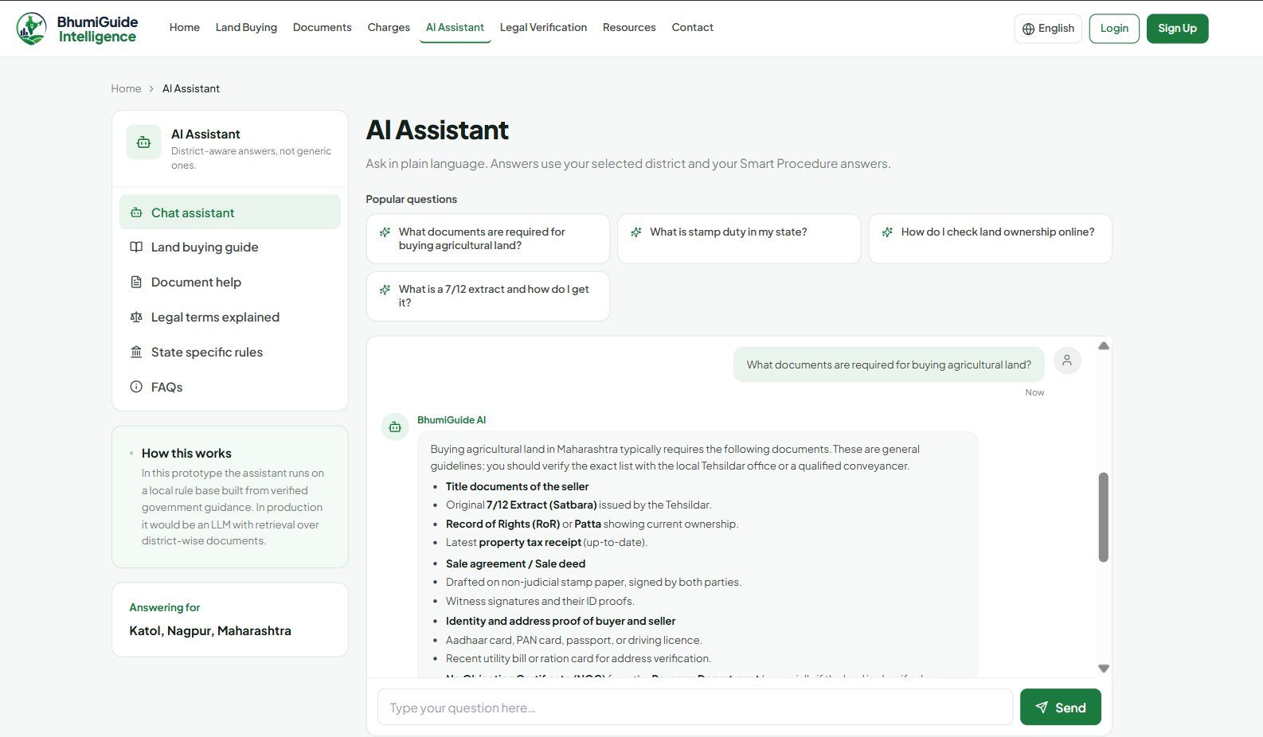
Fig 6. Output of the AI Assistant
5.3. VERIFICATION
The system has been checked by construction and by automated inspection. No user study has been run yet.
Table 4 lists the checks and what each returned. Together they establish that the system does what its own data says, that the interface is complete in all nine languages, and that the arithmetic follows the modelled rules.
They do not establish that the underlying rules are correct in law, which only the concerned department can confirm, nor that the interface actually helps a real buyer, which needs a user study.

Table 4. Verification Performed
Check | Method | Outcome
Production build | Vite build of the full frontend | Passes
Unbound translation calls | AST scan of every page for translation calls whose helper is not in scope | 0 found
Translation coverage | Computed at run time from the measured phrase inventory | 100 % for all 9 languages over 2,521 strings
Untranslated text on screen | Scripted browser sweep of every page, every dropdown and the first ten controls per page, in five language and state combinations | 0 Latin fragments outside brand and portal names
Runtime errors | Console and page errors captured during the same sweep | 0
Charge arithmetic | Calculator driven through the browser for Gujarat and Rajasthan, male and female buyers, agricultural and residential land | Matches (1) and (2) in every case
Dataset integrity | Per-state district and taluka counts recomputed from the state files | 197 districts, 1,501 talukas

6. LIMITATIONS
The rule followed throughout this project is that a fact which could not be verified is left open and documented, not filled in with something plausible. Table 5 is the resulting list.

Table 5. Known Limitations
Area | Status
Land records, charge rates, document rules | Real. Taken from state government portals and statutes, with the source URL recorded per entry.
Office addresses and telephone numbers | Generated. No public API publishes an office directory for India. Distance to an office is not displayed at all, because the only figure available was not measured.
Legal verification progress indicator | A simulated timer. Real title verification needs a lawyer and record access this application does not have.
Gujarat taluka list | 262 talukas across 34 districts, current to the notification of 2 October 2025 that created Vav-Tharad. Panchmahal carries only Godhra, because no second source for its remaining talukas could be reached. Press reports give Gujarat 269 talukas; the per-district sum here is 262, and the missing names were not invented.
Rajasthan tehsil list | 425 tehsils across 41 districts, current to the reorganisation of 1 January 2025. One row of the official list was unreadable in its legacy font, so one tehsil name comes from a secondary source.
Rajasthan stamp surcharge | 30 % of duty is used. Two secondary reports in early 2026 claimed a higher rate above ₹10 lakh of duty. No gazette notification confirming it was found, and the interface says so on screen.
Place names in non-local scripts | Transliterations. The official spelling is used for each state’s own language. For small tehsils with no published spelling the name was written out sound by sound, so a few may not match what the local record office prints.
Local office contacts | Compiled by hand for the first three states and not published by any department. Gujarat and Rajasthan have none, so the list falls back to district level and says so.
Stamp duty figures | Indicative, and not legal advice. The interface states this beside every result.
Evaluation | No user study has been conducted. Every result in Section 5 is structural and automated.

7. CONCLUSION
BhumiGuide Intelligence shows that what defeats a first-time land buyer in India is rarely a shortage of published data. It is the absence of any assembly of it. The substance of this work is therefore a data model and not a new algorithm. Expressing each state’s naming, applicability and cost rules as sourced data makes the differences between states visible to the buyer in advance, instead of leaving them to be discovered at a counter, and it turns a sixth state into a data task rather than a code change. Around that model sit a charges engine that respects structures a single rebate field cannot express, a translation architecture whose coverage is measured rather than claimed, and an assistant that stays useful, and localised, with no external service configured.
Four directions follow. The first is a user study with first-time buyers in the covered districts, which is the evaluation this paper does not yet have. The second is extension to further states, each admitted only with its sources attached on the same terms as the present five. The third is optical character recognition in place of filename matching in the readiness check, so that the contents of a record extract, such as holder name, area and tenure class, can be read and compared against what the user entered. The fourth is retrieval-augmented answering, in which the assistant cites the specific provision behind each statement instead of relying on the model’s own knowledge. That would make an answer as traceable as the rest of the dataset already is.
8. ACKNOWLEDGMENT
This project was guided throughout by Asst. Prof. Ashish Trivedi, to whom the authors record their thanks, as they do to the CSE department at G H Raisoni University, Amravati, where the work was carried out. The authors further acknowledge the revenue and registration departments of Maharashtra, Karnataka, Madhya Pradesh, Gujarat and Rajasthan, whose public portals and published rules are the source of the dataset used in this work.
9. REFERENCES
[1] V. Thakur, M. N. Doja, Y. K. Dwivedi, T. Ahmad, and G. Khadanga, “Land records on blockchain for implementation of land titling”, International Journal of Information Management, Published in: Volume 52 | Article 101940 | Year June – 2020, ISSN: 0268-4012.
[2] K. Narayanaprakash, P. D. Sheba Kezia Malarchelvi, S. Ranjithkumar, and R. Sridevi, “A Survey Analysis on Decentralized Land Registry System Using Blockchain and Smart Contracts”, IEEE conference publication, Year 2023. Available: https://ieeexplore.ieee.org/document/10346967
[3] A. S. Yadav and D. S. Kushwaha, “Query Optimization in a Blockchain-Based Land Registry Management System”, Ingénierie des Systèmes d’Information, Published in: Volume 26 | Issue 1 | Year 2021 | page number 13 – 21, ISSN: 1633-1311.
[4] R. K. Bhardwaj and M. Margam, “Online legal information system for Indian environment: a user’s perspectives”, Library Review, Published in: Volume 65 | Issue 8/9 | Year November – 2016 | page number 593 – 609, ISSN: 0024-2535.
[5] Nikita, K. Shreeram, A. Patil, A. Agrawal, D. P. Rana, and R. G. Mehta, “Natural Language Understanding (NLU)-Powered Information Retrieval from Indian Legal Property Graph”, Procedia Computer Science, Published in: Volume 258 | Year May/June – 2025, ISSN: 1877-0509.
[6] Revenue Department, Government of Maharashtra, “Mahabhulekh: 7/12 and land records”. [Online]. Available: https://bhulekh.mahabhumi.gov.in/
[7] Revenue Department, Government of Karnataka, “Bhoomi: RTC and land records”. [Online]. Available: https://landrecords.karnataka.gov.in/
[8] Government of Madhya Pradesh, “MP Bhulekh: Khasra and Khatauni”. [Online]. Available: https://mpbhulekh.gov.in/
[9] Revenue Department, Government of Gujarat, “AnyRoR: Any Records of Rights Anywhere”. [Online]. Available: https://anyror.gujarat.gov.in/
[10] Board of Revenue, Government of Rajasthan, “Apna Khata: e-Dharti”. [Online]. Available: https://apnakhata.rajasthan.gov.in/
[11] Superintendent of Stamps, Government of Gujarat, “Garvi: registration, e-stamping and Index-2 services”. [Online]. Available: https://garvi.gujarat.gov.in/
[12] Registration and Stamps Department, Government of Rajasthan, “e-Panjiyan”. [Online]. Available: https://epanjiyan.rajasthan.gov.in/
[13] The Gujarat Stamp Act, 1958, Section 3A.
[14] The Bombay Land Revenue Code, 1879, Sections 65 and 65B, as applicable in Gujarat.
[15] The Rajasthan Land Revenue Act, 1956, Section 90-A.
[16] The Rajasthan Tenancy Act, 1955, Sections 42 and 42B.
[17] The Karnataka Municipal Corporations Act, 1976, Section 114.
[18] Groq Inc., “Groq API reference: OpenAI-compatible chat completions”. [Online]. Available: https://console.groq.com/docs/

