BhumiGuide Intelligence: A District-Aware, Multilingual Guidance System for Land Purchase in India
Pratik Kale^{#1}, Yuvraj Naktode^{#2}, Saurabh Bansod^{#3}, Avantika Chaudhari^{#4}, Vrushali Lade^{#5}, Roshni Kirnapure^{#6}, Ashish Trivedi^{#7}
#Department of Computer Science and Engineering, G H Raisoni University, Amravati, Maharashtra, India
2hexateam160@gmail.com (corresponding author)

Abstract— In India the buyer, not a bank or a builder, carries the burden of checking whether a seller really owns the land being sold. The information needed is public, but it is scattered across state revenue portals that call the same record by different names — a 7/12 Extract in Maharashtra, an RTC in Karnataka, a Khasra–Khatauni in Madhya Pradesh, a 7/12 Utara in Gujarat and a Jamabandi in Rajasthan — and it is published almost entirely in English. This paper presents BhumiGuide Intelligence, a web platform that assembles the buying procedure, the documents actually required, the applicable stamp duty and the offices to visit for a buyer’s own district, and presents all of it in nine Indian languages. The system is a React front end over a Node.js and Express API, with one data file per state in which every rule carries the government URL it was taken from. A charges engine models each state’s own rate structure, including cases a single rebate field cannot express, such as Gujarat’s full registration-fee exemption for a woman buying in her sole name. An optional large-language-model assistant answers in the user’s language and falls back to a deterministic rule engine when no API key is present. The dataset covers five states, 197 districts and 1,501 talukas, and the interface is verified at 100 % translation coverage over 2,521 strings. Data that could not be verified is reported as such rather than filled in.
Keywords— land records, e-governance, multilingual user interface, internationalisation, stamp duty computation, large language model, India
I. Introduction
Buying land in India is not like buying a flat from a developer. In a developer sale a bank, an approving authority and the builder have each examined the title before the buyer signs. In a land sale none of that happens. The buyer alone has to establish who owns the plot, whether any charge is running against it, whether the land may lawfully be sold to a person like them, and what the transaction will cost at the Sub-Registrar’s counter.
The information needed to do that is, in principle, public. Every state runs a land-records portal and a registration portal, and the governing Acts are published. In practice three things stand between a first-time buyer and that information. First, vocabulary: the record of rights is a 7/12 Extract in Maharashtra, an RTC or Pahani in Karnataka, a Khasra–Khatauni in Madhya Pradesh, a 7/12 Utara in Gujarat and a Jamabandi in Rajasthan, and a buyer who searches for the wrong word finds nothing. Second, applicability: a document that is compulsory in one state does not exist in another — Maharashtra issues no document called an Encumbrance Certificate, and neither Gujarat nor Rajasthan has the municipal Khata certificate that Karnataka requires. Third, language: almost all of this material is written in English, while a great many buyers are more comfortable in the language of their own district.
The practical result is dependence on intermediaries, and a market in which a buyer often does not know which question to ask. This work addresses that gap directly. Its contributions are:
1) a per-state data model in which the naming, applicability and cost rules of each state are expressed as data, each rule carrying the government source it was taken from, so that adding a state is a data task rather than a code change;
2) a charges engine that reproduces each state’s own rate structure, including surcharge-on-duty schemes and a registration-fee exemption that a single “female rebate” field cannot represent;
3) a translation architecture in which the English phrase is itself the dictionary key and the coverage figure is computed from the source at run time, so an untranslated string lowers the reported figure instead of silently rendering blank;
4) an assistant that answers in the user’s selected language through a large language model when one is configured, and through a deterministic rule engine when it is not, without shipping the translation dictionary to the server; and
5) an explicit record of what in the system is real and what is not, carried both in the repository and in Section VII of this paper.
II. Literature Survey
Research on Indian land administration has concentrated on the registry itself. Thakur et al. [1] analyse the use of blockchain for land titling and report that computerisation of records improves transparency and reduces the manual paperwork behind many land disputes. Narayanaprakash et al. [2] survey decentralised land-registry designs and find that a tamper-resistant ledger with smart contracts can automate parts of the transfer process. Yadav and Kushwaha [3] take the same architecture further and study query optimisation inside a blockchain-based registry, showing that a digital land-administration layer improves the accessibility of land services.
A second line of work concerns access to legal information rather than the registry. Bhardwaj and Margam [4] study online legal information systems from the user’s side in the Indian environment and report that retrieval, not availability, is the limiting factor for ordinary users. Nikita et al. [5] apply natural-language understanding over an Indian legal property graph and show that a language interface can answer property questions that a keyword search cannot.
Table I summarises the reviewed work. Two observations follow from it. The registry literature optimises the record-keeping system, which is operated by the state, not by the buyer; even a perfect registry does not tell a buyer which counter to visit or which paper to carry. The information-retrieval literature does address the citizen, but works on legal corpora in English and is not organised around a buyer’s own district. Neither line produces procedural, district-level, multilingual guidance for the person actually making the purchase. That is the gap this work occupies, and it is deliberately complementary: the system described here consumes what the official records publish rather than proposing to replace them.
TABLE I
Summary of the Reviewed Literature
Ref. | Work and authors | Publication | Finding relevant to this work
[1] | Land records on blockchain for implementation of land titling — Thakur, Doja, Dwivedi, Ahmad, Khadanga | Int. J. Information Management, vol. 52, 2020 | Digitisation improves transparency of records and reduces disputes arising from manual paperwork.
[2] | A survey analysis on decentralized land registry system using blockchain and smart contracts — Narayanaprakash et al. | IEEE conference publication, 2023 | A tamper-resistant ledger keeps a traceable ownership history; smart contracts can automate transfer steps.
[3] | Query optimization in a blockchain-based land registry management system — Yadav, Kushwaha | Ingénierie des Systèmes d’Information, vol. 26, no. 1, 2021 | Digital land administration improves accessibility and efficiency of land services.
[4] | Online legal information system for Indian environment: a user’s perspectives — Bhardwaj, Margam | Library Review, vol. 65, no. 8/9, 2016 | For ordinary users the difficulty is retrieving relevant legal information, not its availability.
[5] | NLU-powered information retrieval from Indian legal property graph — Nikita et al. | Procedia Computer Science, vol. 258, 2025 | A natural-language interface answers property questions that keyword search does not reach.

III. Proposed System
BhumiGuide Intelligence is a web application that takes one input from the user — state, district and taluka — and returns the buying procedure, the documents that state actually requires, an estimate of the charges payable and the offices involved, in the language the user selects. Its objectives follow from Section I:
a) present the procedure for the user’s own district rather than a generic national checklist;
b) use each state’s own name for each document and say plainly when a document is not used there at all;
c) estimate stamp duty and registration fee from that state’s own rate structure;
d) make every visible string available in nine Indian languages; and
e) answer free-form questions with the selected district’s rules in context.
A. Design Principles
Rules travel with their source. Every per-state rule in the dataset carries the URL of the government page or statutory provision it was taken from, and the interface exposes that link to the user as “Official source”. A claim the system cannot attribute is not displayed as fact.
Gaps are recorded, not filled. Where a taluka list, a rate or a rule could not be confirmed from a second source, the omission is written into the data file as a comment and into the project’s documentation, rather than completed with a plausible value. Section VII lists the gaps that remain.
Optional services degrade, they do not break. The application runs with no database installed and with no AI key configured. Absent a database it starts an in-memory instance; absent an AI key it answers from a rule engine. Neither absence disables any other feature.
Nothing is uploaded silently. The document-readiness check reads the files a user selects inside the browser. A file reaches the server only if the user chooses to save it to an account.
IV. System Architecture
Fig. 1 shows the four layers of the system. The client is a single-page React application. On start-up it fetches the reference data once and then holds it in module-level caches, so every page reads locations, documents, per-state rules, charge rules and the procedure synchronously from one in-memory copy. The API is a stateless Express service exposing twenty-one endpoints across six route modules: reference data, authentication, progress, uploads, the assistant and contact.
Persistence is deliberately optional. When a MongoDB connection string is supplied, users, saved progress and verification records are stored through Mongoose; when it is blank the server starts an in-memory MongoDB instance and seeds it on boot, so the project can be cloned and run without installing a database. The reference data itself is not user data: it lives in the repository as JavaScript modules and is seeded into whichever database is active.
The fourth layer is the set of sources the dataset was compiled from — the state revenue and registration portals [6]–[12], the governing Acts and rules [13]–[17], and official district and tehsil lists. This layer is offline: it is consulted by the authors, and what it yields is checked into the repository as code with the source URL attached, so a reader of the code can retrace any single rule.
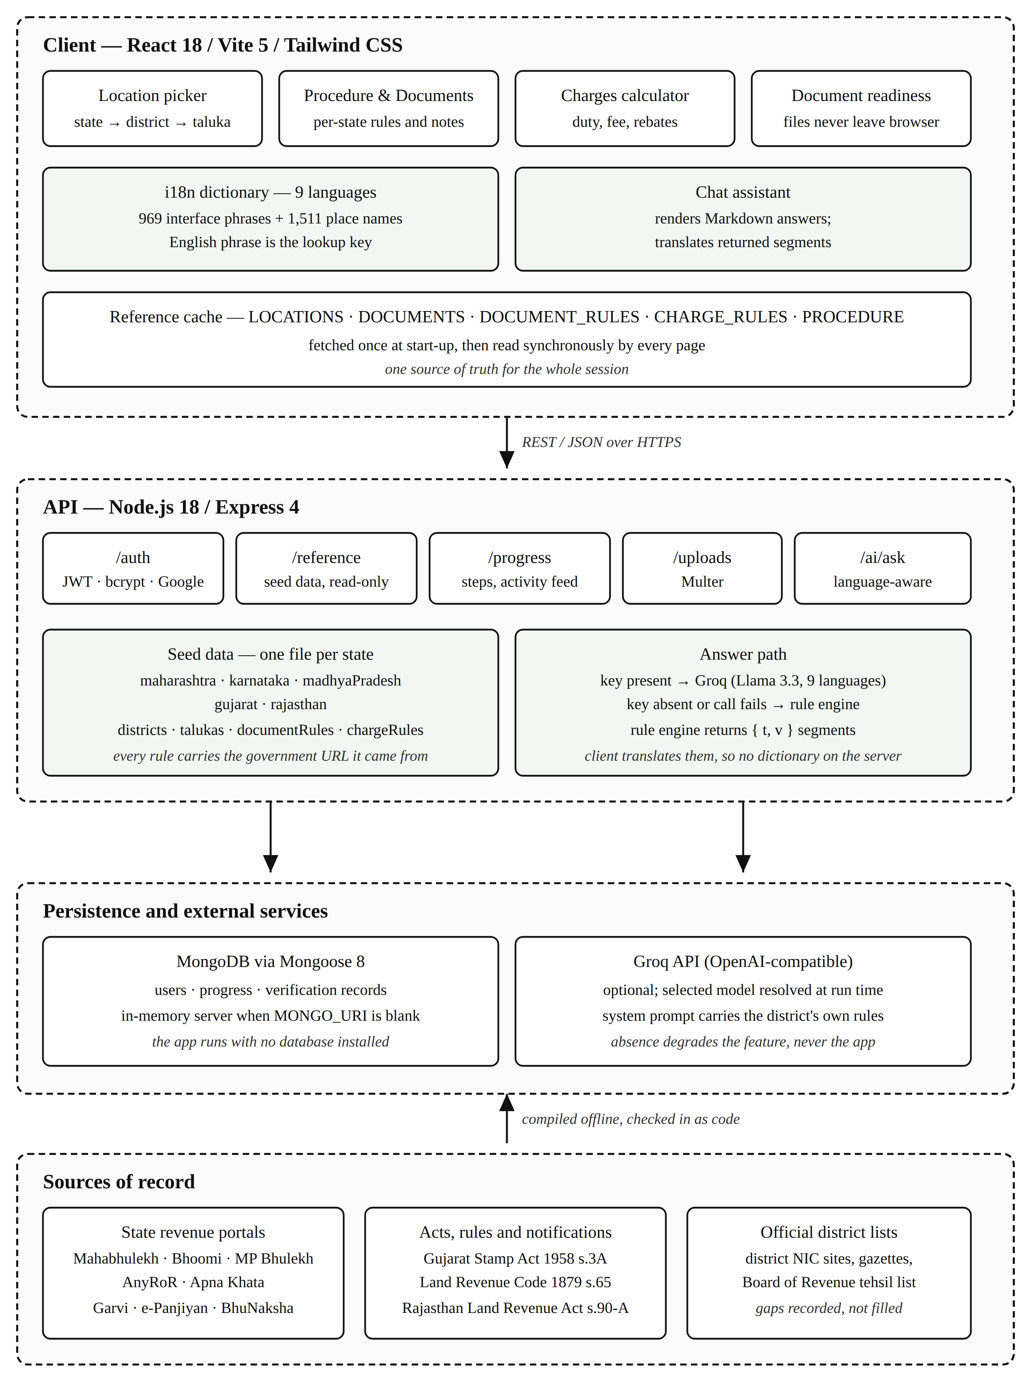
Fig. 1 System architecture. The client holds one cached copy of the reference data; the API is stateless; the database and the language model are both optional.
V. Implementation
A. The Per-State Data Model
Each supported state is one file exporting four things: its district-to-taluka map, its charge rules, its document rules, and a short header recording what was verified and what was not. A document rule may rename a document, change its status, replace the note explaining it, and state where it is obtained. Status takes one of three values — mandatory, optional or not-applicable — and the third is displayed rather than hidden, so a buyer comparing two states can see that Karnataka requires a municipal Khata certificate [17] and that Gujarat issues a Property Card in the City Survey system instead. Where a state adds a document of its own — Gujarat’s non-agricultural permission under s. 65 of the Bombay Land Revenue Code [14], Rajasthan’s conversion order under s. 90-A of its Land Revenue Act [15] — the same mechanism carries it. A rule overrides only the fields it declares; everything else falls through to the shared sixteen-document list. Adding a state is therefore one new file and one line in an index, with no change to any page.
B. Charges Computation
For a declared value V the total payable is computed as
T = V·(s + a − f)/100 + R + V·b/100 + h + m (1)
where s is the state’s basic stamp rate, a an adjustment for agricultural land, f the stamp rebate for a woman buyer, b the local-body cess, and h and m the fixed handling and miscellaneous charges. The registration component R is
R = 0 if the buyer qualifies for an exemption,
R = min(V·r/100, c) otherwise (2)
with r the registration rate and c the cap where the state sets one.
The two branches of (2) exist because two states cannot be expressed by a single rebate field. Maharashtra caps the registration fee at ₹30,000, so the fee stops rising above a value of ₹30 lakh. Gujarat gives a woman buying in her sole name no reduction in stamp duty at all, but exempts her from the registration fee entirely; modelling that as a duty rebate would report both the rate and the total incorrectly. Gujarat’s headline 4.9 % is itself a composite: a 3.5 % basic rate plus a surcharge of 40 % of that duty under s. 3A of its Stamp Act [13]. Rajasthan needs a third treatment: its headline 7.8 % is a 6 % basic duty plus a surcharge of 30 % of that duty, and a woman’s concession applies to the basic rate, giving 6.5 %. Because a headline rate that is a composite of several levies looks wrong against the state’s own published basic rate, each such state carries an explanatory note that the interface shows beside the result.
C. Multilingual Interface
The interface is available in English, Hindi, Marathi, Tamil, Telugu, Kannada, Gujarati, Bengali and Punjabi. Three decisions shape the implementation.
The English phrase is the key. A lookup for a phrase with no translation returns the English phrase itself. A string added to the interface therefore renders in English rather than as a blank or a raw key identifier, and the application cannot be broken by an incomplete dictionary.
Sentences containing values are stored whole. A sentence such as “Question 3 of 7” is stored as a single entry “Question {0} of {1}”, so each language places the numbers where its own grammar requires; Tamil renders the same sentence as “7-இல் 3-ஆவது கேள்வி”. Splitting it into the fragments “Question” and “of” would force every language into English word order.
Coverage is measured, not asserted. The percentage shown in the language menu is computed at run time as the share of the measured phrase inventory that the language actually has. Adding an English string without translating it lowers the figure by itself.
District and taluka names are handled separately, in their own dictionary of 1,511 names. These are transliterations, not translations: the name is written in another script, never turned into a different word. Only a descriptive suffix is translated, so “Mumbai Suburban” becomes “मुंबई उपनगर” rather than “Mumbai Upanagar”. For each state’s own language the official spelling is used.
D. The Assistant and the Segments Protocol
The assistant has two paths. When an API key is configured the question, the recent turns of the conversation and a system prompt carrying the selected district’s own rules — its record name, issuing office, duty and fee rates and any concession — are sent to a hosted Llama 3.3 model through Groq’s OpenAI-compatible endpoint [18], with an instruction to answer in the selected language. The model replies in Markdown, which the client renders into real headings, tables and lists.
When no key is configured, or the call fails, a deterministic rule engine answers instead. This engine runs on the server, which has no translation dictionary; shipping one there would mean duplicating 2,521 strings including all 1,511 place names. Instead of a finished sentence the engine returns an English template and its values, for example
{ t: "In {0} the land record is called the {1}, issued by the {2}.",
v: ["Maharashtra", "7/12 Extract (Satbara)", "Tehsildar Office"] }
The client renders that through the same dictionary as the rest of the interface, so the template, the state name, the record name and the office name are each translated. The fallback answer is therefore fully localised without the server knowing any language but English.
E. Document Readiness and Accounts
The readiness check identifies each file a user selects by matching its name against the document list, flags files that are too small to be legible at a counter, too large for government upload limits, in a format offices reject, or older than the three-to-six month window a record extract is usually accepted within, and lists what is still missing for that state. The analysis runs in the browser. Accounts use bcrypt password hashing with JSON Web Tokens, optional Google sign-in and optional e-mail verification; completed steps, collected documents and the activity feed are stored per user.
VI. Results and Discussion
Table II reports the dataset and interface as measured from the source at the time of writing. Table III shows what the per-state model actually captures: five states that name the same record five different ways, charge five different rates, and disagree on who may buy farmland and on whether a municipal Khata exists at all. The farmland row is not a simple yes or no: Rajasthan places no bar on a non-agriculturist buyer in general, but a sale by a Scheduled Caste or Scheduled Tribe khatedar to a buyer outside that category is void unless the Collector validates it [16].
TABLE II
Dataset and Interface Coverage
Item | Measured value
States | 5 — Maharashtra, Karnataka, Madhya Pradesh, Gujarat, Rajasthan
Districts | 197
Talukas / tehsils | 1,501
Documents explained | 16, with per-state overrides
Procedure steps | 7 main + 6 conditional
API endpoints | 21 across 6 route modules
Interface languages | 9
Translated strings | 2,521 (969 interface phrases, 1,511 place names, 41 keyed strings)
Local office contacts | 1,414 — first three states only

TABLE III
How the Five States Differ
 | Maharashtra | Karnataka | Madhya Pradesh | Gujarat | Rajasthan
Land record | 7/12 Extract (Satbara) | RTC / Pahani | Khasra / Khatauni | 7/12 Utara (VF-7 & VF-12) | Jamabandi (Nakal)
Issued by | Tehsildar Office | Nadakacheri / Taluk Office | Tehsil Office | e-Dhara Kendra, Mamlatdar Office | Tehsil Office
Encumbrance | Index II certified copy | Form 15 EC | — | EC (Boja Certificate) | e-Search; no EC issued
Municipal Khata | not used | mandatory | not used | Property Card instead | Patta instead
Non-agriculturist may buy farmland | no | no | yes | no | yes, except SC/ST land
Stamp duty | 6 % | 5 % | 7.5 % | 4.9 % | 7.8 %
Woman buyer | 1 % off duty | — | 2 % off duty | registration fee waived | 1.3 % off duty
Mandatory documents | 9 | 10 | 9 | 9 | 8

Fig. 2 to Fig. 6 show the running system. Fig. 2 is the procedure for a selected taluka, with the responsible office, indicative time and indicative fee against each step. Fig. 3 is the document list under Maharashtra’s rules, where the record extract is titled “7/12 Extract (Satbara)” and the note records that the state does not use the term Encumbrance Certificate. Fig. 4 is the same page with Gujarat selected and the language set to Marathi: the document names, the explanatory notes and the categories are all in Marathi while the statutory and portal names — Village Form 7, Garvi, AnyRoR, City Survey — remain in Latin script, which is how a reader of any of these languages would search for them.
Fig. 5 is the case that motivated the second branch of (2): a woman buying in Gujarat is charged the full 4.9 % stamp duty but a registration fee of zero, and the note beside the figure explains how the 4.9 % is composed. Fig. 6 shows the assistant answering with the live model, in context for the selected taluka.
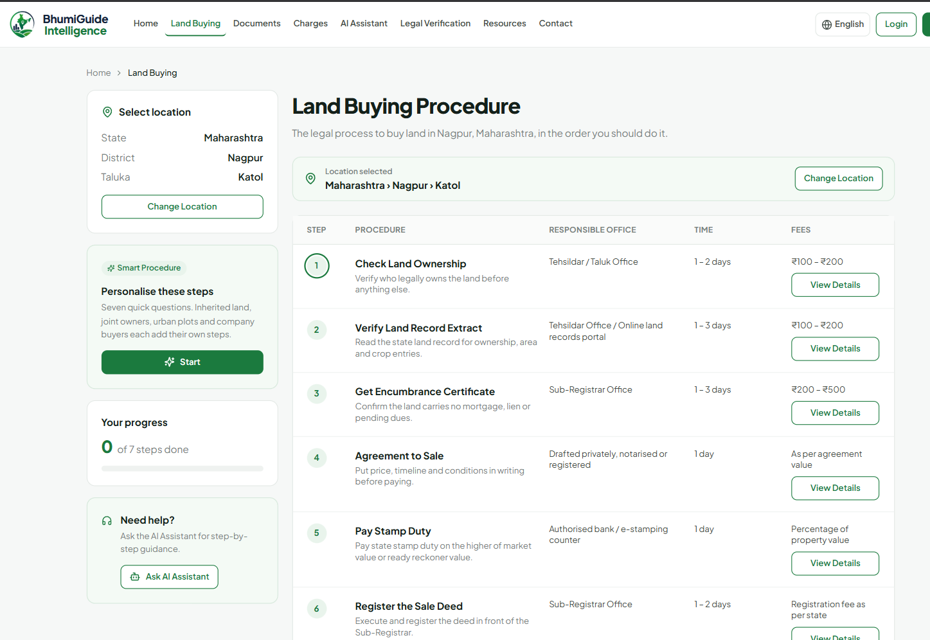
Fig. 2 The buying procedure for a selected taluka, with the responsible office, indicative time and indicative fee for each step.
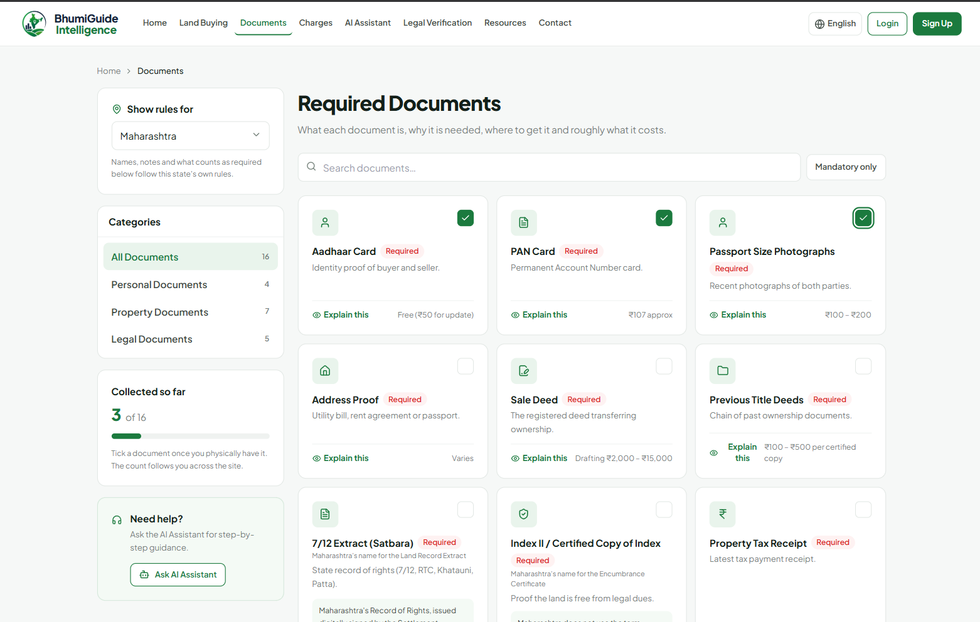
Fig. 3 Required documents under Maharashtra’s own rules; each state note carries a link to the government page it came from.
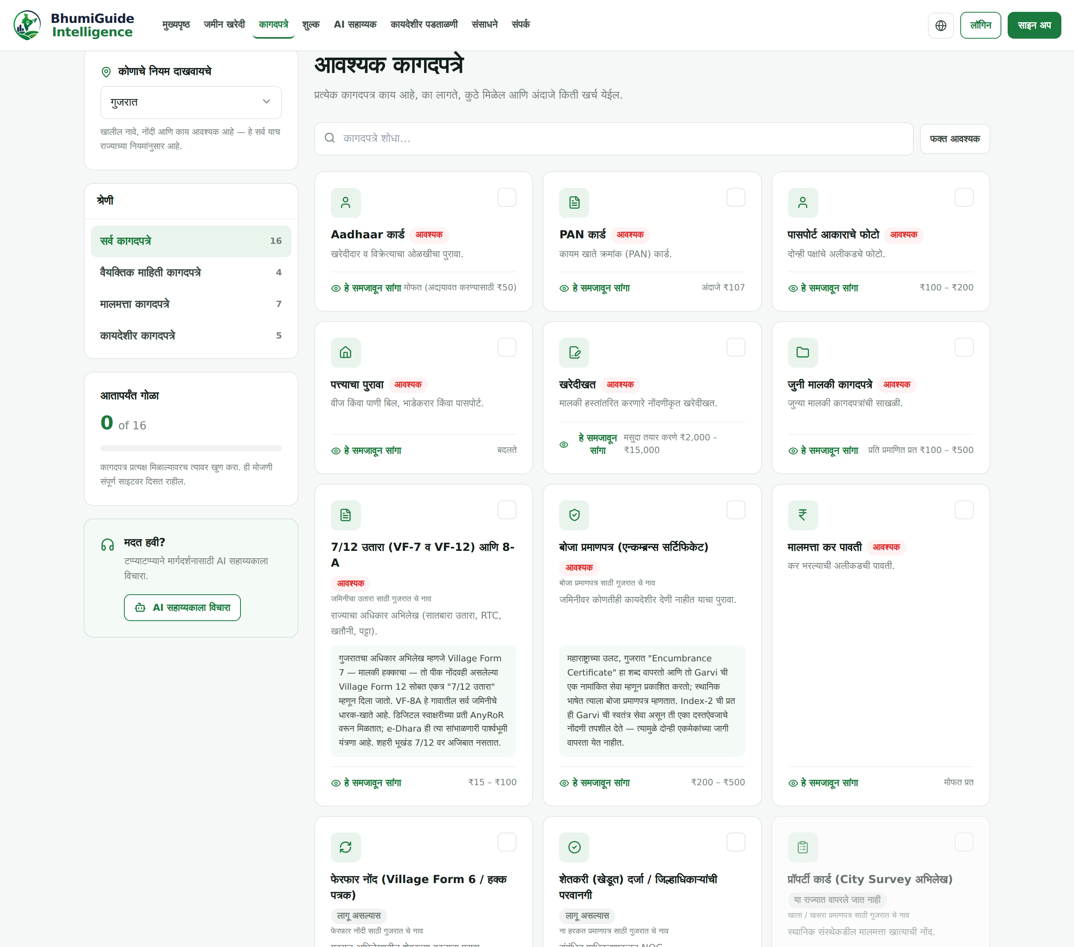
Fig. 4 The same page with Gujarat selected and Marathi chosen. Statutory and portal names stay in Latin script inside the translated sentences.
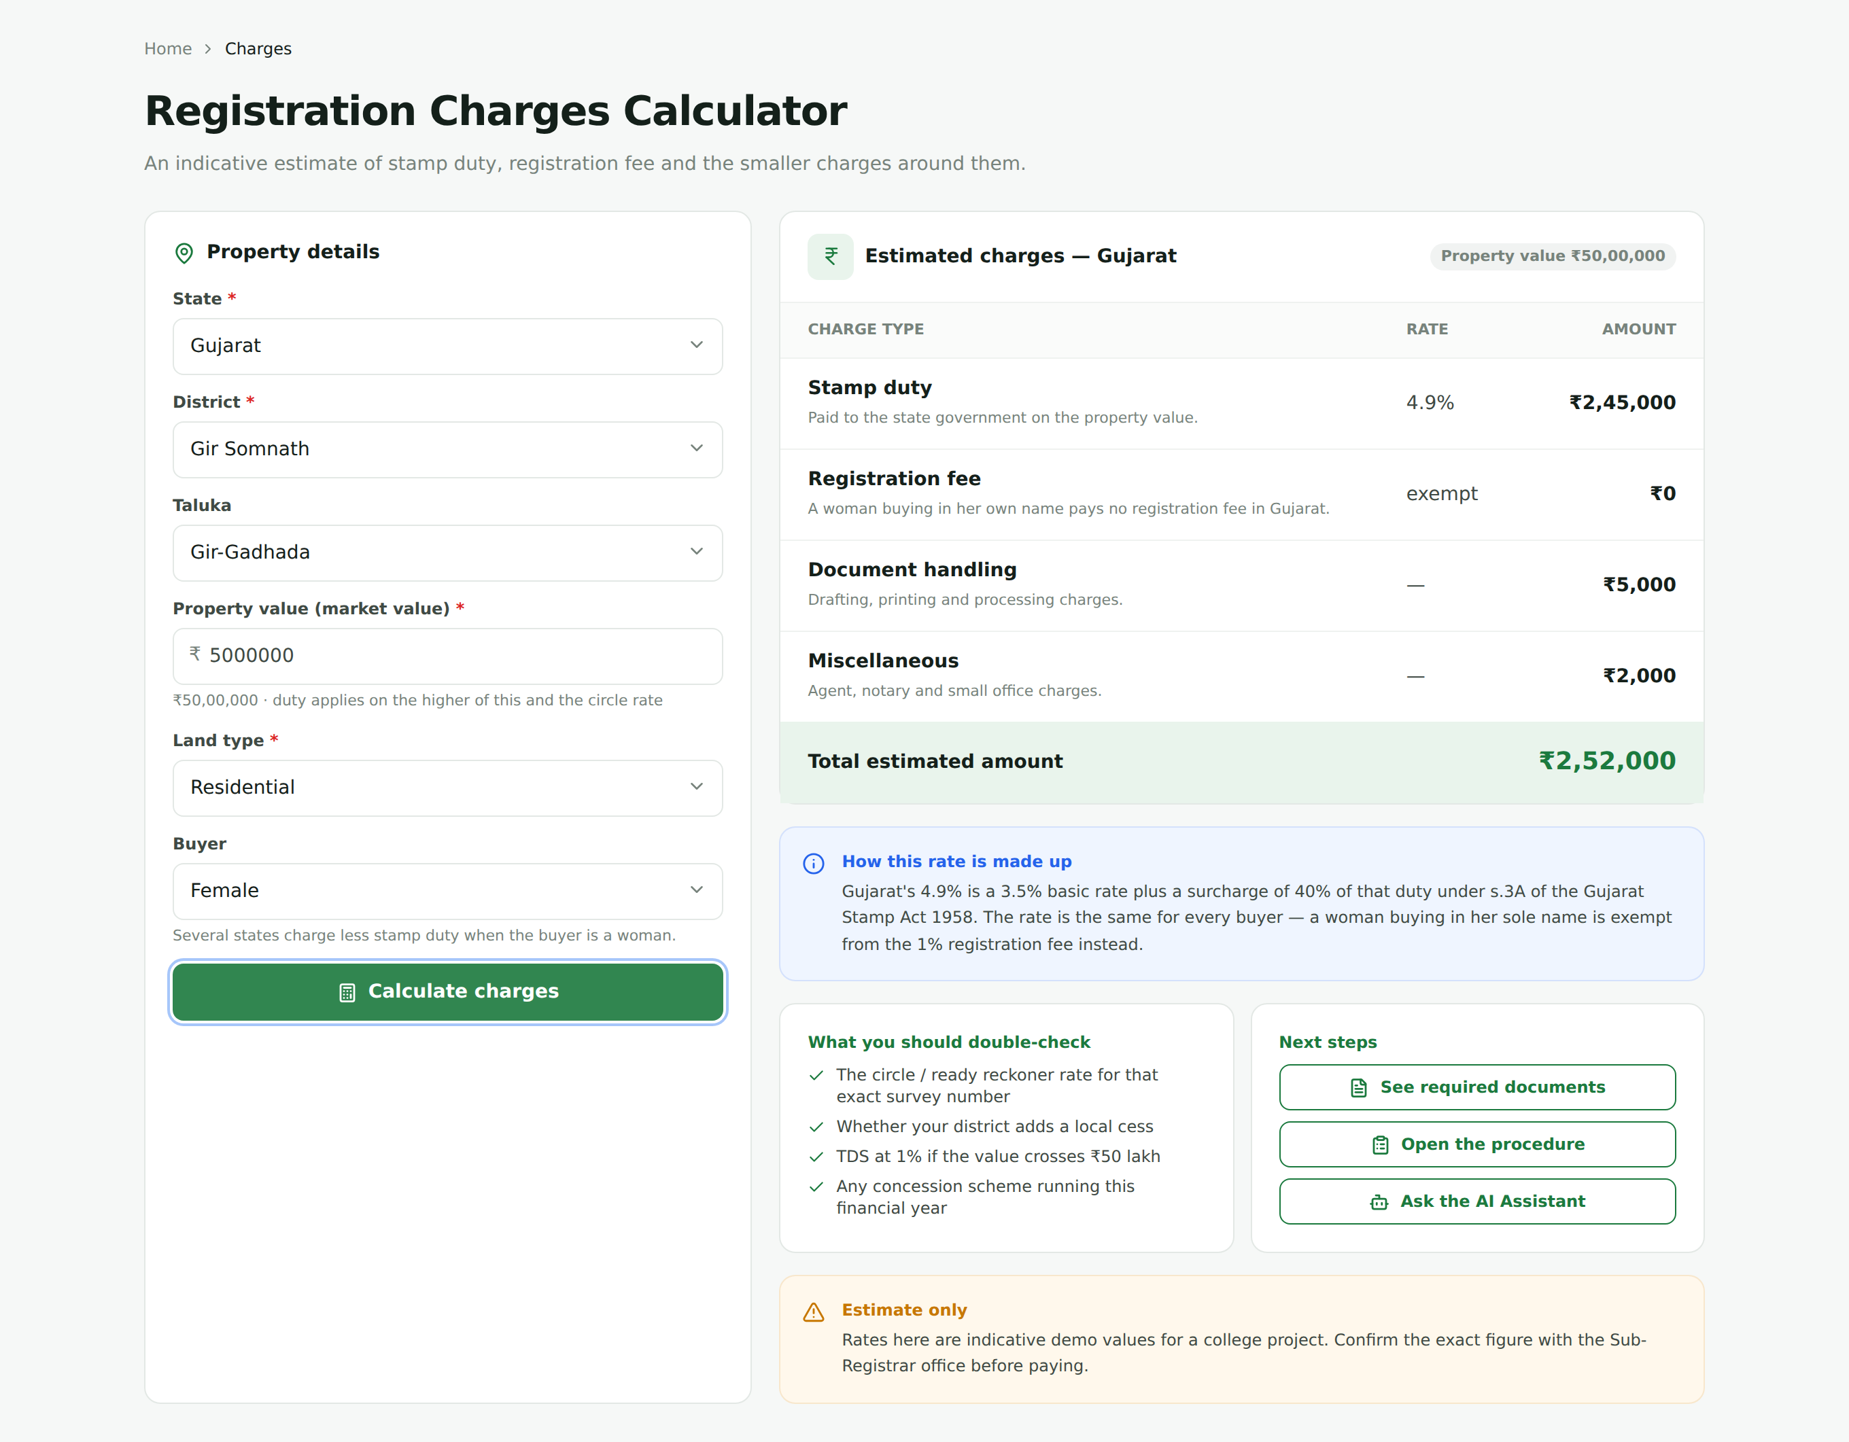
Fig. 5 Charges for a woman buying in Gujarat: full stamp duty, registration fee exempt, with the composition of the 4.9 % rate shown beside the result.
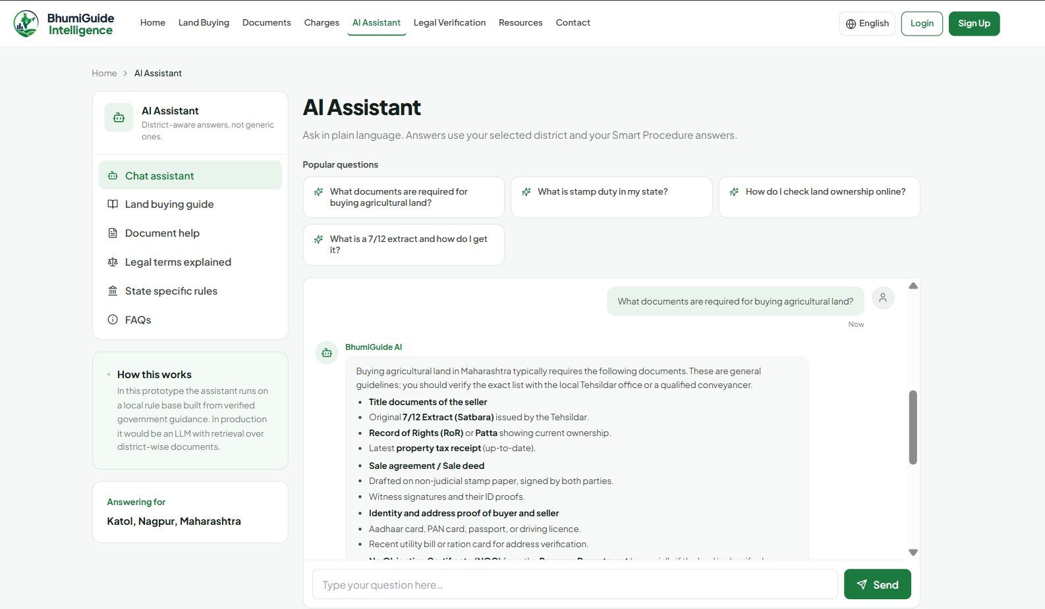
Fig. 6 The assistant answering through the live model, with the selected taluka in context.
A. Verification
The system has been verified by construction and by automated inspection rather than by a user study, which has not yet been run. Table IV lists the checks and their outcome.
TABLE IV
Verification Performed
Check | Method | Outcome
Production build | Vite build of the full front end | passes
Unbound translation calls | AST scan of every page for translation calls whose helper is not in scope | 0 found
Translation coverage | computed at run time from the measured inventory | 100 % for all 9 languages over 2,521 strings
Untranslated text on screen | scripted browser sweep of every page, every dropdown and the first ten controls per page, in five language–state combinations | 0 Latin fragments outside brand and portal names
Runtime errors | console and page errors captured during the same sweep | 0
Charge arithmetic | calculator driven through the browser for Gujarat and Rajasthan, male and female, agricultural and residential | matches (1) and (2) in every case
Dataset integrity | per-state district and taluka counts recomputed from the state files | 197 districts, 1,501 talukas

These results should be read for what they are. They establish that the system does what its own data says, that the interface is complete in all nine languages and that the arithmetic follows the modelled rules. They do not establish that the underlying rules are correct in law, which only the concerned department can confirm, nor that the interface helps a real buyer, which needs the user study described in Section VIII.
VII. Limitations
The rule followed throughout the project is that a fact which could not be verified is left open and documented rather than filled with something plausible. Table V is the resulting list.
TABLE V
Known Limitations
Area | Status
Land records, charge rates, document rules | Real, taken from state government portals and statutes, with the source URL recorded per entry.
Office addresses and telephone numbers | Generated. No public API publishes an office directory for India, and distance to an office is not displayed at all because the only figure available was not measured.
Legal verification progress indicator | A simulated timer. Real title verification needs a lawyer and record access this application does not have.
Gujarat taluka list | 262 talukas across 34 districts, current to the notification of 2 October 2025 that created Vav-Tharad. Panchmahal carries only Godhra, because no second source for its remaining talukas could be reached. Press reports give Gujarat 269 talukas; the per-district sum here is 262 and the missing names were not invented.
Rajasthan tehsil list | 425 tehsils across 41 districts, current to the reorganisation of 1 January 2025. One row of the official list was unreadable in its legacy font, so one tehsil name comes from a secondary source.
Rajasthan stamp surcharge | 30 % of duty is used. Two secondary reports in early 2026 claimed a higher rate above ₹10 lakh of duty; no gazette notification confirming it was found, and the interface says so on screen.
Place names in non-local scripts | Transliterations. The official spelling is used for each state’s own language. For small tehsils with no published spelling the name was written out sound by sound, so a few may not match what the local record office prints.
Local office contacts | Compiled by hand for the first three states and not published by any department. Gujarat and Rajasthan have none; the list falls back to district level and says so.
Stamp duty figures | Indicative, and not legal advice. The interface states this beside every result.
Evaluation | No user study has been conducted. All results in Section VI are structural and automated.

VIII. Conclusion and Future Scope
This paper described BhumiGuide Intelligence, a district-aware and multilingual guidance system for land purchase in India. The work’s substance is not a new algorithm but a data model: expressing each state’s naming, applicability and cost rules as sourced data makes the differences between states visible to a buyer instead of leaving them to be discovered at a counter, and makes a sixth state a data task rather than a code change. Around that model the system adds a charges engine that respects structures a single rebate field cannot express, a translation architecture whose coverage is measured rather than claimed, and an assistant that remains useful, and localised, with no external service configured.
Four directions follow. First, a user study with first-time buyers in the covered districts, which is the evaluation this paper does not have. Second, extension to further states, each admitted only with sources attached on the same terms as the present five. Third, replacing filename matching in the readiness check with optical character recognition, so that the contents of a record extract — holder name, area, tenure class — can be read and compared against what the user has entered. Fourth, retrieval-augmented answering, in which the assistant cites the specific provision behind each statement instead of relying on the model’s own knowledge, which would make an answer as traceable as the rest of the dataset already is.
Acknowledgment
The authors thank Asst. Prof. Ashish Trivedi for his guidance through the project, and the Department of Computer Science and Engineering, G H Raisoni University, Amravati, for its support. The authors also acknowledge the revenue and registration departments of Maharashtra, Karnataka, Madhya Pradesh, Gujarat and Rajasthan, whose public portals and published rules are the source of the dataset used in this work.
References
- V. Thakur, M. N. Doja, Y. K. Dwivedi, T. Ahmad, and G. Khadanga, “Land records on blockchain for implementation of land titling,” International Journal of Information Management, vol. 52, art. no. 101940, Jun. 2020.
- K. Narayanaprakash, P. D. Sheba Kezia Malarchelvi, S. Ranjithkumar, and R. Sridevi, “A survey analysis on decentralized land registry system using blockchain and smart contracts,” IEEE conference publication, 2023. [Online]. Available: https://ieeexplore.ieee.org/document/10346967
- A. S. Yadav and D. S. Kushwaha, “Query optimization in a blockchain-based land registry management system,” Ingénierie des Systèmes d’Information, vol. 26, no. 1, pp. 13–21, 2021.
- R. K. Bhardwaj and M. Margam, “Online legal information system for Indian environment: a user’s perspectives,” Library Review, vol. 65, no. 8/9, pp. 593–609, 2016.
- Nikita, K. Shreeram, A. Patil, A. Agrawal, D. P. Rana, and R. G. Mehta, “Natural language understanding (NLU)-powered information retrieval from Indian legal property graph,” Procedia Computer Science, vol. 258, 2025.
- Revenue Department, Government of Maharashtra. Mahabhulekh — 7/12 and land records. [Online]. Available: https://bhulekh.mahabhumi.gov.in/
- Revenue Department, Government of Karnataka. Bhoomi — RTC and land records. [Online]. Available: https://landrecords.karnataka.gov.in/
- Government of Madhya Pradesh. MP Bhulekh — Khasra and Khatauni. [Online]. Available: https://mpbhulekh.gov.in/
- Revenue Department, Government of Gujarat. AnyRoR — Any Records of Rights Anywhere. [Online]. Available: https://anyror.gujarat.gov.in/
- Board of Revenue, Government of Rajasthan. Apna Khata — e-Dharti. [Online]. Available: https://apnakhata.rajasthan.gov.in/
- Superintendent of Stamps, Government of Gujarat. Garvi — registration, e-stamping and Index-2 services. [Online]. Available: https://garvi.gujarat.gov.in/
- Registration and Stamps Department, Government of Rajasthan. e-Panjiyan. [Online]. Available: https://epanjiyan.rajasthan.gov.in/
- The Gujarat Stamp Act, 1958, s. 3A.
- The Bombay Land Revenue Code, 1879, ss. 65 and 65B, as applicable in Gujarat.
- The Rajasthan Land Revenue Act, 1956, s. 90-A.
- The Rajasthan Tenancy Act, 1955, ss. 42 and 42B.
- The Karnataka Municipal Corporations Act, 1976, s. 114.
- Groq Inc. Groq API reference — OpenAI-compatible chat completions. [Online]. Available: https://console.groq.com/docs/

