 | G H RAISONI UNIVERSITY, AMRAVATI  DEPARTMENT OF COMPUTER SCIENCE & ENGINEERING  B.Tech. CSE – VII Sem. Major Project  “BHUMIGUIDE INTELLIGENCE: A DISTRICT-AWARE MULTILINGUAL  GUIDANCE SYSTEM FOR LAND PURCHASE IN INDIA”  Name of the Students: 1. Pratik Kale 2. Yuvraj Naktode 3. Saurabh Bansod 4. Avantika Chaudhari 5. Vrushali Lade 6. Roshni Kirnapure  Name of the Guide: Mr. Ashish Trivedi  Session: 2026-27

Introduction: Buying land in India can be confusing. The buyer is the one who has to check that the seller really owns the land, but every state calls the same record by a different name — a 7/12 Extract in Maharashtra, an RTC in Karnataka, a Jamabandi in Rajasthan — and most of it is published only in English. BhumiGuide Intelligence brings the steps, the documents, the charges and the offices for the user’s own district into one place, in nine Indian languages, with every rule linked to the government source it came from.

Objectives:  • Show the land-buying steps for the chosen district, with the office responsible for each step.  • Name each document the way that state names it, and say clearly when a state does not issue it.  • Calculate stamp duty and registration fee from the state’s published rates, with a full break-up.  • Give the whole website in nine Indian languages, with coverage checked automatically.  • Answer the user’s questions using that district’s own rules, with or without an AI service.  • Show the source behind every rule, so the user can verify it.  Problem Statement:  • Different names. Every state calls the land record something else.  • Different rules. A document needed in one state may not exist in another.  • Language. Most government websites and fee details are only in English. | Design:  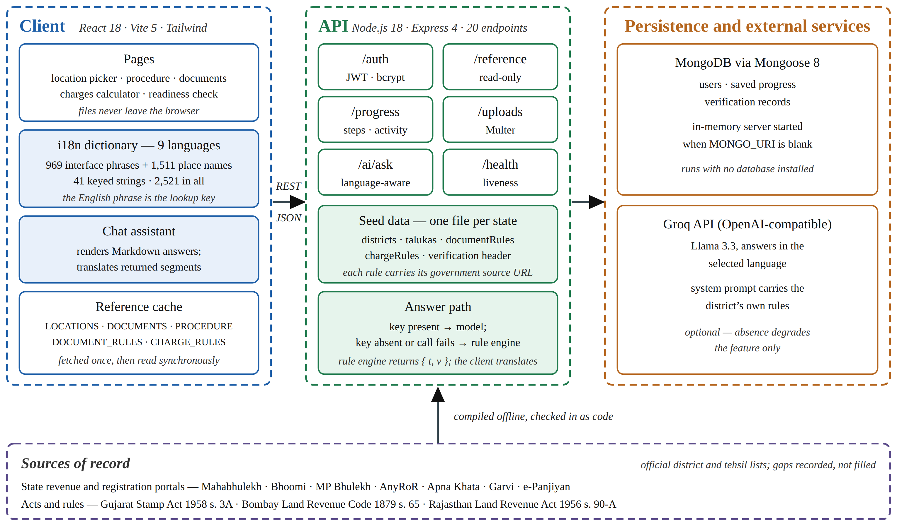  Fig. 1 – System architecture: client, API, persistence and the attributed state sources | Strength & Limitation:  Strengths  • Covers 5 states, 197 districts and 1,501 talukas.  • 2,521 interface texts translated into 9 Indian languages, verified automatically at start-up.  • District-wise guidance instead of one general checklist, every document under its own state’s name.  • Stamp duty and registration fee follow each state’s published rates, with the full break-up shown.  • Works without any paid AI key — a built-in rule engine answers on its own.  • Every rule shows the government source it came from, so the user can check it.  Limitations — and the step that closes each  • The data is checked against the project’s own sources; a revenue official has not reviewed it yet. Next step: get an official review.  • Five states are covered today. Next step: add more states, checked and sourced the same way.  • The document check reads the file name, not what is inside the file. Next step: add OCR so the system reads the document itself.
Methodology:  • State rules are stored as separate data files, each one carrying its government source.  • React 18 with Vite for the website; Node.js, Express and MongoDB on the server.  • The fee calculator follows each state’s own rates and shows a break-up of the charges.  • The AI assistant replies in the user’s language; a rule engine answers if no AI key is set.  • Translation coverage is measured from the live source every time the system starts.  • A state is added only after six key details are checked and sourced.  Tools & Technologies:  • Front end: React 18, Vite 5, Tailwind CSS.  • Back end: Node.js 18, Express 4 — 20 REST endpoints.  • Database: MongoDB with Mongoose 8.  • AI service: Groq API (Llama 3.3), with a rule-engine fallback.  • Data: one JSON file per state — districts, talukas, documents, charges.  • Version control: Git and GitHub. | Result:  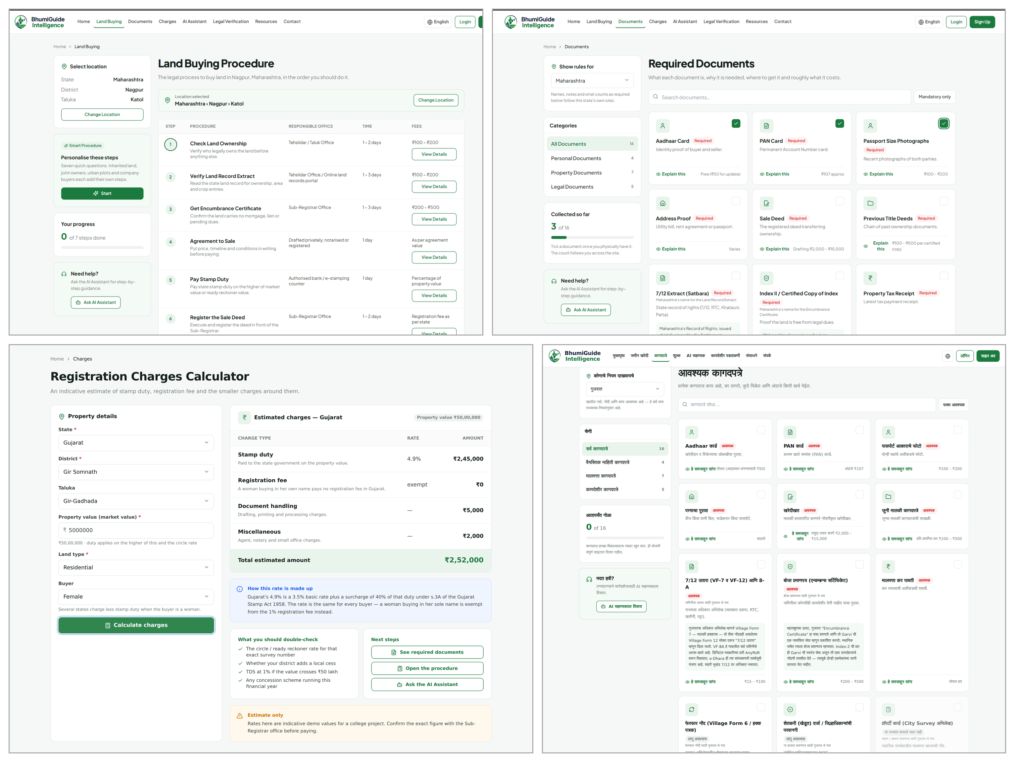  Fig. 2 – Working platform: procedure, documents, charges and the Marathi interface | Result & Conclusions:  • The platform works end to end: district procedure, document checklist, charge calculator, readiness check and a multilingual AI assistant.  • The result is a clear, source-linked collection of land-purchase information a buyer can check.  • The work has been published in IJCRT, Volume 14, Issue 10, October 2026.  • Future work: more states, review by a revenue official, OCR document checks, and AI answers that cite the exact rule.  References:  [1] A. Prakash and R. De’, “Importance of development context in ICT4D projects: a study of computerization of land records in India”, Information Technology & People, Volume 20, Issue 3, pages 262–281, 2007, ISSN 0959-3845.  [2] K. Deininger and A. Goyal, “Going digital: Credit effects of land registry computerization in India”, Journal of Development Economics, Volume 99, Issue 2, pages 236–243, November 2012, ISSN 0304-3878.  [3] P. Mishra and R. Suhag, “Land Records and Titles in India”, analytical report, PRS Legislative Research, New Delhi, 2017.  Paper Publication:  Ashish Trivedi, Pratik Kale, Yuvraj Naktode, Saurabh Bansod, Avantika Chaudhari, Vrushali Lade and Roshni Kirnapure, “BhumiGuide Intelligence: A District-Aware Multilingual Guidance System for Land Purchase in India”, International Journal of Creative Research Thoughts (IJCRT), Volume 14, Issue 10, pages f94–f100, October 2026, ISSN 2320-2882. Paper ID: IJCRT2610498. (Published)
Student Signature:

Guide Signature:

