BHUMIGUIDE INTELLIGENCE – A DISTRICT-AWARE
MULTILINGUAL GUIDANCE SYSTEM FOR LAND
PURCHASE IN INDIA

A THESIS
Submitted by
PRATIK KALE
YUVRAJ NAKTODE
SAURABH BANSOD
AVANTIKA CHAUDHARI
VRUSHALI LADE
ROSHNI KIRNAPURE

for the award of the degree
of
BACHELOR OF TECHNOLOGY
In
COMPUTER SCIENCE AND ENGINEERING
Under the guidance of
Mr. Ashish Trivedi

DEPARTMENT OF COMPUTER SCIENCE AND ENGINEERING
SCHOOL OF ENGINEERING AND TECHNOLOGY
G H Raisoni University, Amravati
2026-27

DECLARATION
We declare that
a. The work contained in the Report is original and has been done by us under the general supervision of our supervisor.
b. We have followed the guidelines provided by the University in writing the Report.
c. We have conformed to the norms and guidelines given in the Ethical Code of Conduct of the University.
d. Whenever we have used materials (data, theoretical analysis, and text) from other sources, we have given due credit to them by citing them in the text of the Report and giving their details in the references.
e. The Report has been subjected to plagiarism check using professional software and found to be within the permissible limit.
f. The work has not been submitted to any other Institute for any degree or diploma.

Name of Students | Enrolment No.
PRATIK KALE | GHRUA23011060903
YUVRAJ NAKTODE | GHRUA23011060611
SAURABH BANSOD | GHRUA23011060698
AVANTIKA CHAUDHARI | GHRUA23011060544
VRUSHALI LADE | GHRUA23011060306
ROSHNI KIRNAPURE | GHRUA23011060829

CERTIFICATE
This is to certify that the report entitled
BhumiGuide Intelligence – A District-Aware Multilingual Guidance System for Land Purchase in India
is a bonafide work and it is submitted to
G H Raisoni University, Amravati
by
PRATIK KALE
YUVRAJ NAKTODE
SAURABH BANSOD
AVANTIKA CHAUDHARI
VRUSHALI LADE
ROSHNI KIRNAPURE

For the partial fulfillment of the requirement in the degree of Bachelor of Technology in Computer Science and Engineering, during the academic year 2026-27.
Mr. Ashish Trivedi | Dr. Suresh Salankar
Project Guide | Dean, Department of CSE

PROCEEDINGS OF EXTERNAL VIVA-VOCE EXAMINATION
The viva-voce examination of PRATIK KALE, YUVRAJ NAKTODE, SAURABH BANSOD, AVANTIKA CHAUDHARI, VRUSHALI LADE, ROSHNI KIRNAPURE on this B.Tech dissertation titled BhumiGuide Intelligence – A District-Aware Multilingual Guidance System for Land Purchase in India was conducted in School of Engineering and Technology in the Department of Computer Science and Engineering at G H Raisoni University, Amravati on ………………….. 2026.
During the viva-voce examination following examiners were present.
1. Guide: Mr. Ashish Trivedi
2. External Examiner: …………………………………
Based on the presentation given by the above students, both the examiners approve the dissertation for the partial fulfillment of the requirements for the degree of Bachelor of Technology in Computer Science and Engineering.
Signature:
Project Guide: …………………………………
External Examiner: …………………………………

ACKNOWLEDGEMENT
We would like to acknowledge our deep sense of gratitude to our project guide and project in-charge Mr. Ashish Trivedi, Department of Computer Science and Engineering, G H Raisoni University, Amravati, for his constant valuable guidance and encouragement. He gladly accepted all the pains in going through our work again and again and gave us the opportunity to learn essential research skills. This Report would not have been possible without his insightful and critical suggestions, his active participation in constructing the right models, and his very supportive attitude. We will always remain grateful to him for giving direction to our work.
We express our sincere thanks to the Honorable Vice Chancellor, the Dean of the Department of Computer Science and Engineering, the Project In-charge and Guide for providing the necessary facilities for carrying out the project work.
We would also like to acknowledge the support of our parents and siblings for their continuing support and encouragement.

Name of Students | Enrolment No.
PRATIK KALE | GHRUA23011060903
YUVRAJ NAKTODE | GHRUA23011060611
SAURABH BANSOD | GHRUA23011060698
AVANTIKA CHAUDHARI | GHRUA23011060544
VRUSHALI LADE | GHRUA23011060306
ROSHNI KIRNAPURE | GHRUA23011060829

CONTENTS

Chapter / Illustration Page

List of Tables i
List of Figures ii
List of Photographs (Screenshots) iii
List of Symbols and Abbreviations iv
Abstract vi
1. INTRODUCTION 1
1.1 Background 1
1.2 Problem Statement 2
1.3 Motivation 2
1.4 Objectives 3
1.5 Scope of the Work 4
1.6 Existing System 4
1.7 Proposed System 5
1.8 System Features 5
1.9 Organisation of the Report 6
2. LITERATURE SURVEY 7
2.1 Introduction 7
2.2 Computerisation of Land Records in India 7
2.3 Blockchain and Decentralised Registry Designs 8
2.4 Citizen Access to Legal Information 9
2.5 Summary of the Reviewed Literature 10
2.6 Research Gap 11
3. METHODOLOGY 12
3.1 Development Approach 12
3.2 System Architecture 12
3.3 Per-State Data Model 14
3.3.1 Document rules and overrides 14
3.3.2 Location data and its provenance 15
3.4 Database Design 15
3.5 Charges Computation 17
3.5.1 Why a single rebate field is insufficient 17
3.5.2 Composite headline rates 18
3.6 Multilingual Interface 19
3.6.1 The English phrase as its own key 19
3.6.2 Whole sentences with positional placeholders 19
3.6.3 Coverage computed rather than asserted 19
3.6.4 Place names as transliterations 20
3.7 The Assistant and the Segments Protocol 20
3.7.1 The hosted-model path 21
3.7.2 The rule-engine path and the segments protocol 21
3.8 Document Readiness Check 22
3.9 Authentication and Saved Progress 22
3.10 API Design 23
3.11 Tools and Technologies 23
4. STRENGTH AND LIMITATION OF THE PROJECT 25
4.1 Strengths of the Approach 25
4.2 Limitations 25
4.3 Threats to Validity 26
5. RESULT AND DISCUSSION 28
5.1 Dataset and Interface Coverage 28
5.2 What the Per-State Model Captures 28
5.3 System Outputs 29
5.4 Worked Charge Computations 33
5.5 Verification Performed 34
5.6 Discussion 34
6. CONCLUSIONS AND SCOPE FOR FUTURE WORK 36
6.1 Conclusions 36
6.2 Scope for Future Work 37
6.2.1 A user study with first-time buyers 37
6.2.2 Extension to further states 37
6.2.3 Optical character recognition in the readiness check 38
6.2.4 Retrieval-augmented answering 38
6.3 Closing Remark 38
REFERENCES 39
BIBLIOGRAPHY 41
PUBLICATIONS BASED ON THIS RESEARCH WORK 42
CERTIFICATE OF RESEARCH PUBLICATION 43

LIST OF TABLES

Table Title Page No

2.1 Summary of the Reviewed Literature 10
3.1 Database Collections and Their Origin 16
3.2 Charge Rule Parameters Held for Each State 18
3.3 API Route Modules and Endpoints 23
3.4 Tools and Technologies Used 24
4.1 Strengths of the Approach and Their Basis 25
4.2 Known Limitations and Unverified Facts 26
5.1 Dataset and Interface Coverage as Measured 28
5.2 How the Five States Differ 29
5.3 Charges on a Declared Value of ₹50,00,000, Non-Agricultural Land 33
5.4 Verification Performed and Outcomes 34

LIST OF FIGURES

Figure Title Page No

3.1 System architecture of BhumiGuide Intelligence 14
3.2 Database schema and the seeding relationship 16
3.3 The two answer paths of the assistant 20

LIST OF PHOTOGRAPHS (SCREENSHOTS)

Photograph Title Page No

5.1 Land buying procedure for a selected taluka, with office, indicative time and indicative fee against each step 30
5.2 Required documents under Maharashtra’s rules, with the state’s own name for the record of rights 30
5.3 The same page with Gujarat selected and the interface language set to Marathi 31
5.4 Registration charges calculator showing the Gujarat case: full stamp duty and a registration fee of zero 32
5.5 The assistant answering in context for the selected taluka, rendered from Markdown 32

LIST OF SYMBOLS AND ABBREVIATIONS

Symbol / Abbreviation | Description
API | Application Programming Interface
AST | Abstract Syntax Tree
BCrypt | Blowfish-based password hashing function
CSE | Computer Science and Engineering
CSS | Cascading Style Sheets
DOM | Document Object Model
EC | Encumbrance Certificate
GHRU | G H Raisoni University
HTTP | Hypertext Transfer Protocol
i18n | Internationalisation
JSON | JavaScript Object Notation
JWT | JSON Web Token
LLM | Large Language Model
NA | Non-Agricultural
OCR | Optical Character Recognition
OTP | One-Time Password
RTC | Record of Rights, Tenancy and Crops
SC / ST | Scheduled Caste / Scheduled Tribe
SPA | Single-Page Application
URL | Uniform Resource Locator
VF-7 / VF-12 | Village Form 7 / Village Form 12 (Gujarat)

Symbols used in the charge equations
Symbol / Abbreviation | Description
V | Declared value of the property, in rupees
T | Total amount payable, in rupees
s | Basic stamp duty rate of the state, per cent of value
a | Adjustment to the stamp rate for agricultural land, percentage points
f | Stamp duty rebate for a woman buyer, percentage points
b | Local-body cess, per cent of value
r | Registration fee rate, per cent of value
c | Cap on the registration fee, in rupees, where the state sets one
R | Registration fee component of the total, in rupees
h | Fixed handling charge, in rupees
m | Fixed miscellaneous charge, in rupees

ABSTRACT
Responsibility for establishing that a seller actually owns a plot rests, in India, with the buyer. On a private land sale neither a lender nor a developer performs that check. The material required is published, but it lies distributed across state revenue portals that each use a different name for the same instrument — Rajasthan calls it a Jamabandi, Gujarat a 7/12 Utara, Madhya Pradesh a Khasra-Khatauni, Karnataka an RTC and Maharashtra a 7/12 Extract — and very little of it appears in any language other than English.
This report describes BhumiGuide Intelligence, a web platform that assembles, for whichever district the buyer selects, the sequence of steps to follow, the papers that particular state demands, the duty and fee that will fall due, and the offices at which each is handled, then renders the whole of it in nine Indian languages. React with Vite drives the interface; Node.js and Express over MongoDB serve it, with one data file per state in which each rule is accompanied by the government page or statutory section it was taken from. The cost engine follows each state’s published rate structure, among them arrangements that no single rebate parameter can capture: a woman purchasing in Gujarat in her own name, for instance, is relieved of the registration fee rather than given a discount on duty. Questions are answered by a hosted language model where one is configured and by a deterministic rule engine where none is. The second path remains localised because what the server emits is an English frame together with its values, both of which the browser looks up in its own dictionary.
Five states, 197 districts and 1,501 talukas make up the dataset, and translation coverage is measured at 100 per cent over 2,521 strings. Any fact that resisted confirmation against an official source has been written down as a gap rather than supplied from guesswork; twelve are listed. The checks presented establish fidelity between the system and its dataset. They say nothing about whether the dataset states the law correctly, and no study with real buyers has yet been carried out.
Keywords: Land Records, e-Governance, Multilingual Interface, Stamp Duty Computation, AI Assistant, React, Node.js, MongoDB.

INTRODUCTION
1.1 Background
Land is the single largest asset most Indian households ever buy, and it is also the one they buy with the least institutional help. Buying a flat from a developer and buying a plot of land look similar from the outside, but the work that stands behind the two transactions is not comparable at all. In a developer sale a bank has examined the title before sanctioning a loan, a planning authority has approved the layout, and the developer’s own legal team has already assembled the chain of ownership. The buyer inherits the result of all that scrutiny. In a land sale between two private parties none of it happens. The buyer alone has to establish who owns the plot, whether any charge or mortgage is running against it, whether the law even permits a person in their position to acquire that class of land, and what the transaction will cost once the Sub-Registrar applies the state’s own rate schedule.
The surprising part is that almost none of this information is secret. Every state in India runs a land-records portal and a registration portal. The Acts that govern stamp duty, tenancy and land revenue are published. District and tehsil lists are notified in official gazettes. Rate schedules are issued by the Inspector General of Registration in each state. The raw material a careful buyer needs is, in principle, open to anyone with an internet connection. What does not exist is any assembly of it that is organised around the buyer’s own question, which is never “what does the Rajasthan Tenancy Act say” but always “I am buying this plot, in this tehsil, as this kind of person — what do I do, what do I carry, and what will it cost”.
This project was undertaken because the distance between those two framings is where first-time buyers lose money. A buyer who does not know that the record of rights in Karnataka is called a Record of Rights, Tenancy and Crops, abbreviated RTC and known locally as a Pahani, cannot search for it. A buyer who assumes that the Encumbrance Certificate their cousin obtained in Bengaluru exists everywhere will go looking for one in Maharashtra, where no document of that name is issued at all. A buyer who takes a headline stamp duty figure from a property website and multiplies it by the sale value will budget the wrong amount in at least two of the five states studied here, because the headline figure in those states is itself a composite of a basic rate and a statutory surcharge. Each of these is a small error, and each of them is expensive.
1.2 Problem Statement
Three specific barriers separate a first-time land buyer in India from information that is already public.
[1] The first is vocabulary. The record of rights carries a different name in every state. It is a 7/12 Extract, locally the Satbara, in Maharashtra; an RTC or Pahani in Karnataka; a Khasra and Khatauni in Madhya Pradesh; a 7/12 Utara, issued as Village Form 7 and Village Form 12, in Gujarat; and a Jamabandi, whose certified copy is the Nakal, in Rajasthan. A buyer searching with the wrong term finds nothing, and silence from a search engine reads as absence rather than as a vocabulary mismatch.
[2] The second is applicability. A document that is compulsory in one state may not be issued in the next. Karnataka requires a municipal Khata certificate before a property transfer is recognised by the local body; neither Gujarat nor Rajasthan issues such a document, substituting a Property Card and a Patta respectively. Maharashtra does not issue an Encumbrance Certificate; the equivalent assurance is obtained from certified copies of Index II. Treating the union of all states’ requirements as a national checklist produces a list that is wrong everywhere.
[3] The third is language. Nearly all of this material — the portals, the Acts, the rate schedules and the private commentary around them — is published in English. A great many of the people buying agricultural or peri-urban land read their district’s own language far more comfortably than they read English. The practical consequence is dependence: the buyer asks an agent, a relative or a document writer, and accepts whatever answer comes back because there is no way to check it.
The result is a market in which the buyer’s main disadvantage is not that the facts are hidden but that the buyer does not know which question to ask. The problem this project addresses is therefore one of assembly, translation and attribution rather than one of data collection.
1.3 Motivation
Three observations motivated the work. The first came from reading the state portals side by side. Each one is competently built, and each one answers a different question from the one a buyer starts with: the portals publish records, and a buyer who already knows the survey number, the village and the name of the document can retrieve what they need in a few clicks. Nothing on those portals explains the sequence of steps, names the office responsible for each, or warns that the next state over does things differently.
The second observation came from the stamp duty calculators on private property websites. Almost all of them carry a single headline rate per state and multiply. Several carry no date, so a reader cannot tell whether the rate predates the last budget. Few of them model the registration-fee cap that Maharashtra applies, and none of the ones examined modelled the Gujarat case in which a woman buying in her sole name receives no reduction in stamp duty but a complete exemption from the registration fee. A calculator that gets that case wrong does not merely report a slightly wrong total; it reports the wrong structure, and the buyer plans for the wrong set of payments.
The third observation is that multilingual support in Indian civic software is usually claimed rather than measured. An interface advertises nine languages, and three screens in, half the labels are back in English because a developer added a string and nobody translated it. If the share of translated text is computed from the source at run time rather than recorded in a release note, the number cannot drift away from the truth. That design decision is small, and it is the one that keeps the rest of the multilingual claim honest.
1.4 Objectives
Six objectives were set at the outset of the project.
[1] To set out the purchase procedure as it applies in the district the user has chosen, attaching to each step the office answerable for it, in place of a checklist written for the country as a whole.
[2] To refer to every document by the title the relevant state itself uses, and to say openly where a state issues no such document, rather than dropping it from the list without comment.
[3] To derive duty and registration fee from the rate structure the state publishes, surcharges, ceilings and concessions included.
[4] To offer every string the interface displays in nine Indian languages, the proportion actually translated being calculated from the source rather than declared.
[5] To take open-ended questions and answer them with the chosen district’s rules already supplied as context, and to retain that capability where no external language-model service has been configured.
[6] To write down, rather than silently complete, each fact that no official source could be found to support.
1.5 Scope of the Work
The work covers five states — Maharashtra, Karnataka, Madhya Pradesh, Gujarat and Rajasthan — comprising 197 districts and 1,501 talukas or tehsils. These five were chosen because they differ from one another along every axis the data model is meant to express: they name the record of rights five different ways, they charge five different rates, two of them publish a composite rate rather than a simple one, three of them give a concession to women buyers and each gives it in a different form, and they disagree both on who may purchase agricultural land and on whether a municipal Khata certificate exists at all. A set of states that agreed with each other would not have tested the model.
The system is a guidance tool and not a transaction system. It does not file documents, it does not connect to any government API, it does not transfer money, and it does not replace a title search by a competent advocate. The charge figures it produces are indicative estimates computed from published rate structures and are displayed as such. The scope deliberately excludes any claim of legal advice, and the interface repeats that limitation at the point where the estimate is shown rather than burying it in a terms-of-use page.
1.6 Existing System
A buyer today works from several disconnected places at once. The state land-records portal supplies the record of rights once the survey number is known. The state registration portal supplies rate schedules and, in some states, an online appointment facility. General property websites supply a national checklist and a single-rate stamp duty calculator. Legal commentary sites supply explanations of individual Acts. Local agents and document writers supply everything else, for a fee that is rarely itemised.
Taken one at a time these sources are perfectly sensible; taken together they still leave the buyer short. A portal issues records, not instructions, and expects a visitor who can already name the paper being sought. A checklist written for the country passes over exactly those differences between one state and the next that a buyer has no means of working out alone. The private calculators overlook ceilings, surcharges and the concessions that are structurally odd, and seldom say when they were last revised. English is, almost without exception, the only language on offer. The shortfall lies in assembly for one buyer in one tehsil, not in the supply of data.
1.7 Proposed System
One input is asked of the user — state, district and taluka — and against it BhumiGuide Intelligence returns four things in whichever of nine languages has been selected: the procedure to follow, the papers that state genuinely requires, an estimate of what will be payable, and the offices at which the business is done. Four principles govern the design, and each of them was adopted before coding began rather than retrofitted.
[1] A rule is never separated from its authority. Attached to each state-specific rule is the address of the government page, or the section of the Act, on which it rests, and the interface displays that reference next to the statement itself. Anything the system cannot trace to a source is not shown as established.
[2] A gap stays a gap. Whenever a taluka list, a rate or a rule resisted confirmation against a second independent source, the shortfall was noted as a comment in the data file and carried into the project documentation, instead of being closed with a figure that merely looked right.
[3] Losing an optional service costs a feature, not the application. Neither an installed database nor a language-model key is required to run it. Absent the first, an in-memory instance is started and seeded; absent the second, replies come from a deterministic rule engine.
[4] No file moves without an instruction to move it. Document readiness is assessed on the files as the browser holds them, and a file travels to the server only where the user has chosen to attach it to an account.
1.8 System Features
Seven features of the delivered system follow from those four principles.
[1] A district-aware procedure of seven main steps and six conditional ones, each naming the responsible office together with the time and fee it usually takes.
[2] A sixteen-document list that each state may rename, re-rank, re-describe or mark as not applicable, with the governing source shown against the override.
[3] A charges engine covering basic duty, the adjustment for agricultural land, statutory surcharge, local-body cess, registration fee, caps and concessions, including concessions that a single rebate field cannot express.
[4] A nine-language interface whose coverage is computed at run time from the measured phrase inventory and shown in the language menu.
[5] An assistant that answers free-form questions through a hosted language model when one is configured, and through a deterministic rule engine when one is not, remaining fully localised on both paths.
[6] A browser-side document readiness check that reports size, format and age problems and lists what is still missing for the selected state.
[7] Optional accounts secured with BCrypt password hashing and JSON Web Tokens, with Google sign-in, e-mail verification and saved progress.
1.9 Organisation of the Report
Chapter 2 reviews the published work on Indian land administration and on citizen access to legal information, and identifies the gap this project occupies. Chapter 3 describes the methodology: the architecture, the per-state data model, the database design, the charge computation, the translation architecture, the assistant and the API surface. The strengths of the approach, together with its limitations and the facts that could not be confirmed, are set out in Chapter 4. Measured dataset figures, the system’s outputs, worked charge computations for all five states and the verification performed appear in Chapter 5. Chapter 6 concludes and sets out the scope for future work.

LITERATURE SURVEY
2.1 Introduction
The published work touching this problem falls into three groups that have grown up largely independently of one another. The first studies what happens when an Indian state computerises its land records, and asks what that computerisation did and did not change for the people whose land it is. The second treats the registry as an object of engineering and asks how the record itself can be made more tamper-resistant, more traceable and faster to query. The third treats the citizen as the object of study and asks how a person without legal training, often reading in a second language, retrieves the law that applies to them. This chapter reviews ten studies drawn from all three groups, notes what each contributes to the present project, and then states the gap that none of them fills.
2.2 Computerisation of Land Records in India
Prakash and De' [1] examine the computerisation of land records in India as an ICT4D project and reach a conclusion that is easy to state and hard to act on: the way a state defines “development” shapes the design of the system it builds, and technology by itself does not decide the outcome. Their case study is useful here as a warning. A system can be technically sound and still fail the person it was meant to serve, because the question it was built to answer was never the question that person asks.
Deininger and Goyal [2] supply the most concrete evidence in this group. Studying 387 sub-registry offices in Andhra Pradesh through a computerisation roll-out between 1999 and 2005, and administrative data running from 1995 to 2007, they find significant though quantitatively modest increases in credit access in urban areas, and none in rural ones. Two things follow for the present work. Computerising a registry does produce measurable benefits, so the raw material this project consumes is worth consuming. And the benefit was uneven, which is consistent with the view taken here that publishing a record is not the same as making it usable.
Mishra and Suhag [5], in an analytical report for PRS Legislative Research, set out the feature of Indian land administration on which this entire project rests. Ownership in India is established by a registered sale deed rather than by a title guaranteed by the state, so ownership is presumptive and open to challenge, and the burden of verifying the chain of past ownership falls on the buyer. They further record that records are maintained across departments that do not reconcile with one another, and that modernisation under the Digital India Land Records Modernisation Programme has been uneven. This is the premise of the present work stated in policy terms: the buyer is the party who must check, and the material they must check is scattered.
Jain, Saxena, Sen and Sanan [8] demonstrate what becomes possible once records are digital. Analysing digital land records across twelve Indian states and union territories, they show that ownership patterns can be studied at a scale that paper records never permitted, and report that women hold sole title less often than men and that the parcels they do hold are smaller and of lower quality. The methodological point matters more here than the substantive one: digital land records are now a usable data source, and a system built on top of them inherits that reach.
2.3 Blockchain and Decentralised Registry Designs
Thakur, Doja, Dwivedi, Ahmad and Khadanga [6] examine the use of blockchain for the implementation of land titling in India. Their central argument is that a large share of Indian land litigation can be traced to the condition of the record rather than to any genuine dispute about who occupies the land, and that computerising records improves transparency while cutting the volume of manual paperwork through which errors enter. The paper is useful to the present work for its characterisation of the record itself: it establishes that the record of rights is the pivot of the whole transaction, which is why BhumiGuide treats the name of that record as the first per-state fact it must get right.
Yadav and Kushwaha [7] study query optimisation inside a blockchain-based land-registry management system. Their concern is performance — how to keep retrieval efficient as the chain grows — and their broader finding is that a digital land-administration layer improves the accessibility and efficiency of land services while reducing paperwork. That finding is the premise on which the present project rests: the records are reachable, so the remaining difficulty must lie elsewhere.
Narayanaprakash, Sheba Kezia Malarchelvi, Ranjithkumar and Sridevi [9] survey decentralised land-registry designs built on blockchain and smart contracts. Their survey finds that a tamper-resistant ledger keeps a traceable history of ownership and that smart contracts can automate parts of the transfer process that are presently manual. The contribution relevant here is the emphasis on traceability. BhumiGuide adopts the same value at a much lower level of ambition: every rule it states carries the address of the source it came from, so a reader can retrace a claim even though the system holds no ledger of its own.
What the three studies in this group share is a focus on the system the state operates. The registry is improved, and the buyer benefits indirectly. None of them addresses what the buyer does on the day of the purchase, and a flawless registry still does not tell a buyer which counter to approach or which paper to carry to it.
2.4 Citizen Access to Legal Information
The third group turns the question around and studies the citizen rather than the register. Bhardwaj and Margam [3] study online legal information systems in the Indian setting from the user’s point of view, and report a result that is directly relevant here: for ordinary users the binding constraint is retrieval and not availability. The material is published; the difficulty is finding the part of it that applies. This is the same diagnosis the present project arrived at on its own, approaching the matter from the land-purchase side, and that is why BhumiGuide is organised around a district rather than around a corpus.
Brazier and Harvey [4] address the half of the problem that the Indian studies leave implicit. Observing the information behaviour of users reading English as a second language while searching government services, they find that such users frequently settle on documents that are only partly relevant, and that the more confident among them search less thoroughly and retain more irrelevant results than the careful ones. The finding is uncomfortable and useful in equal measure. A buyer reading in a second language does not merely work more slowly; they are liable to stop at the wrong answer while believing it to be the right one. That is the strongest available argument for presenting the material in the reader’s own language rather than offering a translation tool beside an English page.
Nikita, Shreeram, Patil, Agrawal, Rana and Mehta [10] run natural-language understanding across a graph of Indian legal property data, and demonstrate that questions about property which defeat a keyword search can nevertheless be resolved by a language interface. Their work shows that the gap between a lay question and a legal corpus can be bridged by a language layer. The present project uses a language model for the same purpose, but with an important difference of emphasis: the model is given the selected district’s rules in its system prompt and is treated as a presentation layer over a dataset that already exists, rather than as the source of the facts themselves. A deterministic fallback answers from the same dataset when no model is available.
2.5 Summary of the Reviewed Literature
Table 2.1 summarises the ten works reviewed above, their place of publication and the finding each contributes to this project. They are listed in order of publication.
Table 2.1. Summary of the Reviewed Literature
Sr. No. | Paper title and its authors | Details of publication | Findings relevant to this work
1 | Importance of development context in ICT4D projects: a study of computerization of land records in India — A. Prakash, R. De’ | Information Technology & People, Volume 20, Issue 3, pages 262–281, ISSN 0959-3845, 2007 | How a state defines development shapes the design of a land-records ICT project; technology alone does not decide the outcome.
2 | Going digital: credit effects of land registry computerization in India — K. Deininger, A. Goyal | Journal of Development Economics, Volume 99, Issue 2, pages 236–243, ISSN 0304-3878, 2012 | Computerising 387 sub-registry offices raised urban credit supply, but produced no comparable gain in rural areas.
3 | Online legal information system for Indian environment: a user’s perspectives — R. K. Bhardwaj, M. Margam | Library Review, Volume 65, Issue 8/9, pages 593–609, ISSN 0024-2535, 2016 | For ordinary users the difficulty lies in retrieving relevant legal information, not in whether it is available.
4 | E-Government and the digital divide: a study of English-as-a-second-language users’ information behaviour — D. Brazier, M. Harvey | Advances in Information Retrieval (ECIR), LNCS Volume 10193, pages 266–277, Springer, 2017 | Second-language readers settle on partly relevant documents, and the more confident among them search least thoroughly.
5 | Land Records and Titles in India — P. Mishra, R. Suhag | Analytical report, PRS Legislative Research, New Delhi, 2017 | Ownership rests on a sale deed, so it is presumptive and the buyer must verify the chain; records are held across departments that do not reconcile.
6 | Land records on blockchain for implementation of land titling — V. Thakur et al. | International Journal of Information Management, Volume 52, Article 101940, ISSN 0268-4012, 2020 | Digitisation makes land records easier to reach, improves transparency and reduces the paperwork behind many disputes.
7 | Query optimization in a blockchain-based land registry management system — A. S. Yadav, D. S. Kushwaha | Ingénierie des Systèmes d’Information, Volume 26, Issue 1, pages 13–21, ISSN 1633-1311, 2021 | A digital land-administration layer improves the accessibility and efficiency of land services and reduces paperwork.
8 | Women’s land ownership in India: evidence from digital land records — C. Jain et al. | Land Use Policy, Volume 133, Article 106835, ISSN 0264-8377, 2023 | Digital records across twelve states can be analysed at scale; women hold sole title less often and on smaller, poorer parcels.
9 | A survey analysis on decentralized land registry system using blockchain and smart contracts — K. Narayanaprakash et al. | IEEE International Conference on Computer Science and Emerging Technologies (CSET), 2023 | A tamper-resistant ledger keeps a traceable history of ownership, and smart contracts can automate parts of a transfer.
10 | Natural language understanding (NLU)-powered information retrieval from Indian legal property graph — Nikita et al. | Procedia Computer Science, Volume 258, ISSN 1877-0509, 2025 | A natural-language interface answers property questions that a keyword search cannot reach.

2.6 Research Gap
The review supports three observations. The computerisation studies establish that digitising a registry yields real but uneven benefits, and that the person who must still do the checking is the buyer. The registry-engineering studies improve the machinery of record-keeping, and that machinery belongs to the state, not to the purchaser; any gain reaches a buyer only once the state has adopted it, and even a faultless registry settles the question of what stands recorded rather than the question of what to do next. The retrieval studies do address the citizen directly, but they operate over English-language legal corpora and take no district as their organising unit, so what comes back is a passage of law and not an ordered set of actions with offices and costs against them.
Between them the three groups leave untouched the thing the purchaser needs: step-by-step, district-specific, multilingual guidance. It is that space the present work occupies. The relationship is worth stating plainly as one of complement rather than competition. What the official records put out is what this system consumes, so improving the registry sharpens the system rather than displacing it. What is offered is a data model holding each state’s rules on naming, applicability and cost as attributed data, plus the interface layers through which a buyer can read that model in a language of their choosing.
A third observation concerns method. None of the reviewed work reports what it could not establish. Papers in this area tend to describe the system that was built and the tests that passed. The present project adopts the opposite convention, carrying an explicit register of unverified facts through the data files, the source code and this report, on the reasoning that a guidance system which quietly fills a gap is more dangerous to its user than one which leaves the gap visible.

METHODOLOGY
3.1 Development Approach
Development proceeded in iterations whose unit was a state, not a feature. Maharashtra came first and was carried through end to end, with the application’s three remaining layers — procedure, documents and charges — built against it. Karnataka followed, and the work of adding it brought to the surface every assumption that had quietly become a Maharashtra assumption. Then came Madhya Pradesh, Gujarat and Rajasthan. The data model stopped changing at the fourth state, and the team took that as the sign that the abstraction had settled.
Research preceded implementation for every state without exception. Six items had to be settled first: the record of rights together with the title the state gives it, the office responsible for issuing it, whatever instrument discloses an encumbrance, the local-body record where one is kept, whatever restricts who may acquire agricultural land, and the applicable duty and fee rates with their concessions. Each item was recorded in a working note together with the URL of the government page or the section of the Act it came from. Only after all six were settled was anything written into the data model. Where a second independent source could not be found, the item was written into the file as a comment beginning with the words “NOT VERIFIED”, and the same item was carried forward into the limitations register that appears as Table 4.2 of this report.
This discipline had a measurable cost. Gujarat’s registration-fee cap could not be confirmed because the Garvi portal was unreachable on every attempt, so the field holds a null that means “not found” rather than “confirmed to be uncapped”, and a comment in the file says exactly that. Two secondary reports in early 2026 claimed that Rajasthan’s surcharge rises above a threshold of duty; no gazette notification confirming the change could be located, so the earlier figure was retained and the claim was recorded rather than adopted. In both cases the alternative — writing a plausible number — would have produced a cleaner dataset and a less trustworthy one.
3.2 System Architecture
Four layers make up the system, and Figure 3.1 sets them out. On the client side sits a single-page React 18 application, bundled by Vite 5 and given its appearance by Tailwind CSS. One fetch at start-up brings the reference data down, after which it is retained in module-level caches; from that point a page obtains locations, documents, state-specific rules, charge rules and the procedure from a single resident copy, without waiting. The benefit is to the interface rather than to speed. Because a page reads its data without waiting, it can lay out a state’s document list and the translations of that list in one pass, and never passes through a half-drawn stage in which some labels are missing.
The API is a stateless Express service. It exposes twenty endpoints, nineteen of them across five route modules and one health check registered directly on the application, together with a static mount that serves uploaded files back. Statelessness is deliberate: the server holds no session, authentication is carried in a JSON Web Token, and any instance can answer any request. Section 3.10 sets out the route modules and what each carries.
Nothing about the storage layer is compulsory. Supply a MongoDB connection string and Mongoose will persist accounts, saved progress and verification records against it. Leave that string empty and an in-memory instance is brought up and seeded during boot, which means the repository can be cloned and exercised on a machine where no database has ever been installed. That behaviour was not a development shortcut that survived into the finished system; it is what the third design principle demands. A student, an examiner or a reviewer ought to be able to take a copy and watch the system work before provisioning anything.
Reference data and user data are different things, and the whole persistence design turns on keeping them apart. Locations, documents, procedure steps and charge rules are held in the repository as JavaScript modules and are written into whichever database is active at the time. Putting a rule right is consequently a matter of editing one source file and restarting, not of composing a migration to run against live storage. Since none of the three reference collections holds anything belonging to a user, an empty database is all the application needs in order to start.
In the fourth layer are the materials the dataset was assembled from: revenue and registration portals run by the states [11]–[17], the Acts and rules that govern the subject [18]–[22], and the notified lists of districts and tehsils. Nothing in this layer is reachable by the running system. It is consulted by the authors, and whatever it produces enters the repository as code carrying the address it came from, which leaves anyone reading the code able to follow a given rule back to the page or the provision behind it.
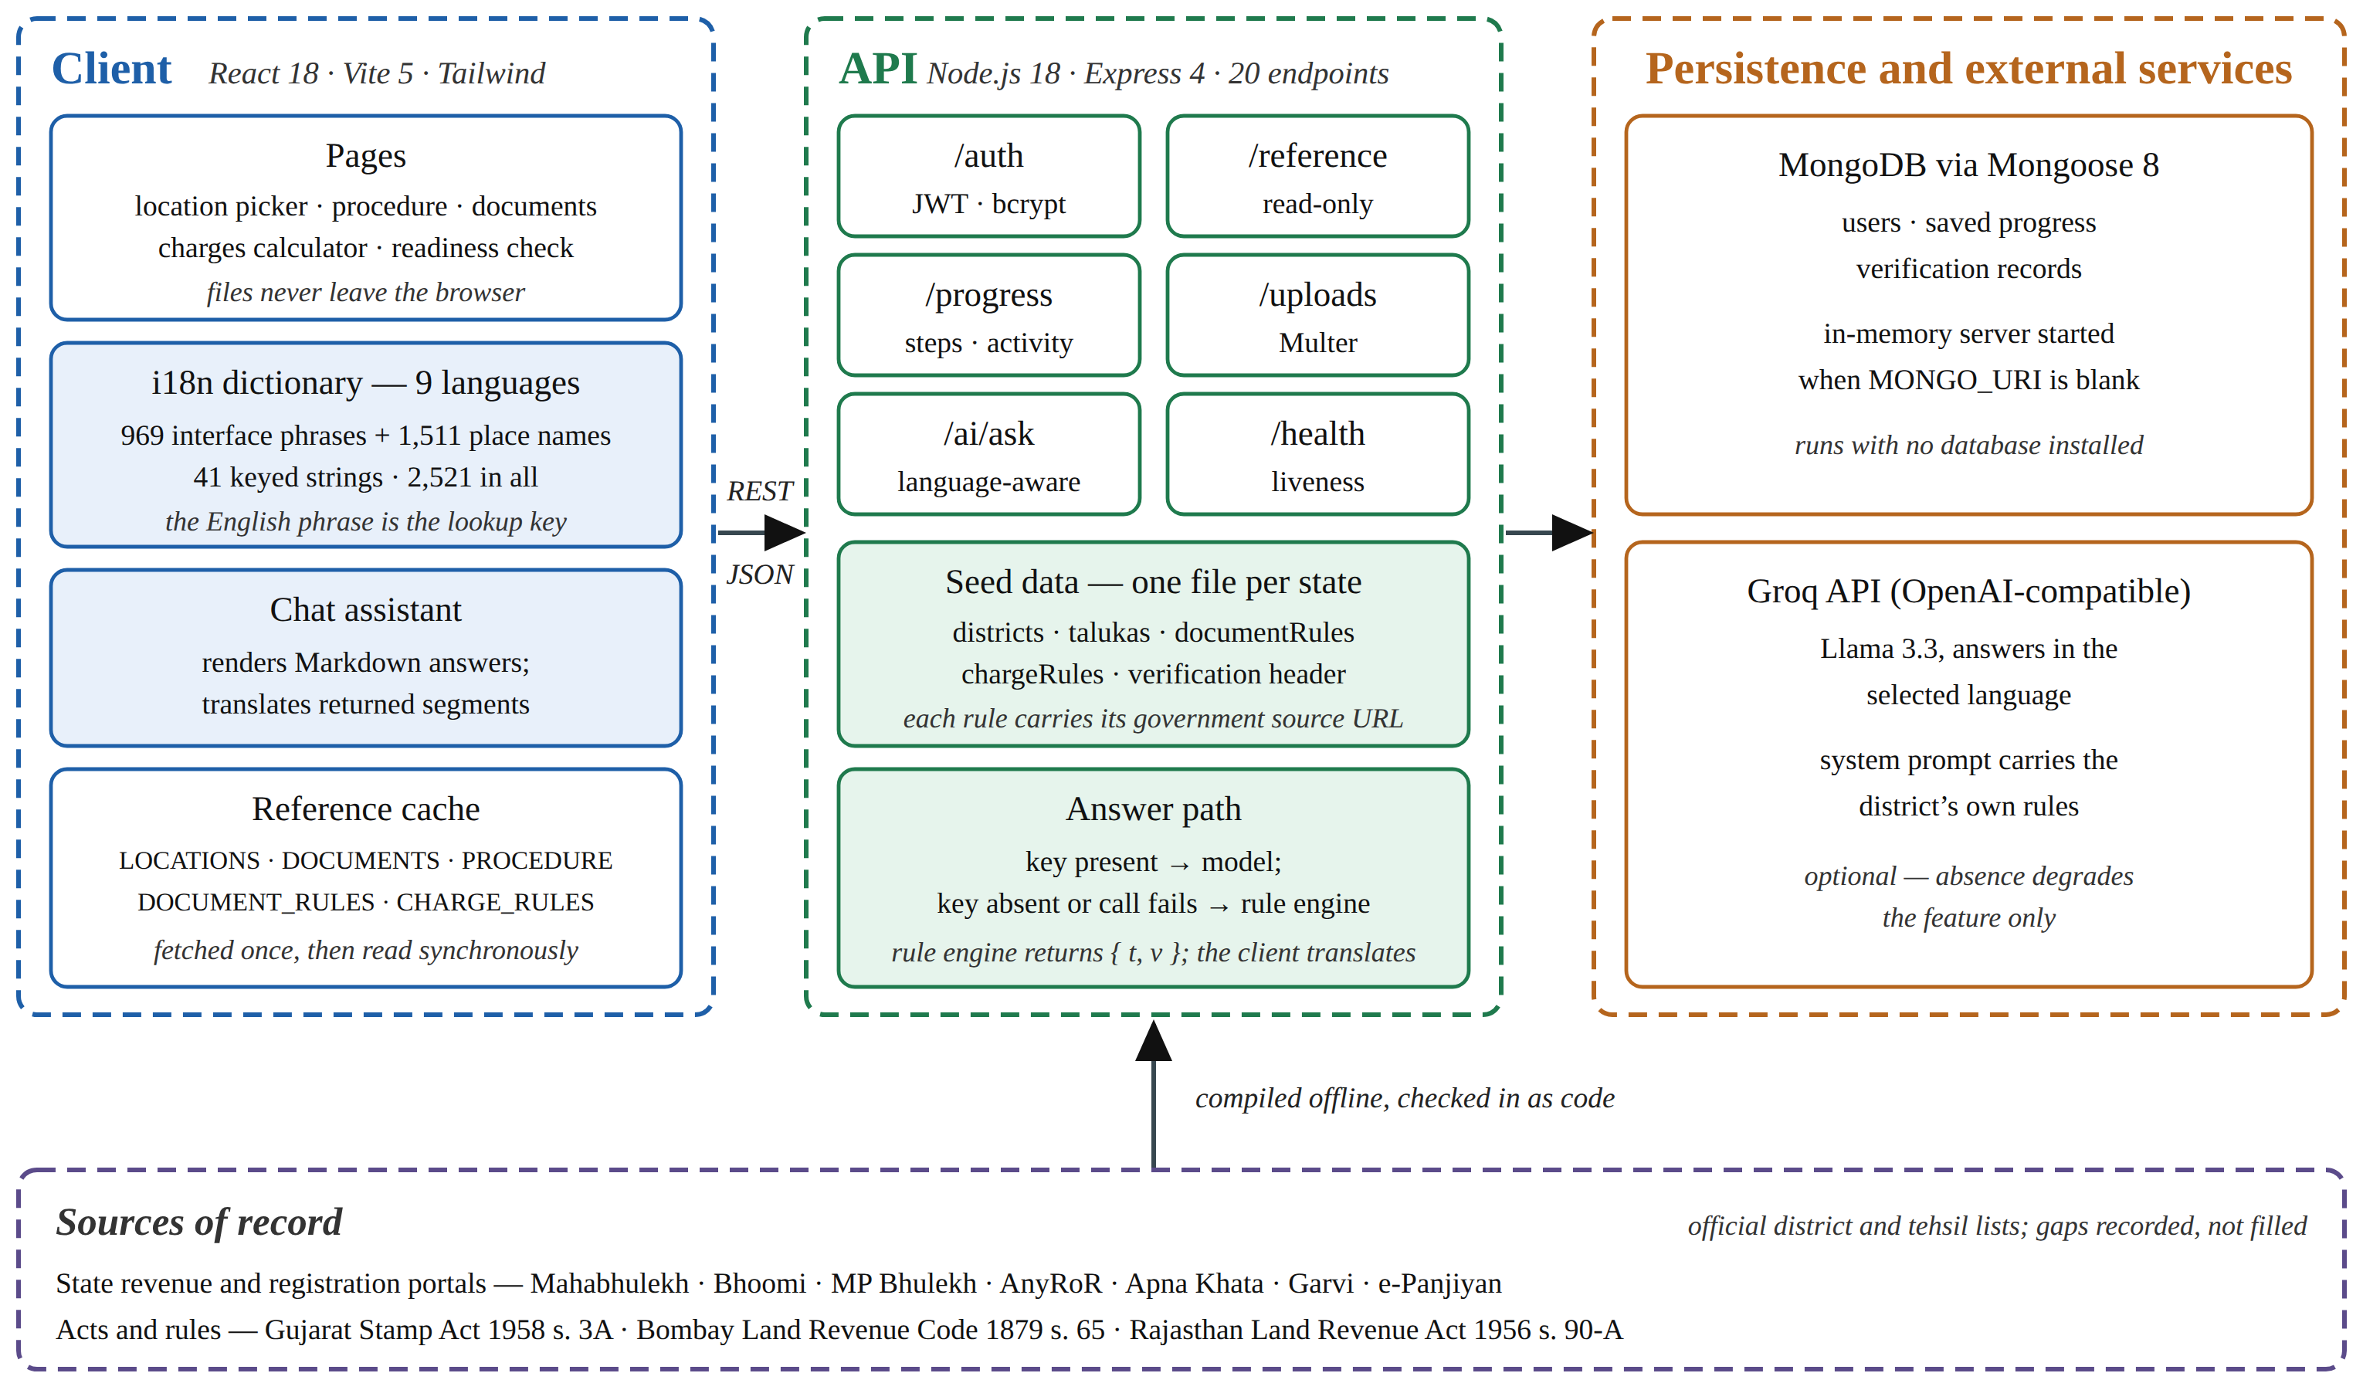
Figure 3.1. System architecture of BhumiGuide Intelligence
3.3 Per-State Data Model
One file stands behind each supported state, and it exports four items: the mapping from districts to talukas, the charge rules, the document rules, and a header comment setting down what was and was not verified. Bringing in a further state means writing that file and adding a line to an index module. No page, route or component is touched.
3.3.1 Document rules and overrides
A shared list of sixteen documents forms the base. Each entry carries an identifier, a display name, a category, a short description, an explanation of what the document is and why it is needed, where it is obtained, the indicative fee, and whether it is mandatory. A state’s document rules then override this base entry by entry. A rule may rename a document, change its status, replace the note that explains it, change where it is obtained, or reorder it within the list. A rule overrides only the fields it declares; everything it does not mention falls through to the shared entry.
Three values are available for status: mandatory, optional, not-applicable. It is the third that gives the model its value, and the interface shows it instead of suppressing it. Set Karnataka beside Gujarat and a buyer can see that section 114 of the Karnataka Municipal Corporations Act [22] calls for a municipal Khata certificate, whereas Gujarat puts a Property Card from the City Survey system in its place. Drop the not-applicable entries altogether and the two lists would simply have come out different, with nothing to tell the buyer whether an absence was deliberate or an oversight.
The same mechanism carries a document that a state adds on its own account. Gujarat requires non-agricultural permission under section 65 of the Bombay Land Revenue Code as it applies in that state [19]; Rajasthan requires a conversion order under section 90-A of its Land Revenue Act [20]. Both are expressed as additional document rules rather than as special cases in code.
3.3.2 Location data and its provenance
The district-to-taluka map for each state was taken from that state’s official notification of administrative divisions and cross-checked against the taluka dropdown of the state’s own land-records portal where one is published. The counts obtained are 36 districts and 359 talukas for Maharashtra, 31 and 184 for Karnataka, 55 and 271 for Madhya Pradesh, 34 and 262 for Gujarat, and 41 and 425 for Rajasthan, giving 197 districts and 1,501 talukas in all. Two of these lists are sensitive to the date they were compiled. Gujarat’s taluka list is current to the notification in force at the time of compilation, and Rajasthan’s tehsil list reflects the reorganisation current at that date. Both facts are recorded in the file headers and in Table 4.2, because an administrative reorganisation would make the list wrong without making it look wrong.
3.4 Database Design
Figure 3.2 shows the six collections the system uses and the relationships between them. Three of them hold user data and three hold reference data.
The user collection stores the display name, a unique e-mail address, a BCrypt password hash that is null for accounts created through Google sign-in, a a sparse Google identifier, a verification flag, and the hash and expiry of any outstanding one-time password. The progress collection has a one-to-one relationship with the user and holds the identifiers of completed procedure steps, the identifiers of documents the user has marked as collected, the answers given to the profile generator, notification preferences, a bounded activity feed and a list of notifications. The verification-record collection has a one-to-many relationship with the user and holds a survey number, the location it refers to, and the files attached to it, each file recording its original name, its stored name, its media type, its size and the document identifier matched when it was uploaded.
The three reference collections carry no user data. The document collection holds the sixteen shared documents, the procedure collection holds the seven main and six conditional steps, and a key-value collection holds the two structures that do not fit a flat document shape: the per-state charge rules, and the location tree, in which a taluka sits within a district and a district within a state. All three are written once at start-up from the seed modules in the repository, which is the mechanism described in Section 3.2.
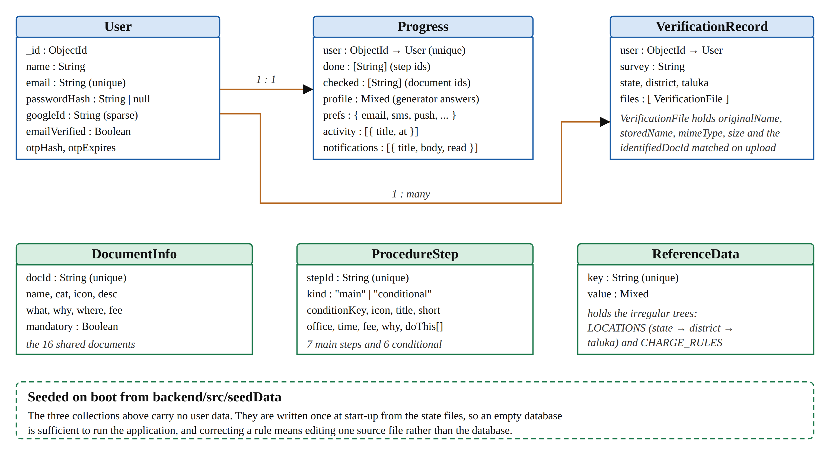
Figure 3.2. Database schema and the seeding relationship
Table 3.1 lists the collections, the kind of data each holds and where that data originates.
Table 3.1. Database Collections and Their Origin
Collection | Holds | Written by | Lifetime
User | Name, unique e-mail, BCrypt hash or null, sparse Google identifier, verification flag, OTP hash and expiry | Registration, Google sign-in | Permanent, per user
Progress | Completed steps, collected documents, profile answers, preferences, activity feed, notifications | The application, as the user works | Permanent, one per user
VerificationRecord | Survey number, state, district, taluka and the attached files with their matched document identifiers | Deliberate upload by a signed-in user | Permanent, many per user
DocumentInfo | The sixteen shared documents and their explanatory text | Seeded on boot from the repository | Rewritten each start-up
ProcedureStep | Seven main and six conditional steps with office, time, fee and sub-tasks | Seeded on boot from the repository | Rewritten each start-up
ReferenceData | The location tree and the per-state charge rules, held as keyed values | Seeded on boot from the repository | Rewritten each start-up

3.5 Charges Computation
The charge engine reproduces each state’s own rate structure rather than applying a single headline percentage. For a declared value V the total payable T is computed as
T = V(s + a − f)/100 + R + Vb/100 + h + m (3.1)
The symbols carry the following meanings. V is the declared value. The term s is the basic rate of stamp duty in force in the state; a is the correction applied where the land is agricultural; f is the reduction in duty allowed to a woman purchaser; b is the cess levied by the local body; and h and m are two fixed charges, for handling and for sundries, currently ₹5,000 and ₹2,000. A floor of zero is placed on the bracketed rate, so no concession can drive duty below nothing. Where an outright exemption applies, the registration term R is nil; in every other case
R = min(Vr/100, c) (3.2)
Here r stands for the registration rate and c for the ceiling, in those states that impose one. The reason (3.2) is written with two branches is that one rebate field is not expressive enough to carry every state’s concession, and the two states that defeat the simple form do so in opposite ways.
3.5.1 Why a single rebate field is insufficient
In Maharashtra the registration fee is subject to a ceiling of ₹30,000, beyond which it does not grow however large the declared value becomes past ₹30 lakh. Multiply value by rate with no ceiling in the formula and every transaction above that point is quoted too high, the discrepancy widening as the property grows dearer — which is precisely the band in which an accurate estimate matters most to a buyer.
The difficulty in Gujarat runs the other way. Duty is not reduced at all for a woman purchasing in her own name; she pays the same rate as anybody else. What she is spared is the registration fee, and the whole of it. Expressed as a duty rebate — the only form available to a single-field model — that concession would make both the quoted rate and the quoted total wrong, and would leave the buyer with a false impression of which charge she is actually escaping. A separate flag for registration-fee exemption therefore sits alongside the duty rebate in the data model, and the second branch of (3.2) is there to read it.
3.5.2 Composite headline rates
Two of the five headline rates are themselves composites, and presenting them without explanation invites the user to conclude that the system is wrong. Gujarat’s 4.9 per cent is a basic rate of 3.5 per cent under Schedule I Article 20(a) of the Gujarat Stamp Act 1958, plus an additional stamp duty of 40 per cent of that duty levied by section 3A of the same Act [18]; 3.5 multiplied by 1.4 gives 4.9. The local-body increment is zero in the model not because Gujarat levies none, but because section 3A expressly folds the panchayat increment into the same surcharge, so adding it again would charge it twice. Rajasthan’s 7.8 per cent is a basic duty of 6 per cent plus a surcharge equal to 30 per cent of the duty — made up of infrastructure, cow-protection and natural-calamity components of 10 per cent each — and 6 multiplied by 1.3 gives 7.8.
The Rajasthan case also determines where the surcharge is modelled. It multiplies the duty rather than the value, so a woman’s statutory rebate of one percentage point on the basic rate becomes 1.3 points of value once grossed up, giving her an effective 6.5 per cent. Recording the surcharge as a flat local-body cess would have left her rebate ungrossed and overcharged her. For both states the interface displays an explanatory note beside the result, because a composite rate that contradicts the state’s own published basic rate is otherwise indistinguishable from an error.
The rate parameters stored against each state appear in Table 3.2. What is shown is not a summary of the data model but the model itself — these are the fields the engine actually reads.
Table 3.2. Charge Rule Parameters Held for Each State
Parameter | Maharashtra | Karnataka | Madhya Pradesh | Gujarat | Rajasthan
Basic stamp rate, s | 6 % | 5 % | 7.5 % | 4.9 % | 7.8 %
Agricultural adjustment, a | −1 | −0.5 | 0 | 0 | 0
Woman’s stamp rebate, f | 1 | 0 | 2 | 0 | 1.3
Registration rate, r | 1 % | 1 % | 3 % | 1 % | 1 %
Registration cap, c | ₹30,000 | None | None | Not found | None
Woman’s registration exemption | No | No | No | Yes | No
Local-body cess, b | 1 % | 0.5 % | 0 | 0 | 0
Composite headline rate | No | No | No | Yes, s. 3A | Yes, 30 % of duty

3.6 Multilingual Interface
Nine languages are offered: English alongside Hindi, Marathi, Tamil, Telugu, Kannada, Gujarati, Bengali and Punjabi. The implementation rests on three decisions, each of which was taken in order to close off one particular way of failing.
3.6.1 The English phrase as its own key
The first decision is that the English phrase is itself the dictionary key. A lookup for a phrase that has no translation in the active language returns the English phrase unchanged. The failure mode this removes is the one every keyed translation system eventually produces: a screen showing a raw identifier such as docs.title.satbara, or a blank where a label should be. With the phrase as the key an incomplete dictionary degrades to English, which a user can read, rather than to an identifier, which nobody can. The cost is that changing the English wording of a string breaks its translations, and the project accepts that cost; the English text of a shipped string is treated as an interface contract and is changed deliberately.
3.6.2 Whole sentences with positional placeholders
Second, a sentence that carries values is held in one piece. What is stored for “Question 3 of 7” is the single entry “Question {0} of {1}”, leaving each language free to put the numerals where its own grammar wants them. Were the sentence instead broken into the pieces “Question” and “of” and reassembled around the numerals at run time, English word order would be imposed on all nine languages, and the output would be ungrammatical in the other eight. The convention covers all 969 interface phrases without exception, so a translator is never left guessing whether a fragment is about to be joined to something else.
3.6.3 Coverage computed rather than asserted
The third decision is that coverage is measured at run time. The percentage shown beside each language in the menu is computed as the share of the measured phrase inventory for which that language actually holds an entry. Adding an English string without translating it lowers the displayed figure by itself, with no release note and no manual bookkeeping. This converts the multilingual claim from an assertion in documentation into a property of the running system, and it is the mechanism by which the coverage result reported in Chapter 5 is obtained.
3.6.4 Place names as transliterations
A dictionary of its own, 1,511 entries deep for each language, holds the district and taluka names. What it contains are transliterations rather than translations: a name is set down in a different script and is never replaced by a different word. The one exception is a descriptive suffix, which is translated, giving मुंबई उपनगर for Mumbai Suburban in place of the transliterated Mumbai Upanagar. Where a state’s own language is concerned the official spelling takes precedence over anything derived mechanically, that being the form a resident recognises and the form the state’s portal itself prints.
Revenue vocabulary receives the same treatment. Terms such as Utara, Mamlatdar, Khasra, Jamabandi, Nakal, Patta, Patwari and Intkal are transliterated into each target script rather than left in Latin, because a reader working in Devanagari or Kannada expects to see them in the script they are reading. Portal and product names — AnyRoR, Garvi, Bhoomi, Apna Khata, e-Panjiyan — are deliberately left in Latin script, because those are the strings a user must type into a search engine or a browser address bar to reach the service.
3.7 The Assistant and the Segments Protocol
The assistant answers free-form questions, and it has two paths. Figure 3.3 shows both and the point at which the system chooses between them.
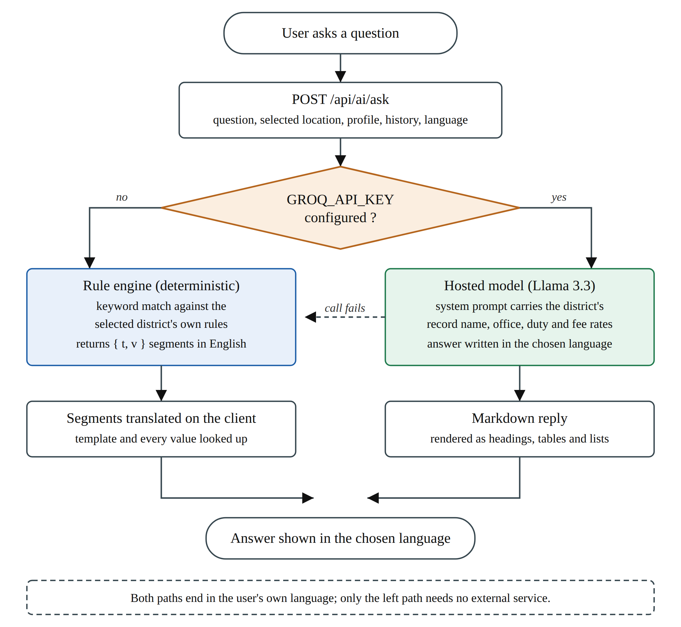
Figure 3.3. The two answer paths of the assistant
3.7.1 The hosted-model path
Where an API key has been supplied, three things travel to a hosted Llama 3.3 70B model over an OpenAI-compatible chat-completions endpoint [23]: the question itself, the eight most recent turns of the exchange, and a system prompt. The conversation history is trimmed so that it begins with a user turn, because the opening greeting of a fresh conversation is an assistant turn and leading with it degrades the reply. The model name is not hard-coded: the client asks the endpoint which models the key can actually use and selects the first available from a preference list, caching the result, so that the retirement of a model version does not break the feature. Non-text models are filtered out of that list.
The system prompt is where the district-awareness enters. It carries the selected district’s own rules — the name of the record of rights, the issuing office, the stamp and registration rates and any concession that applies — so the model is not asked to recall facts about Indian land administration but to present facts it has been given. It is instructed to answer in the language the user has selected and to reply in plain Markdown with a restricted set of constructs: short bullet lists, numbered steps, tables only for genuine comparisons and at most three columns, headings no deeper than level three, no HTML and no emoji. The client renders that Markdown into real headings, tables and lists through a small dependency-free renderer rather than inserting raw HTML, so no markup from the model reaches the DOM unescaped.
3.7.2 The rule-engine path and the segments protocol
When no key is configured, or when the hosted call fails, a deterministic rule engine answers instead. It matches the question against keyword groups and composes an answer from the selected district’s own rules. This engine runs on the server, and the server holds no translation dictionary. Shipping one there would mean duplicating all 2,521 strings, the 1,511 place names included, and keeping two copies in step.
The protocol that avoids this is to return not a finished sentence but an English template together with its values:
{ t: "In {0} the land record is called the {1},
issued by the {2}.",
v: ["Maharashtra", "7/12 Extract (Satbara)",
"Tehsildar Office"] }

Rendering happens on the client, against the dictionary that serves every other part of the interface. Both the frame and each of its values are resolved as phrases, so the sentence skeleton, the name of the state, the name of the record and the name of the office are translated one at a time and then assembled in whatever order the target language calls for. English remains the only language the server understands, yet the fallback reply comes out fully localised in all nine, and the dictionary is kept in a single place.
3.8 Document Readiness Check
The readiness check identifies each file the user selects by matching its filename against the document list, and then reports four classes of problem: a file too small to be legible when printed at a counter, a file too large for the upload limits government portals impose, a file in a format offices reject, and a record extract older than the three-to-six month window within which such an extract is normally accepted. It also lists which of the state’s mandatory documents are still missing from the set, using the per-state rules rather than the shared list, so that a user in Maharashtra is not told to obtain an Encumbrance Certificate.
The whole analysis runs inside the browser. No file is transmitted while the check is being performed, and the check works with the network disconnected. A file reaches the server only along a separate path, when a signed-in user deliberately attaches it to a verification record. This separation is the fourth design principle expressed in code: a user who merely wants to know whether their documents are in order never uploads anything.
Filename matching is a weak identification method and the report says so. A file named scan1.pdf cannot be classified, and a file named 7-12.pdf is accepted as a record extract without any inspection of what it actually contains. Section 6.3 sets out optical character recognition as the planned replacement.
3.9 Authentication and Saved Progress
Accounts are optional. The entire guidance surface — procedure, documents, charges, offices and the assistant — works without signing in, because requiring registration before answering a question would defeat the purpose of the tool. An account buys persistence rather than access.
Where an account is created, the password is hashed with BCrypt and never stored or logged in plaintext. Sessions are carried in a JSON Web Token rather than in server-side state, which is what allows the API to remain stateless. Google sign-in is offered as an alternative, in which case the password hash is null, and the account is identified by a sparse Google identifier. E-mail verification uses a hashed one-time password with an expiry, so that the stored value is not itself a usable credential. Signed-in users keep their completed steps, their collected-document marks, the answers given to the profile generator, their notification preferences and a bounded activity feed of the last fifty actions.
3.10 API Design
Table 3.3 lists the route modules, the endpoints each exposes and what they carry. The count is twenty: nineteen handlers across five route modules, plus a health check registered directly on the application. A static mount serves previously uploaded files back to their owner and is not counted as an endpoint. Only the progress module and the upload module require authentication; the reference module and the assistant are open, because the guidance they return is public information and gating it would contradict the purpose of the project.
Table 3.3. API Route Modules and Endpoints
Module | Base path | Endpoints | Purpose | Auth
Reference | /api/reference | 5 — locations, charges, procedure, documents, offices | Serves the seeded reference dataset to the client on start-up | None
Authentication | /api/auth | 6 — register, login, google, me, verify-otp, resend-otp | Account creation, sign-in, Google sign-in and e-mail verification | Token on /me
Progress | /api/progress | 5 — read, update, activity, notify, mark notifications read | Per-user saved progress, activity feed and notifications | Required
Uploads | /api/uploads | 2 — upload, list | Attaching documents to a verification record | Required
Assistant | /api/ai | 1 — ask | Question answering on either of the two paths of Section 3.7 | Optional
Health | /api/health | 1 — health | Liveness check used during deployment | None

3.11 Tools and Technologies
Table 3.4 lists the technologies used and the reason each was selected. The frontend dependency list is deliberately short: React, React DOM and an icon set, with Vite, Tailwind, PostCSS and Autoprefixer as build-time tools. The Markdown renderer described in Section 3.7.1 was written rather than installed, partly to keep the dependency surface small and partly because rendering model output through a general-purpose library that emits HTML would have reintroduced the injection risk the custom renderer avoids.
Table 3.4. Tools and Technologies Used
Layer | Technology | Version | Reason for the choice
Client framework | React with React DOM | 18.3 | Component model suits a page set that shares one cached reference dataset
Build tool | Vite | 5.3 | Fast development server and a production build that was used as a verification check
Styling | Tailwind CSS with PostCSS and Autoprefixer | 3.4 | Utility classes keep styling local to the component and avoid a growing stylesheet
Icons | lucide-react | 0.400 | Single icon dependency, tree-shaken at build time
Server runtime | Node.js with Express | Express 4.19 | Stateless HTTP service with a small, well-understood middleware model
Database | MongoDB with Mongoose | Mongoose 8.5 | Document shape matches the per-state rule objects without a schema migration for each state
Fallback database | mongodb-memory-server | 9.4 | Allows the project to run with no database installed
Authentication | bcryptjs, jsonwebtoken, google-auth-library | — | Password hashing, stateless sessions and Google sign-in
File handling | multer | 1.4 | Multipart upload handling for the verification record
Mail | nodemailer | 6.9 | One-time password delivery for e-mail verification
Language model | Llama 3.3 70B over an OpenAI-compatible endpoint | — | Writes the nine supported languages acceptably; selected at run time from a preference list

STRENGTH AND LIMITATION OF THE PROJECT
4.1 Strengths of the Approach
The strengths of this project are mostly architectural rather than algorithmic, and they follow from decisions described in Chapter 3. Table 4.1 sets them out together with the design decision each rests on.
Table 4.1. Strengths of the Approach and Their Basis
Strength | Design decision it rests on | Consequence
Adding a state is a data task | Each state is one file exporting its locations, charge rules, document rules and verification header; an index lists the files | A sixth state requires one new file and one line, with no change to any page, route or component
Every claim is attributable | Each per-state rule carries the URL of the government page or the statutory provision it came from | A reader of the code can retrace any single rule; an unattributable claim is never shown as fact
Concessions are modelled, not approximated | A separate registration-exemption flag alongside the stamp rebate, and a cap on the registration component | Maharashtra’s cap and Gujarat’s registration exemption are reported with the correct structure, not only the correct total
Incomplete translation degrades to English | The English phrase is itself the dictionary key | A missing entry produces readable English rather than a raw identifier or a blank
Coverage cannot drift from the truth | The figure is computed at run time from the measured phrase inventory | Adding an untranslated string lowers the displayed figure automatically
The assistant stays localised with no external service | The rule engine returns an English template and its values, both translated on the client | The fallback answer appears in all nine languages, although the server holds no dictionary
The project runs with nothing installed | An in-memory database is started and seeded when no connection string is given | A reviewer can clone the repository and see the system work without provisioning infrastructure
Nothing is uploaded silently | The readiness check runs wholly in the browser; uploads use a separate, deliberate path | A user who only wants to check their documents transmits no file at all

Two of these deserve a further word. The first is the cost of adding a state. The claim is not that the work of adding a state is small — the research behind one state took the greater part of a week — but that the engineering work is bounded and does not grow with the number of states already supported. The second is the treatment of concessions. Reporting the correct total through the wrong structure is a failure that is invisible in testing and expensive in use, because a buyer who is told she receives a stamp-duty discount will plan for a different set of payments from the one she will actually make.
4.2 Limitations
One rule governed the project from beginning to end: an unverifiable fact is left standing open and written down, never closed with a value that merely sounds right. Table 4.2 is what that rule produced. Its contents are taken from the comments the source files themselves carry, so code and report make the same admissions.
Table 4.2. Known Limitations and Unverified Facts
Area | Status
Land records, charge rates, document rules | Real. Drawn from the states’ own portals and statutes, each rule in the data files carrying either the address it came from or the section number it rests on.
Office addresses and telephone numbers | Generated. There is no public API from which a directory of Indian revenue and registration offices can be obtained, so the entries on display are illustrative only; they will not reach anyone and must not be used as contact details. For the same reason the distance to an office is not shown at all, the only figure that could have been quoted being one nobody had measured.
Legal verification progress indicator | A simulated timer and nothing more. Verifying a title in earnest takes an advocate and a search of the registry; this indicator exists to show the interface working and verifies nothing.
Gujarat taluka list | 34 districts holding 262 talukas, matching the notification of 2 October 2025 by which Vav-Tharad was created. Only Godhra is carried for Panchmahal, no second source for that district’s remaining talukas having been reachable. Press reports put the state at 269 talukas; the figure here is what the per-district lists add up to, and the names that were missing were left missing rather than invented. A further reorganisation would date the list without leaving any sign that it had.
Rajasthan tehsil list | 41 districts holding 425 tehsils, matching the reorganisation of 1 January 2025. One row of the official list could not be read because of the legacy font it was set in, so a single tehsil name rests on a secondary source. The same warning about later reorganisation applies.
Gujarat registration-fee cap | Not found. Every attempt to reach the Garvi portal failed, so the null stored in this field means that nothing was located, not that the absence of a ceiling was established.
Rajasthan stamp surcharge | The figure used is 30 per cent of duty. Early in 2026 two secondary reports asserted a higher rate once duty passes ₹10 lakh; since no gazette notification to that effect could be found, the existing figure was kept, the assertion was noted, and the interface says as much on screen.
Gujarat rate decomposition | Published audit material quotes the 4.9 per cent total directly. The division into 3.5 plus 1.4 is inferred from that total together with s. 3A, and is not quoted from any rate schedule.
Place names in non-local scripts | Transliterations. For a state’s own language the official spelling is used. Small tehsils for which no spelling has been published were written out sound by sound in the other eight scripts, so a few of those may not match what the local record office itself prints.
Local office contacts | Assembled by hand for the first three states and published by no department. Nothing exists for Gujarat or Rajasthan, so for those two the list falls back to district level and says on screen that it has done so.
Stamp duty figures | Indicative figures, not legal advice. That warning appears next to the result itself rather than buried in a terms-of-use page.
Evaluation | No study with users has been carried out. Everything reported in Chapter 5 is a property of the system or of its dataset, and none of it is evidence that a buyer is helped.

4.3 Threats to Validity
Three threats to the validity of this work should be stated explicitly, because the limitations register above lists facts while this section concerns inference.
The first is that correctness here is correctness with respect to the modelled rules, not with respect to the law. Every check reported in Chapter 5 establishes that the system does what its own dataset says. None of them establishes that the dataset itself states the law correctly, which only the concerned department can confirm. A rule that was transcribed wrongly from a correct source would pass every check in Table 5.4.
The second is temporal. Stamp duty rates change at budgets, administrative divisions are reorganised by notification, and portals are restructured. A dataset compiled at one date is a snapshot, and nothing in the present system detects that a rate has moved. The file headers record the date of compilation, which lets a reader judge how much to trust a figure, but recording a date is not the same as staying current.
The third is that no user study has been run. The project’s central claim is that assembling public information around a district and a language helps a first-time buyer. That claim is plausible and it is untested. Everything reported in Chapter 5 is a property of the artefact; none of it is evidence about a buyer. This is the largest gap in the work, and it is the first item of future scope in Chapter 6.

RESULT AND DISCUSSION
5.1 Dataset and Interface Coverage
What Table 5.1 sets out is the dataset and the interface as they measured at the time of writing, taken from the source itself. No figure was carried over from an earlier draft; each was computed afresh against the repository, by the methods listed in Section 5.5.
Table 5.1. Dataset and Interface Coverage as Measured
Item | Measured value
States covered | 5 — Maharashtra, Karnataka, Madhya Pradesh, Gujarat and Rajasthan
Districts | 197 — 36, 31, 55, 34 and 41 respectively
Talukas or tehsils | 1,501 — 359, 184, 271, 262 and 425 respectively
Documents explained | 16 shared documents, with per-state overrides for name, status, note and source
Procedure steps | 7 main and 6 conditional
API endpoints | 20 — 19 across five route modules, plus a health check
Interface languages | 9 — English, Hindi, Marathi, Tamil, Telugu, Kannada, Gujarati, Bengali and Punjabi
Translated strings | 2,521 — 969 interface phrases, 1,511 place names and 41 keyed strings
Translation coverage | 100 per cent in all nine languages, computed at run time from the phrase inventory
Local office contacts | 1,414, for the first three states only; see Table 4.2

The translated-string figure deserves a note on how it is composed, because the three parts behave differently. The 969 interface phrases are sentences and labels; they are the part that changes when the interface changes. The 1,511 place names are district and taluka names and are stable unless an administrative reorganisation occurs. The 41 keyed strings are the small residue of text that genuinely needs an identifier rather than an English phrase as its key, chiefly page titles that appear in more than one grammatical context. Multiplying the inventory by nine languages gives 22,689 individual entries held in the dictionaries.
5.2 What the Per-State Model Captures
Placing the five states alongside one another on the attributes where they diverge, Table 5.2 shows what the per-state model is really holding. Nowhere is the case against a national checklist put more plainly: one record goes under five names, five rates are charged, and the states cannot agree either on who is permitted to buy farmland or on whether a municipal Khata is issued at all.
Table 5.2. How the Five States Differ
Attribute | Maharashtra | Karnataka | Madhya Pradesh | Gujarat | Rajasthan
Land record | 7/12 Extract (Satbara) | RTC / Pahani | Khasra / Khatauni | 7/12 Utara (VF-7 & VF-12) | Jamabandi (Nakal)
Issued by | Tehsildar Office | Nadakacheri / Taluk Office | Tehsil Office | e-Dhara Kendra, Mamlatdar Office | Tehsil Office
Encumbrance | Index II certified copy | Form 15 EC | Not issued | EC (Boja Certificate) | e-Search; no EC issued
Municipal Khata | Not used | Mandatory | Not used | Property Card instead | Patta instead
Non-agriculturist may buy farmland | No | No | Yes | No | Yes, except SC/ST land
Stamp duty | 6 % | 5 % | 7.5 % | 4.9 % | 7.8 %
Woman buyer | 1 % off duty | No concession | 2 % off duty | Registration fee waived | 1.3 % off duty
Mandatory documents | 9 | 10 | 9 | 9 | 8

Two of the rows reward a second look. Rajasthan cannot be answered yes or no on farmland. Nothing in that state stops a non-agriculturist buying as a general matter, yet where the seller is a Scheduled Caste or Scheduled Tribe khatedar and the buyer falls outside that category, the sale is void without the Collector’s validation [21]; a model storing nothing but “yes” would steer a buyer straight into the transaction most likely to collapse. Three concessions of quite different shape sit in the woman-buyer row — a cut in the rate, no relief whatever, and the complete removal of a separate charge — and it was that observation which gave equation (3.2) its second branch.
5.3 System Outputs
The running system appears in Photographs 5.1 to 5.5. Every one of them was captured from the application itself, against real dataset values, with no mock-up involved.
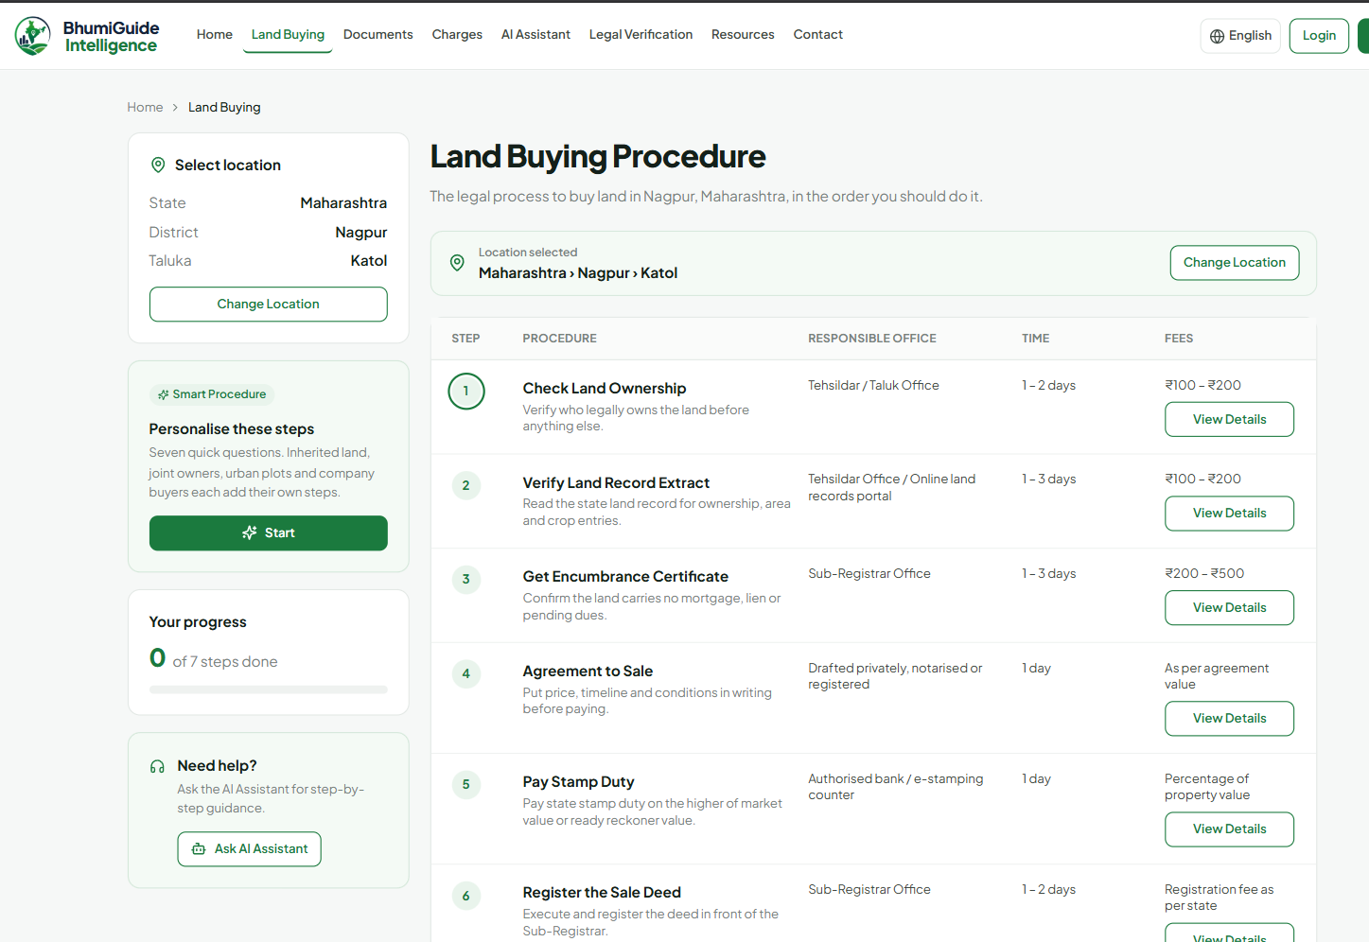
Photograph 5.1. Land buying procedure for a selected taluka, with office, indicative time and indicative fee against each step
A procedure for one chosen taluka is shown in Photograph 5.1. Rather than describing an action in the abstract, each step names the office answerable for it and attaches an indicative time and fee. Conditional steps surface only where the profile answers say they apply, which is why a buyer acquiring non-agricultural land inside a municipal area never sees the conversion step.
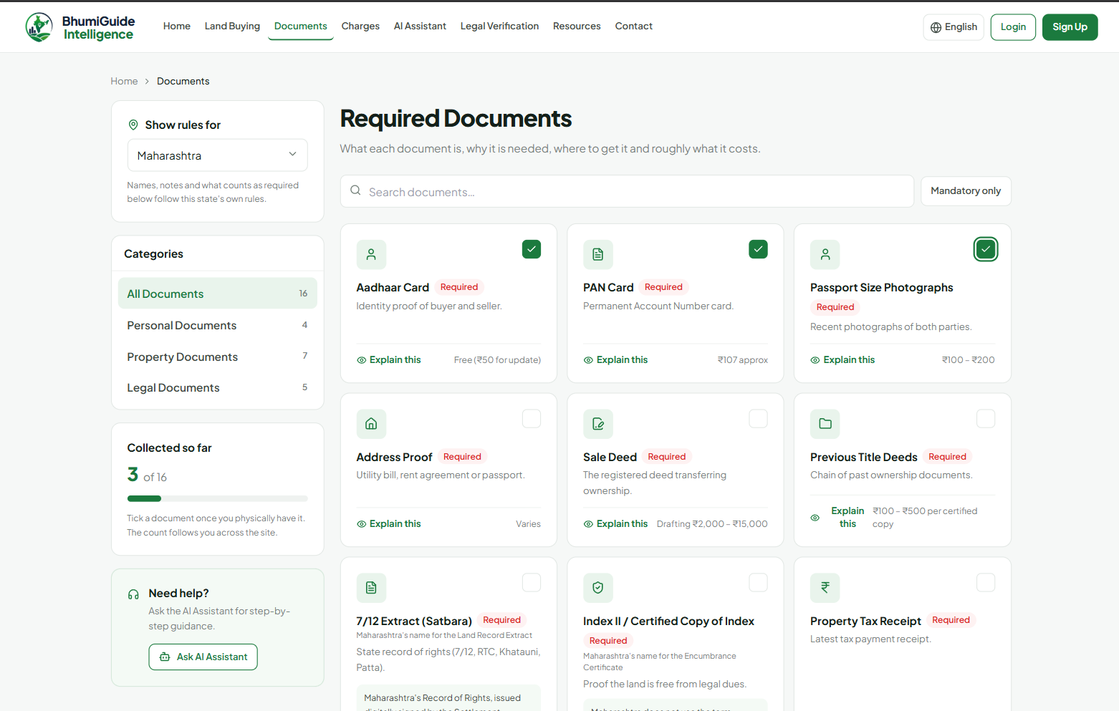
Photograph 5.2. Required documents under Maharashtra’s rules, with the state’s own name for the record of rights
Maharashtra’s rules govern the document list in Photograph 5.2. In place of a generic label the record extract appears as “7/12 Extract (Satbara)”, and the note beside it sets down that no document bearing the name Encumbrance Certificate is issued in that state — the kind of absence a buyer would otherwise learn about only on reaching a counter.
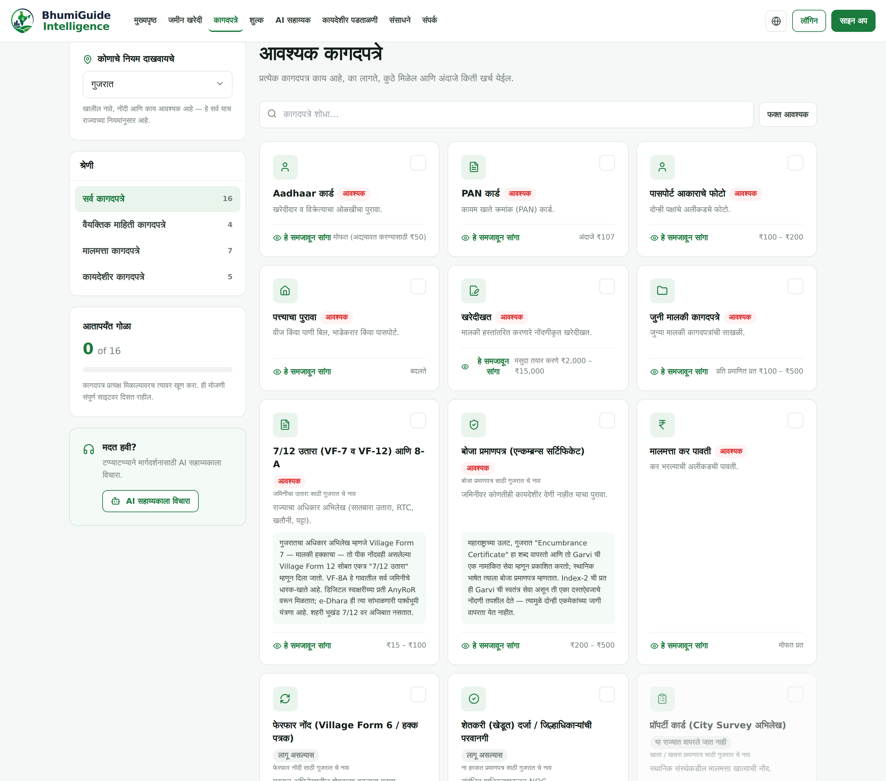
Photograph 5.3. The same page with Gujarat selected and the interface language set to Marathi
The page reappears in Photograph 5.3, this time with Gujarat chosen and Marathi set as the language. Marathi carries the document names, the notes that explain them and the category labels, while names drawn from statute or belonging to a portal — Village Form 7, Garvi, AnyRoR, City Survey — stay in Latin script. Nothing about that mixture is accidental; it is the policy set out in Section 3.6.4, and the reason is that a Marathi reader looking for the Gujarat portal has to type AnyRoR rather than any rendering of it.
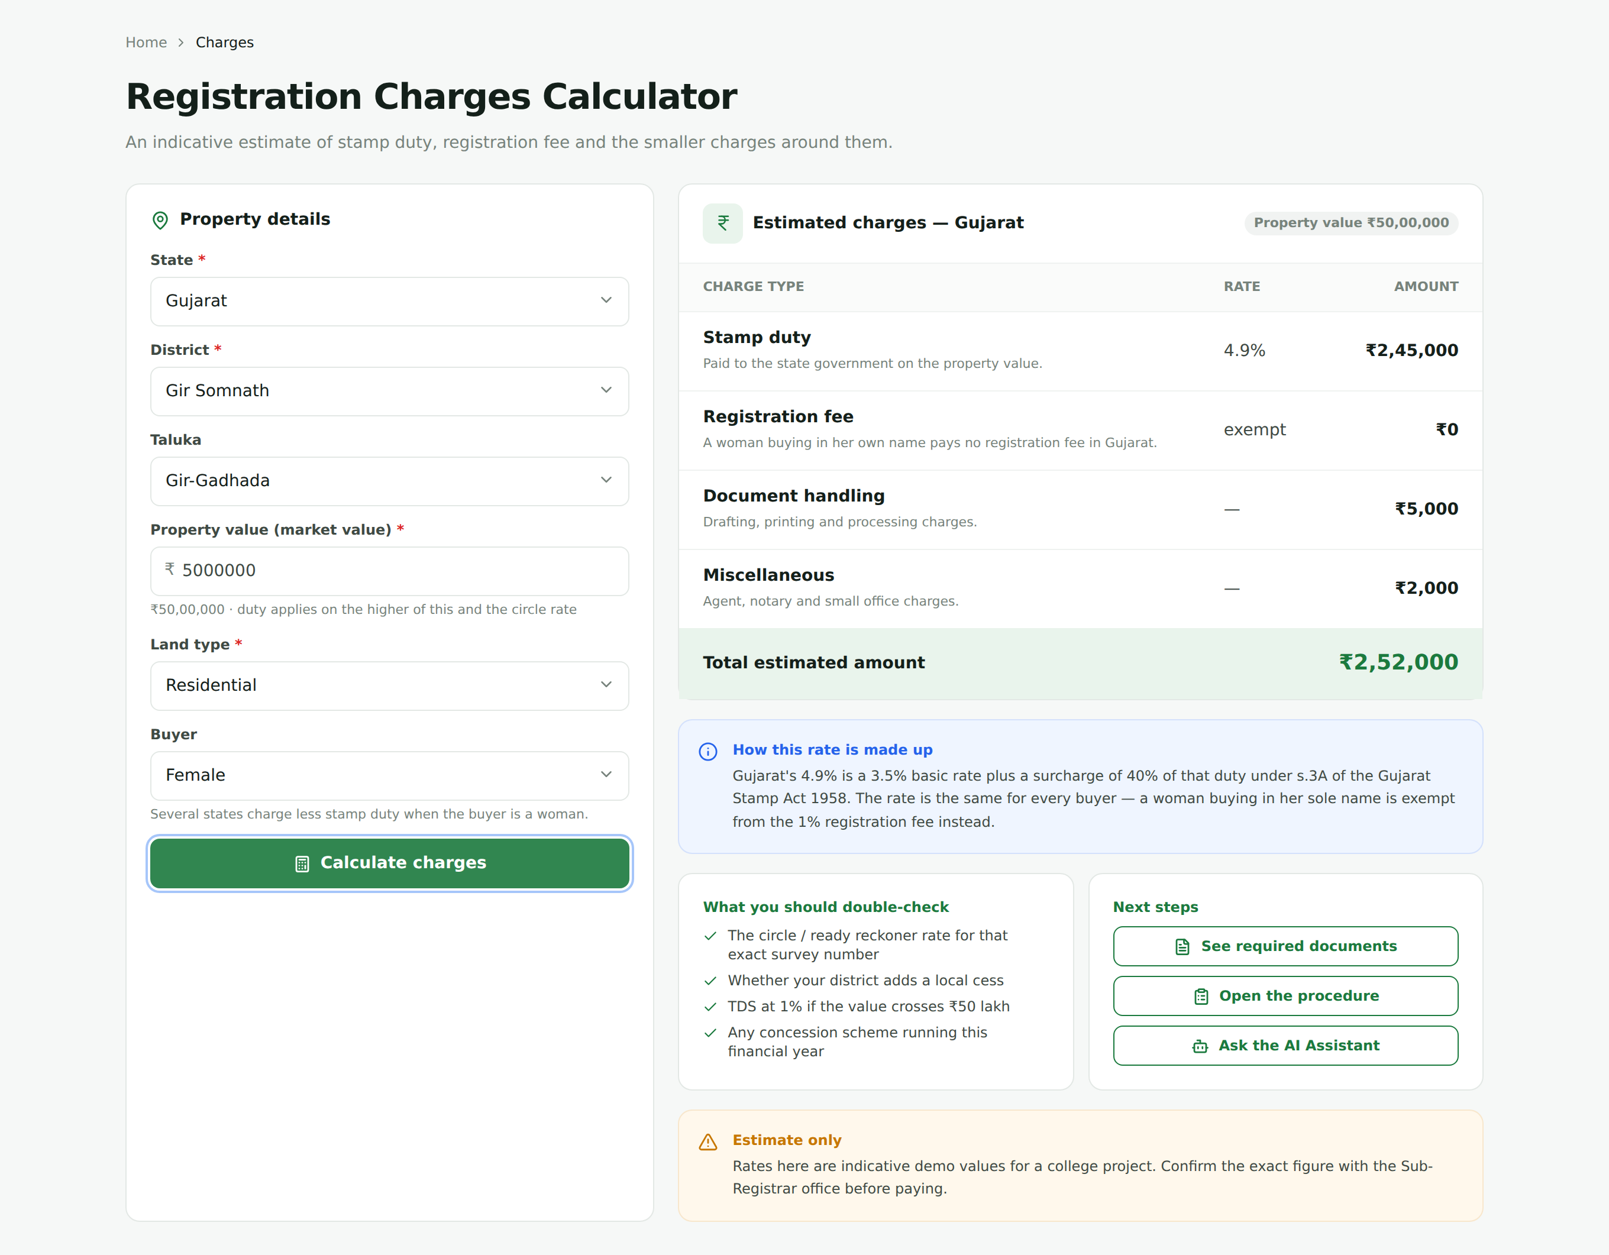
Photograph 5.4. Registration charges calculator showing the Gujarat case: full stamp duty and a registration fee of zero
The situation that called equation (3.2)'s second branch into being is the one in Photograph 5.4. Stamp duty for a woman buying in Gujarat runs to the full 4.9 per cent while the registration fee comes to nothing, and an explanation of how the rate is composed sits next to the result, so that the figure does not look as though it contradicts the 3.5 per cent basic rate the state publishes.
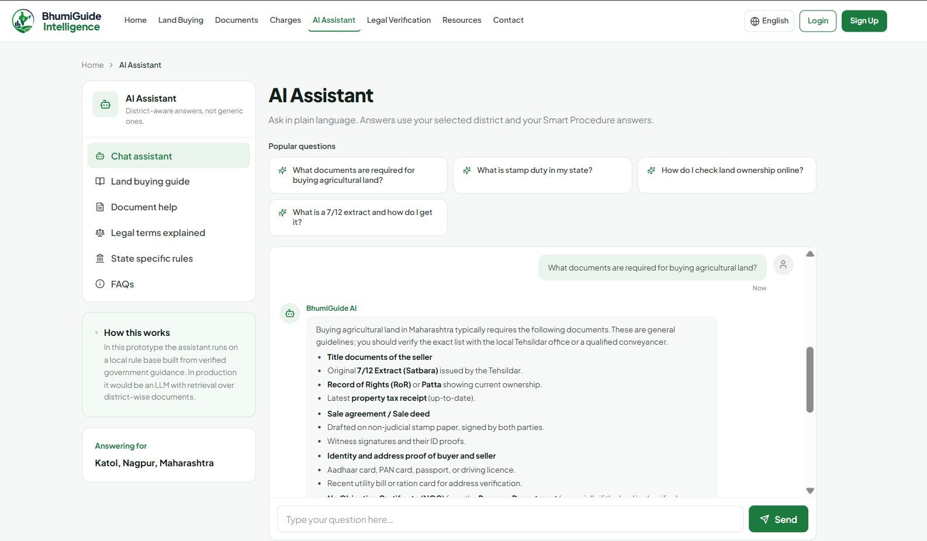
Photograph 5.5. The assistant answering in context for the selected taluka, rendered from Markdown
In Photograph 5.5 the assistant is answering by way of the hosted model, in context for the taluka that has been selected. Instead of appearing as raw text, the reply has been turned from Markdown into headings, a table and a list by the renderer of Section 3.7.1.
5.4 Worked Charge Computations
What the cost engine returns for a declared value of ₹50,00,000 on non-agricultural land is set out in Table 5.3, across all five states and for two buyers: one general, one a woman purchasing in her own name. Each figure comes from equations (3.1) and (3.2) applied to the parameters in Table 3.2, and the fixed handling and sundry charges of ₹5,000 and ₹2,000 are included in every total.
Table 5.3. Charges on a Declared Value of ₹50,00,000, Non-Agricultural Land
State | Rate | Stamp duty | Registration | Cess | Total | Woman’s total
Maharashtra | 6 % | ₹3,00,000 | ₹30,000 (capped) | ₹50,000 | ₹3,87,000 | ₹3,37,000
Karnataka | 5 % | ₹2,50,000 | ₹50,000 | ₹25,000 | ₹3,32,000 | ₹3,32,000
Madhya Pradesh | 7.5 % | ₹3,75,000 | ₹1,50,000 | — | ₹5,32,000 | ₹4,32,000
Gujarat | 4.9 % | ₹2,45,000 | ₹50,000 | — | ₹3,02,000 | ₹2,52,000
Rajasthan | 7.8 % | ₹3,90,000 | ₹50,000 | — | ₹4,47,000 | ₹3,82,000

Three observations follow. The spread between the cheapest and the dearest of the five states on the same transaction is ₹2,30,000, which is 4.6 per cent of the declared value, so a buyer comparing plots across a state border is comparing more than the asking price. Maharashtra’s registration component is ₹30,000 rather than the ₹50,000 that one per cent of the value would give, because the cap in equation (3.2) binds at this value; without the cap the state’s total would be ₹4,07,000. Gujarat’s woman buyer saves exactly the registration fee of ₹50,000 and nothing on the duty, while Madhya Pradesh’s saves ₹1,00,000 on the duty and nothing on the fee — the two concessions are of similar size and of entirely different kind, and a single-rebate model would report one of them wrongly.
The agricultural case separates the states further. Maharashtra reduces the stamp rate by one point and Karnataka by half a point for agricultural land, while the other three make no distinction. On the same ₹50,00,000 the Maharashtra total falls to ₹3,37,000 and the Karnataka total to ₹3,07,000, with Madhya Pradesh, Gujarat and Rajasthan unchanged at ₹5,32,000, ₹3,02,000 and ₹4,47,000.
5.5 Verification Performed
Checking was done partly by construction and partly by automated inspection; Table 5.4 names each check and records what came back from it.
Table 5.4. Verification Performed and Outcomes
Check | Method | Outcome
Production build | Full frontend put through a Vite production build | Passes
Unbound translation calls | Every page walked as an abstract syntax tree, looking for translation calls whose helper is out of scope | 0 found
Translation coverage | Derived at run time from the measured inventory of phrases | 100 per cent in each of the nine languages, over 2,521 strings
Untranslated text on screen | Scripted browser pass over every page, every dropdown and the assistant, in five language-and-state combinations | No Latin fragments except brand and portal names
Runtime errors | Console and page errors recorded during that same browser pass | 0
Charge arithmetic | Calculator exercised through the browser for Gujarat and Rajasthan, the woman-buyer and agricultural cases included | Agrees with equations (3.1) and (3.2) throughout
Dataset integrity | District and taluka counts recounted per state from the state source files | 197 districts, 1,501 talukas, agreeing with Table 5.1
Endpoint inventory | Handlers counted across the five route modules together with the application file | 20, as Table 3.3 reports

5.6 Discussion
Three conclusions follow from the checks collected in Table 5.4: the system behaves as its own data specifies, the interface is complete across all nine languages, and the arithmetic obeys the rules as modelled. Nothing further follows, and where the line falls is important. Whether the rules themselves are a correct statement of the law is not settled by any of this — only the department concerned can settle it — and neither is the question of whether a real buyer is helped, which would take a user study that has not been run.
The result that was least expected is the one in Table 5.2’s woman-buyer row. The project began with a single rebate field, because four of the five states fit one, and the Gujarat case was discovered during the research phase for that state rather than during testing. Had Gujarat been added before the model was exercised on it, the system would have reported a plausible and wrong figure, and no automated check in Table 5.4 would have caught it, because the arithmetic check verifies the engine against the model rather than the model against the law. This is the clearest illustration of the third threat to validity in Section 4.3.
The second point worth drawing out is the effect of making coverage computable. During development the figure fell below 100 per cent on several occasions, always because a string had been added to the interface without being translated, and always within minutes of the change. A release-note figure would have carried the stale number until someone remembered to recompute it. The property that makes this work is not that the computation is clever but that it reads the same source the interface reads, so there is no second copy to fall out of step.
The third is the cost of the no-fabrication rule. Table 4.2 has twelve rows, and a project willing to fill gaps with plausible values would have had two or three. The dataset would have looked more complete and would have been less useful, because a buyer cannot tell a confident wrong answer from a confident right one. The office directory is the clearest case: no public API publishes one, the entries shown are illustrative, and the honest course was to say so in the interface, in the data file and in this report rather than to present generated addresses as contact details.

CONCLUSIONS AND SCOPE FOR FUTURE WORK
6.1 Conclusions
What this project demonstrates is that a first-time buyer of land in India is seldom defeated by any scarcity of published material. Nothing the system displays was private before the work started: a state portal carries the record of rights, a rate schedule carries the duty, an Act carries the restriction on who may acquire agricultural land. Missing was any arrangement of those facts around the question the buyer is actually asking, which concerns one plot, in one tehsil, bought by one kind of person.
A data model, then, rather than a new algorithm, is what the work amounts to, and the report has been written so that the claim can be checked rather than merely accepted. Holding each state’s rules on naming, applicability and cost as attributed data brings the differences between states into view before the buyer sets out, instead of leaving them to surface at a counter, and it reduces the admission of a sixth state to a piece of research followed by a piece of data entry, with no code to change. It was precisely because they disagree with one another that these five states were chosen, and every disagreement encountered was absorbed: one record under five names, three concessions for women buyers built on three different principles, two headline rates that are composites, and two states that issue no municipal Khata certificate at all.
Three further pieces are built around that model. The first is a cost engine that honours structures no single rebate field could hold, and that reports the right arrangement of payments rather than only the right sum. The second is a translation layer whose coverage is derived from the running source instead of asserted in a document, and which falls back to readable English, not to an identifier, wherever an entry is absent. The third is an assistant that stays useful and stays localised across all nine languages with no external service configured, achieved by handing back a frame and its values for the client to translate rather than a finished sentence the server has no means of translating.
The project also carries a methodological conclusion that the authors consider as important as the technical one. Twelve facts could not be confirmed from an official source, and all twelve are recorded in Table 4.2, in comments in the source files and in the interface where the user would be affected. The temptation in each case was to write a plausible value and produce a dataset that looked complete. A guidance system that quietly fills a gap is more dangerous to its user than one that leaves the gap visible, because the user has no way to tell a confident wrong answer from a confident right one. Carrying that register through the code and the report is the practice this project would most want to be copied.
What has not been shown should be stated with equal clarity. The checks reported in Chapter 5 establish that the system is faithful to its own dataset. They do not establish that the dataset is correct in law, and no user study has been run, so the project’s central claim — that this assembly helps a first-time buyer — remains plausible and untested.
6.2 Scope for Future Work
Four directions follow from the limitations above, and they are listed in the order the authors would pursue them.
6.2.1 A user study with first-time buyers
The first and most important is an evaluation with first-time buyers in the covered districts. The study would need to measure something more specific than satisfaction: whether a participant can name the record of rights for their own state, whether they can state which documents their state does not use, and whether the charge figure they budget for matches the one the state would levy. A comparison condition using the state portals and a general property website would establish whether the assembly contributes anything beyond the sum of its sources. Conducting such a study would also, for the first time, produce evidence about the multilingual claim, which is presently verified only as coverage and not as comprehension.
6.2.2 Extension to further states
Second comes the admission of further states, on terms identical to those applied to the present five. Six items must be settled and attributed before a state enters: its record of rights, the office that issues it, its encumbrance instrument, its local-body record, whatever restricts agricultural purchase, and its duty and fee rates. Whatever resists confirmation goes into the limitations register instead of being filled. Population makes Uttar Pradesh, Tamil Nadu and West Bengal the obvious candidates next, and each is likely to bring at least one structure the current model has no place for. Finishing the office directory for Gujarat and Rajasthan, listed as a limitation in Table 4.2, forms part of the same work.
6.2.3 Optical character recognition in the readiness check
The third is to replace filename matching with optical character recognition in the document readiness check. Matching on the filename cannot classify a file called scan1.pdf and accepts a file called 7-12.pdf without inspecting it. Reading the contents of a record extract would allow the holder’s name, the area and the tenure class to be extracted and compared against what the user entered, turning the check from a test of file hygiene into a test of consistency between the documents and the transaction. The practical difficulty is that these extracts are printed in nine scripts and scanned at widely varying quality, so the work is a recognition problem before it is an interface problem.
6.2.4 Retrieval-augmented answering
Fourth is retrieval-augmented answering, under which each statement the assistant makes would carry the particular provision it rests on, rather than drawing on whatever the model happens to know about Indian land law. As matters stand the hosted path is handed the chosen district’s rules in its system prompt, which bounds what it may say without making the reply traceable in the way everything else in the dataset is. Build an index over the Acts, the rate schedules and the portal pages the data files already cite, oblige the assistant to quote from it, and a reply becomes as easy to follow back to its source as a rule in a state file. The attribution principle would then hold across the one remaining part of the system where it does not.
6.3 Closing Remark
The problem this project addressed is not a technological one, and the solution offered is not a technological advance. It is an assembly, in nine languages, of information that the Indian state already publishes, arranged around the question a buyer actually asks and annotated with what the authors could not confirm. If the result is useful, it is useful because of the care taken over which facts were allowed into it, and that care is a practice rather than a feature.

REFERENCES
[1] A. Prakash and R. De’, “Importance of development context in ICT4D projects: a study of computerization of land records in India”, Information Technology & People, Volume 20, Issue 3, pages 262–281, 2007, ISSN 0959-3845.
[2] K. Deininger and A. Goyal, “Going digital: Credit effects of land registry computerization in India”, Journal of Development Economics, Volume 99, Issue 2, pages 236–243, November 2012, ISSN 0304-3878.
[3] R. K. Bhardwaj and M. Margam, “Online legal information system for Indian environment: a user’s perspectives”, Library Review, Volume 65, Issue 8/9, pages 593–609, November 2016, ISSN 0024-2535.
[4] D. Brazier and M. Harvey, “E-Government and the digital divide: a study of English-as-a-second-language users’ information behaviour”, in Advances in Information Retrieval (ECIR 2017), Lecture Notes in Computer Science, Volume 10193, pages 266–277, Springer, 2017. doi: 10.1007/978-3-319-56608-5_21
[5] P. Mishra and R. Suhag, “Land Records and Titles in India”, analytical report, PRS Legislative Research, New Delhi, 2017. [Online]. Available: https://prsindia.org/policy/analytical-reports/land-records-and-titles-india
[6] V. Thakur, M. N. Doja, Y. K. Dwivedi, T. Ahmad, and G. Khadanga, “Land records on blockchain for implementation of land titling”, International Journal of Information Management, Volume 52, Article 101940, June 2020, ISSN 0268-4012.
[7] A. S. Yadav and D. S. Kushwaha, “Query Optimization in a Blockchain-Based Land Registry Management System”, Ingénierie des Systèmes d’Information, Volume 26, Issue 1, pages 13–21, 2021, ISSN 1633-1311.
[8] C. Jain, D. Saxena, S. Sen, and D. Sanan, “Women’s land ownership in India: Evidence from digital land records”, Land Use Policy, Volume 133, Article 106835, 2023, ISSN 0264-8377.
[9] K. Narayanaprakash, P. D. Sheba Kezia Malarchelvi, S. Ranjithkumar, and R. Sridevi, “A Survey Analysis on Decentralized Land Registry System Using Blockchain and Smart Contracts”, 2023 International Conference on Computer Science and Emerging Technologies (CSET), IEEE, 2023. doi: 10.1109/CSET58993.2023.10346967
[10] Nikita, K. Shreeram, A. Patil, A. Agrawal, D. P. Rana, and R. G. Mehta, “Natural Language Understanding (NLU)-Powered Information Retrieval from Indian Legal Property Graph”, Procedia Computer Science, Volume 258, May/June 2025, ISSN 1877-0509.
[11] Revenue Department, Government of Maharashtra, “Mahabhulekh: 7/12 and land records”. [Online]. Available: https://bhulekh.mahabhumi.gov.in/
[12] Revenue Department, Government of Karnataka, “Bhoomi: RTC and land records”. [Online]. Available: https://landrecords.karnataka.gov.in/
[13] Government of Madhya Pradesh, “MP Bhulekh: Khasra and Khatauni”. [Online]. Available: https://mpbhulekh.gov.in/
[14] Revenue Department, Government of Gujarat, “AnyRoR: Any Records of Rights Anywhere”. [Online]. Available: https://anyror.gujarat.gov.in/
[15] Board of Revenue, Government of Rajasthan, “Apna Khata: e-Dharti”. [Online]. Available: https://apnakhata.rajasthan.gov.in/
[16] Superintendent of Stamps, Government of Gujarat, “Garvi: registration, e-stamping and Index-2 services”. [Online]. Available: https://garvi.gujarat.gov.in/
[17] Registration and Stamps Department, Government of Rajasthan, “e-Panjiyan”. [Online]. Available: https://epanjiyan.rajasthan.gov.in/
[18] The Gujarat Stamp Act, 1958, Section 3A and Schedule I Article 20(a).
[19] The Bombay Land Revenue Code, 1879, Sections 65 and 65B, as applicable in Gujarat.
[20] The Rajasthan Land Revenue Act, 1956, Section 90-A.
[21] The Rajasthan Tenancy Act, 1955, Sections 42 and 42B.
[22] The Karnataka Municipal Corporations Act, 1976, Section 114.
[23] Groq Inc., “Groq API reference: OpenAI-compatible chat completions”. [Online]. Available: https://console.groq.com/docs/

BIBLIOGRAPHY
Bhardwaj, R. K. and Margam, M., “Online legal information system for Indian environment: a user’s perspectives”, Library Review, Volume 65, Issue 8/9, 2016.
Board of Revenue, Government of Rajasthan, Apna Khata (e-Dharti) land records portal.
Brazier, D. and Harvey, M., “E-Government and the digital divide: a study of English-as-a-second-language users’ information behaviour”, Advances in Information Retrieval (ECIR), LNCS 10193, Springer, 2017.
Deininger, K. and Goyal, A., “Going digital: Credit effects of land registry computerization in India”, Journal of Development Economics, Volume 99, Issue 2, 2012.
Government of Gujarat, Revenue Department, AnyRoR land records portal and the Garvi registration portal.
Government of Karnataka, Revenue Department, Bhoomi land records portal.
Government of Madhya Pradesh, MP Bhulekh land records portal.
Government of Maharashtra, Revenue Department, Mahabhulekh land records portal.
Jain, C., Saxena, D., Sen, S. and Sanan, D., “Women’s land ownership in India: Evidence from digital land records”, Land Use Policy, Volume 133, 2023.
Mishra, P. and Suhag, R., “Land Records and Titles in India”, PRS Legislative Research, 2017.
Narayanaprakash, K., Sheba Kezia Malarchelvi, P. D., Ranjithkumar, S. and Sridevi, R., “A Survey Analysis on Decentralized Land Registry System Using Blockchain and Smart Contracts”, IEEE CSET, 2023.
Nikita, Shreeram, K., Patil, A., Agrawal, A., Rana, D. P. and Mehta, R. G., “Natural Language Understanding (NLU)-Powered Information Retrieval from Indian Legal Property Graph”, Procedia Computer Science, Volume 258, 2025.
Prakash, A. and De’, R., “Importance of development context in ICT4D projects: a study of computerization of land records in India”, Information Technology & People, Volume 20, Issue 3, 2007.
Registration and Stamps Department, Government of Rajasthan, e-Panjiyan registration portal.
Thakur, V., Doja, M. N., Dwivedi, Y. K., Ahmad, T. and Khadanga, G., “Land records on blockchain for implementation of land titling”, International Journal of Information Management, Volume 52, 2020.
The Bombay Land Revenue Code, 1879, as applicable in Gujarat.
The Gujarat Stamp Act, 1958.
The Karnataka Municipal Corporations Act, 1976.
The Rajasthan Land Revenue Act, 1956.
The Rajasthan Tenancy Act, 1955.
Yadav, A. S. and Kushwaha, D. S., “Query Optimization in a Blockchain-Based Land Registry Management System”, Ingénierie des Systèmes d’Information, Volume 26, Issue 1, 2021.

PUBLICATIONS BASED ON THIS RESEARCH WORK
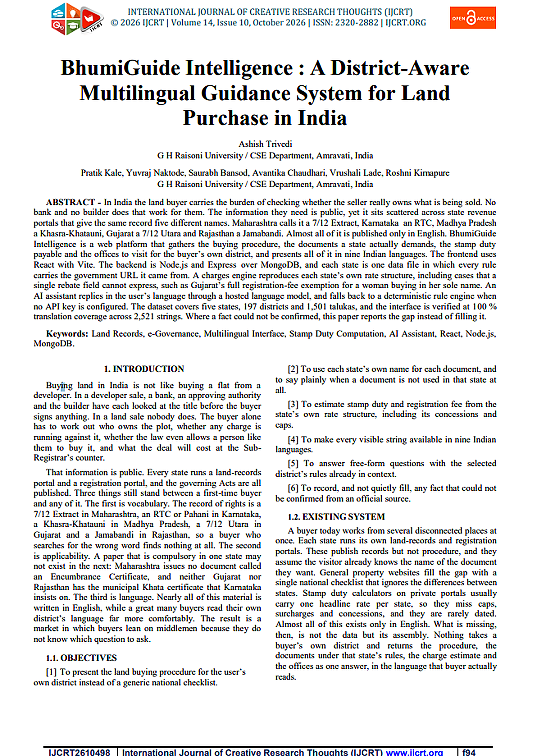

CERTIFICATE OF RESEARCH PUBLICATION




