**Classification**

Performed a classification learning algorithm to find a best model for predicting chronic kidney diseases is present/not.

Based on multiple algorithms performance Logistic Regression & Support Vector Machine looks very good predictive classification model.

**Decision Tree**:

The f1_macro value of best parameter is {'criterion': 'entropy', 'max_features': 'log2', 'splitter': 'best'}: 0.98490261799076

Roc_auc value: 0.9803921568627452

**Random Forest**:

The f1_macro value of best parameter is {'criterion': 'entropy', 'max_features': 'sqrt', 'n_estimators': 100}: 0.9849624060150376

Roc_auc value: 0.9997608799617408

**Support Vector Machine**:

The f1_macro value of best parameter is {'C': 10, 'gamma': 'auto', 'kernel': 'sigmoid'}: 0.9924946382275899

Roc_auc value: 1.0

**LogisticRegression**:

The f1_macro value of best parameter is {'penalty': 'l2', 'solver': 'liblinear'}: 0.98490261799076

Roc_auc value: 0.9985652797704447

**KNN**:

The f1_macro value of best parameter is {'algorithm': 'auto', 'metric': 'minkowski', 'n_neighbors': 3, 'p': 2, 'weights': 'uniform'}: 0.9626932787797391

Roc_auc value: 0.998804399808704

**Naives Bayes**:

GaussianNB:

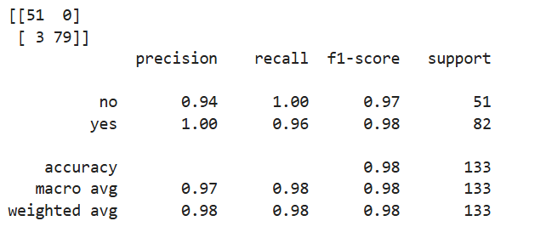

MultinomialNB:

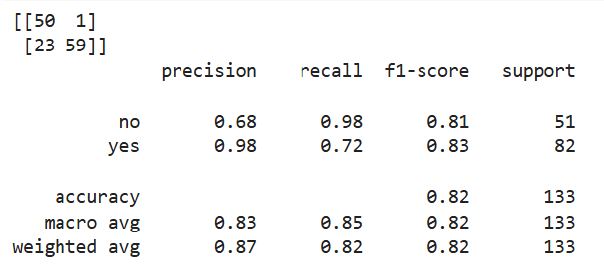

BernoulliNB:

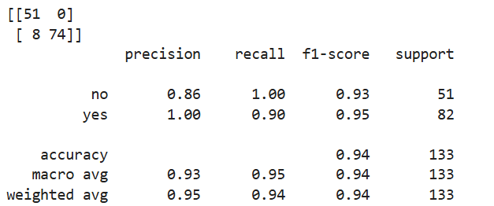

CategoricalNB:

