 | JSPM’s  RAJARSHI SHAHU COLLEGE OF ENGINEERING  TATHAWADE, PUNE-33 | 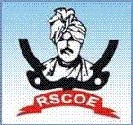
DEPARTMENT OF COMPUTER ENGINEERING

Mini Project
on
“SMS Spam Classifier”

-Submitted by-
Yuvraj Kadam (RBT24CS150)
Roll No.: 09

Class and Division: TY Div C-1
Course: Data Mining and Analytics (DMA)
Academic Year 2026-27
(Semester-I)

- Title

- Abstract

- Introduction

- Problem Statement

- Objectives

- Data set and Libraries required

- Approach/ Methodology

- Implementation

- Results

- Conclusion

