# minor-project-yuvraj-aditya

# 🍽️ MealScale – Smart Recipe & Cooking Guide

**Developed by:** Yuvraj Saini (23FS10BCA00057)
**Semester:** BCA – V Sem
**Subject Code:** CA3170

**Developed by:** Aditya Gandhi (23FS10BCA00009)
**Semester:** BCA – V Sem
**Subject Code:** CA3170

## 📖 Overview
#MealScale is an Android app that personalizes cooking by scaling recipes based on available ingredients, guiding users step-by-step, and including a built-in timer.

🍳 Features
- Splash Screen: A welcoming splash screen (activity_login.xml) to launch the app.
- User Login: A simple login interface to get started. (Note: Functionality to be expanded in future versions).
- Recipe Dashboard: A main screen (activity_main.xml) to display and browse a wide variety of recipes.
- Extensive Recipe Database: Includes dozens of recipes with images, from aloo_gobi to veg_spring_rolls.
- Custom UI: Features custom-styled elements like gradient backgrounds (gradient_background.xml).
🛠️ Technologies Used
- Language: Kotlin
- Platform: Android Native
- IDE: Android Studio
- UI: XML (eXtensible Markup Language)
- Build System: Gradle

🚀 How to Run
To run this project:
- Clone the repository:
- git clone [https://github.com/Yuviiii67/minor-project-yuvraj-aditya.git](https://github.com/Yuviiii67/minor-project-yuvraj-aditya.git)
- Open in Android Studio:
  - Open Android Studio.
  - Select "Open" or "Open an existing Android Studio project".
  - Navigate to the cloned minor-project-yuvraj-aditya folder and select it.
- Sync Gradle: Let Android Studio build the project and sync the Gradle files.
- Run: Select an emulator or a physical device and click the "Run" button.

📸 Screenshots
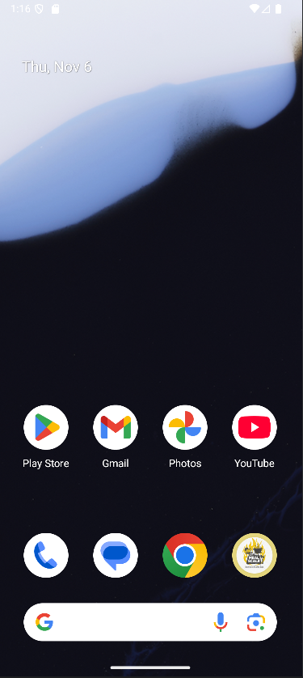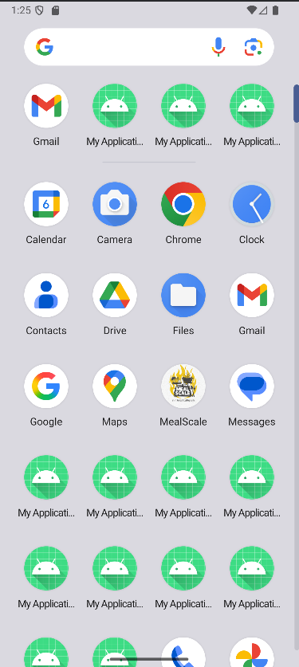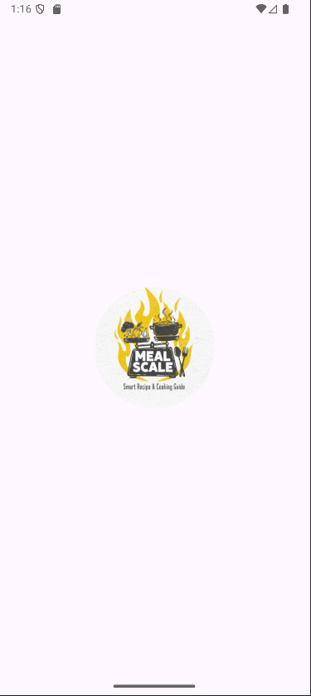

Mobile screen Grid view Splash screen

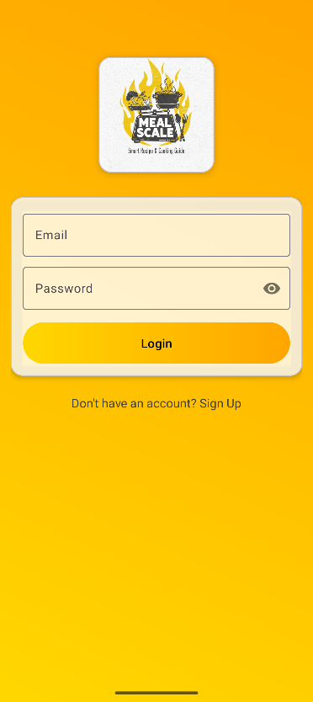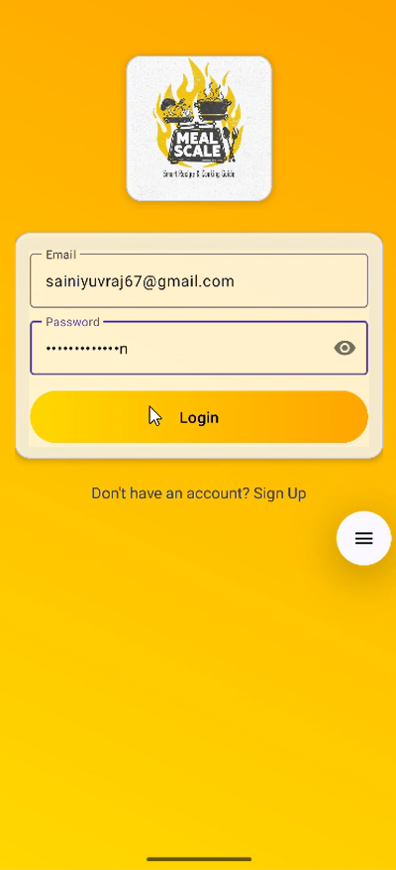
Login page
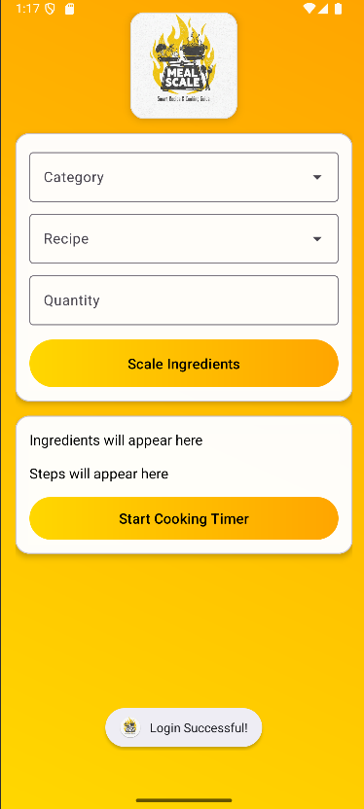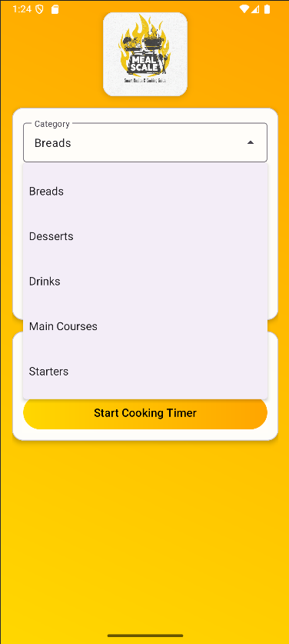
Home page Category

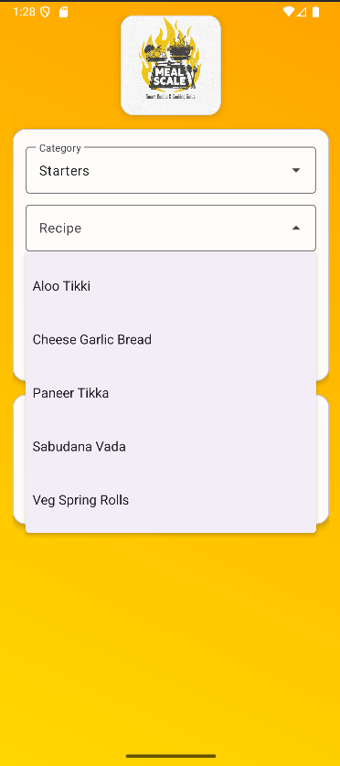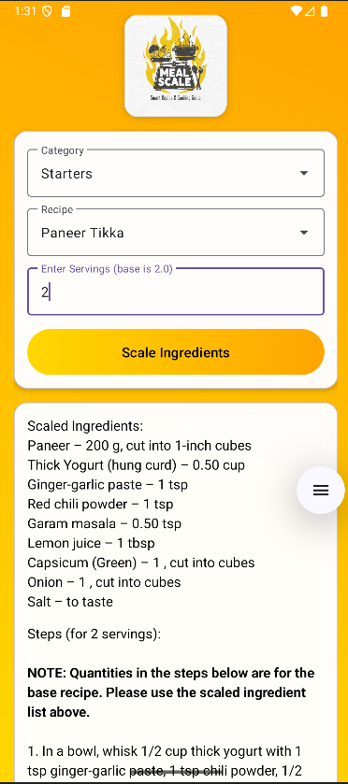
Recipies Serving people for 2

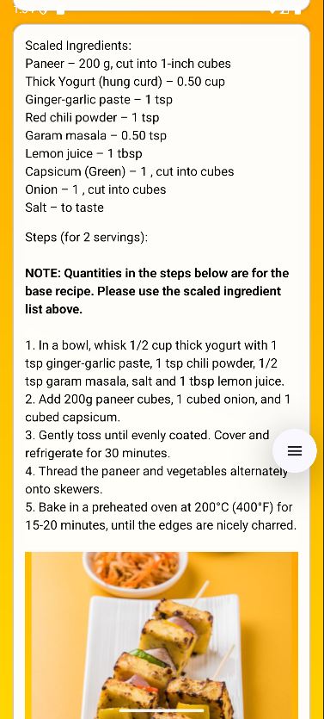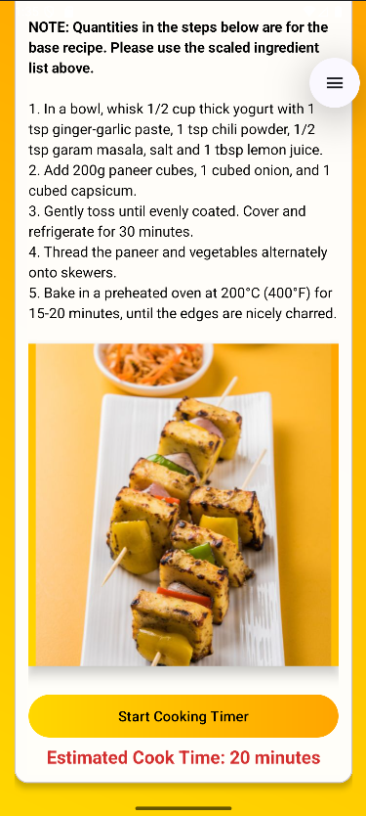
Ingredients and steps how to cook

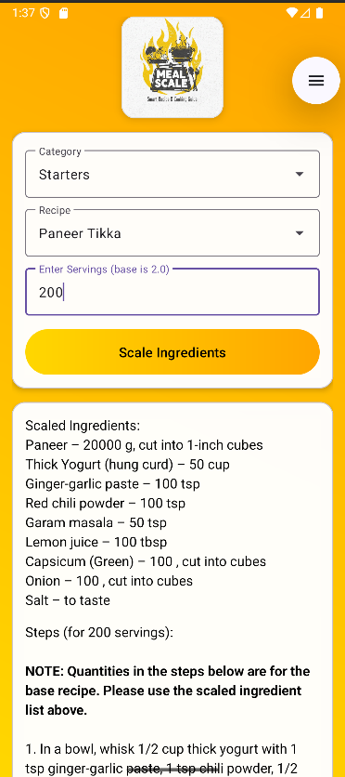
For 200 peoples

## 📁 File Structure Here is the high-level structure of the `app/src` directory, which contains all the source code for the application. ```bash
Tree structure of the recipe app
app
└───src
├───androidTest
│ └───java
│ └───com/example/myapplication
│ └── ExampleInstrumentedTest.kt
│
├───main
│ │ AndroidManifest.xml
│ │
│ ├───java
│ │ └───com/example/myapplication
│ │ LoginActivity.kt
│ │ MainActivity.kt
│ │
│ └───res
│ ├───drawable
│ │ aloo_gobi.png
│ │ paneer_butter_masala.png
│ │ button_gradient.xml
│ │ ... (and 30+ other recipe images)
│ │
│ ├───layout
│ │ activity_login.xml
│ │ activity_main.xml
│ │
│ ├───mipmap-anydpi-v26
│ │ ic_launcher.xml
│ │ ic_launcher_round.xml
│ │
│ ├───mipmap-hdpi (and mdpi, xhdpi, etc.)
│ │ ... (app launcher icons)
│ │
│ ├───values
│ │ colors.xml
│ │ strings.xml
│ │ themes.xml
│ │
│ ├───values-night
│ │ themes.xml
│ │
│ └───xml
│ backup_rules.xml
│ data_extraction_rules.xml
│
└───test
└───java
└───com/example/myapplication
└── ExampleUnitTest.kt

Key Folders
- src/main/java: Contains all the Kotlin source code (.kt files), like MainActivity.kt and LoginActivity.kt.
- src/main/res: Contains all non-code resources.
  - res/drawable: All images and custom shapes used in the app.
  - res/layout: The XML files that define the app's user interface (screens), like activity_main.xml.
  - res/mipmap: The app's launcher icons for different device densities.
  - res/values: Core app values like colors (colors.xml), text strings (strings.xml), and styles (themes.xml).
- src/main/AndroidManifest.xml: The central file that describes the app's components (like its activities) and permissions to the Android system.
- androidTest & test: Folders for writing automated tests (unit tests and instrumentation tests).

