**Introduction to the Project**

**1.1 Introduction:**

The term 'RFID' stands for radio Frequency Identification. In recent years automatic identification procedures (Auto-ID) have become very popular in many service industries, purchasing and distribution logistics, industry, manufacturing companies and material flow systems. Automatic identification procedures exist to provide information about people, animals, goods and products in transit. The omnipresent bar code labels that triggered a revolution in identification systems some considerable time ago, are being found to be inadequate in an increasing of cases. Bar codes may be extremely cheap, but their stumbling block is their low storage   
capacity and the fact that they cannot be reprogrammed. The technically optimal solution would be the storage of data in a silicon chip.

Radio Frequency Identification (RFID) is a generic term for non-contacting technologies that use radio waves to automatically identify people or objects. There are several methods of identification, but the most common is to store a unique serial   
that identifies a person or object on a microchip that is attached to an antenna. The combined antenna and microchip are called an "RFID transponder" or 'RFID tag" and work in combination with an "RFID reader" (sometimes called an "RFID interrogator").

**1.2Project** **Overview:**

In this project we describe the design, construction and operation of a digital voting machine using RFID system and a microcontroller profoundly.

Here, a RFID card is used for identification of a person before giving his vote by placing his RFID Card before the RFID Reader module. When the card is placed before the reader, the details stored with the unique number in the microcontroller will be checked and will displayed. If he/she is eligible for voting, they'll be sent to voting unit where they will giving their vote to the any of the parties candidates   
listed only once. If they try to violate any of the rules like giving their vote more than once or if he/she is not the eligible person, then an alarming Buzzer will activated. And at last by pressing the result switch, the Candidate with maximum votes will declared as winner or it'll be displayed 'Tie'

**Block Diagram and its Description**

**2.1 Basic block diagram:**

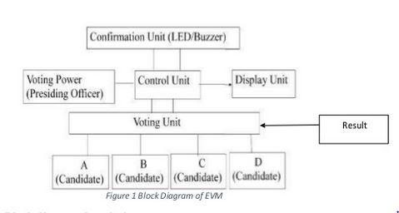

The block diagram comprises of few major blocks as follows,

* Power supply unit
* Voting unit (RFID Module and Microcontroller)
* Conformation Unit (LED/Buzzer)
* Display unit (LCD)

**2.2 Block diagram description:**

**Voting unit:**

It is a combination of two very major units

* WD Module
* Arduino Uno

**2.2.2.1 RFID Reader Module and Card:**

**Tags**

A radio-frequency identification system uses tags, or labels attached to the objects to be identified. Two-way radio transmitter-receivers called interrogators or readers send a signal to the tag and read its response.

RFID tags can be either passive, active or battery-assisted passive. An active tag has an on-board battery and periodically transmits its ID signal. A battery-assisted passive (BAP) has a small battery on board and is activated when in the presence of an RFID reader. A passive tag is cheaper and smaller because it has no battery; instead, the tag uses the radio energy transmitted by the reader. However, to operate a passive tag, it must be illuminated with a power level roughly a thousand times stronger than for signal transmission. That makes a difference in interference and in exposure to radiation.

Tags may either be read-only, having a factory-assigned serial number that is used as a key into a database, or may be read/write, where object-specific data can be written into the tag by the system user. Field programmable tags may be write-once, read-multiple; "blank" tags may be written with an electronic product code by the user.

RFID tags contain at least two parts: an integrated circuit for storing and processing information, modulating and demodulating a radio-frequency (RF) signal, collecting DC power from the incident reader signal, and other specialized functions; and an antenna for receiving and transmitting the signal. The tag information is stored in a non-volatile memory. The RFID tag includes either fixed or programmable logic for processing the transmission and sensor data, respectively.

An RFID reader transmits an encoded radio signal to interrogate the tag. The RFID tag receives the message and then responds with its identification and other information. This may be only a unique tag serial number, or may be product-related information such as a stock number, lot or batch number, production date, or other specific information. Since tags have individual serial numbers, the RFID system design can discriminate among several tags that might be within the range of the RFID reader and read them simultaneously.

**Readers**

RFID systems can be classified by the type of tag and reader. A Passive Reader Active Tag (PRAT) system has a passive reader which only receives radio signals from active tags (battery operated, transmit only). The reception range of a PRAT system reader can be adjusted from 1–2,000 feet (0–600 m)[citation needed], allowing flexibility in applications such as asset protection and supervision.

An Active Reader Passive Tag (ARPT) system has an active reader, which transmits interrogator signals and also receives authentication replies from passive tags.

An Active Reader Active Tag (ARAT) system uses active tags awoken with an interrogator signal from the active reader. A variation of this system could also use a Battery-Assisted Passive (BAP) tag which acts like a passive tag but has a small battery to power the tag's return reporting signal.

Fixed readers are set up to create a specific interrogation zone which can be tightly controlled. This allows a highly defined reading area for when tags go in and out of the interrogation zone. Mobile readers may be hand-held or mounted on carts or vehicles.

**Switching Section:**

It comprises of series of switches (We used Tactile switches) allocated for of parties present. These switching section will be activated only when it receives conformation signal from the Micro controller. i.e. only a valid person with his/her valid RFID card will able to give his vote.

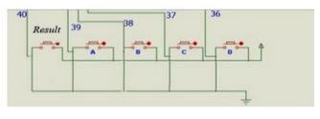

Figure 7: Graphical Representation of Switching section

**2.2.3 Micro controller:**

* It is that heart of this project. We used Uno micro controller.

* It is able to receive unique code from RFID module. Then it checks weather the code is authorized or not by comparing the received code to already stored code.

* If received code and stored code are matched, then it allows the voter to put his vote to either of the parties.
* It also displays voter name and weather he has finished giving his vote or not.

**2.2.4 Conformation unit**

From this unit we are able to know that the voter has voted his vote   
or not. If the vote is successful a buzzer is beeped. And if the voter is a valid voter and if he tries to come again the second time after giving his vote , there Will be a long buzzing sound(for 5 sec) from the buzzer. If the voter is not at all a valid voter then the buzzer Will be on for 3 Here we used a 12 V Buzzer shown in the below figure.

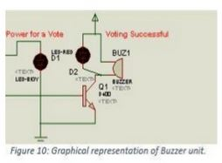 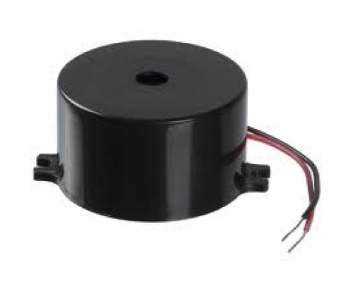

**2.2.5 Display unit:**

* For display purpose we use 20x4 led dispIay.
* It can display 80 characters.
* It is able to display Alpha Numeric Characters.

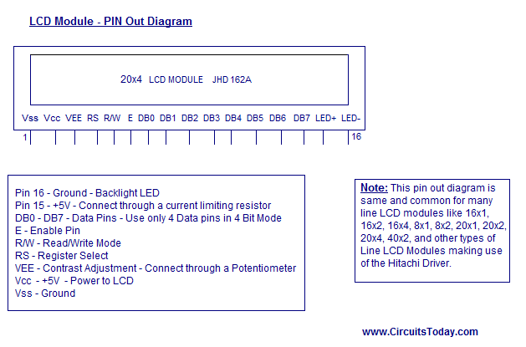

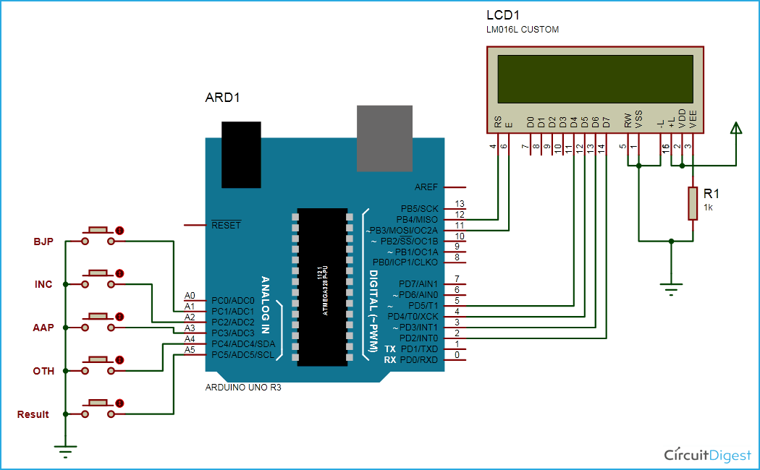**Schematic Diagram**

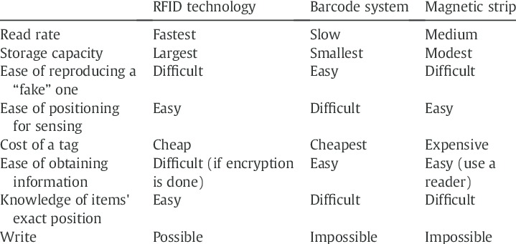

**Hardware Design & Descriptions**

**Procedure Followed While Designing:**

Then we programmed the micro-controller using a software.

Then soldering was done. After completion of the soldering we tested the circuit.

**List of Components:**

Following are the list of components that are used to build the assembly of the power supply unit, voting unit, display unit and for buzzer.

1. Micro controller At-mega 16

2. RFID module

3. RFID cards

4. Switches

5. LCD

**Liquid Crystal Display (LCD):**

An LCD consists of two glass panels, with the liquid crystal material sand witched between in them. The inner surface of the glass plates are coated with transparent electrodes which define the character, symbols or patterns to be displayed on polymeric layers which are present in between electrodes and the liquid crystal, which makes the liquid crystal molecules to maintain a defined orientation angle.

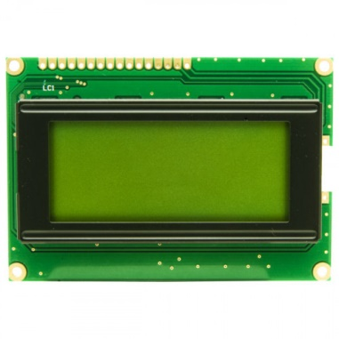

**Software Design**

Another important section in this project is the program code. It can't be possible without writing a code to interface all the major components like Micro controller, RFID cards and LCD.   
The flow chart for easy understanding is given below :-

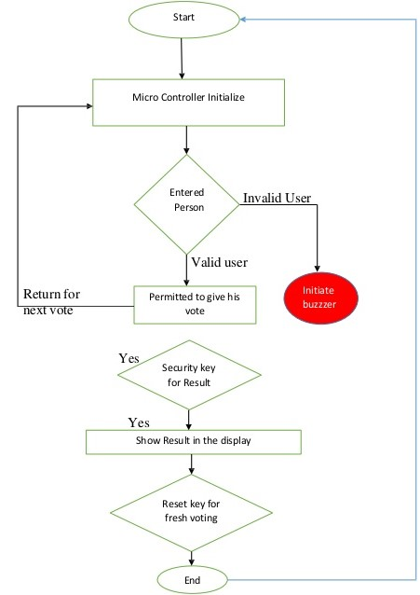

**Evolution**

**Applications:**

* It can used in taking group decisions where voting is confidential.
* It can used in companies, industries, schools, colleges or any private or government sectors.
* It can used for different purposes not only for voting system.

**Advantages:**

* Tampering is not possible.
* Good security can be achieved by using this technology.
* Process for voting would be very easy.

**Disadvantages:**

* If micro controller is damaged, then it'll be difficult to re install, program and solder the part.
* There must be scrutiny of the persons because RFID card is transferable and there can be a chance for a person come with other person’s card.
* Extreme care must be taken to protect the entire circuit/PCB from getting damaged.