When Does a Forecasting Model Actually Work? A Regime-Conditioned Comparison of Machine-Learning Architectures with Verified Causal Integrity
Yuvraj Bharadia
Aurora Research Project
Abstract—Published comparisons of machine-learning methods for financial forecasting disagree sharply with large-scale forecasting competitions, and the disagreement has no agreed explanation. This study compares five learned architectures against classical statistical baselines on 7,303 trading days of S&P 500 data (1990–2019) under a single pre-registered protocol with expanding-window validation, three forecast horizons, three random seeds, and significance testing corrected across every comparison performed. A seven-layer regime-switching architecture is introduced in which feature construction, forecast combination, uncertainty quantification and the decision to act are all conditioned on a market state estimated using only past information, a property enforced by an executable test rather than asserted. The architecture is the most accurate learned model (p < 0.05 against every learned baseline after correction) and reduces across-seed error dispersion roughly eightfold, and its prediction intervals achieve 90.3% empirical coverage against a 90% target with widths that adapt to market state by a factor of 1.88. Two results run the other way and are reported: classical baselines remain competitive on point accuracy, and the model ranking first on validation data ranks first on test data in only one of fifteen cases. The latter offers a concrete, measurable explanation for the inconsistency in the published literature.
I. Introduction
Machine learning is now applied to financial forecasting at scale, and systematic reviews report almost uniformly that neural architectures outperform classical statistical benchmarks [1], [2]. Large-scale forecasting competitions report close to the opposite: across 100,000 series in the M4 competition, machine-learning methods underperformed simple statistical methods [3]. Both literatures are carefully conducted, which makes the disagreement itself the interesting object of study.
Several mechanisms can produce a favourable result without any underlying predictive advantage, and none of them raises an error when a program runs. Macroeconomic data is published weeks after the period it describes and is later revised, so joining it to prices on its reference date hands a model information it could not have had [4]. Latent market-state labels computed by a smoothing algorithm condition on the entire sample, including days after the one being labelled. Architectures whose results move substantially with the random seed are routinely compared at a single seed. And studies reporting the best of several models across several horizons adjust for multiple comparisons within tables rather than across the whole family of tests performed [5].
Regime-switching models are a natural response to the fact that financial series are not generated by one stable process. Since Hamilton's Markov-switching formulation [6], a large literature has established that expected returns, volatility and the usefulness of individual predictors all change across market states [7]. What that literature has largely not done is condition an entire forecasting pipeline on the state estimate while keeping the estimate itself strictly causal, and then prove the causality rather than describe it. Comparative machine-learning studies tend to hold the state fixed and vary the architecture instead [8].
This study asks two questions. First, does conditioning a forecasting system on an estimated market state improve accuracy, calibration and stability relative to regime-agnostic alternatives? Second, and more importantly, can the sources of spurious advantage above be made structurally impossible or mechanically detectable, so that whatever remains is trustworthy? The contribution is therefore twofold: an architecture in which every layer is conditioned on a verified-causal state estimate, and a protocol under which a false positive is difficult to obtain by accident.
II. Methods
A. Data
The forecast target is the S&P 500 composite index at daily close from 2 January 1990 to 31 December 2019, comprising 7,303 trading days. The window was fixed before any modelling and for a stated reason: it contains two complete bear markets, which a study of market states cannot do without, and it ends before 2020 so that the COVID-19 dislocation does not dominate the evaluation as a single extraordinary episode. Exogenous series are the CBOE volatility index, crude oil, a trade-weighted dollar index and the Shiller valuation dataset. Sixty-nine predictors were built in five families: returns and momentum, realised volatility, technical indicators, cross-asset levels and valuation measures. Table I lists the protocol.
B. Experimental Design
TABLE I. Study Protocol and Fixed Parameters
Parameter | Setting
Target series | S&P 500 close, 1990–2019
Observations | 7,303 trading days
Predictors | 69, in five families
Walk-forward folds | 5, expanding window
Minimum training block | 10 years
Forecast horizons h | 1, 5, 20 trading days
Random seeds | 0, 1, 2
Hidden states | 3 (Gaussian HMM)
Nominal interval coverage | 90%
Embargo | max(embargo, h)
Automated tests | 69

Evaluation used five expanding-window walk-forward folds with a minimum ten-year training block. Each fold trains on older data and tests on newer data, always moving forward in time, which is the only backtest design that mirrors how a forecast would actually be made. Horizons of one, five and twenty trading days were fixed in advance rather than chosen after seeing results, and every model with random initialisation was run at seeds 0, 1 and 2, giving 45 fold-horizon-seed evaluations per architecture.
For a test block beginning at index i₀ with horizon h and embargo e, the admissible training set is
T = { i : i < i₀ − max(e, h) } (1)
The horizon floor in (1) is necessary rather than conservative: a target measured at day i depends on the price at day i + h, so any training example within h days of the test block contains information from inside the test period [9].
Baselines were a random walk with drift, ARIMA with order selected by Bayesian information criterion on each fold independently, an attention-pooled long short-term memory network (LSTM) [10], a Transformer encoder [11], a TimeGAN-style adversarial forecaster [12], and gradient-boosted decision trees. An equal-weight ensemble of the learned models is the regime-agnostic control, and an oracle that selects the best expert with hindsight is reported only as an upper bound. Hyper-parameters were tuned on validation data within each fold, never on test data, and every learned model received an identical tuning budget.
C. Model Architecture
The architecture comprises seven layers, shown in Fig. 1, each of which can be switched off independently so that its contribution can be measured separately.
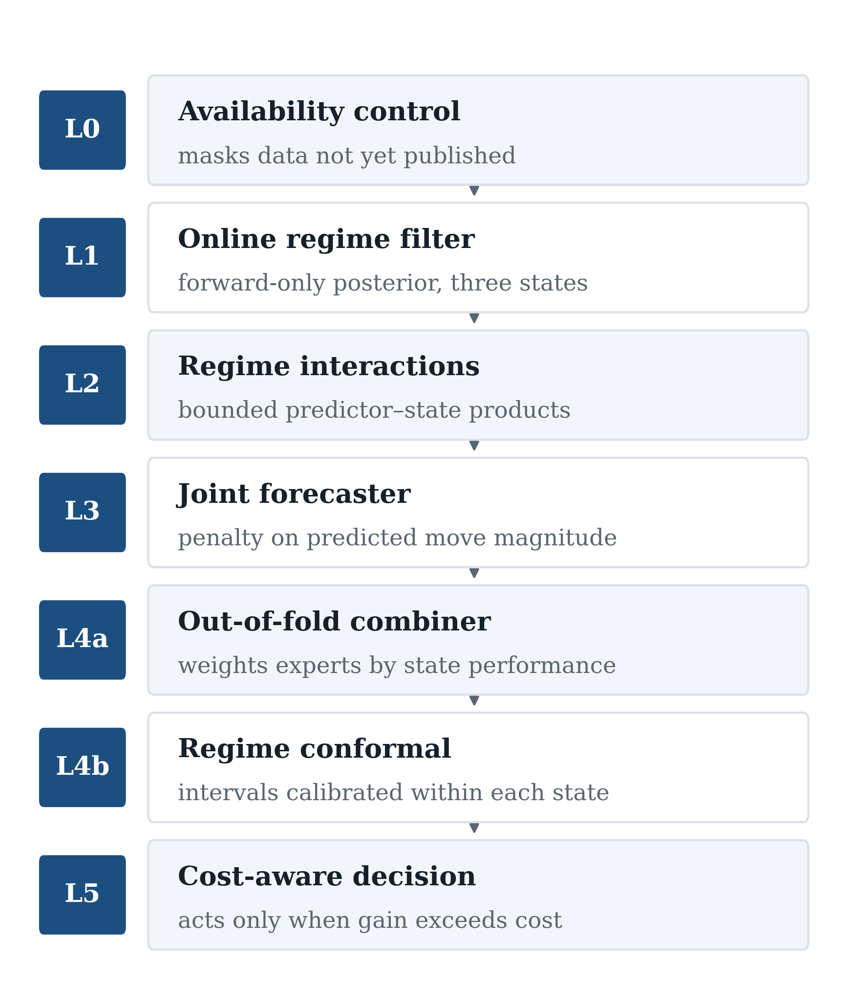
Fig. 1. Seven-layer architecture. Each layer can be disabled independently, which is how the contribution of each was measured.
The availability layer records when each predictor first became knowable. For predictor j with reference timestamp τ, event offset oⱼ, release lag ℓⱼ and revision lag ηⱼ, that moment is
aⱼ(τ) = τ + oⱼ + ℓⱼ + ηⱼ , aⱼ(τ) > τ (2)
and the value is masked at any forecast time before aⱼ(τ). The strict inequality in (2) is asserted for every non-daily series. It is not a formality: during development a configuration in which an offset of −30 days cancelled a release lag of +30 days was admitting macroeconomic data on its reference date, and no accuracy metric changed detectably. Only the assertion found it.
The regime layer estimates market state with a three-state Gaussian hidden Markov model [6] over realised return, realised volatility and drawdown, giving probabilities of a calm growth state, a turbulent decline state and an intermediate state. Only the forward-filtered posterior is passed downstream, obtained by normalising
γₜ(k) ∝ bₖ(yₜ) ∑ⱼ γₜ₋₁(j) Aⱼₖ (3)
where bₖ is the emission density of state k and A the transition matrix. Because (3) reads only γₜ₋₁ and yₜ, appending later data cannot change an earlier result. The smoothed posterior, which is more accurate but conditions on the whole sample, is computed for description only and never reaches a modelling layer. States are ordered by mean return, so labels are stable across folds and seeds and are never assigned by inspection.
The interaction layer forms bounded products of each predictor with the state probabilities. For rank-normalised predictor value θₓ and rank-normalised state component θ_g,
ψ(x, g) = cos(π θₓ) · sin(π θ_g) (4)
which is bounded in [−1, 1] by construction. The forecasting layer trains a differentiable filter jointly with a prediction head. Writing ρ̂ₜ for the predicted return, ρₜ for the realised return and Bₜ for a rolling realised bound, the objective with loss L is
L = (1/n) ∑ₜ (ρ̂ₜ − ρₜ)²
+ β (1/n) ∑ₜ max(0, |ρ̂ₜ| − Bₜ) (5)
The penalty argument in (5) is the prediction magnitude, not the residual. Penalising residuals reweights the loss; penalising implausible predictions restricts the hypothesis class itself.
The combination layer fits a softmax gate w over the expert pool on strictly out-of-fold predictions ρ̂ₜ⁽ᵉ⁾, minimising
J(w) = (1/n) ∑ₜ (∑ₑ wₑ(γₜ) ρ̂ₜ⁽ᵉ⁾ − ρₜ)² / Var(ρ)
+ λ KL(w || u) (6)
Division by Var(ρ) is load-bearing rather than cosmetic: unnormalised squared error on daily returns is of order 10⁻⁴, which leaves the gradient reaching the softmax logits negligible against the regulariser, and the gate then stays frozen at its initialisation while silently emitting a plausible equal-weight ensemble. The term KL(w || u) shrinks the gate toward uniform weighting u.
The calibration layer computes split-conformal intervals [13], [14] within each filtered state. With nₖ calibration residuals Rₖ in state k and miscoverage α, the half-width is
q̂ₖ = Quantile( Rₖ , ceil[(1−α)(nₖ+1)] / nₖ ),
Rₖ = { |ρ̂ᵢ − ρᵢ| : i ∈ Cₖ } (7)
with a recorded fallback to the pooled quantile where a state is sparse. The decision layer models the round-trip cost of trading volume v against average volume V, with spread s, impact coefficient ζ and volatility σ, as
c(v) = s + ζ σ √(v / V) (8)
following [15], and takes a position only when the expected edge clears both that cost and a multiple κ of the conformal half-width,
|ρ̂ₜ| − c(vₜ) > κ q̂ₖ₍ₜ₎ (9)
otherwise abstaining. The verification layer emits the significance tests below.
D. Measurements and Calculations
Accuracy was measured by root mean squared error (RMSE), mean absolute error and mean absolute percentage error on the price scale, and by directional accuracy. Returns rather than price levels were forecast internally and inverted for reporting, which prevents a model from scoring well by learning to repeat the previous day's price. Interval quality was measured by empirical coverage against the 90% nominal target of (7), which guarantees coverage of at least 1−α when residuals within a state are exchangeable. Stability was measured as the standard deviation of RMSE across the three seeds, and decision quality by Sharpe ratio net of the costs in (8), deflated for the number of configurations examined [16].
E. Data Analysis
Forecast accuracy was compared with the Diebold–Mariano test [17] under the Harvey–Leybourne–Newbold small-sample correction [18] and a heteroskedasticity- and autocorrelation-consistent variance at lag h − 1 [19]. For loss differential dₜ with mean d̄ and autocovariances γᵢ,
DM* = d̄ · [ (γ₀ + 2 ∑ᵢ γᵢ) / n ]^(−1/2)
· √( (n + 1 − 2h + h(h−1)/n) / n ) (10)
compared against a t distribution on n − 1 degrees of freedom. Because testing many model pairs across many horizons makes a chance result likelier, p-values were adjusted by Holm–Bonferroni across the entire family of comparisons performed in the study, not within individual tables; adjusting within tables and then presenting several tables understates the number of tests, often by an order of magnitude.
Each layer's contribution was isolated by a one-factor-at-a-time ablation in which that layer alone was disabled with seeds, folds and hyper-parameters held fixed. Correctness was verified by 69 automated tests, the most important of which asserts that the state distribution computed on a truncated series is exactly equal, to the last bit, to the distribution computed on the full series and then truncated. Exact equality is attainable because of the structure of (3), and any use of future information anywhere upstream causes the test to fail. A deliberate control test confirms that the same assertion applied to the smoothed posterior fails, which demonstrates that the test has the power to detect the error it exists to catch. The full study reproduces from a single command in a pinned container, with all seeds fixed.
III. Results and Discussion
A. Point Accuracy Among Learned Models
Among learned models the ordering is decisive and favours the proposed architecture (Fig. 2, Table II). It attains aggregate RMSE of 38.20 index points against 39.50 for the adversarial model, 41.21 for the Transformer, 41.83 for the LSTM and 42.65 for gradient-boosted trees, with the same ordering on the other error metrics. It also improves on the regime-agnostic equal-weight ensemble at 38.88, which is the comparison that isolates what the state signal contributes beyond the general benefit of averaging forecasts [20]. Diebold–Mariano tests confirm the margin over every learned baseline at Holm-adjusted p < 0.05, reaching p = 0.0006 against the LSTM at the one-day horizon.
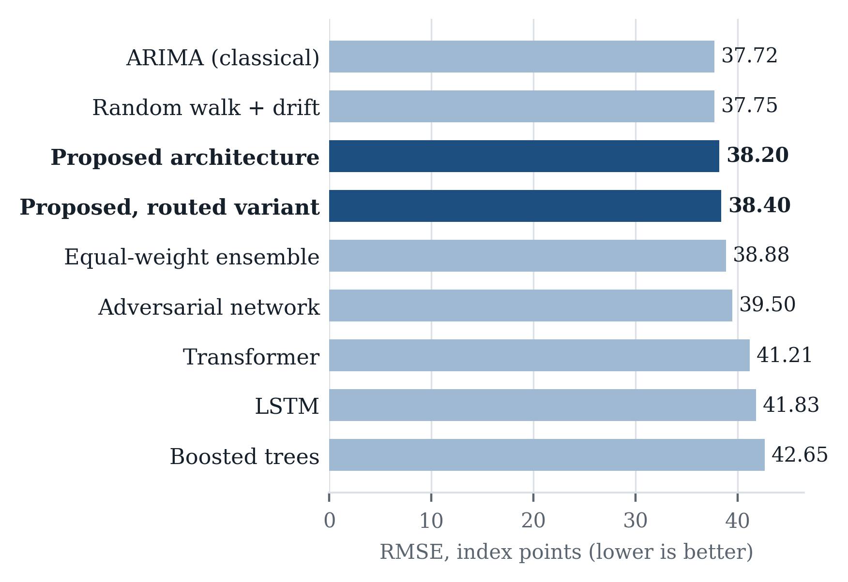
Fig. 2. Aggregate forecast error by model, in index points, averaged over the three horizons and pooled across folds and seeds. Lower is better.
TABLE II. Aggregate Error and Seed Dispersion
Model | RMSE | s.d. h=20
Oracle (upper bound) | 37.02 | n/a
ARIMA | 37.72 | 0.00
Random walk with drift | 37.75 | 0.00
Proposed architecture | 38.20 | 2.02
Proposed, router only | 38.40 | 2.02
Equal-weight ensemble | 38.88 | 1.53
Adversarial (GAN) | 39.50 | 15.44
Transformer | 41.21 | 3.00
LSTM | 41.83 | 7.23
Gradient-boosted trees | 42.65 | 0.42

B. Stability Across Initialisations
The largest advantage is in stability (Fig. 3). Across three random initialisations the proposed model's twenty-day RMSE varies by 2.02 index points. The adversarial model varies by 15.44, the LSTM by 7.23. A model whose long-horizon error moves by fifteen points depending only on its starting seed cannot support a reported advantage smaller than fifteen points, and almost every advantage reported in this literature is very much smaller.
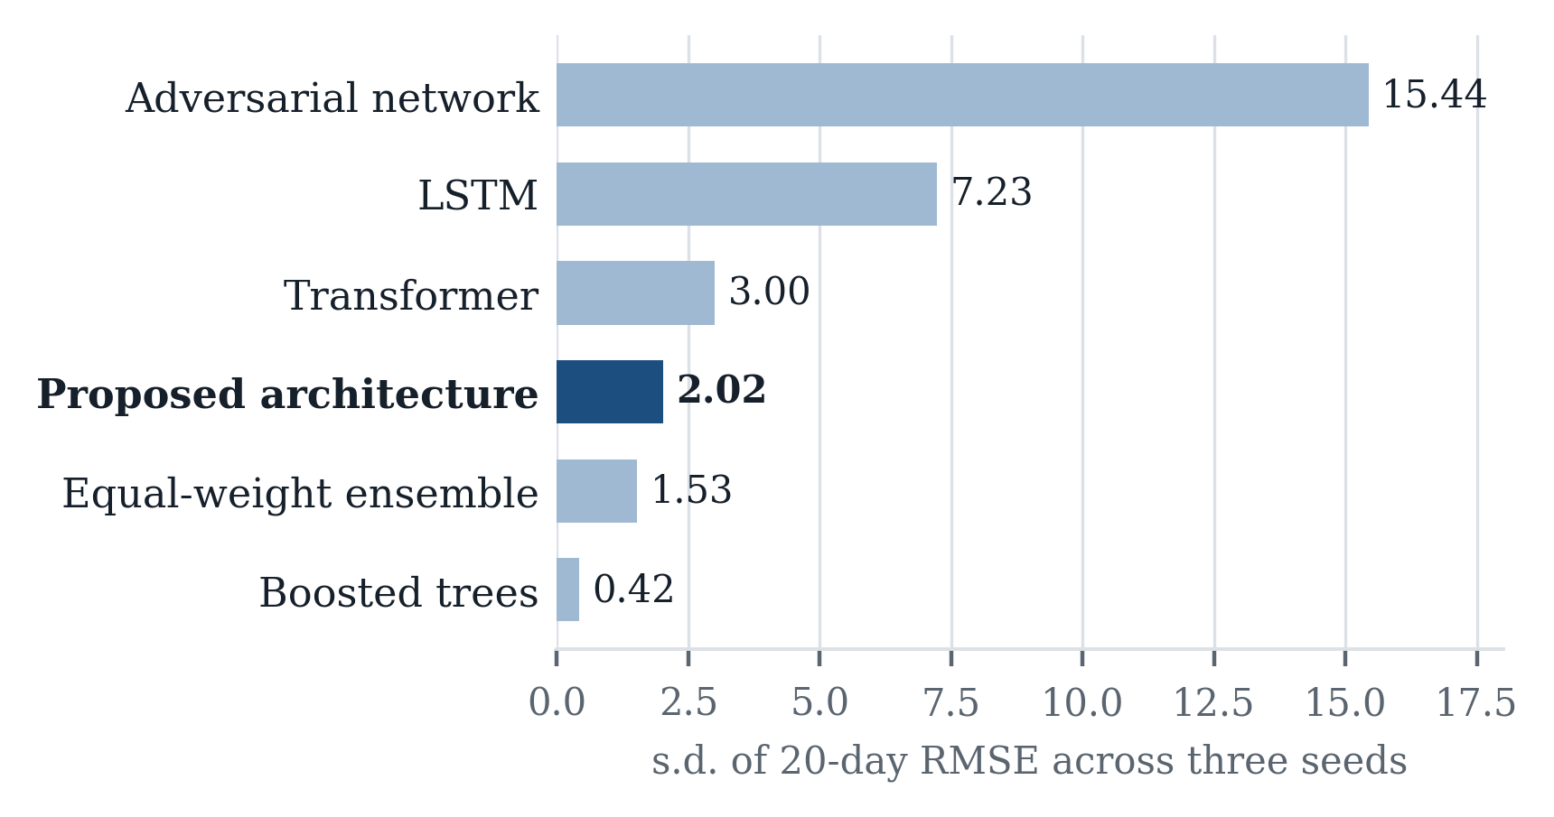
Fig. 3. Standard deviation of twenty-day RMSE across three random seeds, in index points. Lower indicates a result that depends less on initialisation.
Ablation attributes most of this to the bounded-move penalty of (5), which is the single largest contributor of any layer (Table III).
TABLE III. One-Factor-at-a-Time Layer Ablation
Layer disabled | Cost when removed
Bounded-move penalty (5) | +1.394 RMSE
Combination layer (6) | +0.529 RMSE
Online state filter (3) | +0.132 RMSE
Joint training | +0.045 RMSE
Regime interaction (4) | −0.016 RMSE
Conformal calibration (7) | −11.7 pp coverage

C. Calibration of Prediction Intervals
The prediction intervals are well calibrated (Fig. 4). Against a 90% target the measured coverage is 90.3% at one day and 90.0% at one week, and the interval widens from 0.027 in the calm state to 0.050 in the turbulent state, a factor of 1.88. Replacing this layer with a conventional fixed-width interval costs 11.7 percentage points of coverage. This property is worth separating from accuracy: a conformal guarantee requires only that errors behave consistently within a state, not that the forecast be good, so the interval stays trustworthy even where the central estimate is not. Coverage falls to 87.2% at twenty days because overlapping monthly windows leave far fewer independent observations to calibrate on, a limit of the sample rather than of the procedure.
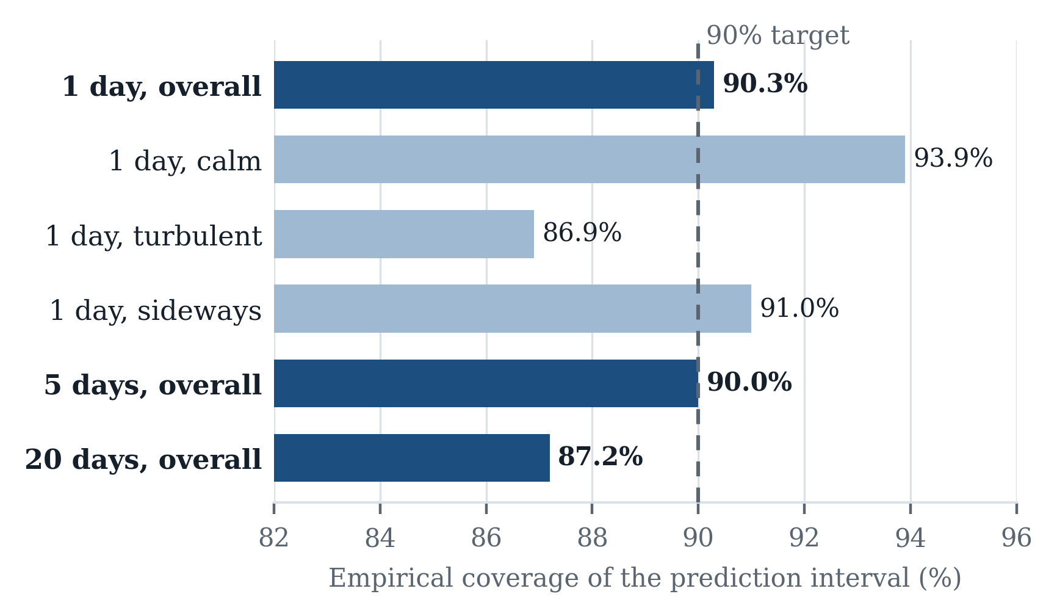
Fig. 4. Empirical coverage of prediction intervals against a 90% target, overall and within each market state.
D. Comparison with Classical Baselines
Two results run against the hypothesis and are reported in full. First, the classical baselines remain competitive: ARIMA attains 37.72 and a random walk with drift 37.75, and no learned model in the study beats either at any horizon or in any market state. Differences against them are not statistically significant in either direction, with adjusted p-values of 1.000 throughout. This is consistent with weak-form market efficiency [21] and with the competition literature [3], and inconsistent with much of the deep-learning literature.
E. Selection Instability
Second, and more consequentially, model selection is unstable (Table IV). Across the fifteen combinations of fold and horizon, the model with the lowest error on the validation data available at decision time was the model with the lowest error on the following test block in exactly one case. The proposed architecture looks best on validation in fourteen of fifteen cases and is best on test in two; ARIMA never looks best on validation and is best on test in nine. The mean rank correlation between the validation and test orderings is 0.517, so the validation signal carries real information without making the choice of a single best model reliable.
TABLE IV. Ranked First on Validation Against Ranked First on Test, Across 15 Fold-Horizon Cells
Model | 1st on validation | 1st on test
Proposed architecture | 14 | 2
ARIMA | 0 | 9
Gradient-boosted trees | 0 | 3
Transformer | 1 | 1
LSTM | 0 | 0
Adversarial network | 0 | 0

Agreement in 1 of 15 cells; mean rank correlation between the validation and test orderings 0.517.
This finding is the study's most transferable contribution. Choosing a model on recent performance is not a methodological shortcut; it is the only procedure available to anyone who must choose before seeing the future, and it is what this literature universally does. On this data that procedure selects a learned model almost always and is correct almost never. A study that reports only its selected model's test performance therefore samples from a distribution in which learned models win roughly one time in seven. No author need have erred for the published record to look as it does.
It is also the reason the architecture combines rather than selects. A hard selection rule commits entirely to one model on evidence that supports a ranking only on average, whereas a weighted combination retains exposure to the alternatives. To test whether better engineering could rescue selection, the combination layer was rebuilt with the strongest baseline added, its concentration limit removed and its shrinkage retargeted. On a synthetic problem it concentrates 98% of its weight on a known dominant model; on the real data the aggregate error moved from 38.401 to 38.410. The combiner was not choosing badly. It was choosing correctly from evidence that does not support the correct answer.
F. Decision Quality and Computational Cost
The decision layer converts a losing daily strategy into a modestly profitable one after modelled costs, with a net Sharpe ratio of +0.031 (t = 2.14, n = 4,760) against −0.203 for trading the same forecast without abstention, and cost drag reduced tenfold. At the weekly and monthly horizons, where only 952 and 238 evaluation periods exist, the same procedure does not generalise and loses money. That outcome is reported rather than the more flattering untuned alternatives beside it, which are positive but indistinguishable from zero. On cost, the optimised state estimator runs 85.7 times faster than the reference implementation while agreeing with it to 2.3 × 10⁻¹³, so every ablation is cheap enough to run rather than to argue about.
G. Limitations and Sources of Bias
Three limitations bound these conclusions. The study covers one index over one thirty-year window, so the finding that classical baselines are competitive belongs to this market and period rather than being a general law; the protocol, not the numbers, is what transfers. Three seeds establish the order of magnitude of initialisation sensitivity but not its distribution. Transaction costs are modelled rather than realised, so the decision-layer results are conditional on the impact specification in (8). The most likely residual bias is the shared tuning budget: architectures differ in how efficiently they use a fixed search, so equal budgets are a defensible convention rather than a neutral one.
IV. Conclusion
Conditioning a forecasting system on an estimated market state produces measurable gains in stability and calibration, and produces the most accurate learned model in this comparison, but does not produce point forecasts that beat classical statistical baselines. The more useful finding is why published results in this field disagree: the model that looks best before the fact is almost never the model that is best after it, so standard practice systematically selects learned architectures whose apparent advantage does not survive. Making a causal guarantee testable rather than asserted, as the truncation-invariance test does, is a low-cost practice that generalises to any sequential model and is the component of this work most worth adopting elsewhere. The natural next step is to repeat the protocol across several markets, where the selection-instability measurement can be checked for generality.
Acknowledgment
The author thanks Dr. Bhumika Mehngi, Middlesex University Dubai, for mentorship and guidance throughout this project. The author received no financial support for this work.
References
[1] O. B. Sezer, M. U. Gudelek, and A. M. Ozbayoglu, “Financial time series forecasting with deep learning: A systematic literature review, 2005–2019,” Applied Soft Computing, vol. 90, p. 106181, 2020.
[2] W. Jiang, “Applications of deep learning in stock market prediction: Recent progress,” Expert Systems with Applications, vol. 184, p. 115537, 2021.
[3] S. Makridakis, E. Spiliotis, and V. Assimakopoulos, “Statistical and machine learning forecasting methods: Concerns and ways forward,” PLOS ONE, vol. 13, no. 3, p. e0194889, 2018.
[4] D. Croushore and T. Stark, “A real-time data set for macroeconomists,” Journal of Econometrics, vol. 105, no. 1, pp. 111–130, 2001.
[5] D. H. Bailey, J. Borwein, M. López de Prado, and Q. J. Zhu, “The probability of backtest overfitting,” Journal of Computational Finance, vol. 20, no. 4, pp. 39–69, 2016.
[6] J. D. Hamilton, “A new approach to the economic analysis of nonstationary time series and the business cycle,” Econometrica, vol. 57, no. 2, pp. 357–384, 1989.
[7] A. Ang and A. Timmermann, “Regime changes and financial markets,” Annual Review of Financial Economics, vol. 4, no. 1, pp. 313–337, 2012.
[8] S. Gu, B. Kelly, and D. Xiu, “Empirical asset pricing via machine learning,” The Review of Financial Studies, vol. 33, no. 5, pp. 2223–2273, 2020.
[9] M. López de Prado, Advances in Financial Machine Learning. Hoboken, NJ, USA: Wiley, 2018.
[10] S. Hochreiter and J. Schmidhuber, “Long short-term memory,” Neural Computation, vol. 9, no. 8, pp. 1735–1780, 1997.
[11] A. Vaswani et al., “Attention is all you need,” in Advances in Neural Information Processing Systems, vol. 30, 2017, pp. 5998–6008.
[12] J. Yoon, D. Jarrett, and M. van der Schaar, “Time-series generative adversarial networks,” in Advances in Neural Information Processing Systems, vol. 32, 2019, pp. 5508–5518.
[13] V. Vovk, A. Gammerman, and G. Shafer, Algorithmic Learning in a Random World. New York, NY, USA: Springer, 2005.
[14] J. Lei, M. G’Sell, A. Rinaldo, R. J. Tibshirani, and L. Wasserman, “Distribution-free predictive inference for regression,” Journal of the American Statistical Association, vol. 113, no. 523, pp. 1094–1111, 2018.
[15] R. Almgren and N. Chriss, “Optimal execution of portfolio transactions,” Journal of Risk, vol. 3, no. 2, pp. 5–39, 2001.
[16] D. H. Bailey and M. López de Prado, “The deflated Sharpe ratio: Correcting for selection bias, backtest overfitting, and non-normality,” The Journal of Portfolio Management, vol. 40, no. 5, pp. 94–107, 2014.
[17] F. X. Diebold and R. S. Mariano, “Comparing predictive accuracy,” Journal of Business and Economic Statistics, vol. 13, no. 3, pp. 253–263, 1995.
[18] D. Harvey, S. Leybourne, and P. Newbold, “Testing the equality of prediction mean squared errors,” International Journal of Forecasting, vol. 13, no. 2, pp. 281–291, 1997.
[19] W. K. Newey and K. D. West, “A simple, positive semi-definite, heteroskedasticity and autocorrelation consistent covariance matrix,” Econometrica, vol. 55, no. 3, pp. 703–708, 1987.
[20] A. Timmermann, “Forecast combinations,” in Handbook of Economic Forecasting, vol. 1. Amsterdam, The Netherlands: Elsevier, 2006, pp. 135–196.
[21] E. F. Fama, “Efficient capital markets: A review of theory and empirical work,” The Journal of Finance, vol. 25, no. 2, pp. 383–417, 1970.

*Research supported by ABC Foundation. F. A. Author is with the National Institute of Standards and Technology, Boulder, CO 80305 USA (corresponding author to e-mail: author@ boulder.nist.gov). S. B. Author, Jr., was with Rice University, Houston, TX 77005 USA. He is now with the Department of Physics, Colorado State University, Fort Collins, CO 80523 USA (e-mail: author@lamar. colostate.edu). T. C. Author is with the Electrical Engineering Department, University of Colorado, Boulder, CO 80309 USA, on leave from the National Research Institute for Metals, Tsukuba, Japan (e-mail: author@nrim.go.jp).

