**UTA025**

**INNOVATION AND ENTREPRENEURSHIP**

**LAB ASSIGNMENT-1**

**BIG FIVE PERSONALITY TRAITS**

**“OCEAN THEORY”**

**Submitted by:**

**Yuvraj Singh Chauhan**

**102103664**

**B.E. III Year**

**Group No: 3COE24**

**Submitted to:**

**Dr. Richa Babbar**

# The OCEAN Theory

The OCEAN model, also known as the Big Five personality traits, is a widely accepted and research-backed framework used to describe and assess human personality. It

comprises five major dimensions:-

O- Openness: The degree of openness, creativity, and willingness to engage with new ideas and experiences.

C- Conscientiousness: The level of organization, responsibility, and diligence in managing tasks and meeting goals.

E- Extraversion: The degree of sociability, assertiveness, and enthusiasm in social interactions.

A- Agreeableness: The extent of cooperativeness, empathy, and friendliness in interpersonal relationships.

N- Neuroticism: The level of emotional stability and resilience in facing stress and negative emotions.

These traits are considered relatively stable over time and across different situations, forming a foundational framework for understanding and studying personality differences. The Big Five model is widely accepted in psychology and provides a

comprehensive way to describe and analyze individual variations in personality.

Below is an analysis that compares the personality traits of two prominent entrepreneurs, **Chad Hurley (founder of YouTube) and Harshil Mathur (founder of Razorpay)**, using the OCEAN theory.

# A Comparison between the personality traits:

**X** : Represents Chad Hurley

* : Represents Harshil Mathur

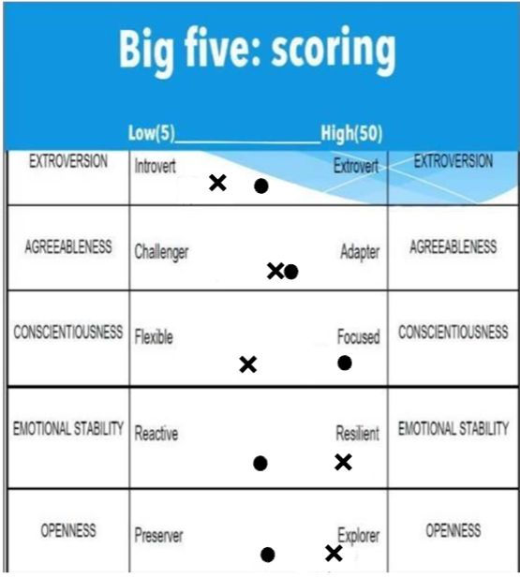

# Chad Hurley

Chad Hurley is the co-founder of YouTube, a platform that revolutionized online video sharing. Born in 1977, Hurley, along with his partners Steve Chen and Jawed Karim, founded YouTube in 2005. The platform quickly became the go-to site for user-generated content, changing the way people share and consume videos globally. Hurley's role in YouTube's success reflects his openness to new ideas, creativity, and a certain level of emotional resilience, as the platform faced and overcame various challenges in its journey to becoming one of the most visited websites on the internet.



**Openness (40):** Chad Hurley's entrepreneurial journey reflects a profound sense of openness to new ideas and experiences, most notably demonstrated through the creation of YouTube. As a co-founder of the groundbreaking platform, Hurley played a pivotal role in reshaping the landscape of online video sharing. The boldness and innovation behind YouTube, which allowed users to freely express themselves through video content, underscore his high level of openness. This trait fueled the platform's success and its transformative impact on how people consume and share media globally

**Conscientiousness (33):** Balancing creativity with organizational demands, Chad Hurley demonstrated a moderate level of conscientiousness in managing the rapidly growing platform. The development and maintenance of YouTube required meticulous attention to technical infrastructure, copyright concerns, and user experience. While his creativity and openness played a significant role, the need for a structured approach in handling the challenges of a burgeoning platform showcased Hurley's ability to blend creative vision with pragmatic organization.

**Extraversion (28):** While assertive in promoting YouTube, Chad Hurley exhibited a low to moderate level of extraversion. Although he was instrumental in marketing and advancing the platform, his personality did not necessarily align with an extremely outgoing demeanour. Instead, Hurley's focus on the platform's features and functionality took precedence over an overtly extroverted public persona.

**Agreeableness (37):** The user-friendly nature of YouTube points towards a moderate level of agreeableness in Chad Hurley's personality. The platform's design prioritized a positive user experience, reflecting a cooperative and amiable approach. However, while the user interface suggests agreeableness in a professional context, his interpersonal relationships, not extensively documented, may not prominently showcase this trait.

**Neuroticism (42):** The success of YouTube and its journey through challenges indicates a high level of emotional stability and resilience in Chad Hurley. The ability to navigate the complexities and uncertainties of building and sustaining a platform as significant as YouTube underscores his emotional strength and stability.

# Harshil Mathur

Harshil Mathur is the co-founder of Razorpay, a leading financial technology company based in India. Born in 1991, Mathur played a pivotal role in establishing Razorpay in 2014, offering digital payment solutions for businesses. Razorpay has since become a key player in the fintech sector, providing payment gateway services and other financial products. Harshil Mathur's leadership reflects a combination of openness to venture into the evolving fintech space, conscientiousness in managing a tech startup, and agreeableness in fostering collaboration within the financial industry. His role requires a degree of emotional stability to navigate the challenges inherent in the dynamic fintech landscape.

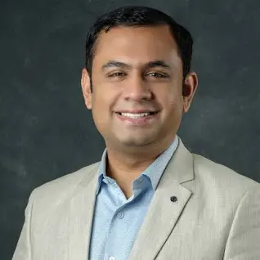

**Openness (36):** Harshil Mathur's venture into the fintech space with Razorpay reflects a moderate level of openness. While not as groundbreaking as YouTube, his decision to establish a fintech company demonstrates a willingness to engage with new and evolving ideas in the financial technology sector.

**Conscientiousness (41):** Essential for running a fintech company, Harshil Mathur exhibits a high level of conscientiousness. The intricate nature of financial transactions and the regulatory landscape demands meticulous attention to detail, organization, and responsibility – qualities that are central to the success of Razorpay under Mathur's leadership.

**Extraversion (34):** Harshil Mathur's moderate level of extraversion is evident in his role in networking and promoting Razorpay within the tech and finance industry. While not an extremely outgoing personality, his ability to engage with industry stakeholders highlights the importance of interpersonal skills in building a successful fintech enterprise.

**Agreeableness (39):** Harshil Mathur's high level of agreeableness is crucial for effective collaboration in the fintech sector. The success of Razorpay relies on positive interactions with clients, partners, and regulatory bodies, showcasing Mathur's cooperative and friendly approach in fostering strong relationships.

**Neuroticism (34):** Running a startup like Razorpay in a dynamic industry requires a moderate level of emotional stability to handle challenges. Harshil Mathur's ability to maintain composure and navigate uncertainties within the fintech landscape indicates a balanced level of emotional resilience.

## References:

* https://en.wikipedia.org/wiki/Chad_Hurley
* https://www.linkedin.com/in/chadhurley
* https://www.crunchbase.com/person/harshil-mathur
* https://in.linkedin.com/in/harshilmathur