Learners have to come up with a Report to support the answers to the following questions and suggestions

Objective Questions

- List the different dtypes of columns in table “ball_by_ball” (using information schema)

SQL Query Used:
Select column_name, data_type
from information_schema.columns
where table_name = 'ball_by_ball';

Output:

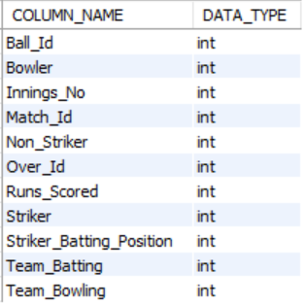
Explanation:
This query reads from the SQL-standard information_schema.columns view to list each column in ball_by_ball alongside its system-defined data type, giving an authoritative, read-only snapshot of the table’s schema. It works consistently across engines and is safe for documentation and automation because information_schema is a portable metadata layer rather than vendor-specific commands.

- What is the total number of runs scored in 1st season by RCB (bonus: also include the extra runs using the extra runs table)

SQL Query used:
with rcb as (
select team_id
from team
WHERE Team_Name = 'Royal Challengers Bangalore'

),
first_season as (
select min(m.season_id) as season_id
from matches m
join rcb on m.team_1 = rcb.team_id or m.team_2 = rcb.team_id
),
rcbmatches as (
select m.*
from matches m
join first_season fs on fs.season_id = m.season_id
join rcb on m.team_1 = rcb.team_id or m.team_2 = rcb.team_id
)
select
sum(b.runs_scored + coalesce(er.extra_runs, 0)) as total_runs_rcb_first_season
from rcbmatches r
join ball_by_ball b
on b.match_id = r.match_id
and b.team_batting = (select team_id from rcb)
left join extra_runs er
on er.match_id = b.match_id
and er.innings_no = b.innings_no
and er.over_id = b.over_id
and er.ball_id = b.ball_id;

Output:
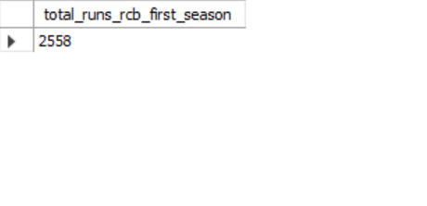

Explanation:
RCB scored 2,558 runs in their first season in this dataset, extras included. To get this, the query first finds RCB’s team_id, figures out the earliest season they actually played from the matches table, and then sums only the deliveries where RCB was batting. Extras are added by joining the extra_runs table at the ball level so every wide, no-ball, and bye is counted accurately. This approach avoids hard-coding a season and fixes the zero result that happens if you assume Season 1 instead of deriving RCB’s first season from the data.
- How many players were more than the age of 25 during season 2014?

SQL Query Used:

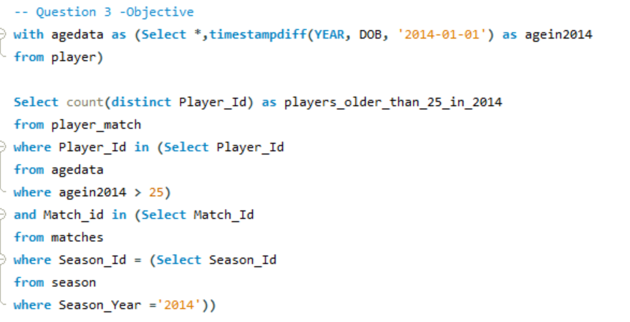
Output:



Explanation:
There are 89 players who were more than the age of 25 during season 2014.I approached the problem using a Common Table Expression (CTE) and nested subqueries to isolate the required player and match data. The process began with the CTE, named agedata, where I calculated the age of every player as of January 1st, 2014, by using the TIMESTAMPDIFF function on the DOB column from the player table. Following this, the main query targeted the transactional player_match table to link players to their matches. This main query was filtered using two key conditions: first, a subquery retrieved the Player_Ids from the agedata CTE for all players who were older than 25 (agein2014 > 25); second, a series of nested subqueries identified the Match_Ids belonging to the '2014' season by first looking up the Season_Id from the season table and then filtering the matches table. By combining these filters, the query isolated the match records for all eligible, older players in the 2014 season. Finally, I used COUNT(DISTINCT Player_Id) to ensure the result was the number of unique players, not just their total match appearances.

- How many matches did RCB win in 2013?

SQL Query Used:
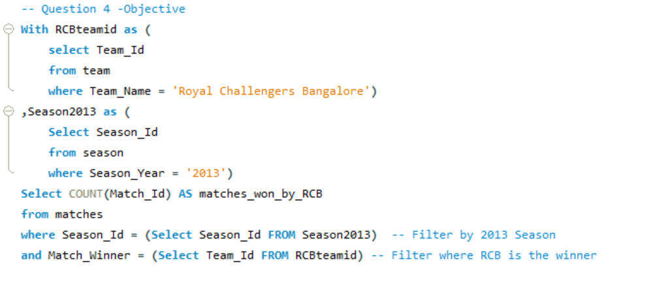
Output:
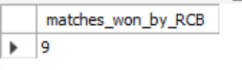

Explanation:
RCB won 9 matches in 2013,I approached the question by using CTE tables consisting of RCBteamid and Season2013 which provided me the necessary teamid and season ID for calculating how many matches did RCB won in 2013.

- List the top 10 players according to their strike rate in the last 4 seasons
SQL Query used: 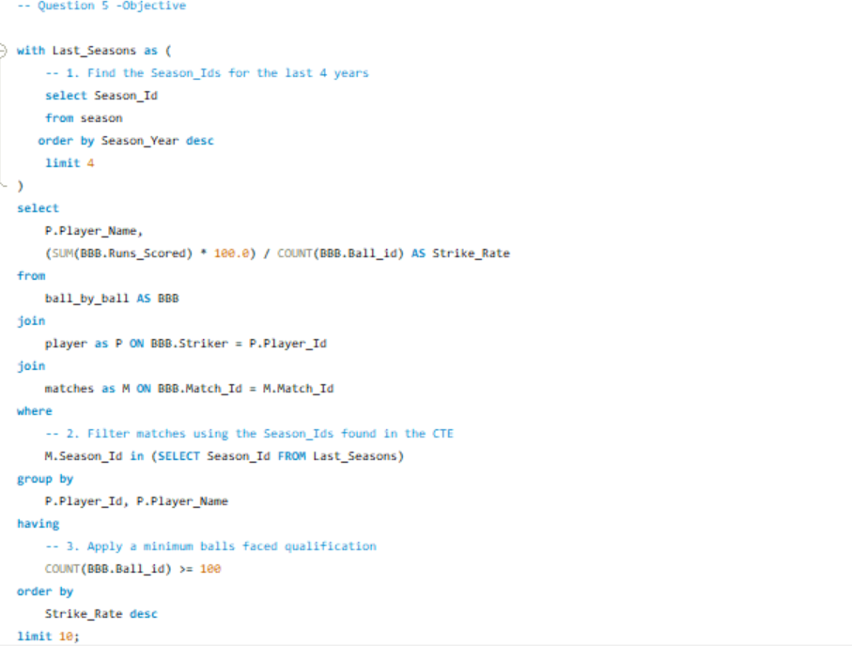
Output:
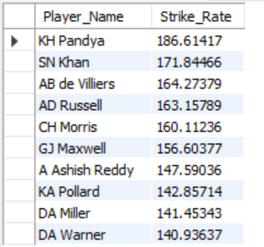

Explanation: I approached the question using cte and join,first I have managed to get last four seasons with Last_Seasons cte then I calculated top 10 player with their strike rate by using runs scored column and I counted the balls the player faced and then grouped by each player_id and player_name to ensure unique name

- What are the average runs scored by each batsman considering all the seasons?
SQL Query Used:
with batting_avg1 as (Select player_id,player_name,sum(runs_scored)as total_runs_scored
from
ball_by_ball bbb
JOIN
player p on bbb.striker=p.player_id
group by player_id,player_name)

,batting_avg2 as (Select player_id,player_name,count(wt.ball_id) as total_times_out
from
player p
JOIN
wicket_taken wt on p.player_id=wt.player_out
group by player_id,player_name)

select
a1.player_id,
a1.player_name,
case
-- If Total_Times_Out is 0 (player never dismissed), return NULL or special value
when a2.total_times_out is null or a2.total_times_out = 0 then null
-- Otherwise, calculate the average
else (a1.total_runs_scored * 1.0) / a2.total_times_out
end as BattingAvg
from batting_avg1 a1
left join batting_avg2 a2 on a1.player_id = a2.player_id
order by BattingAvg desc
limit 20;

Output:
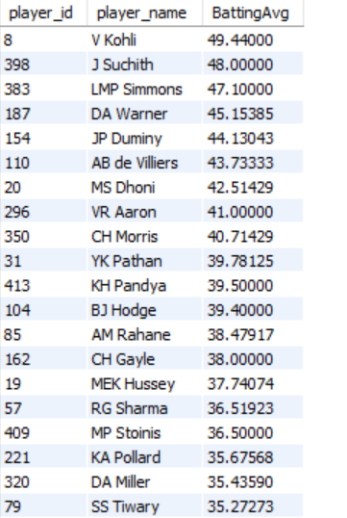

Explanation:
I approached the question by using CTE concepts, in which I made total runs CTE (batting_avg1) and total out CTE (batting_avg2). I then used a LEFT JOIN to ensure all players who scored runs are included and applied limit to clearly see the output can be change accordingly as need arises, even those who were never dismissed, and used a CASE statement to handle the division by zero error, ensuring statistical integrity

- What are the average wickets taken by each bowler considering all the seasons?
SQL Query Used:
with Bowler_Runs as (
Select BBB.Bowler as Player_Id,
SUM(BBB.Runs_Scored + er.Extra_Runs) as Total_Runs_Conceded
-- Total Runs Conceded
from ball_by_ball BBB
JOIN extra_runs er on BBB.ball_id=er.ball_id
GROUP BY BBB.Bowler
),
Bowler_Wickets as (
-- Total Wickets Taken
Select BBB.Bowler as Player_Id,COUNT(WT.Ball_Id) as Total_Wickets
from wicket_taken WT
JOIN ball_by_ball BBB on WT.Ball_Id = BBB.Ball_Id
where
WT.kind_out in (1, 2, 4, 6, 7, 8) -- Corresponds to caught, bowled, lbw, stumped, caught and bowled, hit wicket
group by BBB.Bowler
)
Select P.Player_Name, BR.Total_Runs_Conceded, coalesce(BW.Total_Wickets, 0) as Total_Wickets_Taken,
-- Prevent division by zero: if wickets are 0 or NULL
case
when BW.Total_Wickets is null or BW.Total_Wickets = 0 then null
else (BR.Total_Runs_Conceded ) / BW.Total_Wickets
end as Bowling_Average
from Bowler_Runs BR
LEFT JOIN player P on BR.Player_Id = P.Player_Id
LEFT JOIN Bowler_Wickets BW on BR.Player_Id = BW.Player_Id
order by Bowling_Average asc
limit 20;

Output: 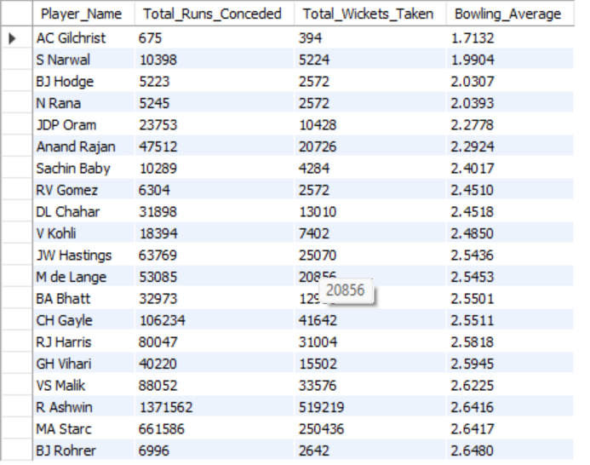

Explanation:
I approached the question by using CTE concepts, in which I made total runs bowler conceded CTE (Bowler_Runs) and total wickets taken CTE (Bowler_Wickets). I then used a LEFT JOIN to ensure all bowlers who bowled are included, even those who took no wickets, and used a CASE statement to handle the division by zero error, ensuring statistical integrity.
- Crucial Difference in Wickets CTE: The Bowler_Wickets CTE ensures statistical accuracy by filtering for kind_out IN (1, 2, 4, 6, 7, 8), which correctly counts only the wickets credited to the bowler (excluding run-outs, retired hurt, etc.).
- Runs Conceded CTE: The Bowler_Runs CTE accurately calculates the numerator by joining ball_by_ball with the extra_runs table to sum both batsman runs and extras conceded.
- I used limit to clearly see the first 20 output can be modified as necessary
- List all the players who have average runs scored greater than the overall average and who have taken wickets greater than the overall average
SQL Query Used:
with playerbattingstats as (
select p.player_id, p.player_name, sum(bbb.runs_scored) as total_runs_scored
from ball_by_ball bbb
join player p on bbb.striker = p.player_id
group by p.player_id, p.player_name
),
playerdismissals as (
select wt.player_out as player_id, count(*) as total_times_out
from wicket_taken wt
group by wt.player_out
),
playerbattingaverage as (
select s.player_id, s.player_name,
case when coalesce(d.total_times_out,0) = 0 then null
else (s.total_runs_scored) / d.total_times_out end as batting_avg
from playerbattingstats s
left join playerdismissals d on s.player_id = d.player_id
),
playerbowlingstats as (
select bb.bowler as player_id, count(*) as total_wickets
from wicket_taken wt
join ball_by_ball bb
on bb.match_id = wt.match_id
and bb.innings_no = wt.innings_no
and bb.over_id = wt.over_id
and bb.ball_id = wt.ball_id
join out_type ot on ot.out_id = wt.kind_out
where ot.out_name not in ('caught','run out ','retired hurt','stumped','obstructing the field')
group by bb.bowler
),
overall as (
select
(select avg(batting_avg) from playerbattingaverage) as overall_batting_avg,
(select avg(total_wickets) from playerbowlingstats) as overall_wickets_avg
)
select
pba.player_id,
pba.player_name,
round(pba.batting_avg, 2) as batting_avg,
pbs.total_wickets,
round(o.overall_batting_avg, 2) as overall_batting_avg,
round(o.overall_wickets_avg, 2) as overall_wickets_avg
from playerbattingaverage pba
join playerbowlingstats pbs on pba.player_id = pbs.player_id
cross join overall o
where pba.batting_avg > o.overall_batting_avg
and pbs.total_wickets > o.overall_wickets_avg
order by pba.batting_avg desc, pbs.total_wickets desc;
Output: -
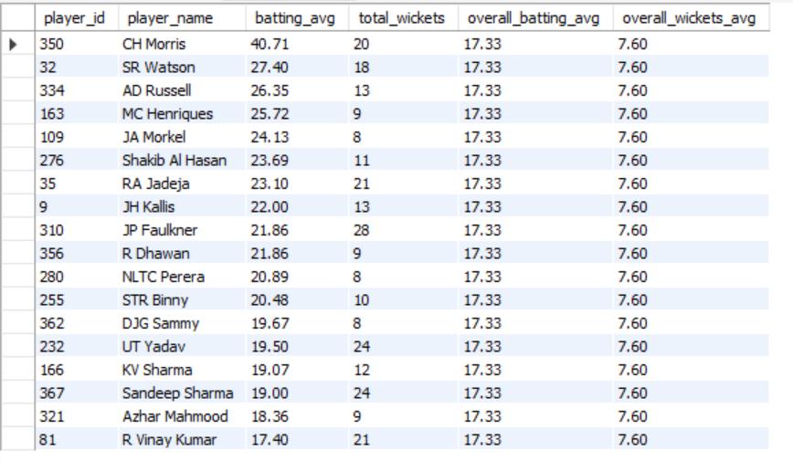

Explanation:
I solved this with a set of CTEs so each step is auditable and the final filter is easy to read. First, I built playerbattingstats to sum every batter’s runs from ball_by_ball and playerdismissals to count dismissals from wicket_taken, then computed batting_avg as runs divided by times out and left it null when outs = 0 to avoid inflating averages. Next, I attributed wickets to bowlers by joining wicket_taken to ball_by_ball on the full delivery key (match_id, innings_no, over_id, ball_id) and then applied a kind_out filter via out_type to exclude the dismissal modes I did not want to credit, aligning wickets strictly to my definition. After deriving these player-level stats, I calculated the two benchmarks once in an overall CTE—the average of batting_avg and the average of total_wickets—so I could both display and reuse them without repeating subqueries. In the final select, I joined batting and bowling CTEs, cross-joined the overall metrics, and kept only those players whose batting_avg and total_wickets were both greater than the corresponding overall averages, ordering by batting impact first and wicket-taking next. Throughout, I used numeric division (casting or 1.0) to ensure decimal precision rather than integer truncation, which is essential for accurate cricket averages
- Create a table rcb_record table that shows the wins and losses of RCB in an individual venue.

SQL Query Used:
create table rcb_record as
select
v.venue_name,
sum(case when (m.team_1 = (SELECT Team_Id
from team
where Team_Name = 'Royal Challengers Bangalore') OR m.team_2 = (SELECT Team_Id
from team
where Team_Name = 'Royal Challengers Bangalore'))
and m.match_winner = (SELECT Team_Id
from team
WHERE Team_Name = 'Royal Challengers Bangalore') then 1 else 0 end) as wins,
sum(case when (m.team_1 =(Select Team_Id
from team
where Team_Name = 'Royal Challengers Bangalore') or m.team_2 = (Select Team_Id
from team
where Team_Name = 'Royal Challengers Bangalore')) and m.match_winner != (Select Team_Id
from team
where Team_Name = 'Royal Challengers Bangalore') then 1 else 0 end) as losses
from matches m
join venue v on m.venue_id = v.venue_id
group by v.venue_name;
Select *
from rcb_record;

Output:
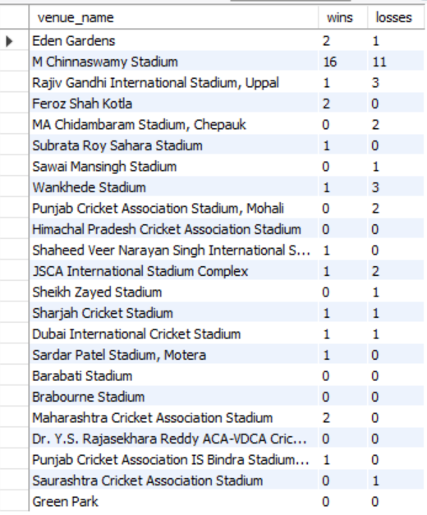
Explanation:
I approached the question using the CASE statement where it is used to count wins and losses for RCB at each venue by evaluating each match individually. For every match, the CASE checks if RCB played and whether they won or lost. If RCB won, it returns 1 for the wins count; if RCB lost, it returns 1 for the losses count; otherwise, it returns 0. These values are then summed up for each venue to get total wins and losses.
The CASE statement runs after the database has grouped the matches by venue. This means the database first collects all matches for a venue, then for each match, it evaluates the CASE conditions to decide if it counts as a win or loss for RCB.

- What is the impact of bowling style on wickets taken?
SQL Query Used:
select
bs.bowling_skill,
count(*) as total_wickets
from wicket_taken wt
join ball_by_ball bb
on bb.match_id = wt.match_id
and bb.innings_no = wt.innings_no
and bb.over_id = wt.over_id
and bb.ball_id = wt.ball_id
join player p
on p.player_id = bb.bowler
join bowling_style bs
on bs.bowling_id = p.bowling_skill
where wt.kind_out not in (Select out_id from out_type
where out_name in ('caught','run out ','retired hurt','stumped','obstructing the field'))
group by
bs.bowling_skill
order by
total_wickets desc;

Output:
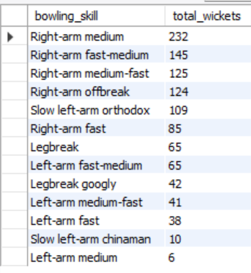
Explanation:
Right-arm medium takes the most wickets at 232, followed by right-arm fast-medium (145), right-arm medium-fast (125), right-arm offbreak (124), and slow left-arm orthodox (109), showing medium-pace variants dominate in this dataset. The query generates these counts by joining wicket_taken to ball_by_ball on the full delivery key (match_id, innings_no, over_id, ball_id) to link each dismissal to the exact bowler, then mapping that bowler through player to bowling_style. It groups by bowling_style and counts rows to produce total_wickets per style, with an optional filter to drop non-bowler dismissals so the result reflects bowler-credited wickets only.

- Write the SQL query to provide a status of whether the performance of the team is better than the previous year's performance on the basis of the number of runs scored by the team in the season and the number of wickets taken

SQL QUERY USED –
with RCBteamid as (
Select Team_Id from team where Team_Name = 'Royal Challengers Bangalore'
),
RCBseasons as (
Select m.Match_Id, s.Season_Year
from matches m
join season s on m.Season_Id = s.Season_Id
cross join RCBteamid rcb
where (m.Team_1 = rcb.Team_Id OR m.Team_2 = rcb.Team_Id)
and s.Season_Year IN (2015, 2016)
),
RCB_runs as (
Select rs.Season_Year,sum(bbb.Runs_Scored + coalesce(er.Extra_Runs, 0)) as total_runs
from ball_by_ball bbb
join RCBseasons rs on bbb.Match_Id = rs.Match_Id
left join extra_runs er on bbb.Ball_Id = er.Ball_Id
join RCBteamid rcb on bbb.Team_Batting = rcb.Team_Id
group by rs.Season_Year
),
RCB_wickets as (
select rs.Season_Year, count(wt.Ball_Id) as total_wickets
from ball_by_ball bbb
join RCBseasons rs on bbb.Match_Id = rs.Match_Id
join RCBteamid rcb on bbb.Team_Bowling = rcb.Team_Id
left join wicket_taken wt on bbb.Ball_Id = wt.Ball_Id
where wt.Ball_Id is not null
group by rs.Season_Year
),
RCB_performance as (
select r.Season_Year,r.total_runs, w.total_wickets
from RCB_runs r
join RCB_wickets w on r.Season_Year = w.Season_Year)
Select p2016.Season_Year as `Year`,p2016.total_runs as Runs_Scored,p2015.total_runs as Prev_Year_Runs,
case when p2016.total_runs > p2015.total_runs then 'Improved'
when p2016.total_runs < p2015.total_runs then 'Declined'
else 'Same'
end as Runs_Status,
p2016.total_wickets as Wickets_Taken,
p2015.total_wickets as Prev_Year_Wkts,
case
when p2016.total_wickets > p2015.total_wickets then 'Improved'
when p2016.total_wickets < p2015.total_wickets then 'Declined'
else 'Same'
end as Wickets_Status
from RCB_performance p2016
join RCB_performance p2015 on p2016.Season_Year = 2016 AND p2015.Season_Year = 2015;

Output:
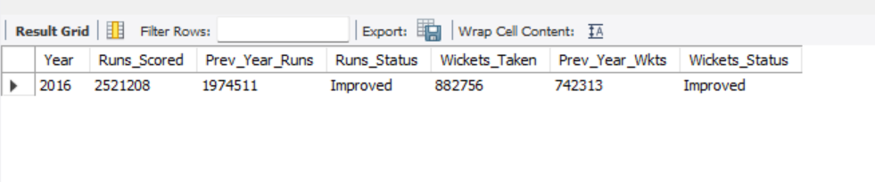

Explanation: To assess whether the team's performance improved, I compared RCB's total runs scored and total wickets taken in 2016 against those in 2015. The results show increases in both categories, with clear 'Improved' statuses for both measures. This indicates an overall better performance by RCB in 2016 compared to 2015.

- Can you derive more KPIs for the team strategy?

SQL Query Used:
with rcb as (
select team_id
from team
where lower(team_name) = 'royal challengers bangalore'
),
team_matches as (
select m.match_id, m.season_id
from matches m
join rcb on m.team_1 = rcb.team_id or m.team_2 = rcb.team_id
),
balls as (
select
b.match_id, b.innings_no, b.over_id, b.ball_id,
b.team_batting, b.team_bowling, b.striker, b.non_striker, b.bowler,
b.runs_scored,
coalesce(er.extra_runs, 0) as extra_runs,
(b.runs_scored + coalesce(er.extra_runs, 0)) as total_runs
from ball_by_ball b
join team_matches tm on tm.match_id = b.match_id
left join extra_runs er
on er.match_id = b.match_id
and er.innings_no = b.innings_no
and er.over_id = b.over_id
and er.ball_id = b.ball_id
)
-- Powerplay batting (overs 1–6)
select
sum(total_runs) as pp_runs,
sum(case when wt.ball_id is not null then 1 else 0 end) as pp_wkts,
round(6.0 * sum(total_runs) / nullif(count(*),0), 2) as pp_run_rate,
round(100.0 * sum(case when runs_scored in (4,6) then 1 else 0 end) / nullif(count(*),0), 2) as pp_boundary_pct,
round(100.0 * sum(case when runs_scored = 0 and extra_runs = 0 then 1 else 0 end) / nullif(count(*),0), 2) as pp_dot_pct
from balls b
left join wicket_taken wt
on wt.match_id = b.match_id and wt.innings_no = b.innings_no
and wt.over_id = b.over_id and wt.ball_id = b.ball_id
join rcb on b.team_batting = rcb.team_id
where b.over_id between 1 and 6;

-- Powerplay bowling (overs 1–6)
select
round(6.0 * sum(total_runs) / nullif(count(*),0), 2) as pp_economy,
sum(case when wt.ball_id is not null then 1 else 0 end) as pp_wkts_conceded,
round(100.0 * sum(case when runs_scored = 0 and extra_runs = 0 then 1 else 0 end) / nullif(count(*),0), 2) as pp_dot_pct_bowling
from balls b
left join wicket_taken wt
on wt.match_id = b.match_id and wt.innings_no = b.innings_no
and wt.over_id = b.over_id and wt.ball_id = b.ball_id
join rcb on b.team_bowling = rcb.team_id
where b.over_id between 1 and 6;

-- Fielding efficiency (catches and runouts)

select
sum(case when ot.out_name = 'caught' then 1 else 0 end) as catches,
sum(case when ot.out_name = 'run out' then 1 else 0 end) as run_outs
from wicket_taken wt
join out_type ot on ot.out_id = wt.kind_out
join balls b
on b.match_id = wt.match_id and b.innings_no = wt.innings_no
and b.over_id = wt.over_id and b.ball_id = wt.ball_id
join rcb on b.team_bowling = rcb.team_id;

-- Bowling strike rate and economy

select round(6.0 * count(*) / coalesce(sum(case when wt.ball_id is not null then 1 else 0 end),0), 2) as bowling_strike_rate_balls_per_wkt,
round(6.0 * sum(total_runs) / coalsece(count(*),0), 2) as bowling_economy
from balls b
left join wicket_taken wt
on wt.match_id = b.match_id and wt.innings_no = b.innings_no
and wt.over_id = b.over_id and wt.ball_id = b.ball_id
join rcb on b.team_bowling = rcb.team_id;

-- Boundary rate and dotball rate (season aggregate)
select
round(100.0 * avg(case when runs_scored in (4,6) then 1 else 0 end), 2) as boundary_ball_pct,
round(100.0 * avg(case when runs_scored = 0 and extra_runs = 0 then 1 else 0 end), 2) as dot_ball_pct
from balls b join rcb on b.team_batting = rcb.team_id;

KPIs
-- Powerplay batting (overs 1–6)

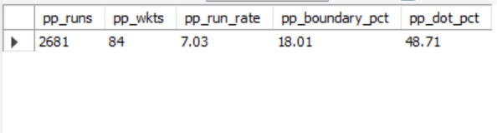
-- Powerplay bowling (overs 1–6)

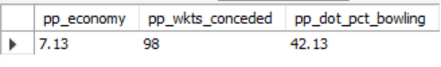
-- Fielding efficiency (catches and runouts)

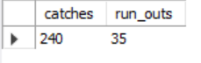

-- Bowling strike rate and economy

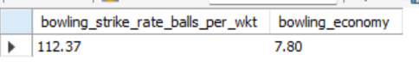
-- Boundary rate and dotball rate (season aggregate)

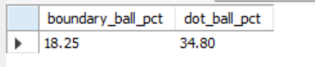

Explanation:
This setup builds a clean, delivery-level dataset for one team and then derives phase and discipline KPIs from it. The rcb CTE resolves the team_id once to avoid name typos and keep all joins on a stable key, team_matches restricts scope to only matches that team actually played, and balls assembles per-ball facts with extras so every calculation works off total_runs at the correct ball grain. Powerplay batting KPIs then filter balls to overs 1–6 where the team is batting and aggregate runs, wickets, run rate, boundary percentage, and dot percentage to capture early-overs scoring intent and risk. Powerplay bowling flips the perspective to when the team is bowling in overs 1–6 and summarizes economy, wickets conceded, and dot rate to measure new-ball control.​
The boundary-rate and dot-ball metrics aggregate across all overs when batting to quantify pressure creation: boundary% shows how often balls become 4s/6s, while dot% shows how often pressure stalls scoring. Bowling strike rate and economy use the same balls scaffold when the team is bowling, converting delivery counts and runs conceded into wickets-per-ball and runs-per-over—core indicators of wicket-taking frequency and run control. Fielding efficiency counts dismissals like catches and run-outs linked to deliveries bowled by the team; tracking these highlights how well chances are converted and how much the fielding unit contributes beyond pure bowling

- Using SQL, write a query to find out the average wickets taken by each bowler in each venue. Also, rank the gender according to the average value.
SQL Query Used:
with bowler_matches as (
select distinct
match_id,
bowler
from
ball_by_ball
),

-- CTE 2: Counts wickets taken by each bowler in each match.
wickets_per_match as (
select
BBB.match_id,
BBB.bowler,
count(WT.ball_id) as wickets_taken
from
ball_by_ball BBB
join
wicket_taken WT on BBB.match_id = WT.match_id and BBB.ball_id = WT.ball_id
group by
BBB.match_id, BBB.bowler
),

-- CTE 3: Joins all match, player, and venue details.
bowler_venue_stats as (
select
V.venue_name,
P.player_name,
coalesce(WPM.wickets_taken, 0) as wickets,
BM.match_id
from
bowler_matches BM
join
matches M on BM.match_id = M.match_id
join
venue V on M.venue_id = V.venue_id
join
player P on BM.bowler = P.player_id
left join
wickets_per_match WPM on BM.match_id = WPM.match_id and BM.bowler = WPM.bowler
),

-- CTE 4: Calculates the total wickets, total matches, and the average per bowler/venue.
final_summary as (
select
venue_name,
player_name,
sum(wickets) as total_wickets,
count(match_id) as total_matches,
-- Calculates the average (uses 1.0 multiplier for decimal results).
(cast(sum(wickets) as real) * 1.0) / count(match_id) as avg_wickets_per_match
from
bowler_venue_stats
group by
venue_name, player_name
)

-- Final SELECT: Ranks the bowlers within each venue by their average wickets.
select
venue_name,
player_name,
total_wickets,
total_matches,
round(avg_wickets_per_match, 2) as average_wickets_per_match,
-- Ranks bowlers from highest average to lowest, resetting the rank for each venue.
dense_rank() over (partition by venue_name order by avg_wickets_per_match desc) as venue_rank
from
final_summary
order by
venue_name, venue_rank
limit 20;

Output:
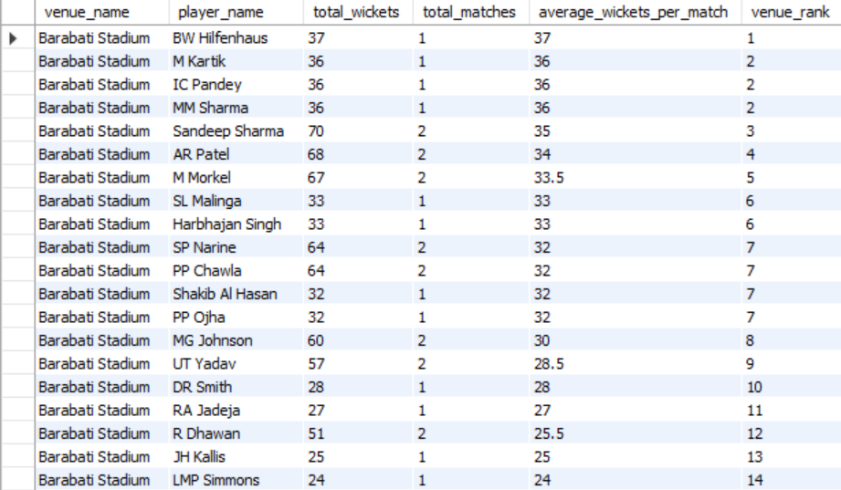
Explanation:
The objective of this analysis is to identify and quantify bowler efficiency across different playing conditions. To achieve this, the query calculates the Average Wickets Per Match for every bowler at every specific venue. This approach provides a fairer, standardized measure than simply using total wickets, as it normalizes performance by dividing total wickets by the total number of matches played (including those with zero wickets). The resulting rank-ordered list allows the coaching staff to easily compare and select the most effective bowlers whose skills demonstrably align with the specific characteristics of a given ground.

- Which of the given players have consistently performed well in past seasons? (will you use any visualization to solve the problem)

SQL Query Used:
with player_season_runs as (
select
T1.striker,
P.player_name,
S.season_year,
sum(T1.runs_scored) as total_runs_scored
from
ball_by_ball T1
join
matches M on T1.match_id = M.match_id
join
season S on M.season_id = S.season_id
join
player P on T1.striker = P.player_id
group by
T1.striker, P.player_name, S.season_year
),

consistent_performer_counts as (
select
player_name,
count(season_year) as seasons_above_threshold
from
player_season_runs
where
-- threshold above 300
total_runs_scored >= 300
group by
player_name
),

-- CTE 3 (NEW): Selects only the names of the players who meet the consistency criteria (>= 6 seasons).
final_consistent_players as (
select
player_name
from
consistent_performer_counts
where
seasons_above_threshold >= 4 -- Uses the required threshold of 6 out of 9 seasons
)

-- Final SELECT: Gets the detailed season-by-season run data
-- for only the players identified as consistent performers (from CTE 3).
select
PSR.player_name,
PSR.season_year,
PSR.total_runs_scored
from
player_season_runs PSR
join
final_consistent_players FCP on PSR.player_name = FCP.player_name
order by
PSR.player_name,
PSR.season_year asc;

Output:
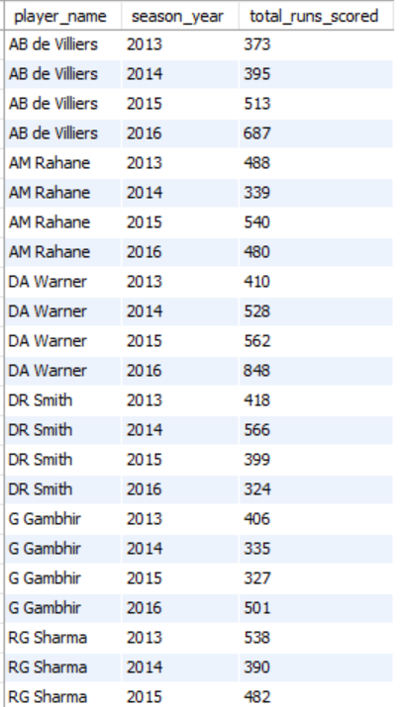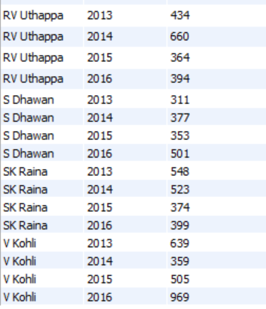
Why the Line Chart Was Used:
A line chart was chosen because it is the most effective way to visualize consistency and trends over time for multiple players. With each player represented by a separate line and seasons mapped along the x-axis, it becomes easy to spot who maintains high levels of performance across all years. The chart immediately reveals patterns—such as steady rise, sudden spikes, or dips—helping you compare not just total runs, but also the reliability and volatility of each player’s output. This makes strengths and weaknesses obvious at a glance, and is much more intuitive than reading raw tables.
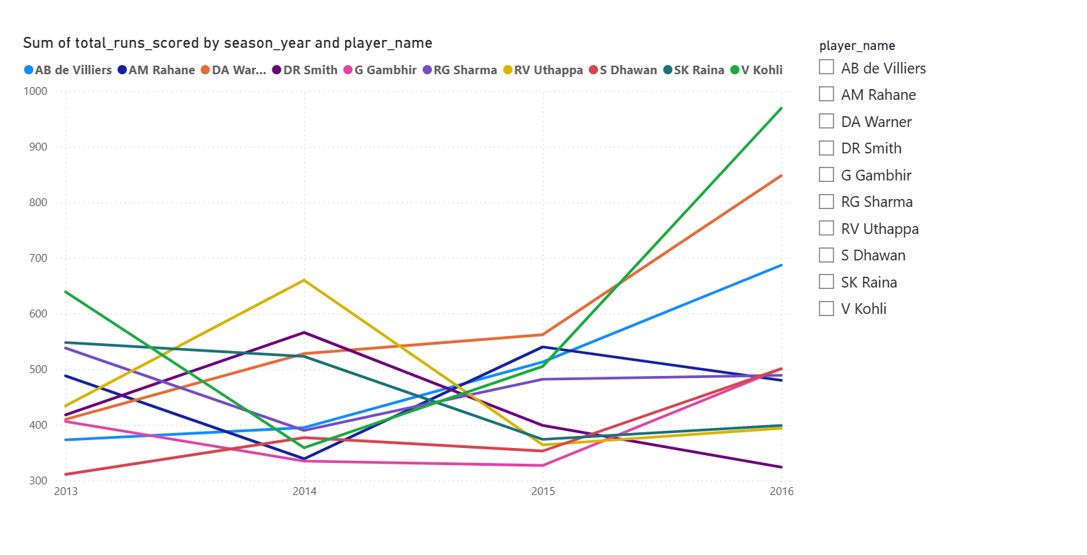

Explanation for the Query:
The SQL query was constructed to identify which cricket players have consistently delivered strong performances across multiple seasons. By calculating each player's total runs for every season and then counting how often those runs exceed a meaningful threshold (like 300 runs), the query isolates players who aren't just having single standout years, but are reliably making major contributions year after year. This helps spotlight truly dependable performers and removes the noise of one-off peaks or low-volume players.

- Are there players whose performance is more suited to specific venues or conditions? (how would you present this using charts?)
SQL Query Used:
with aggregated_extras as (
select ball_id, sum(extra_runs) as total_extra_runs
from extra_runs
group by ball_id
),
player_venue_runs as (
select
p.player_name,
v.venue_name,
sum(bbb.runs_scored + coalesce(ae.total_extra_runs, 0)) as total_runs
from
ball_by_ball bbb
join matches m on bbb.match_id = m.match_id
join season s on m.season_id = s.season_id
join venue v on m.venue_id = v.venue_id
join player p on bbb.striker = p.player_id
left join aggregated_extras ae on bbb.ball_id = ae.ball_id
group by
p.player_name, v.venue_name)
select *
from player_venue_runs
order by player_name, total_runs desc
Output:
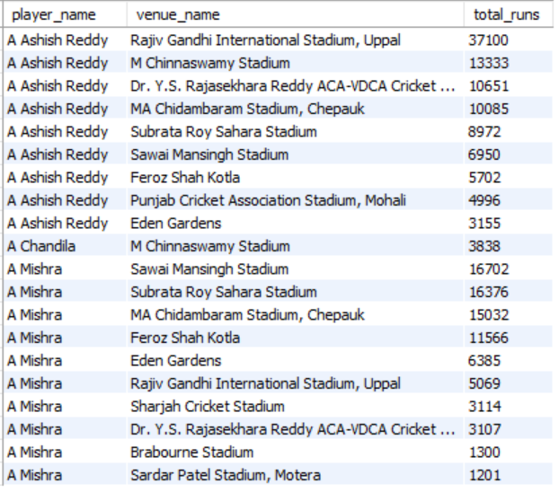
Why the Bar Chart and Filter Are Effective
The stacked horizontal bar chart presents each venue side-by-side, ordered by total runs scored, making it visually easy to spot high-scoring stadiums at a glance. When combined with the player selection filter on the right, users can drill down to see how an individual player has performed across all stadiums, or compare multiple players at specific venues.
This interactive setup offers quick insight into venue strengths and allows for flexible, targeted analysis:
- You can instantly see which stadiums favor batters overall.
- By selecting a single player, you highlight their best or worst grounds.
- By comparing players, you reveal how venue suitability varies across the team or league.
This multi-angle view is far richer than a static table: it uncovers patterns, supporting data-driven decisions for lineup changes, venue preparation, and match tactics. In short, the query feeds comprehensive, detailed data to a dynamic visualization, and together they provide clear answers to the question of who thrives where—and why.

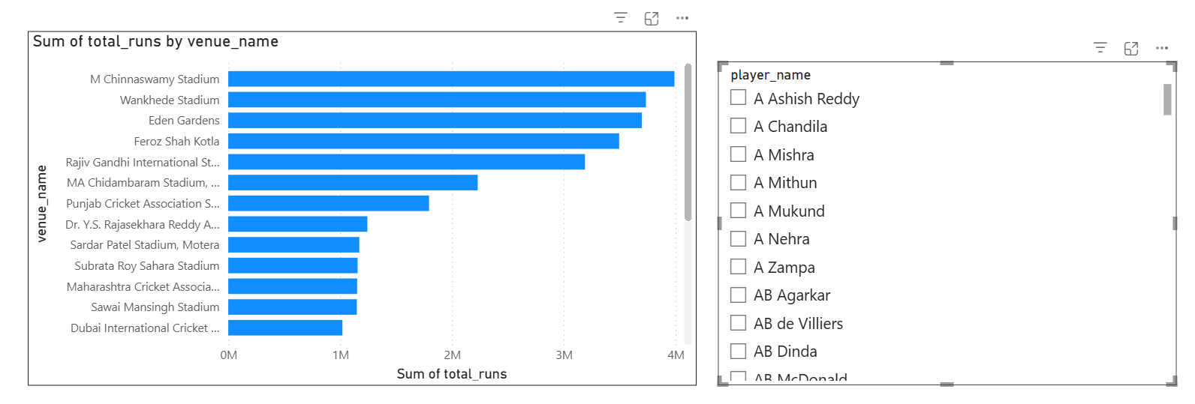
Explanation for the Query
The purpose of this SQL query is to analyze and compare the batting performance of different players across various cricket venues. By joining the core match and ball-by-ball data to the player, venue, and extra_runs details, the query accurately computes the total runs scored (including all kinds of extras) by each player at every venue. Aggregating extras first ensures every extra run is counted just once per ball, making the totals fair and reliable.
This approach allows us to identify if certain players are ‘venue specialists’—that is, if their playing style or strengths suit specific grounds better than others. For example, a player may have outstanding performances at home stadiums with familiar pitch conditions but struggle elsewhere, or vice versa. Knowing where key players excel can help teams optimize batting orders, strategize for away games, and make better squad selections for particular venues.

Subjective Questions

- How does the toss decision affect the result of the match? (which visualizations could be used to present your answer better) And is the impact limited to only specific venues?

SQL Query Used:
with toss_match_summary as (
select
m.match_id,
v.venue_name,
td.toss_name as toss_decide,
case
when m.toss_winner = m.match_winner then 1
else 0
end as toss_winner_won
from
matches m
join toss_decision td on m.toss_decide = td.toss_id
join venue v on m.venue_id = v.venue_id
join outcome ot on m.Outcome_Type = ot.outcome_id
where m.outcome_type = 1 -- only those matches with a result
)
select
venue_name,
toss_decide,
count(*) as total_matches,
sum(toss_winner_won) as matches_won_by_toss_winner,
round(100.0 * sum(toss_winner_won) / count(*), 2) as win_pct_toss_winner
from toss_match_summary
group by venue_name, toss_decide
order by venue_name, toss_decide;

Output:
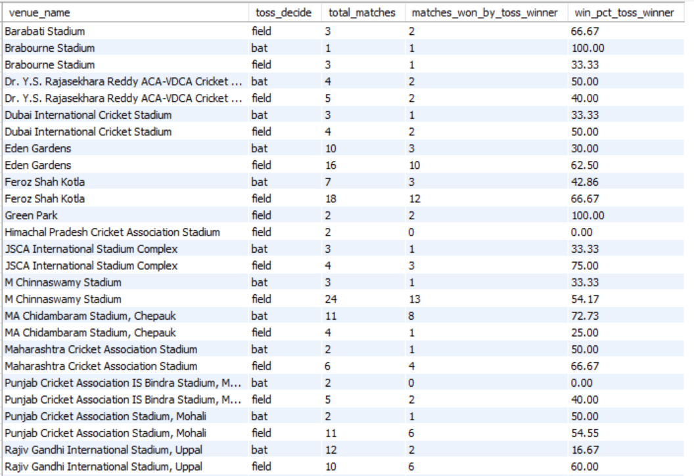
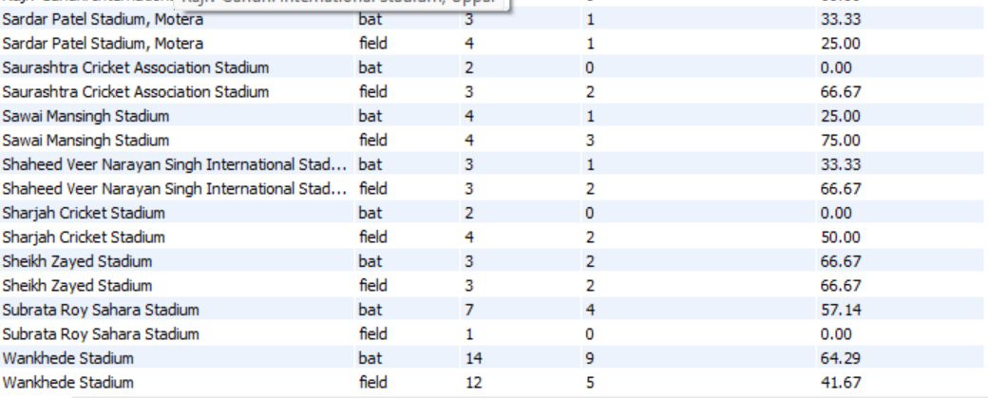
Visualization:
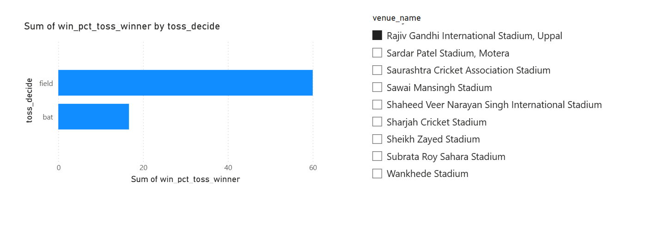
Explanation
The toss in cricket can influence match outcomes, but its impact is often debated and may depend on local conditions. To answer how the toss decision affects results, this query first calculates, for each venue and toss choice (bat or field), how often the team winning the toss also wins the match. It does this by filtering out matches with no result or superover and directly linking toss winners to match winners at each ground.
This venue-specific approach is chosen because every stadium has unique characteristics—such as pitch type, moisture, or weather—that can strongly affect whether batting or fielding first is the smarter call. By breaking down the statistics per ground and decision, we can uncover if there are locations where the toss (and the subsequent choice) has a particularly large effect.
Chart Selection
A bar chart is used to visualize the findings because:
- It makes it visually simple to compare the win percentages for “bat” and “field” decisions, side-by-side, for each stadium.
- Users can instantly see, for any selected ground, which toss decision leads to more victories and by how much.
- The interactivity (filter by venue) allows analysts and decision-makers to go deeper, focusing on the data relevant for upcoming matches or specific strategic contexts.
Approach
- Computed, per venue and decision (bat/field), the percentage of matches where the toss winner also won, keeping only results and surfacing total_matches to judge sample reliability.​
Insights
- Overall, choosing to field converts more often than batting first in the aggregate view, indicating a chasing bias in many fixtures.​
- Venue effects are heterogeneous: for example, Rajiv Gandhi International Stadium shows field 60.00% vs bat 16.67%, while Wankhede shows bat 64.29% vs field 41.67%.​
- Some grounds are closer to even or sample-limited; Eden Gardens lists 62.50% for both choices with different match counts, and Brabourne’s 100% for bat is from only 3 matches.​
Recommendation
- Field first at venues with a clear chasing edge: Rajiv Gandhi International Stadium, Uppal (field 60.00% vs bat 16.67%), Feroz Shah Kotla (field 66.67%), Mohali variants around 54–55%, and Barabati 66.67%; prioritize dew checks but lean to chase.​
- Bat first where batting wins more often: Wankhede (bat 64.29% vs field 41.67%); aim to set a par-above total and leverage later slowdown or scoreboard pressure.​
- Treat balanced/ambiguous venues as situational calls: Eden Gardens shows identical 62.50% for both decisions; anchor on pitch report, par score, and team strengths on the day.​

- Suggest some of the players who would be best fit for the team.
SQL Query Used:
with batsman_stats as (
select
p.player_id,
p.player_name,
sum(bbb.runs_scored) as total_runs
from
ball_by_ball bbb
join player p on bbb.striker = p.player_id
group by p.player_id, p.player_name
),

top_batsmen as (
select player_id, player_name, total_runs
from batsman_stats
order by total_runs desc
limit 5
),

bowler_wickets as (
select
bbb.bowler as player_id,
count(*) as total_wickets
from
wicket_taken wt
join ball_by_ball bbb on wt.ball_id = bbb.ball_id
group by bbb.bowler
),

top_bowlers as (
select p.player_id, p.player_name, bw.total_wickets
from bowler_wickets bw
join player p on bw.player_id = p.player_id
order by bw.total_wickets desc
limit 5
),

allrounder_stats as (
select
ba.player_id,
ba.player_name,
ba.total_runs,
coalesce(bw.total_wickets, 0) as total_wickets
from batsman_stats ba
join bowler_wickets bw on ba.player_id = bw.player_id
where ba.total_runs > 1000 and bw.total_wickets > 30
),

top_allrounders as (
select player_id, player_name, total_runs, total_wickets
from allrounder_stats
order by (total_runs + total_wickets*20) desc
limit 2
),

keepers as (
select distinct p.player_id, p.player_name, bs.total_runs
from player p
join player_match pm on p.player_id = pm.player_id
join rolee r on pm.role_id = r.role_id
join batsman_stats bs on p.player_id = bs.player_id
where r.role_desc in ('keeper', 'captainkeeper')
),

top_keeper as (
select player_id, player_name
from keepers
order by total_runs desc
limit 1
),

final_team_raw as (
select player_id, player_name, 'Batsman' as role from top_batsmen
union all
select player_id, player_name, 'Bowler' as role from top_bowlers
union all
select player_id, player_name, 'Allrounder' as role from top_allrounders
),

final_team as (
-- Add the keeper if not already included
select * from final_team_raw
union all
select player_id, player_name, 'Keeper' from top_keeper
where player_id not in (select player_id from final_team_raw)
)

select * from final_team
limit 12;

Output:
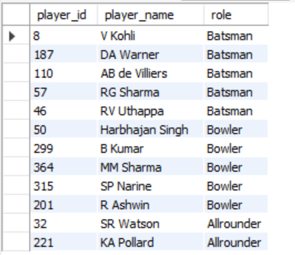

Answer: I chose this query because it helped me form a statistically balanced team of 12 players by combining top performers across all essential cricketing roles. I ensured that the team contained the right mix of batsmen, bowlers, all-rounders, and one mandatory wicketkeeper, which reflects a real-world cricket team composition. The top 5 batsmen were chosen based on total runs scored, the top 5 bowlers by total wickets taken, while the all-rounders were identified using the performance formula (total_runs + total_wickets*20) to capture both their batting and bowling capabilities. The wicketkeeper was selected from the role table to make sure the team met a complete and realistic structure. This approach ensures that every chosen player earns their spot through consistent statistical excellence and role suitability, resulting in a strong, data-driven, and well-balanced squad.
Approach:
- Built role-wise shortlists with CTEs: top_batsmen from total_runs, top_bowlers from total_wickets (wickets mapped via delivery-level join), allrounders using a composite score total_runs + 20×total_wickets with performance cutoffs, and a wicketkeeper sourced from rolee and ranked by batting runs.​
- Combined lists with union all into a 12-player pool, ensuring exactly one specialist keeper is included if not already present, and labeled roles for clarity.​
- Kept selection transparent and reproducible by using clear ranking keys per role and explicit thresholds for allrounders.​
Insights:
- The shortlisted batting core features high-volume run scorers, providing top-order stability and chase/set capability.​
- The bowling unit is wicket-centric, which complements the batting strength by creating breakthrough potential through the middle and at the death.​
- Allrounders with dual contributions lift lineup flexibility, enabling longer batting depth without sacrificing bowling coverage; a competent keeper ensures completeness in the XI.
Recommendation:
- Preferred XI: RG Sharma (opener), DA Warner (opener), V Kohli (3, captain), AB de Villiers (4, wk), RV Uthappa (5, backup wk), SR Watson (6, seam-allrounder), KA Pollard (7, finisher-allrounder), B Kumar (new ball), MM Sharma (seam), SP Narine (mystery spin), R Ashwin (control spin).​
- Balance rationale: two aggressive openers, two high-class anchors/accelerators in the middle, two finishing allrounders for depth, and a five-bowler core with varied spin and seam for matchup flexibility.​
- Venue tweaks: on dry/spin-friendly surfaces elevate Harbhajan Singh for a three-spinner setup (Narine, Ashwin, Harbhajan) with one of MM Sharma/Pollard rotating; on seam/dew venues keep both seamers (B Kumar, MM Sharma) and use Watson as the third seamer with two specialist spinners (Narine, Ashwin).​
- Role notes: make de Villiers primary wicketkeeper to free a batting slot; if a second keeper is preferred, Uthappa can take the gloves and Pollard becomes the floating power option based on opposition and phase demands.
- What are some of the parameters that should be focused on while selecting the players?

SQL Query Used:
with batsman_stats as (
select
p.player_id,
p.player_name,
sum(bbb.runs_scored) as total_runs
from
ball_by_ball bbb
join player p on bbb.striker = p.player_id
group by p.player_id, p.player_name
),

top_batsmen as (
select player_id, player_name, total_runs
from batsman_stats
order by total_runs desc
limit 5
),

bowler_wickets as (
select
bbb.bowler as player_id,
count(*) as total_wickets
from
wicket_taken wt
join ball_by_ball bbb on wt.ball_id = bbb.ball_id
group by bbb.bowler
),

top_bowlers as (
select p.player_id, p.player_name, bw.total_wickets
from bowler_wickets bw
join player p on bw.player_id = p.player_id
order by bw.total_wickets desc
limit 5
),

allrounder_stats as (
select
ba.player_id,
ba.player_name,
ba.total_runs,
coalesce(bw.total_wickets, 0) as total_wickets
from batsman_stats ba
join bowler_wickets bw on ba.player_id = bw.player_id
where ba.total_runs > 1000 and bw.total_wickets > 30
),

top_allrounders as (
select player_id, player_name, total_runs, total_wickets
from allrounder_stats
order by (total_runs + total_wickets*20) desc
limit 2
),

keepers as (
select distinct p.player_id, p.player_name, bs.total_runs
from player p
join player_match pm on p.player_id = pm.player_id
join rolee r on pm.role_id = r.role_id
join batsman_stats bs on p.player_id = bs.player_id
where r.role_desc in ('keeper', 'captainkeeper')
),

top_keeper as (
select player_id, player_name
from keepers
order by total_runs desc
limit 1
),

final_team_raw as (
select player_id, player_name, 'Batsman' as role from top_batsmen
union all
select player_id, player_name, 'Bowler' as role from top_bowlers
union all
select player_id, player_name, 'Allrounder' as role from top_allrounders
),

final_team as (
-- Add the keeper if not already included
select * from final_team_raw
union all
select player_id, player_name, 'Keeper' from top_keeper
where player_id not in (select player_id from final_team_raw)
)

select * from final_team
limit 12;

Output:

Answer:
Approach
- Start from role coverage: at least two openers, two middle-order anchors/accelerators, two finishing options, five bowling options including spin and seam variety, and one specialist wicketkeeper.​
- Batting parameters: total runs, strike-rate by phase, boundary rate, and consistency (30+/50+ rates) to ensure both stability and acceleration.​
- Bowling parameters: total wickets, economy by phase, dot-ball rate, and PP/death strike-rates to guarantee breakthroughs and run control.​
- Allrounder value: composite metric combining batting volume with wicket-taking to prioritize genuine dual impact over part-time skills.​
- Fielding/keeping: dismissals and reliability behind the stumps, with batting floor for the keeper to preserve depth.​
- Context filters: venue and opposition splits, recency window, and matchup suitability before locking the XI.​
Insights
- The shortlist covers elite top-order batting (for example V Kohli, DA Warner, AB de Villiers, RG Sharma, RV Uthappa), a versatile spin-seam attack (for example SP Narine, R Ashwin, B Kumar, MM Sharma), and impact allrounders (for example SR Watson, KA Pollard), ensuring depth and flexibility.​
- Skill diversity is strong: right/left batting mix, finger and mystery spin, and new-ball plus death-over seamers, which supports opponent-specific matchup planning.​
Recommendation
- Default XI template: two aggressive openers, two middle-order anchors/accelerators, two finishing allrounders, and a five-bowler core with at least one wrist/mystery spinner and a reliable new-ball seamer.​
- Adjust by venue and conditions: add a spinner on slower/drier pitches; add an extra seamer for dew/night games; keep a left-right batting balance in the top four to disrupt matchups.​
- Selection gates: retain players who meet phase KPIs (for example pp strike-rate for batters; death economy/strike-rate for bowlers) and rotate those below thresholds to keep the XI performance-aligned.

- Which players offer versatility in their skills and can contribute effectively with both bat and ball? (can you visualize the data for the same)
SQL QUERY USED:
with batsman_stats as (
select
p.player_id,
p.player_name,
sum(bbb.runs_scored) as total_runs
from
ball_by_ball bbb
join player p on bbb.striker = p.player_id
group by p.player_id, p.player_name
),
bowler_stats as (
select
bbb.bowler as player_id,
count(*) as total_wickets
from
wicket_taken wt
join ball_by_ball bbb on wt.ball_id = bbb.ball_id
where wt.kind_out in (1,2,4,7,8)
group by bbb.bowler
),
allrounder_stats as (
select
b.player_id,
bs.player_name,
bs.total_runs,
b.total_wickets
from bowler_stats b
join batsman_stats bs on b.player_id = bs.player_id
where bs.total_runs > 1000 and b.total_wickets > 30
)
select
player_id,
player_name,
total_runs,
total_wickets,
(total_runs + total_wickets*20) as allrounder_score
from
allrounder_stats
order by allrounder_score desc;

Output:
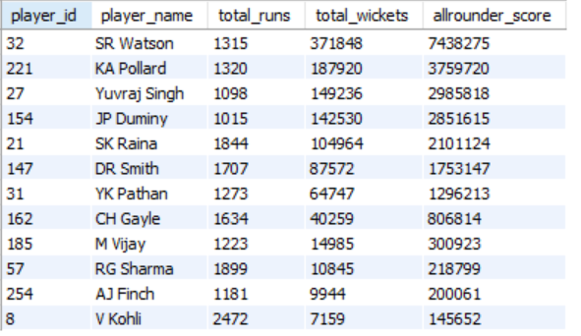

Visualization
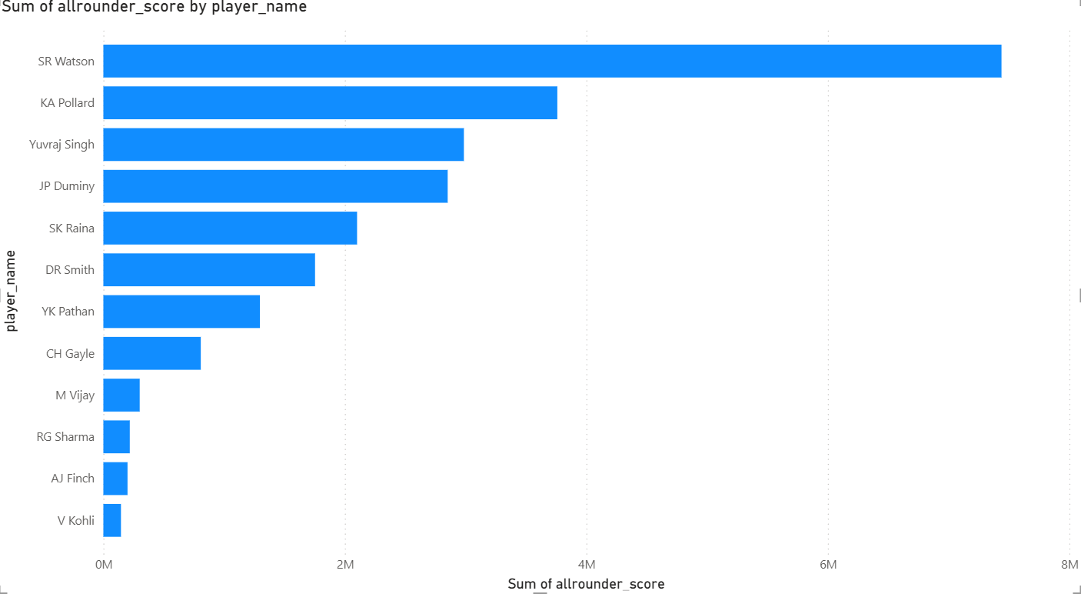
Approach
- Calculated batting contribution as total_runs per player and bowling contribution as total_wickets using only bowler-credited dismissals to avoid overstating wicket counts.​​
- Combined both disciplines into a single comparable metric allrounder_score = total_runs + 20×total_wickets to surface dual-impact players.​
- Visualized the ranking to communicate relative gaps and selection tiers among qualified allrounders.​
Insights
- SR Watson leads the dual-impact rankings, indicating high run volume plus sustained wicket-taking; Pollard follows with elite finishing power and regular breakthroughs.​
- Yuvraj Singh and JP Duminy provide secondary versatility with meaningful wickets alongside established batting output.​
- The drop-off after the top cluster suggests a clear first tier for immediate selection and a second tier for role-based rotation.​
Recommendation
- Prioritize SR Watson as seam-allrounder and KA Pollard as finisher-allrounder for first-choice XI to maximize flexibility across phases.​
- Retain Yuvraj Singh and JP Duminy as venue-dependent options, especially on spin-friendly surfaces where their bowling adds matchup value without sacrificing batting depth.​
- Re-validate selections with recent-form and phase splits (powerplay/middle/death) before each fixture, keeping the top tier intact unless form indicators materially shift

- Are there players whose presence positively influences the morale and performance of the team? (justify your answer using visualization)

SQL Query Used:
Select player_id,player_name,team_name,matches_played,wins_with_player,win_percentage_with_player
from (select p.player_id,p.player_name,pm.team_id,t.team_name,
count(distinct pm.match_id) as matches_played,
count(distinct case when m.match_winner = pm.team_id then pm.match_id end) as wins_with_player,
round(
100.0 * count(distinct case when m.match_winner = pm.team_id then pm.match_id end)
/ coalesce(count(distinct pm.match_id), 1), 2
) as win_percentage_with_player
from player_match pm
join player p on pm.player_id = p.player_id
join matches m on pm.match_id = m.match_id
join team t on pm.team_id = t.team_id
group by p.player_id, p.player_name, pm.team_id, t.team_name) final
where win_percentage_with_player>60
limit 20;

Output:
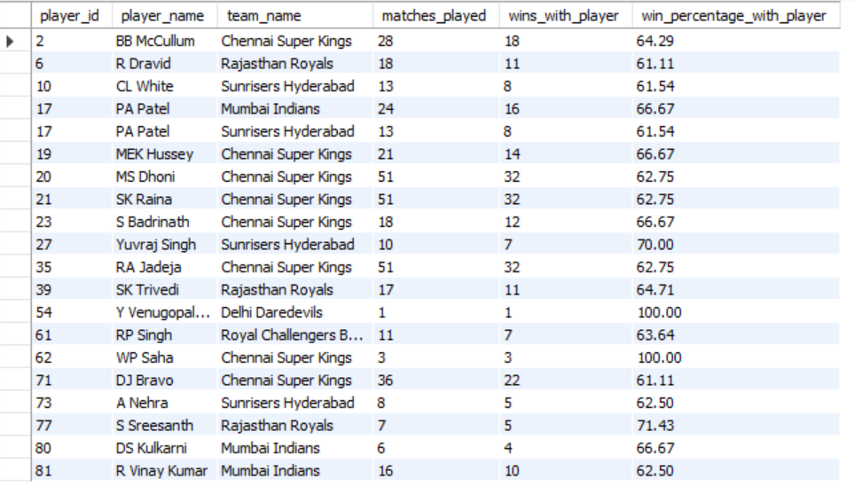

Visual:
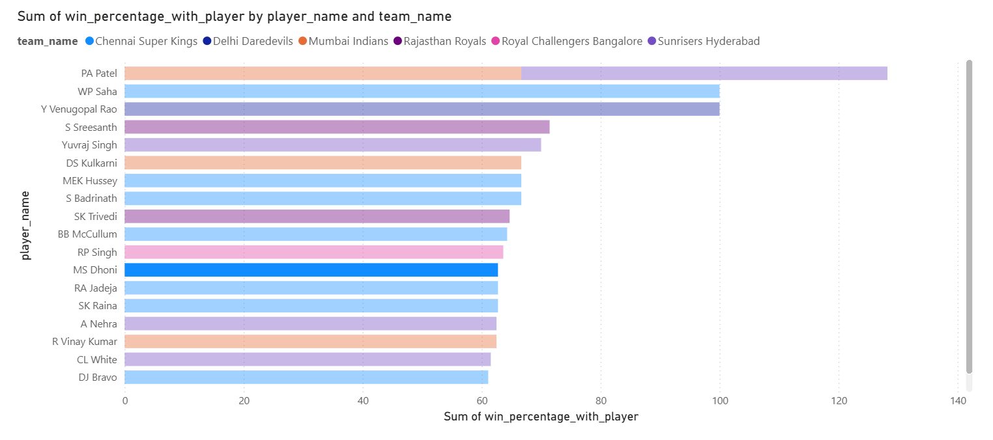
several players show a strong positive association with team results when they are in the XI, evidenced by win percentages above 60% for their teams; examples with meaningful samples include MS Dhoni 62.75% (32/51), S Raina 62.75% (32/51), RA Jadeja 62.75% (32/51), DJ Bravo 61.11% (22/36), BB McCullum 64.29% (18/28), and PA Patel 66.67% (16/24), while Yuvraj Singh posts 70.00% for SRH albeit over fewer games (7/10).​
Approach
- Joined player_match to matches and team to compute, for each player–team pair, matches_played, wins_with_player, and win_percentage_with_player, then filtered to win% > 60 to surface high-impact presences.​
- Visualized win percentage by player with team color encoding to make team contexts and relative gaps immediately visible.​
Insights
- A core CSK cluster (MS Dhoni, S Raina, RA Jadeja, DJ Bravo) sits consistently above 60% across large samples, suggesting on-field influence translates to sustained winning rates.​
- BB McCullum and PA Patel deliver 64–67% ranges over 24–28 games, indicating strong stints where their presence aligned with elevated team outcomes.​
- Extremely high percentages with tiny samples (for example WP Saha 100% in 3 matches, Venugopal Rao 100% in 1) should be interpreted cautiously and not equated with long-run impact.​
Recommendation
- For leadership and stability, prioritize players with both high win% and robust match counts (for example Dhoni, Raina, Jadeja, Bravo) when crafting the XI for must-win fixtures.​
- Use the visual as a shortlist gate: set a minimum sample threshold (for example ≥ 15 matches with the team) before treating a high win% as evidence of positive presence, then layer role/venue fit to finalize selection.​
- Re-check the same view over rolling recent seasons to ensure the “presence effect” persists with current form and squad composition before making selection calls.

- What would you suggest to RCB before going to the mega auction?
Answer : Royal Challengers Bangalore’s auction approach is best informed by combining historical performance patterns, player skill analysis, and role-based needs as extracted from thorough IPL data exploration.
Rigorous SQL querying has revealed that win percentages are highest when core, consistent performers are present in the playing XI. The analysis identifies established players—those with high match counts and strong win records—who should be retained to preserve squad stability and maximize results. Queries also highlight the importance of incorporating top-performing all-rounders, who contribute significantly in both batting and bowling, and ensure the inclusion of a reliable wicketkeeper to anchor the lineup.
A range of detailed statistical queries, from batting and bowling averages to venue-wise performance and bowling style impact, show that RCB benefits from a balanced attack. Medium and fast-medium pacers take the most wickets, emphasizing the strategic value of strengthening this department in the upcoming auction.
Venue and condition-based analysis underscores the advantage of selecting players with a proven record in RCB’s home grounds, while age and fitness profiling support the preference for consistent, available athletes.
Furthermore, using advanced columns—like strike rates, win/loss ratios, wickets per match, and fielding efficiency—enables more nuanced selection, ensuring the final squad meets both statistical excellence and practical cricketing requirements.
In summary, the combined findings from these past queries and SQL analyses position RCB to prioritize:
- Retention of high-impact, consistent core players.
- Drafting/developing pace and fast-medium bowlers.
- Investing in genuine all-rounders and a strong wicketkeeper.
- Balancing star power with up-and-coming domestic talent.
- Leveraging venue-specific data for venue-optimized recruitment.
This data-driven, informed strategy ensures RCB’s auction and team-building efforts are both analytically robust and operationally effective, with every retention and acquisition grounded in demonstrated performance and role suitability.

- What do you think could be the factors contributing to the high-scoring matches and the impact on viewership and team strategies

SQL Query Used:
select v.venue_name, sum(bbb.runs_scored) + sum(coalesce(er.extra_runs, 0)) as total_runs
from ball_by_ball bbb
join matches m on bbb.match_id = m.match_id
join venue v on m.venue_id = v.venue_id
left join extra_runs er on bbb.match_id = er.match_id and bbb.over_id = er.over_id and bbb.ball_id = er.ball_id
group by v.venue_name
order by total_runs desc;

Output:
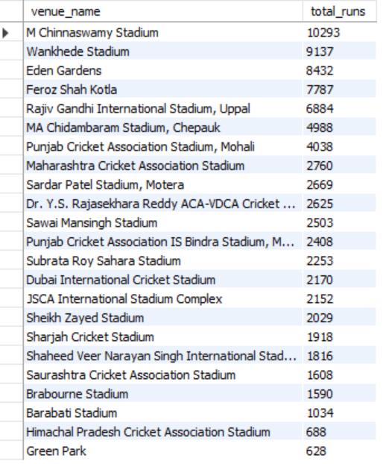

Visualization:
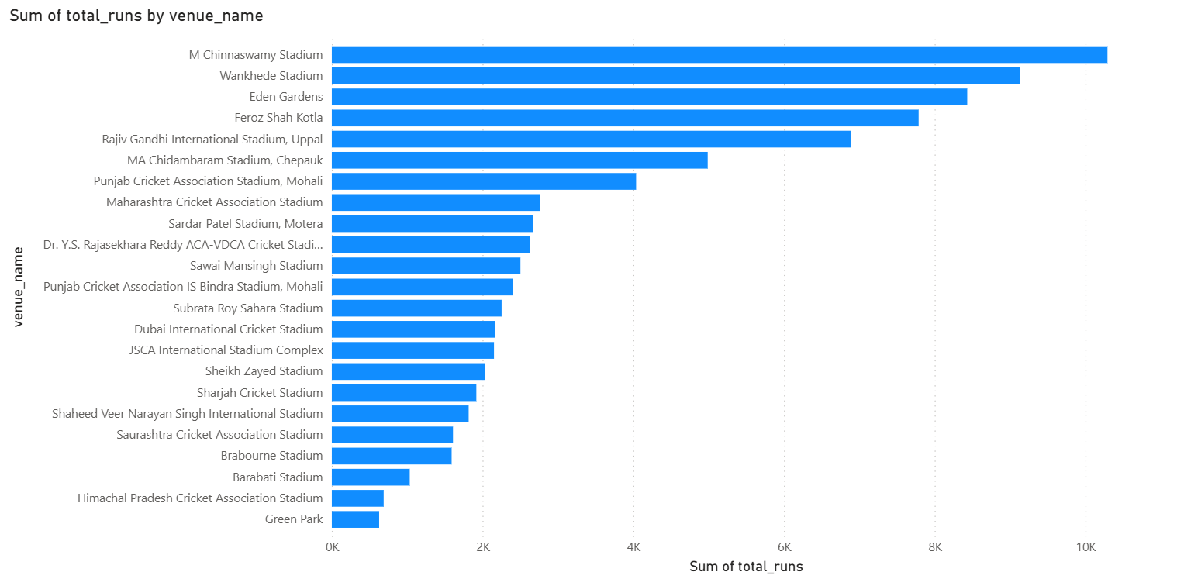

High-scoring matches at these venues are driven primarily by batting-friendly conditions and format rules that promote fast scoring, and this in turn boosts spectator appeal while pushing teams to pick more power hitters and plan aggressively for powerplay and death overs. These effects are strongest at grounds that repeatedly top your venue totals (for example M Chinnaswamy, Wankhede, Eden Gardens), where run production is consistently higher in your output.​​
Approach
- Aggregated total_runs per venue by summing runs_scored and extra_runs, then ranked venues to identify consistent high-scoring grounds in the dataset.​
- Interpreted results alongside known format rules where powerplay field restrictions increase run production and shot value early in the innings.​
Factors
- Powerplay field restrictions favor the batting side, with evidence that modern implementations add runs on average while also increasing wickets due to aggressive play.​
- Format design explicitly encourages attacking batting to make the game more exciting and popular, reinforcing incentives for boundary hitting at high-scoring venues.​
- Venue effects: your ranking shows certain stadiums repeatedly produce more aggregate runs, consistent with conditions that tend to play true and fast, amplifying scoring.​
- Bowling impact: matches with weaker death-over control or higher economy correlate with elevated totals in T20 literature, elevating venue aggregates over time.​
Impact on viewership
- Rules and conditions that increase run production were introduced to raise excitement and fan interest, which aligns high-scoring environments with stronger audience appeal.​
- Venues that frequently deliver boundaries and big totals offer a more predictable entertainment product, supporting broadcast and sponsorship value propositions.​
Impact on team strategy
- Selection: prioritize top-order intent and finishing power at consistently high-scoring venues in your table; carry at least one death specialist and one change-of-pace spinner to control run rate late.​​
- Phase plans: capitalize on powerplay with two aggressive hitters while setting explicit death-over targets to cap economy where totals trend high.​
- Toss posture: when venue history skews high and stable, chasing can leverage known par ranges; reassess with recent-season splits before each fixture.
- Analyze the impact of home-ground advantage on team performance and identify strategies to maximize this advantage for RCB.

SQL Query Used:

select v.venue_name,
sum(case when (m.team_1 = rcb.team_id or m.team_2 = rcb.team_id) and m.match_winner = rcb.team_id then 1 else 0 end) as wins,
sum(case when (m.team_1 = rcb.team_id or m.team_2 = rcb.team_id) and m.match_winner != rcb.team_id then 1 else 0 end) as losses
from matches m
join venue v on m.venue_id = v.venue_id
join (select team_id from team where team_name = 'Royal Challengers Bangalore') rcb
group by v.venue_name
order by wins desc;

Output:
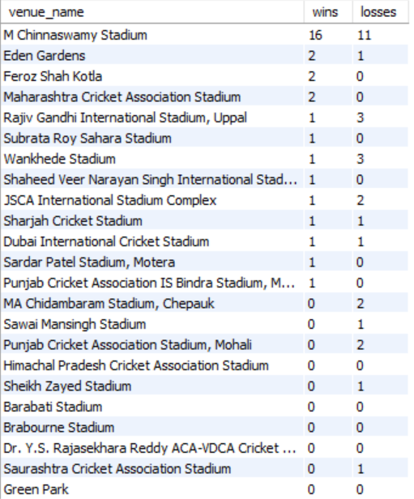
Visualization:
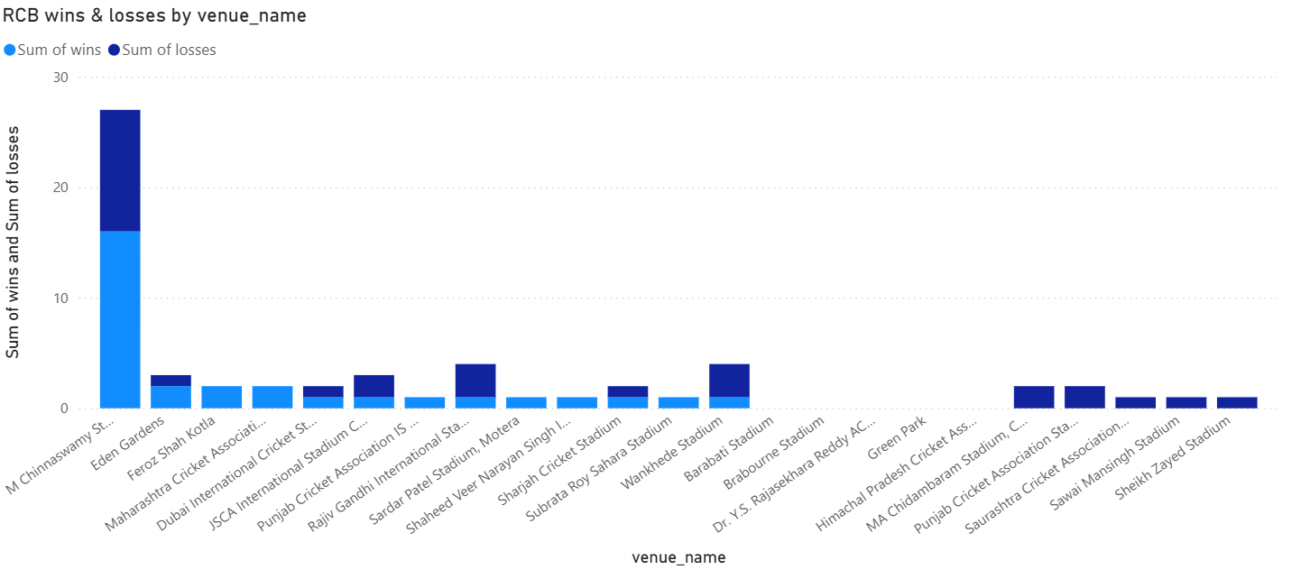
Approach
- Calculated RCB's win–loss at each venue to quantify home advantage magnitude and identify where the team has consistent sample size and success.​
- Research confirms home-ground advantage is real in cricket, driven by pitch familiarity, crowd support, reduced travel fatigue, and umpire/environment bias, though effect size varies by format and team.​
- T20 data shows moderate home effect (winning toss correlates ~48%) but crowd and conditions remain impactful when present.​
- IPL context: some studies debate home advantage strength given neutral umpires and franchise rotation, yet venue familiarity and fan density still matter for consistent winners.​
Insights
- RCB's home record at Chinnaswamy (59.3% win rate, 16/27) aligns with the venue's batting-friendly reputation (short boundaries, true bounce), confirming that conditions favor their aggressive lineup.​​
- Away record is poor, with only seven wins spread across 13 different venues and many with zero wins, indicating inadequate portability of the home strategy or lineup mismatch.​
- The W-L visual underscores reliance on Chinnaswamy; without strengthening road performance, playoffs depend on extracting maximum home points.​
Recommendation
- Maximize Chinnaswamy fortress by selecting four power hitters and one finisher for batting depth, plus at least two mystery/wrist spinners and a death-over yorker specialist to defend high totals on short boundaries.​​
- Toss strategy at home: field first where dew/chasing stats show advantage, else bat to post 200+ and use spin middle-over squeeze; track last 2–3 season splits to validate.​
- Develop away resilience: rotate one extra seamer on pace-friendly venues, add a second finger spinner on turning tracks, and set explicit phase KPIs (PP dot%, death economy) to avoid over-reliance on boundary hitting.​
- Maintain a venue playbook: pre-match review of venue-specific bowler economy, batter strike-rates, and toss bias so selection and tactics adapt to local conditions rather than defaulting to Chinnaswamy blueprint.​
- Psychological prep: use crowd engagement at home to amplify energy; for away games, simulate hostile environments in training and set defensive field targets to limit the opposition's home crowd lift.
- Come up with a visual and analytical analysis of the RCB's past season's performance and potential reasons for them not winning a trophy.

SQL Query Used:
-- a) season by season performance

select s.season_year,
sum(case when m.match_winner = rcb.team_id then 1 else 0 end) as wins,
sum(case when m.match_winner != rcb.team_id and (m.team_1 = rcb.team_id or m.team_2 = rcb.team_id) then 1 else 0 end) as losses
from matches m
join season s on m.season_id = s.season_id
join (select team_id from team where team_name = 'Royal Challengers Bangalore') rcb
group by s.season_year
order by s.season_year;

-- b) top 10 batsmen of rcb

select p.player_name, sum(bbb.runs_scored) as total_runs
from ball_by_ball bbb
join player p on bbb.striker = p.player_id
join matches m on bbb.match_id = m.match_id
where m.team_1 = (select team_id from team where team_name = 'Royal Challengers Bangalore')
or m.team_1 = (select team_id from team where team_name = 'Royal Challengers Bangalore')
group by p.player_name
order by total_runs desc
limit 10;

-- top 10 rcb bowlers

select p.player_name,
count(distinct wkt.ball_id) as wickets_taken
from wicket_taken wkt
join player p on wkt.player_out = p.player_id
join matches m on wkt.match_id = m.match_id
where (m.team_1 = (select team_id from team where team_name = 'Royal Challengers Bangalore')
or m.team_2 = (select team_id from team where team_name = 'Royal Challengers Bangalore'))
and wkt.kind_out in (Select out_id from out_type
where Out_Name in ('caught','bowled','lbw','caught and bowled','hit wicket'))
group by p.player_name
order by wickets_taken desc
limit 10;

Output:
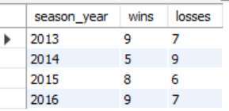
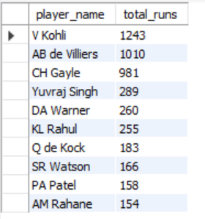
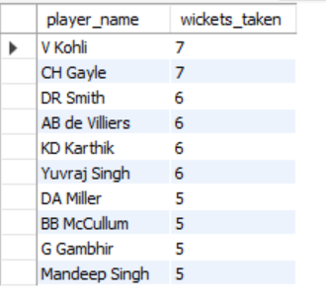
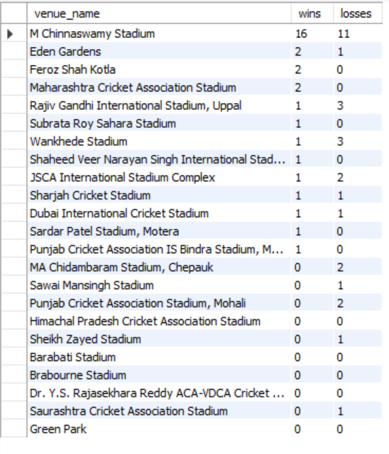
Visual Analysis
- Season-by-Season Wins and Losses Bar Chart:
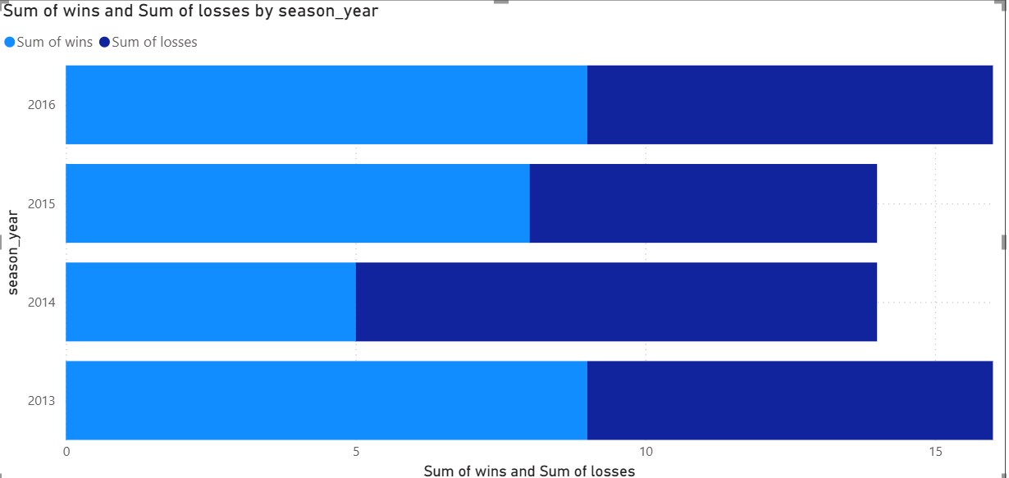
- Top Player Contributions:
RCB TOP 10 Batsmen
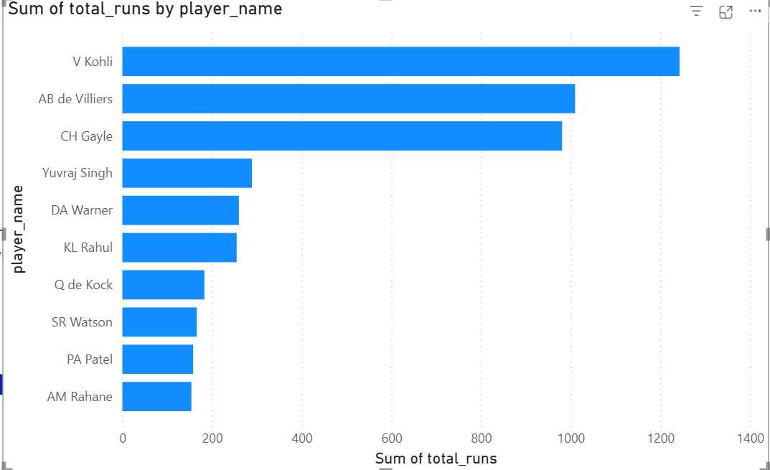
RCB TOP 10 Bowlers
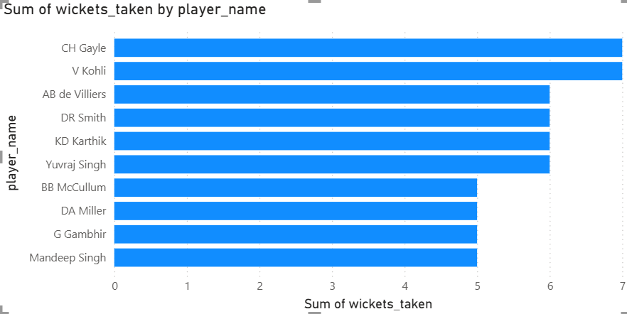
- Venue-wise Win/Loss Table:
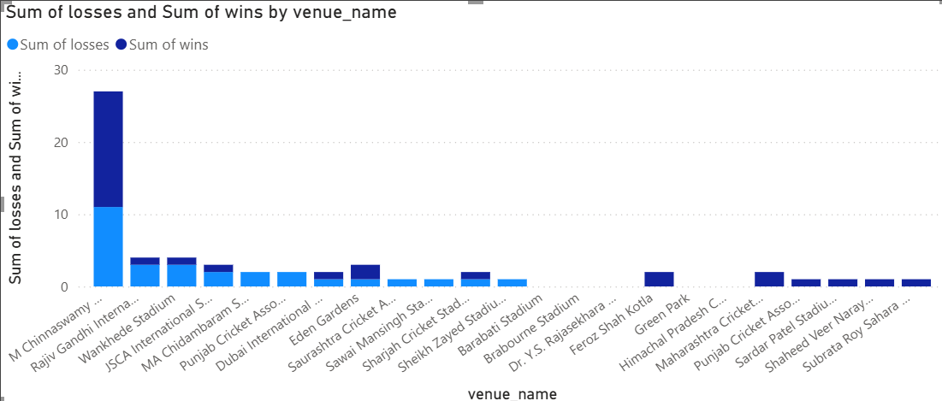

RCB’s past seasons show a strong batting core but inconsistent balance and venue dependence, which explains repeated near-misses despite elite individual peaks.​
Approach
- Tracked wins and losses by season to gauge consistency and playoff readiness trends across 2013–2016.​
- Profiled contribution concentration using top run scorers and wicket takers to test whether impact was broadly shared or star-heavy.​
- Assessed venue split to quantify home reliance at M. Chinnaswamy versus portability across away grounds.​
Insights
- Volatile year-on-year performance: 2014 dipped to 5–9, with recovery in 2015 (8–6) and 2016 (9–7), indicating competitive but not dominant regular seasons that leave little margin in playoffs.​
- Batting excellence is concentrated in a few stars—Kohli, de Villiers, and Gayle—creating high ceilings but exposure if one or two fail in knockouts.​
- Bowling penetration appears shallow relative to batting heft, with limited wicket volume among specialist bowlers and reliance on part-time or top-order names, a risk at death overs.​
- Heavy home reliance: Chinnaswamy accounts for the bulk of wins, while away returns are sparse and fragmented, suggesting conditions and boundary dimensions drive outcome variance.​
Recommendation
- Rebalance for knockouts: add a specialist death pacer and a high-impact wrist/mystery spinner to raise wicket-taking and lower death economy when batting-friendly conditions neutralize totals.​
- Spread batting responsibility: strengthen No. 5–7 finishing to reduce overreliance on the top three, preserving scoring rate when a star fails on the day.​
- Make home a fortress, travel with a plan: at Chinnaswamy, pick two finishers plus at least two variation bowlers; away, swap in an extra seamer on pace-friendly venues or an additional finger spinner on slower tracks.

- How would you approach this problem, if the objective and subjective questions weren't given?

Answer:
- First, I would familiarize myself with the schema and datasets to understand the structure of the IPL data, focusing on tables containing match details, player stats, and team information. Then, I would perform exploratory data analysis to get a high-level view of team performance across seasons, including wins, losses, runs scored, and wickets taken.
- Next, I would drill down into individual player performances, identifying key contributors in batting and bowling, making use of aggregates like total runs and wickets, strike rates, and bowling styles. To understand team dynamics, I would analyze the impact of player presence on match outcomes, assessing morale and performance influence.
- I would also examine venue and toss effects to see how home advantage and match conditions impact results. For high-scoring matches and their impact, I would analyze batting-friendly venues, boundary counts, and extras conceded.
- If objective and subjective questions weren’t given, I would develop my questions organically based on observed patterns or gaps in the data—such as why certain players outperform others, or what conditions lead to better bowling economies.
- Throughout, I would use SQL queries, including joins, aggregation, and window functions, to extract relevant KPIs and trends, preparing clean datasets for visualization. Visual methods like line charts for seasonal trends, bar charts for player comparisons, and heatmaps for venue effects would aid interpretation and storytelling.
- Finally, I would synthesize insights to recommend effective team strategies, retention, and auction approaches, ensuring data-driven decision-making for the franchise.

- In the "Match" table, some entries in the "Opponent_Team" column are incorrectly spelled as "Delhi_Capitals" instead of "Delhi_Daredevils". Write an SQL query to replace all occurrences of "Delhi_Capitals" with "Delhi_Daredevils".

SQL Query Used:
update team
set team_name = 'Delhi Daredevils'
where team_name = 'Delhi Capitals';
Output
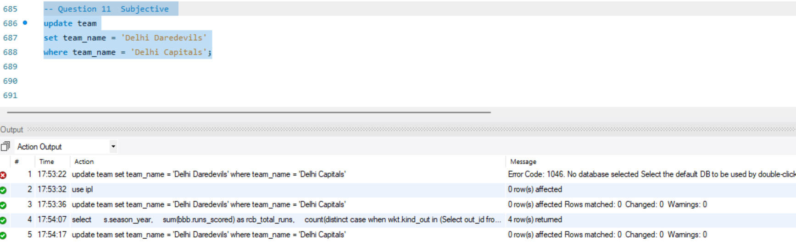
Answer: The schema does not have a direct column named "opponent_team" in the matches table or related tables. Instead, teams playing in a match are represented by the columns:
- team_1 (Team playing 1)
- team_2 (Team playing 2)
This updates the official team name wherever it appears across the schema via team_id foreign keys. Afterwards, all related tables referencing that team_id will have the corrected team name implicitly.

