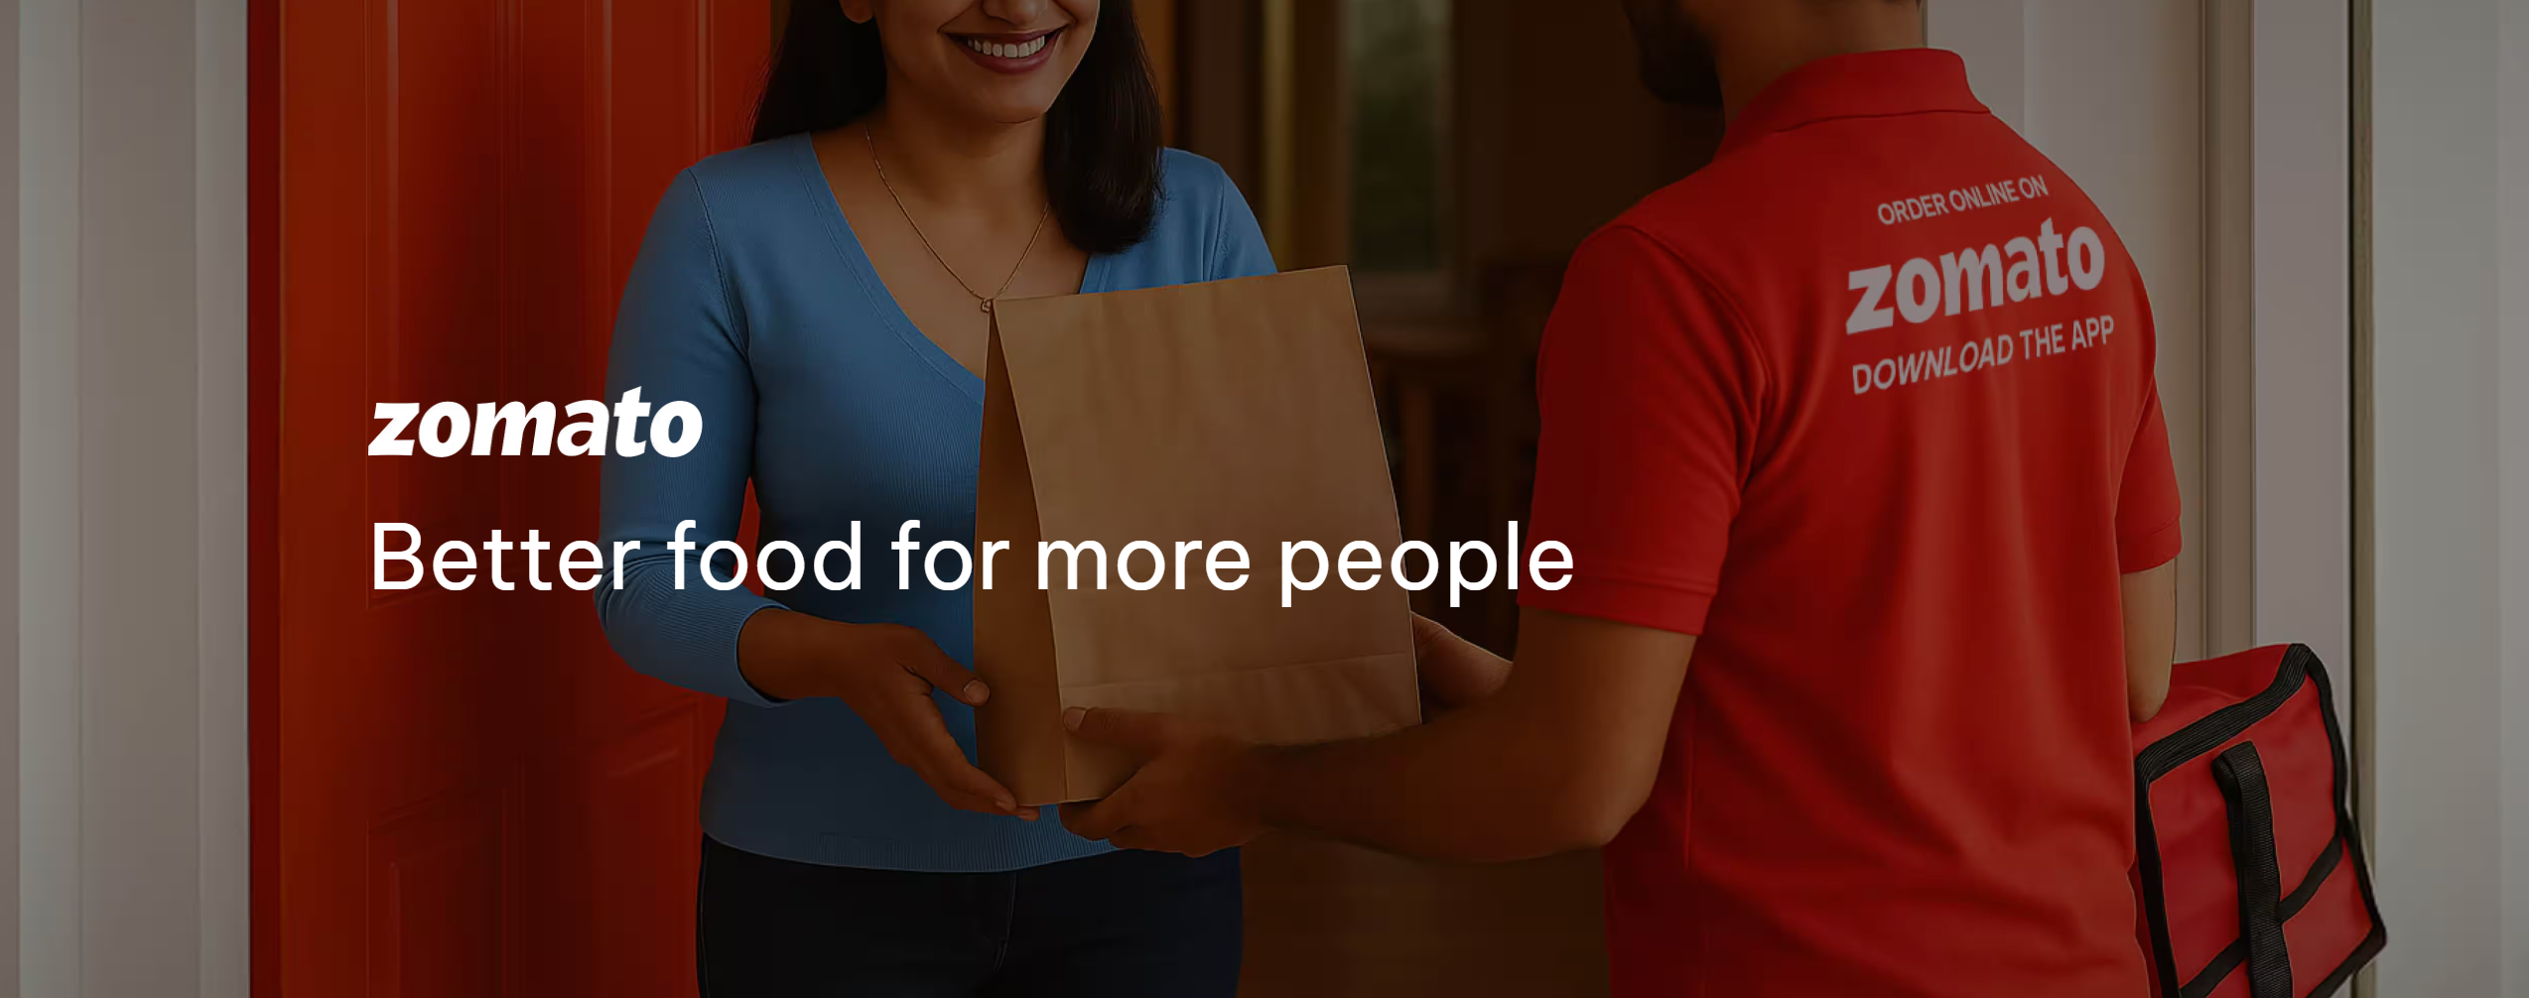

**Problem Statement**

You are hired as a consultant data analyst by Zomato where the team is looking for expansion andopening restaurants. Your task is to come up with strategies/suggestions about opening newer restaurants.

**Name- Yuvraj Gupta**

**Tasks**

**Objective Questions**:

1. What is the total no. of tables present in the data?

**Answer: - 2 Tables are present in the data**

1. What is the total no. of attributes present in the data?

**Answer: - In Table 1: - Total no of Attributes = 20**

**In Table 2: - Total no of Attributes = 2**

1. How many categorical columns are there in the data? [Search about categorical and continuous data, and try to answer this question]

**Answer: - Raw Data Sheet:- CountryCode, City,Locality,LocalityVerbose,** **Updated_Cuisines,Currency,Has_Table_booking,Has_Online_delivery,Is_delivering_now,Switch_to_order_menu,Price_range**

**Country description sheet:-** **Country Code, Country Name**

**There are 13 categorical columns in data (marked as gold, Accent 4, Lighter 80%)**

1. The data consists of some inconsistent and missing values so ensure that the data used for further analysis is cleaned.

**Answer: - Steps involving in handling inconsistent and missing values in data are as follows: -**

* **Removed Duplicates: -By using remove duplicates option in data ribbon->found no duplicates in data**
* **Handling null values: - I first pinpointed the exact locations of the nulls within the 'Cuisine' column of the "Raw Data" sheet by using Excel's "Go to Special" (Ctrl + G) feature and selecting "Blanks."**
* **Imputation Strategy: Instead of using a generic value, I opted for a more accurate, context-aware approach. The strategy was to fill each missing cuisine with the most popular (mode) cuisine specific to its corresponding 'Locality.'**
* **Executing the Imputation:**
  + **I created a Pivot Table to analyse the relationship between localities and cuisines.**
  + **In the Pivot Table, I placed 'Locality' and 'Cuisines' in the "Rows" field and 'Count of Cuisines' in the "Values" field.**
  + **By sorting the 'Count of Cuisines' in descending order for each locality, I was able to quickly identify the most frequently occurring cuisine for every unique location in the dataset.**
  + **Finally, I used this information to manually update the 9 empty cells with the appropriate, most popular cuisine for their respective locality.**
* **Handling Errors: - Checked for errors using Goto command in excel (Ctrl + G) -> selected the special field -> selected the formula field -> error -> found none**
* **Maintaining proper datatype: - Converted Datekey_Opening column (Raw Data) to proper format using text to column function (data ribbon)->selected (_) as delimiter extracted year, month and day -> created Updated_Datekey_Opening Column using date function.**

1. Using the LookUp functions, fill up the countries in the original data using the country code.

**Answer: - Formula used is =VLOOKUP (C2,'country description’! $A$1: $B$16,2,0)**

**Location of the formula: - Raw Data, X Column**

1. Create a table to represent the number of restaurants opened in each country.

|  |  |
| --- | --- |
| Countries | Count of Restaurant |
| Australia | 24 |
| Brazil | 60 |
| Canada | 4 |
| India | 8652 |
| Indonesia | 21 |
| New Zealand | 40 |
| Philippines | 22 |
| Qatar | 20 |
| Singapore | 20 |
| South Africa | 60 |
| Sri Lanka | 20 |
| Turkey | 34 |
| United Arab Emirates | 60 |
| United Kingdom | 80 |
| United States of America | 434 |
| Grand Total | **9551** |

1. Also, the management wants to look at the number of restaurants opened each year, so provide them with something here.

|  |  |
| --- | --- |
| Years | Count of Restaurant |
| 2010 | 85 |
| 2011 | 103 |
| 2012 | 111 |
| 2013 | 107 |
| 2014 | 105 |
| 2015 | 106 |
| 2016 | 89 |
| 2017 | 94 |
| 2018 | 99 |

1. What is the total number of restaurants in India in the price range of 4?

**Answer: - India has 388 in the price range of 4,To conclude this I have used COUNTIFS as I required to satisfy to two conditions that the Country should be India and price range should be 4**

**Formula used is =COUNTIFS ('Raw Data’! P2:P9552,"4",'Raw Data’! X2:X9552,"India")**

**Location of the formula: - Data_Assessment Sheet under the name Q8**

1. What is the average number of voters for the restaurants in each country according to the data?

|  |  |  |  |  |  |  |  |  |  |  |  |  |  |  |  |  |  |  |  |  |  |  |  |  |  |  |  |  |  |  |  |  |
| --- | --- | --- | --- | --- | --- | --- | --- | --- | --- | --- | --- | --- | --- | --- | --- | --- | --- | --- | --- | --- | --- | --- | --- | --- | --- | --- | --- | --- | --- | --- | --- | --- |
| |  |  | | --- | --- | | **Countries** | **Avg Voters** | | India | 137.21 | | United States of America | 428.22 | | United Kingdom | 205.49 | | Singapore | 31.9 | | Canada | 103 | | New Zealand | 243.03 | | United Arab Emirates | 493.52 | | Brazil | 19.62 | | Australia | 111.42 | | Turkey | 431.47 | | Qatar | 163.8 | | South Africa | 315.17 | | Philippines | 407.41 | | Sri Lanka | 146.45 | | Indonesia | 772.1 | |

**Answer: - Used Unique array function to bring out the country names in the Data_Assessment sheet, then used the average if to find average number of voters in each country and used round function to round it up to 2 decimals point**

**Formula used is** = **=ROUND(AVERAGEIF('Raw Data'!$X$2:$X$9552,Data_Assessment!O4,'Raw Data'!$Q$2:$Q$9552),2)**

**Location of the formula: - Data_Assessment Sheet under the name Q9**

1. Calculate the average rating for all the restaurants that have price_range < 4 and provide online delivery. Use only the “IF” function, Logical Operators, and Aggregation functions to solve this problem. **[Note: Don’t use Conditional aggregation in this question.]**

**Answer: - 3.27381151, Used the array based and(*) filtering as the typical and condition inside if takes only the first row of the dataset and gave the output based, to avoid this we use array based and(*).**

**Formula used is =** **AVERAGE(IF(('Raw Data'!P2:P9552<4)*('Raw Data'!M2:M9552="Yes"),'Raw Data'!S2:S9552))**

**Location of the formula: - Data_Assessment Sheet under the name Q10**

1. Using Conditional formatting highlight the rows of restaurants that are located in the countries or cities that you’ve suggested to the management for opening new restaurants.

**Answer:** **I have highlighted them in Market_Entry_Strategy**

**To identify suitable countries for Zomato's expansion, we employed a pivot table analysis with the following key metrics for each country: Count of Restaurant IDs, Average Restaurant Ratings, and Percentage of Restaurants Offering Online Delivery. This approach allowed for a comprehensive comparison of market conditions across different regions.**

**Our selection criteria were based on the following strategic considerations:**

1. **Lower Existing Restaurant Count (Less Competition):**
   * **Criterion: Prioritizing countries with fewer existing restaurants.**
   * **Reasoning: A lower density of existing restaurants indicates reduced market saturation, which translates to less intense competition for market share. This provides a more favorable environment for a new entrant like Zomato to establish its presence and grow its customer base with less initial friction.**
2. **Mid-Range Average Restaurant Ratings (Potential for Improvement and Demand):**
   * **Criterion: Selecting countries where the average restaurant rating falls between 3 and 4.**
   * **Reasoning: This mid-range rating suggests a market that is not overly saturated with exceptionally high-rated establishments, yet still demonstrates existing demand for dining services. It signals a viable market where Zomato can introduce new, high-quality restaurant options and leverage its platform to elevate the overall dining experience, thereby capturing market share by offering improvements.**
3. **Low Percentage of Online Delivery Adoption (Market Opportunity):**
   * **Criterion: Focusing on countries with a low current percentage of restaurants offering online delivery services.**
   * **Reasoning: A low penetration of online delivery represents a significant market gap and a prime opportunity for Zomato to differentiate itself. By entering these markets with robust and efficient online delivery capabilities, Zomato can quickly establish a strong competitive advantage and cater to an underserved demand, thereby standing out easily.**

**Countries Suggested: Canada, Singapore, Sri Lanka, Australia**

1. Create a new customized price column that consists of the abbreviation/symbol of the currency along with the Average_cost_for_two value. [Use string operations to do this task]

**Answer: Used String formula MID to find the characters from the middle where starting index is “(“, and no of characters it would take is difference of indexes “)”and “(“,used fill handle to fill the column.**

**Formula used is =** MID(K2,FIND("(",K2)+1,(FIND(")",K2)-1)-FIND("(",K2))&" "&R2

**Location of the formula: - Raw Data, Column Y , Row 2.**

1. How can you create an array formula in Excel or Google Sheets to count the number of restaurants listed that do not offer online delivery, are in the lowest price range, and have an average cost for two people less than or equal to 250 Indian Rupees?

**Answer: Used SUMPRODUCT array formula which first multiplies all the logical conditions and the ones which ought to be True(in binary it is 1)and then adds them.**

**Formula used is =** SUMPRODUCT(('Raw Data'!$M$2:$M$9552="No")*('Raw Data'!$P$2:$P$9552=1)*('Raw Data'!$R$2:$R$9552<=250)*('Raw Data'!$K$2:$K$9552="Indian Rupees(Rs.)"))

**Location of the formula: - Data_Assessment, Column I , Row 21.**

**Subjective Question:**

1. Suggest a few countries where the team can open newer restaurants with lesser competition. Which visualization/technique will you use here to justify the suggestions?

**Answer: -To suggest a few countries where the team can open new restaurants with less competition, I used a Pivot Table. I set the rows as countries and added count of restaurant IDs, average ratings, and count of online delivery options in the values section. This helped me easily compare the number of restaurants, how well they’re rated, and how many offer online delivery in each country.**

**Based on this, I recommended countries that:**

* **Have fewer existing restaurants (meaning less competition),**
* **Have an average rating between 3 and 4 (showing that there’s potential but also room for improvement),**
* **And have a low percentage of online delivery (which is a gap we can fill).**

**Criteria for Country Selection and Data Justification**

**To identify countries with less competition suitable for new restaurant openings, I utilized a Pivot Table with the following configuration:**

* **Rows: Country**
* **Values:**
  + **Count of Restaurant IDs (to quantify the number of existing restaurants)**
  + **Average of Ratings (to assess overall market potential and quality)**
  + **Count of Online Delivery Options (to identify gaps in existing services)**

**This pivot table allowed for a clear, comparative analysis of these key metrics across various countries. Based on this analysis, I established the following criteria for recommending target countries, with data-driven justifications:**

1. **Fewer Existing Restaurants (Less Competition):**
   * **Criterion: Countries exhibiting a lower Count of Restaurant IDs.**
   * **Data Justification: A lower restaurant count directly indicates a less saturated market. For example, if Country A has a Count of Restaurant IDs of 500, while Country B has 5,000, Country A presents significantly less existing competition, making it easier for new entrants to gain market share without aggressively competing with numerous established players. This reduces the initial barrier to entry and allows for a more focused market penetration strategy.**
2. **Mid-Range Average Rating (Potential and Room for Improvement):**
   * **Criterion: Countries with an Average of Ratings between 3 and 4.**
   * **Data Justification: This sweet spot suggests a market with existing demand (indicated by ratings above a poor baseline) but also significant room for improvement in service quality or offerings. If a country's average rating is, for instance, 3.5, it signifies that while some establishments are performing adequately, there's no overwhelming dominance by highly-rated competitors (e.g., an average rating of 4.5+ across the board). This provides an opportunity for new restaurants to differentiate themselves through superior quality, service, or unique culinary experiences, thereby capturing market share by exceeding current expectations.**
3. **Low Percentage of Online Delivery (Untapped Market Opportunity):**
   * **Criterion: Countries with a low Count of Online Delivery Options.**
   * **Data Justification: A low count of online delivery options highlights a significant unaddressed market need. For instance, if a country shows that only 10% of its restaurants offer online delivery, this identifies a substantial gap in the market. By entering with a strong emphasis on robust online delivery services, new restaurants can immediately cater to a demand that is currently underserved, establishing a competitive advantage and a unique selling proposition from day one. This allows for rapid market capture by fulfilling an existing, unmet consumer need.**

**Reasoning: - I went with these criteria because lower restaurant count means we won’t have to fight hard for market share. A mid-range average rating means the market isn't too tough, but still has demand. And if online delivery is low, we can take that as an opportunity to enter with strong delivery services and stand out easily.**

**Countries Suggested: Canada, Singapore, Sri Lanka, Australia**

**Visualization Technique used: Combo Chart**

**Location: Market_Entry_Strategy, Table- Countries where the team can open newer restaurants with lesser competition**

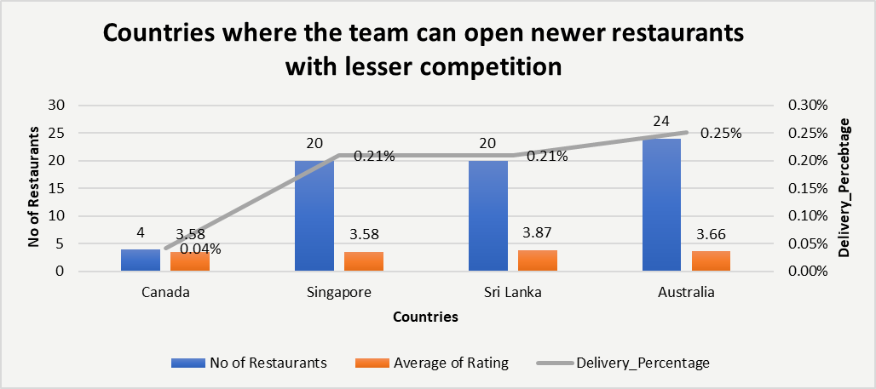

1. Come up with the names of States and cities in the suggested countries suitable for opening restaurants.

**Answer: I used a Pivot Table with cities in rows, and values including count of restaurants, average rating, and online delivery. I shortlisted cities that have:**

* **Low to moderate restaurant count,**
* **Average rating between 3 and 4,**
* **Low online delivery percentage.**

**Criteria for City Selection and Data Justification**

**To pinpoint specific cities within the suggested countries for new restaurant openings, I employed a Pivot Table with the following setup:**

* **Rows: City (nested under Country if you kept the country filter from the previous step, which is good practice for this analysis)**
* **Values:**
  + **Count of Restaurant IDs (to assess local competition)**
  + **Average of Ratings (to gauge local customer sentiment and market quality)**
  + **Count of Online Delivery Options (to identify localized service gaps)**

**This pivot table allowed for a granular comparison of these metrics at the city level, guiding the shortlisting process based on the following criteria and their data justifications:**

1. **Low to Moderate Restaurant Count:**
   * **Criterion: Cities with a relatively small Count of Restaurant IDs (e.g., 2 to a few dozen, depending on the overall city size).**
   * **Data Justification: A low to moderate restaurant count in a city directly translates to a less saturated local market. For instance, cities with only "2 restaurants" (as you mentioned in your reasoning) or a handful indicate minimal direct competition, making it easier for a new restaurant to quickly establish a customer base and achieve profitability without facing intense market share battles. This strategy focuses on maximizing initial market penetration and minimizing operational challenges related to fierce competition.**
2. **Average Rating Between 3 and 4:**
   * **Criterion: Cities where the Average of Ratings falls within the 3 to 4 range.**
   * **Data Justification: An average rating within this range suggests a local market that is not entirely devoid of demand (indicating some level of customer interest in dining out) but also one where existing dining options are not overwhelmingly high-quality. For example, if a city's average rating is 3.7, it implies that while some places are satisfactory, there's considerable room for a new establishment to excel by offering superior food, service, or ambiance, thereby attracting customers looking for better options. This indicates a market ripe for quality-driven disruption.**
3. **Low Online Delivery Percentage:**
   * **Criterion: Cities with a low Count of Online Delivery Options (or a low proportion of restaurants offering online delivery).**
   * **Data Justification: A limited number of online delivery options within a city highlights an unmet demand for convenient food services. If the data shows that only a small fraction of existing restaurants in a city offer online delivery, it presents a significant opportunity. By entering these markets with robust and efficient online delivery services, new restaurants can tap into a largely unserviced segment of the consumer base, immediately gaining a competitive edge and strong market appeal.**

**Suggested Countries & Cities:**

* **Australia – Armidale, Balingup, Dicky Beach, Flaxton, Forrest, Inverloch, Hepburn Springs, Lakes Entrance, Lorn, Macedon,Middleton Beach, Penola, Phillip Island, Victor Harbor**
* **Canada – Chatham-Kent, Consort, Yorkton**
* **Singapore – Singapore**
* **Sri Lanka – Colombo**

**Reasoning: - These cities reflect a healthy opportunity — they aren’t oversaturated, have fair-to-good customer sentiment (ratings between 3–4), and limited online delivery options. Some even have 2 restaurants, which is still manageable from a competition standpoint.**

**Visualization Technique used: Pivot Table**

**Location: Market_Entry_Strategy, Table- States and cities in the suggested countries suitable for opening restaurants**

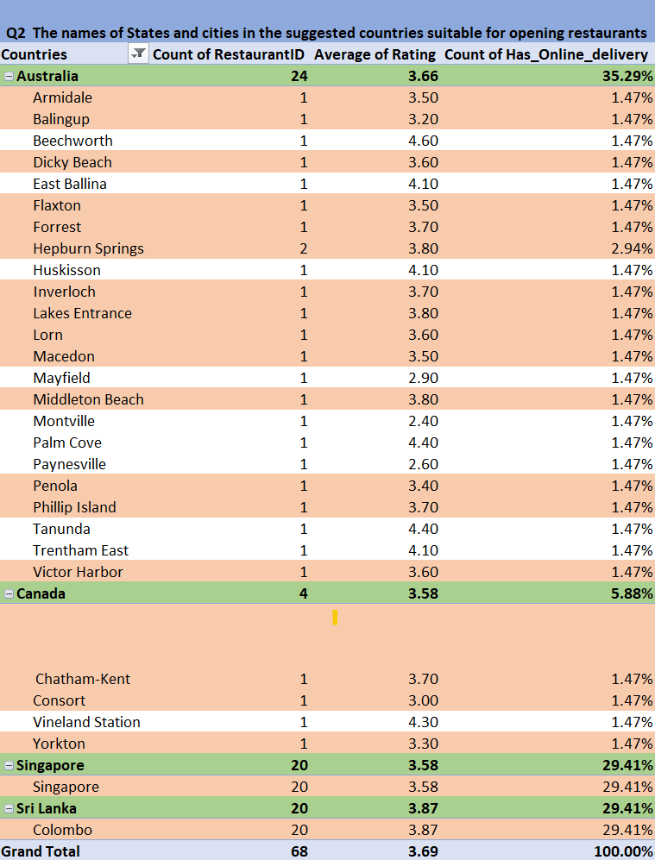

1. According to the countries you suggested, what is the current quality regarding ratings for restaurants that are open there?

**Answer: Based on the data, here are the suggested countries with their average restaurant ratings**

**Suggested Countries:**

* **Sri Lanka – 3.87**
* **Australia – 3.66**
* **Canada – 3.58**
* **Singapore – 3.58**

**These average ratings indicate that the quality of restaurants is decent, showing that people are engaging with the food and service, but there’s still room for improvement and innovation, especially in online delivery and customer experience.**

**Reasoning: All selected countries have average ratings between 3.5 and 4, which is a positive sign. It means the market isn’t highly saturated with top performers, but also not poorly rated — which gives us the opportunity to enter and stand out with quality service.**

**Visualization Technique used: Column Chart**

**Location: Market_Entry_Strategy, Chart- Suggested Countries with their respective average rating**

1. Also, what is the current expenditure on food in the suggested countries, so we can keep our financial expenditure in control?

**Answer:**  
**After standardizing the Average Cost for Two across all restaurants into INR for consistency and comparability, I applied the following approach:**

* **Extracted the list of unique currencies and recorded their respective current exchange rates.**
* **Used the VLOOKUP function to match each restaurant’s currency with its corresponding exchange rate.**
* **Created a new column, Average Cost for Two (INR), by multiplying the original cost (in local currency) by the matched exchange rate.**

**This conversion enabled a uniform cost metric, allowing for accurate cross-country comparisons. Based on this standardized measure, the total food expenditure in each of the suggested countries was calculated as follows:**

**Suggested Countries & Average Cost of two (in INR):**

* **Canada – ₹** **12536.7**
* **Singapore – ₹** **269322.9**
* **Sri Lanka – ₹** **13775.0**
* **Australia – ₹** **49973.88  
  From the pie chart, it's clear that Singapore holds the largest share of total food expenditure, followed by Australia, while Canada and Sri Lanka contribute a much smaller portion. This visual comparison helps in identifying high-cost zones for better financial planning.**

**Reasoning:  
By converting the total expenditure to Indian Rupees, we get a standardized view of costs across countries. This allows us to identify regions where we may need tighter budgeting (like Singapore) and where costs are relatively manageable (like Canada or Sri Lanka).**

**Visualization Technique used:  
Pivot Table to calculate total food cost per country, followed by a 3D Pie Chart for comparative visualization.**

**Location:  
*Market_Entry_Strategy* → Table & Chart: *The current expenditure on food (INR) in the suggested countries***

1. Come up with the names of restaurants from the recommended states that are our biggest competitors and also those that are rated in the lower brackets, i.e. 1-2 or 2-3.

**Answer:**  
**I have used five pivot tables to organize the analysis. Out of these, four are created country-wise, displaying the names of restaurants along with their average ratings to identify the biggest competitors in each suggested country.**

**In addition to that, I created one more table using aggregate functions, where I mapped the suggested states and cities and tried to find restaurant names that could be considered direct competitors based on their presence and ratings. This helped in identifying both high-performing competitors and cities with little or no competition, supporting better market entry decisions.**

**Top Rated Competitors: I have highlighted the top-rated restaurants using the Orange Accent 2 - Lighter 40% fill colour. These restaurants represent the highest-rated competitors in their respective countries and serve as key benchmarks for market entry analysis.**

**Low Rated Competitors: The low-rated competitors are highlighted with Orange Accent 2 - Lighter 80%, showcasing the weakest performers and potential areas of opportunity. Restaurants with average ratings have not been highlighted, as they fall in the middle tier but still play a crucial role in understanding the overall market dynamics and competition landscape.**

**Visualization Technique used:  
Pivot Tables**

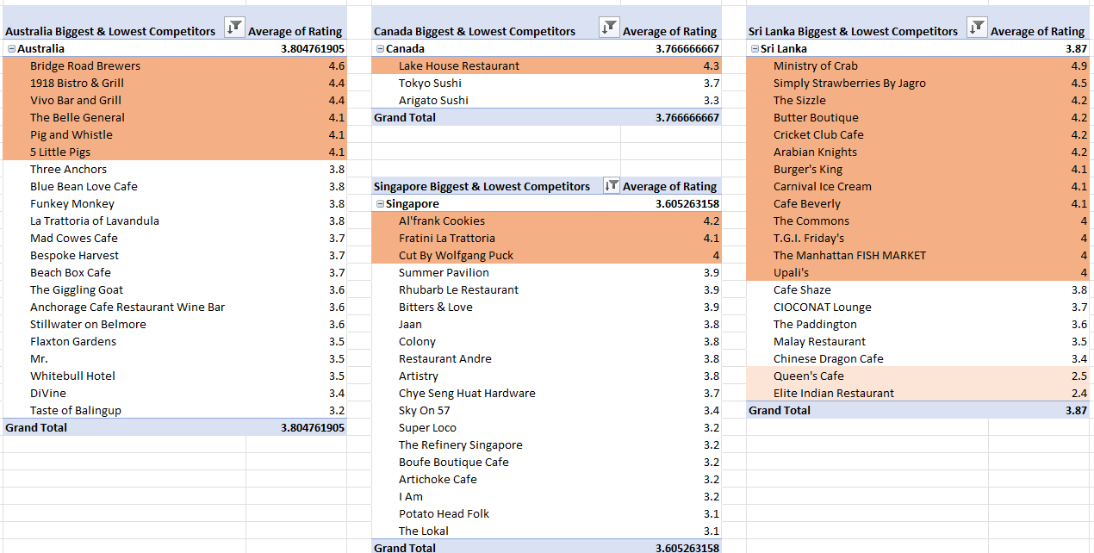

**Location:** **Competition_Analysis**

1. Which cuisines should we focus on in the newer restaurants to get better feedback? Does the choice of cuisines affect the restaurant ratings?

**Answer**: - **In this analysis, I utilized six pivot tables, each corresponding to a different country, to identify the most commonly consumed cuisines on a country-wise basis. Additionally, I examined the average ratings of restaurants serving these cuisines and observed that they consistently received higher ratings compared to other restaurants not offering these cuisines.**

**This indicates that the choice of cuisine does influence restaurant ratings, and focusing on popular, high-performing cuisines could lead to better customer feedback and improved ratings for newer restaurants.**

**Common Cuisines found: - American, Steak, Seafood, Italian, Mediterranean, Bakery, Pizza.**

**Reasoning: - These Cuisines above mentioned are common in at least 2 countries. Restaurants offering the above cuisines consistently achieved higher-than-average ratings in their respective countries.**

* **This suggests a strong positive correlation between these cuisines and customer satisfaction.**
* **Therefore, focusing on these cuisines in newer restaurants can potentially lead to better customer feedback and higher ratings**

**Visualization Technique used: Pivot Table**

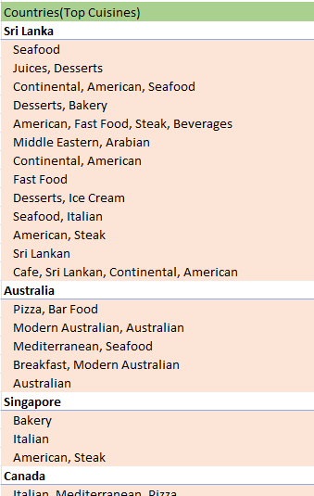

**Location: Top_Cuisines_Selection Sheet**

1. According to our current data, should we go for online delivery and table booking? Does that affect the customer’s ratings?

**Answer: Based on the current dataset, it is recommended to enable both online delivery and table booking services. The analysis indicates a positive association between these features and higher customer ratings.**

**Reasoning:**

* **Online Delivery:**
  + **Restaurants offering online delivery have an average rating of 3.29.**
  + **Restaurants not offering it average 2.75.**
  + **Insight: Online delivery is linked to better customer feedback.**
* **Table Booking:**
  + **Restaurants with table booking have an average rating of 3.48.**
  + **Those without have 2.81.**
  + **Insight: Providing a reservation option enhances perceived service quality.**
* **Currently Delivering (Real-time availability):**
  + **Restaurants currently delivering average 3.18.**
  + **Those not delivering at the moment average 2.89.**
  + **Insight: Real-time availability contributes to improved customer satisfaction.**

**Visualization Technique used:**

1. **Pivot Table Configuration:**

* **Rows:**
  + **Has_Online_delivery**
  + **Has_Table_booking**
  + **Is_delivering_now**
* **Values: Average of Rating**
* **Purpose: To compare rating differences based on service availability.**

1. **Bar Chart:**

* **A bar chart was created to visually compare the average ratings across the Yes and No categories for each feature.**
* **This helped in clearly highlighting the difference in ratings between restaurants that do and do not provide these services.**

**Location:** **Delivery_Booking_Impact Sheet**

1. Should the team keep the rate of cuisines higher? Will that affect the feedback? According to our data are the rates of cuisines and ratings, correlated?

**Answer:** **After analyzing the data on top cuisines across our suggested target countries, there’s a clear story: Charging higher prices for cuisines does not guarantee better customer ratings. In fact, in my findings show almost no relationship between what diners pay and how happy they are with their experience.**

**Reasoning:**

* **Correlation Coefficient:  
  The correlation between average cuisine price and customer rating is -0.0549. In simple terms, this number is extremely close to zero and slightly negative—suggesting that raising prices could even hurt ratings slightly, but the connection is so weak that it really doesn’t matter either way.**
* **Visual Insights:  
  When we plot average price against average rating for each top cuisine, there’s no clear pattern. High-priced and low-priced cuisines alike can achieve great feedback. For example, in Australia and Singapore, some of the most highly rated cuisines are also among the most affordable. Meanwhile, expensive options in Sri Lanka don’t necessarily stand out in ratings.**

**Visualization Technique Used:**

**We used a scatter plot to show the relationship between average cost for two (Y-axis) and average rating (X-axis) for top cuisines across Sri Lanka, Australia, Singapore, and Canada. The data points do not form any clear trend, visually confirming the lack of correlation.**

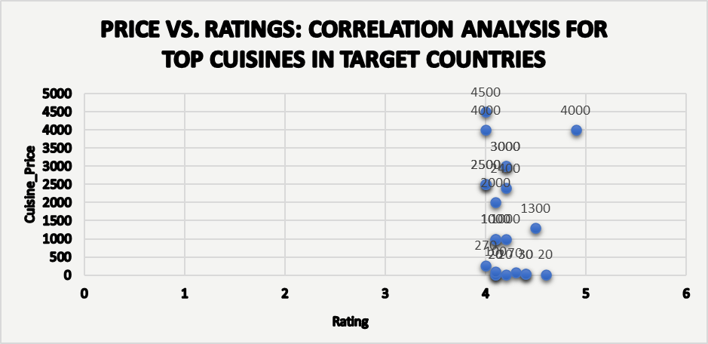

**Location: Price_Rating_Correlation**

1. What is the distribution of the number of restaurants of different price ranges in all the countries?

**Answer:**

**The distribution of the number of restaurants across different price ranges shows strong regional variation. The United States of America dominates with a significantly higher number of restaurants in all four price ranges, particularly in Price Range 3. Other countries like the United Kingdom and South Africa also have notable counts but are far behind the USA. Most other countries have a moderate to low number of restaurants, with certain price ranges being more prominent.**

**Reasoning:**

* **United States of America:**

**Clearly leads in restaurant count across all price ranges, especially in Price Range 3, followed by Range 2, Range 4, and Range 1. This indicates a well-distributed market with a strong upper-mid pricing focus.**

* **United Kingdom & South Africa:**

**Have a relatively balanced mix with stronger presence in Price Ranges 1 and 4, indicating both budget and premium market coverage.**

* **Indonesia & United Arab Emirates:**

**Skew towards Price Range 3, suggesting a higher preference for mid-to-high priced dining options.**

* **Brazil:**

**Significant presence in Price Range 4, indicating a lean towards premium restaurants.**

* **Australia, Turkey, Sri Lanka, Qatar, Philippines, Singapore, Canada, and New Zealand:These countries show lower overall restaurant counts, with a noticeable skew towards Price Ranges 2 and 3.**
* **Canada:Very few restaurants, distributed across Price Range 1 and 4, indicating a polarized market.**
* **Overall Trend: Price Range 3 dominates globally, suggesting a preference for upper-mid-range restaurants across most countries.**

**Business Insight:**

**This distribution suggests that Zomato should prioritize expansion in countries with growing mid and upper-mid restaurant segments (Price Range 3), especially the USA, UK, and South Africa, while exploring premium offerings in Brazil and Singapore. Countries like Canada and Sri Lanka may require more tailored, small-scale strategies due to their lower market size.**

**Visualization Technique Used:**

* **Pivot Table: To group the number of restaurants by country and price range.**
* **Stacked Bar Chart (Horizontal): Countries on the Y-axis and number of restaurants on the X-axis, segmented by Price Ranges (1 to 4) using distinct colours for clear comparison.**

**Location: Distribution_of_Restaurants**

1. Explain your approach in brief for suggesting countries/cities in order to open new restaurants, if the objective and subjective questions would have not been given to assist you. **[you have to give bullet pointers in order to answer this question]**

* **First, I would identify the countries where restaurant competition is low**
* **I would then focus on cities within those countries where people have higher spending capacity on food**
* **I would check if there is potential for offering online delivery; if not, I would assess the challenges and estimate its cost-effectiveness**
* **I would analyse the popular local cuisines as well as trending international cuisines and study customer feedback for both**
* **I would evaluate which price ranges attract the most customers and plan the restaurant infrastructure to match that demand**
* **I would begin by opening a single restaurant in the selected city, gather feedback, and then plan further expansion based on the response**
* **I would check if these cities have a good mix of low-, mid-, and high-priced restaurants to identify underserved price segments**
* **I would study the number of top-rated and low-rated restaurants in each city to understand the level of service and competition**
* **I would look at cities that have low adoption of services like table booking to offer a better overall experience and stand out**
* **I would use pivot tables and charts to compare parameters across cities and back up decisions with visual data analysis**
* **I would verify that the average cost and operational expenses in each city fit within the company’s financial goals**

**The dashboard must consist of Year-wise and country slicers.**

