Final Report
Course 591
Name : - Yuvraj Singh Bhatia (ybhatia2)
Date: April 27, 2026

1. Overview
This report presents emotion and stress recognition experiments on the WESAD dataset using wrist-based photoplethysmography (PPG). The objective was to evaluate whether the wrist blood volume pulse signal can distinguish baseline, stress, and amusement states, and whether stress can be separated from non-stress under a subject-independent setting.
To make the evaluation realistic, Leave-One-Subject-Out (LOSO) validation was used. In this setting, each subject is held out once for testing while the remaining subjects are used for training. Three models were evaluated: Support Vector Machine (SVM), Random Forest, and a one-dimensional Convolutional Neural Network (CNN). Results are reported for both 3-class classification and binary classification.

2. Data Processing
The synchronized SX.pkl files from WESAD were used. Only the wrist BVP signal and the protocol labels were retained. The signal was filtered using a Butterworth-style bandpass filter with a low cutoff of 0.7 Hz, a high cutoff of 3.7 Hz, and order 3. This step reduces baseline drift and high-frequency noise while preserving the frequency range that carries useful cardiac information.
After filtering, each subject signal was normalized with subject-wise z-score normalization. Fixed-length windows of 60 seconds were extracted with a step size of 5 seconds, and windows containing mixed labels were discarded. For the binary setting, baseline and amusement windows were merged into a non-stress class, while stress windows remained unchanged. For the 3-class setting, baseline, stress, and amusement were kept as separate labels.
Item | Value
Subjects used | 15
Signal | Wrist BVP
Filter | 0.7-3.7 Hz, order 3
Window size | 60 seconds
Step size | 5 seconds
Evaluation | LOSO
3-class windows | 6090
Binary windows | 6090
3-class label counts: baseline 3342, stress 1814, amusement 934. Binary label counts: non-stress 4276, stress 1814.
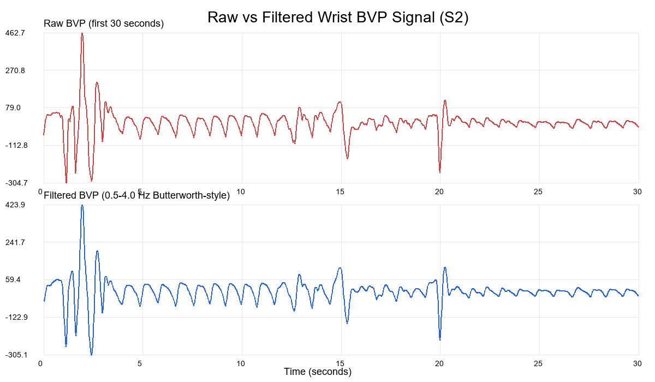
Figure 1. Example of raw and filtered wrist BVP signal used in preprocessing.
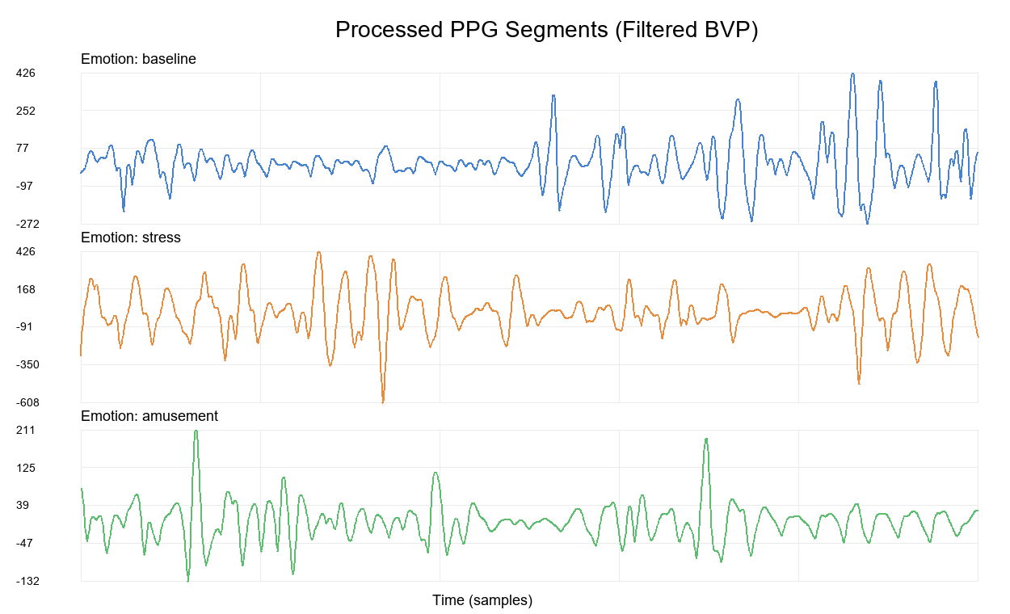
Figure 2. Example processed PPG segments for baseline, stress, and amusement after filtering.

3. Methodology
Three classification models were implemented in order to compare feature-based learning with end-to-end deep learning. The first two models, SVM and Random Forest, used the same handcrafted PPG feature set. The CNN used normalized raw windows directly as input.
Support Vector Machine (SVM)
The SVM model was implemented as a one-vs-rest linear classifier. Input features were standardized before training. This model provides a strong margin-based baseline and is well suited to smaller physiological datasets.
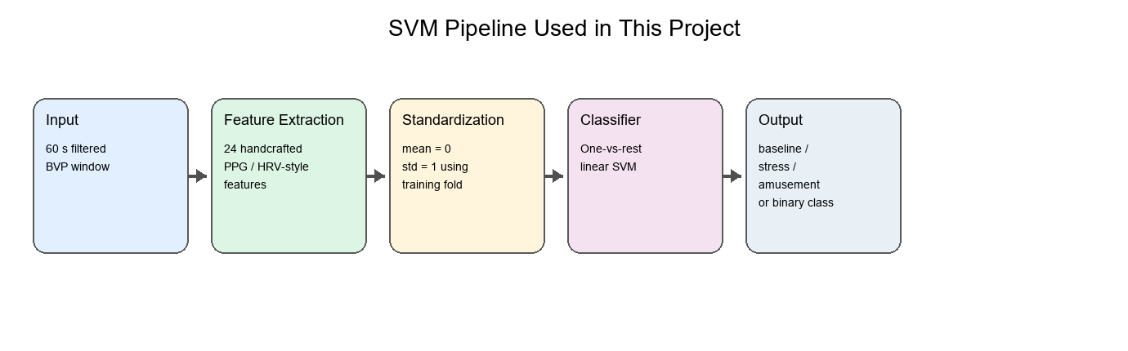
Figure 3. SVM processing pipeline used in the LOSO experiments.
Random Forest
The Random Forest model was trained on the same handcrafted features. The forest used 25 trees, a maximum depth of 8, a minimum split size of 10, a minimum leaf size of 5, and square-root feature sampling at each split. This model is useful because it can capture nonlinear feature interactions without requiring extensive feature scaling.
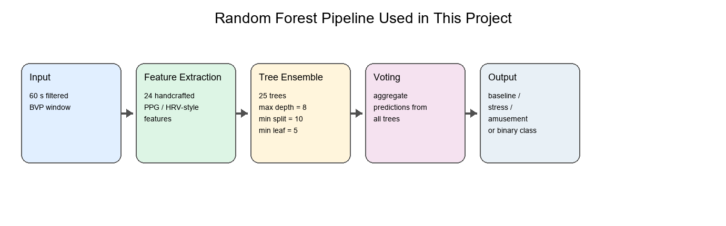
Figure 4. Random Forest processing pipeline used in the LOSO experiments.
CNN
The CNN model was designed as a one-dimensional convolutional network over 60-second normalized BVP windows. It used stacked convolutional layers, ReLU activations, pooling, and a small fully connected classifier. For the binary LOSO setting, the final CNN was trained for 10 epochs per fold. For the 3-class LOSO setting, the final CNN was also trained for 10 epochs per fold. Weighted loss was used to reduce the effect of class imbalance.
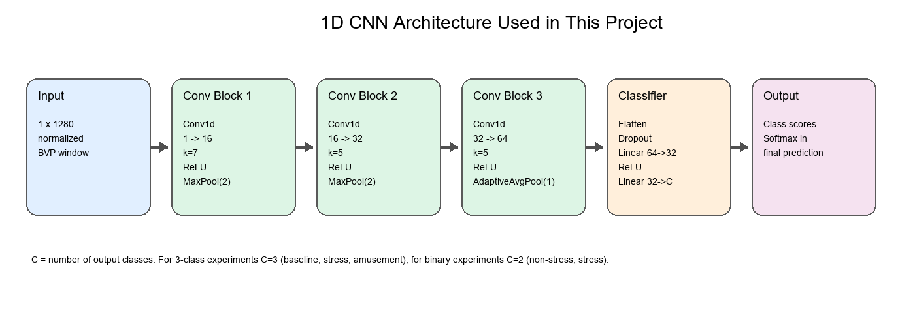
Figure 5. CNN architecture used for the LOSO experiments.

4. Experiments and Analysis
Performance was measured using accuracy, macro F1 score, and confusion matrices. Accuracy indicates overall correctness, while macro F1 emphasizes balance across classes. This is especially important in physiological classification tasks where class behavior is not equally easy to learn.
3-Class Evaluation Metrics
Model | Accuracy | Macro F1 | F1-Baseline | F1-Stress | F1-Amusement
SVM | 0.720 | 0.521 | 0.800 | 0.750 | 0.012
Random Forest | 0.687 | 0.541 | 0.780 | 0.687 | 0.155
CNN | 0.600 | 0.562 | 0.662 | 0.657 | 0.368
Binary Evaluation Metrics
Model | Accuracy | Macro F1 | F1-Non-Stress | F1-Stress
SVM | 0.850 | 0.819 | 0.894 | 0.743
Random Forest | 0.824 | 0.785 | 0.877 | 0.692
CNN | 0.836 | 0.821 | 0.874 | 0.768
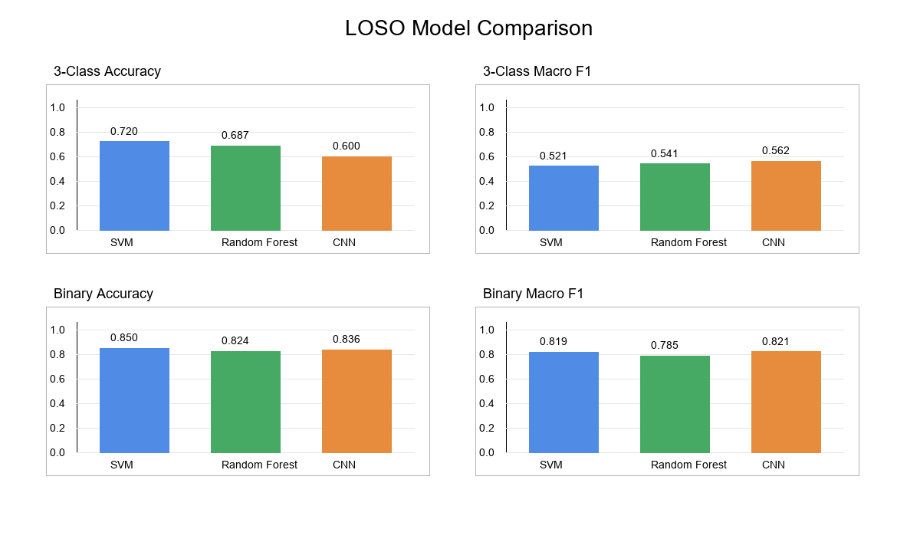
Figure 6. Comparison of accuracy and macro F1 across models.
Binary Classification Metrics
SVM
Class | Precision/Accuracy | Recall/Macro F1 | F1 | Support
Overall | 0.8496 | 0.8185 | - | -
non-stress | 0.8876 | 0.8997 | 0.8936 | 4276
stress | 0.7557 | 0.7315 | 0.7434 | 1814
Random Forest
Class | Precision/Accuracy | Recall/Macro F1 | F1 | Support
Overall | 0.8241 | 0.7845 | - | -
non-stress | 0.8621 | 0.8922 | 0.8769 | 4276
stress | 0.7231 | 0.6637 | 0.6922 | 1814
CNN
Class | Precision/Accuracy | Recall/Macro F1 | F1 | Support
Overall | 0.8363 | 0.8206 | - | -
non-stress | 0.9535 | 0.8061 | 0.8737 | 4276
stress | 0.6651 | 0.9074 | 0.7675 | 1814
3-Class Classification Metrics
SVM
Class | Precision/Accuracy | Recall/Macro F1 | F1 | Support
Overall | 0.7195 | 0.5206 | - | -
baseline | 0.7313 | 0.8836 | 0.8003 | 3342
stress | 0.7176 | 0.7845 | 0.7495 | 1814
amusement | 0.0870 | 0.0064 | 0.0120 | 934
Random Forest
Class | Precision/Accuracy | Recall/Macro F1 | F1 | Support
Overall | 0.6870 | 0.5405 | - | -
baseline | 0.7230 | 0.8468 | 0.7800 | 3342
stress | 0.6808 | 0.6924 | 0.6865 | 1814
amusement | 0.2961 | 0.1049 | 0.1549 | 934
CNN
Class | Precision/Accuracy | Recall/Macro F1 | F1 | Support
Overall | 0.5997 | 0.5623 | - | -
baseline | 0.7859 | 0.5721 | 0.6622 | 3342
stress | 0.6157 | 0.7040 | 0.6569 | 1814
amusement | 0.2925 | 0.4957 | 0.3679 | 934
In the binary LOSO setting, SVM achieved the strongest overall result with accuracy 0.8496 and macro F1 0.8185. The CNN improved substantially after training for 10 epochs and reached accuracy 0.8363 with macro F1 0.8206, which made it highly competitive with the classical baselines.
In the 3-class LOSO setting, SVM gave the highest accuracy at 0.7195, while CNN achieved the highest macro F1 at 0.5623. This suggests that SVM made the most correct predictions overall, whereas CNN produced the most balanced performance across baseline, stress, and amusement.
Confusion Matrix Analysis
The confusion matrices provide a more detailed view of model behavior than accuracy and macro F1 alone. In the binary setting, the main source of error is confusion between stress and non-stress windows. In the 3-class setting, amusement is the most challenging class, while baseline and stress are generally recognized more consistently.
Binary Confusion Matrices
SVM Confusion Matrix
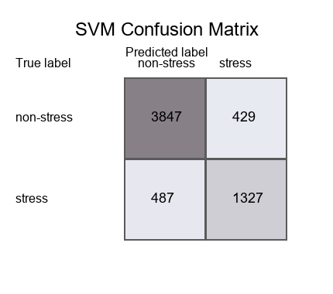
Random Forest Confusion Matrix
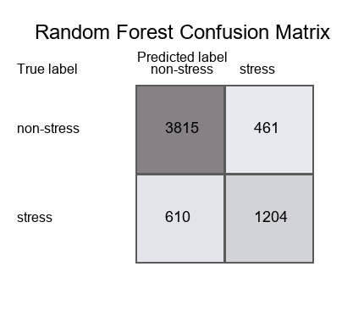
CNN Confusion Matrix
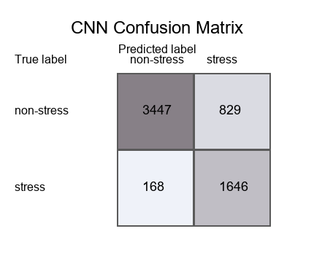
3-Class Confusion Matrices
SVM Confusion Matrix
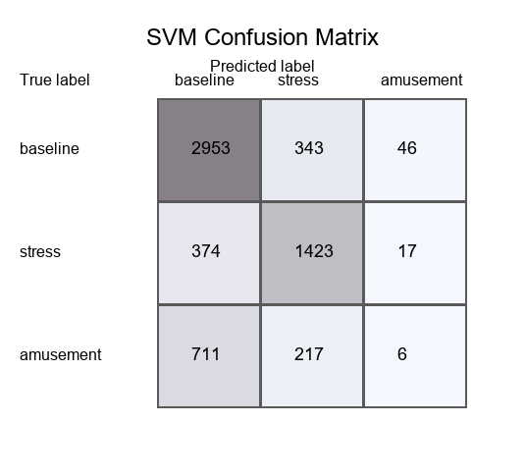
Random Forest Confusion Matrix
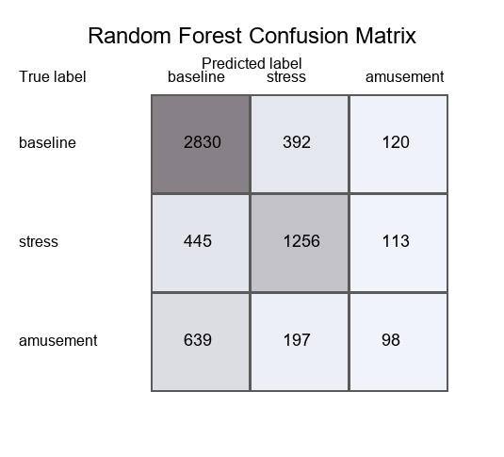
CNN Confusion Matrix
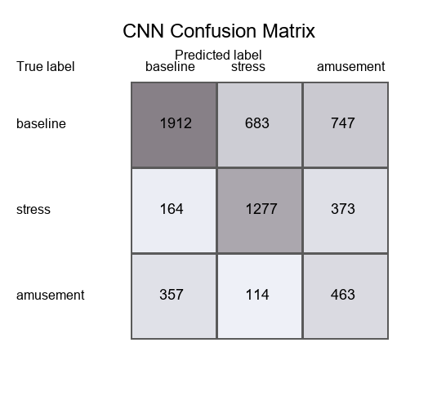

5. Conclusion
This study showed that wrist-based PPG from WESAD can support both binary stress recognition and 3-class emotion recognition under a strict LOSO evaluation protocol. The preprocessing pipeline, longer windows, and subject-wise normalization produced stable inputs for all three models.
Among the evaluated models, SVM was the strongest binary classifier and also produced the highest 3-class accuracy. The CNN benefited significantly from longer training, and after 10 epochs it achieved the highest 3-class macro F1, indicating improved class balance. Overall, the results show that both classical machine learning and deep learning are viable for PPG-based affect recognition, with the best model depending on whether overall accuracy or balanced class performance is prioritized.

