
Jaypee Univeristy of Information Technology, Waknaghat Solan H.P

Tutorial Sheet
Hashing Solutions

Q.1) (c) Input (4322, 1334, 1471, 9679, 1989, 6171, 6173, 4199)

Given Hash function,
h(a) = x mod 10
h(a) = h(1)
= {1471, 6171} hash to the same value
h(a) = h(2) = {4322}
h(a) = h(3) = {6173}
h(a) = h(9)
= {9679, 1989, 4199} hash to the same value.

h(0), h(5), h(6), h(7), h(8) are empty for given input.
So the statement (1) and (2) are correct.

Q.2) (b) Size of hash table = 7
h(x) = (3x + 4) mod 7
h(1) = (3.1 + 4) mod 7 = 7 mod 7 = 0; insert at 0th location.
h(3) = (3.3 + 4) mod 7 = 13 mod 7 =6; insert at 6th position.
h(8) = (3.8 + 4) mod 7 = 28 mod 7 = 0; 0th position is already filled by element 3 so insert 8 at next free location which is 1st position.
h(10) = (3.10 + 4) mod 7 = 34 mod 7 = 6; 6th position is already filled with the element 3 so insert 10 at next free location which is 2nd position.

Q.3) (a) We have 100 slots each of which are picked with equal probability by the hash function (since hashing is uniform). So, to avoid first 3 slots, the hash function has to pick from the remaining 97 slots. And repetition is allowed, since chaining is used meaning a list of elements are stored in a slot and not a single element.

So, required probability = 97/100×97/100×97/100 = (97 * 97 * 97)/(100 ^ 3)

Q.4) (c)
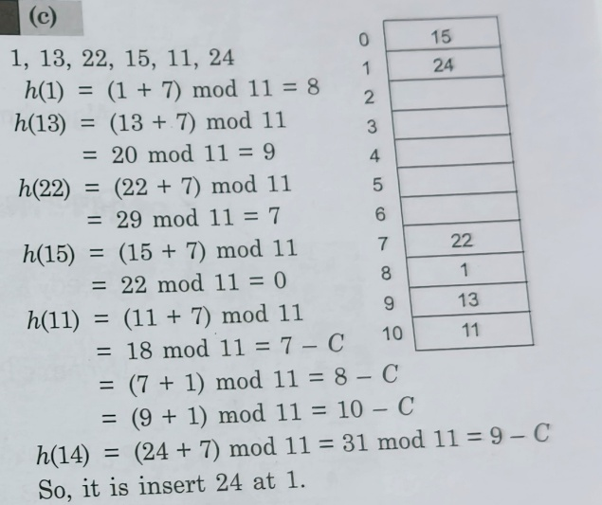

Q.5) Ans = 10
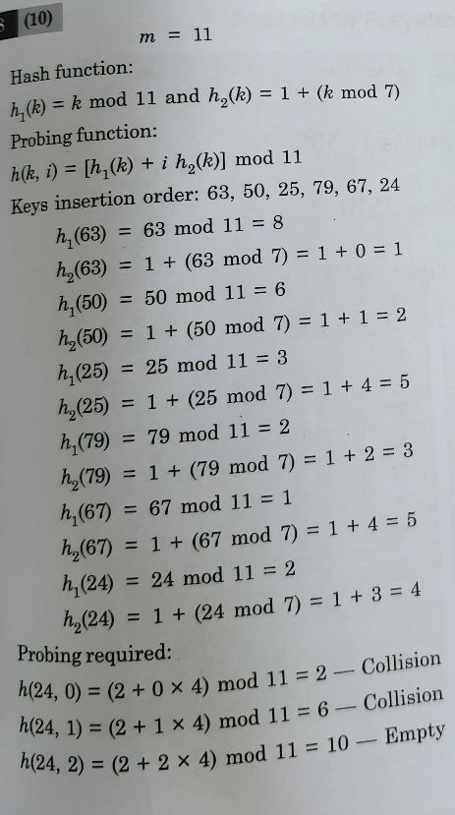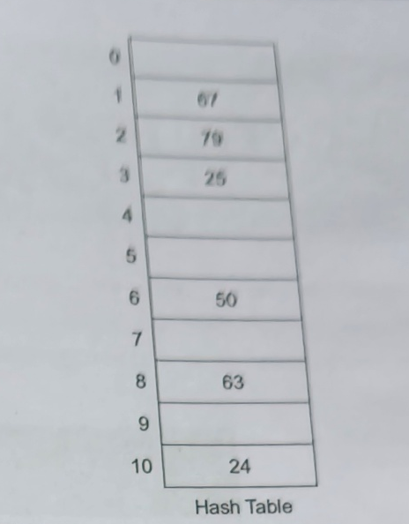

Q.6) Ans = 3
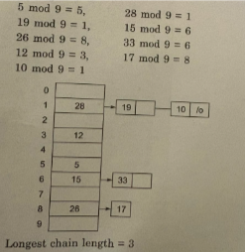

Q.7) Resulting Hashing Table
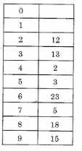

Q.8) Ans = 80
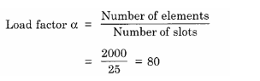

Q.9) Ans = 6
43->3
165->5
62->2
123->3(occupied) So acc. to linear probing 3+1=4
142 ->2(occupied),3(occupied),4 (occupied) ,5 (occupied) ->6

Q.10)
