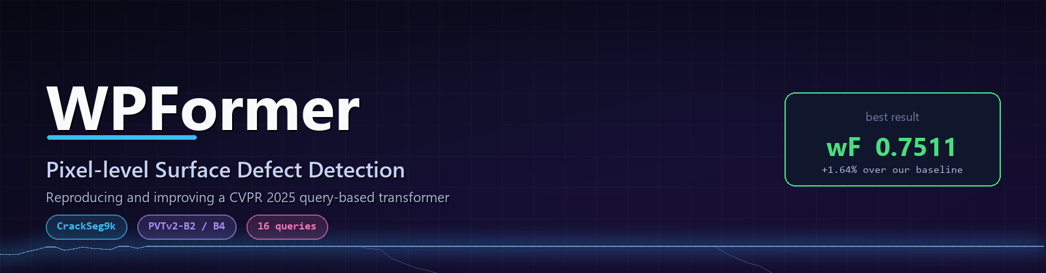
Reproducing and improving a CVPR 2025 query-based transformer for pixel-level surface defect detection
Yuvraj Singh · Nishkarsh Khandelwal · Darrsheni Sapovadia — Computer Vision and Deep Learning
6  configurations trained | 0.7511  best weighted F-measure | +1.64%  over our own baseline | 21 h  total GPU time

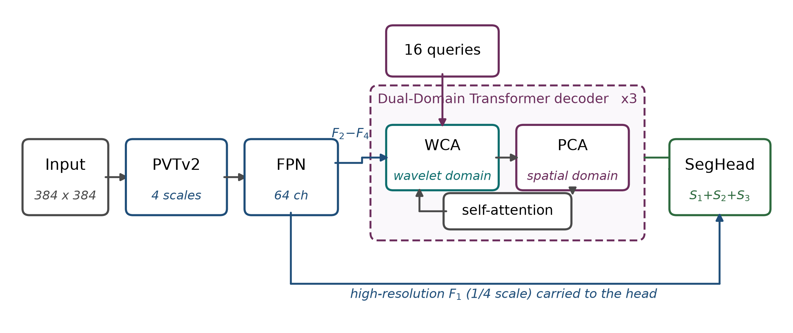
Sixteen learnable queries, refined in the wavelet and spatial domains. Our winning change replaces only the encoder.
Every heuristic, measured one at a time
Run | What changed | wFβ | Δ | Δ %
baseline | paper recipe (PVTv2-B2) | .7390 | — | —
backbone | PVTv2-B2 → B4 | .7511 | +.0121 | +1.64%
ema | averaged weights | .7364 | −.0026 | −0.35%
loss_only | boundary-weighted loss | .7317 | −.0073 | −0.99%
loss | loss + supervision reweighting | .7286 | −.0104 | −1.41%
aug | vflip, rot90, colour jitter | .7111 | −.0279 | −3.78%
Four of the five heuristics made the model worse. Only added capacity helped. Every run peaked in its final three epochs, so nothing converged — a regulariser is charged its cost at once and repays it only near convergence. Test-time augmentation degraded in proportion to how many averaged views the model had never been trained on, and was neutral once restricted to views it had seen.
  GitHub repository  code · notebooks · report · results · logs  https://github.com/Yuvraj0208/WPFormer-Surface-Defect-D… |  |   Run it on Colab  one click, no local setup  https://colab.research.google.com/github/Yuvraj0208/WPF…

PVTv2 backbone · FPN · 16 queries · wavelet and prototype cross-attention · CrackSeg9k 7243 / 395 · 384 × 384 · single NVIDIA T4

