Lab 2: Agile Backlog Creation & Sprint Simulation

Progress Screenshots — Project: escrow-ck (Milestone Escrow Platform)
A running record of the Jira workspace build, in the order it was completed.

1. Setting Up Work Items — Epic Creation
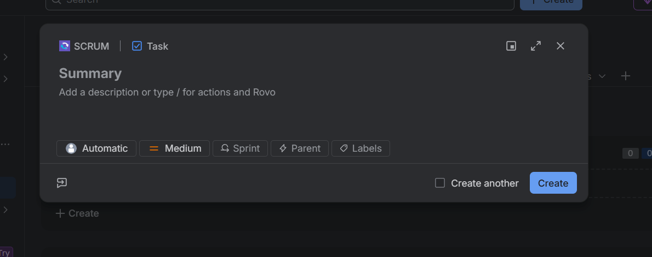
The quick-create panel defaults to work type "Task." Clicking the type label lets you switch it to Epic or Story.
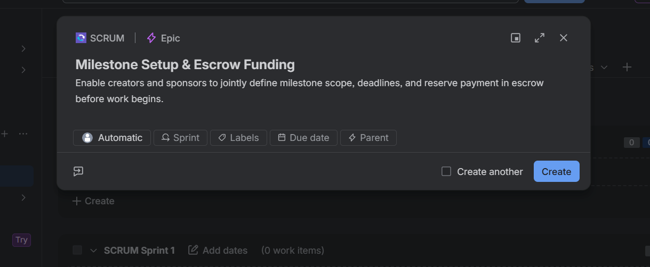
Epic 1: Milestone Setup & Escrow Funding, created with its full description and ready for Stories to link underneath it.

2. Populating the Backlog
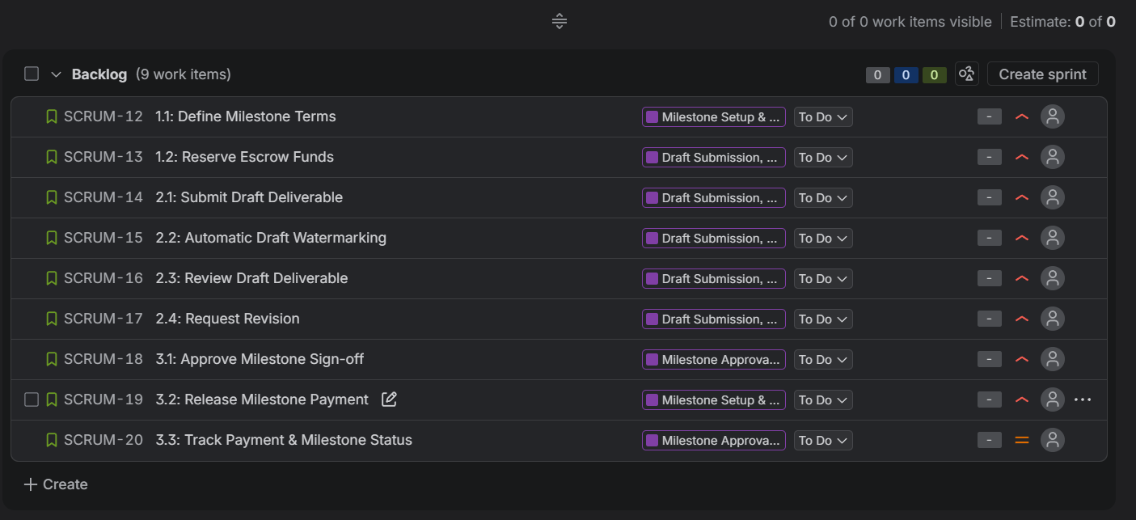
All 9 User Stories created across the 3 Epics and visible in the Backlog, prior to fixing story points and the Epic link on 3.2.

3. Sprint 1 — Milestone Setup & Draft Submission Stories
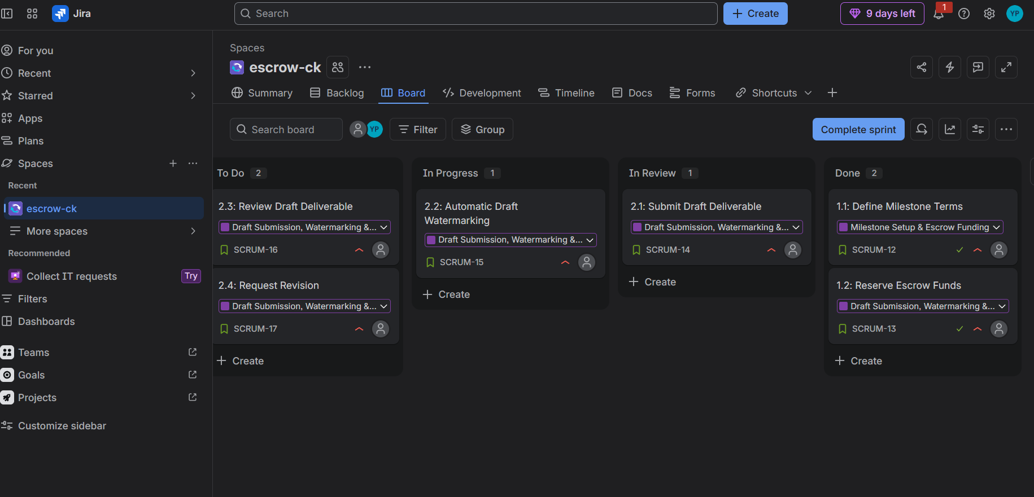
Sprint 1 board mid-progress: stories spread across To Do, In Progress, In Review, and Done.
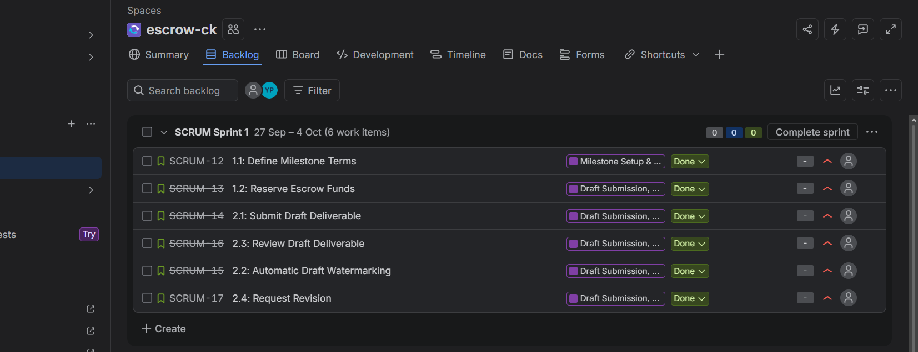
Sprint 1 backlog view after all 6 stories reached Done, just before completing the sprint.

4. Sprint 2 — Milestone Approval, Payment Release & Tracking
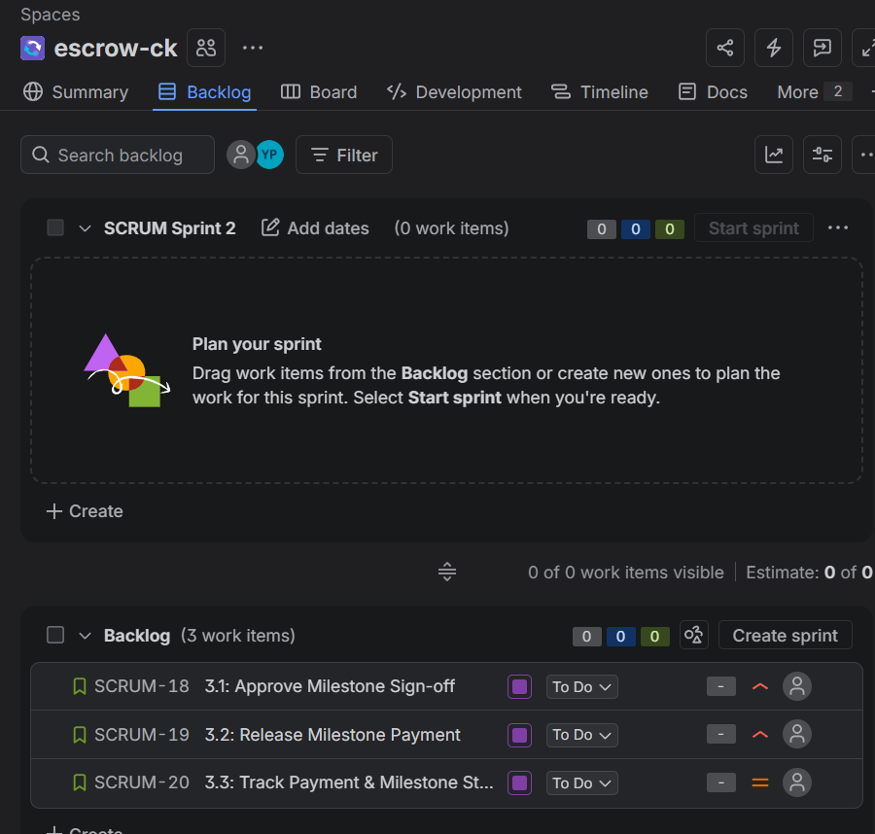
Sprint 2 staged with the final 3 stories (3.1, 3.2, 3.3) in the Backlog, ready to start.
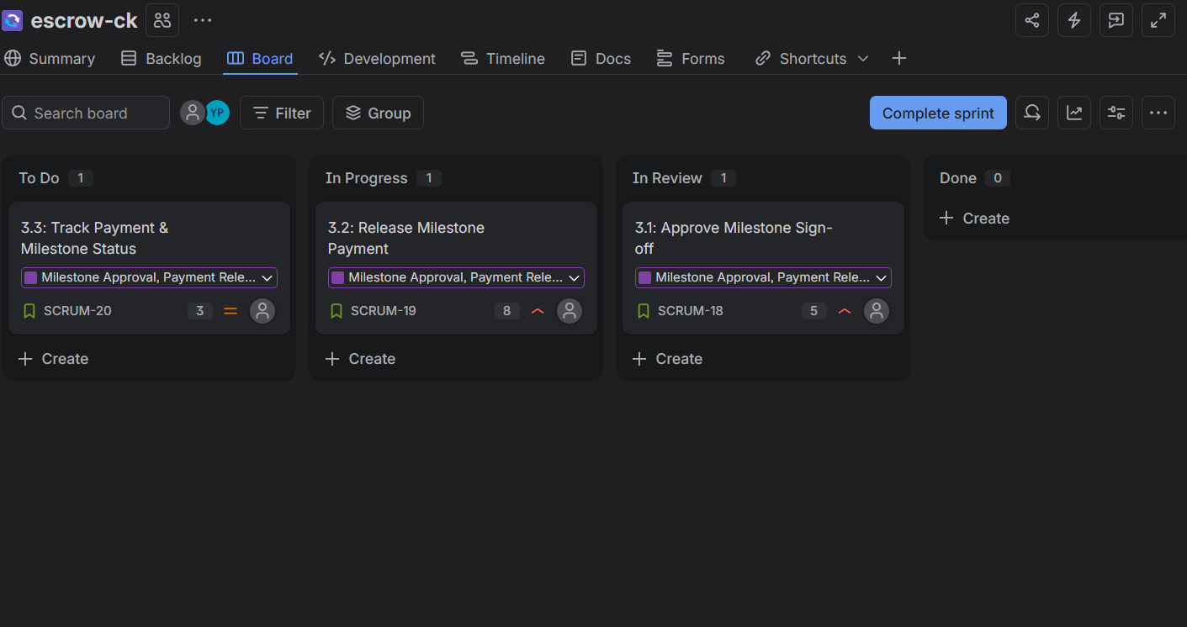
Sprint 2 board mid-progress, with Story Points (5, 8, 3) correctly assigned this time before the sprint started.
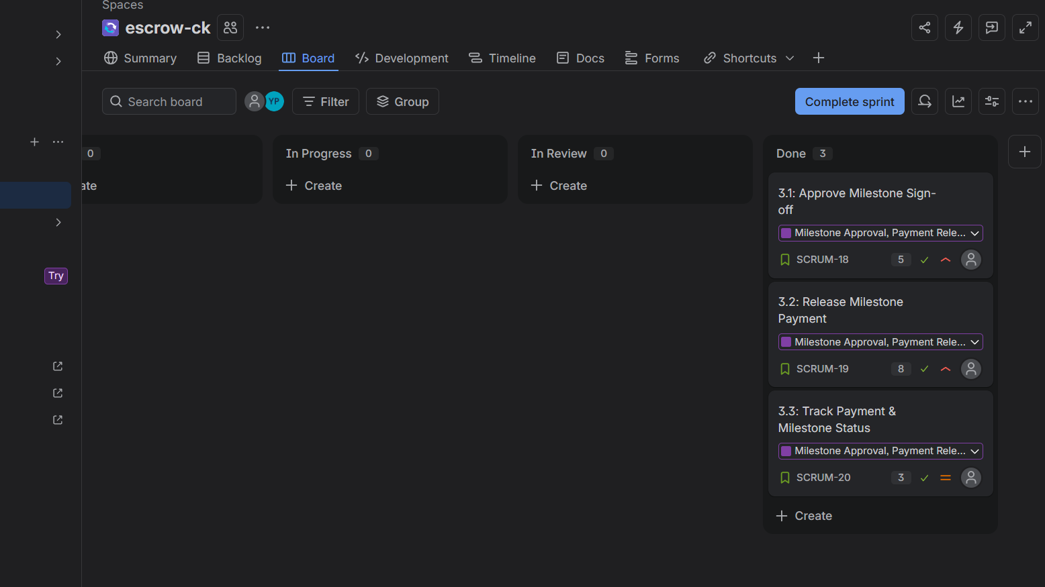
Sprint 2 board with all 3 stories moved to Done, ready to complete the sprint.

Still needed for the full lab submission
• A full Backlog screenshot with all 3 Epics expanded, showing their Stories underneath.
• The Burndown Chart for Sprint 1 and Sprint 2 (Reports → Burndown Chart).
• Written answers to the four reflection questions.

