SKYFORCE
PRELIMINARY DESIGN SIMULATION & ENERGY REPORT
Final reporting record for the supplied MATLAB run and exported CSV/figure set
Report date: 11 October 2026

Executive summary
This report consolidates the latest supplied SKYFORCE MATLAB outputs, the eight-row scenario summary, trajectory export, launch-gate table, energy/sensitivity tables, mass ledger, overweight-policy table, and the supplied figure set. The model is a preliminary 2-D point-mass simulation with assumed control and energy parameters. It is not a validated aircraft-performance model, and this report does not claim verified physical interception, capture, towing, parachute deployment, radio-link reliability, or safe recovery.
The current outputs demonstrate several distinct software decisions: a geometric candidate can be reached; a tow may complete or remain incomplete; a launch can be denied by a trajectory/time gate; an overweight target can trigger a simulated parachute-request/no-tow state; and an extended-pursuit case can be stopped by the energy guard before candidate registration. These are model-state outcomes, not evidence of real-world performance.

1. Scope and interpretation
- Coordinate model: 2-D XY point-mass trajectories. Scenario tracks and boundaries are illustrative.
- Tracking/decision geometry: outer tracking radius 2,000 m; inner 1,000 m reference/engagement-zone circle. The launch-gate examples assess predicted track entry and available response time.
- Candidate event: the 5–15 m range window is a geometric capture candidate only. It does not model net deployment or prove a physical capture.
- Control limits: model speed limit 25 m/s and applied acceleration cap 4.5 m/s². Requested guidance may exceed the model cap; the model limits the applied command. This is not a measured aircraft/controller capability.
- Energy: estimates use assumed power/profile inputs and exported integration. Remaining-segment energy and phase buffers are projections, not a measured battery-discharge trace.
- Performance validation: explicitly excluded from this work, as requested. No physical performance is certified by these simulations.

2. Changes made during the simulation development
- Initial simulation framing — Built scenario-based 2-D point-mass trajectories for slower-target attack, faster/equal-target defense, towing, and guidance diagnostics. Added trajectory, range, speed, acceleration, and energy plots.
- Guidance and controller reporting — Separated raw guidance demand, bounded/controller-limited command, and applied model acceleration; added requested-over-cap indicators and acceleration-cap annotations. Added a proportional-navigation heading-correction diagnostic.
- Scenario and event semantics — Clarified that a 5–15 m event is a geometric candidate, not verified capture. Added candidate-window/candidate-registration distinctions and explicit mission-outcome labels.
- Two-boundary launch gate — Added outer 2,000 m track-assessment radius and 1,000 m reference/engagement-zone prediction. Gate-only cases distinguish predicted zone entry with adequate response time, a track that misses the zone, and a threat detected too late.
- Launch-site and working-range bookkeeping — Operational trajectory scenarios use a fixed launch-pad reference at 1,500 m from the protected-site origin; separate working-range exports check initial ranges against the nominal 1.5–2.0 km band. Some scenarios are explicitly diagnostic exceptions rather than proof of universal range compliance.
- Tow/recovery state — Added safe-area geometry, nearest safe-point distance, tow-required decisions, tow-duration and safe-area-entry criteria. A tow reaching the safe-area boundary is not treated as a completed landing or full recovery.
- Energy guard and communications guard — Added estimated future segment reserve, phase buffer, mission ceiling comparison, effective telemetry/radio range bookkeeping, and stop/abort reason fields. The extended-pursuit case records an energy-guard stop before candidate registration.
- Overweight contingency — Target mass above 5 kg does not cause a mass-only launch abort. For the 6 kg example, the simulated policy requests parachute recovery after a geometric candidate and disables towing. Deployment physics and recovery are not simulated.
- Exports and reporting — Added scenario summary, trajectory export, boundary-gate summary, working-range assessment, propulsion sensitivity, mass ledger, component-reference comparison, assumptions/limitations, overweight-policy summary, and figure manifest/export outputs.
- Final visual corrections — Clarified scenario titles and status labels; separated geometric-window reach from candidate registration; adjusted extended-pursuit energy-plot range/annotations. This report preserves inconsistencies found between the summary CSV and trajectory export rather than silently reconciling them.

3. Baseline parameters and energy arithmetic
These are the stated model inputs/budget values, not measured aircraft data:
Parameter | Value | Interpretation
Nominal interceptor mass | 18.00 kg | Provisional baseline
Component ledger subtotal | 14.78 kg | Estimated BOM subtotal
Integration/growth allowance | 3.22 kg | Arithmetic headroom; not installed component mass
Post-capture mass for 5 kg target | 23.00 kg | 18 kg nominal + 5 kg target
Battery nominal energy | 355.2 Wh | 12S nominal voltage 44.4 V × 8.0 Ah
Counted usable battery energy | 284.16 Wh | 355.2 Wh × 0.80 assumed usable fraction
No-tow sizing ceiling | 207 Wh | Model sizing/energy-guard threshold
Tow sizing ceiling | 253 Wh | Model sizing/energy-guard threshold
Target mass limit | 5.0 kg | Overweight policy threshold
Tow cruise setpoint | 5 m/s | Model setpoint only
Applied acceleration cap | 4.5 m/s² | Model parameter, not measured capability
Maximum model speed | 25 m/s | Simulation constraint, not demonstrated aircraft speed
Battery arithmetic: E_nominal = V_nominal × capacity = 44.4 V × 8.0 Ah = 355.2 Wh. Counted usable energy = 355.2 Wh × 0.80 = 284.16 Wh (rounded to 284 Wh in plots). The 207 Wh and 253 Wh ceilings are scenario sizing limits, not the full nominal battery capacity.
The mass-reference export contains unresolved differences: ESC set ledger 0.78 kg vs bare-reference 0.438 kg; propeller set 0.60 kg vs bare-reference 0.354 kg; flight-controller/GPS/IMU ledger 0.40 kg vs bare flight-controller module 0.053 kg; companion computer 0.30 kg vs dev-kit reference 0.174 kg; radio/antenna ledger 0.50 kg vs bare modem 0.014 kg. These are not necessarily like-for-like assemblies, but the discrepancies need BOM reconciliation before hardware claims.

4. Scenario-by-scenario results and decisions

Scenario 1 — Attack mode, slower target; candidate outside safe area
Initial range 2,879.24 m; geometric candidate at 13.35 m after 88.45 s; relative closing speed 33.31 m/s. Candidate is outside designated safe areas, so tow is required. Tow remained incomplete at the simulated 60 s tow checkpoint; safe-area entry/release/landing are not demonstrated.
Energy accounting. Trajectory export reports 120.2606 Wh cumulative simulated-phase energy at the last sample (148.45 s). The summary CSV conflicts: it records EnergyUsed_SimulatedPhases_Wh = 253.0 Wh, which does not match the trajectory export or the supplied figure annotation (~120.26 Wh). No complete-mission energy estimate is provided for this incomplete tow. Treat 120.26 Wh as the trajectory-export/figure value and flag the summary row as inconsistent; do not call it a reconciled final total.
Final decision/inference. Decision: geometric candidate registered; tow required; mission incomplete in the supplied simulation. No full mission-energy conclusion.

Scenario 2 — Defense mode, faster/equal target; lead-point intercept
Initial range 2,353.72 m; candidate range 14.595 m at 73.55 s; closing speed 26.97 m/s. Candidate is inside a designated safe area, so the simulated decision is immediate release rather than tow.
Energy accounting. Simulated phases = 42.7214 Wh; estimated remaining segment = 27.1588 Wh; phase buffer = 9.7 Wh. Projection = 42.7214 + 27.1588 + 9.7 = 79.5802 Wh (reported 79.5803 Wh), below the 207 Wh no-tow ceiling by about 127.42 Wh. Remaining segment is estimated, not dynamically simulated.
Final decision/inference. Decision: geometric candidate registered; release inside safe area; projected model energy is within the no-tow ceiling. Physical capture/release is unvalidated.

Scenario 3 — Tow required; candidate outside safe area
Initial range 2,729.47 m; candidate range 13.969 m at 82.85 s; closing speed 33.99 m/s. Nearest safe point at candidate is outside the 120 m safe-area radius; tow is required. The model enters the designated safe area after 13.3 s of tow, within the 60 s criterion.
Energy accounting. Simulated phases/tow segment = 85.1765 Wh; tow buffer = 18.8 Wh. Endpoint projection = 85.1765 + 18.8 = 103.9765 Wh (reported 103.9765 Wh), below the 253 Wh tow ceiling by about 149.02 Wh. This endpoint projection excludes subsequent landing/return.
Final decision/inference. Decision: geometric candidate registered; safe-area entry criterion met within 60 s; tow/release/landing physics remain unmodelled.

Scenario 4 — Abort; target reaches boundary too soon
Gate-only demonstration. Estimated time available before inner-zone entry is 15.0 s, while the model response-time estimate is 33.8 s.
Energy accounting. No mission flight simulated; energy is not applicable. The 207 Wh no-tow ceiling is a reference threshold only, not an energy result for this scenario.
Final decision/inference. Decision: no takeoff in this gate example because available lead time is less than the assumed response estimate.

Scenario 5 — PN correction diagnostic
In-flight guidance diagnostic only, initialized with heading offset. Candidate range 14.275 m at 81.35 s; closing speed 16.09 m/s. It is not a launch-gate/mission-energy case.
Energy accounting. Trajectory export reports 78.7710 Wh simulated-phase energy through the diagnostic endpoint. No full mission projection or comparison against a mission ceiling is claimed.
Final decision/inference. Decision: guidance correction/candidate geometry demonstrated in the model only. Do not use as an operational mission-energy result.

Scenario 6 — Outer tracking only; predicted track misses inner zone
Gate-only example: initial range 4,103.66 m; predicted closest approach 1,800 m, outside the 1,000 m inner circle. No interceptor flight is simulated.
Energy accounting. No mission energy consumed in this gate-only simulation; 207 Wh is a reference ceiling only.
Final decision/inference. Decision: no takeoff because the predicted track does not enter the inner engagement/reference zone.

Scenario 7 — Overweight target; simulated parachute request and no tow
Target mass estimate 6.0 kg exceeds the 5.0 kg nominal target limit by 1.0 kg. Mass alone does not block launch. Candidate range 13.969 m at 82.85 s; closing speed 33.99 m/s. After the candidate event, the model sets the parachute-request flag and disables towing.
Energy accounting. Simulated-phase energy = 76.0390 Wh. No deployment energy, opening shock, suspended-load dynamics, descent, landing, or complete recovery energy is modelled; no complete-mission projection is supplied.
Final decision/inference. Decision: simulated parachute-request/no-tow contingency. This is a state-logic flag only, not a real deployment command or evidence the recovery is safe.

Scenario 8 — Extended pursuit; target exits 1 km reference zone
The integrated gate predicts inner-zone entry with 49.967 s available from track acquisition against a 33.8 s response estimate, so simulated launch is authorized. Target enters and then exits the 1 km reference zone at 127.255 s at approximately (435.89 m, 900 m). The energy guard stops the pursuit before candidate registration.
Energy accounting. At stop: simulated energy already used = 78.4448 Wh; estimated remaining tow segment = 210.5975 Wh; phase buffer = 18.8 Wh. Projected requirement = 78.4448 + 210.5975 + 18.8 = 307.8423 Wh (reported 307.8424 Wh), exceeding the 253 Wh tow ceiling by 54.84 Wh and exceeding the counted usable battery energy of 284.16 Wh by 23.68 Wh. Candidate window was geometrically reached at 13.95 m, but candidate was not registered because the energy guard stopped the run.
Final decision/inference. Decision: energy guard stop; no candidate registration. This scenario is the clearest example that reaching a geometric window and authorizing launch do not imply the mission can be completed within the modeled energy budget.

5. Launch-gate table interpretation
Gate example | Predicted geometry/time | Response estimate | Decision
Engagement-zone entry predicted | 3,000 m initial range; 50 s from outer-ring acquisition to inner entry | 33.8 s | Simulated launch recommendation before entry
Outer ring only; zone missed | Closest approach 1,800 m; no inner-circle entry | Not limiting | No takeoff in gate-only demonstration
Threat detected too late | 25 s predicted to inner entry | 33.8 s | No takeoff: insufficient response time
The launch-gate CSV uses 2,000 m for outer tracking and 1,000 m for the inner reference circle. The gate is synthetic/offline. It should not be described as validated radar tracking or operational launch logic.

6. Propulsion and mass-related checks
The propulsion sensitivity CSV assumes 15%, 20%, and 30% thrust derating. At the 25 m/s model point, available thrust after derating is 365.23 N, 343.74 N, and 300.77 N respectively. The corresponding thrust margins are 1.93, 1.81, and 1.59 for nominal mass, and 1.55, 1.46, and 1.27 post-capture. These are arithmetic model checks based on assumed thrust/drag inputs; they do not establish actual forward-flight capability.
The 16-line component ledger totals 14.78 kg and the stated 3.22 kg allowance yields the 18.00 kg nominal baseline. Since several ledger entries are first-pass placeholders and component references are not always like-for-like assemblies, the mass total remains provisional until the actual BOM and installed assembly masses are reconciled.

7. Cross-output consistency audit — important before final report submission
The supplied files do not all agree. The following issues should be disclosed in the report rather than silently corrected:
- Scenario 1 energy mismatch: the scenario-summary CSV reports 253.0 Wh simulated-phase energy, whereas the trajectory export peaks at 120.2606 Wh and the supplied figure annotation reports about 120.26 Wh. The summary row should be treated as inconsistent until regenerated/reconciled.
- Scenario 1 wording: the latest figure labels the candidate outside the safe area and says the tow did not reach the safe area within 60 s; do not describe it as a successful tow or claim complete-mission energy.
- Scenario 3: the supplied scenario summary says safe-area entry occurred within 60 s and reports a 103.98 Wh endpoint projection; this excludes landing/return and is not total mission energy.
- Scenario 8: geometric window reached at 13.95 m but candidate not registered because the energy guard projects 307.84 Wh against a 253 Wh ceiling. This distinction must remain explicit.
- Working-range assessment marks most operational trajectory starts outside the 1.5–2.0 km band. It labels these as diagnostic/pending confirmation, not a hard gate. Therefore, do not claim every trajectory starts within that band.
- Figures and CSVs are outputs supplied by the user; this report did not execute MATLAB or regenerate them. The review is a consistency/interpretation audit, not an independent numerical rerun.

8. Final conclusions
- The model supports scenario-level decision-logic demonstrations, not verified physical performance.
- The two-boundary gate demonstrates three distinct outcomes: recommend launch with sufficient predicted lead time, deny launch when the predicted track misses the inner zone, and deny launch when response time is insufficient.
- Scenario 2's projected no-tow energy is 79.58 Wh against a 207 Wh ceiling; Scenario 3's tow endpoint projection is 103.98 Wh against a 253 Wh ceiling, but landing/return are excluded.
- Scenario 1's tow is incomplete and its summary/trajectory energy fields disagree; its energy result must be reported as unresolved rather than as a final mission total.
- Scenario 7's overweight response is only a simulated request flag and no-tow state; deployment and recovery are not modelled.
- Scenario 8 is energy-limited: projected requirement 307.84 Wh exceeds both the 253 Wh tow ceiling and 284.16 Wh counted usable energy; pursuit is stopped before candidate registration.
- Hardware claims require later work on measured component masses, selected battery, measured electrical power, verified link budget, forward-flight propulsion, control response, capture/release mechanics, tow loads, and recovery dynamics. These are explicitly outside the current scope.

Appendix A — supplied figure set
Figure 1. Attack-mode candidate outside safe area; tow incomplete.
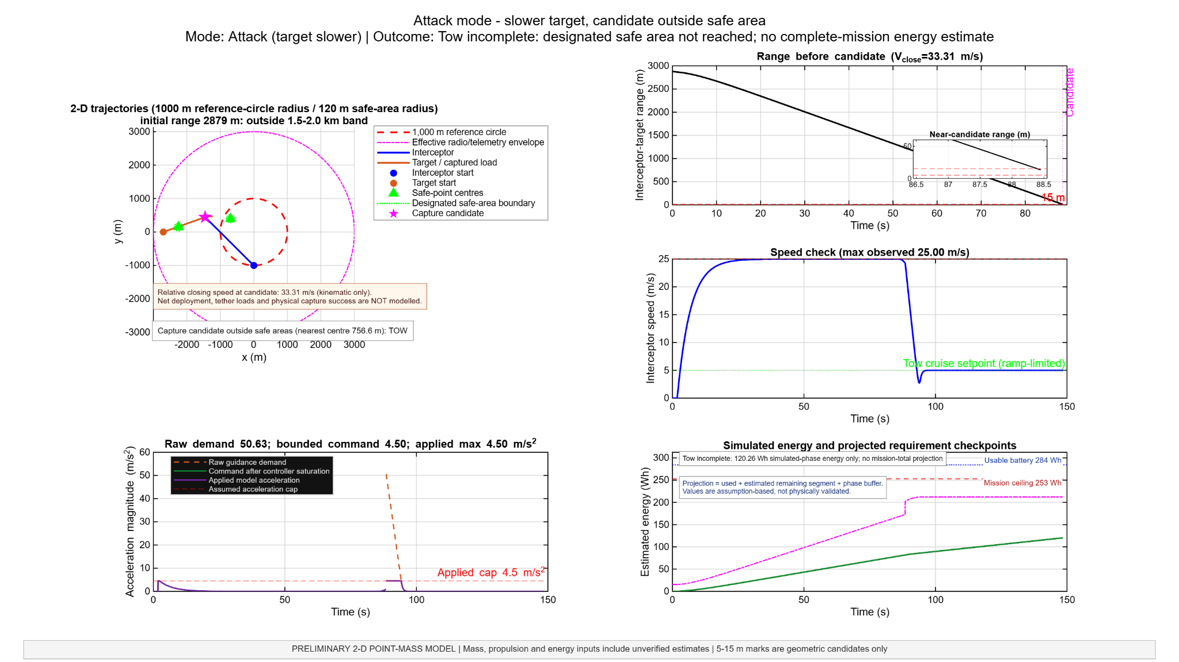
Figure 2. Defense-mode lead-point candidate inside safe area.
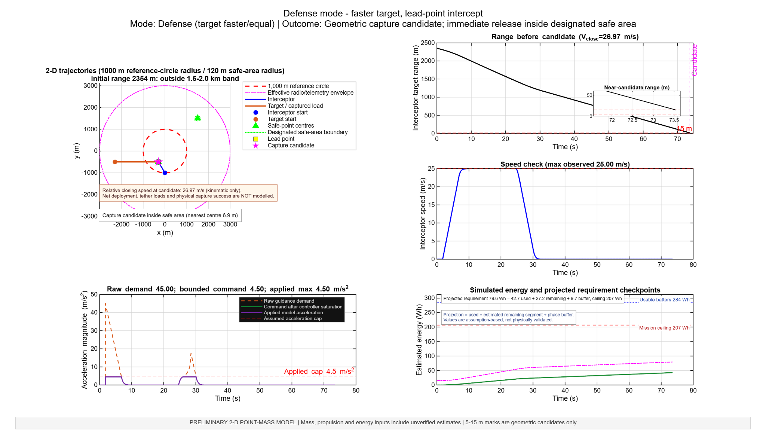
Figure 3. Tow-required scenario; safe-area entry within the model's 60 s criterion.
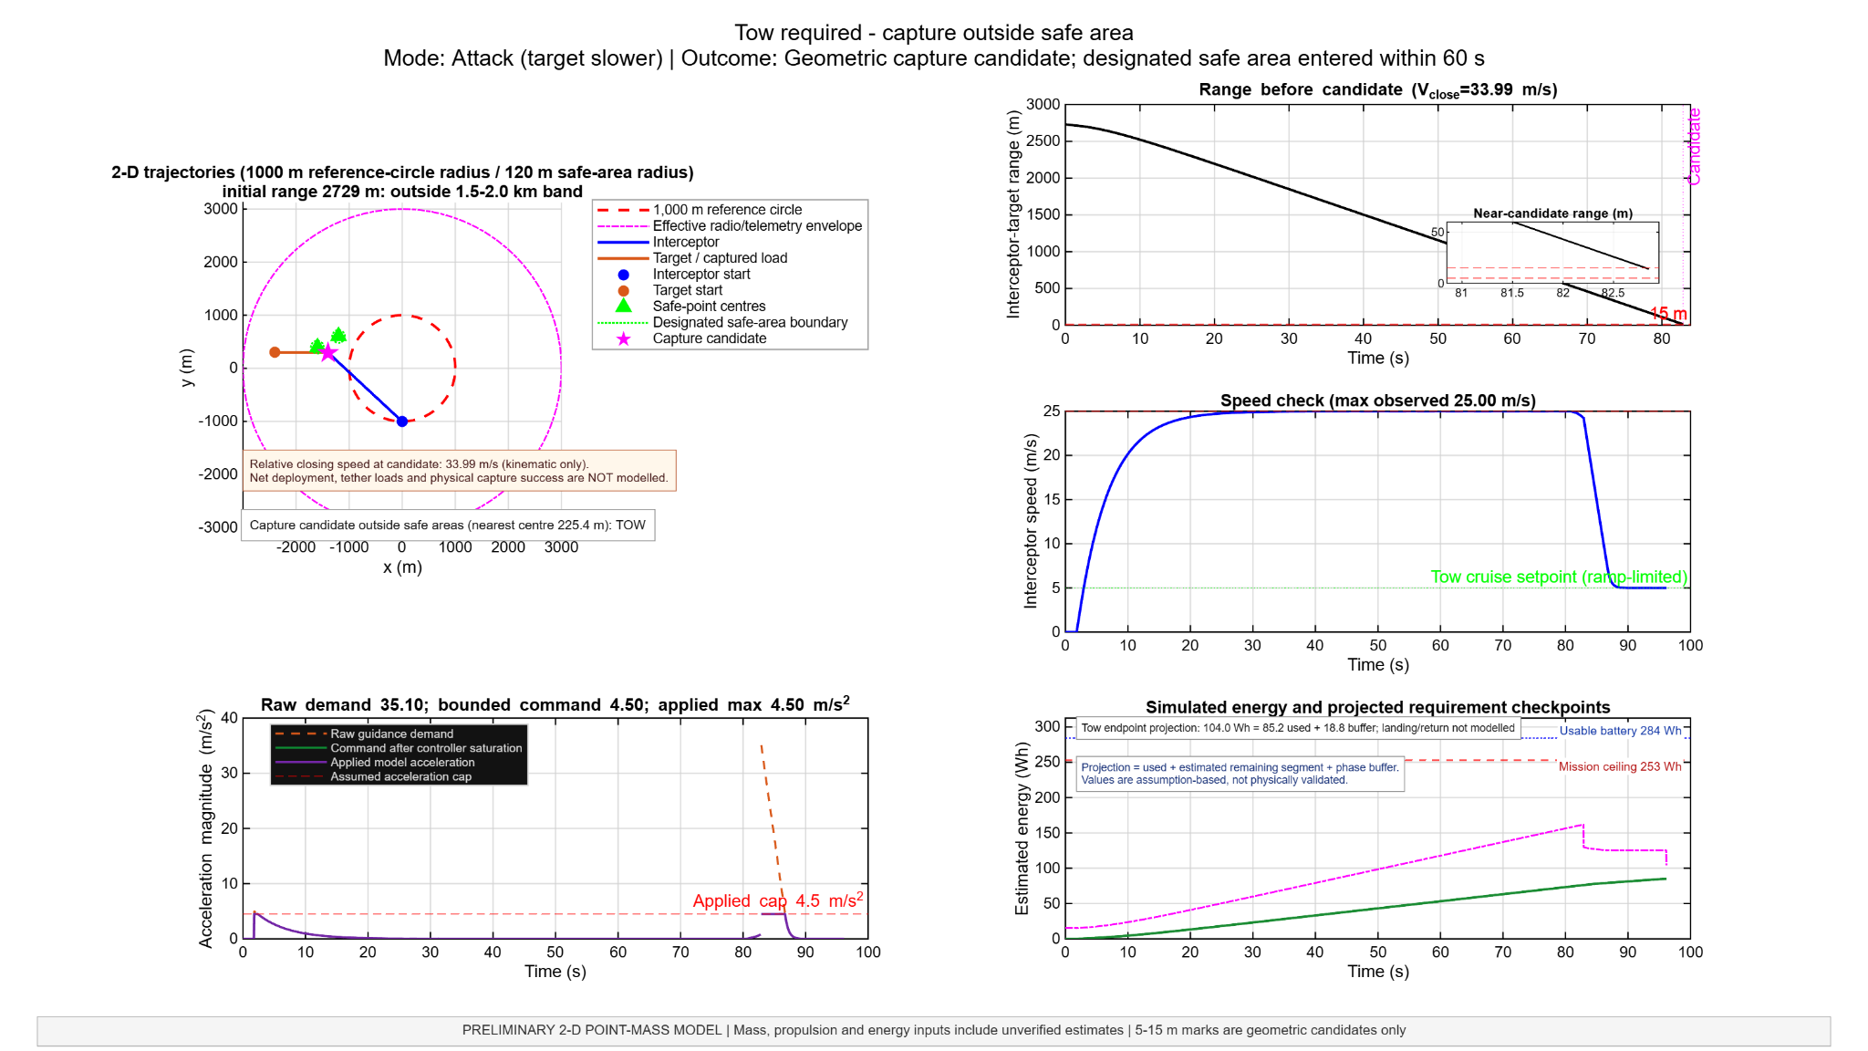
Figure 4. Gate-only abort because response estimate exceeds available lead time.
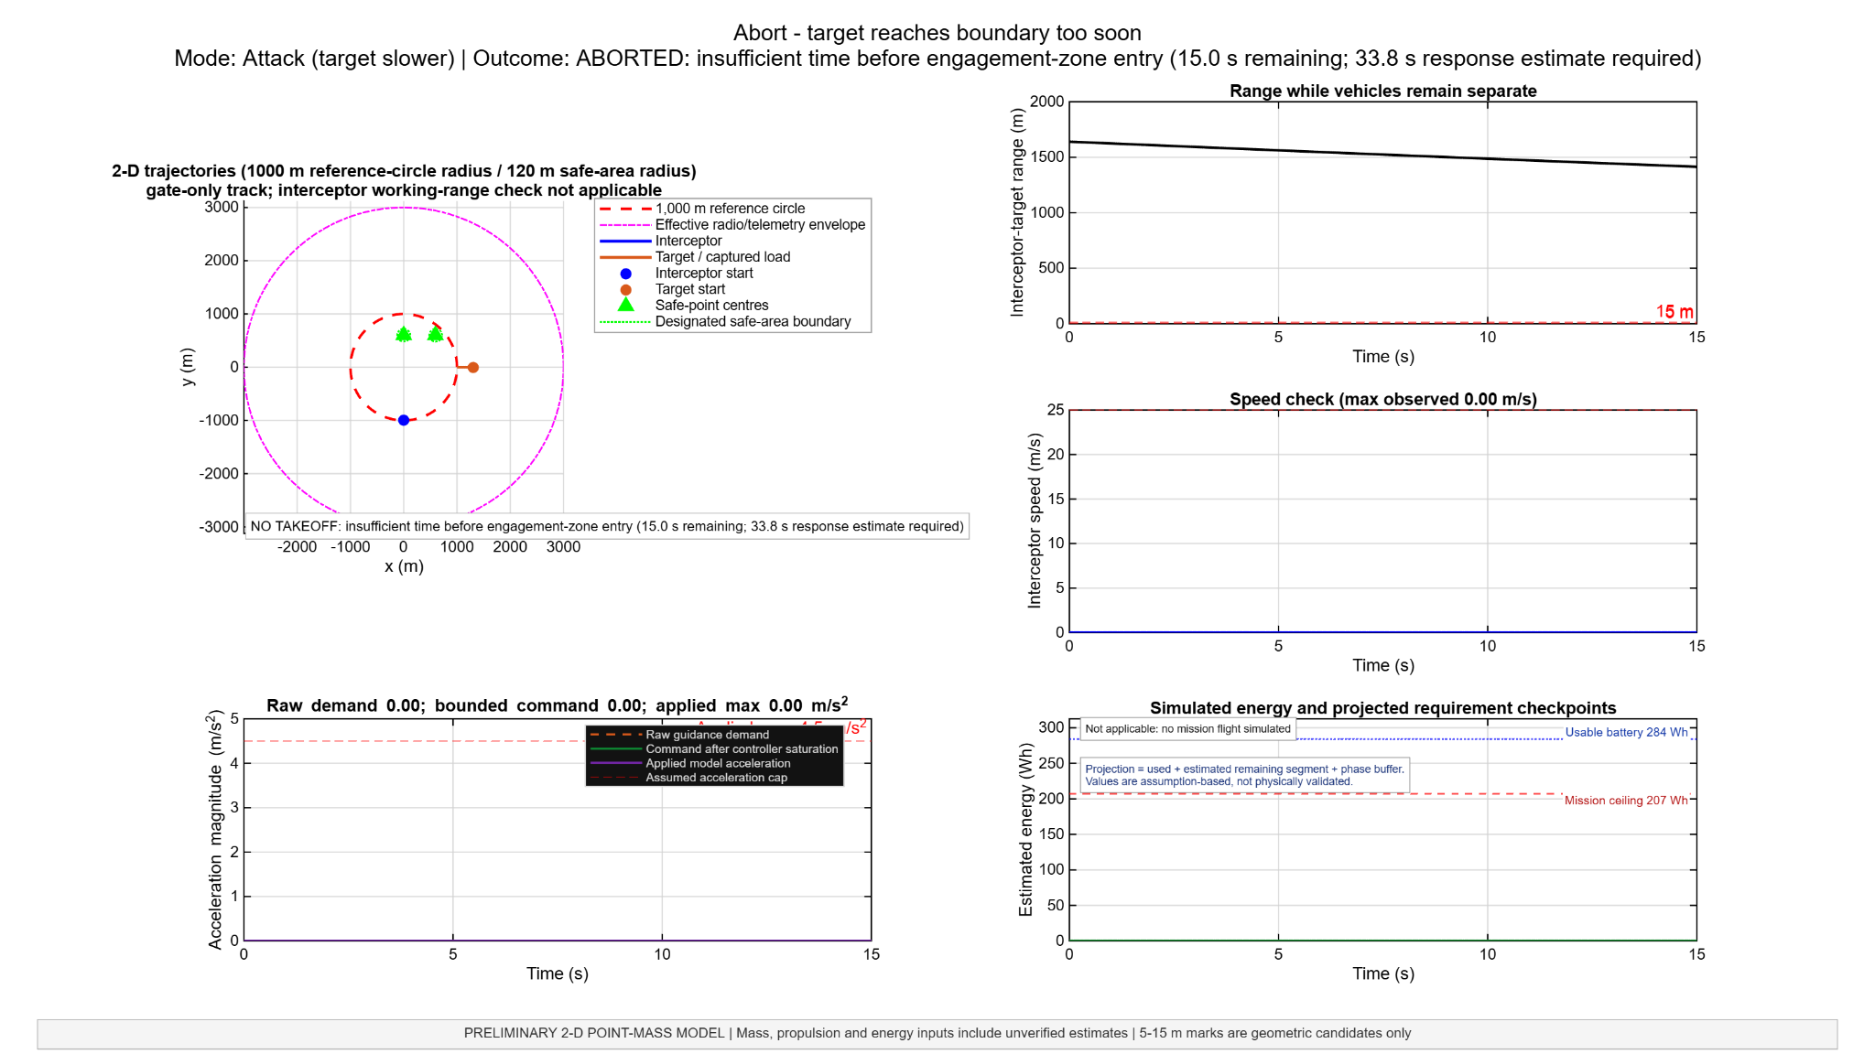
Figure 5. Gate-only no-takeoff case when the predicted track misses the inner zone.
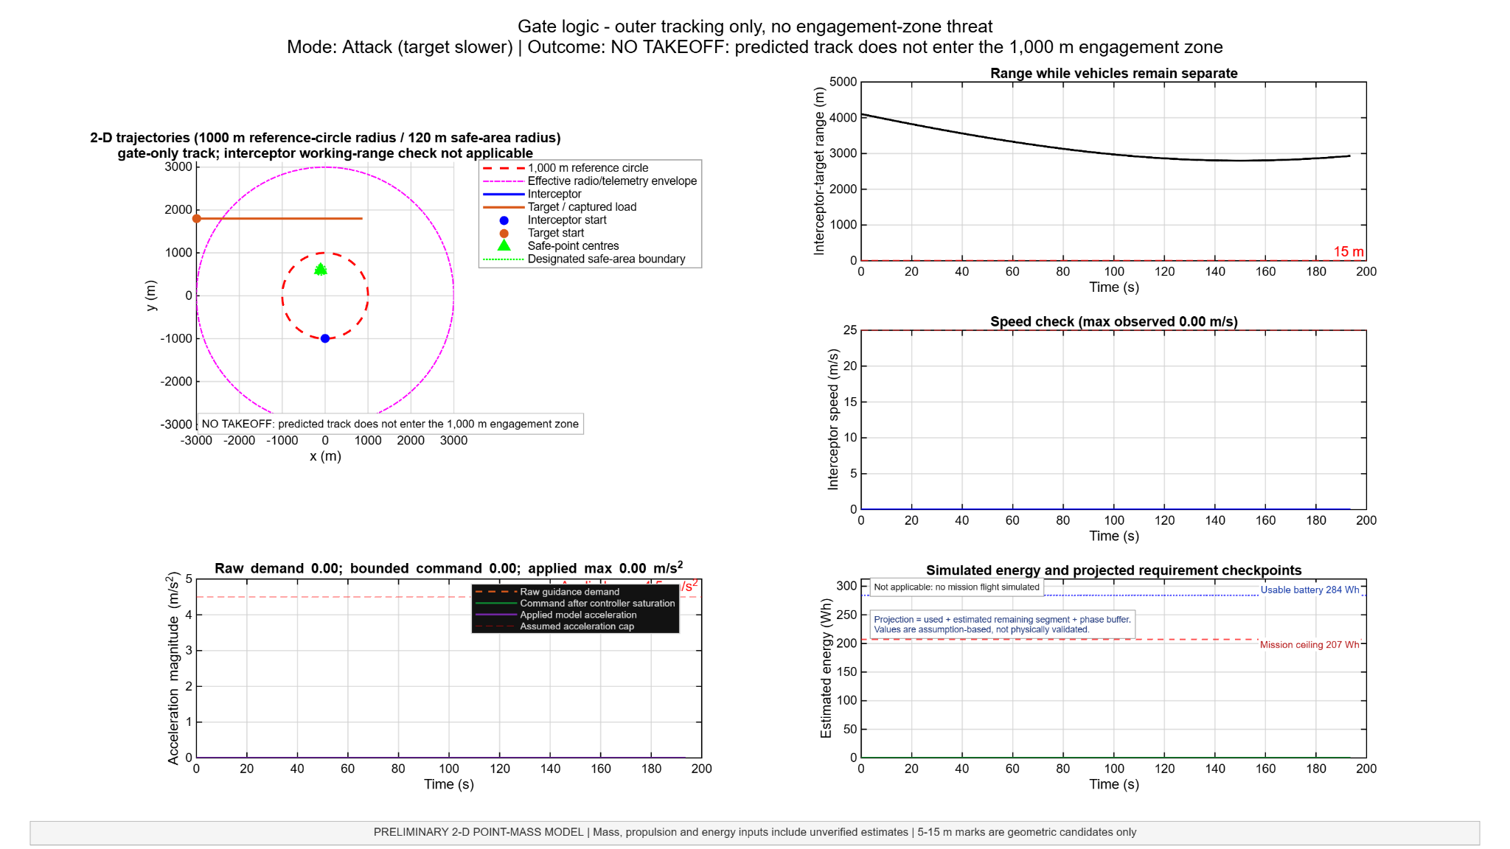
Figure 6. Overweight policy: simulated parachute request, no tow.
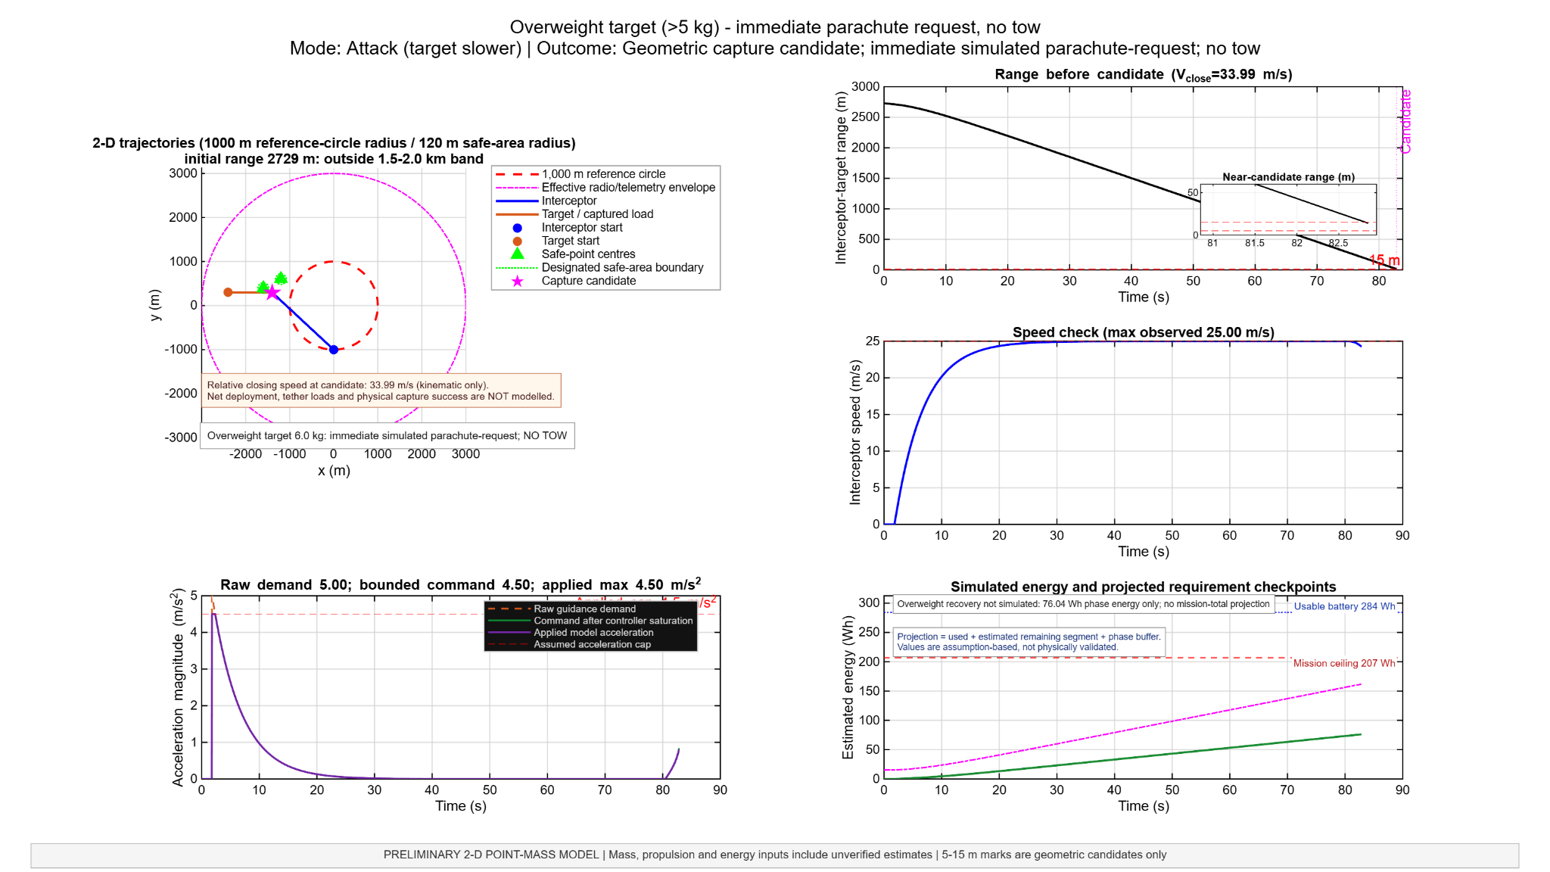
Figure 7. Extended pursuit stopped by the energy guard before candidate registration.
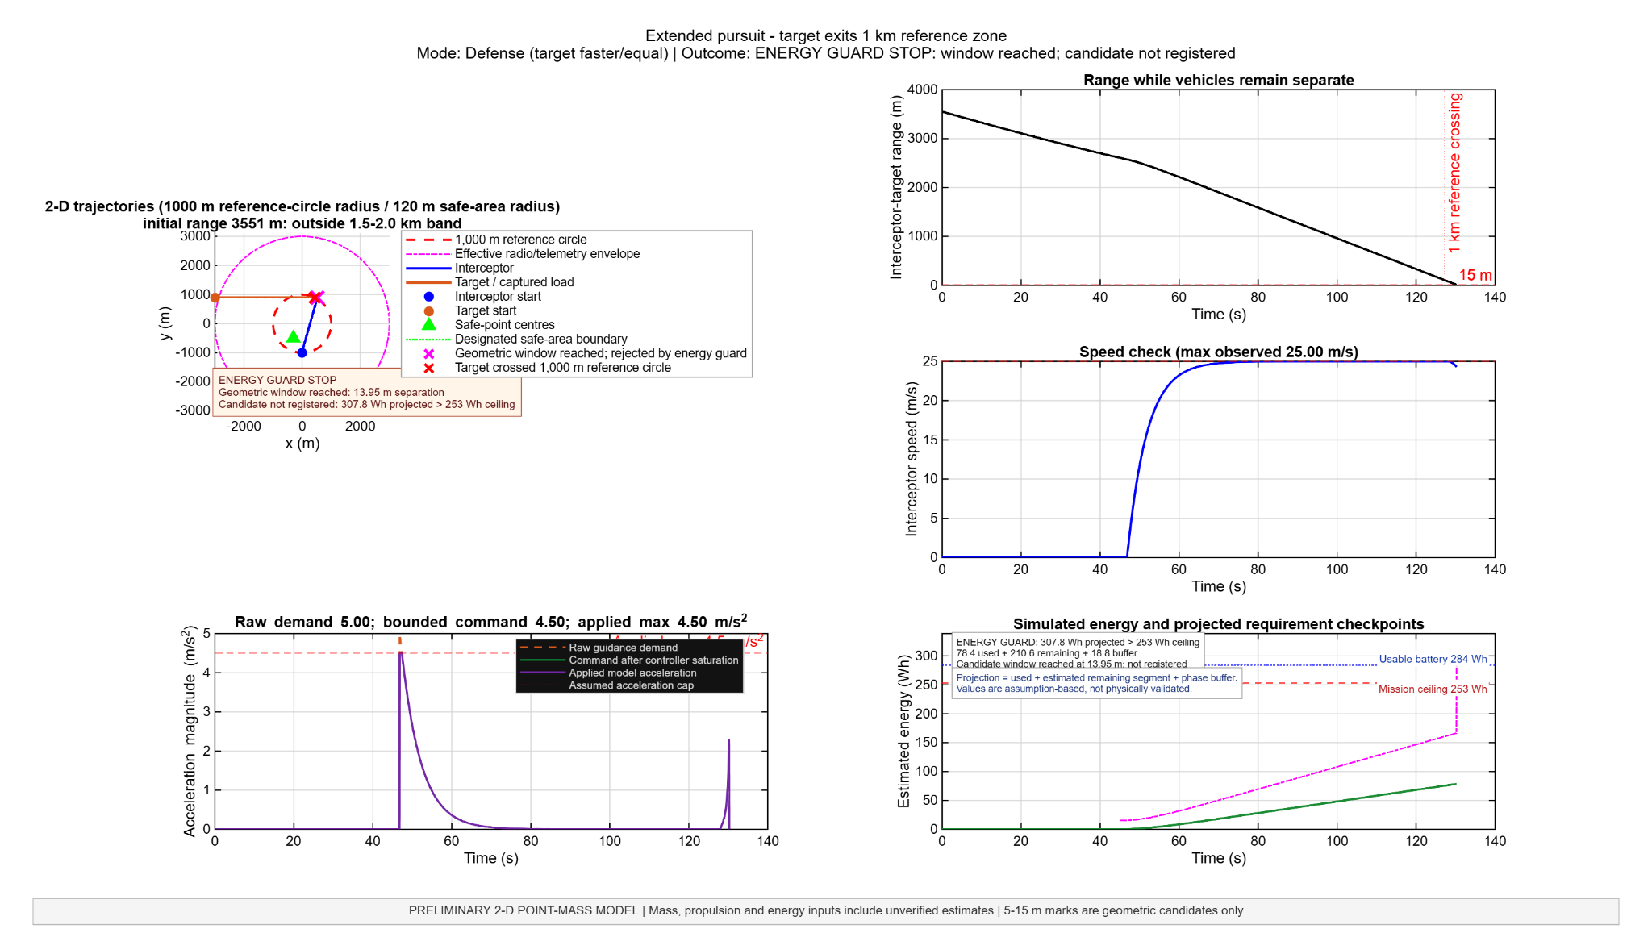
Figure 8. Terminal approach geometry; pre-capture kinematics only.
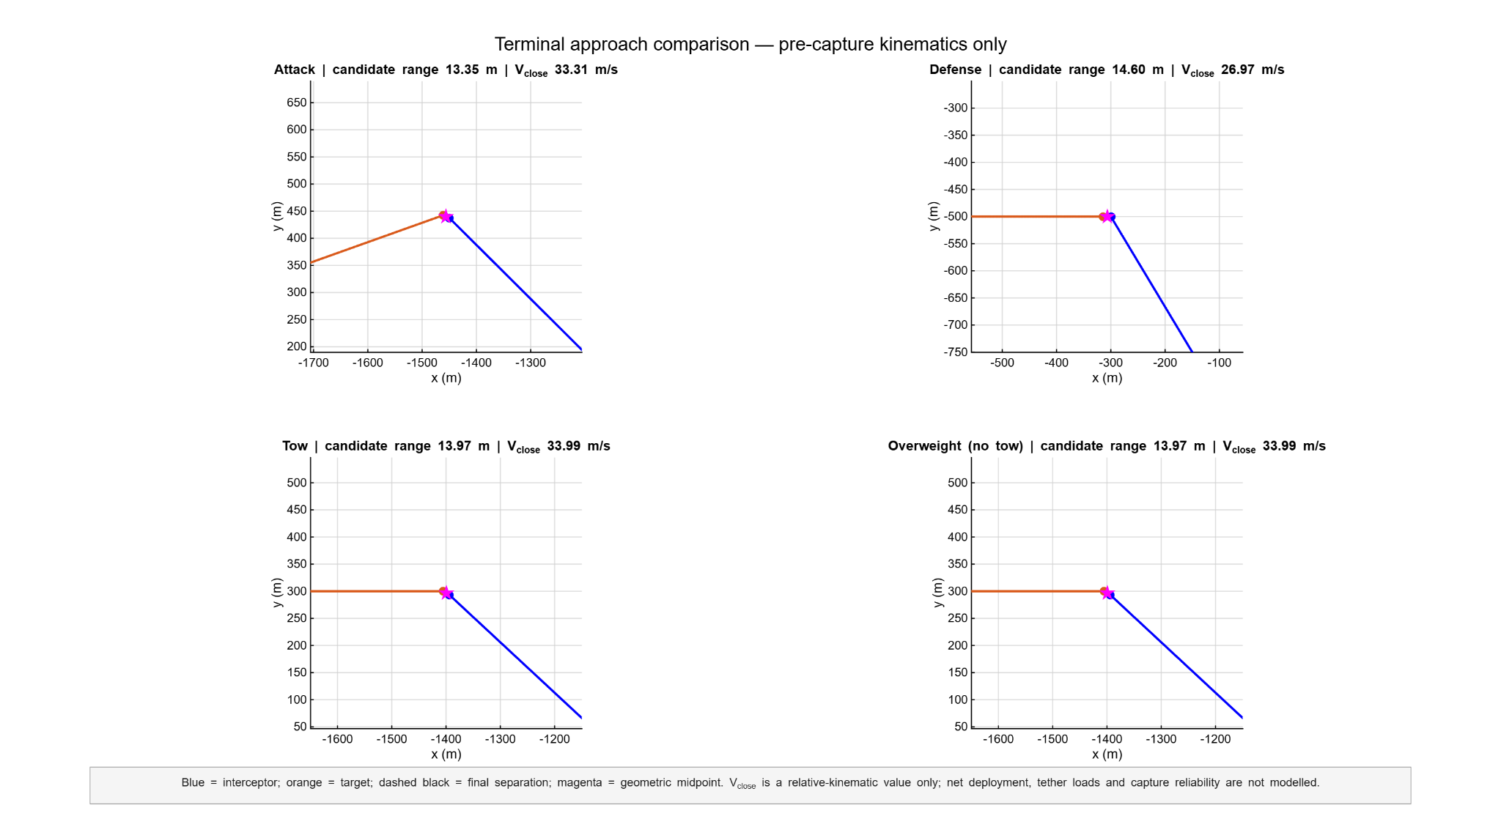
Figure 9. Target-mass contingency/state-logic illustration.
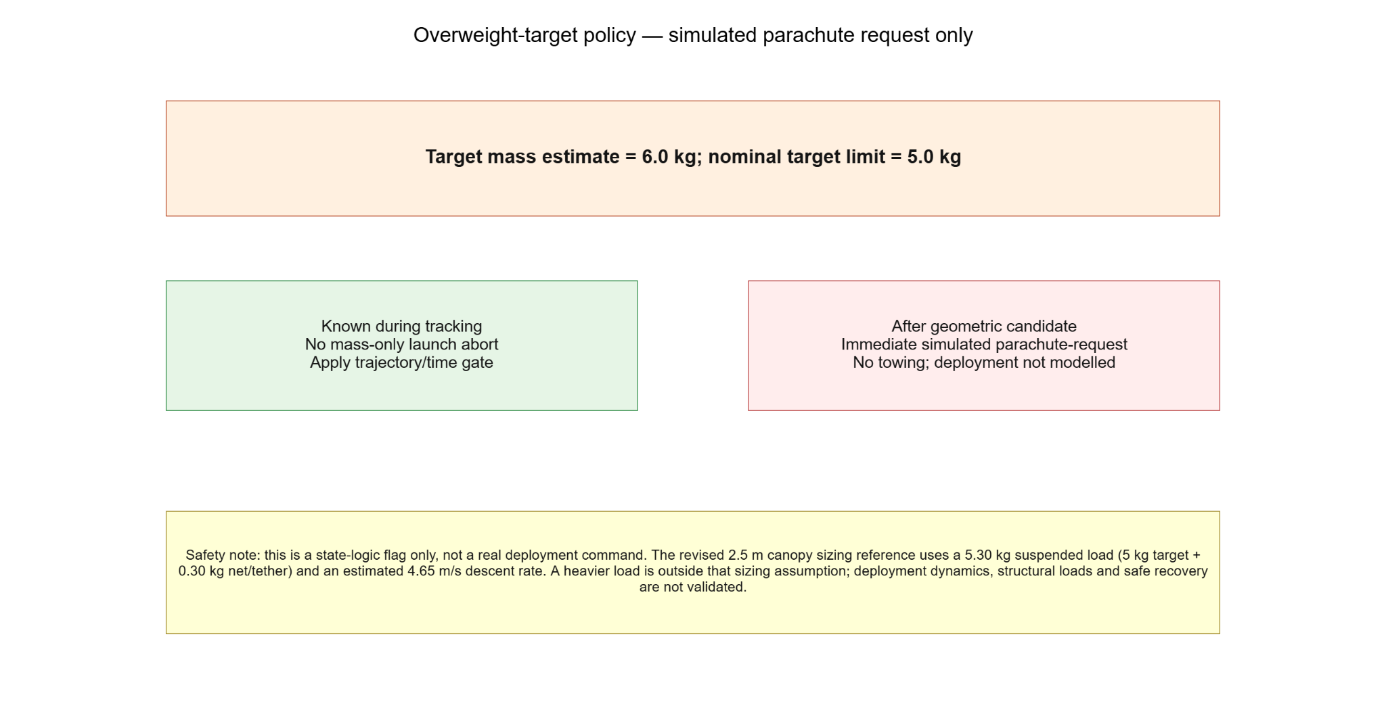

Appendix B — reproducibility files reviewed
- skyforce_intercept_simulation_final_report.m (final supplied MATLAB function; not executed as part of this audit)
- skyforce_simulation_summary(20261011-071638).csv
- skyforce_trajectory_export(9).csv
- skyforce_boundary_gate_summary(8).csv
- skyforce_propulsion_sensitivity(9).csv
- skyforce_working_range_assessment(3).csv
- skyforce_overweight_policy_summary(8).csv
- skyforce_mass_ledger(5).csv
- skyforce_component_mass_references(5).csv
- skyforce_model_assumptions_and_limitations(4).csv
Reporting status: suitable as a preliminary design/simulation record only after the Scenario 1 energy-summary discrepancy is prominently disclosed. Do not describe the energy values as “perfect” or physically validated; they are assumption-based estimates with at least one identified export inconsistency.

