Anti-Drone Interceptor
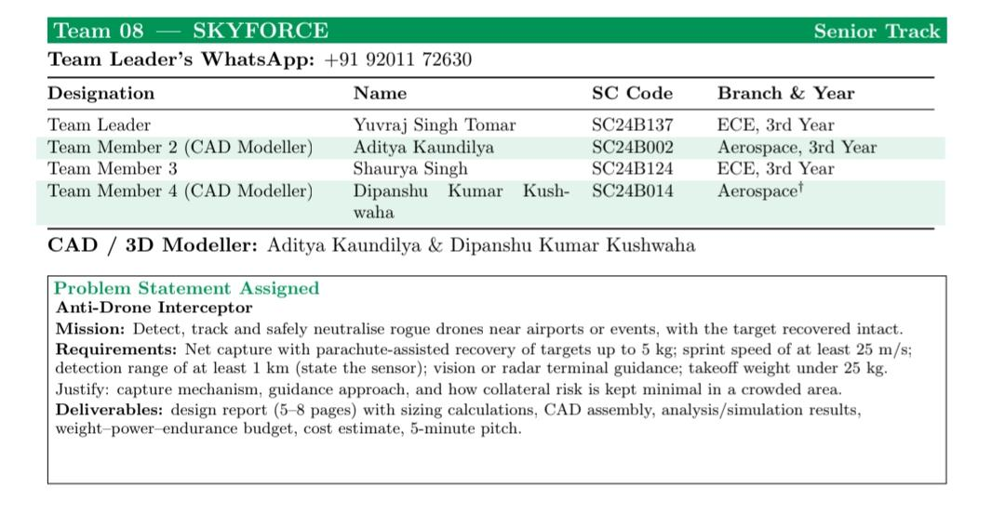
by Team Skyforce

The brief is to detect, track and safely neutralise a rogue drone near an airport or event, with the target recovered intact. The design must justify the capture mechanism, the guidance approach and how collateral risk is kept minimal. The requirements the design and simulation respect are:
• net capture with parachute-assisted recovery of targets up to 5 kg;
• sprint speed of at least 25 m/s;
• detection range of at least 1 km using a stated sensor (ground radar);
• vision or radar terminal guidance;
• takeoff weight under 25 kg.

Deliverables are the design report with sizing calculations, CAD, analysis/simulation results, a budget and a cost estimate.

Inspiration and Literature Review-:
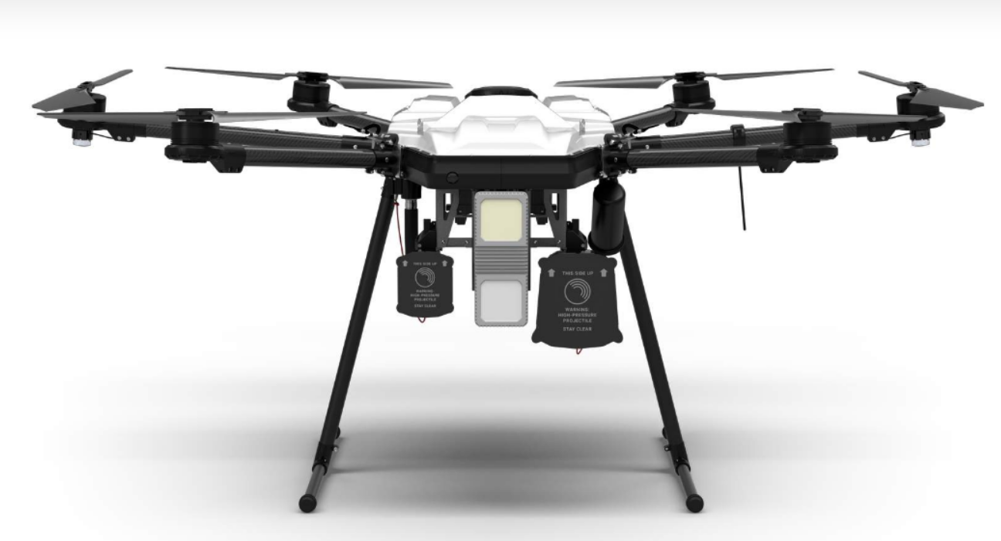
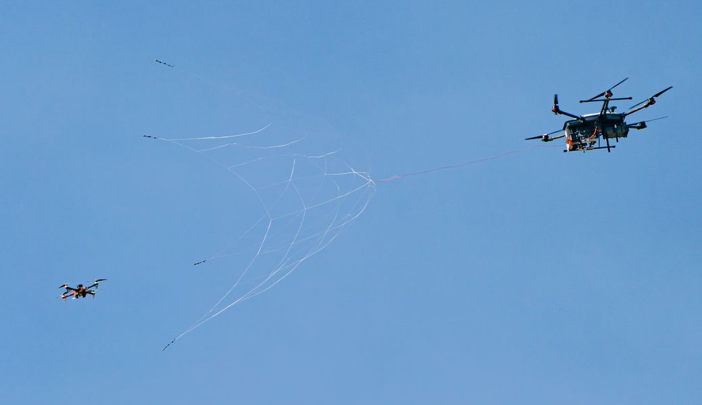
DroneHunter® F700
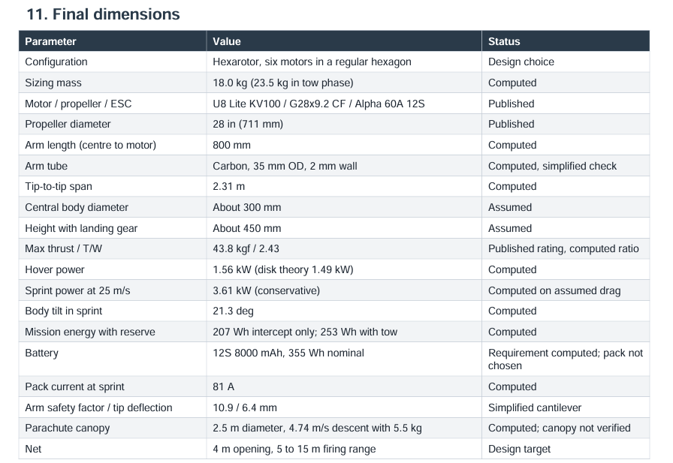
Used by USA Military for drone interception

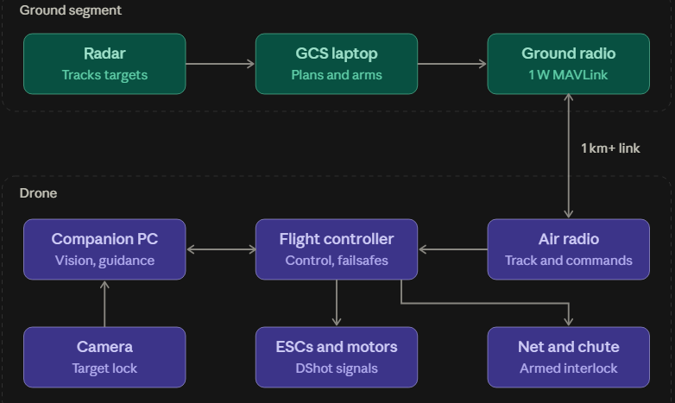
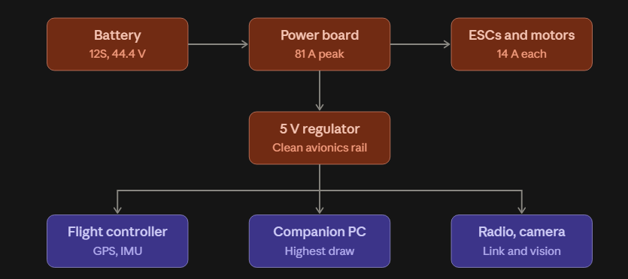

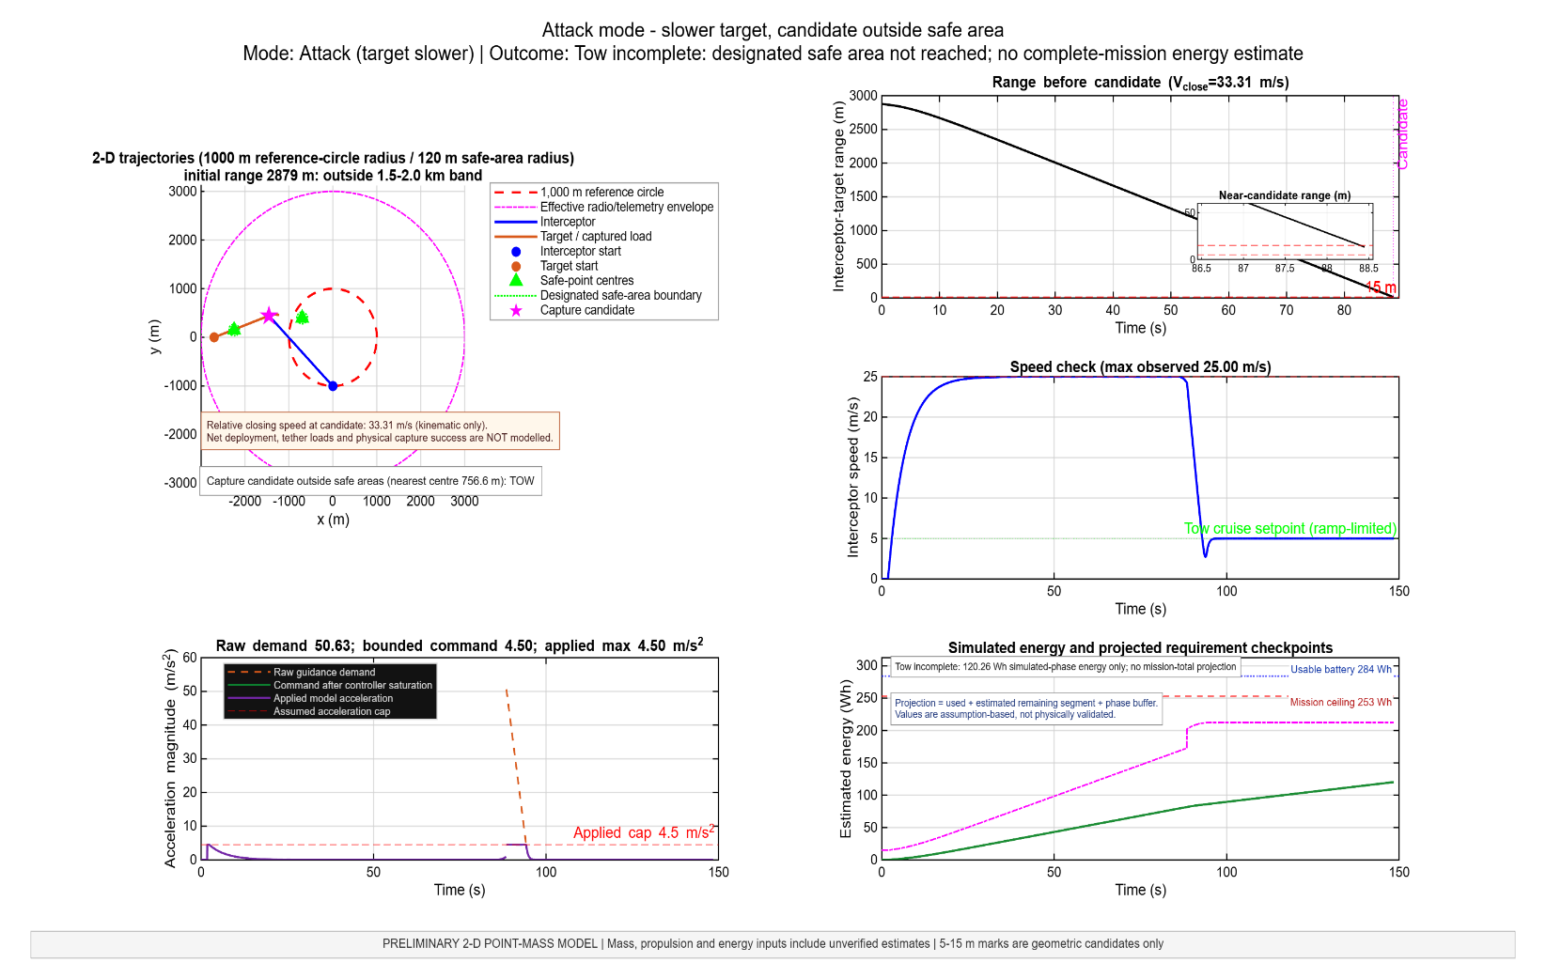
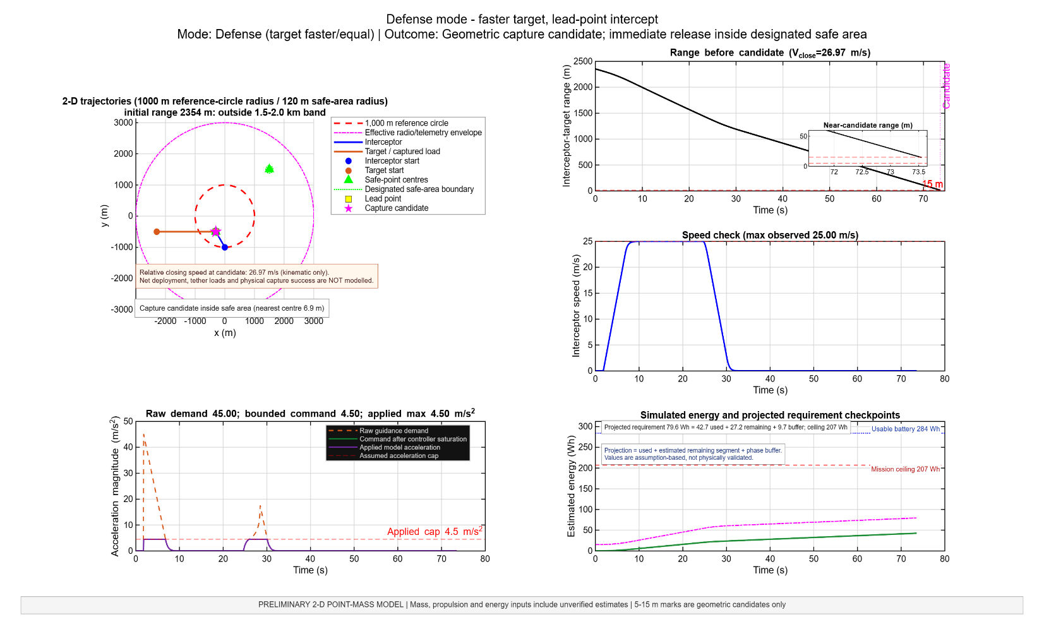
MATLAB SIMULATIONS-:
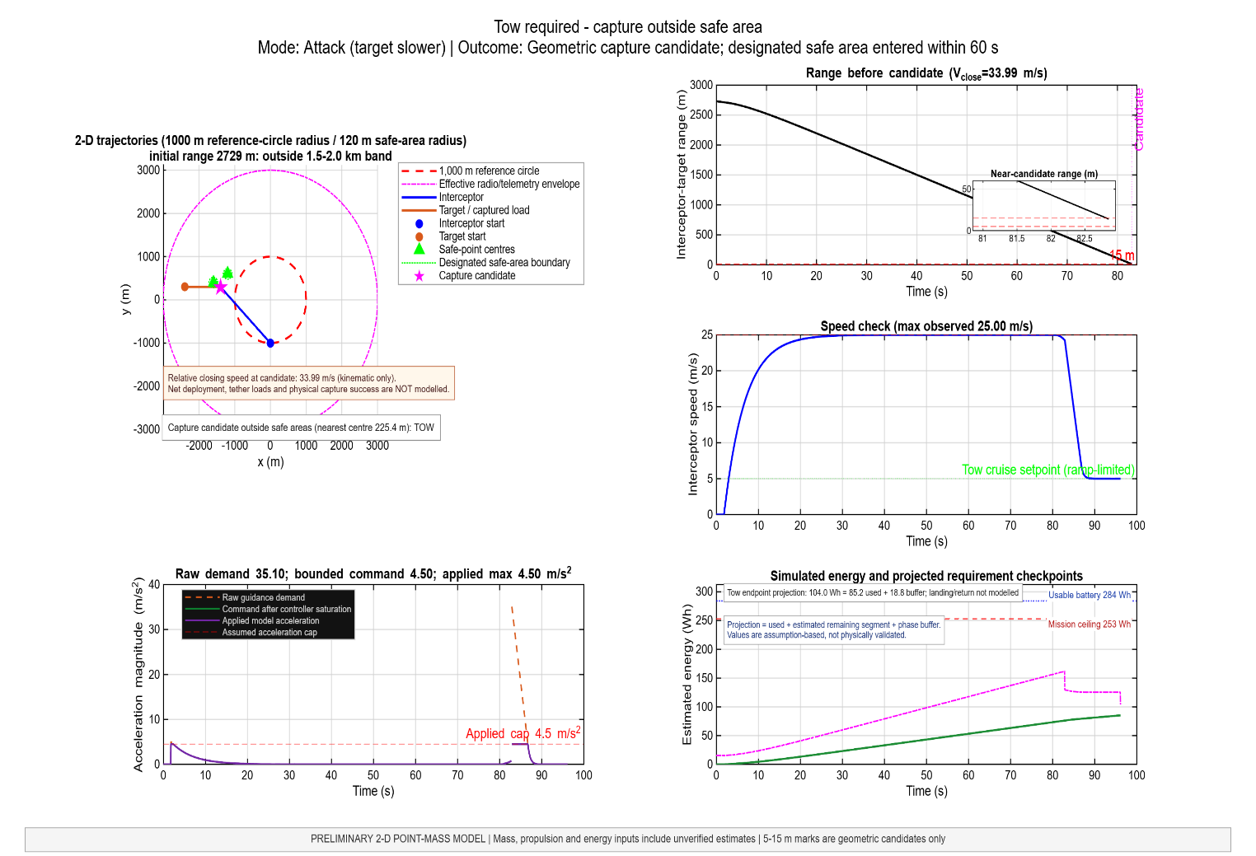
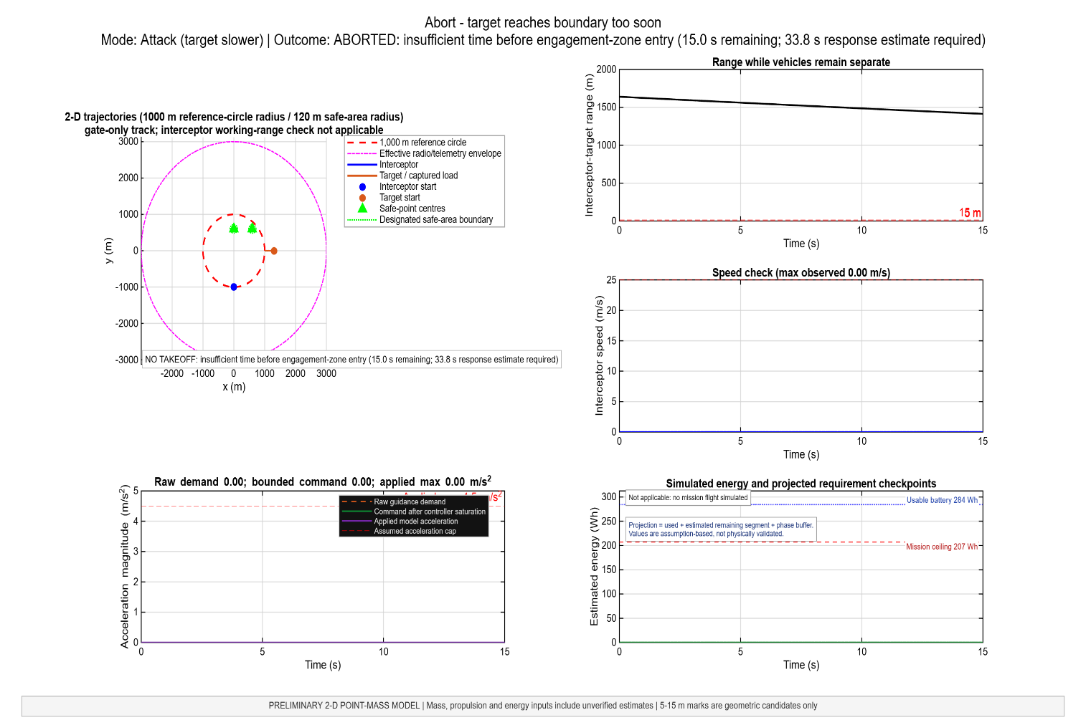
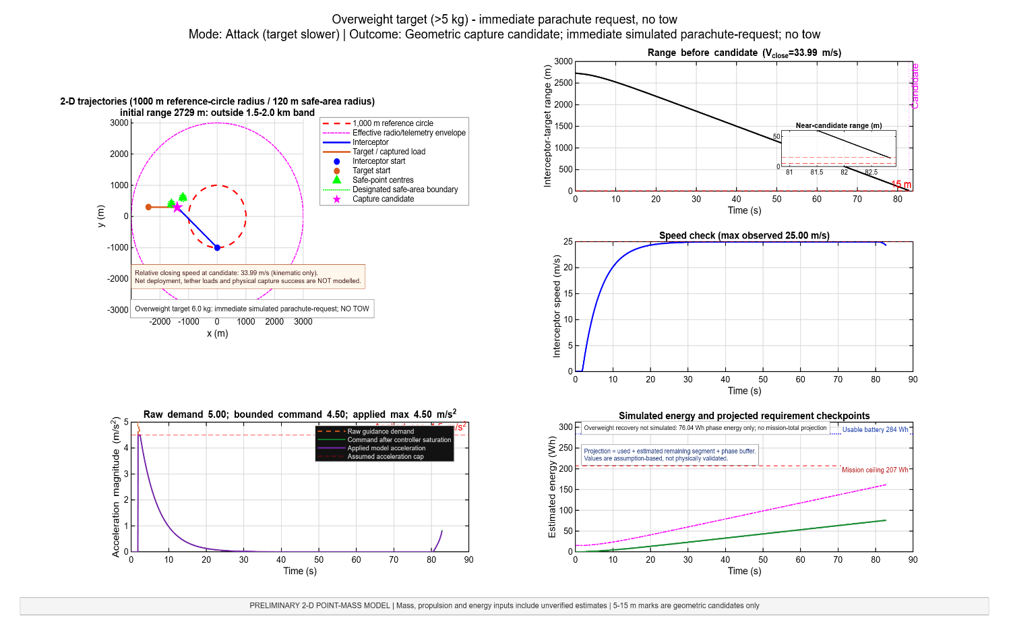
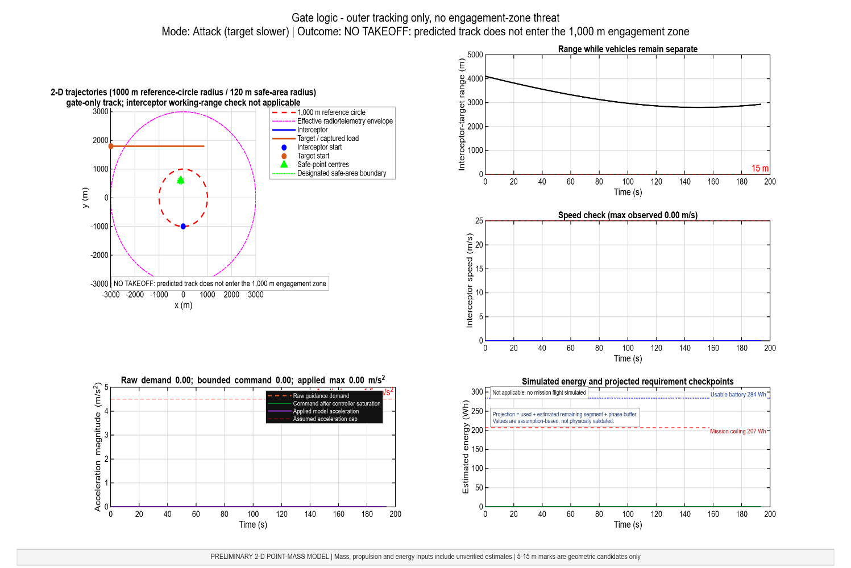

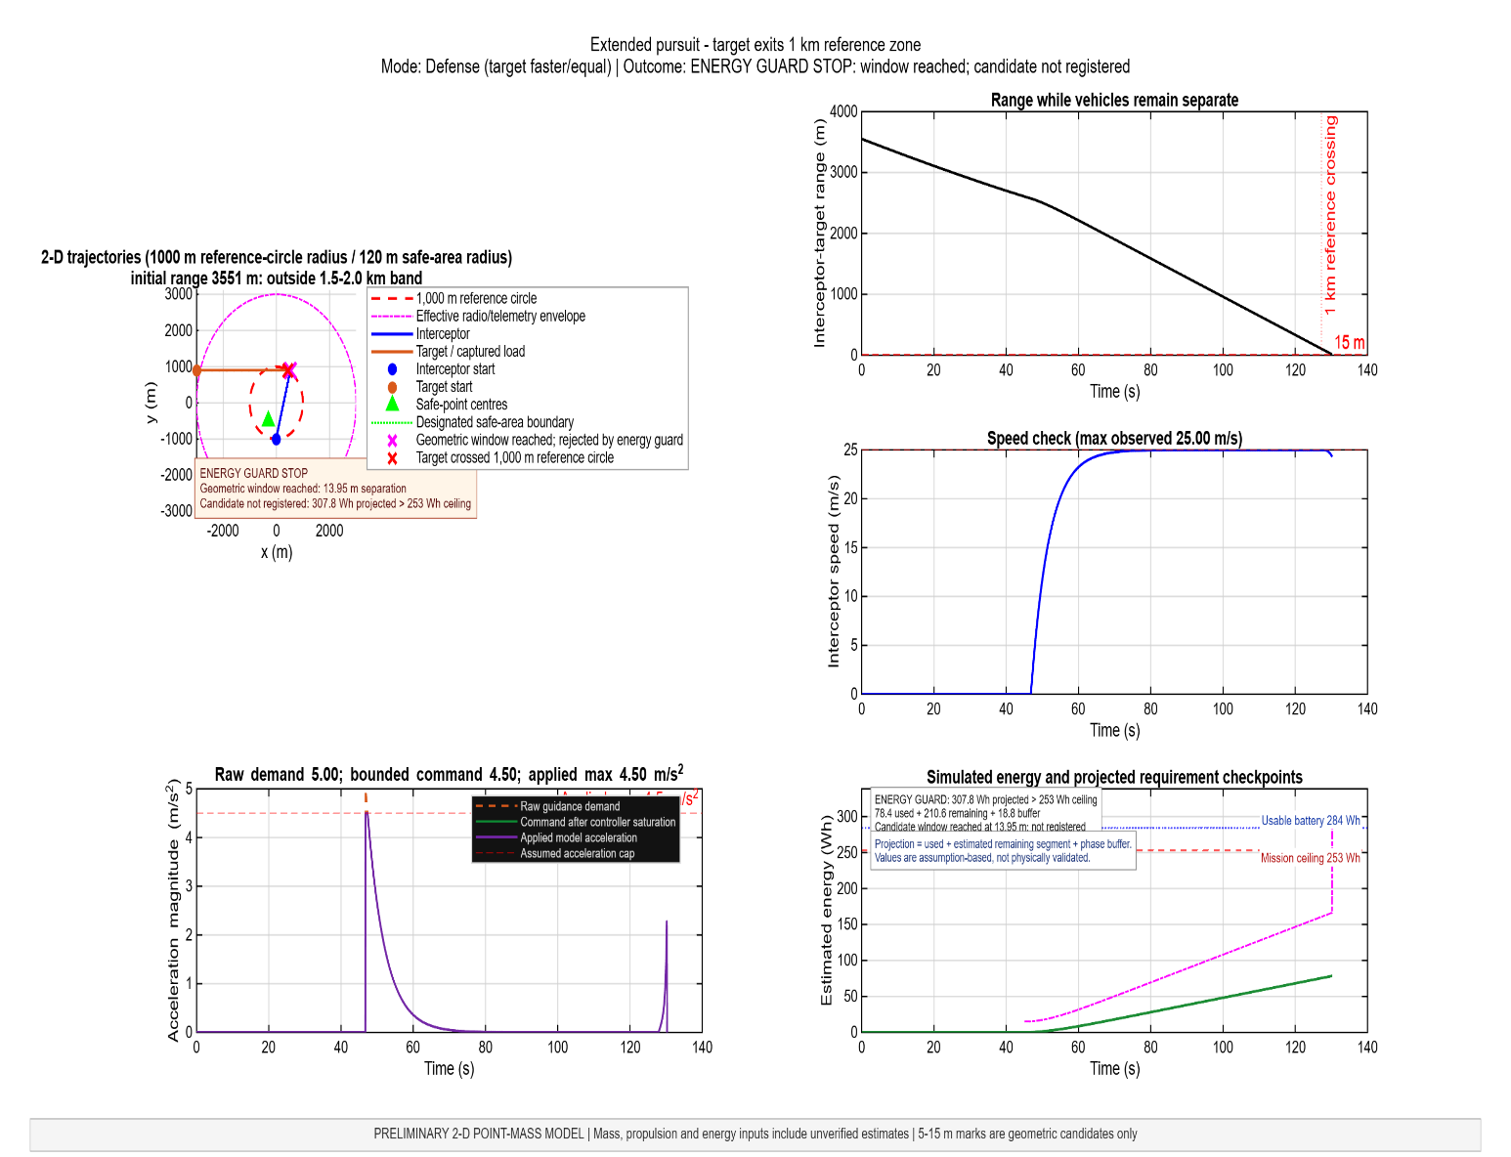

Limitations or Assumptions-:
- We are assuming that wind conditions are normal and constant during the whole simulation.
- We are not accounting for any kind of object collision in the interceptor and target drone path.
- We are assuming that our radio telematary has a range more than 3km
- We are not accounting the energy calculations for the drone landing in the simulations right now.
- The drone is having 18kg of weight in the simulations (it may and will exceed in the real design which we have accounted in the final report)
- We are assuming a maximum of 4.5 m/s^2 can be supplied by the internal PID control of Interceptor drone’s Fc

CAD Designs-:
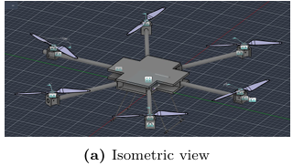

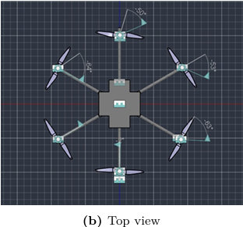

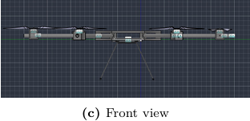

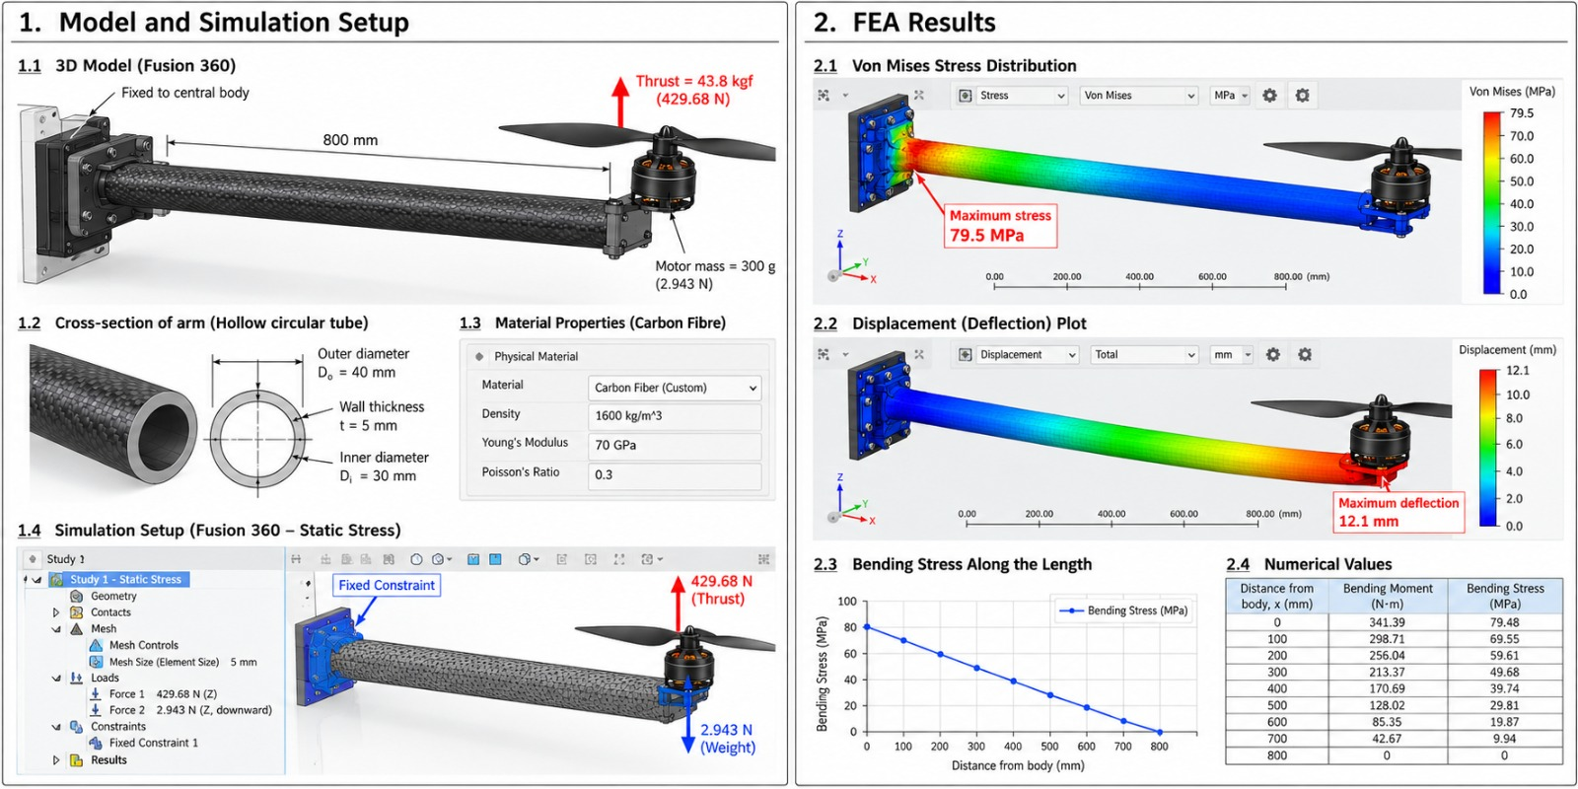

Overall limitations and Future Scope-:

- Right now we are not accounting the actual environment drag and wind conditions cause of which all the calculations will be changed in the future
- We are not discussing the parachute and net mechanism in detail right now, it is treated mostly as a black box
- We haven’t accounted the cases for miss target, from mentor suggestions we are advised to use a second drone
- There is no object detection and collision running in our companion board right now which is a very major limitation.
- We have not done any structural vibrational analysis right now so it may happen that our drone can dismantle in mid air when it reaches the maximum speed of 25 m/s cause of resonant frequency.
- This model is only limited to capturing Multirortors, right now it does not account for Fixed-plane and VTOL models.

Future Scope-:
- Using the actual calculations for simulation (modelling the whole environment and drone more rigorously)
- Using the more accurate CAD models with proper stress and bending analysis on each and every part
- We can increase the number of interceptor drones or number of nets & parachutes in a drone
- We can use the AI based models to predict the path of upcoming target drone for better success and capture rate.

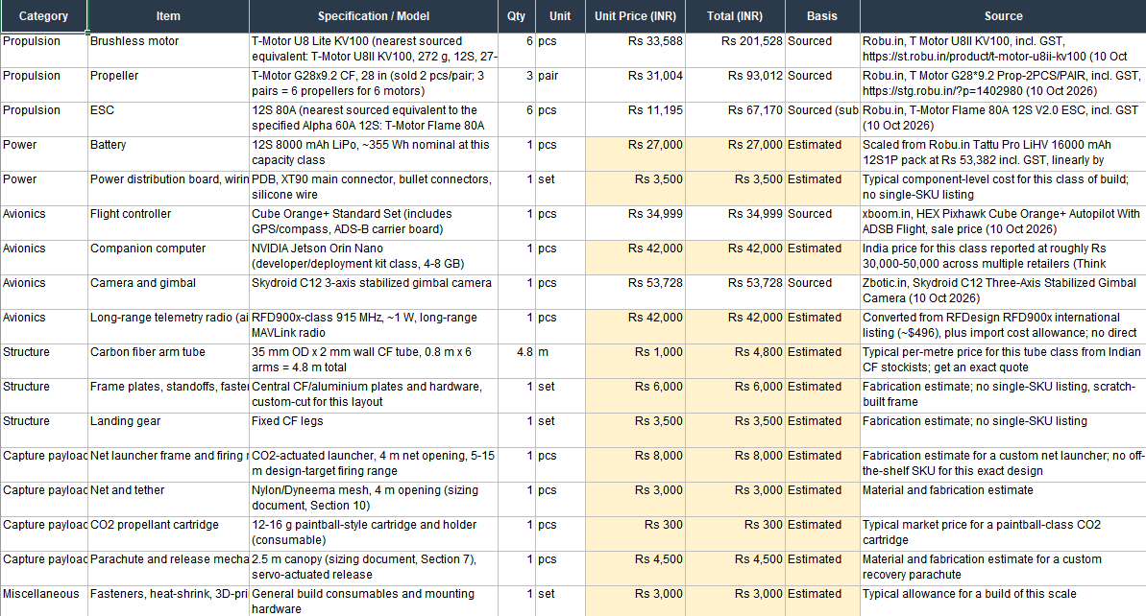

THANKYOU

Open to Q&A

