Game Design Document

Fill up the Following document

1. Write the title of your project.

Mario

1. What is the goal of the game?

Goal of the game is to defeat all of the enemies in each phase.

1. Write a brief story of your game?

A plumber named **Mario** and his brother Luigi travel through the Mushroom Kingdom to save the princess from the evil Bowser. ... But one day, evil cast a shadow over the land and the evil King Bowser Koppa emerged with his army of Goombas, Spinies, Flying Koopas, and other malignant creatures

1. Which are the playing characters of this game?

* Playing characters are the ones which respond to the user based on the input from the user
* Cars, monkeys, dinos, wizards etc, are the playing characters in the game.

|  |  |  |
| --- | --- | --- |
| Number | Character Name | What can this character do? |
| 1 | Mario | The Mario Browse is Kidnap and needs to save himself and run away. |
|  |  |  |
|  |  |  |
|  |  |  |
|  |  |  |
|  |  |  |
|  |  |  |
|  |  |  |

1. Which are the Non Playing Characters of this game?

* Non Playing characters are the ones which don't have an action or a behaviour when the user interacts with the game.
* Hurdles, stones, bananas, coins, etc are non playing characters in the game.

|  |  |  |
| --- | --- | --- |
| Number | Character Name | What can this character do? |
| 1 | Plants | When Mario touches it, the Game over |
| 2 | Paragoomba | When Mario touches it, the Game over |
| 3 | star | When Mario touches it, the Game over |
| 4 | Bullet | When Mario touches it, the Game over |
| 5 |  |  |
| 6 |  |  |
| 7 |  |  |
| 8 |  |  |

Draw your imagination of this game. What does this game look like?

* Draw the game either on your computer or on paper,
* Add 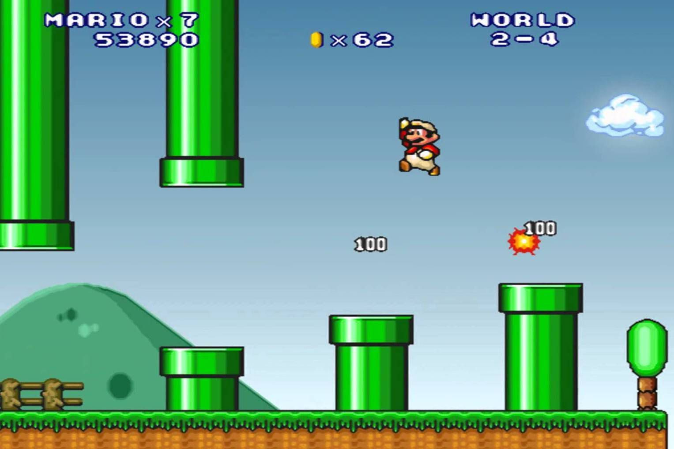

How do you plan to make your game engaging?

First the level of the game would be easy and get harder level by level. And also player will get point as he move further