# albany Leisure and Aquatic Centre

The annual energy consumption of the Albany Leisure and Aquatic Centre (ALAC) is 1.72GWh. ALAC has higher energy consumption during winters as compared to summer which can be seen in the following image:

# Grid Only

The annual energy consumption of the Albany Leisure & Aquatic Centre (ALAC) is 1.723GWh and their annual energy charge as follows:

|  |  |  |
| --- | --- | --- |
|  | Units | Grid Only |
| Annual Energy Charge | $ | 310,757 |
| Other | $ | 1095.47 |
| Total | $ | 311,852 |

# 500kW PV System

|  |  |  |
| --- | --- | --- |
|  | Units | PV |
| Capacity | kW | 500 |
| Annual Energy Charge | $ | 185,292 |
| Annual Savings | $ | 125,465 |

# 500kW PV System and Battery Storage

|  |  |  |
| --- | --- | --- |
| PV (kW) | Battery (kWh) | Annual Energy Charge ($) |
| 500 | 500 | 164,237 |
|  | 1000 | 156,657 |
|  | 1500 | 155,756 |

# findings

500kW PV system produces average 1.9MWh between 8am and 5pm per day whereas average daily energy consumption of ALAC between 8am and 5pm is 2.10MWh. The PV system would produce 159MWh excess energy annually that could be stored in 1MWh battery storage (Annual Throughput 155MWh) to shave off evening load. Following image shows the daily solar energy production and daily energy consumption trend.

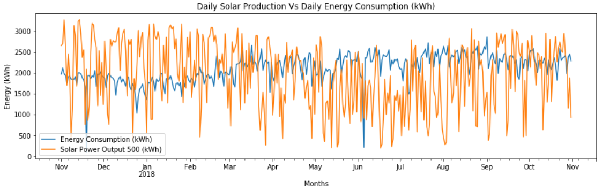

The following table shows the economics of the different energy systems. In comparison to the Grid only system PV system would produce savings of $126,560 per year whereas PV and Battery Storage system would produce savings of $155,195 per year.

|  |  |  |  |  |  |
| --- | --- | --- | --- | --- | --- |
|  | Capital ($) | LCOE ($/kWh) | Payback (Yrs) | Annual Grid Charge ($) | Annual Savings ($) |
| Grid Only | 0 | 0.1809 | 0 | 311,852 | 0 |
| PV System | 357,500 | 0.1313 | 2.85 | 185,292 | 126,560 |
| PV and Battery system | 1,291,157 | 0.1806 | 8.38 | 156,657 | 155,195 |