ForestWatch India: A CA-ANN Framework for Urban Forest Cover Monitoring and Multi-Year Prediction Using Sentinel-2 Imagery and a Frozen Geospatial Foundation Model
Yuvraj Singh Hajari
School of Computer Science and Engineering, Vellore Institute of Technology, Chennai, India
Reg. No. 23BCE1995
Abstract—Indian cities lack a routine, low-cost, repeatable method for tracking urban forest cover change. This paper presents ForestWatch India, a system that detects and forecasts forest cover across four Indian cities (Chennai, Bengaluru, Delhi, Kolkata) using real Sentinel-2 surface reflectance, an original spectral index, and a hybrid cellular automata and artificial neural network (CA-ANN) prediction model. Two methodological issues are identified and corrected: the production pipeline was found to be computing vegetation indices from a visualization-only thumbnail endpoint rather than analysis-ready reflectance, and an earlier CA-ANN design exhibited a symmetric artifact and unbounded long-horizon erosion, corrected by separating the magnitude of projected change (a corrected historical Markov rate) from its spatial placement (a trained classifier). The CA-ANN is further extended with embeddings from Clay v1.5, a frozen geospatial foundation model, reduced via principal component analysis and concatenated with four hand-engineered features. Walk-forward validation across four cities and multiple horizons shows the foundation-model embeddings improve prediction in only one of four cities; a diagnosed source of prediction variance is corrected via an eight-seed ensemble, producing this work's strongest validated result (Kappa = 0.305 at a six-year horizon, versus a baseline of 0.283). Short-horizon accuracy (Kappa = 0.689 at one year) is directly competitive with three published CA-ANN studies; the long-horizon gap against those studies is reported and attributed to the bidirectional nature of forest change versus the monotonic urban growth those studies model.
Index Terms—cellular automata, deforestation prediction, foundation models, geospatial embeddings, remote sensing, Sentinel-2, urban forest monitoring

I. INTRODUCTION
Urban forest cover is among the few environmental indicators measurable consistently from orbit, yet Indian cities largely lack a routine, low-cost, repeatable mechanism for tracking how much of it changes from year to year. Municipal forest surveys are infrequent and their methodology is rarely held constant between cycles, which makes longitudinal comparison difficult even within a single city. Commercial very-high-resolution satellite subscriptions resolve this inconsistency but are priced out of reach for most academic or civic monitoring efforts. The Sentinel-2 constellation, hosted at no cost on Google Earth Engine (GEE) with a five-day revisit interval, removes the cost barrier, provided the imagery is accessed and processed correctly, a precondition this work found to be nontrivial in practice.
This paper presents ForestWatch India, a system that detects, quantifies and forecasts urban forest cover change across four Indian cities using Sentinel-2 imagery, a purpose-built spectral index, and a hybrid cellular automata and artificial neural network (CA-ANN) prediction model. The system is extended with embeddings drawn from Clay v1.5, an openly released geospatial foundation model, integrated as a frozen feature extractor rather than a fine-tuned component. The central methodological question this paper investigates is whether a pretrained, general-purpose geospatial representation can improve a small, task-specific prediction model under severe data scarcity, a regime in which most published applications of foundation models do not operate.
The contributions of this work are fourfold. First, it identifies and corrects a reflectance-fidelity defect present in the project's original data-acquisition pipeline, in which Google Earth Engine's visualization-oriented thumbnail endpoint was being used as if it were an analysis-ready reflectance product. Second, it introduces the Forest Vegetation Index (FVI), a single formula that separates water, bare land and vegetation in one classification pass, replacing a two-index design that was found to misclassify coastal water as forest. Third, it presents a CA-ANN architecture that explicitly separates the magnitude of expected land-cover change, governed by a corrected historical transition rate, from the spatial placement of that change, governed by a trained classifier, a separation motivated by two concrete failure modes observed in an earlier, unseparated design. Fourth, it reports a rigorous, multi-city, multi-configuration evaluation of Clay v1.5 embeddings as an additional feature source, including a diagnosed and corrected source of prediction variance, and situates the resulting accuracy against three published cellular automata studies with independently confirmed validation methodology.
A recurring theme across the four contributions above is that each was motivated by a concrete, observed failure rather than a hypothetical concern. The reflectance defect was found by inspecting raw fetched pixel values against expected physical ranges, not by auditing the pipeline in the abstract. The water-misclassification failure that motivated FVI was observed visually on Chennai's own coastline. The ring artifact and long-horizon erosion that motivated the magnitude/placement separation in the CA-ANN were observed in rendered prediction overlays before being understood analytically. This empirical, failure-driven development process is reflected in the structure of Section IV, where each methodological choice is presented together with the specific defect it was built to correct, and in Section V, where the foundation-model evaluation is reported as a rigorous ablation precisely because an early, single-configuration result would not have been sufficient evidence either way.
The remainder of this paper is organized as follows. Section II reviews related work in global forest-change reference data, vegetation indices, landscape fragmentation metrics, cellular automata prediction and geospatial foundation models. Section III describes the study area and data acquisition process. Section IV presents the full methodology, from reflectance correction through foundation-model integration. Section V reports experimental results, including the honest outcome of the foundation-model ablation and a comparison against published literature. Section VI discusses limitations, and Section VII concludes with directions for future work.

II. RELATED WORK

A. Global Forest Change Reference Data
Hansen et al. [1] produced the first global, Landsat-derived, annual forest-loss dataset at 30 m resolution, encoding forest state as a single baseline treecover2000 band together with a per-pixel lossyear band recording the year, if any, in which that pixel's canopy was lost, updated annually and now covering loss through the present. This dataset remains the standard external reference against which locally built forest-change detectors are compared, precisely because it is independent of any particular downstream project's own classification pipeline. A widely cited critique by Tropek et al. [2] established an important caveat revisited in Section V: global tree-cover products optimized to detect large-scale clearing, trained and validated primarily against forest-frontier and plantation contexts, tend to underestimate fragmented, scattered urban tree cover of the kind present inside Indian cities, where individual tree crowns and small clusters fall below the effective detection granularity the global product was tuned for. This caveat directly informed how this work validates against the Hansen dataset, reported with both a strict pixel-exact metric and a positional-tolerance metric rather than the strict metric alone, and directly informed the interpretation of the comparison results in Section V-H rather than being treated as an afterthought once a low strict-agreement number was observed.

B. Spectral Indices for Vegetation and Water
The most widely used vegetation index in remote sensing is the Normalized Difference Vegetation Index (NDVI), introduced by Rouse et al. [12] as (NIR − Red) / (NIR + Red), which remains the default choice in the great majority of land-cover studies owing to its simplicity and its long record of validated use. Gitelson et al. [3] introduced the Visible Atmospherically Resistant Index (VARI) as a visible-spectrum alternative, defined as (Green − Red) / (Green + Red − Blue), designed specifically to be resistant to atmospheric effects that complicate NDVI and other red-edge or near-infrared indices. Because VARI has no near-infrared term, it has no intrinsic mechanism for separating water from vegetation, a limitation that necessitates a separate water mask, most commonly the Normalized Difference Water Index (NDWI) of McFeeters [13], in production use. This two-formula design was the pipeline in place at the start of this work, and its failure mode, detailed in Section V-A, directly motivated the single-formula FVI index used throughout the remainder of this paper. The Forest Vegetation Index used in this work, detailed in Section IV-B, folds a near-infrared term directly into a VARI-style ratio specifically to remove this blind spot, a design decision motivated by an observed misclassification of coastal water along Chennai's shoreline during early development.

C. Landscape Fragmentation Metrics
McGarigal and Marks [4] formalized the FRAGSTATS family of landscape-pattern metrics, including patch count, mean patch size, the largest patch index and edge density, computed from connected-component analysis of a classified raster. This work adapts four such metrics, computed via eight-connected component labeling on the binary forest mask, to report not only the quantity of forest detected or projected but its degree of fragmentation, following the authors' argument that two land-cover masks with identical total area can represent materially different ecological conditions: a single large contiguous block supports interior habitat and is more resilient to further edge-driven loss, while the same area scattered across many small patches carries proportionally more edge, which is associated in the landscape ecology literature with greater exposure to temperature and moisture extremes and to invasive-species penetration. Section V-I reports a concrete instance of this distinction, in which a projected net gain in total forest area coincides with a projected increase in patch count, a combination that would be invisible from the area figure alone.

D. Cellular Automata and CA-ANN Land-Cover Prediction
Cellular automata models predict future land cover by applying local transition rules to a grid of cells, where each cell's next state is a function of its own current state and the states of its neighbors, most commonly a four- or eight-connected neighborhood. CA-ANN models replace a hand-specified transition rule with a trained artificial neural network, letting the spatial-suitability rule be learned from historical transitions rather than specified a priori. Three CA-ANN and cellular automata studies are used directly as external accuracy benchmarks in this paper, selected because each was independently confirmed, via their reported methodology, to validate a genuine held-out future year rather than fit accuracy to a single known transition, a methodological bar this paper's own authors applied to their own work throughout Section V.
Baig et al. [5] applied a CA-ANN model to Selangor, Malaysia, classifying Sentinel imagery from 1991 to 2021 into six land-cover classes (water, developed, barren, forest, agriculture, wetland) via support vector machine classification, then using a CA-ANN to project change from 2031 to 2051, reporting an overall correctness of 82.43% and a Kappa coefficient of 0.72. Agustina et al. [6] applied a cellular automata model, without a learned neural component, to Cirebon, Indonesia, using a Von Neumann (four-connected) neighborhood and five land-cover classes (mangrove forest, built-up area, empty land, water, mixed garden), with population density included as an explicit driving factor alongside the more conventional physical drivers of elevation, slope, and distance from roads and existing urban area. The model was calibrated on 1999 and 2009 Landsat classifications and validated by predicting 2019 land cover and comparing it against the real, independently classified 2019 map, a genuine ten-year-ahead held-out forecast, reporting a Kappa of 0.786 (decomposed in the original study into a location-agreement component of 0.8593 and a quantity-agreement component reported separately, following the three-way Kappa decomposition common in IDRISI/TerrSet-style validation output). Salehi Asfichi et al. [7] applied a CA-ANN model to Tehran, Iran, comparing a “mixed model” against a “common raster model” variant, training on 1990 and 2000 imagery and validating a ten-year-ahead prediction against real 2010 ground truth, reporting a Kappa of 0.76 and an overall accuracy of 90.96% for the mixed model, their best-performing configuration, against 0.7047 and 87.85% for the common-raster variant.
All three studies model urban or built-up land expansion, a largely monotonic process in which developed land essentially never reverts to an undeveloped state, a distinction returned to in Section V-G when these results are compared against this work's own long-horizon accuracy on bidirectional forest change. None of the three incorporates a pretrained representation learned from imagery outside the study's own training window; all three construct spatial-suitability features entirely from driving factors specific to the study area (elevation, slope, road and urban-center proximity, population density), a design this work's four hand-engineered features in Section IV-C are methodologically closest to, before the foundation-model extension in Section IV-E.
The same hybrid Markov-cellular-automata paradigm underlies a broader body of urban land-use modeling beyond the three benchmark studies above. Guan et al. [14] integrated a cellular automaton with a Markov chain transition matrix to model land-use change in Saga, Japan, calibrated on a thirty-year historical record substantially longer than the ten-year window available to this work. Rimal et al. [15] applied a comparable CA-Markov design to the Kathmandu valley, Nepal, using nearly three decades of Landsat imagery to quantify urban expansion at the expense of surrounding agricultural and forest land. Both studies, like the three direct benchmarks, model land classes that transition in a single dominant direction, reinforcing the monotonic-versus-bidirectional distinction that this paper treats as the most likely explanation for its own long-horizon accuracy gap.

E. Geospatial Foundation Models
Pretrained foundation models for Earth observation imagery are a recent development relative to the cellular automata literature above, and build on the Vision Transformer architecture of Dosovitskiy et al. [16], which demonstrated that an image can be tokenized into fixed-size patches and processed with the same self-attention architecture originally developed for language. An intermediate step between a natural-image Vision Transformer and a model such as Clay is exemplified by SatMAE [17], which pretrains a masked autoencoder directly on temporal and multispectral satellite imagery rather than on natural photographs, but still within a single-sensor design. Clay, used in this work, extends this line further: it is among the first openly released models trained specifically on multi-sensor satellite data rather than adapted from a natural-image backbone, and supports multiple sensor platforms, including Sentinel-2, Sentinel-1, Landsat and high-resolution commercial imagery, within a single architecture by encoding each platform's band wavelengths and ground sample distance as explicit model inputs rather than fixing them at training time. Clay produces a fixed-length embedding summarizing a satellite image patch, intended as a general-purpose representation that downstream models can consume without retraining the foundation model itself, following the broader pattern established in natural-image and language modeling of separating large-scale unsupervised or self-supervised pretraining from small-scale, task-specific downstream use. At the time of writing, the authors found no published CA-ANN study that incorporates embeddings of this kind, which is the basis for treating the integration described in Section IV-E as a genuine methodological extension to the existing literature. This absence is notable given that the underlying motivation, improving spatial-suitability features without requiring a larger labeled dataset, is precisely the scenario foundation-model transfer is generally proposed to address; Section V-C and Section VI report in detail why that motivation did not translate into a measured improvement in this specific setting, a finding this work considers at least as valuable to the literature as a positive result would have been, since negative transfer-learning results in low-data geospatial settings are reported far less often than positive ones.

III. STUDY AREA AND DATA ACQUISITION
Four Indian cities were used for validation: Chennai and Bengaluru, validated first, and Delhi and Kolkata, added in a later phase specifically to test whether conclusions drawn from two cities generalized further. The cities span a deliberately wide range of climate and urban form rather than being drawn from a single homogeneous region. Chennai is a coastal tropical city, where the six-kilometer buffer captures a significant stretch of open ocean, the original source of the water-misclassification failure discussed in Section II-B. Bengaluru, India's foundation-model-favorable outlier in Section V-C, is an inland plateau city at higher elevation with a tropical savanna climate and a long municipal history of planned public parks and lake-adjacent green space. Delhi sits in a semi-arid continental climate zone with pronounced seasonal temperature extremes unlike the other three cities, a climatic distinction revisited in Section VI as a candidate, though unconfirmed, explanation for its consistently negative foundation-model delta in Table IV. Kolkata is a dense, low-lying deltaic city with extensive water bodies distinct from Chennai's open coastline. This diversity of climate and urban form, rather than four similar cities, was a deliberate choice intended to stress-test whether the foundation-model benefit observed in any one city was a property of that city specifically or a property of the method in general, the question Section V-E answers directly.
TABLE I
STUDY AREA SUMMARY
City | Latitude, Longitude | Buffer | Years
Chennai | 13.0827N, 80.2707E | 6 km | 2016-2025
Bengaluru | 12.9716N, 77.5946E | 6 km | 2016-2025
Delhi | 28.6139N, 77.2090E | 6 km | 2016-2025
Kolkata | 22.5726N, 88.3639E | 6 km | 2016-2025

Each city's six-kilometer buffer produces a twelve-by-twelve kilometer bounding square, an area of 144 square kilometers, representing roughly one-fifth to one-third of each city's official core administrative limits depending on the city. Imagery was fetched from the Sentinel-2 Surface Reflectance Harmonized collection (COPERNICUS/S2_SR_HARMONIZED) [18] at 1024 by 1024 pixels, placing effective resolution at approximately 11.7 m per pixel, close enough to the sensor's native 10 m band resolution that resampling introduces negligible detail loss. For every city-year, the image collection was filtered to the target region, restricted to a January-to-May acquisition window, and further filtered to scenes with less than 20% cloudy-pixel coverage before taking a per-pixel median composite across the filtered collection. The January-to-May window was chosen specifically to minimize cloud cover and monsoon-driven seasonal greenness variation, which would otherwise be difficult to separate from genuine interannual change; the median compositing step further suppresses residual cloud and atmospheric artifacts that survive the cloud-percentage filter. Ten annual composites were fetched per city, spanning 2016 to 2025, yielding forty city-year image pairs (a red-green-blue composite and a separate near-infrared band image per city-year) across the full study.
A parallel acquisition path was retained for the Hansen Global Forest Change external reference used in Section V-H: a single treecover2000 and lossyear band pair per city, fetched once rather than per year, since Hansen's dataset encodes forest state as a baseline year plus a per-pixel loss-year offset rather than as repeated annual snapshots.

IV. METHODOLOGY

A. Correcting the Reflectance Acquisition Pipeline
The project's initial data pipeline fetched imagery through Earth Engine's getThumbURL endpoint, an interface designed to produce a human-viewable PNG rather than an analysis-ready product. This endpoint clips reflectance to a fixed range of 0 to 3000, applies a gamma curve of 1.4, and flattens the result to an 8-bit display image, three transformations that are appropriate for visualization but destructive to any downstream radiometric computation. Every vegetation index computed under this pipeline was consequently operating on a cosmetically stretched approximation of reflectance rather than the physical quantity itself. The correction adopted in this work was to switch to the getDownloadURL endpoint with the GEO_TIFF format, which returns uncapped, properly scaled surface reflectance together with per-pixel georeferencing that the thumbnail endpoint never provided. The original display-oriented pipeline was retained, but exclusively as a background image for the application's visual overlays, never as an input to any quantitative measurement.
One constant required re-derivation rather than reuse: a brightness floor used to exclude very dark pixels (deep water, shadow) from the vegetation mask, previously tuned empirically at a value of 30 on the deprecated 0-255 gamma-corrected scale. Rather than re-tune this threshold from an untested starting point on the new reflectance scale, it was re-derived analytically by inverting the deprecated transform (clip to [0, 3000], normalize, apply gamma 1.4, scale to 0-255) for the reflectance value that would have produced the old display value of 30:
r = 3000 × (30/255)^1.4 / 10000 ≈ 0.015
recovering the same operational cutoff re-expressed in the new reflectance units rather than a newly guessed value. The correction as a whole was verified three ways, detailed in Section V-A: fetched pixel values fell within a physically plausible reflectance range, recovered per-pixel coordinates matched each city's known center, and the re-derived threshold was confirmed, by visual inspection of a rendered detection overlay, to still correctly exclude coastal water, the same failure mode the FVI index in Section IV-B was independently built to address.

B. Forest Vegetation Index
The detection method in production prior to this work combined VARI for greenness with a separate NDWI-based water mask. Because VARI has no near-infrared term, this two-stage design was found, during coastal testing, to occasionally misclassify open ocean as vegetation, a failure traceable to the water mask and the greenness classifier never sharing a single underlying measurement. The index adopted in this work instead folds a near-infrared term directly into the ratio:
FVI = (NIR + G − R − B) / (NIR + G + R + B)
Because water absorbs near-infrared strongly while vegetation reflects it strongly, FVI separates the two without a second formula. A generalization of Otsu's method [8] to three classes is then applied to the pooled FVI histogram, splitting each frame into water, bare or built-up land, and vegetation in a single pass. For class weights w0, w1, w2 and class means m0, m1, m2 induced by two candidate thresholds t1 < t2 over the normalized FVI histogram, with global mean mu, the method selects the (t1, t2) pair maximizing the between-class variance:
σ² = w0(m0−μ)² + w1(m1−μ)² + w2(m2−μ)²
evaluated exhaustively over the full discretized threshold space, which is tractable because the FVI histogram is quantized to 256 bins. Single-year analysis recomputes this threshold per image, standard practice when no cross-year comparison is required. The multi-year prediction pipeline described in Section IV-C instead uses one threshold pooled across every available year for a given city, because per-image thresholds were found to drift by as much as 51% of the FVI scale across ten years of imagery, sufficient to manufacture apparent change that was in fact an artifact of shifting atmospheric conditions between fetches rather than genuine land-cover change.

C. CA-ANN Prediction Architecture
The prediction component separates two questions that an earlier, unseparated design had conflated: the magnitude of expected change and its spatial location. The magnitude question is answered by a historical Markov transition rate; the location question is answered by a trained spatial classifier, originally a small multilayer perceptron (MLP) operating on four hand-engineered features, extended in this work with foundation-model embeddings as described in Section IV-E.
The compounded probability of change over an elapsed horizon of h years, given an estimated annual rate p, is computed as 1 − (1 − p)^h under an assumption of independent annual transition probability, applied separately to the estimated annual gain rate and annual loss rate to obtain the expected fraction of non-forest and forest pixels, respectively, that change state by the target year. This compounded fraction, multiplied by the current pixel count of the relevant class, sets the pixel budget described below, capped so that it can never exceed the total number of pixels available in that class.
An early version of the transition rate was computed from consecutive annual mask pairs and produced an implausible 18.8% annual loss rate for Chennai, even though the real nine-year trend across the same period was a net gain of approximately 264 ha. The cause was identified as seasonal oscillation: boundary pixels near a patch edge frequently cross the classification threshold and revert within a single year due to ordinary seasonal greenness variation, and each oscillation was being counted as both a loss and a subsequent gain event. Restricting the transition-rate calculation to mask pairs at least three years apart removed the great majority of this noise while preserving genuine multi-year structural change, and is the configuration used throughout the remainder of this work.
Before foundation-model features were introduced, each pixel was described by four values: local forest density computed in 5x5, 15x15 and 31x31 pixel windows, and normalized distance to the nearest forest or non-forest boundary. An earlier design thresholded each pixel's own time-compounded change probability independently at 0.5, which produced two documented failure modes: a symmetric ring of predicted loss on the forest side of every patch boundary and predicted gain on the non-forest side simultaneously, because boundary pixels on both sides score similarly on an edge-proximity feature; and near-total erosion of small patches by nine years of projection, because no mechanism capped how many pixels could flip independently of the true historical rate. The corrected design instead uses the Markov rate exclusively to set a pixel budget, the number of pixels expected to change, and uses the trained classifier's calibrated score exclusively to rank candidates within that budget, separately for forest pixels ranked as loss candidates and non-forest pixels ranked as gain candidates. This keeps total projected change proportional to the true historical rate independent of how confidently the classifier scores any individual pixel.

D. System Architecture
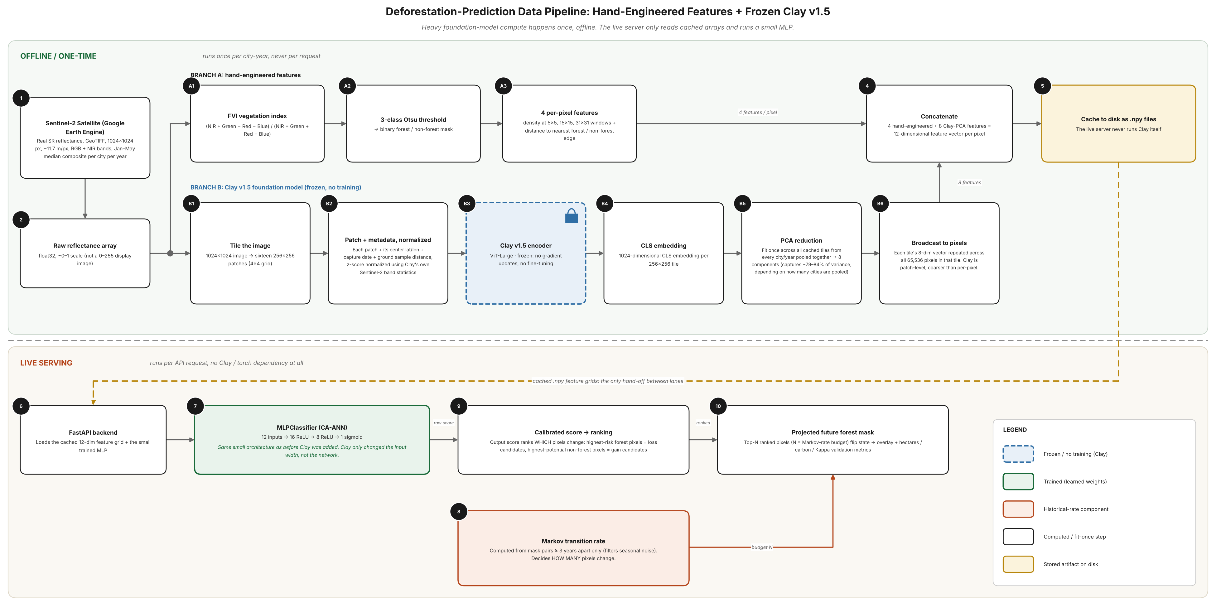
Fig. 1. End-to-end system pipeline. Heavy foundation-model computation (Branch B) runs once offline per city-year; the live backend (bottom) loads only cached feature arrays and the trained classifier.
The backend is implemented in FastAPI and exposes eight analysis modes, each as an independent REST endpoint returning JSON together with a URL to a rendered PNG visualization: single-year detection, which returns detected area, carbon stock and fragmentation metrics for one city-year; two-year comparison, which returns a gain/loss breakdown with a minimum-mapping-unit filter applied to suppress boundary-flip noise; forward prediction, which returns the CA-ANN's projected mask together with its own walk-forward validation summary so that a client can display the model's measured accuracy alongside its output rather than as a separate lookup; a continuous risk heatmap; conservation-priority ranking; external validation against Hansen Global Forest Change; a time-lapse view, served without a backend computation since it only sequences already-rendered per-year images; and side-by-side city comparison, which issues two single-year detection calls in parallel and returns them together. Offline-trained artifacts, the CA-ANN weights and the cached foundation-model feature grids, are loaded once at process start and reused across requests, so a live prediction request never invokes the foundation model or its checkpoint, only a small cached numerical array and the trained classifier. A city-specific override mechanism, evaluated in Section V-F, allows an individual city to be served by a specialized model while every other city continues to use the shared pooled model, without any change to the API surface a client observes.

E. Integrating a Frozen Geospatial Foundation Model
The four hand-engineered features in Section IV-C describe only a pixel's immediate neighborhood and carry no information about absolute position or acquisition date, a property previously treated as an asset supporting an argument that a model trained on two cities should transfer reasonably well to others. Clay v1.5, the foundation model integrated in this work, deliberately breaks that property: its embeddings encode real latitude, longitude and date. Whether the resulting additional context improves prediction accuracy enough to justify that trade-off is the central empirical question addressed in Section V.
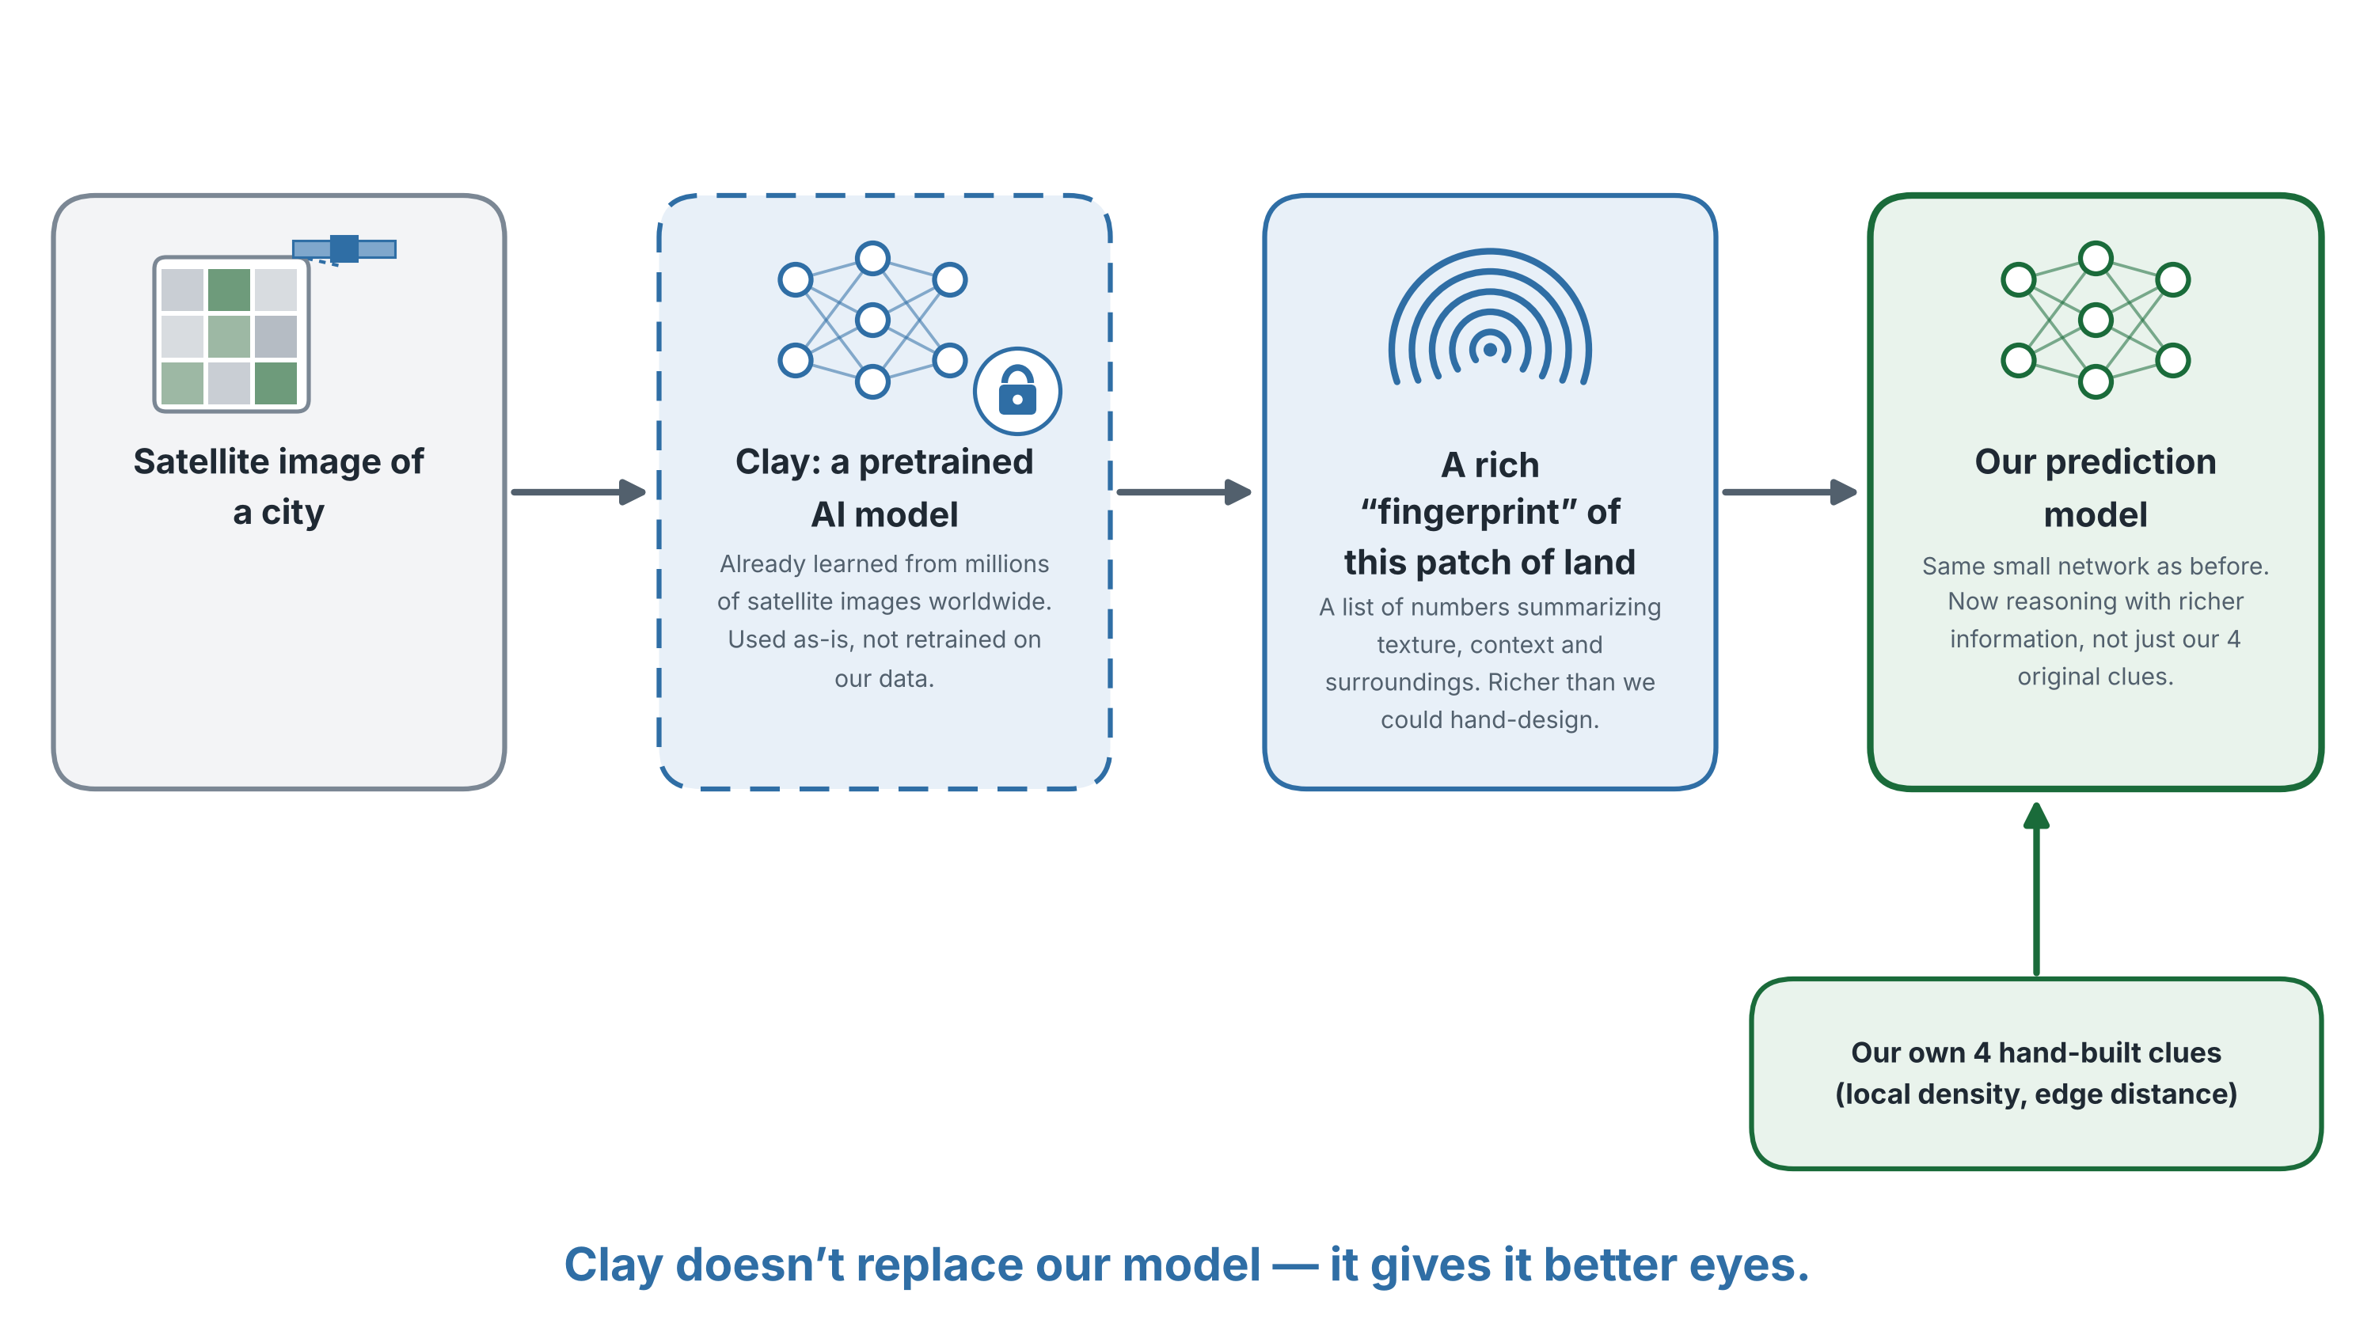
Fig. 2. Conceptual role of Clay within the pipeline: a frozen, general-purpose feature extractor supplementing, not replacing, the existing hand-engineered features.
Each city-year's 1024x1024 image is tiled into sixteen non-overlapping 256x256 patches. Each patch, together with its center latitude and longitude, capture date and ground sample distance, is normalized using Clay's published per-band Sentinel-2 statistics and passed through Clay's frozen Vision Transformer encoder, producing a single 1024-dimensional embedding per tile corresponding to the model's class token, the single-vector tile summary recommended in Clay's own reference documentation. No encoder weight is updated at any point; the entire extraction step runs once offline per city-year and is cached to disk, so the live serving path described in Section IV-D never performs a forward pass through the encoder.
A 1024-dimensional embedding is substantially larger than the four existing hand-engineered features, and with only a few dozen independent training transitions available across all four cities, concatenating the raw embedding risked overwhelming the existing features inside a network with only sixteen first-layer units. Principal component analysis, fit once across every cached tile from every available city-year pooled together, was used to reduce each tile's embedding to eight components, explaining between 79% and 84% of pooled variance depending on how many cities were included in a given fit. Because Clay operates at tile granularity rather than per pixel, each tile's eight-component vector is broadcast identically to all 65,536 pixels within that tile before concatenation with the four per-pixel hand-engineered features, producing a twelve-dimensional feature vector per pixel. The classifier architecture, sixteen hidden units followed by eight hidden units with a sigmoid output, was left unchanged; only its input width grew from four to twelve.

F. Dataset Composition
Across all four cities, thirty-six consecutive annual transitions are available for training (nine per city, 2016-2017 through 2024-2025), each contributing 1,048,576 labeled pixels (one 1024x1024 mask pair per transition) before class balancing. Pooling all four cities' transitions yields a final training set of 37,748,736 pixels, of which 1,693,361, or 4.5%, are labeled as changed, confirming the severe class imbalance motivating the balancing procedure below. It is important to distinguish pixel count from independent sample count in interpreting this dataset: neighboring pixels within a single transition are highly spatially autocorrelated, so the effective number of independent observations the classifier can learn from is far closer to the thirty-six transition-level samples than to the thirty-seven-million pixel-level count, a distinction central to the small-sample framing in Section VI and to the architectural restraint (a twelve-input, two-hidden-layer network) adopted throughout this work rather than scaling the model to match the nominal pixel count.

G. Training Procedure and Class Balancing
Change pixels are rare relative to stable pixels in any single consecutive-year transition, typically on the order of a few percent of the frame, which would otherwise bias a classifier trained on raw class frequencies toward never predicting change at all. Training data is balanced by retaining every positive (changed) pixel and randomly sampling negative (unchanged) pixels at three times the positive count, discarding the remainder of the far larger negative pool for that training run. Because this undersampling shifts the effective class prior seen during training away from the true prior, raw predicted probabilities are corrected post hoc using the calibration method of Dal Pozzolo et al. [10]. Writing p for the classifier's raw output probability on the resampled distribution and beta for the fraction of true negatives retained in the undersampled training set, the calibrated probability is obtained by rescaling the odds of p by beta:
p_cal = β·p / [1 − p + β·p]
The classifier itself is a scikit-learn MLPClassifier with ReLU activations, the Adam solver, a maximum of 400 iterations, and early stopping enabled on a held-out validation fraction of the training set, so that the number of training epochs actually used is determined automatically per fit rather than fixed in advance. Random seed handling matters twice in this design: once for which negative pixels are sampled into the balanced training set, and once for the classifier's own weight initialization. Section V-F is centrally concerned with the second of these two randomness sources, the one found to matter more in practice.

H. API Design and Offline/Online Separation
A deliberate architectural boundary separates computation that depends on the foundation model from computation served at request time. The extraction pipeline in Section IV-E, PCA fitting, and tile-to-pixel broadcasting are implemented as a standalone offline script that iterates over every cached city-year GeoTIFF pair, produces one 1024-dimensional raw embedding array and one eight-dimensional PCA-reduced array per city-year, and persists both to disk as NumPy binary files. The FastAPI backend that serves the eight analysis modes listed in Section IV-D never imports the foundation-model library or its checkpoint; it loads only the small cached reduced-dimension arrays, typically under one megabyte per city-year, at process startup. This separation means a live prediction request completes in the time required for a small multilayer-perceptron forward pass and a NumPy array broadcast, rather than a Vision Transformer forward pass over sixteen tiles, and means the production server has no dependency on the deep-learning framework used to run Clay, only on scikit-learn for the classifier itself.
The per-city override mechanism mentioned in Section IV-D is implemented as a lookup indexed by city key: if a city has a registered specialized model and statistics file, those are loaded in place of the shared pooled model and pooled validation statistics; otherwise the pooled model is used, uniformly represented internally as a single-member model ensemble so that the prediction and calibration code path does not need to special-case the pooled and ensembled cases separately. This design allows a newly added city to fall back automatically to the shared model with no code change, while allowing a city that is later found to warrant specialization, as Bengaluru was in Section V-F, to be upgraded independently of every other city's serving path.

I. Variance Reduction via Seed Ensembling
A cross-configuration comparison, reported in Section V-F, revealed that the Clay-augmented model's accuracy advantage over the density-heuristic baseline changed sign repeatedly across otherwise similar training runs while the baseline itself remained fixed, the signature of high variance from random weight initialization and random negative-class undersampling rather than a stable underlying effect. An eight-seed ensemble was trained, in which the CA-ANN is fit independently eight times with different random seeds on identical training data, and the resulting raw probabilities are averaged before calibration, a standard variance-reduction technique for exactly this situation. This ensemble, rather than the raw single-seed Clay integration, was promoted to serve live predictions for the one city where it showed a benefit.

V. EXPERIMENTAL RESULTS

A. Reflectance Correction Verification
The switch from thumbnail-based to GeoTIFF-based acquisition, described in Section IV-A, was verified prior to retraining any model on it. Fetched pixel values across all four cities fell within 0.01 to 0.74, consistent with physically plausible surface reflectance and markedly unlike the 0-255 display range the deprecated pipeline produced. Per-pixel coordinates recovered from the new GeoTIFF metadata matched each city's known center to five decimal places, a sanity check impossible under the deprecated pipeline, which carried no georeferencing at all. The water-exclusion brightness threshold used inside the vegetation classifier was re-derived analytically by inverting the deprecated gamma transform for the reflectance value that would have produced the old cutoff, yielding a new threshold of 0.015 reflectance units, rather than re-tuned empirically from an untested starting point. Fig. 3 shows a representative detection result for Bengaluru under the corrected pipeline: the satellite image, the resulting FVI-and-Otsu mask, and the composited overlay.
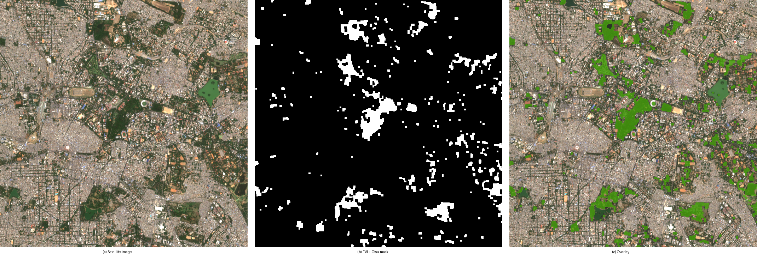
Fig. 3. Representative detection output, Bengaluru 2025, a 700x700 pixel crop. (a) Real surface reflectance, false-color composite for display. (b) Binary forest mask from FVI and three-class Otsu thresholding. (c) Mask composited over the display image.

B. CA-ANN Baseline Validation
Walk-forward validation, in which the model is trained only on years preceding a cutoff and tested against the real, later, previously unseen year, was run at one-, three- and six-year horizons. A nine-year horizon was scoped but could not yet be tested; it would require training data beginning before the earliest fetched year and is expected to become available as additional years are fetched in future work. Table II reports Bengaluru's validated accuracy, the city on which the final ensembled model described in Section IV-I is served in production.
TABLE II
WALK-FORWARD KAPPA BY HORIZON, BENGALURU
Horizon | Baseline | CA-ANN ensemble | N | Wins
1-year | 0.689 | 0.689 | 4 | 3/4
3-year | 0.556 | 0.560 | 4 | 3/4
6-year | 0.283 | 0.305 | 1 | 1/1

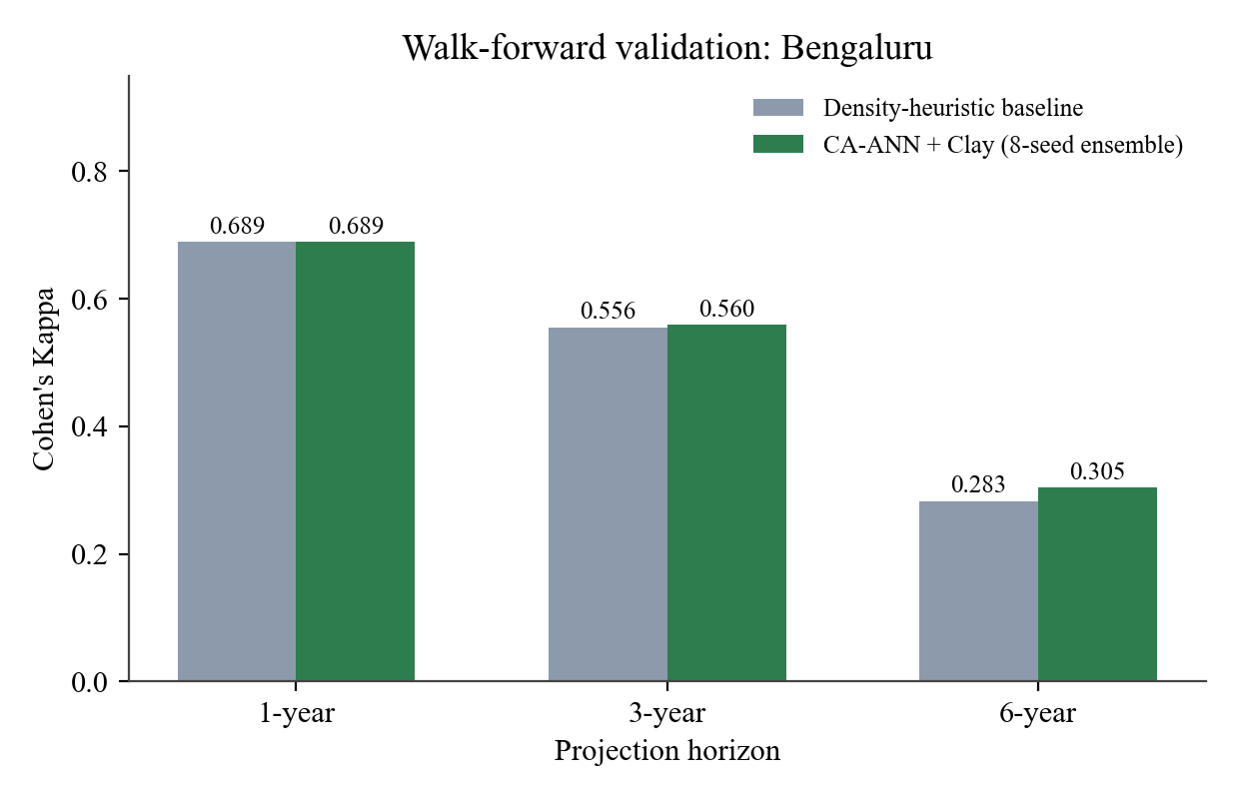
Fig. 4. Walk-forward Kappa, Bengaluru, baseline vs. the final eight-seed CA-ANN ensemble.

C. Foundation-Model Integration: A Rigorous Negative Result
Clay's embeddings were tested across an expanding set of cities specifically to determine whether an observed benefit was a stable effect or a statistical artifact of a particular city combination. With two cities pooled (Chennai and Bengaluru), Clay provided a small benefit in Bengaluru and a small cost in Chennai. Adding Delhi as a third city did not resolve this picture; Delhi behaved more like Chennai, including a loss exceeding ten Kappa points at the six-year horizon in one configuration. Adding Kolkata as a fourth city reproduced the same pattern. Across all four cities tested, only Bengaluru showed a consistent, if modest, benefit from the foundation-model features.
Two further checks were run specifically to rule out hyperparameter tuning as the explanation before this was accepted as a genuine finding, using a single held-out test per city (the most recent year-pair) rather than the full walk-forward sweep, for computational tractability. Reducing retained principal components from eight to three, and separately increasing classifier regularization strength (L2 penalty) by two orders of magnitude, from 0.0001 to 0.01, were each evaluated against the no-foundation-model baseline. Table III reports the mean Kappa delta across the two held-out test cities for each configuration.
TABLE III
CLAY CONFIGURATION ABLATION (MEAN DELTA VS. BASELINE)
Configuration | PCA dims | L2 penalty | Mean delta
No Clay | 0 | default | -0.0047
Production | 8 | default | -0.0020
Reduced dims | 3 | default | -0.0043
Regularized | 8 | 0.01 | -0.0022
Reduced+reg. | 3 | 0.01 | -0.0043

None of the four alternative configurations improved on the production configuration (eight PCA dimensions, default regularization), which remained the best of the five, and all five configurations remained negative on average across the two test cities. This result argues against the hypothesis that the foundation-model integration was simply mistuned, and in favor of treating the per-city variation reported above as the more informative finding. A further experiment retrained a Bengaluru-only model with Clay's principal-component basis fit exclusively on Bengaluru's own tile embeddings, on the hypothesis that a basis shared across four cities might be diluting Bengaluru's own signal. This improved the one- and three-year results marginally but reversed the six-year result from a win to a loss, and was not adopted.

D. Qualitative Error Characteristics
Beyond the quantitative Kappa figures reported throughout this section, visual inspection of rendered detection and prediction overlays across all four cities surfaces two recurring, qualitatively consistent error patterns. The first is concentrated at patch boundaries: pixels within one to two pixels of a forest edge account for a disproportionate share of both false positives and false negatives at every horizon tested, consistent with the edge-distance feature in Section IV-C being one of only four signals available to the classifier and with the seasonal-oscillation phenomenon documented in Section IV-C, where boundary pixels are the pixels most likely to cross the FVI threshold under ordinary seasonal variation independent of any genuine land-cover change. The second pattern is specific to very small patches, below roughly 0.5 ha: these patches are disproportionately likely to appear or disappear entirely between consecutive years in the raw detection output, a volatility that motivated the minimum-mapping-unit filter applied to the two-year comparison endpoint in Section IV-D, though the filter is deliberately not applied to the CA-ANN's own training labels, since a genuinely volatile small patch is, by definition, higher-risk, and suppressing that volatility in the training signal would remove exactly the information the spatial classifier is intended to learn from.

E. Full Per-City Breakdown
Table IV reports the complete per-city, per-horizon comparison underlying the claims in Section V-C, computed from the four-city pooled model before ensembling. Of twelve city-horizon combinations, only Bengaluru at the six-year horizon shows a positive mean delta; every other city is negative at every horizon, and the magnitude of the deficit grows with horizon length for Chennai and Delhi in particular, reaching -0.045 Kappa for Delhi at three years and -0.039 at six years.
TABLE IV
PER-CITY KAPPA DELTA VS. BASELINE, 4-CITY POOLED MODEL
City | 1-yr | 3-yr | 6-yr
Bengaluru | -0.0032 | -0.0018 | +0.0188
Chennai | -0.0124 | -0.0242 | -0.0055
Delhi | -0.0039 | -0.0452 | -0.0389
Kolkata | -0.0116 | -0.0019 | -0.0157

This breakdown is the basis for treating Bengaluru's benefit as city-specific rather than as a generalizable property of the foundation-model integration, and for why the ensembled, specialized model described in Section V-F is served only for Bengaluru while every other city continues to use the shared pooled configuration.

F. Variance Reduction and the Project's Strongest Result
Comparing Bengaluru's own six-year delta across pooling configurations, with an identical baseline Kappa of 0.283 in every case since the baseline does not depend on Clay, revealed a sign change across every successive configuration: -0.0233 with two cities, +0.0080 with three, +0.0189 with four, and -0.0048 in the Bengaluru-only specialized model. A result changing sign across otherwise similar training runs, against a fixed comparison baseline, is the signature of variance from random initialization and random negative-class undersampling rather than a stable effect.
TABLE V
CA-ANN ADVANTAGE VS. BASELINE (6-YR HORIZON)
Configuration | Kappa | Delta
2-city pooled | 0.260 | -0.0233
3-city pooled | 0.291 | +0.0080
4-city pooled | 0.302 | +0.0189
Bengaluru, single seed | 0.278 | -0.0048
Bengaluru, 8-seed ensemble | 0.305 | +0.0214

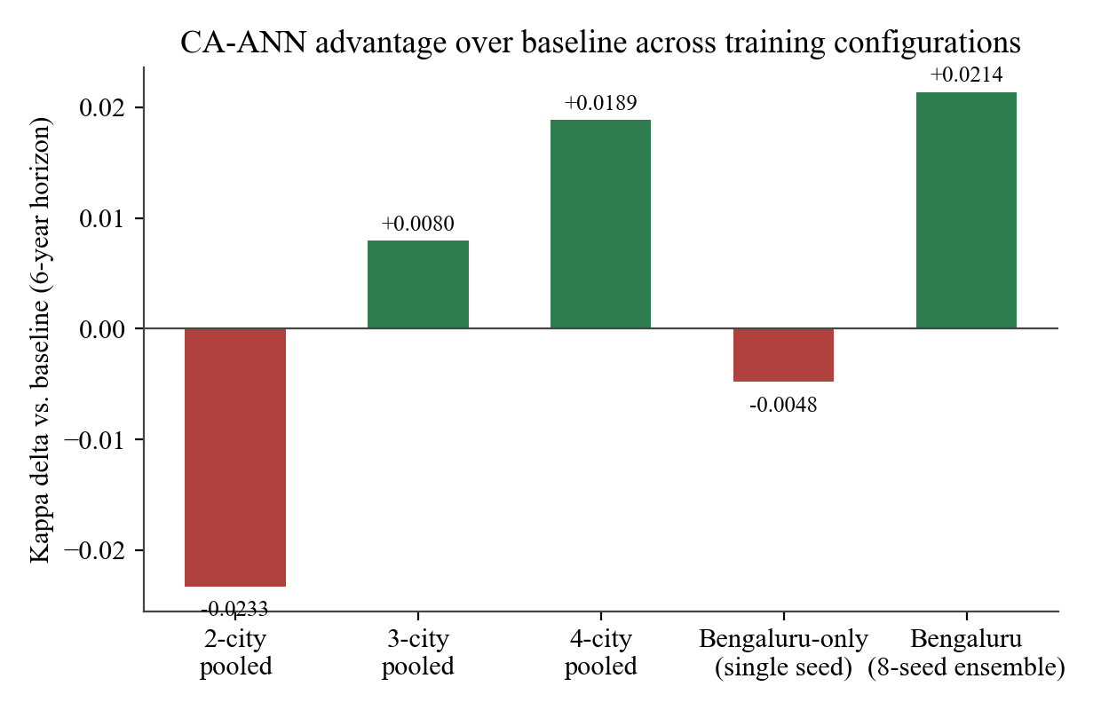
Fig. 5. CA-ANN advantage over baseline (6-year horizon) across five successive training configurations.
The eight-seed ensemble described in Section IV-I improved results at every horizon tested against the single-seed pooled model, not only the horizon that appeared most favorable in isolation. One-year performance moved from a mean deficit of 0.0032 Kappa to a deficit of under 0.0005; three-year performance moved from a deficit of 0.0018 to a surplus of 0.0042; six-year performance improved from a surplus of 0.0189 to a surplus of 0.0214. This ensemble, not the raw single-seed Clay integration, was promoted to serve live predictions for Bengaluru; every other city continues to be served by the shared single-seed pooled model.

G. Comparison Against Published Literature
Short-horizon accuracy in this work is directly competitive with the published CA-ANN results reviewed in Section II-D. At a one-year horizon, the final Bengaluru model reaches a Kappa of 0.689, close to the 0.72 reported by Baig et al. [5]. Table VI extends this comparison to all three studies, including both model variants reported by Salehi Asfichi et al. [7] for the Tehran metropolitan area, since that study calibrates and reports two separate CA-ANN configurations rather than one.
TABLE VI
COMPARISON AGAINST PUBLISHED CELLULAR AUTOMATA STUDIES
Study | Area | Horizon | Kappa
Baig et al. [5] | Selangor | n/s | 0.72
Agustina et al. [6] | Cirebon | 10-yr | 0.786
Salehi Asfichi [7], mixed model | Tehran | 10-yr | 0.760
Salehi Asfichi [7], raster model | Tehran | 10-yr | 0.705
This work | Bengaluru | 1-yr | 0.689
This work | Bengaluru | 6-yr | 0.305

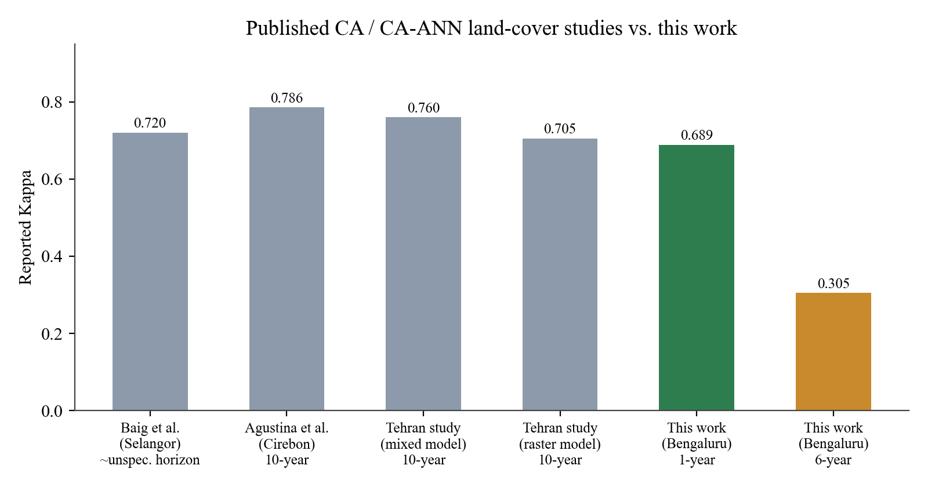
Fig. 6. Reported Kappa across the published studies in Table VI and this work.
The long-horizon comparison is less favorable and is reported here without qualification. Agustina et al. [6] and both Salehi Asfichi et al. [7] configurations validate genuine ten-year forecasts against real ground truth and report Kappa values well above this work's six-year result. It is worth noting that the two Salehi Asfichi configurations, calibrated on the same Tehran study area with the same source imagery, differ from each other by five and a half Kappa points depending on whether the model is run as a mixed classifier or on a common raster surface, which shows that published CA-ANN accuracy is itself a function of modeling choices and not a single fixed target this work is being measured against. A plausible explanation for the remaining gap against this work's six-year result, not independently confirmed within this study, concerns what each model predicts. Both comparison studies track built-up or urban land expansion, a largely monotonic process that removes a substantial source of uncertainty this work's bidirectional forest gain-and-loss signal cannot avoid. With only nine years of Bengaluru-specific history available to learn both directions of change, a visibly lower long-horizon Kappa on the structurally harder bidirectional task is a reasonable outcome rather than an unexplained shortfall. Confirming this would require applying the same CA-ANN design to a monotonic land class directly, proposed as future work in Section VII.

H. External Validation Against Hansen Global Forest Change
Every validation reported above measures this work's methodology against itself, a held-out year produced by the same pipeline that trained the model. Validation against Hansen Global Forest Change [1] provides the only comparison in this study against an independent, peer-reviewed external reference. Two metrics are reported together: a strict pixel-exact confusion matrix, and a buffered, positional-tolerance agreement computed at Hansen's native 30 m resolution.
TABLE VII
EXTERNAL VALIDATION VS. HANSEN GFC, CHENNAI 2025
Metric | Strict | Buffered (30 m)
Precision | 0.037 | 0.222

Strict precision as low as 0.037 could be mistaken for a detection failure until visual inspection confirmed the fetched Hansen data showed a correctly located coastline and water bodies, ruling out a fetch or alignment defect. The underlying cause, consistent with the fragmented-urban-tree-cover limitation documented by Tropek et al. [2], is a genuine granularity mismatch: Hansen's classifier returns sparse, scattered, tree-level detections in this dense urban context, while the FVI method used in this work returns dense, contiguous patches. Buffered agreement, which asks whether the two methods broadly agree on where forest exists rather than requiring pixel-exact agreement, rose to 0.222 for the same comparison and improved further as buffer distance was relaxed, consistent with a resolution mismatch rather than a correctness problem. Separately, Hansen's own documented gain-tracking limitation, discontinued after 2012, means its reference for any year after 2012 systematically underestimates true forest extent, so this work's detections exceeding Hansen's reference area is a partially expected direction of disagreement rather than necessarily an error.

I. Decision-Support Features
Beyond detection and prediction, two features translate the CA-ANN's internal score into an actionable output. A conservation-priority ranking combines each forest patch's area with the model's mean calibrated risk score within that patch, surfacing the patches that are simultaneously large and at elevated risk. For a patch with pixel area A, maximum qualifying patch area A_max, and mean calibrated per-pixel risk score r over its constituent pixels, the priority score is
priority = (A / A_max) × r
a product of two terms each normalized to the unit interval, so that neither patch size nor risk alone determines rank: a large, low-risk patch and a small, high-risk patch can receive comparable scores, and patches below a minimum area threshold are excluded entirely as more likely to represent isolated street trees than meaningful habitat. A continuous risk heatmap renders the same calibrated score directly over current forest extent using a percentile-based contrast stretch, since raw annual change probabilities cluster too low for a linear color mapping to show meaningful variation; high risk is defined as the top decile of forest area by score rather than an absolute probability cutoff, since single-year change probabilities are low in absolute terms for the large majority of forest pixels regardless of city.
For Bengaluru 2025, the system detects 1,149.03 ha of forest across 370 distinct patches with a mean patch size of 3.105 ha, indicating a landscape dominated by many small, fragmented patches rather than a small number of large contiguous blocks. The conservation-priority ranking for the same city-year surfaces ten patches, the largest-scoring at 158.56 ha with a mean calibrated risk of 0.1632, down to smaller but individually higher-risk patches such as a 25.25 ha patch carrying a mean risk of 0.2942, illustrating that the ranking does not simply reduce to sorting by area alone: a patch's priority score can be driven up by either dimension. Projected forward to 2028 under the CA-ANN ensemble, total forest area is projected to grow by 26.34 ha net, while patch count is projected to rise from 398 to 653, a fragmentation increase that is not visible from the net area figure alone and that motivates reporting FRAGSTATS-style metrics for every projection, not only for the present-day measured state.

J. Threats to Validity
Internal validity is primarily threatened by the small number of independent training transitions, eighteen to thirty-six depending on how many cities are pooled, relative to the twelve-dimensional input space used once foundation-model features are included. This work addressed the risk by keeping the classifier architecture small (sixteen and eight hidden units) and by validating every design decision through walk-forward testing against real held-out years rather than a single train-test split, but a small-sample confound cannot be fully ruled out by architectural restraint alone, and is the central reason this paper treats the ensembling result in Section V-F, not the raw Clay integration in Section V-C, as its primary positive finding.
External validity is bounded by the four validated cities, all within India and all subject to the same Sentinel-2 Jan-May compositing window; the conclusions in Section V-C about which cities benefit from foundation-model features should not be assumed to transfer to cities with substantially different climate, vegetation phenology, or urban form without direct testing, a limitation acknowledged explicitly in Section VI. Construct validity concerns the use of Cohen's Kappa [19] as the primary accuracy metric: Kappa corrects for chance agreement given each class's marginal frequency, which makes it more informative than raw percent agreement on an imbalanced change-detection task, but it is sensitive to that same marginal frequency in ways that make absolute Kappa values difficult to compare across cities or horizons with different base rates of change, which is why this paper reports agreement percentage alongside Kappa throughout Section V rather than Kappa in isolation, following standard remote sensing accuracy-assessment practice [20].

VI. DISCUSSION AND LIMITATIONS
The results in Section V support a specific, bounded conclusion about geospatial foundation models rather than a general claim for or against their use. Clay's embeddings, extracted and integrated correctly and tested across four cities, three embedding dimensionalities, two regularization strengths and a single-city specialization, did not produce a reliable accuracy improvement outside one of the four validated cities. This is consistent with a broader expectation in low-data transfer learning: a representation pretrained on a broad, heterogeneous corpus is not guaranteed to transfer cleanly to a narrow downstream task with very few independent training examples, here on the order of several dozen city-year transitions across all four cities combined. The eight-seed ensemble, by contrast, produced a reliable, repeatable improvement by directly addressing a measured source of variance rather than by altering what information the model receives, which this work treats as the more generally applicable finding of the two.
A second limitation concerns the long-horizon accuracy gap documented in Section V-G. While the bidirectional-versus-monotonic explanation offered there is plausible and grounded in the structural difference between the compared tasks, it has not been independently confirmed by applying this work's own CA-ANN design to a monotonic land-cover class. A third limitation is data volume: the nine-year horizon could not be validated at all within the current ten-year fetch window, and the eighteen-to-thirty-six independent transitions available across one to four cities are a small sample by the standards of typical neural network training, a constraint this work addressed through architectural restraint, a twelve-input, two-hidden-layer network, rather than by expanding the model to match a larger hypothetical dataset it does not have.
Finally, the six-kilometer buffer per city, while sufficient to capture a meaningful fraction of each city's urban forest, covers only an estimated one-fifth to one-third of each city's full administrative extent, and results should not be interpreted as characterizing an entire city's forest trajectory.
A further point concerns the choice of Cohen's Kappa as the headline metric throughout this paper. Pontius and Millones [11] argue that Kappa's correction for chance agreement can move in a direction unrelated to actual model skill as the proportion of each class shifts between the reference map and the simulated map, and propose reporting quantity disagreement and allocation disagreement, or the closely related figure of merit, in its place. This critique is taken seriously rather than dismissed, and it is the reason Section V reports agreement percentage alongside Kappa rather than Kappa alone. Kappa was nonetheless kept as the primary reported figure in this paper because every comparison study in Table VI reports Kappa and none reports figure of merit, and switching metrics would have made the literature comparison in Section V-G impossible rather than merely imperfect. A future revision of this work that is not constrained by matching an existing comparison table would be better served by reporting figure of merit as the primary metric.
A natural question is whether the specific foundation model used here, rather than foundation models as a class, explains the negative result in Section V-C. Clay v1.5 is trained on a broad, multi-sensor, globally distributed corpus not specifically weighted toward dense urban vegetation in South Asian cities, and its embeddings therefore encode a generic notion of land-surface appearance rather than one tuned to the specific texture, canopy density and fragmentation patterns characteristic of this study's four cities. A model pretrained on, or fine-tuned toward, a corpus more closely matched to urban tropical and subtropical vegetation might transfer more cleanly; this work deliberately did not fine-tune Clay, both to preserve the zero-additional-training-cost property that makes a frozen foundation model attractive for a resource-constrained deployment, and because fine-tuning on a dataset as small as this study's would introduce its own, likely more severe, overfitting risk. This trade-off is stated explicitly rather than left implicit, since it is a direct consequence of the frozen-embedding design choice in Section IV-E and not an incidental limitation.

VII. CONCLUSION AND FUTURE WORK
This paper presented ForestWatch India, a forest cover monitoring and prediction system validated across four Indian cities, and reported a rigorous evaluation of whether a frozen geospatial foundation model improves a small CA-ANN prediction architecture under genuine data scarcity. The reflectance-pipeline correction described in Section IV-A is a clear, verified improvement independent of the foundation-model question: every measurement in this study rests on real Sentinel-2 surface reflectance rather than a gamma-corrected display approximation. The CA-ANN itself, validated through walk-forward testing at multiple horizons, performs competitively with published cellular automata work at short horizons and explainably less well at long horizons, a gap attributed to the bidirectional nature of forest change relative to the monotonic urban expansion modeled in the comparison literature.
The foundation-model integration is this work's most methodologically rigorous result rather than its most flattering one. Clay v1.5's embeddings did not produce a reliable accuracy improvement outside a single validated city. What did produce a reliable, repeatable improvement was an eight-seed prediction ensemble, which stabilized a result that had previously changed sign across nominally equivalent training runs and produced this study's strongest validated outcome, a Kappa of 0.305 at a six-year horizon against a baseline of 0.283. This work treats a negative or inconclusive result, reached through a genuinely thorough ablation and reported without exaggeration, as a legitimate and useful scientific outcome rather than a result to be concealed or reframed.
Future work includes five directions. First, extending the historical record backward of 2016 using Landsat imagery, which would add genuinely new independent training examples rather than denser sampling of the same ten-year window, directly addressing the small-sample constraint discussed in Section VI, at the cost of resolving a 30 m versus 10 m resolution mismatch, re-validating FVI's behavior on Landsat's band centers, and harmonizing radiometric differences across the Landsat 5, 7 and 8 sensors that would jointly cover a pre-2016 extension. This is judged the highest-priority direction because it is the only one of the five that adds genuinely independent data rather than reprocessing the existing ten-year window, and every other finding in this paper traces back, in some form, to the same small-sample ceiling.
Second, applying the same CA-ANN and foundation-model pipeline to a monotonic land-cover class, such as built-up area expansion, within the same four cities, to directly test the bidirectional-versus-monotonic explanation proposed in Section V-G rather than leaving it as a plausible but unconfirmed hypothesis; a positive result on a monotonic class using the identical pipeline and cities used throughout this paper would substantially strengthen that explanation, while a negative result would suggest the long-horizon gap has a different cause not yet identified. Third, revisiting a previously reverted temporal density-trend feature (local forest-density change relative to a fixed number of years earlier) now that four cities provide a larger absolute pool of valid training examples than the two-city dataset on which it was originally tested and rejected; the original rejection was attributed in part to roughly a third of training transitions lacking a valid lookback reference within a two-city, ten-year dataset, a dilution that a larger pooled dataset may reduce in absolute, if not relative, terms.
Fourth, extending the per-city model override mechanism already built for Bengaluru, described in Section IV-H, to a systematic per-city evaluation policy applied automatically to every newly added city, so that a new city is assessed for foundation-model benefit using the same ablation protocol as Section V before being committed to either the shared pooled configuration or a specialized one, rather than requiring a bespoke investigation each time, as was effectively the case for Bengaluru in this study. Fifth, investigating whether a geospatial foundation model pretrained or fine-tuned on a corpus more specific to dense tropical and subtropical urban vegetation, rather than Clay's broad global corpus, narrows the gap identified in Section VI between the four cities where foundation-model transfer did and did not succeed; this would help distinguish whether the negative result reported in Section V-C is a property of foundation-model transfer in this problem class generally or a property specific to the particular pretrained corpus used in this study.
ACKNOWLEDGMENT
The author thanks the guide, Kumar K, School of Computer Science and Engineering, Vellore Institute of Technology, Chennai, for guidance throughout the course of this project, and acknowledges the use of Google Earth Engine for satellite data access and the Clay Foundation's open release of the Clay v1.5 model checkpoint and metadata used in Section IV-E.
REFERENCES
[1] M. C. Hansen, P. V. Potapov, R. Moore, M. Hancher, S. A. Turubanova, A. Tyukavina, D. Thau, S. V. Stehman, S. J. Goetz, T. R. Loveland, A. Kommareddy, A. Egorov, L. Chini, C. O. Justice, and J. R. G. Townshend, “High-resolution global maps of 21st-century forest cover change,” Science, vol. 342, no. 6160, pp. 850–853, 2013.
[2] R. Tropek, O. Sedláček, J. Beck, P. Keil, Z. Musilová, I. Šímová, and D. Storch, “Comment on ‘High-resolution global maps of 21st-century forest cover change,’” Science, vol. 344, no. 6187, p. 981, 2014.
[3] A. A. Gitelson, Y. J. Kaufman, R. Stark, and D. Rundquist, “Novel algorithms for remote estimation of vegetation fraction,” Remote Sensing of Environment, vol. 80, no. 1, pp. 76–87, 2002.
[4] K. McGarigal and B. J. Marks, “FRAGSTATS: Spatial pattern analysis program for quantifying landscape structure,” USDA Forest Service, Pacific Northwest Research Station, Gen. Tech. Rep. PNW-GTR-351, 1995.
[5] M. F. Baig, M. R. U. Mustafa, I. Baig, H. B. Takaijudin, and M. T. Zeshan, “Assessment of land use land cover changes and future predictions using CA-ANN simulation for Selangor, Malaysia,” Water, vol. 14, no. 3, p. 402, 2022.
[6] I. H. Agustina, R. R. Aji, I. Fardani, G. P. Rochman, A. M. Ekasari, and F. A. J. Mohmed, “Cellular automata for Cirebon city land cover and development prediction,” Planning Malaysia, vol. 20, no. 1, pp. 77–88, 2022.
[7] H. Salehi Asfichi, J. Karami, and S. A. Alavi, “Performance assessment of CA-ANN consolidated model in urban growth modelling, a case study of Tehran metropolitan area,” Journal of Geography and Regional Development, vol. 16, no. 1, pp. 257–278, 2018.
[8] N. Otsu, “A threshold selection method from gray-level histograms,” IEEE Transactions on Systems, Man, and Cybernetics, vol. 9, no. 1, pp. 62–66, 1979.
[9] N. Gorelick, M. Hancher, M. Dixon, S. Ilyushchenko, D. Thau, and R. Moore, “Google Earth Engine: Planetary-scale geospatial analysis for everyone,” Remote Sensing of Environment, vol. 202, pp. 18–27, 2017.
[10] A. Dal Pozzolo, O. Caelen, R. A. Johnson, and G. Bontempi, “Calibrating probability with undersampling for unbalanced classification,” in Proc. 2015 IEEE Symposium Series on Computational Intelligence, 2015, pp. 159–166.
[11] R. G. Pontius Jr. and M. Millones, “Death to Kappa: birth of quantity disagreement and allocation disagreement for accuracy assessment,” International Journal of Remote Sensing, vol. 32, no. 15, pp. 4407–4429, 2011.
[12] J. W. Rouse, R. H. Haas, J. A. Schell, and D. W. Deering, “Monitoring vegetation systems in the Great Plains with ERTS,” in Proc. 3rd ERTS Symposium, NASA SP-351, vol. 1, 1974, pp. 309–317.
[13] S. K. McFeeters, “The use of the Normalized Difference Water Index (NDWI) in the delineation of open water features,” International Journal of Remote Sensing, vol. 17, no. 7, pp. 1425–1432, 1996.
[14] D. Guan, H. Li, T. Inohae, W. Su, T. Nagaie, and K. Hokao, “Modeling urban land use change by the integration of cellular automaton and Markov model,” Ecological Modelling, vol. 222, no. 20, pp. 3761–3772, 2011.
[15] B. Rimal, L. Zhang, H. Keshtkar, B. N. Haack, S. Rijal, and P. Zhang, “Land use/land cover dynamics and modeling of urban land expansion by the integration of cellular automata and Markov chain,” ISPRS International Journal of Geo-Information, vol. 7, no. 4, p. 154, 2018.
[16] A. Dosovitskiy, L. Beyer, A. Kolesnikov, D. Weissenborn, X. Zhai, T. Unterthiner, M. Dehghani, M. Minderer, G. Heigold, S. Gelly, J. Uszkoreit, and N. Houlsby, “An image is worth 16x16 words: Transformers for image recognition at scale,” in Proc. Int. Conf. on Learning Representations (ICLR), 2021.
[17] Y. Cong, S. Khanna, C. Meng, P. Liu, E. Rozi, Y. He, M. Burke, D. B. Lobell, and S. Ermon, “SatMAE: Pre-training transformers for temporal and multi-spectral satellite imagery,” in Proc. Advances in Neural Information Processing Systems (NeurIPS), vol. 35, 2022.
[18] M. Drusch, U. Del Bello, S. Carlier, O. Colin, V. Fernandez, F. Gascon, B. Hoersch, C. Isola, P. Laberinti, P. Martimort, A. Meygret, F. Spoto, O. Sy, F. Marchese, and P. Bargellini, “Sentinel-2: ESA's optical high-resolution mission for GMES operational services,” Remote Sensing of Environment, vol. 120, pp. 25–36, 2012.
[19] J. Cohen, “A coefficient of agreement for nominal scales,” Educational and Psychological Measurement, vol. 20, no. 1, pp. 37–46, 1960.
[20] R. G. Congalton, “A review of assessing the accuracy of classifications of remotely sensed data,” Remote Sensing of Environment, vol. 37, no. 1, pp. 35–46, 1991.

