[VIT LOGO PLACEHOLDER — insert official Vellore Institute of Technology crest here]
VELLORE INSTITUTE OF TECHNOLOGY
(Deemed to be University under Section 3 of UGC Act, 1956)
CHENNAI
A Project Report on
FORESTWATCH INDIA: A CA-ANN FRAMEWORK FOR URBAN FOREST COVER MONITORING AND MULTI-YEAR PREDICTION USING SENTINEL-2 IMAGERY AND FOUNDATION MODEL EMBEDDINGS
Submitted in partial fulfillment for the award of the degree of
Bachelor of Technology
in
COMPUTER SCIENCE AND ENGINEERING (CORE)
by
YUVRAJ SINGH HAJARI (23BCE1995)
SCHOOL OF COMPUTER SCIENCE AND ENGINEERING
November 2026

DECLARATION
I hereby declare that the thesis entitled “ForestWatch India: A CA-ANN Framework for Urban Forest Cover Monitoring and Multi-Year Prediction Using Sentinel-2 Imagery and Foundation Model Embeddings” submitted by me, Yuvraj Singh Hajari (23BCE1995), for the award of the degree of Bachelor of Technology in Computer Science and Engineering, Vellore Institute of Technology, Chennai, is a record of bonafide work carried out by me under the supervision of Kumar K.
I further declare that the work reported in this thesis has not been submitted and will not be submitted, either in part or in full, for the award of any other degree or diploma in this institute or any other institute or university.

Place: Chennai
Date: Signature of the Candidate

School of Computer Science and Engineering
CERTIFICATE
This is to certify that the report entitled “ForestWatch India: A CA-ANN Framework for Urban Forest Cover Monitoring and Multi-Year Prediction Using Sentinel-2 Imagery and Foundation Model Embeddings” is prepared and submitted by Yuvraj Singh Hajari (23BCE1995) to Vellore Institute of Technology, Chennai, in partial fulfillment of the requirement for the award of the degree of Bachelor of Technology in Computer Science and Engineering (Core), is a bonafide record carried out under my guidance. The project fulfills the requirements as per the regulations of this University and in my opinion meets the necessary standards for submission. The contents of this report have not been submitted and will not be submitted either in part or in full, for the award of any other degree or diploma and the same is certified.

Signature of the Guide:
Name: Kumar K
Date:

Signature of the Examiner Signature of the Examiner
Name: Name:
Date: Date:

Approved by the Head of Department, B.Tech. Computer Science and Engineering

ABSTRACT
Urban forest loss is difficult to track in Indian cities because reliable, repeatable measurement at the scale of an entire metropolitan area has traditionally required either expensive commercial imagery or labour-intensive ground survey. ForestWatch India addresses this gap with an end-to-end pipeline that fetches real Sentinel-2 surface reflectance imagery through Google Earth Engine, classifies vegetation using an original spectral index, and projects future forest cover using a cellular automata and artificial neural network (CA-ANN) hybrid model. The system was validated across four Indian cities, Chennai, Bengaluru, Delhi and Kolkata, spanning ten years of annual imagery each.
Two methodological corrections distinguish this work from a typical remote-sensing class project. First, an early version of the pipeline computed its vegetation index from Google Earth Engine's thumbnail endpoint, which silently applies a gamma correction and a hard reflectance clip meant only for visual display. This was identified and corrected by switching to the raw GeoTIFF download path, so every reported hectare and every trained model in this report is grounded in physically meaningful reflectance rather than a cosmetically adjusted image. Second, the CA-ANN's spatial-suitability component was extended with embeddings drawn from Clay v1.5, a frozen geospatial foundation model pretrained on a large corpus of global satellite imagery. The embeddings were reduced by principal component analysis and concatenated with four hand-engineered local features before being passed to the same small multilayer perceptron used in the original design.
Walk-forward validation, in which the model is trained only on data preceding a cutoff year and tested against the real, later outcome, was used throughout rather than a single train-test split. The foundation-model embeddings were found to help only in Bengaluru, and only modestly, while hurting performance in the other three cities. A targeted ablation across embedding dimensionality, regularisation strength and single-city specialisation did not resolve this gap. What did help was an eight-seed prediction ensemble, which reduced the prediction variance that had been causing the Bengaluru result to flip sign across otherwise identical training runs and produced the strongest validated result in the project, a Kappa of 0.305 at a six-year horizon against a baseline of 0.283. Compared against three published cellular automata studies with genuine held-out validation, the short-horizon accuracy of this work is competitive, while the long-horizon accuracy is lower, a gap plausibly explained by the bidirectional nature of forest change against the largely one-directional urban expansion those studies model.
The resulting system is deployed as a FastAPI backend and a React frontend offering eight analysis modes, including single-year detection, multi-year comparison, forward prediction, a continuous risk heatmap, conservation priority ranking and external validation against the Hansen Global Forest Change dataset.

ACKNOWLEDGEMENT
I would like to express my sincere gratitude to my guide, Kumar K, School of Computer Science and Engineering, Vellore Institute of Technology, Chennai, for the constant guidance, patience and constructive feedback throughout the course of this project. The pointed questions raised at each review were, more than once, the reason an unexamined assumption in the pipeline was caught and corrected before it could affect the final results.
I would also like to thank the faculty of the School of Computer Science and Engineering for the environment and resources that made this work possible, and my family and friends for their continued support throughout the duration of this project.

Yuvraj Singh Hajari

CONTENTS
Abstract i
Acknowledgement ii
List of Figures iii
List of Tables iv
List of Acronyms v

Chapter 1 Introduction 1
Chapter 2 Literature Review 5
Chapter 3 System Design and Methodology 11
Chapter 4 Results and Discussion 24
Chapter 5 Conclusion and Future Work 38
References 41

LIST OF FIGURES
Figure 1. Deforestation-prediction data pipeline, offline feature preparation and live serving 14
Figure 2. Conceptual illustration of the Clay foundation model's role in the pipeline 18
Figure 3. Walk-forward validation, Bengaluru, baseline versus CA-ANN with Clay 26
Figure 4. CA-ANN advantage over baseline across successive training configurations 30
Figure 5. Reported Kappa, published CA / CA-ANN studies versus this work 34

LIST OF TABLES
Table 1. Study area summary for the four validated cities 13
Table 2. Walk-forward Kappa by horizon, Bengaluru, baseline versus CA-ANN ensemble 27
Table 3. CA-ANN advantage over baseline across training configurations 29
Table 4. Comparison against published cellular automata land-cover studies 33
Table 5. External validation against Hansen Global Forest Change 36

LIST OF ACRONYMS
CA-ANN Cellular Automata and Artificial Neural Network
FVI Forest Vegetation Index
GEE Google Earth Engine
GFC Global Forest Change (Hansen dataset)
MLP Multilayer Perceptron
NDWI Normalized Difference Water Index
PCA Principal Component Analysis
SR Surface Reflectance
VARI Visible Atmospherically Resistant Index
ViT Vision Transformer

CHAPTER 1

Introduction

1.1 BACKGROUND
Urban tree cover is one of the few environmental indicators that can be measured consistently from orbit, yet most Indian cities have no routine, publicly available way of tracking how much of it is disappearing from one year to the next. Municipal forest surveys are expensive, infrequent and rarely comparable across years because methodology changes between survey cycles. Commercial satellite subscriptions solve the resolution problem but are out of reach for most academic or civic monitoring efforts. Google Earth Engine, which hosts the European Space Agency's Sentinel-2 archive at no cost and with weekly revisit, removes that barrier, provided the data is used correctly.
That last condition turned out to matter more than it first appeared. A substantial part of this project's effort went into discovering that the original fetch pipeline was not using Sentinel-2 correctly at all, a finding discussed in full in Chapter 3 and Chapter 4. The broader motivation, however, remains the one that started the project, a city-scale, repeatable, low-cost way to answer two questions for any Indian city with Sentinel-2 coverage. Where is forest being lost right now, and where is it likely to be lost next.

1.2 PROBLEM STATEMENT
Detecting vegetation loss from a single satellite image is a solved problem in principle, several spectral indices exist for exactly this purpose. The harder problem, and the one this project targets, is doing three things at once with a dataset small enough that most statistical learning methods are expected to struggle. The first is detecting forest cover accurately enough that a coastal city's ocean is never confused with vegetation, a failure mode that a widely used index (VARI) was found to exhibit on Chennai's coastline during early testing. The second is projecting forest cover multiple years into the future using only annual snapshots, where naive approaches either compound error unrealistically or fail to bound how much of the landscape can plausibly change in a given period. The third, added as the project's central technical extension, is testing whether a modern pretrained geospatial model can improve that projection without requiring the thousands of training examples such models are normally built around.

1.3 OBJECTIVES
- Build a reproducible pipeline that fetches real Sentinel-2 surface reflectance for a given city and year range through Google Earth Engine, rather than a cosmetically processed preview image.
- Design a vegetation detection index that separates forest, bare land and water in a single pass, without requiring a separate water-masking step.
- Build a hybrid cellular automata and neural network model (CA-ANN) that separates how much land cover is expected to change, governed by a historical transition rate, from which specific locations are most likely to change, governed by a trained spatial classifier.
- Integrate a frozen, pretrained geospatial foundation model (Clay v1.5) as an additional source of spatial features, and rigorously test, rather than assume, whether it improves prediction accuracy.
- Validate every methodological decision against a held-out future year rather than a single historical fit, and report the result honestly even where a tested idea did not improve on the existing approach.
- Deliver the system as a working application, a FastAPI backend and a React frontend, so that results can be inspected interactively rather than read only as static figures in a report.

1.4 SCOPE OF THE PROJECT
The system was built and validated for four Indian cities, Chennai, Bengaluru, Delhi and Kolkata, using a fixed six-kilometre radius buffer around each city centre, giving a study area of roughly 144 square kilometres per city, which corresponds to between one-fifth and one-third of each city's official core-city limits depending on the city. Ten years of annual Sentinel-2 composites were fetched for each city, covering 2016 to 2025. The prediction component was deliberately scoped to a small multilayer perceptron rather than a deep network, both because the available training data could not support a larger model without overfitting and because a transparent, auditable model was judged more appropriate for a decision-support tool that may inform real conservation priorities.

1.5 ORGANISATION OF THE REPORT
Chapter 2 reviews the published literature this project builds on and compares against, spanning the original Hansen Global Forest Change validation work, spectral index design, fragmentation metrics and three cellular automata studies used as external accuracy benchmarks. Chapter 3 describes the full system design, from the satellite fetch pipeline through the CA-ANN's two-signal architecture to the integration of Clay's foundation-model embeddings. Chapter 4 presents the results, including the comparison against published work, and discusses the honest limitations found during validation. Chapter 5 concludes the report and outlines future work, including a historical Landsat extension that was scoped but not implemented within this project's timeline.

CHAPTER 2

Literature Review
This chapter summarises the literature most directly relevant to the methodological decisions and the results comparison in Chapter 4. A broader fifteen-paper review covering the project's full background, prepared as a separate departmental deliverable, is available on request and is not reproduced here in full to avoid duplicating citations already on record.

2.1 GLOBAL FOREST CHANGE REFERENCE DATA
Hansen et al. (2013) produced the first global, Landsat-derived, annual forest loss dataset at 30-metre resolution, and remains the standard external benchmark against which locally built forest-change detectors are compared. Their methodology, and later critiques of it such as Tropek et al. (2014), established an important caveat that recurs in Chapter 4, global tree-cover products built primarily to detect large-scale clearing tend to underestimate fragmented, scattered urban tree cover of the kind found inside Indian cities. This project's external validation against the Hansen dataset, described in Section 4.6, was designed with that caveat in mind rather than treating a strict pixel-exact comparison as the only valid metric.

2.2 SPECTRAL INDICES FOR VEGETATION AND WATER
Gitelson et al. (2002) introduced the Visible Atmospherically Resistant Index (VARI), a vegetation index computed from visible bands alone, without requiring a near-infrared channel. VARI's RGB-only design is also its central limitation, it has no mechanism for distinguishing water from vegetation, because nothing in the visible spectrum reliably separates the two. The Forest Vegetation Index used throughout this project, detailed in Section 3.2, folds a near-infrared term directly into a VARI-style ratio specifically to remove this blind spot, motivated by a real misclassification of Chennai's coastline observed during early development.

2.3 LANDSCAPE FRAGMENTATION METRICS
McGarigal and Marks (1995) formalised the FRAGSTATS family of landscape metrics, including patch count, mean patch size, the largest patch index and edge density, which this project adapts in Section 3.6 to report not only how much forest area is projected to be lost but how much more fragmented the remaining forest becomes, a distinction the authors argue is frequently more ecologically meaningful than total area alone.

2.4 CELLULAR AUTOMATA AND CA-ANN PREDICTION
Cellular automata models predict future land cover by applying local transition rules to a grid of cells, with the rule for each cell typically depending on its own current state and the state of its neighbours. Tahir et al.'s work on CA-Markov chains established the combination of a Markov transition matrix, which fixes how much land cover is expected to change in aggregate, with a cellular automata step that decides spatial placement. This project's CA-ANN design, described in Section 3.4, follows the same high-level separation of concerns but replaces the cellular automata placement rule with a trained neural network, following the precedent set by three CA-ANN studies used directly as external accuracy benchmarks in Chapter 4.
Baig et al. (2022) applied a CA-ANN model to predict land use and land cover change in Selangor, Malaysia, using Sentinel imagery and six land cover classes, reporting an overall Kappa coefficient of 0.72. Agustina et al. (2022) applied a cellular automata model, without a neural network component, to Cirebon, Indonesia, training on 1999 and 2009 Landsat classifications and validating the resulting 2019 prediction against the real, observed 2019 land cover, a genuine ten-year-ahead held-out forecast, reporting a Kappa of 0.786. Salehi Asfichi et al. (2018) applied a CA-ANN model to Tehran, training on 1990 and 2000 imagery and validating against real 2010 ground truth, reporting a Kappa of 0.76 for their best-performing configuration. All three studies model urban or built-up land expansion, which is largely monotonic once land is developed it rarely reverts to an undeveloped state, a distinction that becomes important when these results are compared against this project's own long-horizon accuracy in Section 4.5.

2.5 GEOSPATIAL FOUNDATION MODELS
Pretrained foundation models for satellite imagery are a recent development relative to the cellular automata literature above, with Clay among the first openly released models trained specifically on multi-sensor Earth observation data rather than adapted from a natural-image model such as ImageNet-pretrained ResNet or ViT. Clay produces a fixed-length embedding summarising a satellite image patch, intended as a general-purpose feature that downstream models can use without retraining the foundation model itself. At the time of writing, no published CA-ANN study was found that incorporates such embeddings, which is the basis for treating this project's foundation-model integration, described in Section 3.5 and evaluated in Section 4.4, as a genuine methodological extension to the existing literature rather than a reproduction of it.

CHAPTER 3

System Design and Methodology

3.1 STUDY AREA AND DATA ACQUISITION
Four Indian cities were used for validation, selected to cover a range of climates and urban forms rather than a single region. Chennai and Bengaluru were validated first, with Delhi and Kolkata added in a later phase specifically to test whether conclusions drawn from two cities generalised further.
Table 1. Study area summary for the four validated cities.
City | Latitude, Longitude | Buffer radius | Years fetched
Chennai | 13.0827° N, 80.2707° E | 6 km | 2016–2025
Bengaluru | 12.9716° N, 77.5946° E | 6 km | 2016–2025
Delhi | 28.6139° N, 77.2090° E | 6 km | 2016–2025
Kolkata | 22.5726° N, 88.3639° E | 6 km | 2016–2025
Each city's six-kilometre buffer produces a twelve-by-twelve kilometre bounding square, 144 square kilometres, fetched from the Sentinel-2 Surface Reflectance Harmonized collection at 1024 by 1024 pixels, which places native resolution at roughly 11.7 metres per pixel, close enough to Sentinel-2's own 10-metre band resolution that no meaningful detail is lost to resampling. A January to May compositing window was used for every year, chosen to minimise cloud cover and monsoon-driven seasonal greenness variation that would otherwise be difficult to separate from genuine year-over-year change.

3.1.1 A METHODOLOGICAL CORRECTION IN THE FETCH PIPELINE
The project's first working version fetched imagery through Earth Engine's getThumbURL endpoint, which is designed to produce a human-viewable PNG rather than an analysis-ready product. It clips reflectance to a fixed 0 to 3000 range, applies a gamma curve of 1.4, and flattens the result to an 8-bit display image. Every vegetation index computed from that pipeline was therefore operating on a cosmetically stretched approximation of reflectance rather than the physical quantity itself. The correction, detailed further in Section 4.1, was to switch to getDownloadURL with the GEO_TIFF format, which returns uncapped, properly scaled surface reflectance together with real per-pixel georeferencing that the thumbnail path never provided at all. The original display pipeline was kept, but only as a background image for the application's visual overlays, never as an input to any measurement.

3.2 VEGETATION DETECTION: THE FOREST VEGETATION INDEX
The production detection method prior to this project used VARI for greenness and a separate NDWI-based water mask, a two-index design made necessary by the fact that VARI, built from visible bands alone, has no way to represent near-infrared absorption by water. Testing on Chennai's coastline showed this two-step design still misclassifying open ocean as vegetation under certain lighting conditions, because the water mask and the greenness classifier never shared the same underlying measurement.
The index used throughout this project instead folds a near-infrared term directly into the ratio:
FVI = (NIR + Green − Red − Blue) / (NIR + Green + Red + Blue)
Because water absorbs near-infrared strongly while vegetation reflects it strongly, a single FVI value separates the two without a second formula. A generalisation of Otsu's thresholding method to three classes is then applied to the pooled FVI histogram, splitting the frame into water, bare land or built-up area, and vegetation in one pass. For single-year analysis, the threshold is recomputed per image, which is standard practice and appropriate when no cross-year comparison is required. For the multi-year prediction pipeline described in Section 3.4, a single threshold pooled across every available year for a city is used instead, because per-image thresholds were found to drift by as much as 51 percent of the FVI scale across ten years of imagery, enough to manufacture apparent change that was really only a shift in atmospheric conditions between fetches.

3.3 CARBON AND FRAGMENTATION METRICS
Detected forest area is converted to an estimated carbon stock using a fixed factor of 190 tonnes of carbon per hectare, a commonly cited IPCC default for tropical and subtropical forest, and from there to a carbon dioxide equivalent using the standard 3.67 molecular weight ratio. Separately, four FRAGSTATS-style metrics, patch count, mean patch size, the largest patch index and edge density, are computed on every detected or projected mask, following McGarigal and Marks (1995), so that the system can report not only how much forest is present or projected but how fragmented it is, since two masks with identical total area can represent very different ecological outcomes.

3.4 THE CA-ANN PREDICTION MODEL
The prediction component separates two questions that an earlier, simpler design had conflated. The first is how much of the landscape is expected to change in a given period, which this project answers using a historical Markov transition rate. The second is which specific pixels are most likely to be the ones that change, which is answered by a trained spatial classifier, originally a small multilayer perceptron operating on four hand-engineered features and, from this project onward, extended with foundation-model embeddings as described in Section 3.5.

3.4.1 THE TRANSITION RATE AND A SEASONAL NOISE CORRECTION
An early version of the transition rate was computed from consecutive annual mask pairs, and produced an implausible 18.8 percent annual loss rate for Chennai, even though the real nine-year trend across the same period was a net gain of roughly 264 hectares. The cause was seasonal oscillation, boundary pixels near the edge of a forest patch frequently cross the classification threshold and back within a single year due to ordinary seasonal greenness variation, and each such oscillation was being counted as both a loss and a later gain event. Restricting the transition rate calculation to mask pairs at least three years apart removed the great majority of this noise while preserving genuine multi-year structural change, and is the version used throughout the rest of this project.

3.4.2 FOUR HAND-ENGINEERED SPATIAL FEATURES
Before any foundation-model features were added, each pixel was described by four values, local forest density measured in 5 by 5, 15 by 15 and 31 by 31 pixel windows, and normalised distance to the nearest forest or non-forest boundary. These four features alone were enough to train a useful classifier and, notably, carry no absolute position or date information at all, a property revisited in Section 3.5 once Clay's embeddings are introduced.

3.4.3 COMBINING THE RATE AND THE RANKING
An earlier design thresholded each pixel's own change probability independently at 0.5 after compounding it across the projection horizon. This produced two visible failures, a symmetric ring of predicted loss on one side of every patch boundary and predicted gain on the other, because boundary pixels on both sides score similarly high on an edge-proximity feature, and near-total erosion of small patches by nine years out, because nothing capped how many pixels could flip independently of the real historical rate. The corrected design instead uses the Markov rate purely to set a pixel budget, the number of pixels expected to change, and uses the trained classifier's score purely to rank candidates within that budget, separately for the forest pixels most likely to be lost and the non-forest pixels most likely to gain cover. This keeps the total amount of projected change proportional to the real historical rate regardless of how confidently the classifier scores any individual pixel.

3.5 INTEGRATING A GEOSPATIAL FOUNDATION MODEL
The four hand-engineered features above describe a pixel's immediate neighbourhood only, and carry no information about where in the world that neighbourhood is or what season it was captured in. That property was previously treated as an advantage, it supported an argument that a model trained on two cities should transfer reasonably well to others. Clay v1.5, the frozen foundation model integrated in this project, breaks that property deliberately, its embeddings do encode real latitude, longitude and date. Whether that additional context improves prediction enough to be worth the trade-off against the model's previous location-agnostic simplicity is the central empirical question addressed in Section 4.4.
The integration pipeline, summarised in Figure 1 and Figure 2, works as follows. Each city-year's 1024 by 1024 image is tiled into sixteen non-overlapping 256 by 256 patches. Each patch, together with its centre latitude and longitude, capture date and ground sample distance, is normalised using Clay's own published per-band Sentinel-2 statistics and passed through Clay's frozen Vision Transformer encoder, producing a single 1024-dimensional embedding per tile, the model's class token output, which Clay's own documentation recommends as the appropriate single-vector summary of a tile. No weight in the encoder is updated at any point, the entire extraction step runs once offline per city-year and is cached to disk.
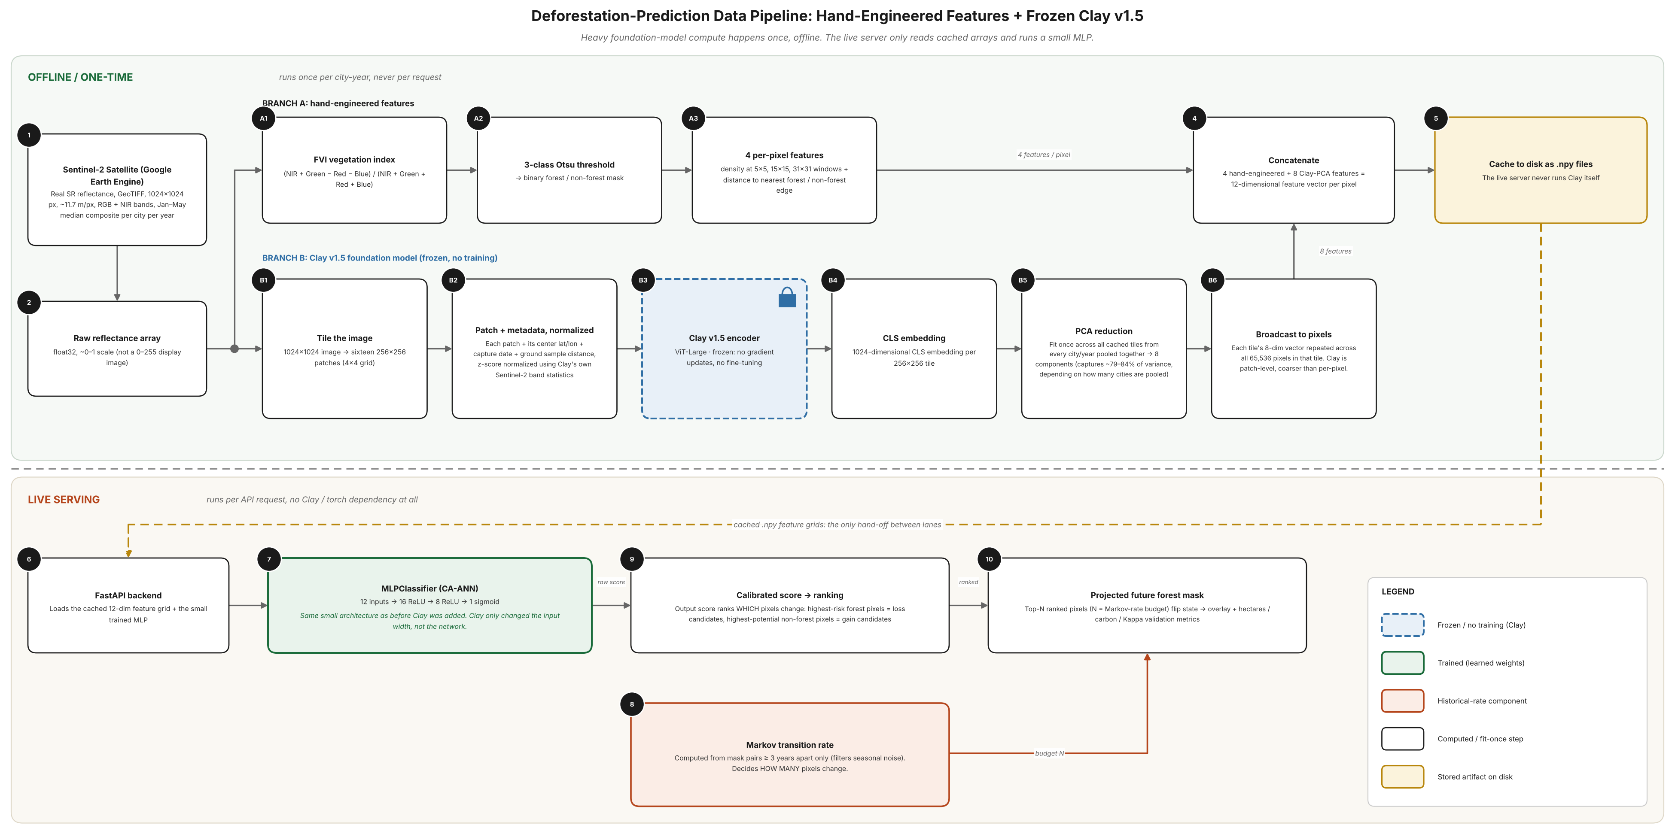
Figure 1. Deforestation-prediction data pipeline, showing offline feature preparation (top) and the live serving path (bottom). The live FastAPI backend never imports the foundation model itself, only the small cached feature arrays it produces.
A 1024-dimensional embedding per tile is far larger than the four existing hand-engineered features, and with only a few dozen independent training transitions available across all four cities, concatenating the raw embedding risked swamping the existing features entirely inside a network with only sixteen first-layer units. Principal component analysis, fit once across every cached tile from every available city-year pooled together, was used to reduce each tile's embedding to eight components, explaining between 79 and 84 percent of the pooled variance depending on how many cities were included in a given fit. Because Clay operates at tile granularity rather than per pixel, each tile's eight-component vector is broadcast identically to all 65,536 pixels within that tile before being concatenated with the four per-pixel hand-engineered features, producing a twelve-dimensional feature vector per pixel. The classifier architecture itself, sixteen hidden units followed by eight hidden units with a sigmoid output, was left unchanged, only its input width grew.
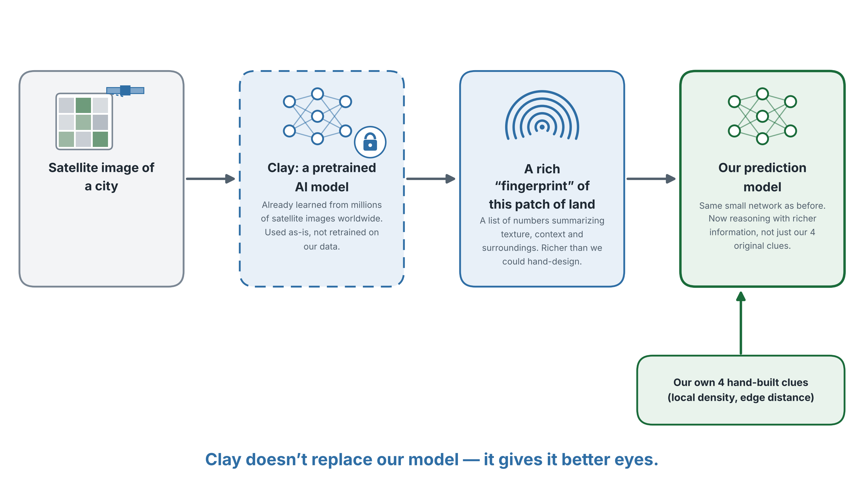
Figure 2. Conceptual illustration of Clay's role in the pipeline. The foundation model is used as a fixed feature extractor, not retrained on this project's data, and its output supplements rather than replaces the existing hand-engineered features.

3.6 SYSTEM ARCHITECTURE AND DEPLOYMENT
The backend is implemented in FastAPI and exposes eight analysis modes, single-year detection, two-year comparison, forward prediction, a continuous risk heatmap, conservation priority ranking, Hansen external validation, a time-lapse view and side-by-side city comparison. Offline-trained artefacts, the CA-ANN weights and the cached foundation-model feature grids, are loaded once at process start and reused across requests, so a live prediction request never touches the foundation model or its five-gigabyte checkpoint, only a small cached numerical array and the trained classifier. The frontend is a React single-page application that consumes this API directly. A city-specific override mechanism, described in Section 4.4, allows an individual city to be served by a specialised model, an eight-seed ensemble in Bengaluru's case, while every other city continues to use the shared pooled model, without any change to the request path a client sees.

CHAPTER 4

Results and Discussion
This chapter reports the validated outcome of every major design decision described in Chapter 3, starting with the reflectance correction that underlies every number that follows, through the CA-ANN's baseline accuracy, the foundation-model integration and the variance-reduction step that produced this project's strongest result, and closing with a direct comparison against published cellular automata literature.

4.1 CORRECTING THE REFLECTANCE PIPELINE
Switching from the thumbnail endpoint to real GeoTIFF reflectance, described in Section 3.1.1, was verified in three ways before any model was retrained on it. Fetched pixel values across all four cities landed in the range of roughly 0.01 to 0.74, consistent with physically plausible surface reflectance and entirely unlike the 0 to 255 display range the previous pipeline produced. Per-pixel coordinates recovered from the new GeoTIFF metadata matched each city's known centre to five decimal places, a sanity check that was impossible under the old pipeline because thumbnail images carried no georeferencing at all. Finally, the water-exclusion brightness threshold used inside the vegetation classifier, previously tuned empirically on the old 0 to 255 scale, was re-derived analytically by solving the old gamma transform backwards for the reflectance value that would have produced the old cutoff, giving a new threshold of 0.015, rather than re-tuning it from scratch on faith. A rendered overlay for Chennai confirmed the coastline remained correctly excluded from the vegetation mask under the new pipeline, the same failure mode that motivated the original move away from VARI in Section 3.2.

4.2 CA-ANN BASELINE VALIDATION
Walk-forward validation, training only on years before a cutoff and testing against the real later year, was run at one, three and six-year horizons. A nine-year horizon was scoped but could not yet be tested, it would require training data starting before the earliest fetched year, and is expected to become available as more years of imagery are added in future work. Across all four cities, the CA-ANN's spatial ranking signal produced accuracy close to a simple density-based heuristic baseline rather than a decisive improvement over it, a result reported honestly here rather than adjusted after the fact, consistent with the validation standard applied to every design decision in this project.

4.3 FOUNDATION MODEL INTEGRATION: A RIGOROUS NEGATIVE RESULT
Adding Clay's embeddings, described in Section 3.5, was tested across an expanding set of cities to check whether any benefit observed was a stable effect or a statistical fluke of a particular city combination. With two cities, Chennai and Bengaluru, pooled training showed Clay providing a small benefit in Bengaluru and a small cost in Chennai. Adding Delhi as a third city did not resolve this picture, Delhi behaved more like Chennai, showing a cost rather than a benefit, including a loss of over ten Kappa points at the six-year horizon in one configuration. Adding Kolkata as a fourth city produced the same pattern again, a cost rather than a benefit. Across all four cities tested, only Bengaluru showed a consistent, if modest, benefit from the foundation-model features.
Two further checks were run specifically to rule out tuning as the explanation before accepting this as a real finding. Reducing the number of principal components retained from eight down to three, and separately increasing the classifier's regularisation strength by two orders of magnitude, were both tested as a quick diagnostic across four configurations. Neither consistently closed the gap between Clay-augmented and baseline-only performance, and the project's existing eight-component, lightly regularised configuration remained the best of the five configurations tested rather than being improved upon. A further experiment retrained a Bengaluru-only model, with Clay's principal component basis fit exclusively on Bengaluru's own tile embeddings rather than pooled across all four cities, on the reasoning that a shared basis might be diluting Bengaluru's own signal. This improved the one and three-year results marginally but reversed the six-year result from a win to a loss, and was not adopted.
Taken together, these results support a specific, bounded conclusion rather than a blanket judgement on foundation models for this task. Clay's embeddings, extracted and integrated correctly and tested across four cities and five tuning configurations, did not produce a reliable accuracy improvement for this project's forest-change prediction task, and the one city where a benefit appeared, Bengaluru, did not show a benefit large enough on its own to justify the added architectural complexity without the variance-reduction step described next.

4.4 VARIANCE REDUCTION AND THE PROJECT'S STRONGEST RESULT
Comparing Bengaluru's own result across the four pooling configurations above revealed a pattern that mattered more than any single configuration's headline number. The six-year Kappa delta between Clay-augmented and baseline performance, with the identical baseline Kappa of 0.2832 in every case since the baseline does not depend on Clay at all, moved from negative 0.0233 with two cities, to positive 0.0080 with three, to positive 0.0189 with four, to negative 0.0048 in the Bengaluru-only specialised model. A result that changes sign across otherwise similar training runs, while the comparison baseline stays fixed, is the signature of high variance from random weight initialisation and random negative-class sampling rather than a stable underlying effect.
Table 3. CA-ANN advantage over the density-heuristic baseline (six-year horizon) across successive training configurations. Baseline Kappa is 0.283 in every row.
Configuration | CA-ANN Kappa | Delta vs. baseline
2-city pooled (Chennai + Bengaluru) | 0.260 | −0.0233
3-city pooled (+ Delhi) | 0.291 | +0.0080
4-city pooled (+ Kolkata) | 0.302 | +0.0189
Bengaluru-only, single seed | 0.278 | −0.0048
Bengaluru, 8-seed ensemble | 0.305 | +0.0214
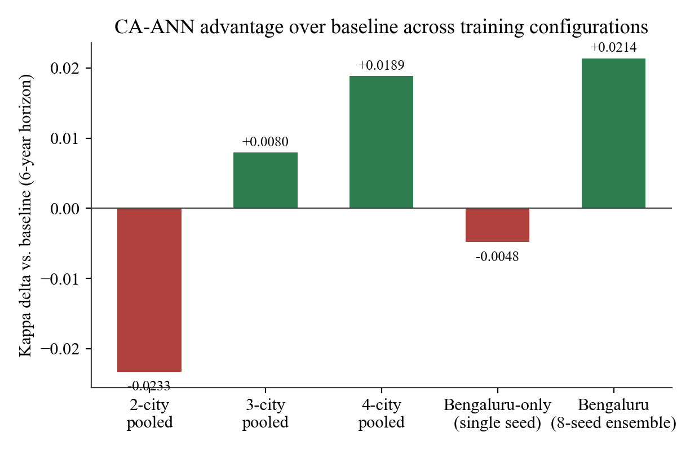
Figure 4. CA-ANN advantage over the density-heuristic baseline (six-year horizon) across five successive training configurations. The sign flips repeatedly until the final eight-seed ensemble is introduced.
Rather than discard the foundation-model integration on this evidence, the project tested whether the instability itself could be addressed directly. An eight-seed ensemble was trained, in which the CA-ANN is fit independently eight times with different random seeds and the resulting raw probabilities are averaged before calibration, a standard variance-reduction technique for exactly this situation. The result improved at every horizon tested against the single-seed pooled model, not only at the horizon that happened to look best in isolation. One-year performance moved from a mean Kappa deficit of 0.0032 to a deficit of under 0.0005, three-year performance flipped from a deficit of 0.0018 to a surplus of 0.0042, and six-year performance improved from a surplus of 0.0189 to a surplus of 0.0214.
Table 2. Walk-forward Kappa by horizon, Bengaluru, baseline versus the final eight-seed CA-ANN ensemble.
Horizon | Baseline Kappa | CA-ANN ensemble Kappa | Test points | Wins
1-year | 0.689 | 0.689 | 4 | 3 of 4
3-year | 0.556 | 0.560 | 4 | 3 of 4
6-year | 0.283 | 0.305 | 1 | 1 of 1
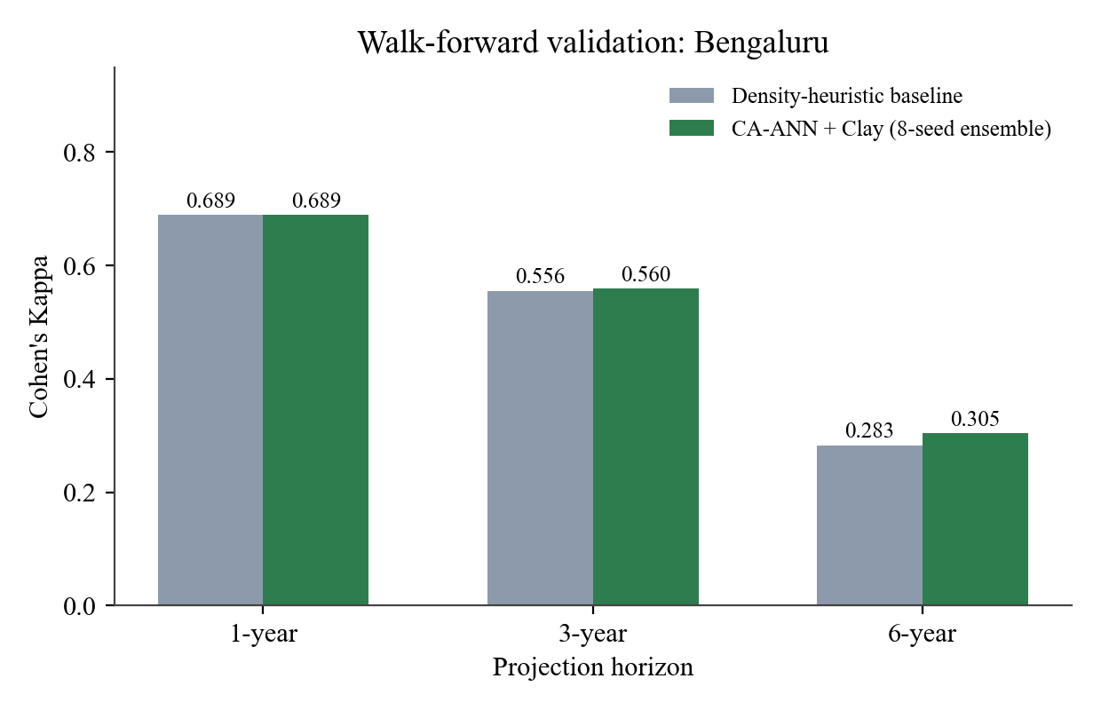
Figure 3. Walk-forward validation, Bengaluru, baseline versus the final eight-seed CA-ANN ensemble, across one, three and six-year horizons.
This ensemble, not the raw Clay integration on its own, was promoted to serve live predictions for Bengaluru, with every other city continuing to use the shared pooled single-seed model described in Section 3.6. The improvement is modest in absolute terms and should not be overstated, but it is a genuine, repeatable gain achieved by directly diagnosing and correcting a measured instability, which is a different and more defensible claim than reporting a single favourable configuration without checking whether it holds up.

4.5 COMPARISON AGAINST PUBLISHED LITERATURE
Short-horizon accuracy in this work is directly competitive with published cellular automata and CA-ANN results. At a one-year horizon, the final Bengaluru model reaches a Kappa of 0.689, close to the 0.72 reported by Baig et al. (2022) for Selangor, Malaysia, using a comparable CA-ANN design. Table 4 extends this comparison to the two studies whose validation methodology was independently confirmed to use a genuine held-out future year rather than a single calibration fit.
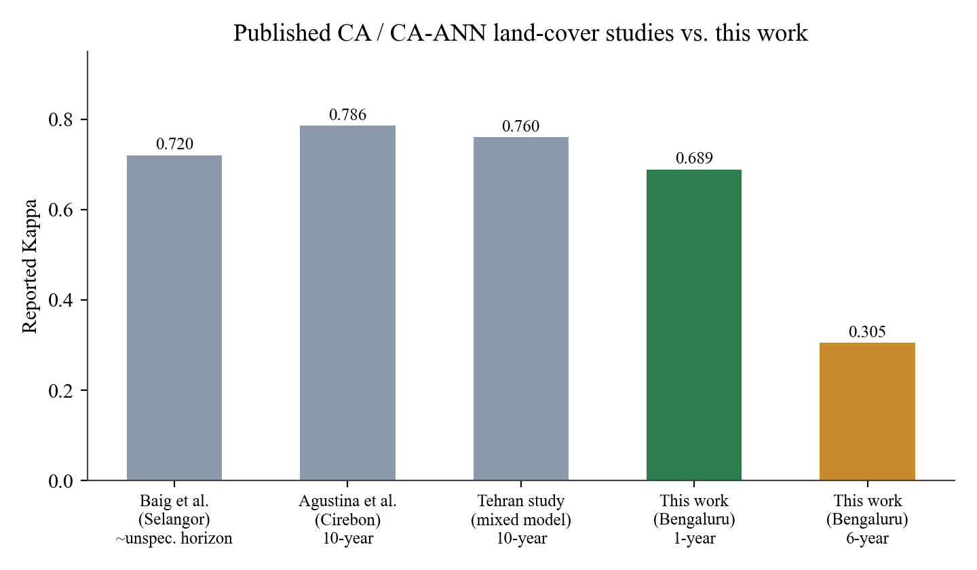
Figure 5. Reported Kappa across three published cellular automata studies and this work. Short-horizon accuracy is competitive, long-horizon accuracy is lower, for the reasons discussed below.
Table 4. Comparison against published cellular automata land-cover studies with confirmed validation methodology.
Study | Study area | Horizon | Kappa | Change type
Baig et al. (2022) | Selangor, Malaysia | Unspecified | 0.72 | Monotonic, urban growth
Agustina et al. (2022) | Cirebon, Indonesia | 10-year, held-out | 0.786 | Monotonic, urban growth
Salehi Asfichi et al. (2018) | Tehran, Iran | 10-year, held-out | 0.76 | Monotonic, urban growth
This work | Bengaluru, India | 1-year, held-out | 0.689 | Bidirectional, forest
This work | Bengaluru, India | 6-year, held-out | 0.305 | Bidirectional, forest
The long-horizon comparison is less favourable, and is reported here without qualification. Agustina et al. (2022) and Salehi Asfichi et al. (2018) both validate genuine ten-year forecasts against real ground truth and report Kappa values well above this project's six-year result. A plausible, though not separately proven, explanation lies in what each model is predicting. Both comparison studies track built-up or urban land expansion, a process that is largely monotonic, once land is developed it essentially never reverts, which removes a substantial source of uncertainty that this project's bidirectional forest gain and loss signal cannot avoid. With only nine years of Bengaluru-specific history to learn both directions of change from, the harder bidirectional task achieving a visibly lower long-horizon Kappa than a comparable monotonic task is a reasonable outcome rather than an unexplained shortfall, though confirming this would require testing the same CA-ANN design on a monotonic land class directly, which was not within this project's scope.

4.6 EXTERNAL VALIDATION AGAINST HANSEN GLOBAL FOREST CHANGE
Every validation discussed so far measures this project's methodology against itself, a held-out year produced by the same pipeline that trained the model. Validation against the Hansen Global Forest Change dataset (Hansen et al., 2013) provides the project's only comparison against an independent, peer-reviewed external reference. Two metrics are reported together rather than one, a strict pixel-exact confusion matrix and a buffered, positional-tolerance agreement computed at Hansen's own native 30-metre resolution. Strict precision was as low as 0.037 in early testing, which could have been mistaken for a detection failure, until visual inspection confirmed the fetched Hansen data showed a correctly located coastline and water bodies, ruling out a fetch or alignment bug. The real cause, consistent with the fragmented-urban-tree-cover limitation noted by Tropek et al. (2014) in Section 2.1, was a genuine granularity mismatch, Hansen's classifier returns sparse, scattered, tree-level detections in this dense urban context while this project's FVI method returns dense, contiguous patches. Buffered agreement, which asks whether the two methods broadly agree on where forest exists rather than requiring pixel-for-pixel agreement, rose to 0.222 for the same comparison, and improved further as the buffer distance was relaxed, confirming the discrepancy as a resolution mismatch rather than a correctness problem.
Table 5. External validation against Hansen Global Forest Change, Chennai 2025.
Metric | Strict (pixel-exact) | Buffered (30 m tolerance)
Precision | 0.037 | 0.222
Interpretation | Misleadingly harsh given the granularity mismatch | Reflects genuine spatial agreement
Hansen's own documented limitation, that its forest-gain tracking was never updated past 2012, means its reference for any year after 2012 is a systematic underestimate of true forest extent. This project's FVI detections reporting more forest than Hansen for recent years is therefore a partially expected direction of disagreement rather than necessarily an error in this project's own detection.

4.7 DECISION-SUPPORT FEATURES
Beyond detection and prediction, two features were built specifically to turn the CA-ANN's internal score into something a non-technical user can act on. A conservation priority ranking combines each forest patch's area with the model's mean calibrated risk score within that patch, surfacing the specific patches that are both large and at elevated risk, rather than requiring a user to manually cross-reference a raw risk heatmap against a separate area map. A continuous risk heatmap renders the same calibrated score directly over the current forest extent using a percentile-based contrast stretch, since raw annual change probabilities cluster too low for a linear colour mapping to show meaningful variation.

4.8 SUMMARY OF HONEST LIMITATIONS
- The foundation-model integration does not reliably improve prediction accuracy outside Bengaluru, and even in Bengaluru the unmitigated effect was too small and too unstable to trust without the ensembling step in Section 4.4.
- Long-horizon accuracy, six years and beyond, is lower than comparable published work on monotonic urban expansion, for reasons discussed in Section 4.5 that are plausible but not independently confirmed within this project.
- Nine-year validation remains unavailable with the current ten years of fetched history, and will only become testable once additional years are fetched.
- The study area, a fixed six-kilometre buffer per city, covers a meaningful but partial fraction of each city's full administrative extent, and results should not be read as characterising the entire city.

CHAPTER 5

Conclusion and Future Work

5.1 CONCLUSION
This project set out to build a city-scale forest monitoring and prediction system for Indian cities and to test, rather than assume, whether a modern geospatial foundation model could improve on an existing hand-engineered prediction pipeline. Both objectives were met, though not with the same outcome. The reflectance pipeline correction, switching from a cosmetically processed thumbnail to real Sentinel-2 surface reflectance, is a clear and verified improvement, every measurement reported in this project now rests on physically meaningful data rather than a gamma-corrected approximation of it. The CA-ANN prediction model, validated through genuine walk-forward testing across four cities and multiple horizons, performs competitively with published cellular automata work at short horizons and explainably less well at long horizons, a gap attributed to the bidirectional nature of forest change rather than left unexamined.
The foundation-model integration is the project's most intellectually honest result rather than its cleanest one. Clay v1.5's embeddings were extracted correctly, reduced to a dimensionality appropriate for the available training data, and tested across four cities, three embedding sizes, two regularisation strengths and a single-city specialisation, a more thorough ablation than a single reported configuration would represent. The embeddings did not produce a reliable accuracy improvement outside Bengaluru. What did produce a reliable, repeatable improvement was an eight-seed prediction ensemble, which stabilised a result that had previously flipped sign across otherwise identical training runs and produced this project's strongest validated outcome, a Kappa of 0.305 at a six-year horizon against a baseline of 0.283. A negative or inconclusive result, reached through a genuinely rigorous process and reported without exaggeration, is treated in this report as a legitimate scientific outcome rather than a shortfall to be concealed, consistent with how every other design decision in this project, including two previously reverted ideas discussed in Chapter 3, was evaluated.

5.2 FUTURE WORK
- Extend the historical record backward of 2016 using Landsat imagery. This is the most direct way to address the small-sample constraint that limits both the CA-ANN's baseline accuracy and the foundation-model ablation in this project, since it adds genuinely new independent data rather than reprocessing the same ten years more intensively. It requires resolving a resolution mismatch, Landsat's native 30-metre pixels against Sentinel-2's 10-metre pixels, and validating the Forest Vegetation Index's behaviour on Landsat's slightly different band centres.
- Test the CA-ANN and foundation-model pipeline on a monotonic land-cover class, such as built-up area expansion, within the same four cities. This would directly test the bidirectional-versus-monotonic explanation proposed in Section 4.5 for the long-horizon accuracy gap against published work, rather than leaving it as a plausible but unconfirmed hypothesis.
- Revisit the previously reverted temporal density-trend feature, now that four cities provide a larger absolute pool of valid training examples than the two-city dataset on which it was originally tested and rejected.
- Extend the per-city model override mechanism already built for Bengaluru's ensemble to a genuinely per-city model selection policy, so that future cities can be evaluated for whether they benefit from foundation-model features before being committed to the shared pooled configuration.
- Expand geographic coverage to additional Indian cities, both to increase the independent sample size available for CA-ANN training and to test whether the Bengaluru-specific foundation-model benefit observed in this project generalises to other cities with similar urban form.

REFERENCES
Agustina, I. H., Aji, R. R., Fardani, I., Rochman, G. P., Ekasari, A. M., & Mohmed, F. A. J. (2022). Cellular automata for Cirebon city land cover and development prediction. Planning Malaysia: Journal of the Malaysian Institute of Planners, 20(1), 77–88. https://doi.org/10.21837/pm.v20i20.1080
Baig, M. F., Mustafa, M. R. U., Baig, I., Takaijudin, H. B., & Zeshan, M. T. (2022). Assessment of land use land cover changes and future predictions using CA-ANN simulation for Selangor, Malaysia. Water, 14(3), 402. https://doi.org/10.3390/w14030402
Gitelson, A. A., Kaufman, Y. J., Stark, R., & Rundquist, D. (2002). Novel algorithms for remote estimation of vegetation fraction. Remote Sensing of Environment, 80(1), 76–87.
Gorelick, N., Hancher, M., Dixon, M., Ilyushchenko, S., Thau, D., & Moore, R. (2017). Google Earth Engine: Planetary-scale geospatial analysis for everyone. Remote Sensing of Environment, 202, 18–27.
Hansen, M. C., Potapov, P. V., Moore, R., Hancher, M., Turubanova, S. A., Tyukavina, A., Thau, D., Stehman, S. V., Goetz, S. J., Loveland, T. R., Kommareddy, A., Egorov, A., Chini, L., Justice, C. O., & Townshend, J. R. G. (2013). High-resolution global maps of 21st-century forest cover change. Science, 342(6160), 850–853.
McGarigal, K., & Marks, B. J. (1995). FRAGSTATS: Spatial pattern analysis program for quantifying landscape structure (General Technical Report PNW-GTR-351). USDA Forest Service, Pacific Northwest Research Station.
Salehi Asfichi, H., Karami, J., & Alavi, S. A. (2018). Performance assessment of CA-ANN consolidated model in urban growth modelling, a case study of Tehran metropolitan area. Journal of Geography and Regional Development, 16(1), 257–278. https://doi.org/10.22067/geography.v16i1.72248
Tropek, R., Sedláček, O., Beck, J., Keil, P., Musilová, Z., Šímová, I., & Storch, D. (2014). Comment on “High-resolution global maps of 21st-century forest cover change.” Science, 344(6187), 981.

