**Title: Advances in Deepfake Video Detection Using Convolutional and Recurrent Neural Networks**

*Department of Computer Applications*

**Abstract:** In recent months, the surge in deep learning-based tools has enabled the creation of highly convincing deepfake (DF) videos, challenging traditional methods of detection. This paper presents a novel approach employing Convolutional Neural Networks (CNN) and Recurrent Neural Networks (RNN) to detect temporal inconsistencies introduced by deepfake creation tools. By training on a diverse dataset, our system competes favourably in detecting deepfake content, showcasing competitive results with a simplified architecture.

**Keywords:** Deepfake Video Detection, Convolutional Neural Network (CNN), Recurrent Neural Network (RNN)

**I. INTRODUCTION:**

The widespread availability of high-quality cameras and internet connectivity has facilitated the effortless creation and sharing of digital videos. However, the rise of deepfake videos, generated by advanced AI tools, poses a significant challenge in distinguishing real from manipulated content. This paper addresses this challenge by employing a combination of Convolutional Neural Network (CNN) and Recurrent Neural Network (RNN) to detect temporal inconsistencies introduced during the creation of deepfake videos.

**II. PROPOSED SYSTEM:**

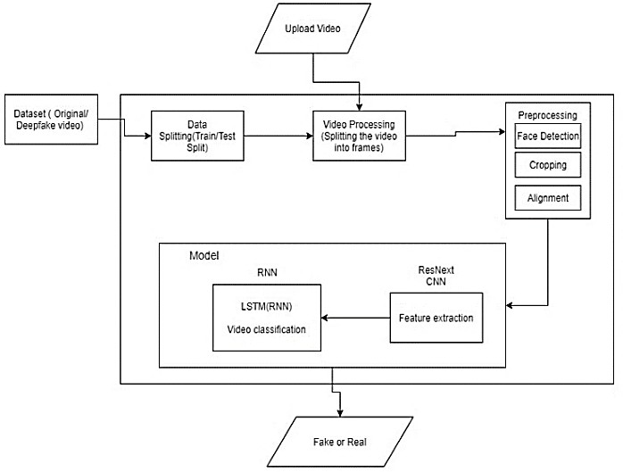

**III. Training Flow**

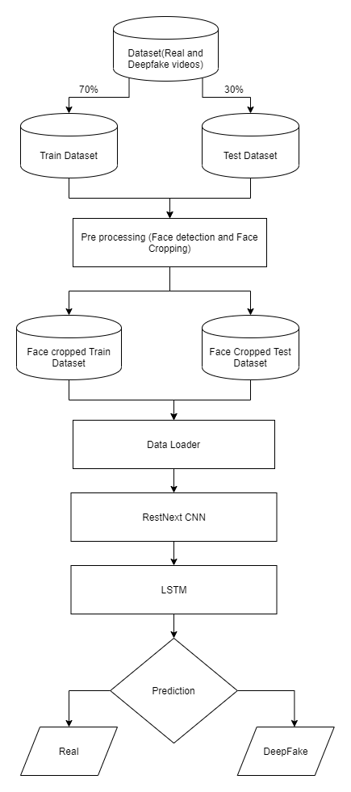

**IV. RESULT:**

Our model's output provides a classification of videos as either deepfake or real, accompanied by the confidence level of the model. The results showcase the capability of our approach to effectively detect deepfake content.



**V. Comparison:**

**Our Model VS Existing Models**

|  |  |
| --- | --- |
| Our proposed system distinguishes itself by combining CNN and RNN to capture temporal inconsistencies, providing a robust and competitive solution | Existing approaches for deepfake detection use capsule networks. |
| Unlike some existing models, our method considers various parameters such as teeth enhancement and wrinkles for a comprehensive detection approach. | Existing models use methods such as detecting face warping artifacts, eye blinking. |
| Our proposed system stands out as it not only detects deepfake videos but also offers a scalable solution, from a web-based platform to integration with popular applications like WhatsApp and Facebook. | While various tools exist for creating deepfake content, the detection tools are limited |
| Pixel by pixel division of frames with different sizes like 2x2, 4x4, 8x8 is done. | Fixed size frames are superimposed. |
| Original Image is not needed to predict the result. | Original Image must be given in the beginning for the reference. |

**VI. CONCLUSION:**

In conclusion, our neural network-based approach, inspired by the processes used in deepfake creation, demonstrates high accuracy in classifying videos as deepfake or real. The proposed method addresses the limitations of existing models by incorporating a frame-level detection using CNN and video classification using RNN with LSTM.

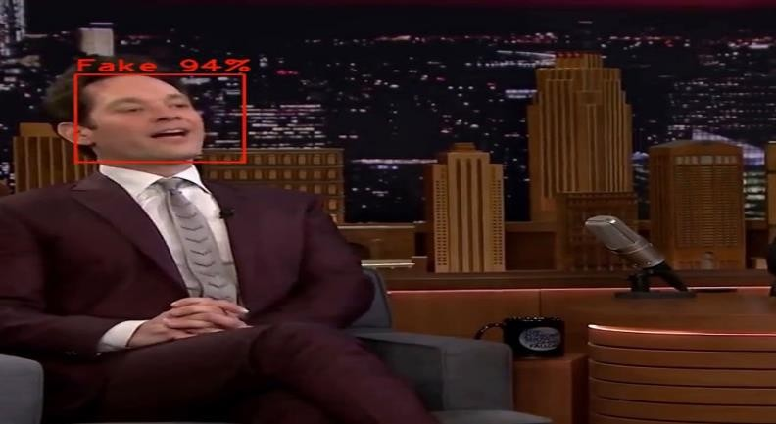

**VII. Mathematical Proof:**

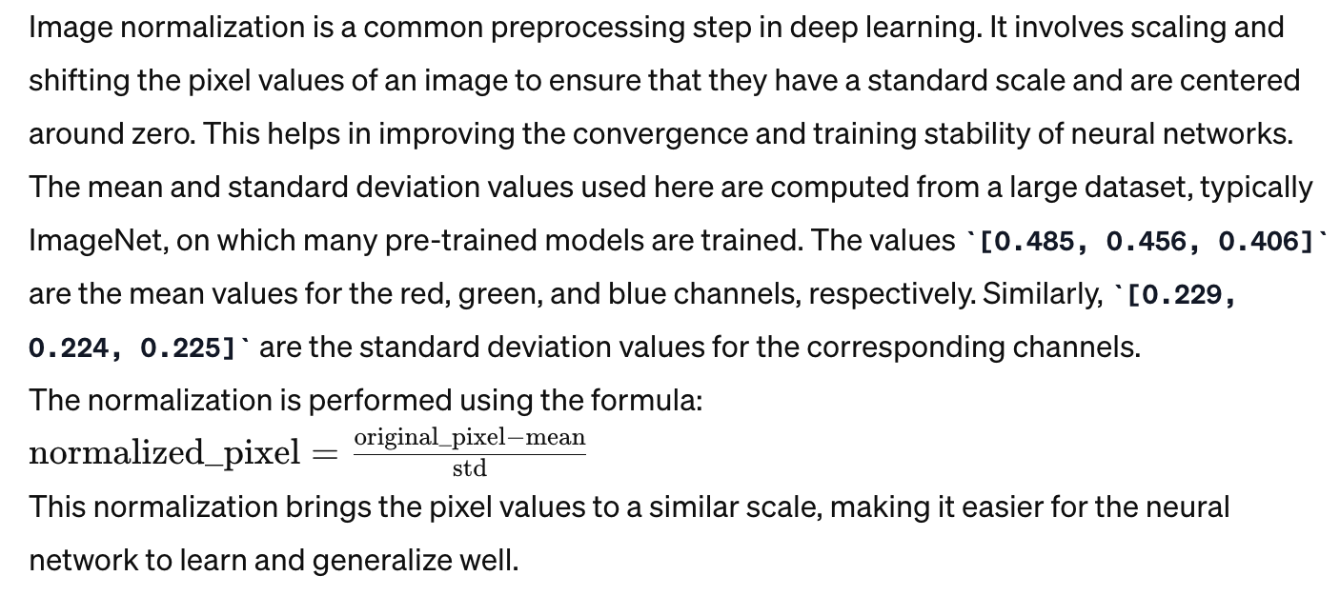

**VIII. LIMITATIONS:**

One limitation of our method is the exclusion of audio deepfake detection. Future work aims to extend the capabilities to detect audio deepfakes.

**REFERENCES:**

Y. Li, S. Lyu, "ExposingDF Videos By Detecting Face Warping Artifacts."

Y. Li, M.-C. Chang, S. Lyu, "Exposing AI Created Fake Videos by Detecting Eye Blinking." H. H. Nguyen, J. Yamagishi, I. Echizen, "Using capsule networks to detect forged images and videos."