Jenkins tool intro-

setup can be done locally, via docker or normally EC2 as well.

pre-requisites for local installation is java in your machine.

These are the steps to download Jenkins setup locally on your machine.

1. go to Jenkins.io (official site for Jenkins)
2. got to downloads section over there you'll find LTS(long term support) version click on the link and then It'll will redirect you to the table which'll have several options such as docker, Kubernetes and many more you need to click on windows if you want to install it on your local windows machine.
3. It'll install the MSI setup for Jenkins o your local machine in downloads section.
4. now you can simply double-click on the setup file in downloads and then Jenkins setup will open which'll ask you the location to install Jenkins. by default it's in program files under c drive. click on next
5. then you'll be getting a service logon credentials page. you need to choose logon type i'll be choosing run service as localsystem.
as we can change the credentials later. click on next
6. then you need to give a port to Jenkins by default it runs on 8080.(the port can be changes later as well in Jenkins.xml) if that's available you'll get succedded in test port. click on next
7. then it'll take the location of you java installed in your machine. if not then you need to install java first and then give the location of java in Jenkins setup.
8. click on next. in service selection keep it by-default.
9. click on install.
10. Jenkins will be installed now on your local machine. click on finish.

11. you can check the https://localhost:{your_port}/ eg: https://localhost:8080/ on which Jenkins will be running.
12. you'll see a page which'll be prompting for admin password. You need to copy the initial admin password from the location on the screen.
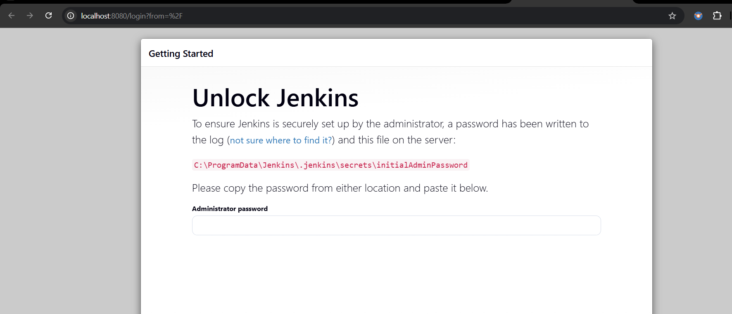

13. then you’ll see a page to install plugins. You can go with the suggested plugins if you don’t have any particular set of choice.
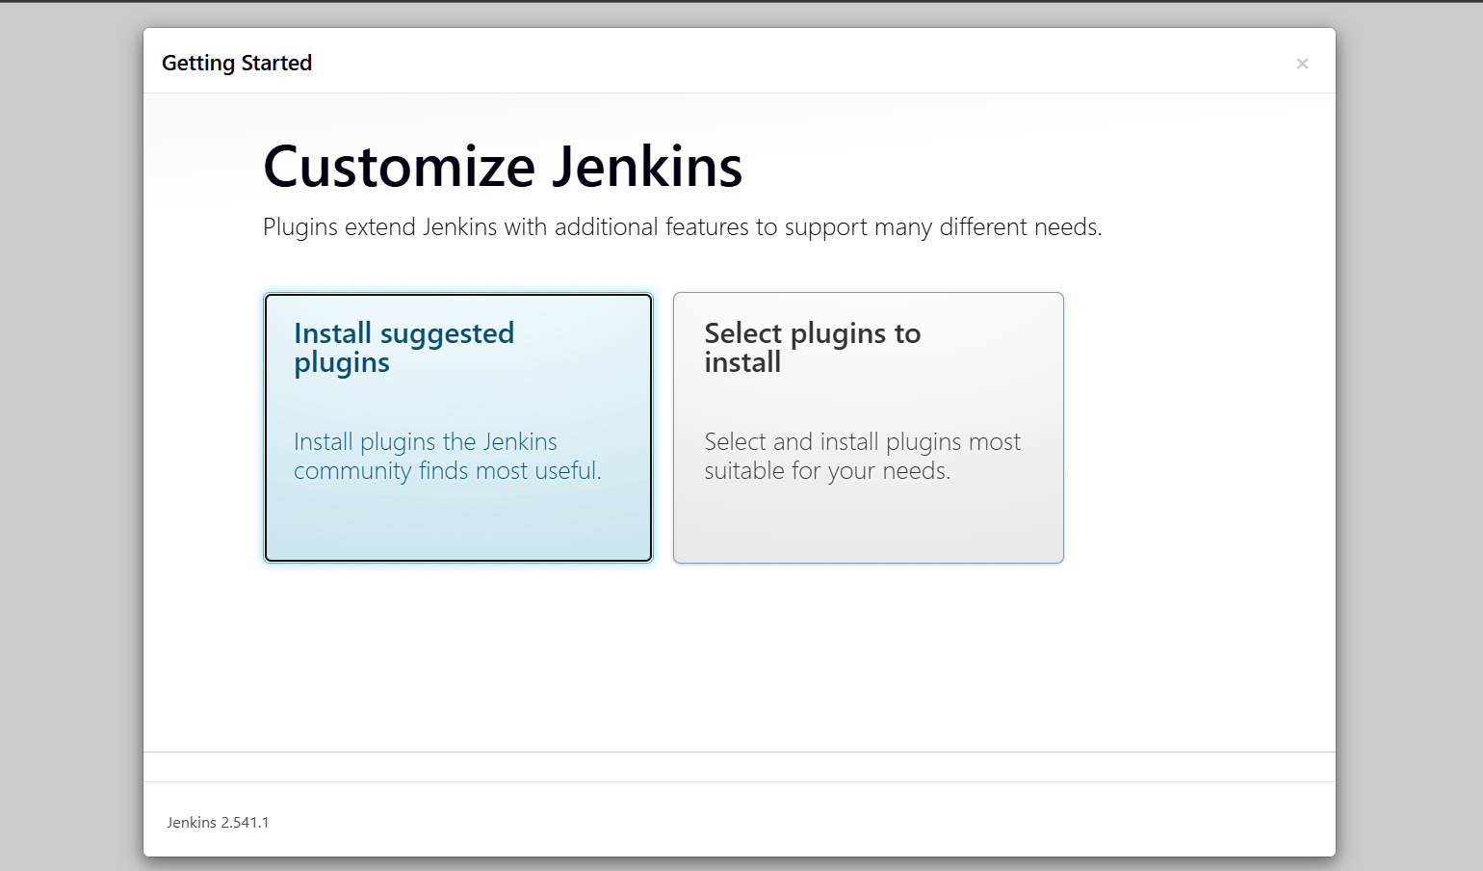

14. then you need to create username password and give email in it. Click on confirm.
15. Then you’ll be prompted to give url for Jenkins. Click on confirm.
16. Then you can click on start using Jenkins your’ setup should be completed and ready for use.

