**Question 1 (10 points):**

Consider again the example application of Bayes rule in Section 6.2.1 of Tom Mitchell’s textbook (or slide page 6 of Lecture 6-2). Suppose the doctor decides to order a second laboratory test for the same patient, and suppose the second test returns a positive result as well. What are the posterior probabilities of *cancer* and ➢*cancer* following these two tests? Assume that the two tests are independent.

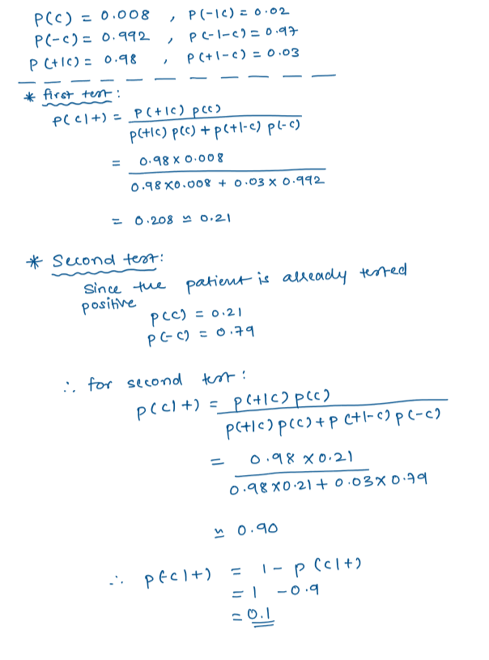

**Question 2 (5 points):**

Consider a learned hypothesis, *h*, for some Boolean concept. When *h* is tested on a set of 100 examples, it classifies 80 correctly. What is the 95% confidence interval for the true error rate for *ErrorD(h)*?

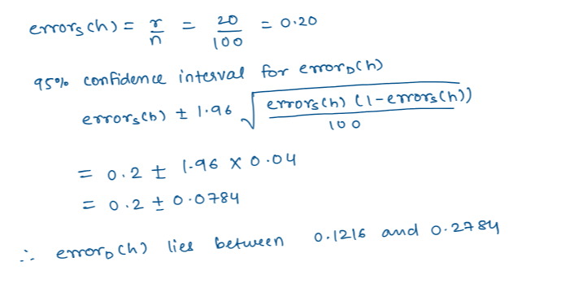

**Question 3 (15 points):**



