**Task 1 (Took 10 minutes)**

This was pretty easy  
  
At first sight I knew this is base64.  
Decoded to this:  
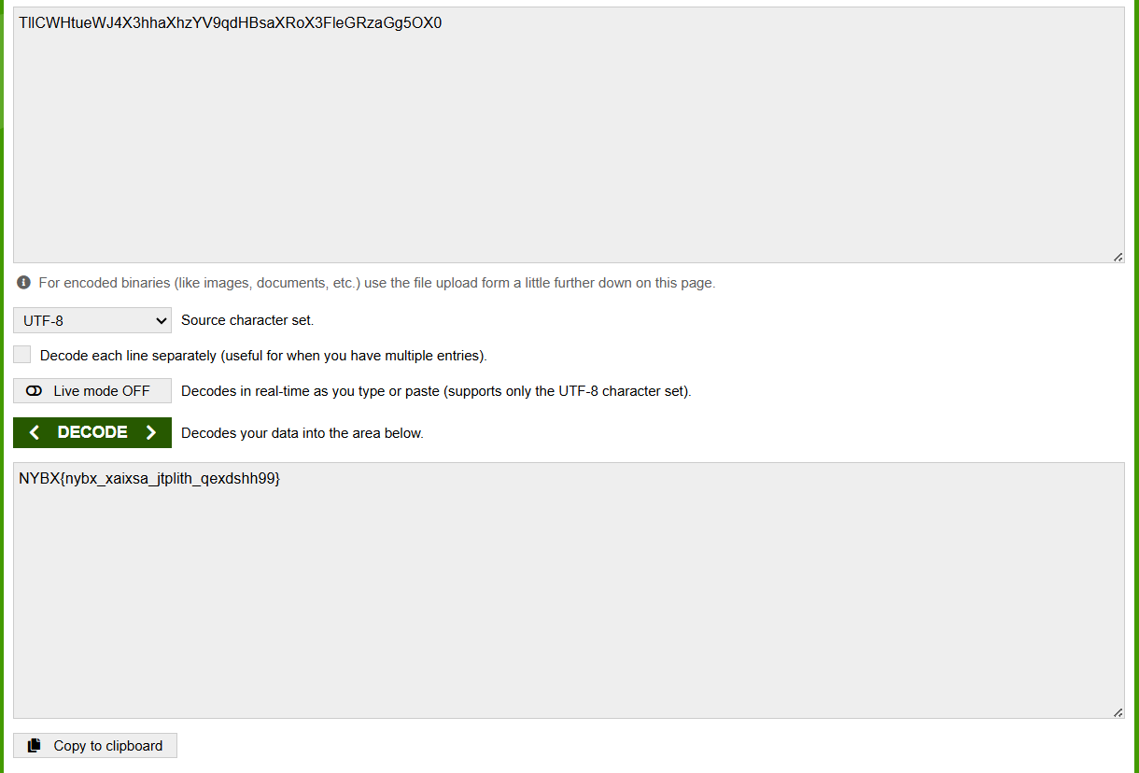

Flag format was BYTE{}  
Asked gemini , with what key can NYBX be translated to BYTE. It did the math Pi​=(Ci​−Ki​)mod26 and gave key as MAIT, which obviously made sense.  
  
So here’s the flag: **BYTE{byte_laaega_badlaav_qwerszo99}**

**Task 2 (Took a few hours)**

As soon as I saw corrupted png, used tools ImageMagick and PngCheck to look into details.  
  
Pngcheck told this:  
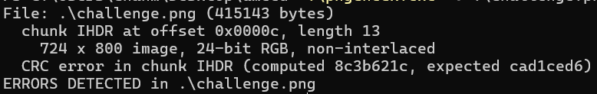  
  
Claude wrote a script to bruteforce dimensions and found out it should be 724 X 850.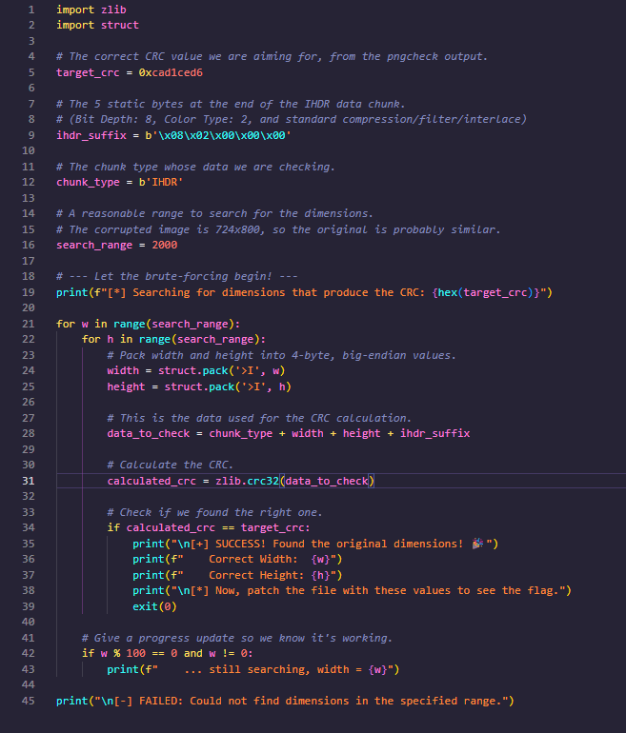  
  
Fixed it in hexed.it , now actual corruption:  
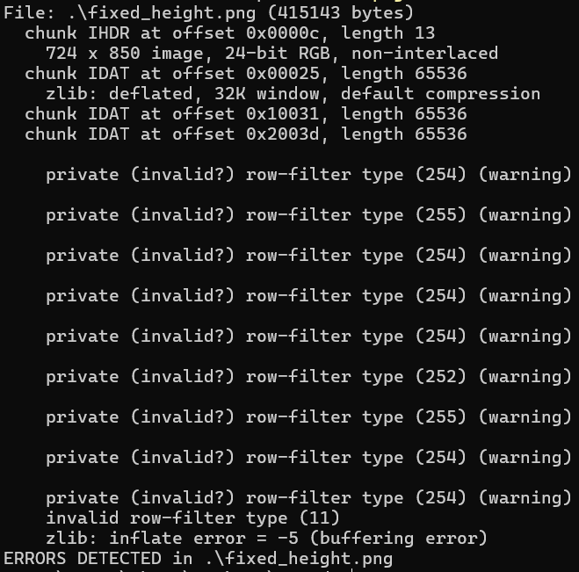  
  
  
  
This happened in 15 mins  
  
Then spent almost 2-3 hours with tools like GIMP, TweakPNG, stegsolve etc to auto correct the corruption but could do nothing.

Then found a hint :  


(Turned out this was a fckin coincidence which wasted 2-3 hours)

Then after 5-6 hours of no real progress I went back to byte website and read 2 things: one that the flag is in the image itself and second “sometimes the simplest approach is the right one”.  
  
So went back to hexed.it and most importantly used chatgpt/gemini to grasp the basic theory of png and IHDR, IDAT, IEND  
  
And finally discovered that IEND is intentionally added (nice one)

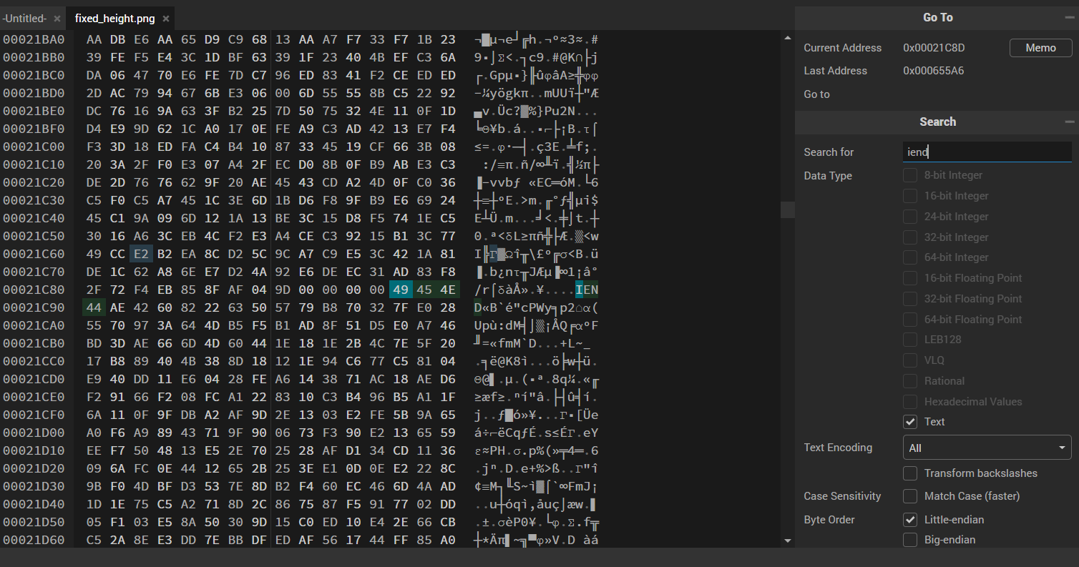  
  
And finally HAKLA was revealed:  
