
PROJECT DOCUMENTATION
Task Management System — TaskFlow
Subject: Full Stack Web Development
Project No.: 120
Program: B.Tech CSE (2025–29)
University: ITM Skills University
Semester: Semester III
Submitted By: Yuvraj Mishra
Roll Number: 150096725036
Cohort: Jeff Bezos
Submission: GitHub Repository

1. Project Overview
TaskFlow is a full-stack, role-based Task Management System built for a small company. Managers create tasks and assign them to employees with a due date, and employees view and update the status of the tasks assigned to them. An employee cannot modify a task that belongs to someone else, and tasks can be filtered by status and due date.
The system is made of two separate applications: a Node.js, Express.js and MongoDB backend that exposes a REST API and enforces every business and security rule, and a React frontend that only calls that API. Authentication uses JSON Web Tokens (JWT), and password recovery uses a security-question flow instead of email, so no SMTP service is required.

1.1 Problem Statement
A small company wants a backend where managers assign tasks to employees, and employees update the status of tasks assigned to them. An employee should not be able to modify a task that is not assigned to them, and tasks should be filterable by status and due date.

1.2 Objectives
- Design Employee, Manager and Task schemas using Mongoose.
- Implement role-based authorization for task assignment.
- Implement ownership-based authorization for status updates.
- Implement filtering by status and due date using query parameters.
- Validate task data on creation and update.
- Provide a responsive React frontend with task board, assignment form, status update and details views.

1.3 Expected Outcomes
- Managers can assign tasks with a due date to specific employees.
- Employees can update only the status of tasks assigned to them.
- Tasks can be filtered by status and due date.
- Unauthorized task modifications are rejected by the backend.

2. Technologies and Tools
TaskFlow uses the MERN-style stack described below. The backend and frontend live in separate folders of one project (backend/ and frontend/).
Layer | Technology | Purpose
Runtime | Node.js | Executes the backend server
Web framework | Express.js | REST API routing, middleware and controllers
Database | MongoDB with Mongoose | Stores employees, managers and tasks using referenced collections
Authentication | JSON Web Tokens (JWT) | Stateless login; token carries user id and role
Password security | bcryptjs | Hashes passwords and security answers (salt rounds: 10)
Configuration | dotenv (.env) | Keeps JWT_SECRET, MONGO_URI and PORT out of source code
Frontend | React with Vite | Single-page application and fast build tooling
Routing | React Router | Page navigation and protected routes
HTTP client | Axios | Calls the backend API and attaches the JWT
UI | Lucide React, Plus Jakarta Sans | Icons and the application typeface

2.1 Functional Modules
Module | Purpose | Main Function
Authentication | Register and sign in users | JWT login, role detection
Password Recovery | Reset a forgotten password without email | Security question, 3-step flow
Dashboard | Overview of workload and progress | Summary counts, calendar, charts
Task List | Browse and filter tasks | Status tabs, search, due-date filter, sort
Create Task | Let managers assign work | Title, description, employee, due date
Status Update | Let employees report progress | Pending / In Progress / Completed
Profile | Show account and permissions | Account details, activity, security info

3. System Architecture
TaskFlow follows a client–server architecture. The React frontend runs in the browser and communicates with the Express API over HTTP using JSON. The API runs on port 5001 and all endpoints are served under the /api prefix.

3.1 Request Flow
- The user signs in and the backend returns a JWT containing the user’s id and role.
- The frontend stores the session in AuthContext and localStorage and sends the token on every request as an Authorization: Bearer header through a shared Axios service.
- The protect middleware verifies the token and loads the user on the server.
- Role middleware (authorize) and ownership middleware (checkTaskOwnership) decide whether the action is allowed.
- The controller validates the data, runs the Mongoose query and returns a JSON response with a suitable HTTP status code.

3.2 Project Structure
Area | Folders / Files | Responsibility
Backend | models, routes, controllers, middleware, validators | Data schemas, endpoints, business rules, authorization and input validation
Frontend | components, context, pages, services, utils | Reusable UI, authentication state, screens, API client and helpers

3.3 Database Design
MongoDB stores three main collections. Tasks reference the employee they are assigned to and the manager who created them.
Collection | Key Fields | Notes
Employee | name, email, password, securityQuestion, securityAnswer | Password and answer are stored only as bcrypt hashes
Manager | name, email, password, securityQuestion, securityAnswer | Separate model from Employee; same recovery fields
Task | title, description, status, dueDate, assignedTo | assignedTo references an Employee; a Manager reference records the creator
Recovery fields | resetAnswerAttempts, resetAnswerLockedUntil, resetPasswordToken, resetPasswordExpires | Used by the account lockout and single-use reset token logic

4. User Roles and Permissions
There are two roles, employee and manager, each backed by its own Mongoose model. The role is stored in the JWT payload. The frontend uses it to decide which controls to display, but the backend remains the real security boundary.
Capability | Employee | Manager
Log in and view profile | Yes | Yes
View tasks | Only tasks assigned to them | All tasks, with filters
Create a task | No | Yes
Assign a task to an employee | No | Yes
Edit task details (title, description, due date) | No | Yes
Update task status | Only their own assigned tasks | Yes
Delete a task | Only if assigned to them AND status is Completed | Any task
View employee list for assignment | No | Yes

Task statuses. The backend supports exactly three values: Pending, In Progress and Completed. The interface shows them as colour-coded badges.
Status | Badge Colour | Meaning
Pending | Amber | Task assigned but not started
In Progress | Blue | Employee is working on the task
Completed | Green | Work is finished

5. Landing Page
The landing page introduces TaskFlow to new visitors. The top navigation links to Features, How it works, Roles, Security and FAQ, with Login and Get Started buttons on the right. The hero section presents the headline “Effortless task management, for every team” with a short description of the manager and employee workflow.
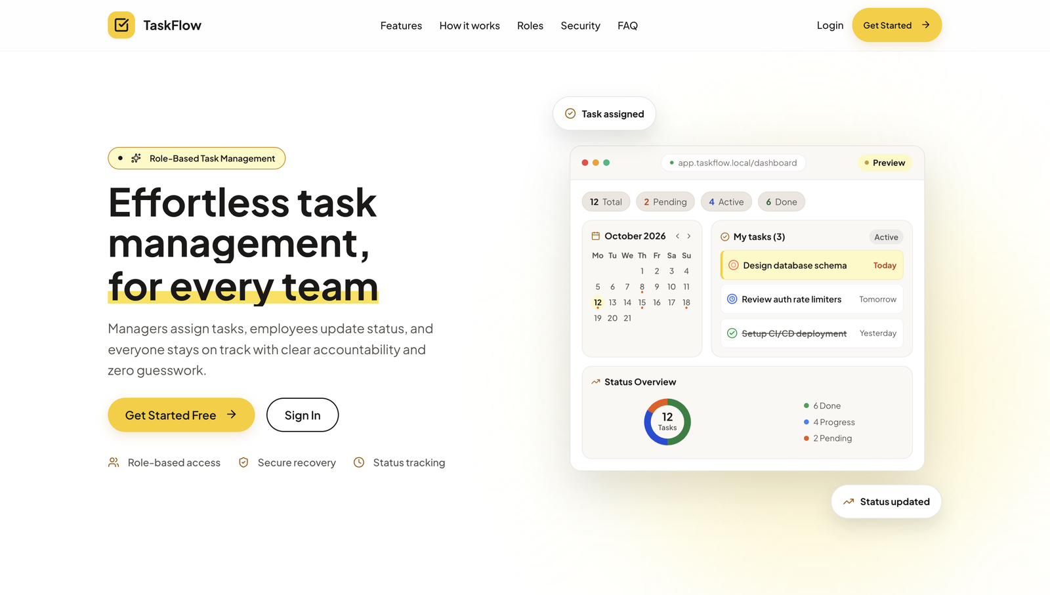
Figure 5.1 — TaskFlow landing page with hero section and dashboard preview.
The call-to-action buttons, Get Started Free and Sign In, lead to registration and login. Three highlights summarise the product: role-based access, secure recovery and status tracking. A dashboard preview on the right shows the calendar, a short task list and a status overview chart.

6. Authentication

6.1 Login
The login screen uses a split layout. The left panel carries the TaskFlow branding and tagline “Assign. Track. Complete.”, and the right panel holds the sign-in form.
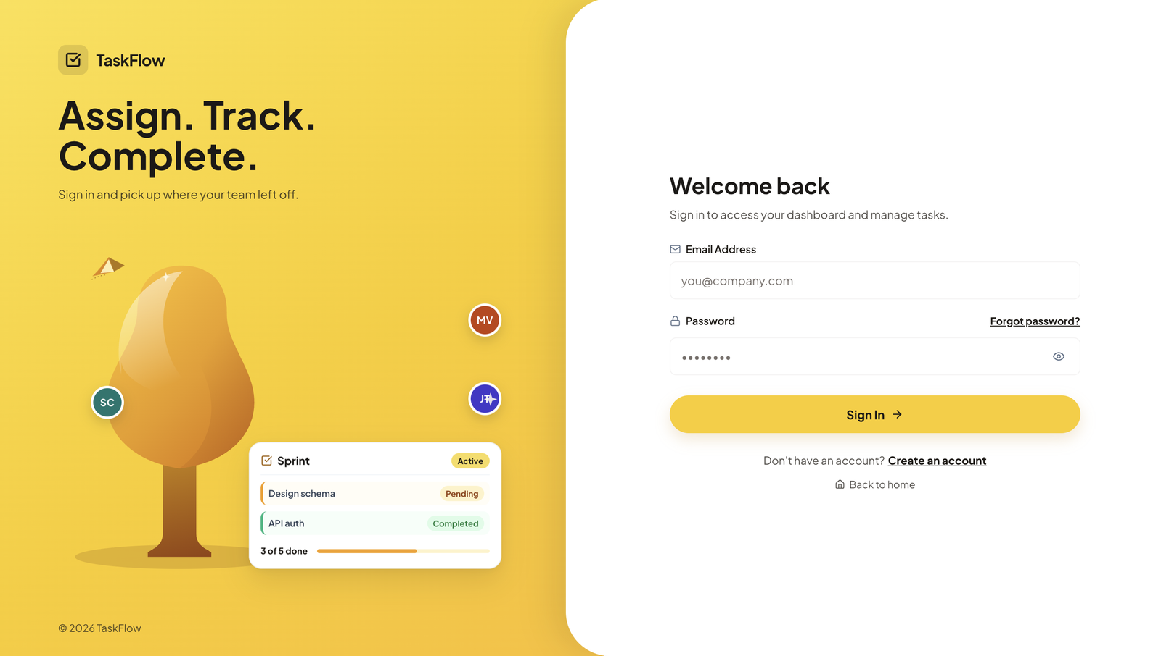
Figure 6.1 — Login screen with email and password fields.
The form has an Email Address field, a Password field with a show/hide toggle, a Forgot password? link, the Sign In button, a Create an account link and a Back to home link. While the request is running the button shows a loading state, and API errors such as invalid credentials are displayed as clear messages.

6.2 Registration
The registration form collects the user’s name, email, password, a security question and the security answer. A short note explains that the question is used to recover the account if the password is forgotten. The available security questions are:
- What is your school name?
- What is your favorite book?
- What is your favorite teacher’s name?
- What is your childhood nickname?
The backend validates the required fields, hashes both the password and the security answer with bcrypt before saving, and creates the account.

6.3 Session Handling with JWT
- On successful login the backend issues a JWT that is valid for 30 days and contains the user id and role.
- AuthContext keeps the signed-in user in React state and in localStorage so the session survives a page refresh.
- The shared Axios service (services/api.js) automatically adds the Authorization: Bearer header.
- The navigation bar and page controls change according to the role in the session.

7. Password Recovery
Password recovery does not need email or SMTP. It uses the security question that the user registered. The flow has three steps, shown to the user as a progress indicator: Account, Security and New Password.
Step | Screen | Endpoint | What Happens
1 | Account | POST /api/auth/forgot-password | User enters their email. The response is generic whether or not the email exists, which prevents account enumeration. If the account exists, its security question is returned.
2 | Security | POST /api/auth/verify-security-answer | User answers the question. The answer is compared with the stored hash. A correct answer returns a reset token.
3 | New Password | POST /api/auth/reset-password | User enters and confirms a new password. The token is validated, the password is re-hashed and the token is invalidated.

After a successful reset the page shows “Password reset successfully” with a Back to Login button. The user is not logged in automatically and must sign in with the new password.

7.1 Protection Mechanisms
Mechanism | Implementation
Rate limiting | The three recovery endpoints allow 5 requests per 15 minutes.
Account lockout | After 5 consecutive wrong answers, resetAnswerLockedUntil is set to 15 minutes ahead. Further attempts return HTTP 429 with a lockout message until it expires.
Attempt tracking | resetAnswerAttempts counts failures and is reset after a successful verification or password reset.
Reset token | A 32-byte random token is generated with Node crypto. Only its SHA-256 hash is stored, and it expires after 15 minutes.
Single use | After the password is updated, the stored token and expiry are cleared so the token cannot be reused.
Hashed answers | Security answers are stored as bcrypt hashes, never as plain text.

8. Dashboard
The dashboard is the main control centre after login. A left sidebar provides navigation, and the top bar contains a search box, the New task button for managers, and the signed-in user’s name with a role badge. The greeting is built from the authenticated user’s name rather than hard-coded text.
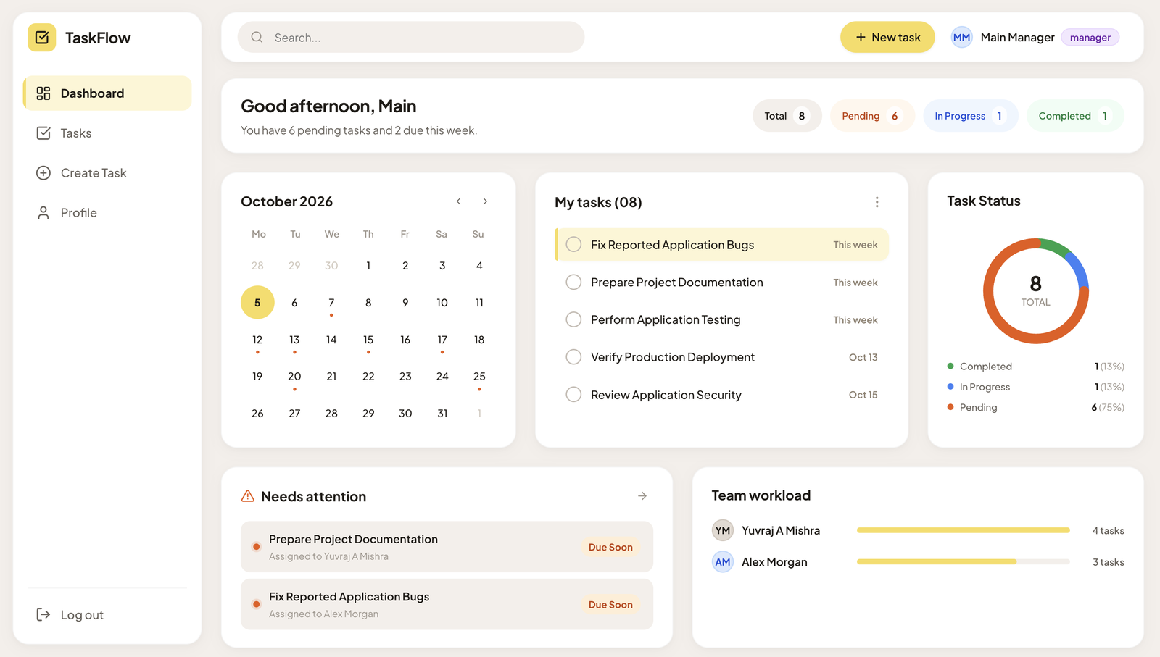
Figure 8.1 — Manager dashboard with summary, calendar, task list and charts.

8.1 Dashboard Components
- Greeting and summary chips: shows a personalised greeting, a line such as “You have 6 pending tasks and 2 due this week”, and the counts for Total, Pending, In Progress and Completed tasks.
- Calendar: a monthly calendar that highlights today and marks days that have tasks due.
- My tasks: a short list of upcoming tasks with a due label such as “This week” or a date.
- Task Status chart: a donut chart with the share of Completed, In Progress and Pending tasks.
- Needs attention: tasks that are due soon, with the assigned employee.
- Team workload: a bar view of how many tasks each employee currently has (shown to managers).
If there are no tasks, the dashboard shows an empty state (“No tasks yet. Your tasks will appear here.”).

9. Task Management
The Tasks page is the most important screen. It lists tasks as cards and provides every filtering and sorting control in one toolbar.
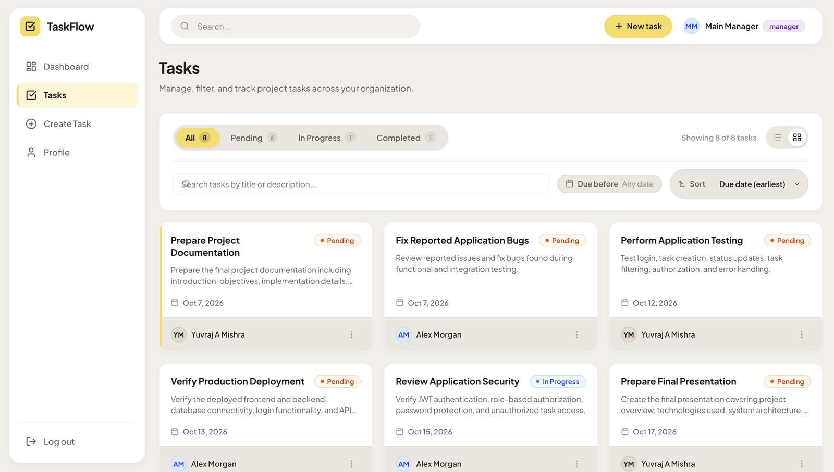
Figure 9.1 — Tasks page in grid view with status tabs, search, due-date filter and sort.

9.1 Task Cards
Each card shows the task title, a coloured status badge, a short description preview, the due date with a calendar icon, and the assigned employee with an avatar. A menu button on the card holds the actions that the current user is allowed to perform. A list/grid toggle changes the layout.

9.2 Filtering, Search and Sorting
- Status tabs: All, Pending, In Progress and Completed, each with a live count.
- Due before: a date picker that shows only tasks due on or before the selected date.
- Search: finds tasks by title or description.
- Sort: orders tasks, for example by due date (earliest first).
- Result count: a label such as “Showing 8 of 8 tasks”, and a clear empty state when nothing matches.
The status and due-date filters are sent to the backend as query parameters on GET /api/tasks, for example:
GET /api/tasks?status=Pending
GET /api/tasks?dueBefore=2026-10-15

9.3 Updating Task Status
Employees update the status of a task assigned to them using PATCH /api/tasks/:id/status. The selector offers only Pending, In Progress and Completed. The ownership middleware checks that the task belongs to the logged-in employee, otherwise the backend returns 403 Forbidden. Managers can also update status.

9.4 Deleting Tasks
Deleting uses a confirmation dialog that names the task and warns that the action cannot be undone, with Cancel and Delete buttons. The delete rules are enforced in the deleteTask controller:
- A manager can delete any task.
- An employee can delete a task only if it is assigned to them and its status is Completed.
- The delete action is hidden in the interface when the user is not allowed to use it, and the backend rejects the request anyway if it is attempted.

10. Create Task (Manager)
Only managers can create tasks. The Create Task page is a structured form split into Task Details and Assignment sections.
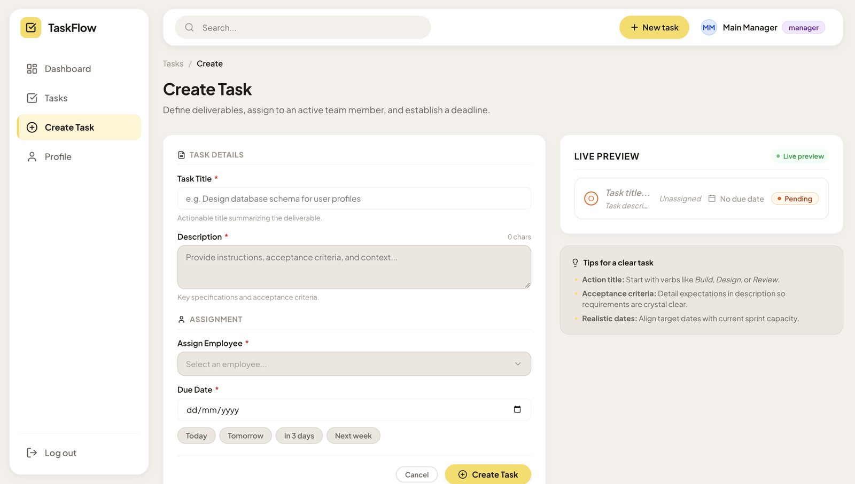
Figure 10.1 — Create Task form with live preview and tips panel.
Field | Required | Description
Task Title | Yes | Short, action-oriented summary of the deliverable
Description | Yes | Instructions and acceptance criteria, with a character counter
Assign Employee | Yes | Dropdown filled from GET /api/auth/employees; employees are never hard-coded
Due Date | Yes | Date picker with quick buttons: Today, Tomorrow, In 3 days, Next week

A Live Preview card on the right updates as the manager types and shows how the task will look, including the default Pending status. A Tips panel suggests writing action titles, clear acceptance criteria and realistic dates. The form shows validation messages, a loading state while the task is being created, and success or error feedback. The request is sent to POST /api/tasks, which is restricted to the manager role.

11. Profile
The Profile page summarises the signed-in account.
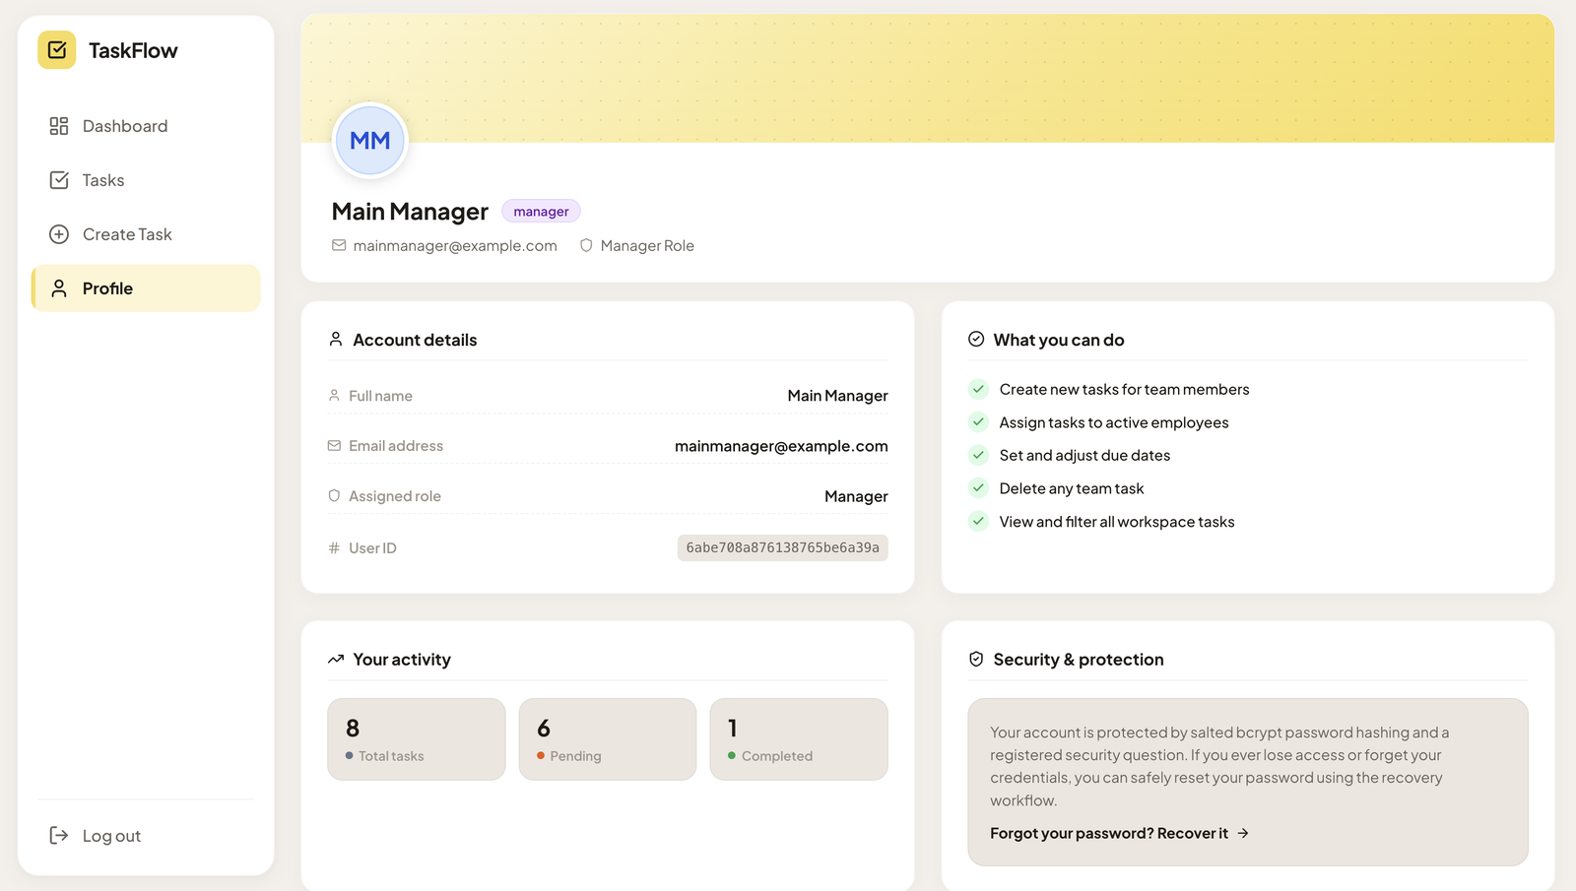
Figure 11.1 — Profile page for the manager account.
- Header: avatar with initials, name, role badge and email.
- Account details: full name, email address, assigned role and user ID.
- What you can do: a checklist of the permissions of the current role (for a manager: create tasks, assign tasks to active employees, set and adjust due dates, delete any team task, and view and filter all workspace tasks).
- Your activity: counts of total, pending and completed tasks.
- Security & protection: explains that the account uses salted bcrypt hashing and a registered security question, with a shortcut to the password recovery flow.

12. Employee Workflow
Employees use the same application with a reduced set of controls. Their navigation shows Dashboard, Tasks, Update Status and Profile, and the manager-only Create Task page is not shown.
- The Tasks page and dashboard list only the tasks assigned to the employee, because the backend filters the results by the logged-in user.
- The employee can change the status of an assigned task between Pending, In Progress and Completed.
- The delete option appears only on tasks that are assigned to the employee and already Completed.
- Opening or modifying a task that belongs to another employee is rejected with 403 Forbidden.
- Status filters, due-date filter and search work in the same way as for managers.

13. API Reference
All endpoints are served from http://localhost:5001/api during development.

13.1 Authentication Endpoints (/api/auth)
Endpoint | Method | Access | Description
/register | POST | Public | Register with security question and answer
/login | POST | Public | Validate credentials and return a JWT
/forgot-password | POST | Public, rate limited | Return the security question for an email
/verify-security-answer | POST | Public, rate limited | Check the answer, apply lockout, issue reset token
/reset-password | POST | Public, rate limited | Set a new password using the reset token
/create-manager | POST | Manager | Create a manager account
/employees | GET | Manager | List employees for the assignment dropdown

13.2 Task Endpoints (/api/tasks)
Endpoint | Method | Authorization Rule | Description
/ | GET | Authenticated | Manager sees all (filterable); employee sees assigned tasks only
/:id | GET | Authenticated + ownership | Get one task
/ | POST | Manager only | Create and assign a task
/:id | PUT | Manager only | Update task details
/:id/status | PATCH | Assigned employee or manager | Update task status
/:id | DELETE | Manager, or assigned employee when Completed | Delete a task

14. Security and Authorization
Security is enforced on the server. The frontend hides controls that a user may not use, but this is only for usability and is never relied on for protection.
Area | How It Is Handled
Authentication | JWT verified by the protect middleware on every private route.
Role-based access | authorize(‘manager’) restricts task creation, task editing and employee listing to managers.
Ownership-based access | checkTaskOwnership compares the task’s assigned employee with the logged-in employee before status updates and single-task access.
Delete rule | The deleteTask controller allows managers, or an employee only for their own Completed task.
Password storage | bcryptjs with 10 salt rounds for passwords and security answers.
Brute-force defence | Endpoint-specific rate limits and a 15-minute lockout after 5 wrong security answers.
Secrets | JWT_SECRET, MONGO_URI and PORT are loaded from the .env file and are not committed to Git.
Error responses | Clear status codes (400, 401, 403, 404, 429) without stack traces or database internals.

The frontend converts these status codes into readable toast messages and banners, for example “You are not authorized to perform this action.”

15. Testing and Verification
A final requirements audit of the backend and frontend was carried out on October 1, 2026. It evaluated functional requirements, authentication, authorization, task lifecycle, password recovery and rate limiting, and reported full compliance with the assignment specification. The audit results are summarised below.

15.1 Requirements Compliance
Requirement | Implementation | Result
Separate Employee and Manager roles with JWT | Two Mongoose models, role in JWT payload, role middleware | Passed
Managers assign tasks to employees | POST /api/tasks restricted to managers | Passed
Employees update status of assigned tasks | PATCH /api/tasks/:id/status with ownership check | Passed
Employees cannot modify unassigned tasks | Assignment check returns 403 Forbidden | Passed
Filtering of tasks | Query parameters handled in getTasks | Passed
Delete rules | Manager: any task. Employee: own task and Completed | Passed
Security question recovery | Three-step flow with reset tokens | Passed
Rate limiting and lockout | Limiters on recovery routes, lock after 5 failures | Passed
Hashed passwords and answers | bcryptjs, 10 salt rounds | Passed
No hard-coded secrets | Values read from .env through dotenv | Passed

15.2 Functional Test Scenarios
Role | Scenario | Expected Result
Employee | Log in and open the dashboard and Tasks page | Only assigned tasks are shown
Employee | Apply status and due-date filters | List and count update correctly
Employee | Change status of an assigned task | Status is saved and badge updates
Employee | Delete an own task with status Completed | Task is deleted after confirmation
Employee | Delete an own task with status Pending | Not allowed; delete is hidden and the API rejects it
Employee | Access another employee’s task | Rejected with 403 Forbidden
Employee | Run the forgot-password flow | Password is reset and user returns to Login
Manager | Log in, view dashboard and all tasks | All tasks and team workload are visible
Manager | Create a task and assign an employee with a due date | Task appears in the list as Pending
Manager | Delete any task | Task is deleted after confirmation

After every interface change, the frontend is built with npm run build from the frontend folder to confirm that the project still compiles.

16. Conclusion
TaskFlow gives a small company a clear and secure way to assign work and track progress. Managers can create tasks, assign them to employees and set due dates, while employees can see their own tasks and update their status. Role-based and ownership-based authorization on the backend ensures that unauthorized changes are rejected.
The project meets the objectives of Project 120. It combines a well-structured Express and MongoDB backend with JWT authentication, security-question password recovery, rate limiting and account lockout, together with a responsive React interface that includes a dashboard, filterable task list, task creation form and profile page.

17. GitHub Repository Link
The complete source code and project files for the TaskFlow Task Management System are available at the following GitHub repository:
Repository: https://github.com/Yuvrajmishra-cell/Task-Management-System.git
Repository name: Task-Management-System
The repository contains the backend and frontend source code and the related project materials used to implement and demonstrate the system. The .env file and node_modules folder are excluded through .gitignore.

