Eva project
- Overview
- This project focuses on analyzing and understanding a dataset using Python and various data analysis libraries. The main objective of the project is to transform raw data into meaningful and useful information.
- The project involves several stages, including data cleaning, data preprocessing, data transformation, exploratory data analysis, and identifying important insights from the dataset. Python libraries such as Pandas, NumPy, Matplotlib, and other relevant libraries were used to perform these tasks.
- Through this project, the raw dataset was cleaned and prepared for analysis, different patterns and trends were explored, and meaningful insights were identified using data visualization and analytical techniques. The project demonstrates how Python can be used to handle real-world data and convert it into useful information for better understanding and decision-making.

1.5 Tools and Technologies Used
The following tools and technologies were used during the project:
Python
Python was used as the primary programming language for data analysis and visualization.
Jupyter Notebook
Jupyter Notebook provided an interactive environment for writing code, performing analysis, and documenting findings.
Pandas
Used for data manipulation, cleaning, merging, and analysis.
NumPy
Used for numerical computations and data processing.
Matplotlib
Used for creating charts and visual representations of the data.
Seaborn
Used for advanced statistical visualizations and improved chart aesthetics.

2. Dataset Information
2.1 Introduction to the Dataset
The dataset used in this project represents the operations of an e-commerce business and contains information related to customers, products, orders, and sales transactions. The data was provided in multiple CSV files, each representing a different aspect of the business process. These datasets were integrated and analyzed to gain insights into customer behavior, product performance, sales trends, and revenue generation.
The analysis was conducted using Python and various data analytics libraries such as Pandas, NumPy, Matplotlib, and Seaborn.

2.2 Dataset Description
The project consists of four separate datasets:
1. Customers Dataset
The Customers dataset contains information about customers who have registered and made purchases on the e-commerce platform. It provides demographic and identification details that help in understanding customer distribution and purchasing behavior.
Key Attributes
- Customer ID
- Customer Name
- City
- Signup Date
Purpose
This dataset is used to:
- Identify unique customers.
- Analyze customer distribution across cities.
- Examine customer growth over time.
- Study customer contribution to revenue generation.

2. Orders Dataset
The Orders dataset contains information related to customer purchases. Each order is associated with a unique order identifier and contains transaction-related details.
Key Attributes
- Order ID
- Customer ID
- Order Date
- Payment Method
Purpose
This dataset is used to:
- Track customer purchases.
- Analyze order frequency.
- Examine payment method preferences.
- Study sales trends over time.

3. Order Items Dataset
The Order Items dataset contains detailed information about products included in each order. It serves as the transactional dataset that links products and orders.
Key Attributes
- Order ID
- Product ID
- Quantity
- Unit Price
Purpose
This dataset is used to:
- Calculate revenue generated from each order.
- Analyze product demand.
- Measure quantity sold.
- Identify top-selling products.

4. Products Dataset
The Products dataset contains information about products available on the e-commerce platform.
Key Attributes
- Product ID
- Product Name
- Category
- Base Price
Purpose
This dataset is used to:
- Analyze product categories.
- Compare product pricing.
- Identify high-performing products.
- Evaluate category-wise revenue contribution.

2.3 Dataset Relationships
The four datasets are interconnected through common identifiers.
Customer and Orders Relationship
The Customers dataset is connected to the Orders dataset using the Customer ID field.
Relationship:
Customer → Multiple Orders
This relationship allows analysis of customer purchasing behavior and order frequency.

Orders and Order Items Relationship
The Orders dataset is linked with the Order Items dataset using the Order ID field.
Relationship:
One Order → Multiple Products
This relationship enables transaction-level sales analysis.

Products and Order Items Relationship
The Products dataset is connected to the Order Items dataset using the Product ID field.
Relationship:
One Product → Multiple Transactions
This relationship helps evaluate product performance and revenue contribution.

2.4 Data Integration Process
To perform comprehensive analysis, all datasets were merged into a single analytical dataset.
The integration process involved:
- Merging Customers and Orders datasets using Customer ID.
- Merging Orders and Order Items datasets using Order ID.
- Merging Products and Order Items datasets using Product ID.
- Creating a consolidated dataset containing customer, product, and transaction information.
The final dataset enabled cross-functional analysis involving customers, products, orders, revenue, and payment methods.

3. Exploratory Data Analysis (EDA)
Exploratory Data Analysis (EDA) is one of the most important stages of the data analytics process. It involves examining, cleaning, transforming, and understanding the dataset before extracting insights. ].

3.1 Data Cleaning
Introduction
Data cleaning is the process of identifying and correcting errors, inconsistencies, and missing information within a dataset.

3.1.1 Importing Libraries and Loading Data
The first step involved importing the necessary Python libraries required for data analysis and visualization. Pandas was used for data manipulation, NumPy for numerical operations, and Matplotlib and Seaborn for visualizations.
After importing the libraries, all four datasets were loaded into Pandas DataFrames.

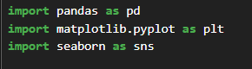
3.1.2 Understanding Dataset Structure
Before performing any cleaning operation, the structure of each dataset was examined using functions such as:
- head()
- info()
- shape
- describe()
These functions provided information regarding:
- Number of rows and columns
- Data types of each attribute
- Presence of missing values
- Statistical summary of numerical columns
This step helped in understanding the quality and completeness of the available data.

3.1.3 Identifying Missing Values
Missing values are common in business datasets and can negatively affect analysis results. Therefore, each dataset was inspected for null values using the isnull() function.
The total number of missing values in each column was calculated to identify incomplete records.
The analysis revealed that some columns contained missing values which required treatment before proceeding further.
Typical methods used for handling missing values include:
- Removing records containing excessive missing data.
- Replacing missing numerical values with mean or median values.
- Replacing missing categorical values with the mode.
Appropriate techniques were applied depending upon the nature of the column and the amount of missing data present.

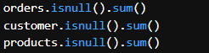

3.1.4 Handling Missing Values
After identifying the missing values, suitable strategies were applied to handle them. Numerical fields were treated using statistical measures where appropriate, while categorical fields were filled using the most frequently occurring values.

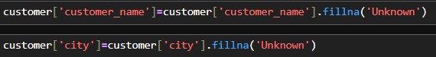

3.1.5 Detecting and Removing Duplicate Records
Duplicate records can distort analysis results by inflating sales figures, customer counts, and revenue calculations.
Therefore, each dataset was checked for duplicate rows using the duplicated() function.
After identifying duplicate entries, they were removed from the datasets to ensure that each observation represented a unique and valid record.
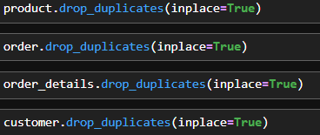
This step improved the reliability and consistency of the analysis.

3.1.6 Data Type Verification and Conversion
Data type consistency is essential for accurate analysis. Several columns, particularly date-related fields, were initially stored as text values and therefore required conversion.
The following transformations were performed:
- Order Date converted to datetime format.
- Signup Date converted to datetime format.
- Numerical columns verified and converted where necessary.
This conversion enabled time-based analysis such as monthly sales trends, yearly revenue comparisons, and customer growth analysis.

3.1.7 Data Validation and Consistency Checks
After cleaning, the datasets were examined again to ensure consistency.
The following checks were performed:
- Verification of category names.
- Verification of city names.
- Checking for unrealistic quantity values.
- Validation of pricing information.
- Ensuring uniqueness of primary identifiers.

3.2 Data Transformation
Introduction
Once the datasets were cleaned, the next stage involved transforming the data into a structure suitable for analysis. Data transformation includes merging datasets, creating new variables, extracting useful information, and preparing the final analytical dataset.

3.2.1 Dataset Integration
The project involved four separate datasets:
- Customers Dataset
- Orders Dataset
- Order Items Dataset
- Products Dataset
Since each dataset contained only a portion of the required information, they were merged using common keys.
The merging process enabled customer, product, and transaction information to be analyzed together.
The following relationships were used:

- a → Orders & Order Items
- b → Customer & Orders
- full data → a&b

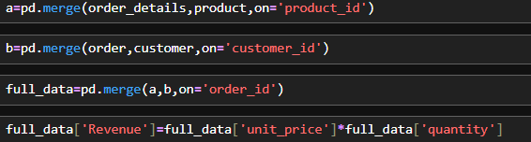

3.2.2 Creation of Revenue Variable
Revenue is one of the most important business metrics. Since the raw dataset did not contain a revenue column, a new feature was created.
Revenue was calculated using the formula:
Revenue = Quantity × Unit Price
This variable became the foundation for most of the subsequent analysis.

3.2.3 Extraction of Time-Based Features
To analyze sales trends over time, additional features were extracted from the order date.
These included:
- Month
- Year
- Day Name
The creation of these variables enabled monthly, yearly, and weekday-based sales analysis.

3.2.4 Final Analytical Dataset
After completing all cleaning and transformation activities, a consolidated dataset was prepared for analysis.
The final dataset contained:
- Customer Information
- Product Information
- Order Details
- Payment Method Information
- Revenue Metrics
- Time-Based Features

4. Insights
Introduction
After cleaning, transforming, and analyzing the e-commerce dataset, several important insights were obtained regarding sales performance, customer behavior, product demand, payment preferences, and revenue generation. ]

4.1 Revenue Analysis
Revenue is one of the most important indicators of business performance. The analysis revealed the overall revenue generated through product sales during the observed period.
The revenue analysis helped identify:
- Overall sales performance.
- Revenue-generating products.
- Revenue contribution of product categories.
- Revenue contribution of different cities.
The results indicated that a small number of products and categories contributed a significant portion of total revenue, demonstrating the importance of focusing on high-performing products.
Key Findings
- Total revenue generated by the business was ₹170000000.
- The highest revenue-generating product was Wireless Mouse.
- The highest revenue-generating category was Smartphone.
- The lowest revenue-generating category was Laptop.

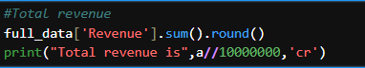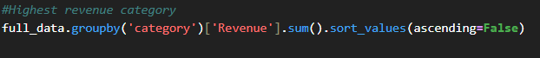
4.2 Product Performance Analysis
Product analysis was conducted to understand customer preferences and identify the most successful products.
The analysis focused on:
- Quantity sold.
- Revenue generated.
- Product popularity.
- Category-wise performance.
The results showed that certain products consistently outperformed others in terms of both sales volume and revenue generation.
Key Findings
- The most sold product was Wireless Mouse.
- The highest revenue-generating product was Wireless Mouse.
- The category with the highest sales volume was Smartphone.
- A small number of products contributed a major share of overall sales.
These findings indicate that customer demand is concentrated around specific products and categories.

4.3 Customer Analysis
Customer analysis was performed to evaluate purchasing behavior and identify high-value customers.
Understanding customer behavior helps businesses improve customer retention and develop targeted marketing strategies.
The analysis examined:
- Customer contribution to revenue.
- Customer distribution by city.
- Top spending customers.
- Customer purchasing patterns.
Key Findings
- The top customer generated revenue of ₹1854728.
- The city with the highest number of customers was Delhi.
- The city contributing the highest revenue was Delhi.
- A small percentage of customers contributed a significant share of total revenue.
This indicates the presence of high-value customers who play an important role in business profitability.
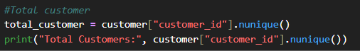

4.4 Payment Method Analysis
Payment methods influence customer convenience and purchasing behavior. The analysis evaluated customer preferences regarding payment options.
The results showed differences in the popularity of various payment methods.
Key Findings
- The most preferred payment method was UPI.
- The least used payment method was Unknown.
- Digital payment methods accounted for the majority of transactions.
These findings suggest a strong customer preference for convenient and secure payment options.


4.5 Sales Trend Analysis
Time-based analysis was conducted to identify patterns and trends in sales performance.
Monthly and yearly sales data were examined to understand fluctuations in revenue and customer demand.
Key Findings
- The highest sales month was January.
- The lowest sales month was August.
- Revenue showed significant variation across different months.
- Certain periods experienced increased customer purchasing activity.
These trends may indicate seasonal demand patterns and provide opportunities for targeted promotional campaigns.

4.6 Geographic Analysis
Geographic analysis was performed to evaluate sales performance across different cities.
Understanding regional performance helps businesses identify profitable markets and expansion opportunities.
Key Findings
- The highest revenue-generating city was Delhi.
- The city with the largest customer base was Delhi.
- Revenue distribution varied significantly across cities.
These findings suggest that certain locations contribute disproportionately to overall business success.

4.7 Business Implications
The insights generated through this analysis provide valuable information for business decision-making.
The analysis suggests that:
- High-performing products should receive greater inventory and marketing focus.
- Top customers should be targeted through loyalty and retention programs.
- High-revenue cities present opportunities for business expansion.
- Seasonal sales trends can be leveraged through promotional campaigns.
- Preferred payment methods should be prioritized to improve customer experience.
By utilizing these insights, businesses can improve operational efficiency, customer satisfaction, and overall profitability.

Conclusion
The analysis successfully identified key drivers of revenue, customer behavior, product performance, and sales trends. The findings demonstrate the value of data analytics in transforming raw transactional data into actionable business insights. These insights form the basis for the visualizations and recommendations presented in the next section of the report.

5. Visualizations and Report
Introduction
Data visualization is an essential component of data analytics as it transforms numerical information into graphical representations that are easier to understand and interpret. Visualizations help identify trends, patterns, relationships, and business opportunities that may not be immediately visible through raw data alone.

5.1 Revenue by Product Category
Visualization

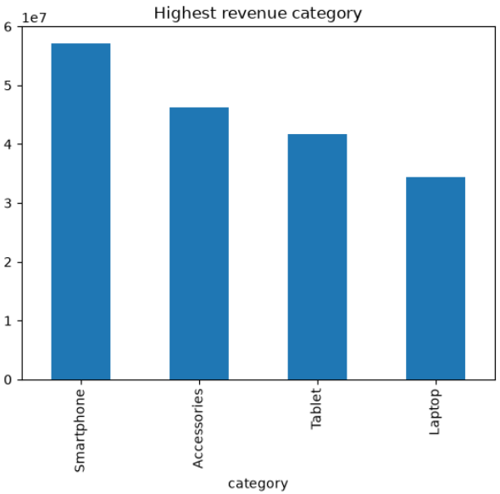

Observation
The chart displays the total revenue generated by each product category. Significant differences can be observed among categories, indicating varying levels of customer demand and profitability.

5.2 Top 10 Revenue Generating Products
Visualization
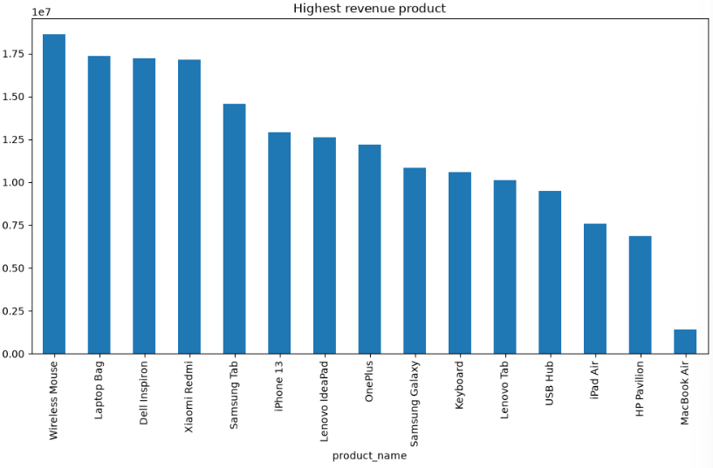Observation
The chart highlights the products generating the highest revenue during the analysis period.

5.3 Monthly Revenue Trend
Visualization
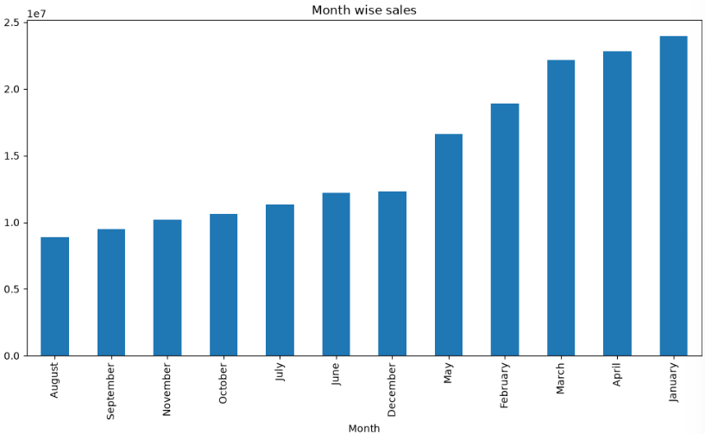Observation
The graph illustrates changes in revenue across different months.

5.4 Revenue by City
Visualization
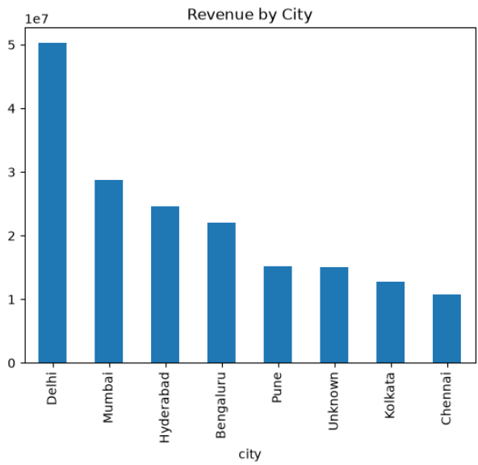
Observation
The chart compares revenue contributions from different cities.

5.5 Payment Method Analysis
Visualization
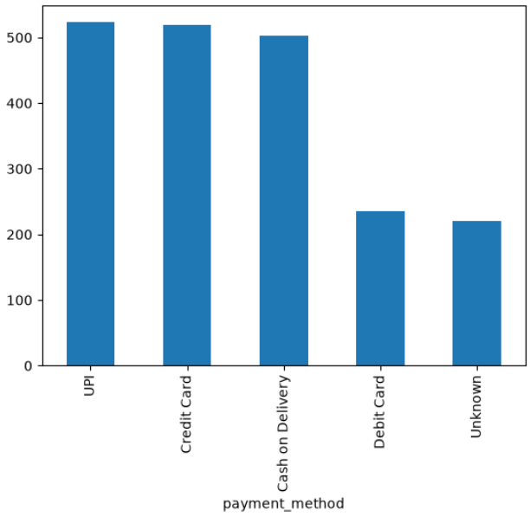
Observation
The chart displays customer preferences for different payment method
5.6 Top 10 Customers by Revenue
Visualization
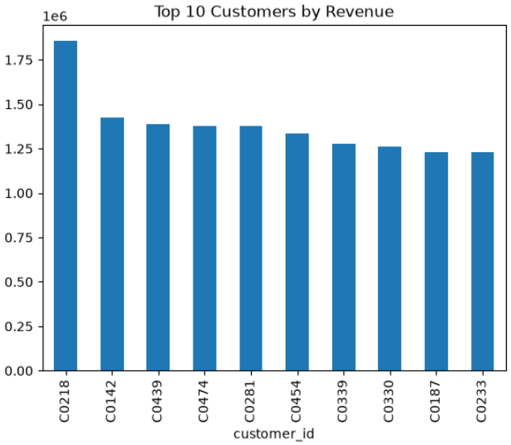
Observation
The chart identifies customers who contributed the highest revenue.

5.7 Quantity Sold by Product Category
Visualization
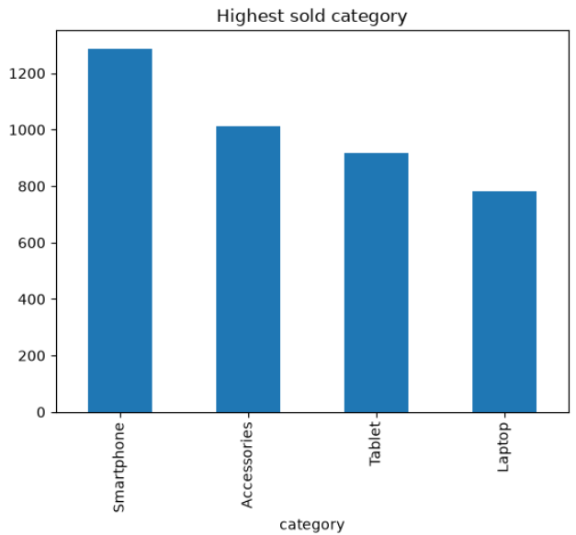
Observation
The chart shows the total quantity sold for each product category.
5.8 Revenue Distribution Analysis
Visualization
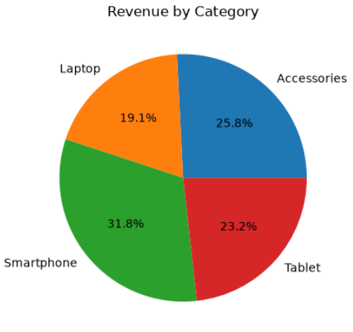
Observation
The histogram illustrates the distribution of revenue across transactions.
5.10 Overall Visualization Summary
The visual analysis revealed several important business trends. Revenue generation was concentrated within a limited number of products and categories. Customer purchasing activity varied across cities and time periods, indicating market-specific and seasonal influences. Payment method preferences showed a strong inclination toward convenient digital transactions, while customer analysis highlighted the importance of high-value customers.
Overall, the visualizations transformed complex transactional data into meaningful business intelligence, enabling a clearer understanding of sales performance and customer behavior.

6. Summary and Conclusion
6.1 Project Summary
The primary objective of this project was to analyze e-commerce sales data and extract meaningful business insights through data analytics techniques. The project utilized multiple datasets containing customer information, product details, order records, and transaction data.
The analysis process began with data cleaning, where missing values, duplicate records, and data inconsistencies were identified and addressed. Data transformation techniques were then applied to integrate multiple datasets into a unified analytical dataset. Additional variables such as revenue, month, year, and other derived features were created to facilitate detailed analysis.
Exploratory Data Analysis (EDA) was conducted to understand the structure and characteristics of the data. Various statistical techniques and visualizations were used to examine sales performance, customer behavior, product demand, revenue generation, payment preferences, and geographical distribution of sales.
The analysis provided valuable insights into the factors driving business performance and highlighted opportunities for improving operational efficiency and profitability.

6.2 Key Findings
The project generated several important business insights:
- Revenue generation was concentrated within a limited number of products and categories.
- Certain products consistently outperformed others in both sales volume and revenue contribution.
- Customer purchasing behavior varied significantly across different locations.
- A small group of customers contributed a substantial portion of total revenue.
- Sales performance showed fluctuations across different months, indicating possible seasonal trends.
- Digital payment methods were preferred by the majority of customers.
- Geographic analysis revealed specific cities that contributed significantly to overall business revenue.
- Product pricing and quantity sold were important factors influencing revenue generation.
These findings demonstrate the value of data-driven analysis in understanding business operations and customer behavior.

6.3 Conclusion
The project successfully transformed raw e-commerce data into meaningful business intelligence through systematic data cleaning, transformation, analysis, and visualization.
The results demonstrate that data analytics can play a crucial role in helping businesses understand customer preferences, identify profitable products, monitor sales performance, and make informed strategic decisions. By analyzing historical sales data, organizations can gain a clearer understanding of their strengths, weaknesses, and growth opportunities.

