Gesture IVP Lab
A Hand-Gesture-Controlled Image Processing Laboratory
Image and Video Processing - Mini-Project Report
Project Title | Gesture IVP Lab: A Hand-Gesture-Controlled Image Processing Laboratory
Course | Image and Video Processing
Student Name(s) | [Student Name 1]  [Student Name 2]  [Student Name 3]
Roll Number(s) | [Roll No. 1]  [Roll No. 2]  [Roll No. 3]
Programme / Semester / Division | [Programme] / Semester [ ] / Division [ ]
Faculty Name | [Faculty Name]
Institute / Department | SVKM's NMIMS Mukesh Patel School of Technology Management & Engineering (MPSTME), [Department]
Academic Year | 2026-27

Abstract
Problem addressed: Classical image-processing algorithms are usually demonstrated with static code and hand-typed parameter values, so it is difficult to see how a parameter changes the result or how different methods compare on the same image. Proposed solution: Gesture IVP Lab is an interactive application in which a photo is captured with the webcam or uploaded, and syllabus operations are applied to it while the user controls everything with hand gestures recognised from the live webcam video. Techniques used: hand-landmark detection and tracking (MediaPipe Hands), temporal smoothing, finger-state and hand-shape classification; grayscale conversion, point processing, histogram equalization, spatial filtering, binary and grayscale morphology, Prewitt/Sobel/LoG/Canny edge detection, and global, Otsu and adaptive thresholding (30 operations in total). Outcome: the application shows the original and processed images side by side together with the algorithm steps, histograms and kernels, runs at about 29 frames per second on an Intel Core i3 laptop, our Otsu implementation matches OpenCV exactly, and the median filter improves PSNR on salt-and-pepper noise from 17.58 dB to 33.22 dB.

Introduction

Background of the problem
A digital image is a two-dimensional array of intensities f(x, y). Image processing changes this array to enhance it, to extract information from it or to prepare it for analysis. The Image and Video Processing course covers image fundamentals, enhancement, transforms, morphology, edge detection, segmentation, colour processing and digital video. Every topic has parameters - a threshold T, a kernel size k, a gamma value, a structuring element - whose effect is best understood by changing them and watching the result immediately. In practice students usually see only one before/after pair produced by a script.

Why the problem is relevant
- Seeing how the output changes while a parameter is varied, and comparing several methods on the same input, makes the concepts much easier to understand.
- Running each algorithm in a separate script is slow; one tool that holds many operations, explains them and compares them side by side shortens the learning loop.
- Touch-free (gesture) control is useful in classrooms and labs, presentations, kiosks and hygienic environments such as hospitals.

Role of image/video processing in solving it
Image and video processing is used in two places. (1) Video processing drives the interface: every webcam frame is mirrored, down-scaled and converted to RGB, the hand is detected and tracked (21 landmarks), the landmarks are smoothed over time, and geometric tests turn them into hand shapes and actions. (2) Image processing is the content of the lab: 30 syllabus operations are applied to the chosen photo, most of them written in NumPy so the algorithm is visible (Otsu, histogram equalization, erosion/dilation, Zhang-Suen thinning).

Motivation for selecting the project
We wanted a project that covers a large part of the syllabus in one working system, can be demonstrated live, and is interesting to use. Combining a gesture interface (a real-time video processing problem) with a library of classical image-processing operations gave us both: every operation is explained on screen with its steps, and the whole lab is controlled by the hand.

Problem Statement and Objectives

Which real-world problem are you solving?
- Classical image-processing operations are hard to understand from static before/after images and code alone.
- There is no single, easy tool to apply many syllabus operations to one's own photo, change their parameters live and compare methods side by side.
- Controlling a computer without touching it (by hand gestures from a normal webcam) is useful for teaching, presentations and hygienic settings.

What are your objectives?
The objective of this project is to build an interactive, touch-free image-processing laboratory that recognises hand gestures from a live webcam video and uses them to select, tune and compare classical image-processing operations on a captured or uploaded photo, showing the original and processed images, the algorithm steps and quantitative values in real time.

Specific objectives
1. To detect the hand in live webcam video and recognise seven hand shapes (1, 2 and 3 fingers, pinch, open hand, thumbs up, fist), using smoothing and hold timers so that one gesture gives exactly one action.
2. To implement 30 image-processing operations from the syllabus (enhancement, morphology, edge detection, segmentation), with the core algorithms written in NumPy.
3. To show Original vs Processed side by side with the algorithm steps, histograms, kernels and a Compare View of four related methods.
4. To change the parameter by pinching and moving the hand, and to rotate the image by tilting the open hand.
5. To keep the interface real-time (20+ frames per second) on a normal laptop.

Scope of the Project

What the project covers
- Image input from the webcam (3-2-1 countdown capture), from a file upload, or from a gallery of saved images.
- 30 operations in five categories: image fundamentals, image enhancement, morphology, edge detection and segmentation (listed in the Techniques section).
- Gesture control with seven hand shapes, with mouse and keyboard as a backup.
- Rotation of the image by hand tilt; every operation then works on the rotated image.
- Compare View, saving of results, and a browser-based interface as well as a desktop window.

What it does not cover
- Frequency-domain filtering and image transforms (DFT, DCT, Walsh-Hadamard), colour-model processing, and video-coding topics (motion estimation, I/P/B frames) are not implemented in this version.
- No machine-learning model was trained by us; the hand landmarks come from the pre-trained MediaPipe Hands model.
- Gesture accuracy was not measured on a large labelled dataset of many users.
- The application runs locally on one computer; it is not an online service.

Type of images/videos used
Still images: colour photographs and test images in JPG, PNG, BMP or TIFF format, processed at a maximum of 640 pixels on the longer side. Video: the live webcam stream (1280 x 720, about 30 frames per second), used for gesture recognition.

Application domain
Education (teaching and demonstrating image processing), touch-free human-computer interaction (presentations, kiosks, labs) and quick visual experimentation with classical operations.

Dataset / Input Description
The project is an interactive tool that works on any photo, so no public dataset is used. The inputs are described below.

Source of images/videos
- A synthetic test image generated with OpenCV/NumPy (images/sample_shapes.png).
- Photographs captured with the laptop webcam inside the app (captures/ folder).
- Photographs uploaded by the user from the laptop (images/ folder).
- Live video from the built-in webcam (USB2.0 HD UVC WebCam).

Dataset name, if applicable
Not applicable - no public dataset was used.

Number of images/videos
Table 1. Number of inputs.
Input | Number
Synthetic test image (+ a low-contrast variant derived from it) | 1 (+1)
Webcam photographs captured during testing | 3
Uploaded photographs | any number (user's choice)
Live video | 1 continuous webcam stream

Image resolution
Test image: 640 x 480 pixels. Webcam photographs: 1280 x 720 pixels. Uploaded photographs: any size. All photos are resized so that the longer side is at most 640 pixels before processing (aspect ratio kept).

Image format
PNG for the test image and webcam captures; JPG, JPEG, PNG, BMP and TIFF are accepted for uploads. Images are 24-bit colour (8 bits per channel, BGR in OpenCV).

Video resolution and duration, if applicable
1280 x 720 pixels at about 30 frames per second (MJPG), continuous for as long as the app runs. For hand detection each frame is down-scaled to 640 x 360.

Sample input images/frames
The synthetic test image was designed for the syllabus operations: a ring with a hole, a rectangle with six small holes, a triangle with sharp corners, text with thin strokes, a speckled ellipse, a thin line, a colour gradient and Gaussian noise (sigma = 6). Webcam photographs of people are not reproduced in this report.
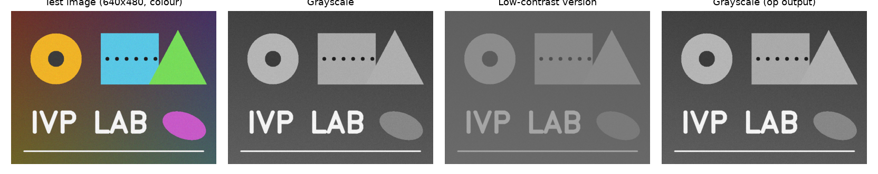
Figure 1. Sample inputs: test image, grayscale version and the low-contrast version used for enhancement experiments.

Methodology / Proposed Approach

Complete processing pipeline
1. Frame capture: a camera thread reads 1280 x 720 frames at 30 fps; only the newest frame is kept and it is mirrored.
2. Hand detection: the frame is down-scaled to 640 px and converted BGR -> RGB; MediaPipe Hands returns 21 landmarks per hand.
3. Smoothing: landmarks are averaged over the last 5 frames to remove jitter.
4. Gesture recognition: finger states and hand shape are computed, debounced over 3 frames, and held shapes become events (next, previous, save, back, click, pinch, rotate).
5. Image input: a photo is captured or uploaded and resized to at most 640 px.
6. Rotation: the photo is rotated by the hand-tilt angle (affine warp).
7. Processing: the selected operation runs in a background thread (Otsu binarization first for morphology); results are cached.
8. Display: Original | Processed, the algorithm steps, histogram / kernel / curve and values are drawn and streamed to the browser; a thumbs-up saves the result.

Block diagram / Flowchart
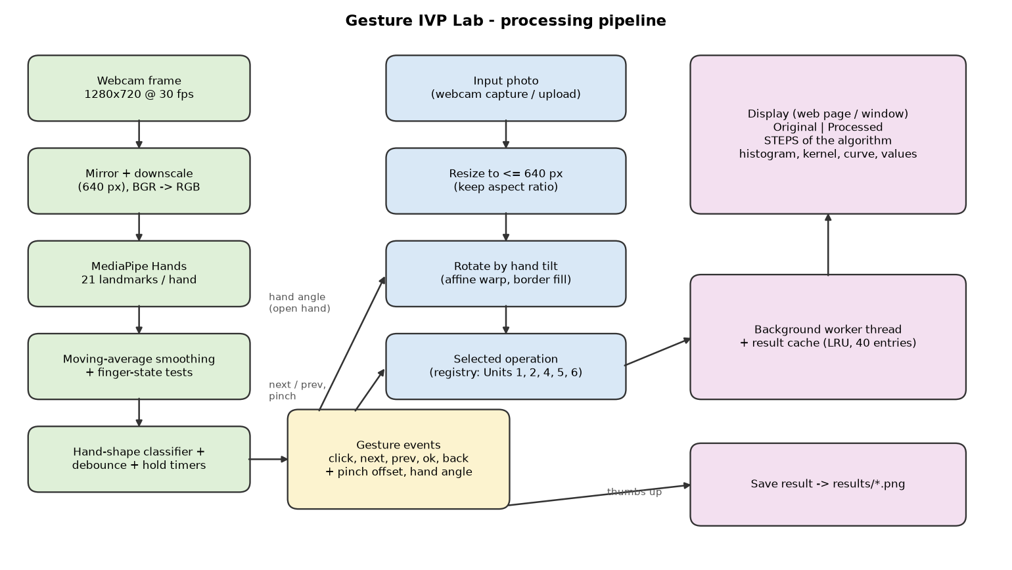
Figure 2. Block diagram. Green: gesture (video) path; blue: image path; yellow: gesture events; purple: processing back-end and output.

Algorithm pseudocode
FOR every webcam frame:
frame = mirror(newest_frame); small = resize(frame, 640); rgb = BGR2RGB(small)
landmarks = MediaPipeHands(rgb); smooth = mean(last 5 landmark sets)
finger_up[i] = |wrist - tip_i| > 1.15 * |wrist - pip_i|
shape = classify(finger_up, thumb, pinch distance) # accepted after 3 equal frames
IF shape held long enough: emit event (next / prev / ok / back / click)
IF pinch: parameter = start_value + (start_height - hand_height) / 0.35
IF open hand: rotation = 1.5 * (angle - start_angle) # 12 degree dead-band
ON change of photo / rotation / operation / parameter:
img = rotate(resize(photo, 640), rotation)
IF operation needs binary: img = otsu_threshold(gray(img))
result = cache.get(key) or worker.run(operation, img, parameter)
draw(original, result, steps, histogram/kernel, values)

Techniques / Algorithms Used

Image Processing
Table 2. Image-processing techniques.
Technique | Used? | How it is used in the project
Grayscale conversion | Yes | Y = 0.299 R + 0.587 G + 0.114 B (own NumPy code).
Histogram equalization | Yes | Own implementation: s_{k} = round((CDF_{k} - CDF_{min}) / (N - CDF_{min}) x 255); before/after histograms shown.
Thresholding | Yes | Point operation s = 255 if r > T else 0; also negative, contrast stretching, level slicing, log and gamma (look-up tables).
Filtering | Yes | Mean (box), separable Gaussian, median (on salt & pepper noise), Laplacian sharpening g = f - c Laplacian(f), unsharp masking / high-boost.
Edge detection | Yes | Prewitt and Sobel |G| = sqrt(G_{x}² + G_{y}²), Laplacian, Laplacian of Gaussian (zero-crossings), Canny (high = 3 x low).
Morphological operations | Yes | Own erosion/dilation (min/max over shifted images; rect, ellipse, cross SE), opening, closing, boundary, hit-or-miss, Zhang-Suen thinning, thickening, grayscale top-hat/black-hat/gradient.
DFT/DCT | No | Not implemented in this version (planned future work).
Image segmentation | Yes | Global threshold; Otsu (own code maximising w₀ w₁ (mu₀ - mu₁)²); adaptive mean / Gaussian.
Feature extraction | Yes | Hand features from landmarks (finger extension, tilt angle, pinch distance); gradient magnitude; region statistics (white-pixel %, mean, std).
Geometric transform | Yes | Rotation with the affine matrix [cos -sin; sin cos], canvas enlarged.

Video Processing
Table 3. Video-processing techniques.
Technique | Used? | How it is used in the project
Frame extraction | Yes | A camera thread grabs frames continuously (1280 x 720, 30 fps); the newest frame is mirrored, down-scaled and converted to RGB.
Background subtraction | No | Not needed: the hand is found by the MediaPipe palm detector.
Optical flow | No | Not used.
Motion detection | Partly | Hand movement is measured from landmarks: vertical movement during a pinch and 'pointer is still' (dwell) detection.
Object tracking | Yes | MediaPipe Hands tracks the hand between frames; the app keeps the same main hand while it is visible; landmarks smoothed over 5 frames.
Frame differencing | No | Not used in this version (planned for the Live Video mode).
Temporal filtering | Yes | Moving average of landmarks, debouncing of shapes over 3 frames, hold timers with a 0.25 s tolerance for missed detections.

Implementation

Programming language
Python 3.11.9.

Software/tools
Visual Studio Code, Windows 11, Python virtual environment (venv), web browser (the app is shown at http://127.0.0.1:8000), Microsoft Word for the report.

Libraries/frameworks
Python 3.11, OpenCV 4.11 (opencv-contrib-python), NumPy 1.26.4 and MediaPipe 0.10.14 (Hands) were used for implementation; Python's built-in http.server and threading for the browser interface; Matplotlib for the report graphs.

Hardware, if relevant
13th Gen Intel Core i3-1315U processor, 7.6 GB RAM, built-in USB2.0 HD UVC webcam. No GPU was used.

Important implementation steps
1. Project structure: config.py (all settings), gestures.py (gesture recognition), registry.py (list of operations), operations/ (one file per topic), ui.py (drawing), web.py (browser interface), main.py (application).
2. Camera: opened with Media Foundation (MSMF) and MJPG, which gave 30 fps instead of 10 fps with DirectShow; automatic reconnection; only one copy of the app may run.
3. Gesture engine: finger tests use distances between landmarks, so tilted hands work. A first design with swipes and screen-edge zones was hard to use and was replaced by held hand shapes.
4. Operation registry: each operation is one function plus one @register(...) line with its parameter range and explanation; the numbered docstring lines are shown on screen as STEPS.
5. Speed: hand detection runs in its own thread and image operations in a worker thread with a 40-entry result cache; static parts of the screen are drawn once.
6. Browser interface: frames are JPEG-encoded and streamed (MJPEG); clicks, keys and uploads are sent back by HTTP; gesture guide cards light up for the detected hand shape.

Results and Discussion

Input vs. output images
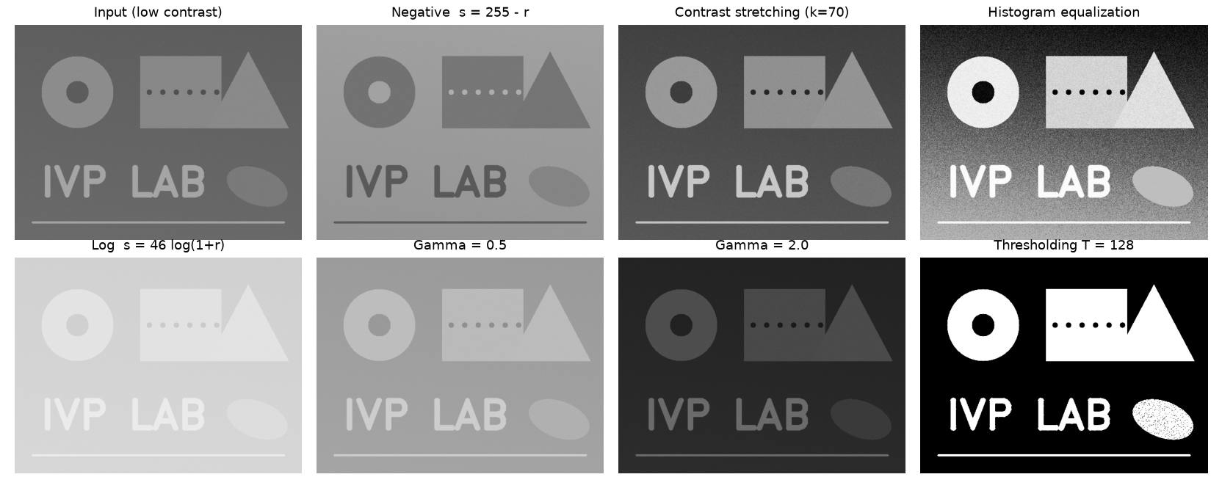
Figure 3. Point processing on the low-contrast input (top row) and thresholding of the original.
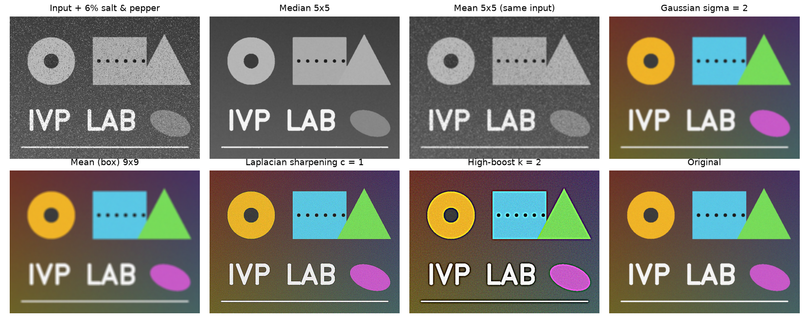
Figure 4. Spatial filtering: salt-and-pepper noise removed by median and mean filters, smoothing, sharpening and high-boost.
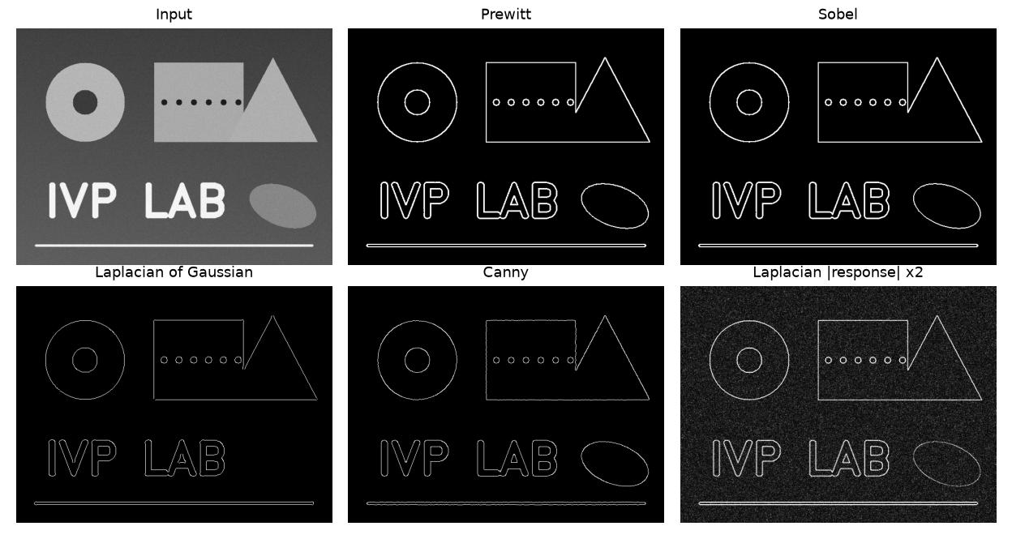
Figure 5. Edge detectors on the same input (Prewitt T = 80, Sobel T = 100, LoG sigma = 2, Canny 50/150, Laplacian).
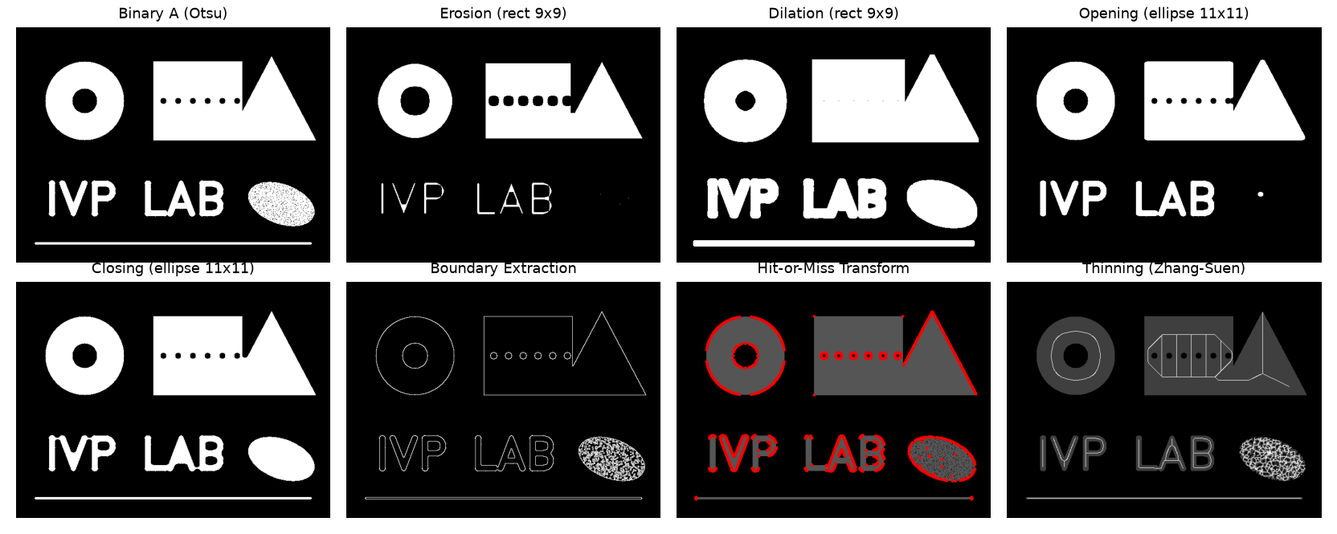
Figure 6. Binary morphology on the Otsu-binarized test image (red dots: hit-or-miss corners; white lines: Zhang-Suen skeleton).
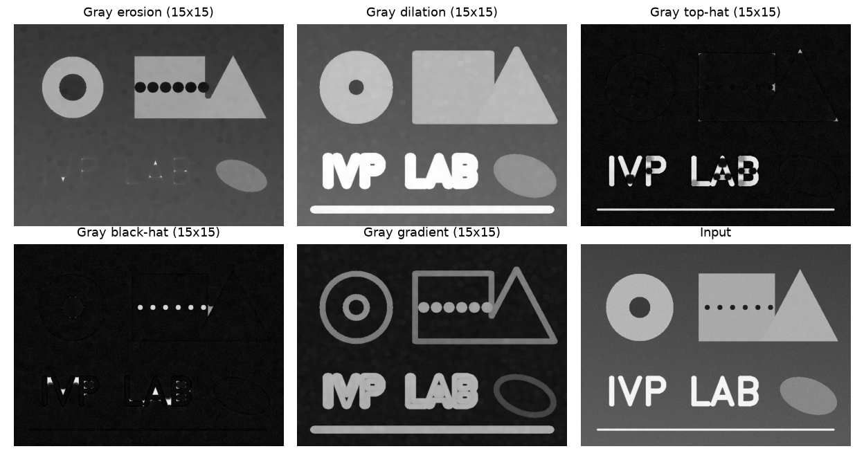
Figure 7. Grayscale morphology with a 15 x 15 elliptical structuring element.
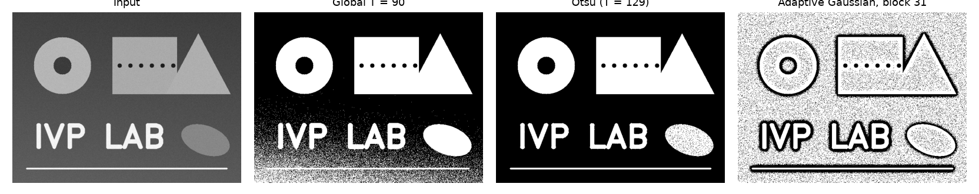
Figure 8. Segmentation: global, Otsu and adaptive thresholding.
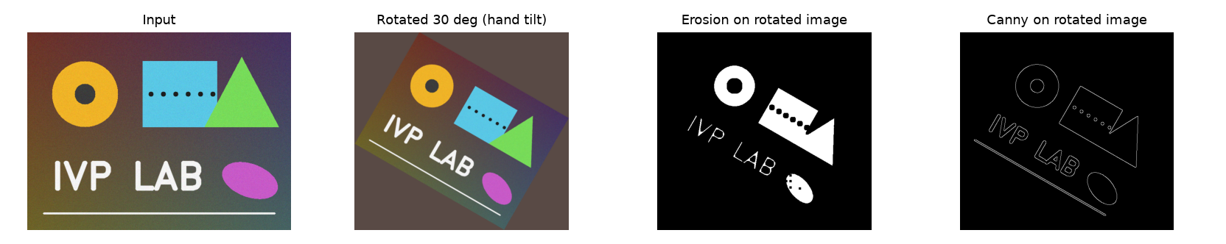
Figure 9. Image rotated by 30 degrees (open-hand tilt) and operations applied to it.

Intermediate processing results
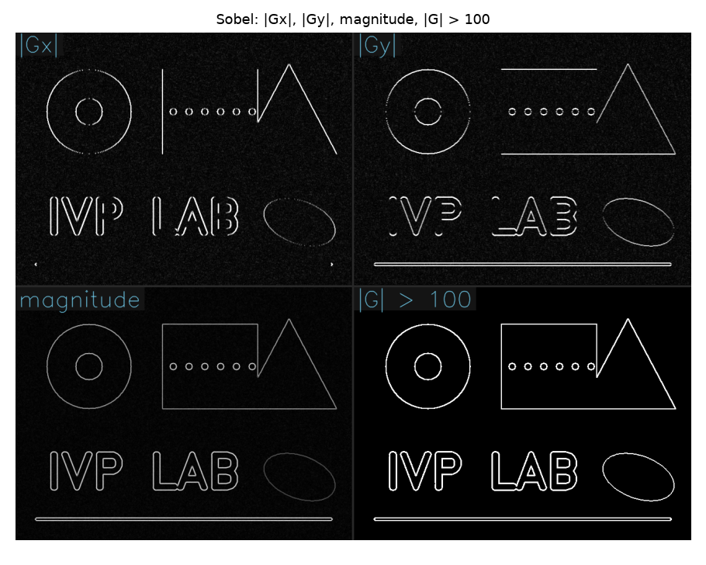
Figure 10. Intermediate results of the Sobel operator: |Gx|, |Gy|, gradient magnitude and thresholded edges.
For morphology, the photo is first binarized with Otsu's threshold; for the median filter, salt and pepper noise is added first so that the effect is visible; for LoG, the smoothed Laplacian response is shown before the zero-crossings are extracted. The app shows these intermediate images as the 'INPUT' image next to the result.

Screenshots
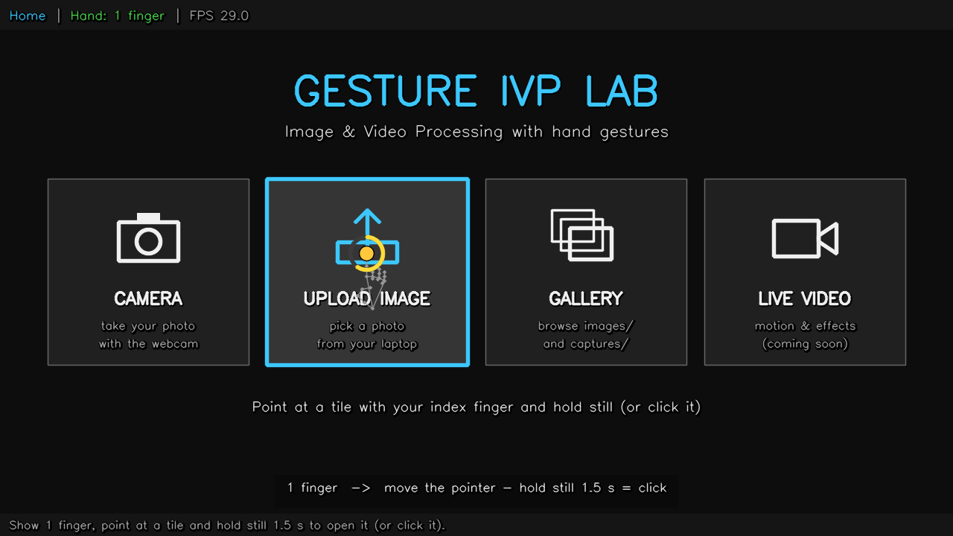
Figure 11. Home screen with the pointer gesture selecting UPLOAD IMAGE (the ring fills while the finger is held still).
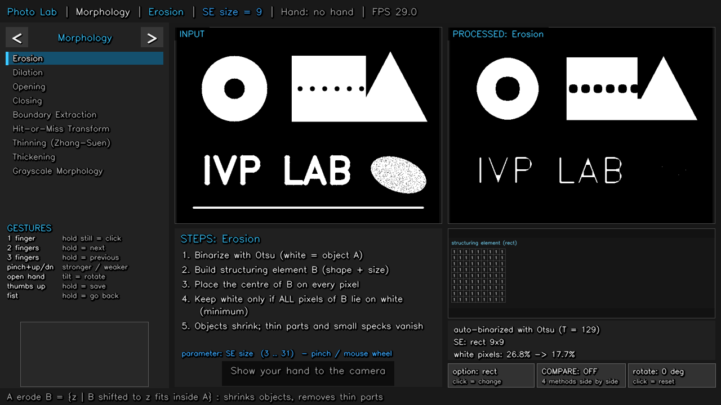
Figure 12. Photo Lab: operation menu, Original and Processed (erosion 9 x 9), STEPS of the algorithm, structuring element and values.
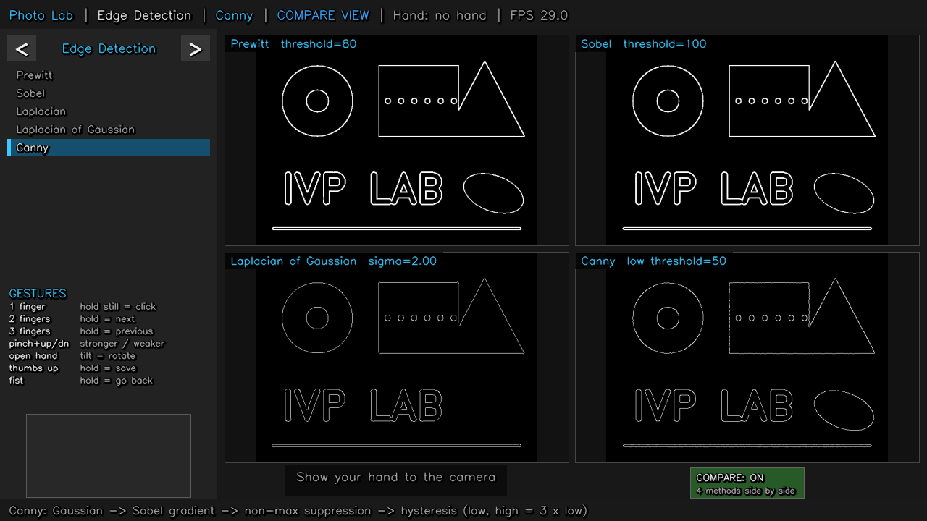
Figure 13. Compare View: Prewitt, Sobel, LoG and Canny side by side.
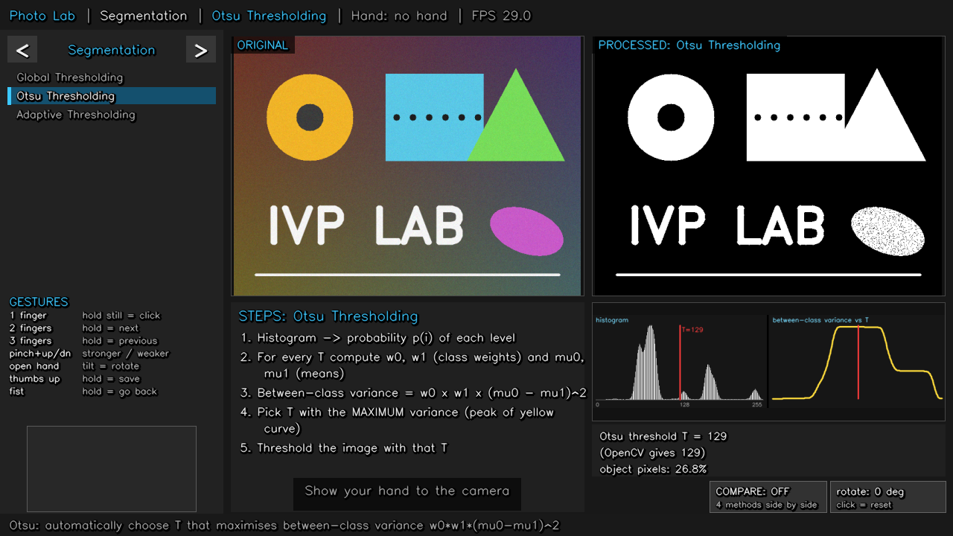
Figure 14. Otsu thresholding in the app with histogram and variance curve.

Graphs/charts
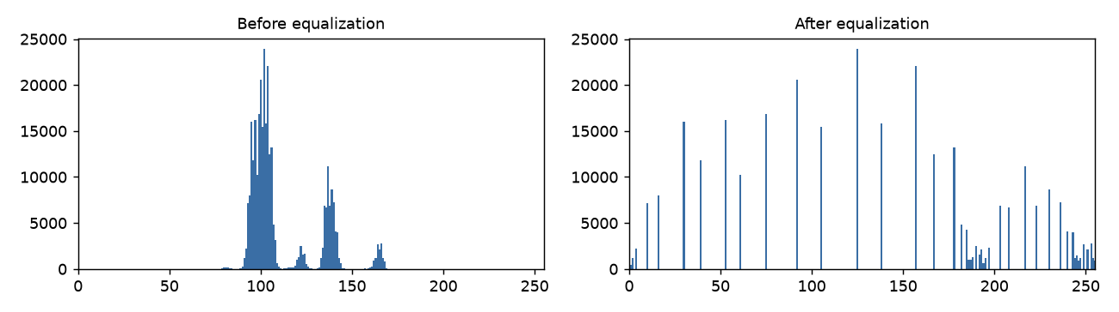
Figure 15. Histogram of the low-contrast input before and after histogram equalization.
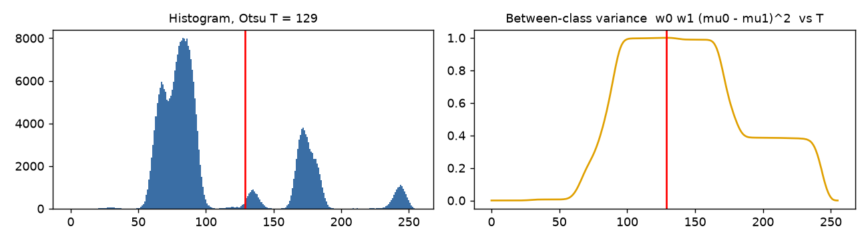
Figure 16. Otsu's method: histogram with the chosen threshold, and between-class variance as a function of T.

Tables
Table 4. Area change produced by morphological operations.
Operation | White pixels (%) | Effect seen
Binary input A | 26.8 | -
Erosion (rect 9x9) | 17.7 | objects shrink, thin line and specks removed
Dilation (rect 9x9) | 34.5 | objects grow, the six small holes are filled
Opening (ellipse 11x11) | 23.1 | speckled ellipse removed, shapes keep their size
Closing (ellipse 11x11) | 27.2 | gaps in the speckled ellipse closed
Boundary A - (A erode B) | 3.2 | 1-pixel outlines

Table 5. Edge detectors compared on the test image.
Detector | Edge pixels (%) | Observation
Prewitt | 4.03 | thick (2-3 px) edges, some noise
Sobel | 4.0 | similar to Prewitt, slightly smoother
Laplacian of Gaussian | 1.51 | thin closed contours
Canny | 1.75 | thin, continuous edges, least noise

Table 6. Our Otsu implementation vs OpenCV.
Test image | Our Otsu (NumPy) | OpenCV Otsu
sample (colour) | 129 | 129
low-contrast | 120 | 120
equalized | 125 | 125
Gaussian-blurred | 125 | 125

Quantitative performance measures
Table 7. Denoising quality, PSNR = 10 log₁₀(255² / MSE).
Image (vs clean grayscale) | PSNR (dB)
Noisy input (6 % salt & pepper) | 17.58
Mean filter 5x5 | 25.71
Gaussian filter, sigma = 1 | 25.97
Median filter 5x5 | 33.22

Table 8. Before / after measurements.
Measure | Before | After
Histogram equalization: gray-level range | 76-170 | 0-255
Histogram equalization: standard deviation | 19.1 | 72.4
Otsu threshold after rotation (black corners vs border fill) | 53 | 128
Interface speed (detection inline vs in its own thread) | 8.1 fps | 28.8-30.2 fps
Camera capture (DirectShow vs MSMF + MJPG) | 10.0 fps | 30.3 fps

Table 9. Processing time of every operation on the 640 x 480 test image (median of 3 runs).
Operation | Category | Time (ms)
Thinning (Zhang-Suen) | Morphology | 1835.4
Thickening | Morphology | 166.0
Unsharp Masking / High-boost | Image Enhancement | 66.9
Prewitt | Edge Detection | 47.6
Sobel | Edge Detection | 45.2
Laplacian of Gaussian | Edge Detection | 45.2
Laplacian Sharpening | Image Enhancement | 32.3
Histogram Equalization | Image Enhancement | 32.0
Grayscale | Image Fundamentals | 24.1
Digital Negative | Image Enhancement | 17.1
Power-law (Gamma) | Image Enhancement | 17.1
Intensity Level Slicing | Image Enhancement | 16.8
Otsu Thresholding | Segmentation | 16.4
Median Filter | Image Enhancement | 15.7
Thresholding | Image Enhancement | 15.1
Hit-or-Miss Transform | Morphology | 14.5
Log Transformation | Image Enhancement | 13.9
Closing | Morphology | 13.1
Opening | Morphology | 13.0
Contrast Stretching | Image Enhancement | 12.3
Laplacian | Edge Detection | 11.8
Erosion | Morphology | 9.0
Gaussian Filter | Image Enhancement | 8.9
Dilation | Morphology | 8.0
Global Thresholding | Segmentation | 7.5
Mean (Box) Filter | Image Enhancement | 6.5
Canny | Edge Detection | 3.7
Boundary Extraction | Morphology | 1.9
Adaptive Thresholding | Segmentation | 1.7
Grayscale Morphology | Morphology | 1.4

Table 10. Gesture and functional tests.
Test | Result
Gesture thread rate (model complexity 1, 640 px) | 18.6 fps
Synthetic hand-shape classification tests | 9 / 9 correct
Synthetic hold / event timing tests | 10 / 10 correct (no early or double firing)
Automated app tests (menus, rotation, pinch, compare, save, all 30 operations) | all passed

Discussion. The median filter gives the best denoising (33.22 dB) because the 0 and 255 outliers are never the median of a neighbourhood, while the mean and Gaussian filters only spread them. Histogram equalization raised the contrast about 3.8 times but also amplified background noise. Canny produced the thinnest and cleanest edges. Our Otsu implementation matched OpenCV on all images. Most operations take a few milliseconds; thinning and thickening are slowest because they iterate until no pixel changes, so they run in the background.

Challenges / Limitations

Problems encountered
- The first gesture design (fast swipes, a control mode, holding the palm at the screen edge) was hard to use; it was replaced by hand shapes that are held still.
- Several copies of the app running together competed for the webcam and showed black images; solved with a single-instance lock and automatic camera reconnection.
- The default DirectShow camera driver gave only 10 fps; switching to MSMF + MJPG gave 30 fps.

Difficult cases
- A bright window or white wall behind the user darkens the hand and makes detection harder.
- Hands that are partly outside the frame, too far (> 1 m) or too close are not detected.
- A relaxed thumb can make '1 finger' look like a pinch; a loose fist can look like thumbs up.

Computational limitations
- MediaPipe needs about 50-65 ms per frame on the Core i3 CPU (no GPU).
- Zhang-Suen thinning takes about 0.6-1.8 s per 640 x 480 image (depending on the load on the laptop); the result appears slightly after the pinch.
- The webcam takes about 8 seconds to start.

Dataset limitations
- No public or labelled dataset was used; tests used a synthetic image, a few webcam photos and synthetic landmark sequences.
- Gesture accuracy for many different users, skin tones, backgrounds and lighting was not measured.

Cases where the method failed
- Rotating the image with black corners made Otsu choose T = 53 instead of 128 (fixed by filling the corners with the border colour).
- Global thresholding with a fixed T fails on the gradient background; adaptive thresholding also outlines interior texture.
- Histogram equalization amplifies noise in flat regions.

Conclusion

What was implemented?
Gesture IVP Lab: a touch-free image-processing laboratory that captures or uploads a photo and applies 30 syllabus operations to it under hand-gesture control, showing Original vs Processed, the algorithm steps, graphs and values, with a Compare View and saving of results.

What techniques were used?
Video processing: frame capture, hand detection and tracking (MediaPipe Hands), temporal smoothing, finger-state features, shape classification and hold timers. Image processing: grayscale conversion, point processing, histogram equalization, spatial filtering, morphology, edge detection, thresholding-based segmentation and affine rotation.

What was achieved?
All five objectives were met for the implemented units: seven gestures, 30 operations, side-by-side comparison with steps, pinch and rotation control, and about 29 fps. Measured results match theory: median filtering gave 33.22 dB PSNR, equalization raised contrast from 19.1 to 72.4, and our Otsu matched OpenCV exactly.

What is your learning?
We learned how the classical algorithms work at the pixel level (look-up tables, convolution, order statistics, structuring elements, between-class variance) and how their parameters change the output. We also learned that real-time video analysis needs smoothing, debouncing and multithreading to feel reliable, and that simple gestures with clear feedback work better than complex ones. Future work: frequency-domain filters, DCT/DFT, colour processing and video motion estimation.

References
[1] R. C. Gonzalez and R. E. Woods, Digital Image Processing, 4th ed., Pearson, 2018.
[2] A. K. Jain, Fundamentals of Digital Image Processing, Prentice Hall, 1989.
[3] N. Otsu, "A threshold selection method from gray-level histograms," IEEE Trans. Systems, Man, and Cybernetics, vol. 9, no. 1, pp. 62-66, 1979.
[4] J. Canny, "A computational approach to edge detection," IEEE Trans. Pattern Analysis and Machine Intelligence, vol. PAMI-8, no. 6, pp. 679-698, 1986.
[5] D. Marr and E. Hildreth, "Theory of edge detection," Proc. Royal Society of London B, vol. 207, pp. 187-217, 1980.
[6] T. Y. Zhang and C. Y. Suen, "A fast parallel algorithm for thinning digital patterns," Communications of the ACM, vol. 27, no. 3, pp. 236-239, 1984.
[7] J. Serra, Image Analysis and Mathematical Morphology, Academic Press, 1982.
[8] F. Zhang et al., "MediaPipe Hands: On-device real-time hand tracking," arXiv:2006.10214, 2020.
[9] C. Lugaresi et al., "MediaPipe: A framework for building perception pipelines," arXiv:1906.08172, 2019.
[10] G. Bradski, "The OpenCV Library," Dr. Dobb's Journal of Software Tools, 2000; OpenCV documentation, https://docs.opencv.org/4.x/
[11] C. R. Harris et al., "Array programming with NumPy," Nature, vol. 585, pp. 357-362, 2020.
[12] Python Software Foundation, Python 3.11 documentation, https://docs.python.org/3.11/

