**PROJECT-NAME:AMAZON**

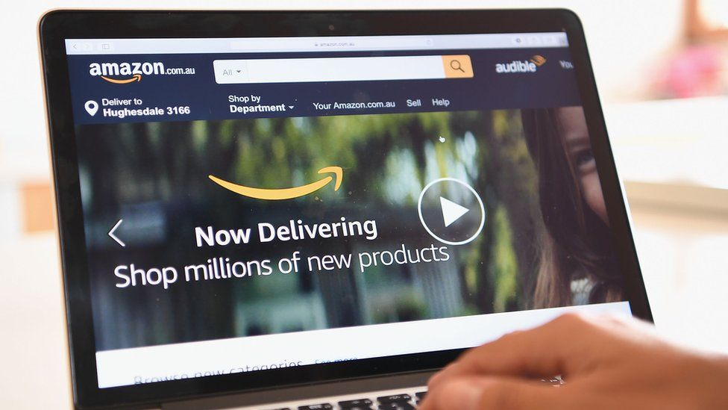

**\*OVERVIEW:** It’s an e-commerce website for all people,

from A to Z everything is available

under the same roof.

1. **HOME PAGE:**

# LOGO

# ICONS - (WISHLIST, ADD TO CART)

# SEARCH BAR

# SLIDERS WITH ARROWS - (IMAGES)

# DEALS - (IMAGES)

# FEATURED - (IMAGES)

# TRENDING - (IMAGES)

# FOOTER – ( CONTACT US , HELPLINES , BRIEF DESCRIPTION

ABOUT THE COMPANY , SOCIAL-MEDIA HANDLE

ICONS , LINK TO MOBILE APP )

1. **REGISTRATION FORM:**

# E-MAIL ADDRESS

# D.O.B

# SHOPPING PREFERENCE

**3. MAIN PAGE:**

# FILTERS - ( BRANDS , COLOR , DISCOUNT RANGE , PRICE

COUNTRY OF ORIGIN , MATERIAL , FEATURES ,

FIT , OCCASION , PATTERN , RATING , SIZE ,

TYPE , SORT BY: )

# IMAGES OF THE CHOSEN PRODUCT WITH DETAILS LIKE -

( BRAND , PRODUCT NAME , PRICE , DISCOUNT% ( IF

ANY ) )

# ON CLICKING THE IMAGE - (MULTIPLE IMAGES OF THE

PRODUCT WILL APPEAR FROM DIFFERENT ANGLES ,

ZOOM IN , ZOOM OUT

# PRODUCT DESCRIPTION - BRAND , PRODUCT NAME ,

PRICE , DISCOUNT% (IF ANY) , SIZE CHART ,

DELIVERY OPTIONS , PRODUCT

DETAILS , SIZE & FIT , MATERIAL & CARE ,

SPECIFICATIONS , RATINGS , CUSTOMER REVIEWS

WITH IMAGES (IF ANY )

# LOWER HALF OF THE PAGE - RELATED PRODUCTS

1. **PAYMENT PAGE:**

# ADDRESS SELECTION

# PAYMENT METHOD - (PHONEPE , GOOGLE PAY , BHIM UPI ,

COD , CREDIT/DEBIT CARD , NET

- BANKING , EMI , PAYTM)