Assignment - 2
🌌 Stellar Classification using Machine Learning

Name : YUWARAJ T K

BITS ID: 2025AC05829

Email ID: 2025ac05829@wilp.bits-pilani.ac.in

A. Problem Statement
The objective of this project is to develop a Multi-Class Classification model that can accurately classify celestial objects into one of the following categories:
- 🌌 Galaxy
- ⭐ Star
- ✨ Quasi-Stellar Object (QSO)
The project utilizes the SDSS Stellar Classification Dataset and compares the performance of five supervised machine learning algorithms:
- Logistic Regression
- Decision Tree
- K-Nearest Neighbors (KNN)
- Gaussian Naive Bayes
- Random Forest (Ensemble)

B. Dataset Description
Dataset Name: SDSS Stellar Classification Dataset
Dataset Source:
https://www.kaggle.com/datasets/fedesoriano/stellar-classification-dataset-sdss17

Dataset Summary
Property | Value
Problem Type | Multi-Class Classification
Number of Samples | 100,000
Number of Features | 14
Target Classes | 3
Target Variable | class

Input Features
No | Feature | Description
1 | alpha | Right Ascension (RA) angle of the celestial object measured at the J2000 epoch. It represents the object's angular position in the sky, similar to longitude on Earth.
2 | delta | Declination (DEC) angle of the celestial object measured at the J2000 epoch. It represents the object's angular position in the sky, similar to latitude on Earth.
3 | u | Brightness (magnitude) measured through the Ultraviolet (U) photometric filter.
4 | g | Brightness (magnitude) measured through the Green (G) photometric filter.
5 | r | Brightness (magnitude) measured through the Red (R) photometric filter.
6 | i | Brightness (magnitude) measured through the Near-Infrared (I) photometric filter.
7 | z | Brightness (magnitude) measured through the Infrared (Z) photometric filter.
8 | run_ID | Identifier of the SDSS observation run in which the celestial object was captured.
9 | cam_col | Camera column number that identifies the specific camera sensor used during the sky survey.
10 | field_ID | Identifier of the observed field within an SDSS imaging run.
11 | redshift | Redshift value indicating how much the wavelength of the object's light has shifted due to the expansion of the universe. It is an important feature for distinguishing galaxies, stars, and quasars.
12 | plate | Spectroscopic plate identifier used during the SDSS spectroscopic observation.
13 | MJD | Modified Julian Date representing the date and time when the observation was recorded.
14 | fiber_ID | Identifier of the optical fiber used to collect light from the celestial object during spectroscopic observation.

Target Classes
- GALAXY
- STAR
- QSO

C. GitHub Repository Link
GitHub Repository:
https://github.com/YuwarajTK-2025ac05829/Stellar-Classification-App

D. Model Comparison
ML Model | Accuracy | AUC | Precision | Recall | F1 Score | MCC
Logistic Regression | 0.9576 | 0.9863 | 0.9576 | 0.9576 | 0.9571 | 0.9248
Decision Tree | 0.9673 | 0.9699 | 0.9673 | 0.9673 | 0.9673 | 0.9420
K-Nearest Neighbors | 0.9032 | 0.9498 | 0.9060 | 0.9032 | 0.9019 | 0.8258
Gaussian Naive Bayes | 0.6911 | 0.7947 | 0.6492 | 0.6911 | 0.6181 | 0.4366
Random Forest (Ensemble) | 0.9794 | 0.9948 | 0.9793 | 0.9794 | 0.9792 | 0.9633

E. Model Performance Observations
ML Model | Observation about Model Performance
Logistic Regression | Logistic Regression achieved an accuracy of 95.76% and provided a strong baseline for the classification task. It produced balanced predictions across all three classes with high precision, recall, and F1-score.
Decision Tree | Decision Tree improved the overall accuracy to 96.73% by effectively learning non-linear decision boundaries. It demonstrated better performance than Logistic Regression but may be more susceptible to overfitting.
K-Nearest Neighbors (KNN) | KNN achieved an accuracy of 90.32%. Although its performance was satisfactory, it was lower than Decision Tree and Random Forest because of its sensitivity to feature scaling and neighboring sample distribution.
Gaussian Naive Bayes | Gaussian Naive Bayes produced the lowest performance with an accuracy of 69.11%. The model struggled to classify the QSO class accurately because the independence assumption among features was not well suited for this dataset.
Random Forest (Ensemble) | Random Forest achieved the highest performance among all evaluated models. It obtained an accuracy of 97.94%, an AUC of 0.9948, and the highest Precision, Recall, F1-score, and MCC, demonstrating excellent generalization capability.
Overall Winner for the Dataset | Random Forest (Ensemble) was selected as the final model because it achieved the best performance across all evaluation metrics. It provided the highest classification accuracy and the most robust predictions, making it the most suitable model for deployment in the Streamlit application.

F. STREAMLIT APP HOSTED URL

https://stellar-classification-app-2025ac05829.streamlit.app/

Project Structure
Stellar-Classification-App/
│
├── app.py
├── README.md
├── requirements.txt
├── test_data.csv
│
├── dataset/
│ └── star_classification.csv
│
├── models/
│ ├── logistic_regression.pkl
│ ├── decision_tree.pkl
│ ├── knn.pkl
│ ├── gaussian_nb.pkl
│ ├── random_forest.pkl
│ ├── scaler.pkl
│ ├── label_encoder.pkl
│ └── Stellar-Classification-App.ipynb
│
├── components/
│ ├── __init__.py
│ ├── classification_report.py
│ ├── confusion_matrix.py
│ ├── dashboard.py
│ ├── dataset_preview.py
│ ├── download.py
│ ├── feature_importance.py
│ ├── metrics.py
│ ├── model_comparison.py
│ ├── model_inspector.py
│ ├── model_selection.py
│ ├── prediction.py
│ └── prediction_mode.py
│
└── utils/
├── __init__.py
├── evaluation.py
└── model_loader.py

How to Run the Project

1. Clone the Repository
git clone https://github.com/YuwarajTK-2025ac05829/Stellar-Classification-App.git

2. Navigate to the Project Folder
cd Stellar-Classification-using-Machine-Learning

3. Install the Required Packages
pip install -r requirements.txt

4. Launch the Streamlit Application
streamlit run app.py

Technologies Used
- Python
- Pandas
- NumPy
- Scikit-learn
- Matplotlib
- Streamlit
- Joblib

Application Screenshots

1. Model Prediction in .ipynb

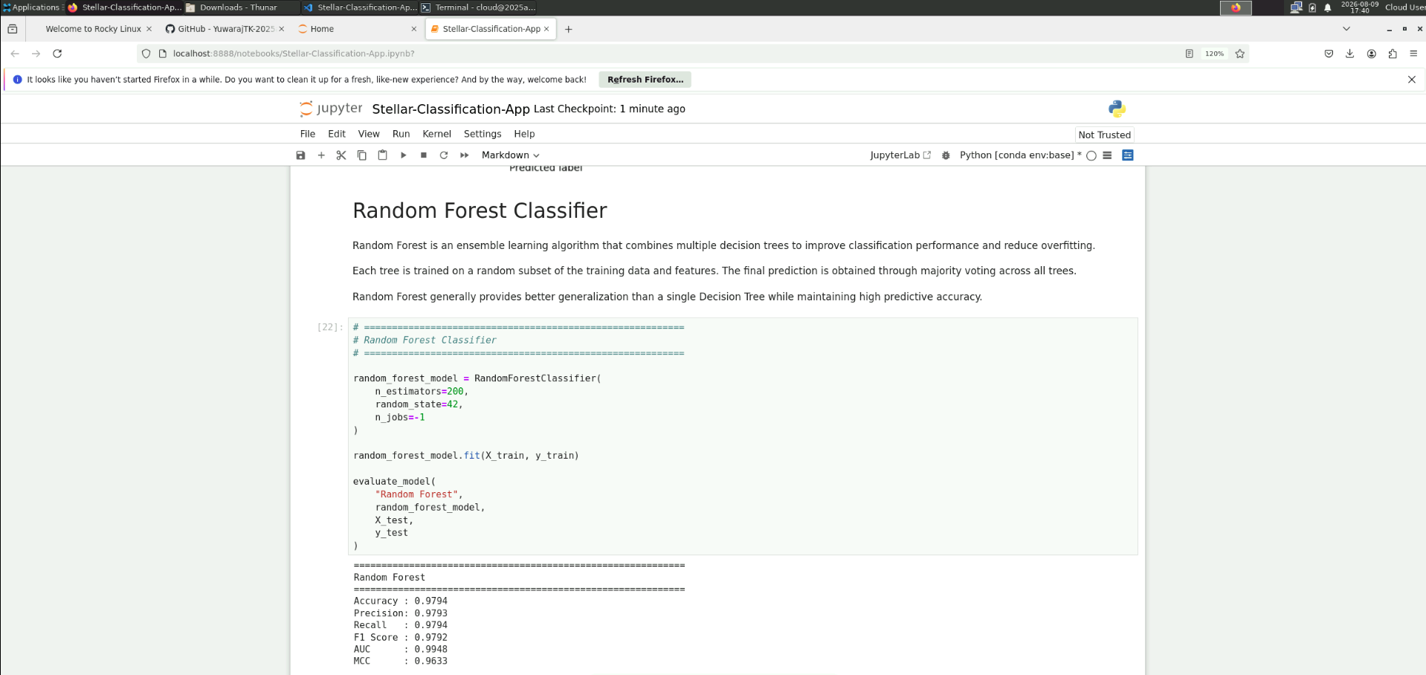

2. Best Model

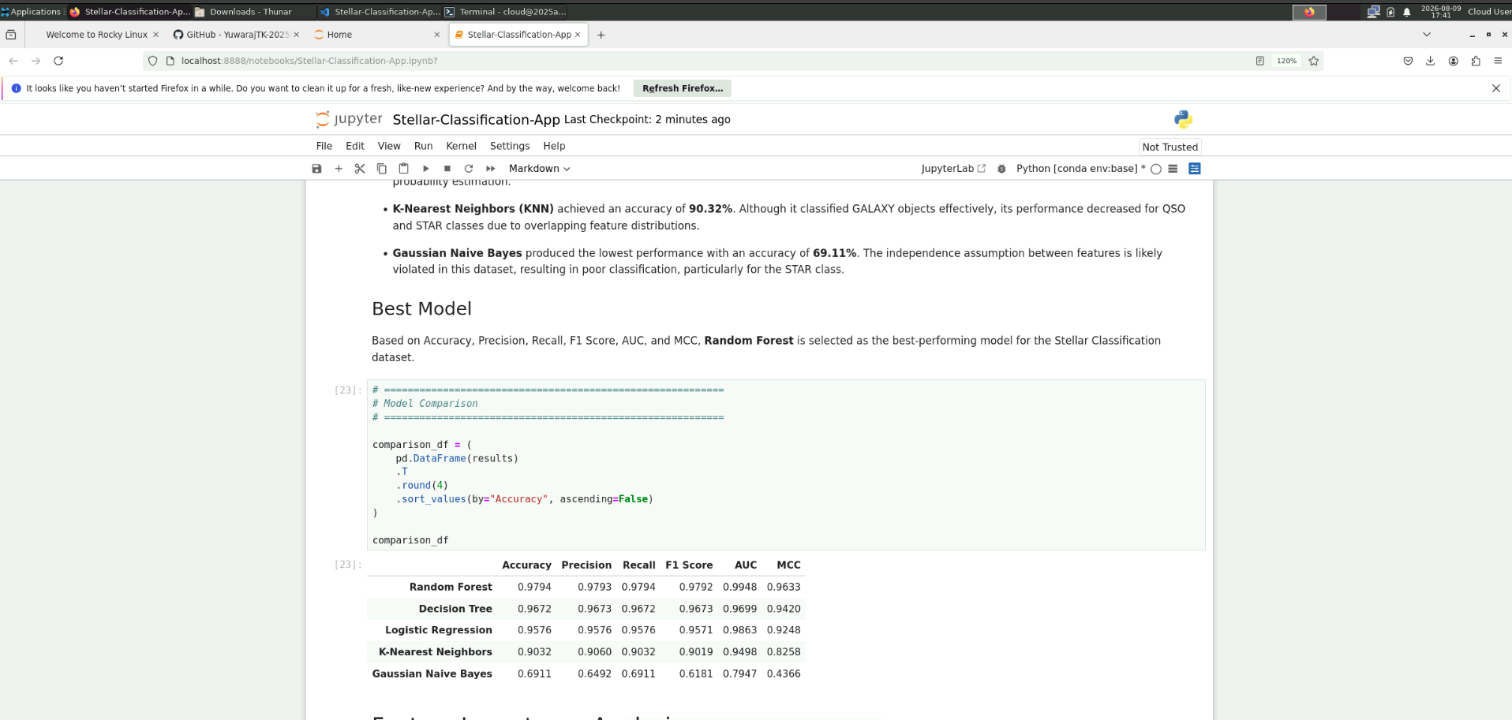

3. Localhost Streamlit app

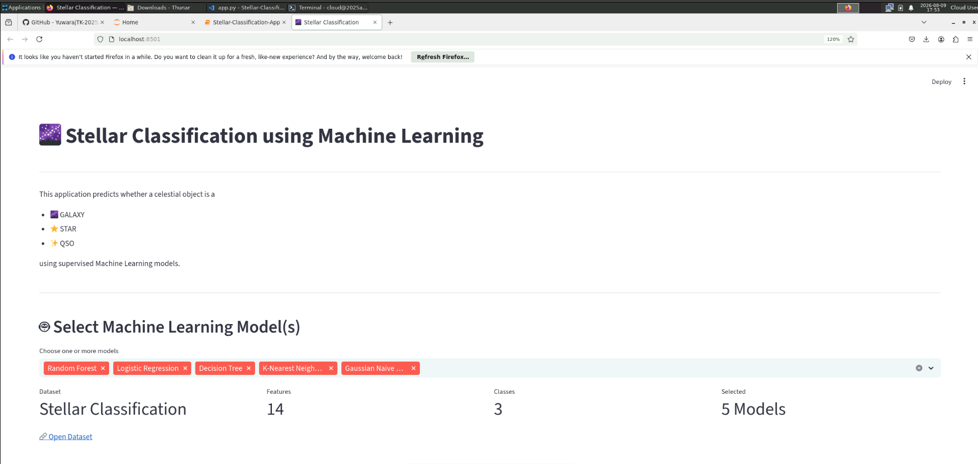

4. Streamlit app Running in terminal
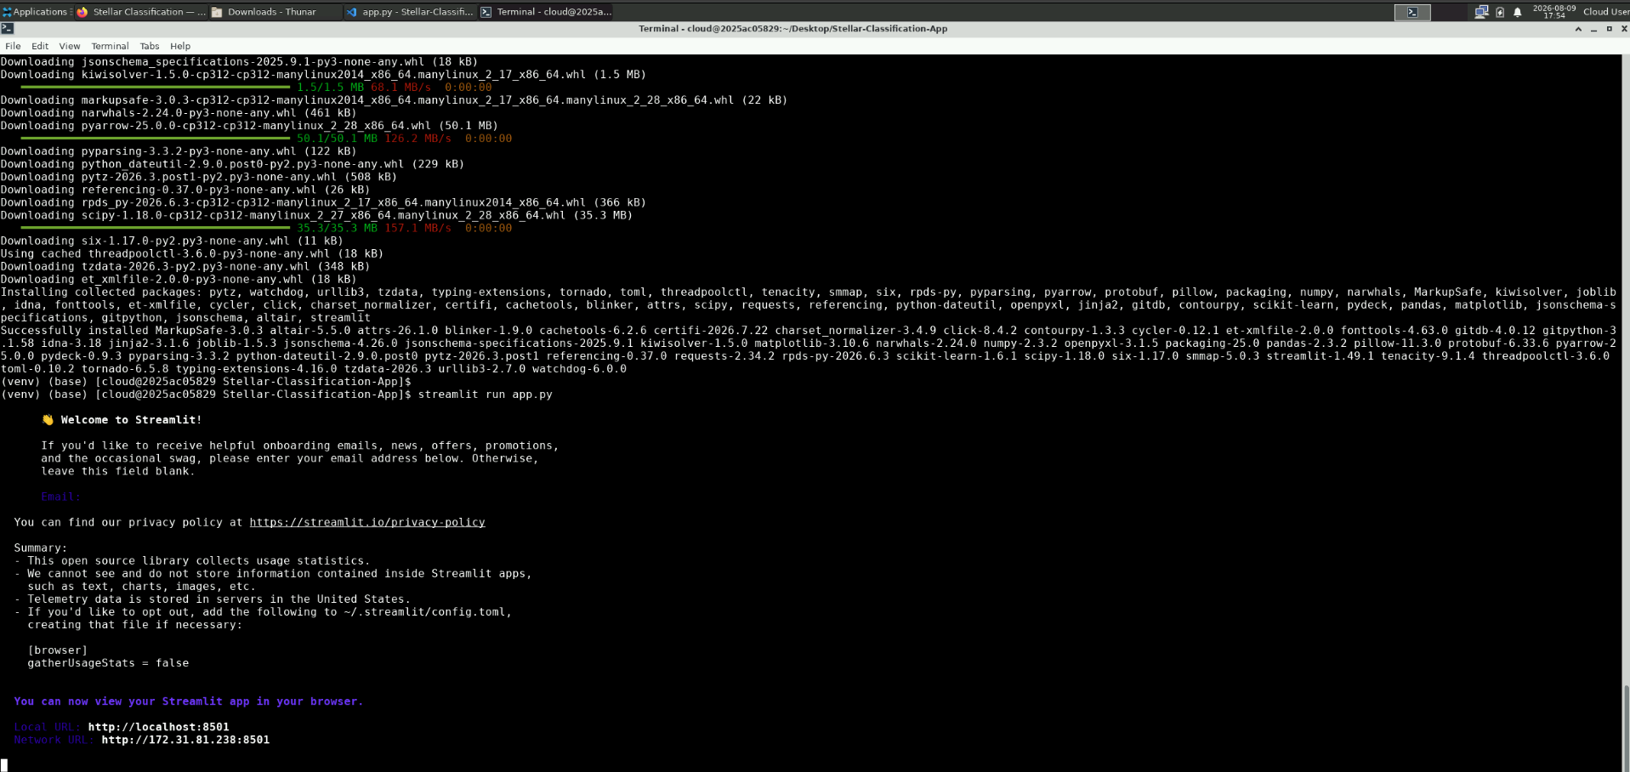

5. Hosted Streamlit app
