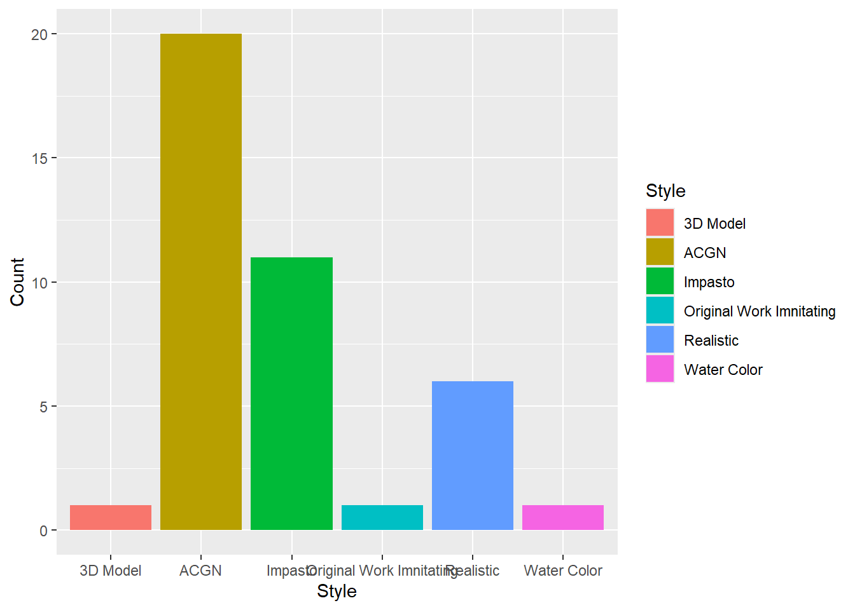
The first bar plot is a visualization counting different styles. In the original dataset, style is a predictor defining the artistic style the AI fan art imnitating. From the visualization, we can see that ACGN style is the most popular among all the collected data, and the 3D Model, Water Color and Original Work Imnitating are the least welcomed. Impasto is the second popular one, and realistic is the third popular one. The ACGN style is closely related to ACGN culture, and this culture is very dominate in fandoms, and ACGN fandoms are the most flourished fandom in China; therefore, the popularity of ACGN style is propobably related to the popularity of ACGN culture in Chinese fandom.

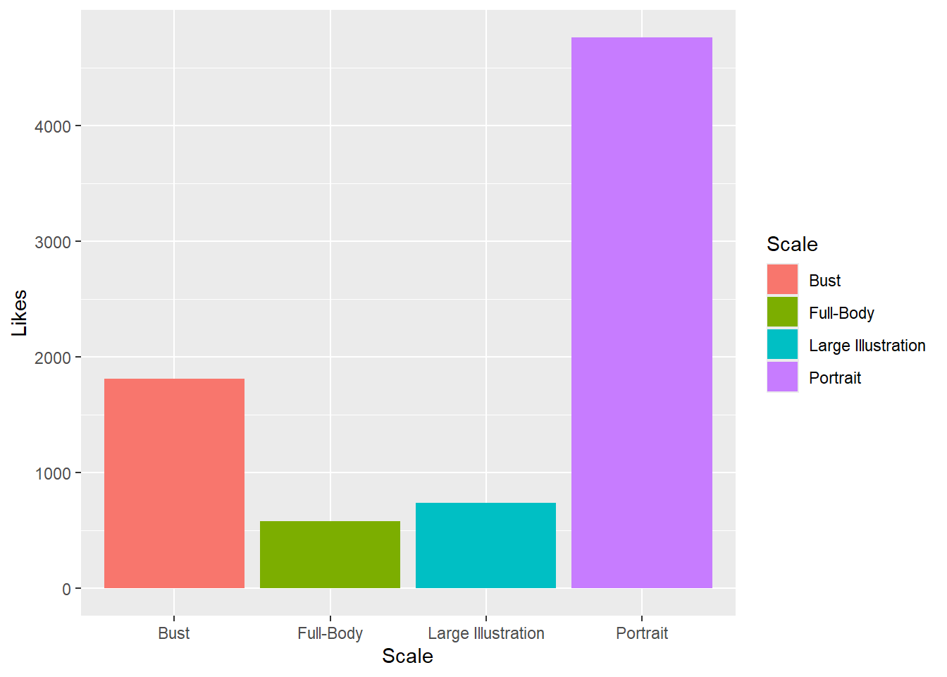
This bar plot shows the relationship between Scale and Likes. Here, the “Scale” indicates in what size of character body the illustration draws. We can see that the Portrait scale is the most welcomed, and the Bust is the second. Comparing to larger scale, portrait and bust scale can more directly display facial features, and although it contains less information, it is very eye-catching. Small-scale illustrations also avoid errors that AI may make during the generation process. In addition, because AI art has lower information density and lacks emotional expression compared to human art, those who choose to support AI art may be more concerned with the direct visual impact than with the information in the illustration.

