**Rigid Two-link Robot Arm Simulink Model Report**

**Assumptions**

1. The two link masses are point masses
2. Linear motor actuator

**Robot Specifications**

* The length of link 1 is: $L_{1}=1m$
* The length of link 2 is: $L_{2}=1m$
* The mass of link 1 is: $m_{1}=1kg$
* The mass of link 2 is: $m_{2}=1kg$
* The rotation angle of joint 1 is: $θ_{1}$
* The rotation angle of joint 2 is: $θ_{2}$

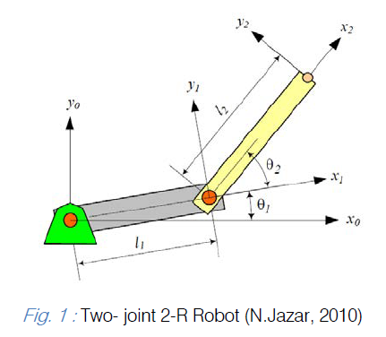

Fig.1 Two-joint Robot Arm [1]

**Robot Kinematics**

* Forward kinematics ($θ_{1}$, $θ_{2}$ $→$ $x_{2}$, $y_{2}$)

$x_{2}=L_{1}\cos{θ_{1}}+L_{2}\cos\left(θ_{1}+θ_{2}\right)$ (1)

$y_{2}=L_{1}\sin{θ_{1}}+L_{2}\sin\left(θ_{1}+θ_{2}\right)$ (2)

* Inverse kinematics ($x_{2}$, $y_{2}$ $→$ $θ_{1}$, $θ_{2}$)

$\cos{θ_{2}}=\frac{x_{2}^{2}+y_{2}^{2}-L_{1}^{2}-L_{2}^{2}}{2L_{1}L_{2}}∶=D$ (3)

$θ_{2}=atan2(±\sqrt{1-D^{2}}, D)$ (4)

$θ_{1}=atan2(y_{2}, x_{2})-atan2(L_{2}\sin{θ_{2}}, L_{1}+L_{2}\cos{θ_{2}})$ (5)

**Robot Dynamics**

* Lagrangian Formulation

$L\left(θ, \dot{θ}\right)=\underset{kinetic energy}{\underbrace{K\left(θ, \dot{θ}\right)}}-\underset{potential energy}{\underbrace{P\left(θ\right)}}$ (6)

* Calculate required torque for robot arm moving

$τ=\frac{d}{dt}\frac{∂L}{∂\dot{θ}}-\frac{∂L}{∂θ}$ (7)

$K_{1}=1/2m_{1}v_{1}^{2}=1/2m_{1}\left({\dot{x}}_{1}^{2}+{\dot{y}}_{1}^{2}\right)=1/2m_{1}L_{1}^{2}{\dot{θ}}_{1}^{2}$ (8)

$K_{2}=1/2m_{2}v_{2}^{2}=1/2m_{2}\left({\dot{x}}_{2}^{2}+{\dot{y}}_{2}^{2}\right)$ (9)

$K_{2}=1/2m_{2}\left(\left(L_{1}^{2}+2L_{1}L_{2}\cos{θ_{2}}+L_{2}^{2}\right){\dot{θ}}_{1}^{2}+2\left(L_{2}^{2}+L_{1}L_{2}\cos{θ_{2}}\right){\dot{θ}}_{1}{\dot{θ}}_{2}+L_{2}^{2}{\dot{θ}}_{2}^{2}\right)$ (10)

$P_{1}=m_{1}gy_{1}=m_{1}gL_{1}\sin{θ_{1}}$ (11)

$P_{2}=m_{2}gy_{2}=m_{2}g\left(L_{1}\sin{θ_{1}}+L_{2}\sin\left(θ_{1}+θ_{2}\right)\right)$ (12)

$τ_{1}=\left(m_{1}L_{1}^{2}+m_{2}\left(L_{1}^{2}+2L_{1}L_{2}\cos{θ_{2}+L_{2}^{2}}\right)\right){\ddot{θ}}_{1}+m_{2}\left(L_{1}L_{2}\cos{θ_{2}+L_{2}^{2}}\right){\ddot{θ}}_{2}-m_{2}L_{1}L_{2}\sin{θ_{2}\left(2{\dot{θ}}_{1}{\dot{θ}}_{2}+{\dot{θ}}_{2}^{2}\right)}+\left(m_{1}+m_{2}\right)L_{1}g\cos{θ_{1}+m_{2}gL_{2}\cos\left(θ_{1}+θ_{2}\right)}$ (13)

$τ_{2}=m_{2}\left(L_{1}L_{2}\cos{θ_{2}+L_{2}^{2}}\right){\ddot{θ}}_{1}+m_{2}L_{2}^{2}{\ddot{θ}}_{2}+m_{2}L_{1}L_{2}{\dot{θ}}_{1}^{2}\sin{θ_{2}}+m_{2}gL_{2}\cos\left(θ_{1}+θ_{2}\right)$ (14)

$τ=M(θ)\ddot{θ}+c\left(θ, \dot{θ}\right)+g\left(θ\right)$ (15)

$M(θ)=\left[\begin{matrix}m_{1}L_{1}^{2}+m_{2}\left(L_{1}^{2}+2L_{1}L_{2}\cos{θ_{2}+L_{2}^{2}}\right) & m_{2}\left(L_{1}L_{2}\cos{θ_{2}+L_{2}^{2}}\right) \\ m_{2}\left(L_{1}L_{2}\cos{θ_{2}+L_{2}^{2}}\right) & m_{2}L_{2}^{2}\end{matrix}\right]$ (16)

$c\left(θ, \dot{θ}\right)=\left[\begin{matrix}-m_{2}L_{1}L_{2}\sin{θ_{2}\left(2{\dot{θ}}_{1}{\dot{θ}}_{2}+{\dot{θ}}_{2}^{2}\right)} \\ m_{2}L_{1}L_{2}{\dot{θ}}_{1}^{2}\sin{θ_{2}}\end{matrix}\right]$ (17)

$g\left(θ\right)=\left[\begin{matrix}\left(m_{1}+m_{2}\right)L_{1}g\cos{θ_{1}+m_{2}gL_{2}\cos\left(θ_{1}+θ_{2}\right)} \\ m_{2}gL_{2}\cos\left(θ_{1}+θ_{2}\right)\end{matrix}\right]$ (18)

$M(θ)$, $c\left(θ, \dot{θ}\right)$, and $g\left(θ\right)$ are used to build robot arm dynamical model in Simulink.

**Model Predictive Controller**

I would not include detailed model predictive control derivation process here, for more details you can check [2].

${\ddot{θ}}_{1}\left(t\right)=v_{1}\left(t\right)=k_{1}\left(θ_{1d}(t)-θ_{1}(t)\right)-k_{2}{\dot{θ}}_{1}(t)$ (19)

${\ddot{θ}}_{2}\left(t\right)=v_{2}\left(t\right)=k_{1}\left(θ_{2d}(t)-θ_{2}(t)\right)-k_{2}{\dot{θ}}_{2}(t)$ (20)

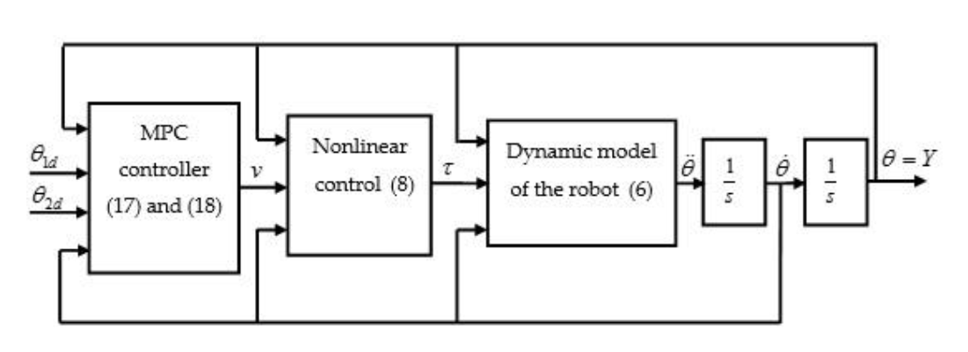

Fig 2. Closed-loop system (model predictive control)

**Simulink Module Explanation**

|  |  |
| --- | --- |
|  | According to the desired end-tip position to calculate the desired joint angles. |
|  | Model predictive controller controls robot arm to desired position. |
|  | According to equation (15) to calculate required torque. |
|  | According to equation (15) to calculate joint acceleration. |

**Simulation Results**

* Desired position: $x_{2}=1.1248, y_{2}=1.4659$
* Desired joint angle: $θ_{1}=\frac{π}{6}, θ_{2}=\frac{π}{4}$

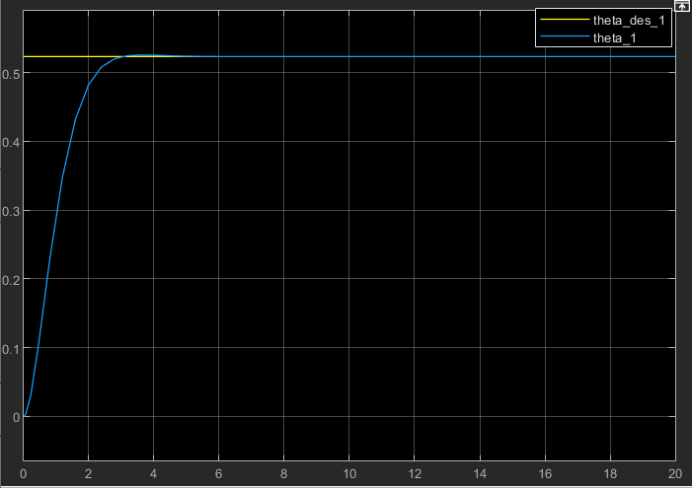

Fig 3. Real and desired orientations of the first link of the robot

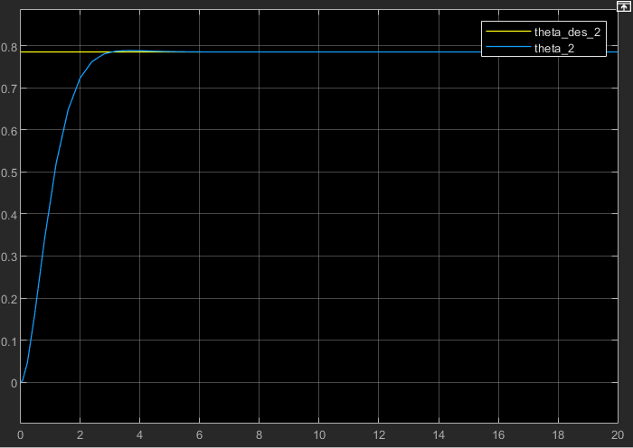

Fig 4. Real and desired orientations of the second link of the robot

Figure 3 and 4 show that model predictive control approach results in a fast and asymptotic convergence of both joint angles and without overshooting.

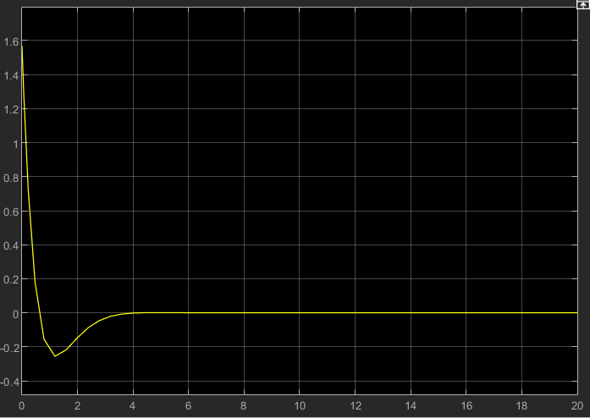

Fig 5. Acceleration of the first link of the robot

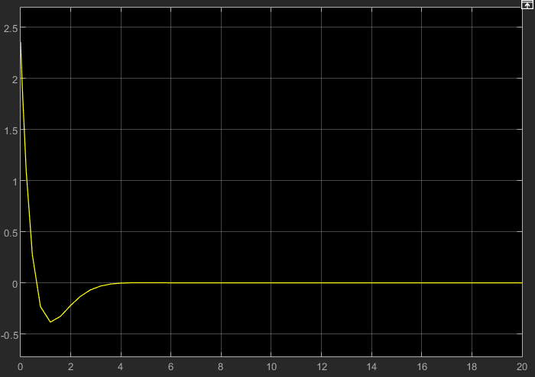

Fig 6. Acceleration of the second link of the robot

Figure 5 and 6 show that the joint acceleration reaches zero when the end-tip of the robot reaches its desired position.

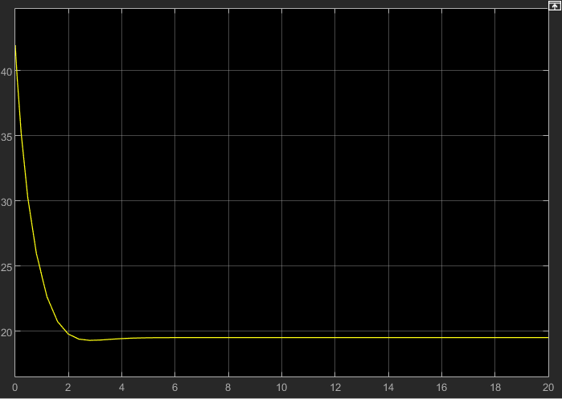

Fig 7. Torque of the robot’s first link

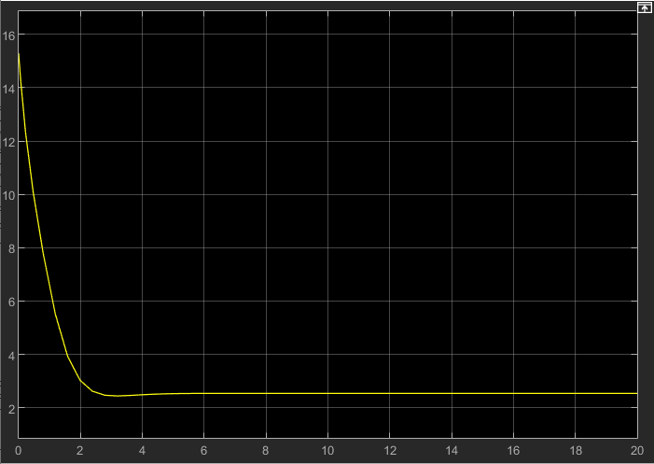

Fig 8. Torque of the robot’s second link

Figure 7 and 8 show that the torques decrease as the robot links move and reach a constant value when robot reaches its desired position.

**Reference**

[1] Mustafa, Aalim. (2014). Modeling, Simulation and Control of 2-R Robot. Global Journal of Research In Engineering.

[2] Guechi, Elhadi & Bouzoualegh, Samir & Youcef, Zennir & Blazic, Saso. (2018). MPC Control and LQ Optimal Control of A Two-Link Robot Arm: A Comparative Study. Machines. 6. 37. 10.3390/machines6030037.